**3.1** Write a Program to find both the maximum and minimum values in the array.Implement using any programming language of your choice. Execute your code and provide the maximum and minimum values found.

**AIM**

To write a program that finds both the **minimum** and **maximum** values from an array of integers.

**ALGORITHM**

1. Input the size of the array **N** and the array elements.
2. Initialize min = a[0] and max = a[0].
3. Traverse the array from index 1 to N-1:

* If a[i] < min, update min = a[i].
* If a[i] > max, update max = a[i].

1. After traversal, print the min and max.

**PROGRAM**

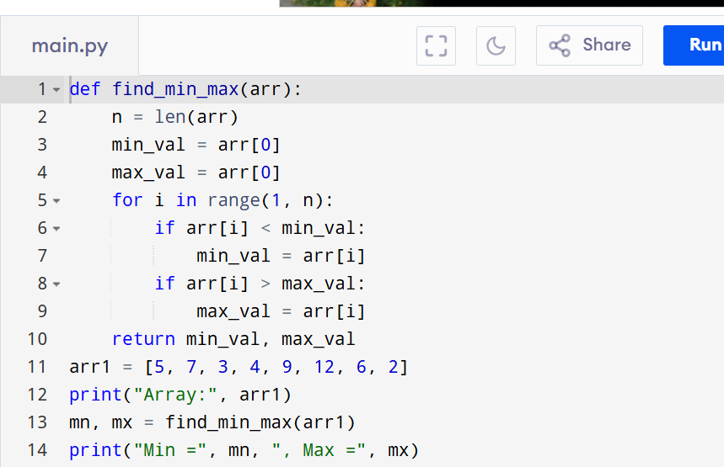

Input:

N=8, a[] = {5,7,3,4,9,12,6,2}

Output:

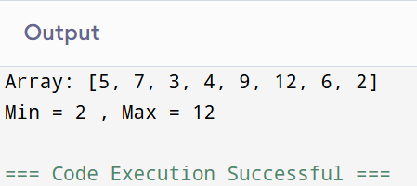

**RESULT:**

Thus the program to find both the maximum and minimum values in the array is successfully executed and the output is verified.

**PERFORMANCE ANALYSIS:**

* Time Complexity:O(N).
* Space Complexity:O(1)