**3.2 MAXIMUM AND MINIMUM VALUES**

**Aim**: To write a Python program to find the **minimum** and **maximum** values in a sorted array.

**Algorithm:**

1. StarT.
2. Input: Read integer N and array a[0...N-1]
3. Initialize:
4. min_val = a[0]
5. max_val = a[0]
6. Repeat for i = 1 to N - 1:
7. If a[i] < min_val, then min_val = a[i]
8. If a[i] > max_val, then max_val = a[i]
9. Output: min_val and max_val

End

**Program:**

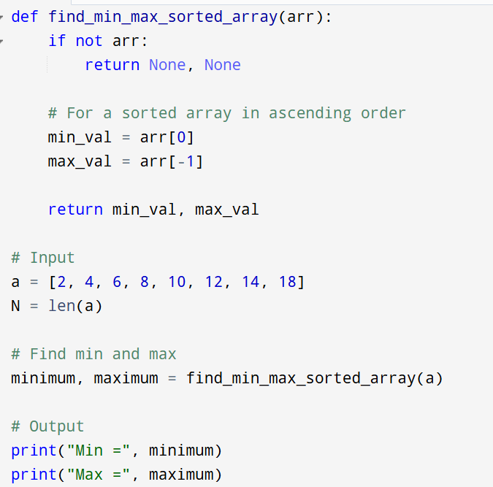

**Input:**

a = [2, 4, 6, 8, 10, 12, 14, 18]

**Output:**

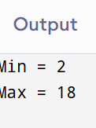

**Result:** Thus the program is successfully executed and the output is verified.

**Performance analysis:**

|  |  |
| --- | --- |
| Time Complexity: | **O(1)** for sorted array (direct access) |
| Space Complexity: | **O(1)** |