**3.3**  You are given an unsorted array 31,23,35,27,11,21,15,28. Write a program for Merge Sort and implement using any programming language of your choice.

**AIM**

To write a program that sorts an unsorted array using the **Merge Sort** algorithm.

**ALGORITHM**

1. Input the array of size N.
2. If the array has only one element, return (base case).
3. Otherwise,Find the middle index.
4. Recursively apply Merge Sort on the left subarray.
5. Recursively apply Merge Sort on the right subarray.
6. Merge the two sorted subarrays into a single sorted array.
7. Output the sorted array.

**PROGRAM**

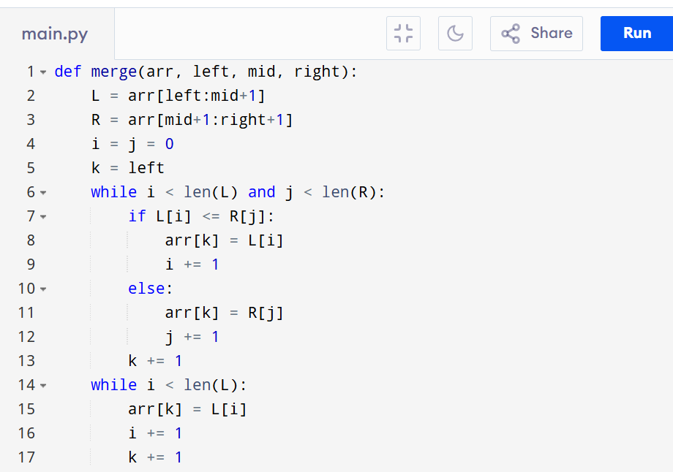

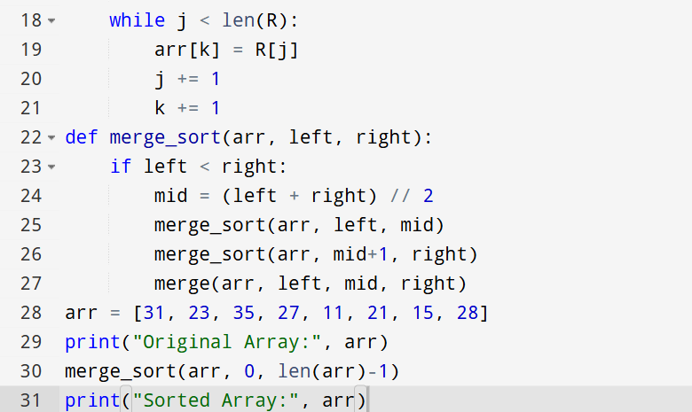

Input:

N=8, a[] = {31,23,35,27,11,21,15,28}

Output:

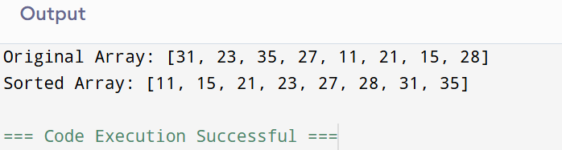

**RESULT:**

Thus the program that sorts an unsorted array using the **Merge Sort** algorithm is successfully executed and the output is verified.

**PERFORMANCE ANALYSIS:**

* + Time Complexity: O(N log N).
  + Space Complexity:O(N)