**3.4 MERGE SORTING**

**Aim**: To write a Python program to execute merge sort.

**Algorithm:**

1. Start
2. Input: Read integer N and array a[0...N-1]
3. If size of array <= 1, return (base case)
4. Divide the array into two halves:
5. Left = first half
6. Right = second half
7. Recursively apply merge sort to both halves
8. Merge the two sorted halves into a single sorted array:
9. While merging, count each comparison between elements
10. Return the merged sorted array
11. Output: Sorted array and number of comparisons
12. End

**Program:**

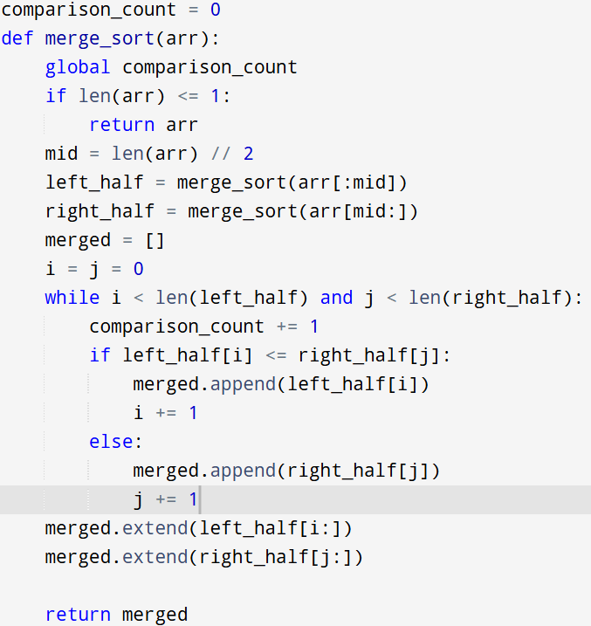

**Input:**

a = [12, 4, 78, 23, 45, 67, 89, 1]

**Output:**

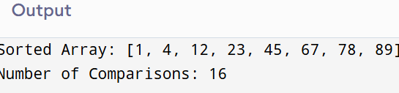

**Result:** Thus the program is successfully executed and the output is verified.

**Performance analysis:**

|  |  |
| --- | --- |
| Time Complexity | :O(n log n) |

|  |  |
| --- | --- |
| Space Complexity | :O(n) (due to new arrays) |

|  |  |
| --- | --- |
|  |  |