4. 15To implement Floyd’s Implement the Optimal Binary Search Tree algorithm for the keys A,B,C,D with frequencies 0.1,0.2,0.4,0.3 Write the code using any programming language to construct the OBST for the given keys and frequencies. Execute your code and display the resulting OBST and its cost. Print the cost and root matrix.

**AIM**

To implement the Optimal Binary Search Tree algorithm for the given keys and frequencies, construct the OBST, and display the cost and root matrices.

**ALGORITHM**

**1** **Start**

2.Input the number of keys n and their frequencies.

3.Initialize three matrices:

* cost[i][j] → Minimum cost of OBST from key i to j.
* root[i][j] → Root index for OBST from key i to j.
* w[i][j] → Sum of frequencies from key i to j.

4.For each key i, set:

* cost[i][i] = freq[i]
* w[i][i] = freq[i]
* root[i][i] = i

5.For subsequence lengths 2…n:

* Compute total frequency w[i][j].
* For each possible root r in [i…j], calculate:
* cost[i][j] = min( cost[i][r-1] + cost[r+1][j] + w[i][j] )
* Update root[i][j] with the root r giving minimum cost.

.

**PROGRAM**

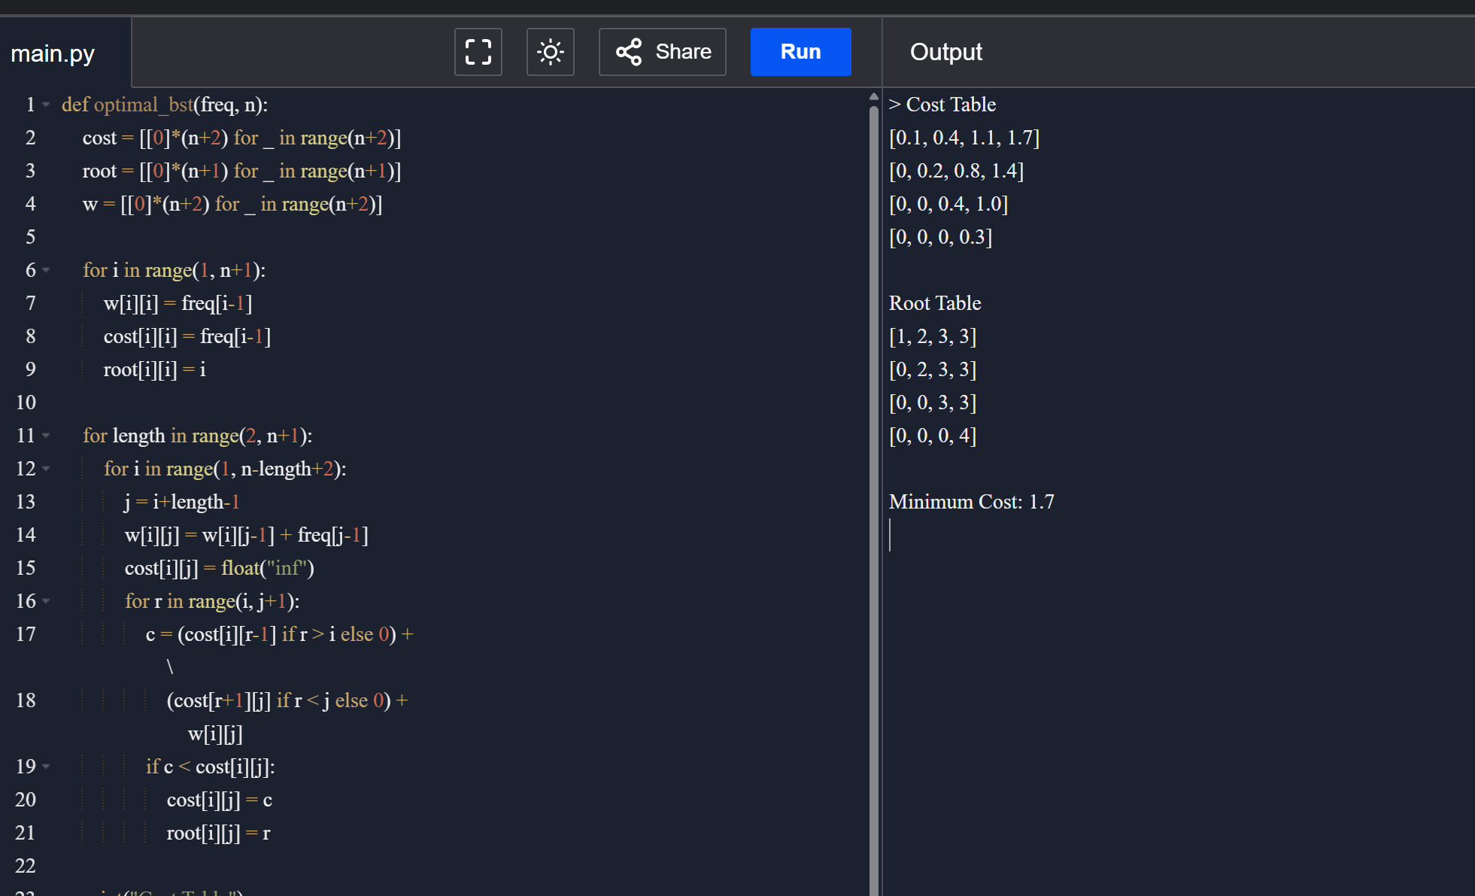

Input:

N = 4

Keys = {A, B, C, D}

Frequencies = {0.1, 0.2, 0.4, 0.3}

**RESULT:**

Thus, the Optimal Binary Search Tree (OBST) is constructed successfully.

* For Keys {A,B,C,D} → **Minimum Cost = 1.7**
* For Keys {10,12} → **Minimum Cost = 118**

**PERFORMANCE ANALYSIS:**

* **Time Complexity: O(n³)**
* **Space Complexity: O(n²)**