WEEK 1 – WIRESHARK TRAFFIC ANALYSIS LOG

Project: Net Guard – Network Intrusion Detection System (NIDS) & Log Analysis Engine

Intern Name: Bhima Geethika Sai
Intern ID: TSH/F0E7D424
Domain: Cyber Security
Week: 01
Tool Used: Wireshark
Capture File: week1_normal_traffic.pcapng
OBJECTIVE
To capture network traffic using Wireshark and perform deep packet inspection (DPI) by analysing TCP handshakes, DNS queries, HTTP traffic, and potential network anomalies.
TOOLS USED:
1. Wireshark
2. Windows Command Prompt
3. Captured PCAP file
NETWORK CAPTURE DETAILS
Capture File: week1_normal_traffic.pcapng
Capture Tool: Wireshark
Capture Type: Normal Network Traffic
Analysis Method: Display Filters and Packet Inspection
- The captured traffic was opened in Wireshark and analysed using display filters. TCP, DNS, HTTP, and TLS traffic were inspected to understand the communication between the local system and remote hosts.
PACKET ANALYSIS
1. TCP 3-WAY HANDSHAKE
A TCP connection begins with a three-way handshake. The three packets observed in the captured traffic were:
Packet 69:
Source: 192.168.1.4
Destination: 49.44.120.211
Source Port: 52163
Destination Port: 80
Flag: SYN

Packet 70:
Source: 49.44.120.211
Destination: 192.168.1.4
Source Port: 80
Destination Port: 52163
Flags: SYN, ACK

Packet 71:
Source: 192.168.1.4
Destination: 49.44.120.211
Source Port: 52163
Destination Port: 80
Flag: ACK
Analysis:
Packet 69 is the SYN packet sent by the client to request a TCP connection. Packet 70 is the SYN-ACK response from the server, acknowledging the request and indicating that the server is ready to establish the connection. Packet 71 is the final ACK sent by the client. After this three-way handshake, the TCP connection is established.
Wireshark Filter Used:
tcp.stream eq 29
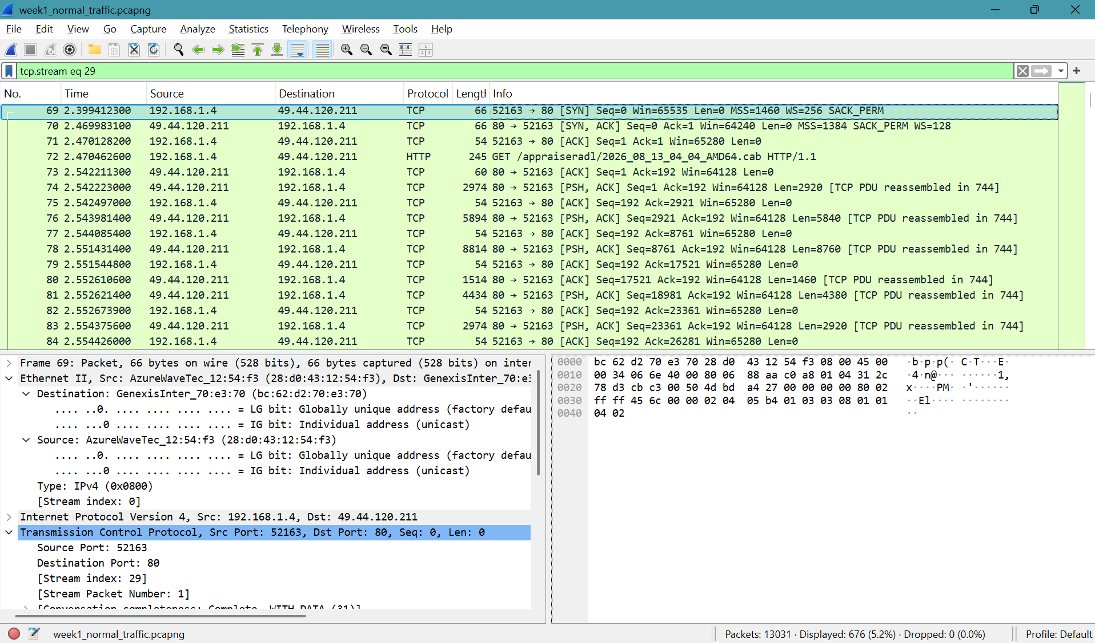
Figure 1: TCP Three-Way Handshake observed in Wireshark
2. DNS QUERY ANALYSIS
A DNS query was observed between the local system and the configured DNS server.
Packet 48:
Source: 192.168.1.4
Destination: 192.168.1.1
Source Port: 51423
Destination Port: 53
Protocol: DNS
Transaction ID: 0xfc17
Query Name: wdcp.microsoft.com
Query Type: A
Class: IN
Analysis:
The system 192.168.1.4 sent a DNS query to the DNS server 192.168.1.1 requesting the IPv4 address of wdcp.microsoft.com. The A record indicates that the query was requesting an IPv4 address. Wireshark identified Packet 49 as the corresponding response.
Wireshark Filter Used: dns
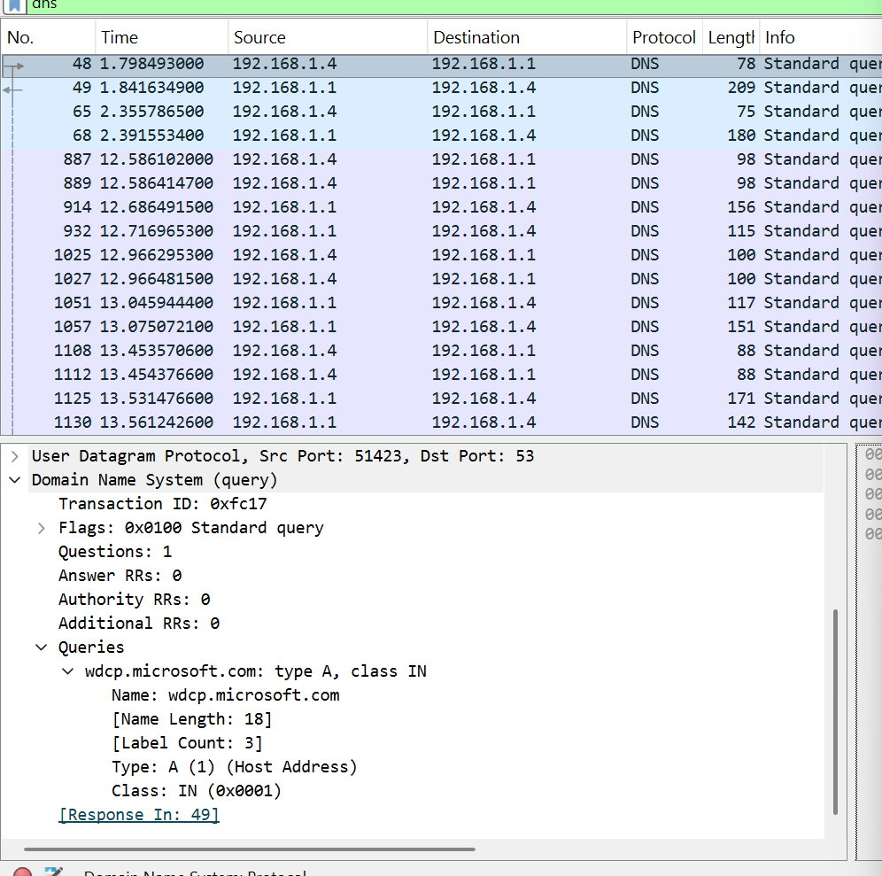
Figure 2: DNS Query for wdcp.microsoft.com
3. DNS RESPONSE ANALYSIS

Packet 49:
Source: 192.168.1.1
Destination: 192.168.1.4
Source Port: 53
Destination Port: 51423
Protocol: DNS
Transaction ID: 0xfc17
Response: No error
Answer Records: 3
- The DNS response corresponds to the query in Packet 48. The response contains a CNAME chain for wdcp.microsoft.com. The final A record resolves to the IPv4 address 57.155.141.116.

CNAME Chain:

wdcp.microsoft.com
↓
wd-prod-cp.trafficmanager.net
↓
wd-prod-cp-as-southeast-2-fe.southeastasia.cloudapp.azure.com
↓
57.155.141.116
Analysis:
The DNS server successfully responded to the client's request. The response contained CNAME records followed by an A record containing the final IPv4 address. No DNS error was observed in this response.
Wireshark Filter Used: dns
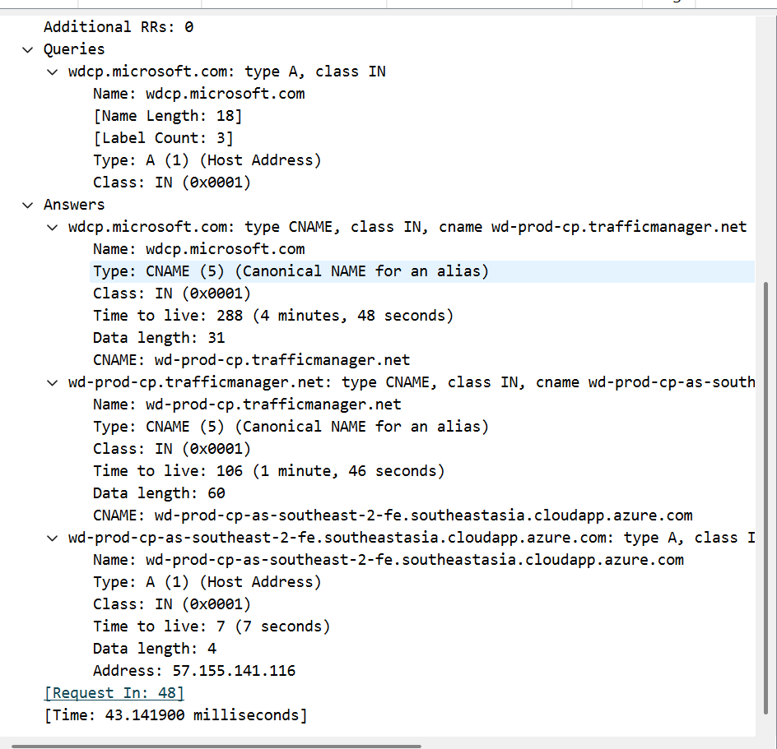
Figure 3: DNS Response and CNAME Resolution in Wireshark
4. HTTP PAYLOAD ANALYSIS
Packet 72:
Source: 192.168.1.4
Destination: 49.44.120.211
Protocol: HTTP
Source Port: 52163
Destination Port: 80

HTTP Request:
Method: GET
Request URI: /appraiseradl/2026_08_13_04_04_AMD64.cab
HTTP Version: HTTP/1.1
Host: adl.windows.com
User-Agent: WicaAgent
Analysis:
Packet 72 contains an HTTP GET request sent from the local system to the remote server. The GET method is used to request a resource from the server. The request includes the host name, requested resource path, HTTP version, and User-Agent information.
The TCP stream analysis also showed an HTTP 200 OK response from the server, indicating a successful HTTP response.
Wireshark Filter Used: tcp.stream eq 29
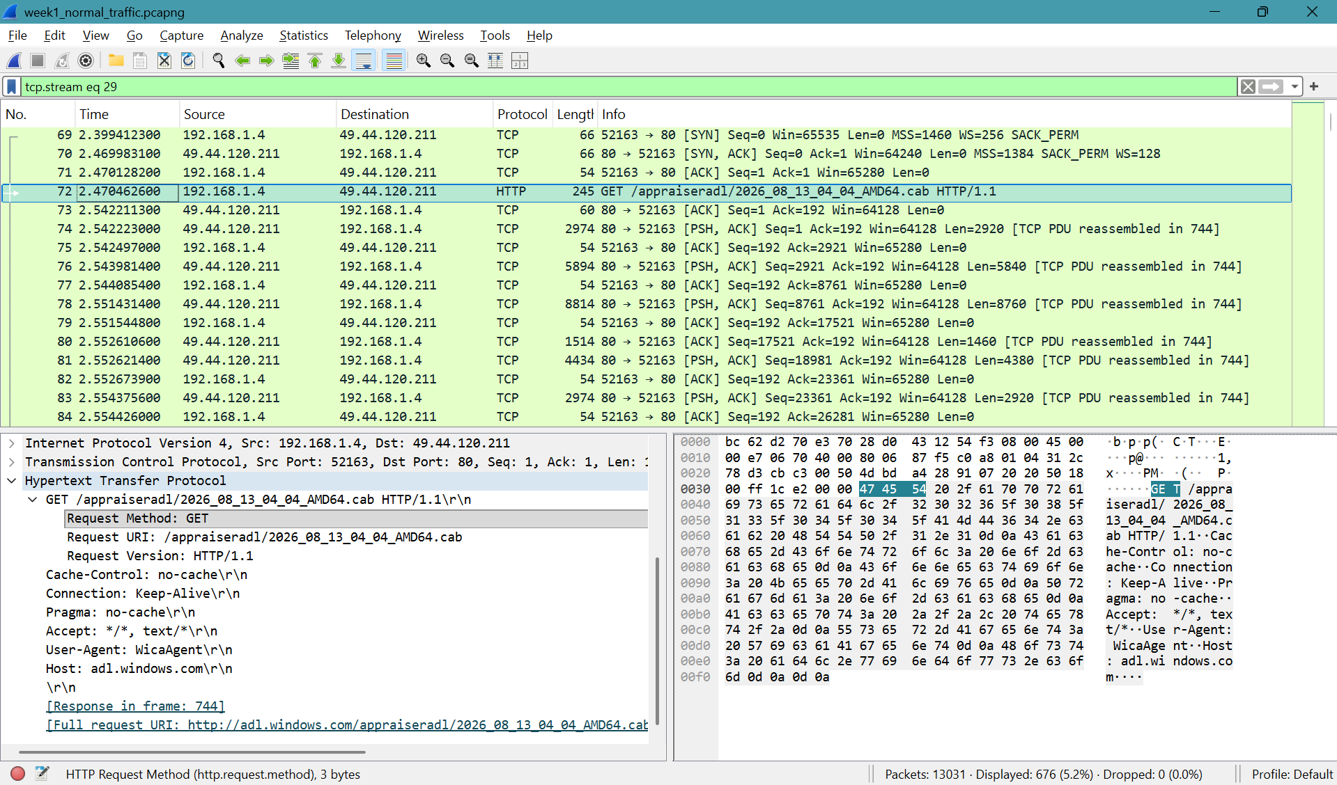
Figure 4: HTTP GET Request Observed in Wireshark

5. HTTPS / TLS TRAFFIC ANALYSIS
The captured traffic was further investigated for encrypted HTTPS communication. A TCP connection was observed between the local system and the remote host 185.199.111.215 on destination port 443.
Observed Details:
Source IP: 192.168.1.4
Destination IP: 185.199.111.215
Destination Port: 443
Protocol: TLS 1.3
Server Name Indication (SNI): github.githubassets.com
Analysis:
The connection followed a normal TCP connection-establishment sequence followed by a TLS 1.3 Client Hello message. The SNI value identified the requested host as github.githubassets.com.
The observed traffic was not classified as malicious based only on this packet sequence. The traffic showed a normal HTTPS/TLS communication pattern, and additional evidence would be required before identifying it as a security threat.
Wireshark Filter Used: Ip. Address == 185.199.111.215
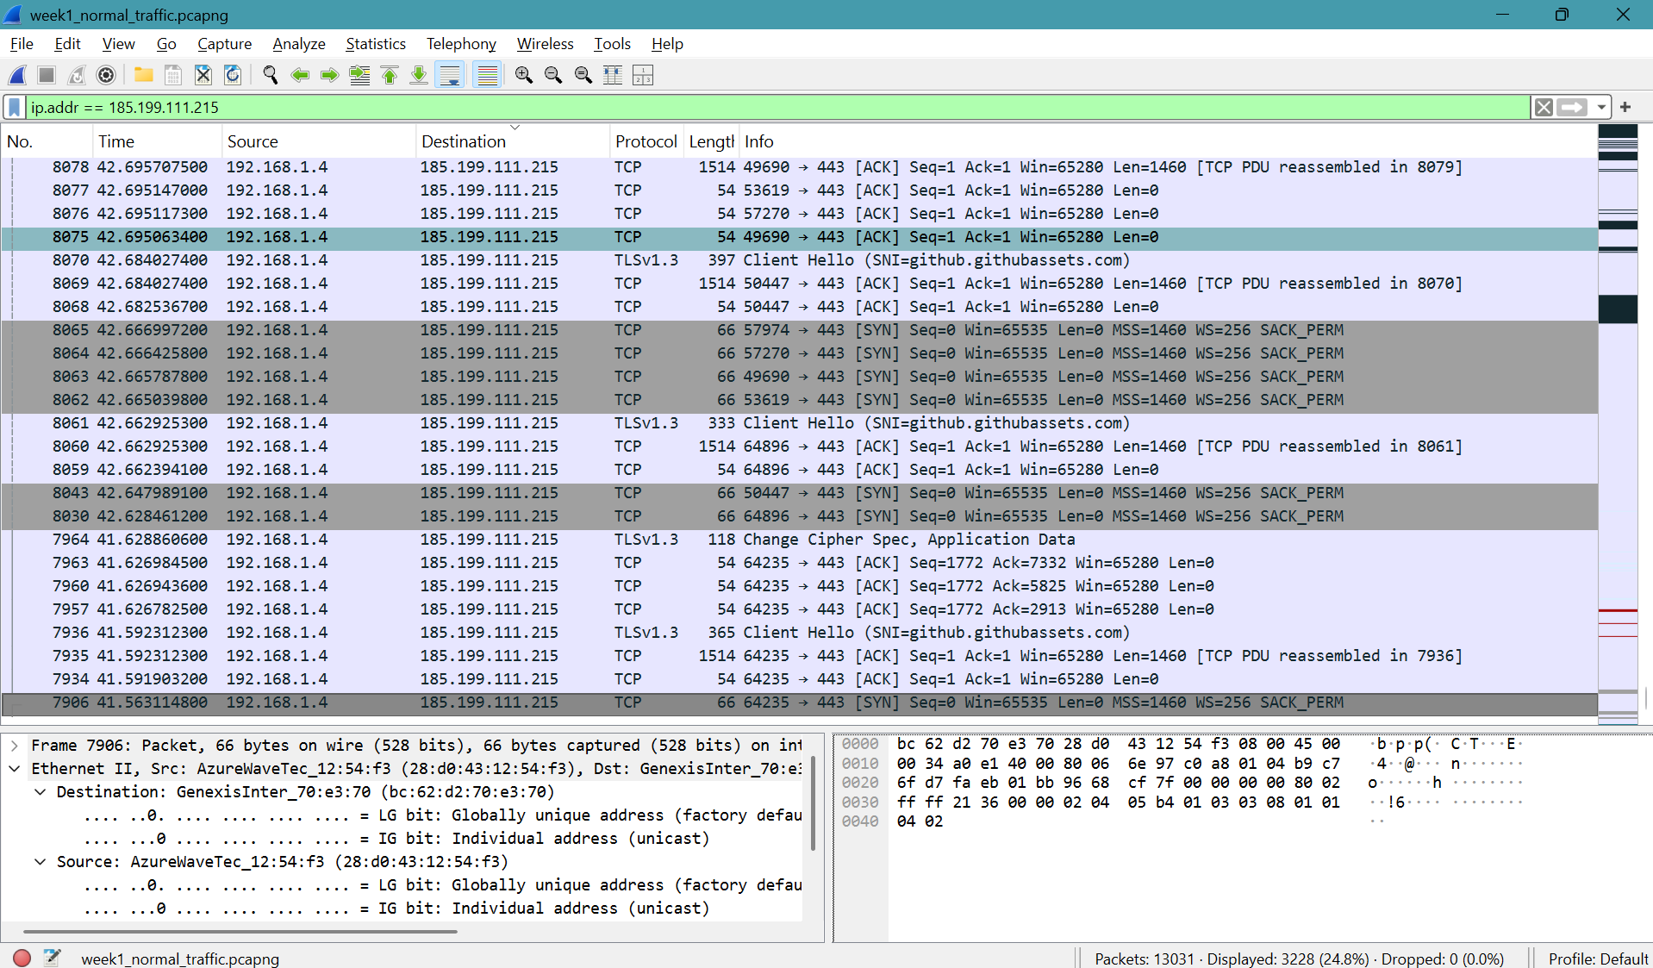
Figure 5: TLS 1.3 HTTPS Traffic Analysis
6. NETWORK ANOMALY / THREAT INVESTIGATION
The captured traffic was investigated for possible anomalous TCP behaviour. Initial SYN packets were filtered using the following Wireshark display filter:
tcp.flags.syn == 1 && tcp.flags.ack == 0
The resulting traffic was reviewed by examining destination IP addresses and destination ports.

Observation:
The traffic mainly consisted of connections to different external hosts using destination port 443. This pattern is consistent with multiple HTTPS connections rather than a typical TCP SYN port scan, where a single destination host is normally contacted across multiple destination ports.
A separate check was performed for SYN retransmissions using:
tcp.flags.syn == 1 && tcp.flags.ack == 0 && tcp.analysis.retransmission
No matching packets were displayed in the capture.

Conclusion:
No clear TCP SYN port-scan or SYN-retransmission pattern was identified in the analysed normal-traffic PCAP. The observed traffic was therefore not classified as malicious based solely on these observations. Further evidence would be required to confirm malicious activity.
7. OVERALL FINDINGS
The Wireshark capture was analyzed to understand the network communication generated during normal system activity. The analysis covered TCP connection establishment, DNS resolution, HTTP communication, HTTPS/TLS traffic, and possible anomalous TCP behavior.

The following observations were made:
1. A complete TCP three-way handshake was identified in Packets 69, 70, and 71.
2. A DNS query for wdcp.microsoft.com was identified in Packet 48, followed by its corresponding response in Packet 49.
3. The DNS response contained a CNAME chain and resolved to the IPv4 address 57.155.141.116.
4. An HTTP GET request was identified in Packet 72.
5. TLS 1.3 traffic to github.githubassets.com was examined and showed a normal HTTPS connection pattern.
6. The SYN traffic was investigated for possible port-scanning behavior.
7. No matching SYN retransmissions were identified using the selected Wireshark filter.
8. No clear malicious activity was established from the analyzed normal-traffic PCAP.

8. CONCLUSION
The Week 1 network traffic analysis was successfully performed using Wireshark. The exercise provided practical experience in packet capture, TCP handshake analysis, DNS query and response analysis, HTTP payload inspection, TLS traffic inspection, and basic network anomaly investigation.
The analysis demonstrated how Wireshark filters and packet-level inspection can be used to understand network communication and identify traffic patterns that may require further security investigation.
END OF WEEK 1 – WIRESHARK TRAFFIC ANALYSIS

