Network Intrusion Detection System (NIDS)
Week 2 – Snort IDS Installation & Custom Rule Writing
Project: NetGuard – Network Intrusion Detection System & Log Analysis Engine
Week: 02
Student Name: Geethika Sai Bhima
Internship: Cybersecurity Internship
Tools Used:
- Snort 3
- Ubuntu via WSL
- Tcpdump
- Scapy
- Wireshark
- VS Code

1. INTRODUCTION
Network Intrusion Detection Systems (NIDS) are used to monitor network traffic and identify suspicious or potentially harmful activities. During Week 2 of the NetGuard project, Snort 3 was installed and configured as the intrusion detection engine.
Custom Snort rules were developed to detect four types of suspicious network patterns:
- ICMP sweep activity
- TCP SYN port scanning
- Repeated SSH connection attempts
- Possible Command-and-Control (C2) beacon patterns
Synthetic network traffic was generated in a controlled laboratory environment using Scapy. The generated PCAP files were then analyzed using Snort to verify that each custom rule correctly generated an alert.

2. OBJECTIVE
The main objectives of Week 2 were:
- Install and configure Snort 3.
- Verify the Snort installation and configuration.
- Create custom Snort detection rules.
- Detect possible ICMP sweep activity.
- Detect possible TCP SYN port scanning.
- Detect repeated SSH connection attempts.
- Detect a possible C2 beacon pattern.
- Generate controlled test traffic for rule verification.
- Save Snort execution results as verification logs.

3. ENVIRONMENT AND TOOLS
Component | Details
Operating System | Ubuntu via WSL
IDS | Snort 3
Traffic Generation | Scapy
Packet Capture/Inspection | Tcpdump / Wireshark
Code Editor | VS Code
Test Format | PCAP
Detection Rules | Custom local.rules
The testing was performed using synthetic traffic in a controlled laboratory environment.

4. SNORT INSTALLATION AND CONFIGURATION
Snort 3 was installed in the Ubuntu WSL environment.
The installation process involved:
- Updating the Ubuntu package repository.
- Installing the required dependencies.
- Downloading the Snort source code.
- Installing LibDAQ.
- Configuring Snort.
- Compiling Snort.
- Installing Snort.
- Validating the Snort configuration.
The installation was successfully verified using the Snort version command.
The Snort configuration was also tested using:
snort -T
The configuration validation completed successfully without configuration warnings.

5. CUSTOM SNORT RULES
A custom rule file named: local.rules
was created inside the Week-2 Snort rules directory.
The following four rules were implemented:
alert icmp any any -> any any (msg:"NETGUARD - Possible ICMP Sweep"; detection_filter:track by_src,count 10,seconds 5; sid:1000001; rev:1;)

alert tcp any any -> any any (msg:"NETGUARD - Possible TCP SYN Port Scan";flags:S; detection_filter:track by_src,count 20,seconds 5; sid:1000002; rev:1;)

alert tcp any any -> any 22 (msg:"NETGUARD - Possible SSH Brute-Force Connection Burst"; flags:S; detection_filter:track by_src,count 5,seconds 60; sid:1000003; rev:1;)

alert tcp any any -> any 8080 (msg:"NETGUARD - Possible C2 Beacon Pattern"; flow:to_server; content:"/beacon"; detection_filter:track by_src,count 5,seconds 60; sid:1000004; rev:1;)

Rule Summary
SID | Detection | Trigger Condition
1000001 | Possible ICMP Sweep | 10 ICMP packets within 5 seconds
1000002 | Possible TCP SYN Port Scan | 20 SYN packets within 5 seconds
1000003 | Possible SSH Brute-Force Connection Burst | 5 SYN attempts to port 22 within 60 seconds
1000004 | Possible C2 Beacon Pattern | 5 /beacon requests to port 8080 within 60 seconds

6. RULE VALIDATION
After creating the custom rules, the rules file was validated with Snort.
The validation command used was:
snort -T -c /usr/local/etc/snort/snort.lua -R ~/NetGuard/Week-2-Snort/rules/local.rules
The configuration and custom rules were successfully validated.

7. TESTING METHODOLOGY
To verify the custom rules, synthetic PCAP files were created using Scapy.
Four test cases were prepared:
Test Case 1 – ICMP Sweep
11 synthetic ICMP packets were generated from:
10.10.10.10
towards multiple destination addresses.
The traffic was designed to exceed the ICMP detection threshold.
Test Case 2 – TCP SYN Port Scan
21 synthetic TCP SYN packets were generated from:
10.10.10.20
towards ports:
1000 – 1020
This exceeded the configured threshold of 20 SYN packets.
Test Case 3 – SSH Connection Burst
6 synthetic TCP SYN attempts were generated from:
10.10.10.30
towards:
10.10.10.1:22
This exceeded the configured threshold of 5 attempts.
Test Case 4 – C2 Beacon Pattern
6 synthetic TCP packets were generated from:
10.10.10.40
towards:
10.10.10.1:8080
The packets contained:
GET /beacon HTTP/1.1
This was used to test the custom C2 beacon-pattern rule.

8. ICMP SWEEP DETECTION
The first test focused on detecting repeated ICMP traffic.
Synthetic ICMP packets were generated from a single source to multiple destination addresses.
Traffic Evidence
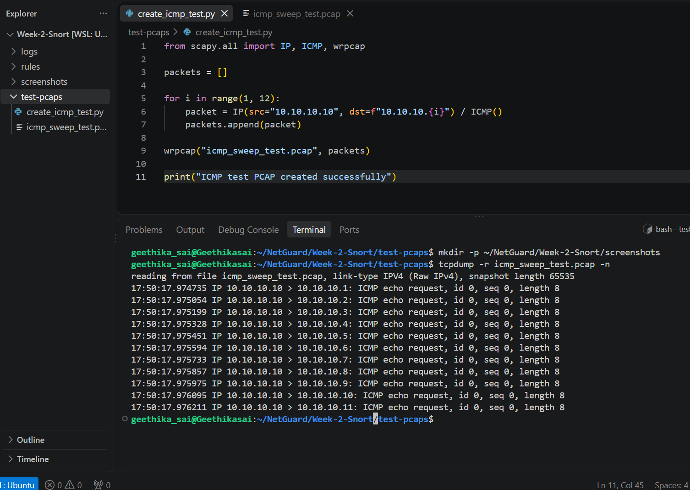
Figure 1: Synthetic ICMP sweep test traffic captured using Tcpdump
The captured traffic showed multiple ICMP echo requests originating from:
10.10.10.10
and targeting multiple destination addresses.
Snort Detection
The custom ICMP rule generated an alert:
NETGUARD - Possible ICMP Sweep
Figure 2: Snort alert for possible ICMP sweep
The alert confirms that Snort successfully detected the synthetic ICMP traffic after the configured threshold was exceeded.
The corresponding execution verification log was saved as:
icmp_sweep_detection.log

9. TCP SYN PORT SCAN DETECTION
The second test focused on detecting a burst of TCP SYN packets targeting multiple ports.
21 synthetic SYN packets were generated against ports 1000 through 1020.
Traffic and Detection Evidence
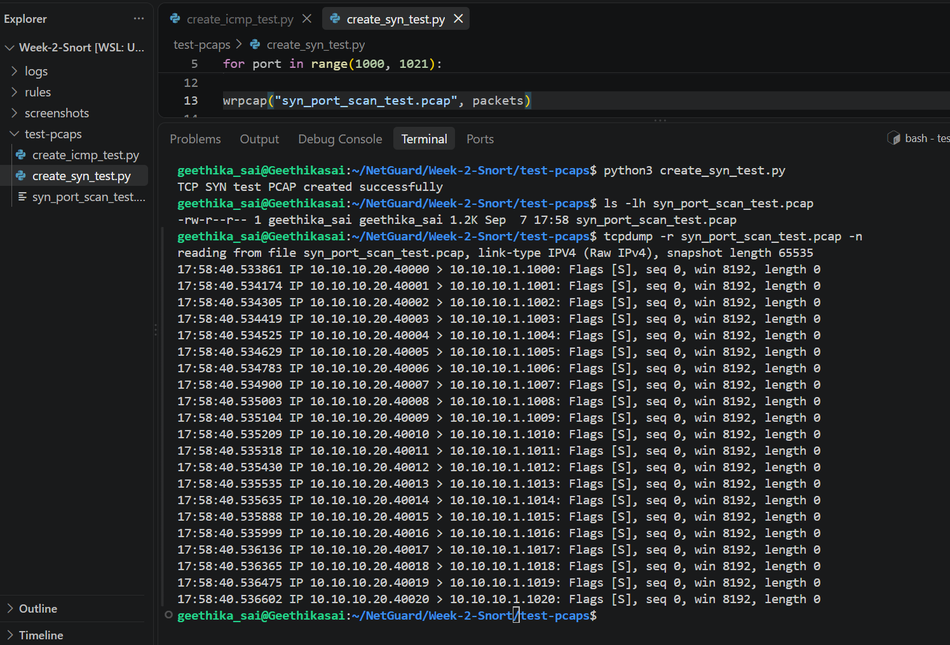
Figure 3: TCP SYN test traffic and Snort detection
The Snort alert generated was:
NETGUARD - Possible TCP SYN PortScan
The alert identified traffic from:
10.10.10.20
to:
10.10.10.1
The corresponding Snort rule had:
SID: 1000002
The execution verification log was saved as:
tcp_syn_scan_detection.log
This confirms that the custom SYN-based detection rule successfully triggered on the synthetic test traffic.

10. SSH BRUTE-FORCE CONNECTION BURST DETECTION
The third test focused on repeated TCP SYN connection attempts to the SSH service.
Six synthetic connection attempts were generated from:
10.10.10.30
to:
10.10.10.1:22
Traffic Evidence
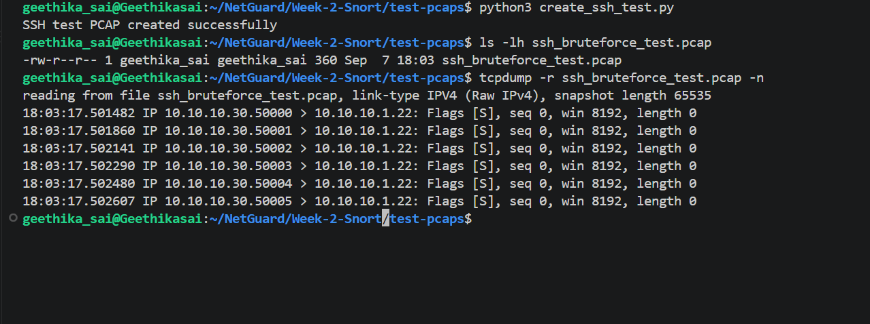
Figure 4: Synthetic SSH connection attempts captured using Tcpdump
The traffic shows repeated SYN attempts towards TCP port 22.
The custom rule was designed to identify a burst of five or more SYN attempts to port 22 from the same source within 60 seconds.
Snort Detection
The rule generated an alert with the message:
NETGUARD - Possible SSH Brute-Force Connection Burst
The corresponding verification log was saved as:
ssh_bruteforce_detection.log
This test demonstrates detection of a suspicious SSH connection burst.
Note: Since the test uses synthetic TCP SYN packets, the result indicates a connection-burst pattern. It does not by itself prove successful or unsuccessful SSH authentication attempts.

11. C2 BEACON PATTERN DETECTION
The fourth test focused on detecting a possible Command-and-Control beacon pattern.
Synthetic HTTP-like traffic was generated towards TCP port 8080.
The payload contained:
GET /beacon HTTP/1.1
Host: lab-server
Six packets were generated from:
10.10.10.40
towards:
10.10.10.1:8080
Traffic Evidence
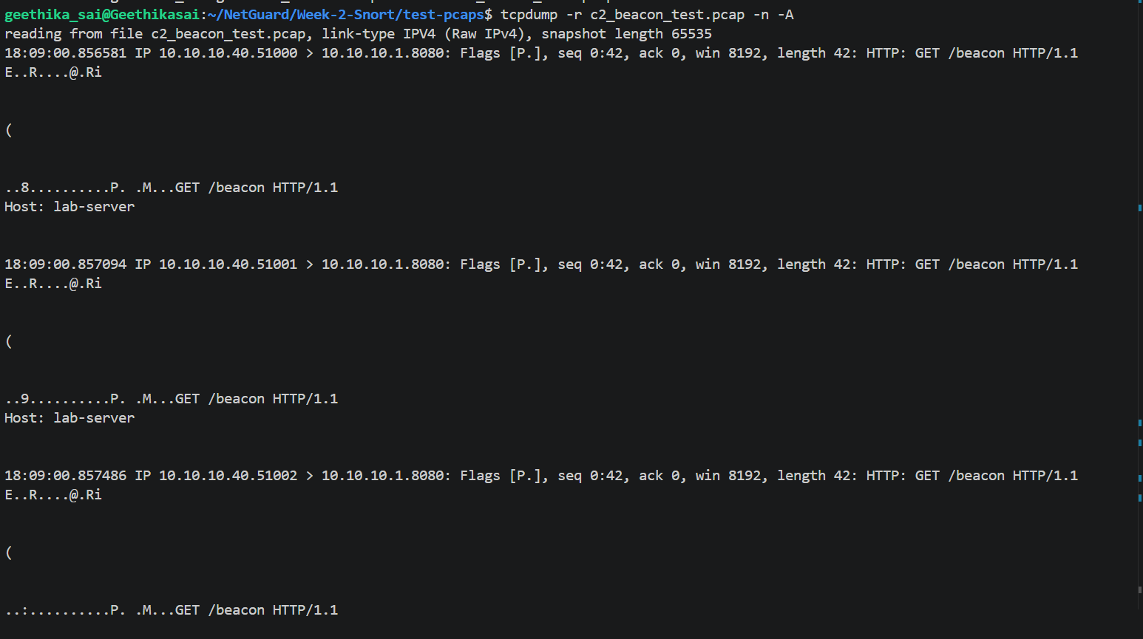
Figure 5: Synthetic C2 beacon-pattern traffic
Snort Detection
Snort generated multiple alerts with the message:
NETGUARD - Possible C2 Beacon Pattern
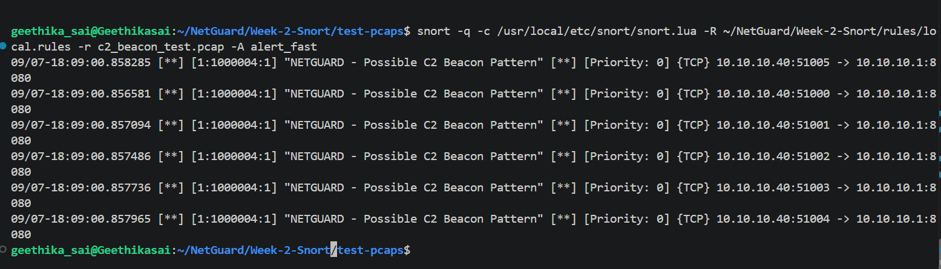
Figure 6: Snort detection of possible C2 beacon pattern
The alerts were generated by:
SID: 1000004
The corresponding execution verification log was saved as:
c2_beacon_detection.log
This demonstrates that the custom rule successfully detected the synthetic /beacon traffic pattern.
Note: This test demonstrates rule-based detection of a beacon-like pattern in controlled traffic. It does not establish that the traffic represents actual malware or a real C2 connection.

12. EXECUTION VERIFICATION LOGS
The Snort execution results were saved in the logs directory.
The following logs were generated:
logs/
├── icmp_sweep_detection.log
├── tcp_syn_scan_detection.log
├── ssh_bruteforce_detection.log
└── c2_beacon_detection.log
These logs provide command-execution evidence that the custom rules successfully generated alerts for the corresponding synthetic PCAP files.

13. RESULTS
The results of the Week-2 testing are summarized below:
Test Case | PCAP | Rule SID | Result
ICMP Sweep | icmp_sweep_test.pcap | 1000001 | ✅ Alert generated
TCP SYN Scan | syn_port_scan_test.pcap | 1000002 | ✅ Alert generated
SSH Connection Burst | ssh_bruteforce_test.pcap | 1000003 | ✅ Alert generated
C2 Beacon Pattern | c2_beacon_test.pcap | 1000004 | ✅ Alert generated
All four custom detection rules were successfully tested against their corresponding synthetic traffic.

15. CONCLUSION
During Week 2 of the NetGuard project, Snort 3 was successfully installed and configured in the Ubuntu WSL environment.
Four custom Snort detection rules were developed for identifying:
- Possible ICMP sweep activity
- Possible TCP SYN port scanning
- Possible SSH brute-force connection bursts
- Possible C2 beacon patterns
Synthetic network traffic was generated using Scapy and stored as PCAP files. The PCAPs were processed by Snort to verify the custom rules.
All four detection scenarios successfully generated Snort alerts, and execution verification logs were created for each test.
The completed work demonstrates the basic functionality of a rule-based Network Intrusion Detection System and provides the foundation for the next stage of the NetGuard project, where Snort alerts can be integrated into a centralized SIEM/log-analysis pipeline.

