NETGUARD – NETWORK INTRUSION DETECTION SYSTEM
WEEK 3 – SIEM LOG INTEGRATION & THREAT MONITORING DASHBOARD
TechSkillHub Cyber Security Internship
Intern Name: Bhima Geethika Sai
Intern ID: TSH/F0E7D424
Week: 03
Topic: SIEM Log Integration using ELK Stack

1. OBJECTIVE
The objective of Week 3 is to integrate Snort IDS alert logs with a centralized SIEM platform using the ELK Stack.
The main objectives are:
- Configure Logstash to collect Snort alert logs.
- Parse Snort alert logs into structured fields.
- Ingest the parsed logs into Elasticsearch.
- Create a Kibana Data View.
- Build a threat monitoring dashboard.
- Visualize security alerts for effective monitoring and analysis.

2. TOOLS AND TECHNOLOGIES USED
- Docker Desktop
- Docker Compose
- Elasticsearch 9.5.3
- Logstash 9.5.3
- Kibana 9.5.3
- Snort 3
- WSL / Ubuntu
- Windows 11
- Visual Studio Code

3. SIEM ARCHITECTURE
The implemented SIEM pipeline follows:
Snort IDS → Snort Alert Logs → Logstash → Elasticsearch → Kibana → Threat Monitoring Dashboard
Description
Snort IDS: Generates alerts based on custom detection rules.
Snort Alert Logs: Store the alerts generated by Snort.
Logstash: Reads, parses and processes the Snort alert logs.
Elasticsearch: Stores and indexes the parsed security events.
Kibana: Provides visualization and dashboard capabilities for monitoring the alerts.

4. SNORT ALERT LOG COLLECTION
The Snort detection logs generated during Week 2 were used as input for the SIEM pipeline.
The following logs were integrated:
- icmp_sweep_detection.log
- tcp_syn_scan_detection.log
- ssh_bruteforce_detection.log
- c2_beacon_detection.log
The logs were copied into the Week 3 SIEM logs directory.
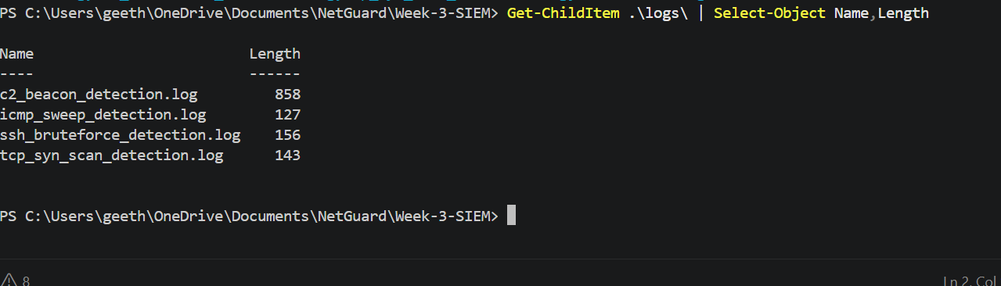
5. ELK STACK DEPLOYMENT
The ELK Stack was deployed using Docker Compose.
Three services were configured:
- Elasticsearch
- Kibana
- Logstash
Elasticsearch was configured to store the security alerts, Kibana was used for visualization, and Logstash was used to collect and process the Snort logs.
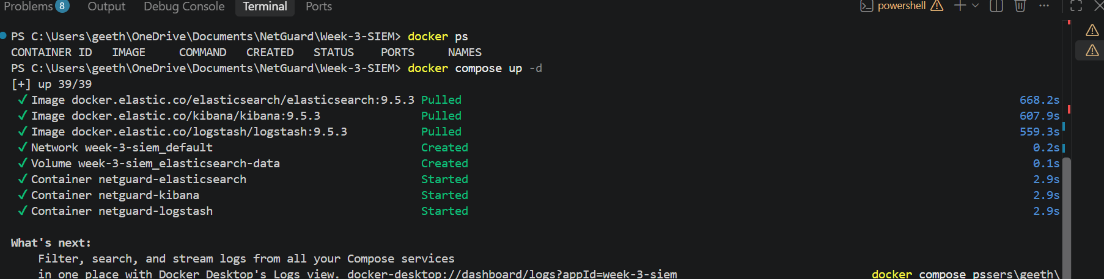

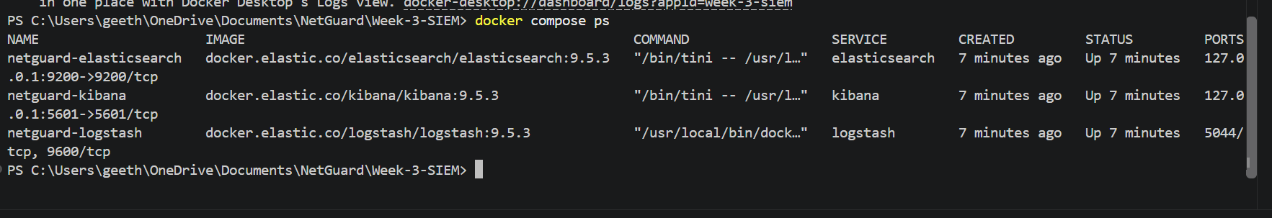
6. ELASTICSEARCH VERIFICATION
Elasticsearch was successfully started and verified through its local endpoint.
http://localhost:9200
The successful response confirmed that the Elasticsearch service was running correctly.
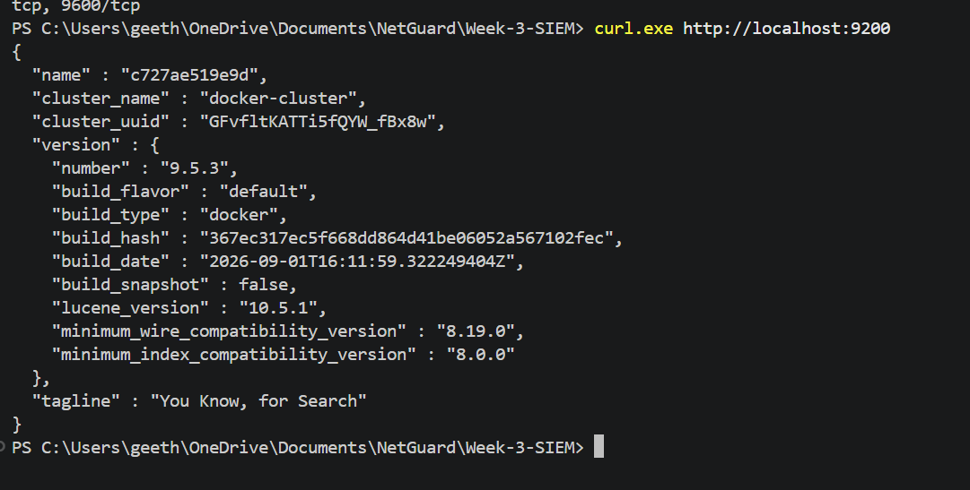Elasticsearch Running

7. KIBANA CONFIGURATION
Kibana was accessed through:
http://localhost:5601
The Kibana interface was successfully loaded and used for creating the Data View and threat monitoring dashboard.
Kibana Home

8. LOGSTASH PIPELINE CONFIGURATION
A Logstash pipeline was created to read the Snort alert log files and forward the parsed events to Elasticsearch.
The pipeline consists of:
- File input
- Grok filter
- Mutate filter
- Elasticsearch output
- Rubydebug output for verification
Logstash Configuration
input {
file {
path => "/usr/share/logstash/data/snort/*.log"
start_position => "beginning"
sincedb_path => "/dev/null"
}
}

filter {
grok {
match => {
"message" => '%{DATA:snort_time} \[\*\*\] \[%{INT:generator}:%{INT:sid}:%{INT:rev}\] "%{DATA:alert_msg}" \[\*\*\] \[Priority: %{INT:priority}\] \{%{WORD:protocol}\} %{IP:src_ip}:%{INT:src_port} -> %{IP:dst_ip}:%{INT:dst_port}'
}
}

mutate {
convert => {
"sid" => "integer"
"rev" => "integer"
"priority" => "integer"
"src_port" => "integer"
"dst_port" => "integer"
}
}
}

output {
elasticsearch {
hosts => ["http://elasticsearch:9200"]
index => "snort-alerts"
}

stdout {
codec => rubydebug
}
}

9. LOG PARSING VERIFICATION
The Grok filter was used to extract important information from Snort alert messages.
The extracted fields include:
- Snort timestamp
- Generator
- SID
- Revision
- Alert message
- Priority
- Protocol
- Source IP
- Source Port
- Destination IP
- Destination Port
The Logstash output confirmed that the Snort alerts were successfully parsed into structured fields.
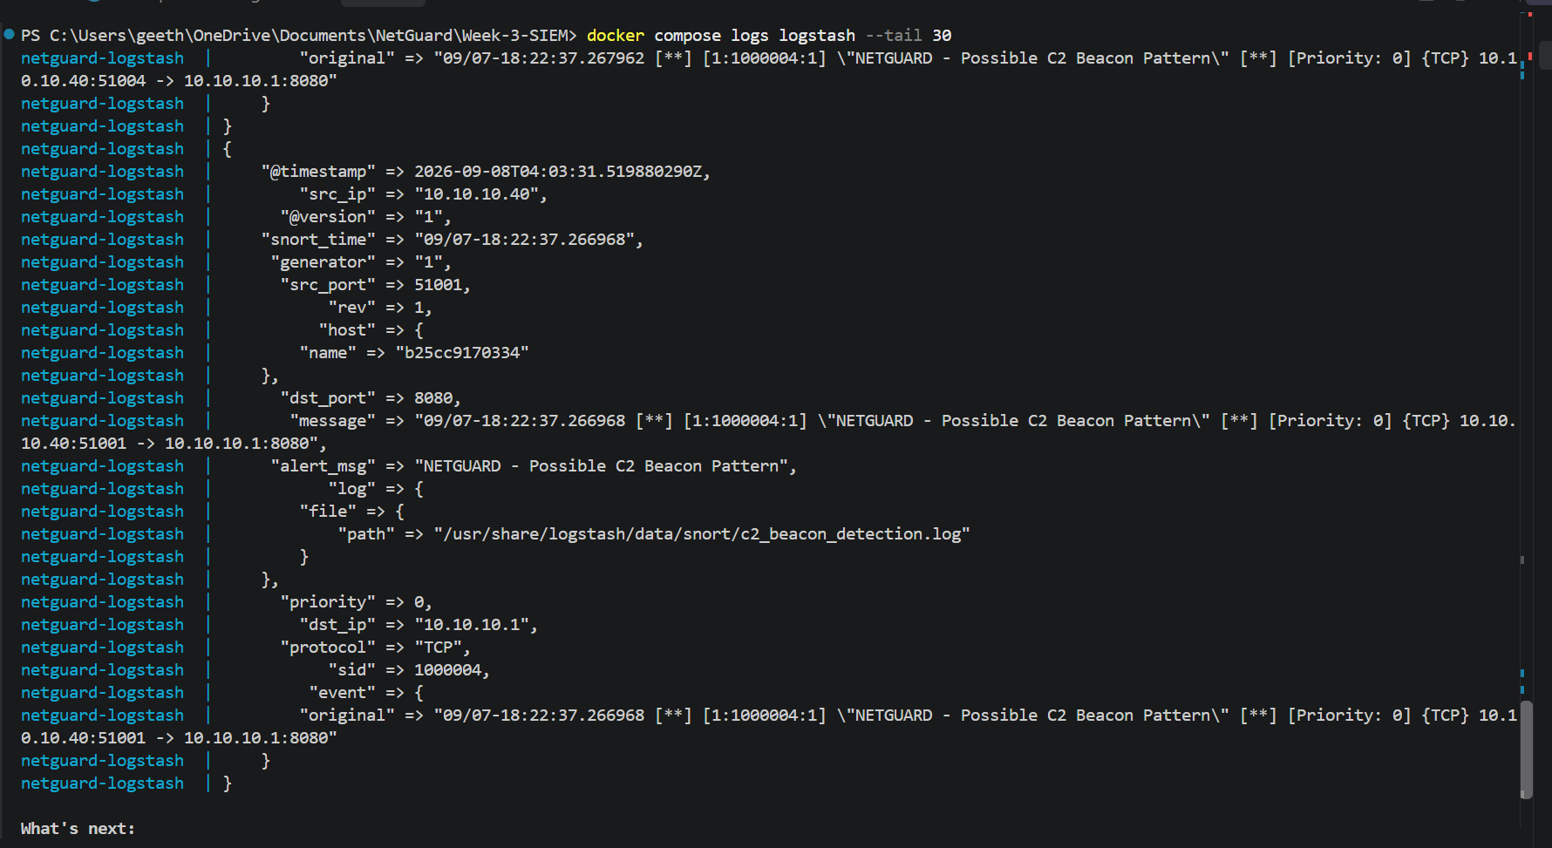Logstash Parsed Snort Alert

10. ELASTICSEARCH ALERT INDEX
The parsed Snort alerts were stored in the Elasticsearch index:
snort-alerts
The Elasticsearch index was verified successfully.
A total of 27 Snort alert records were indexed.
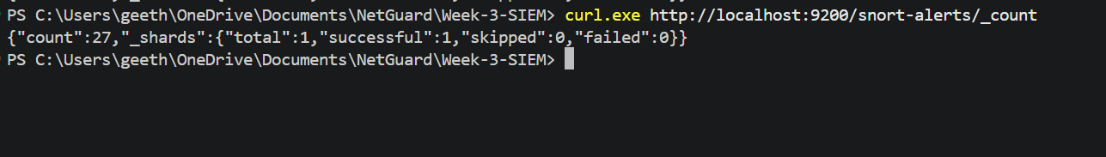Snort Alerts Indexed in Elasticsearch

11. KIBANA DATA VIEW
A Kibana Data View was created using the Elasticsearch index.
Data View Name
NetGuard-Snort-Alerts
Index Pattern
snort-alerts
The Data View made the parsed Snort fields available for visualization and analysis.
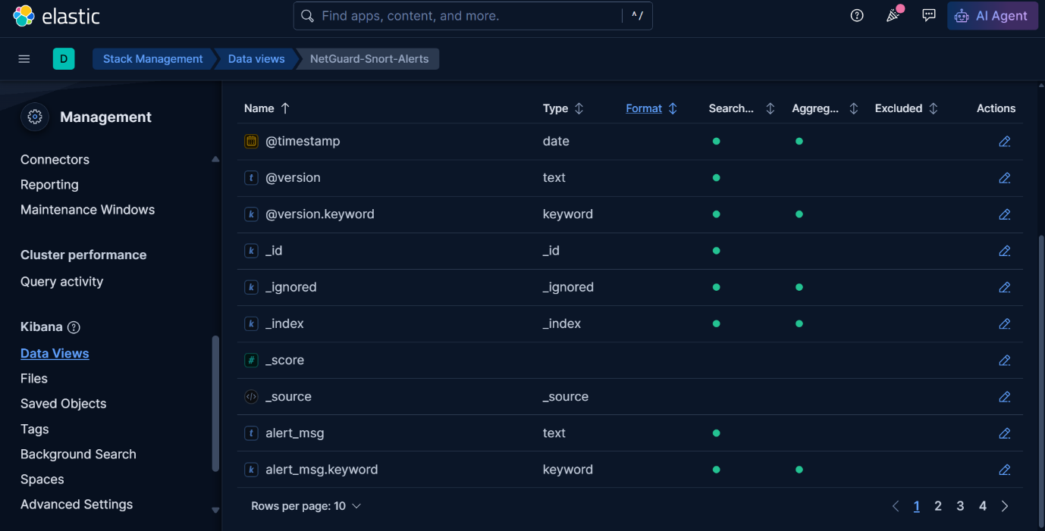Kibana Snort Data View

12. THREAT MONITORING DASHBOARD
A Kibana dashboard was created for centralized monitoring of Snort security alerts.
The dashboard was named:
NetGuard - Threat Monitoring Dashboard
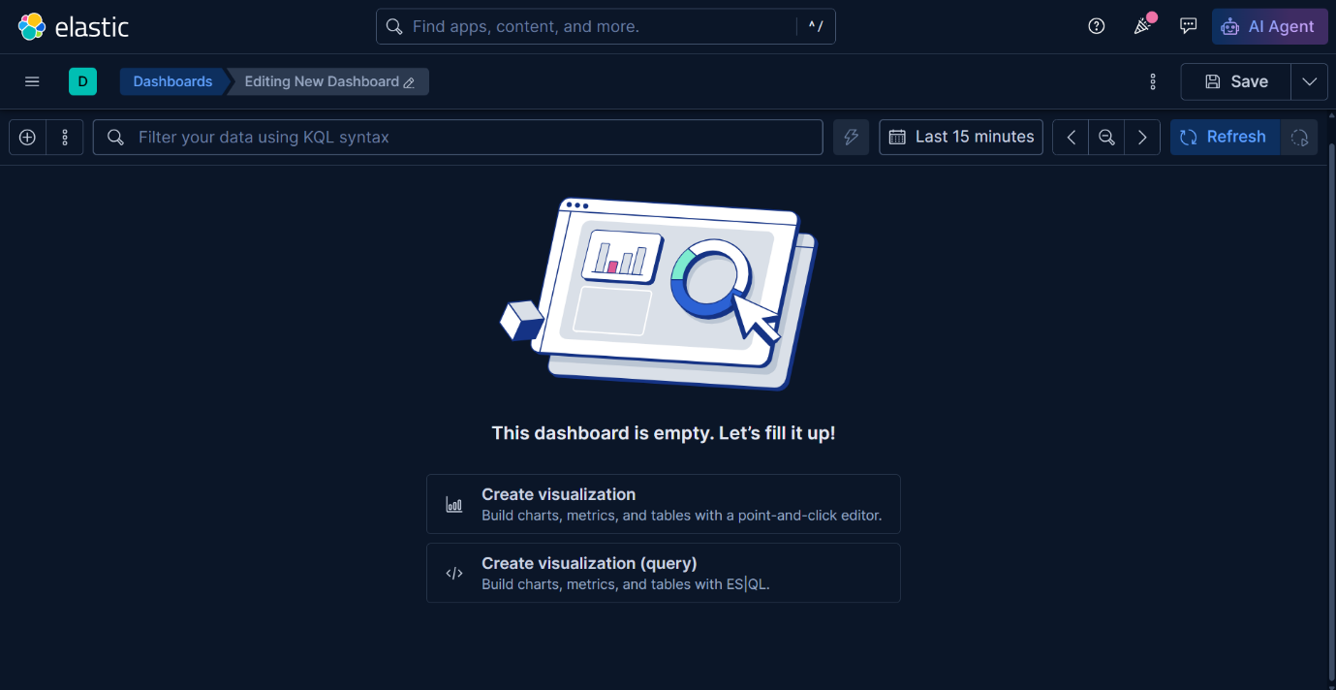Kibana Dashboard Created

12.1 TOTAL SNORT ALERTS
A Metric visualization was created to display the total number of Snort alert records.
Total Snort Alerts: 27
This provides a quick overview of the number of security events indexed in Elasticsearch.

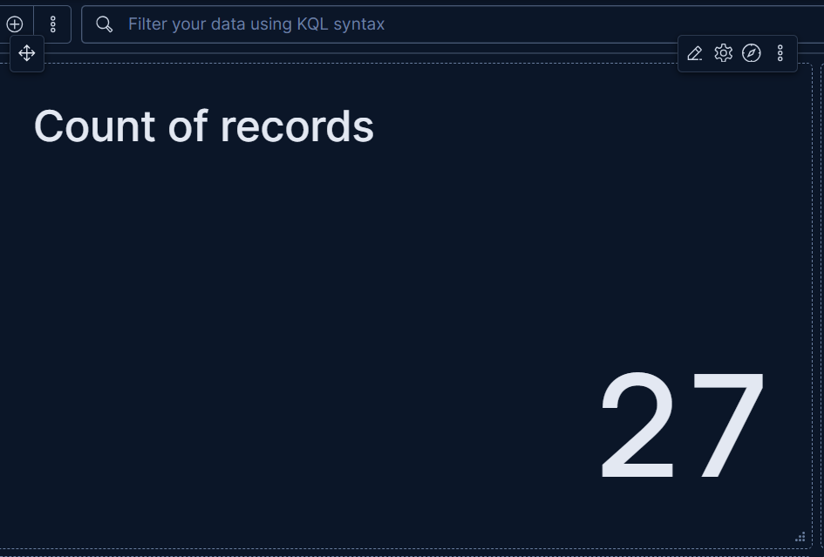

12.2 ALERTS BY RULE
A bar chart was created to display the number of alerts generated by each Snort detection rule.
- Horizontal Axis: alert_msg.keyword
- Vertical Axis: Count of records
This visualization helps identify which detection rules generated the highest number of alerts.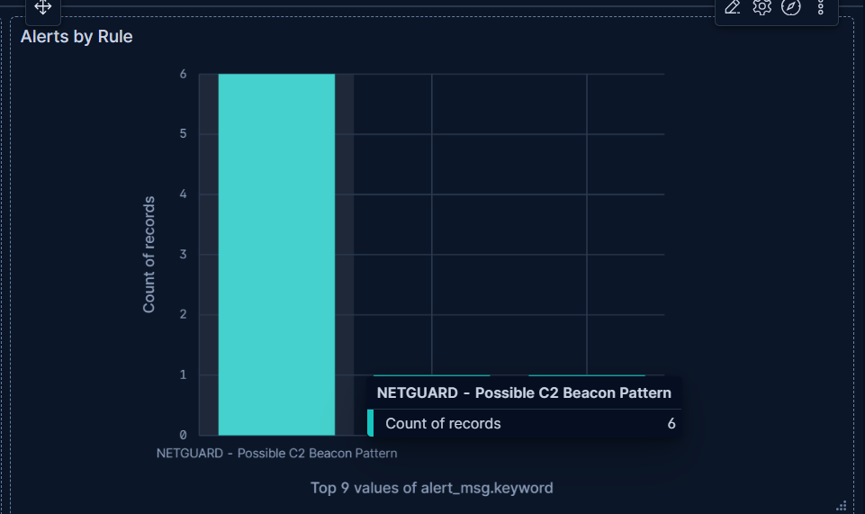

12.3 ALERTS BY SOURCE IP
A bar chart was created using the source IP field.
- Horizontal Axis: src_ip.keyword
- Vertical Axis: Count of records
This helps identify source IP addresses associated with multiple security alerts.
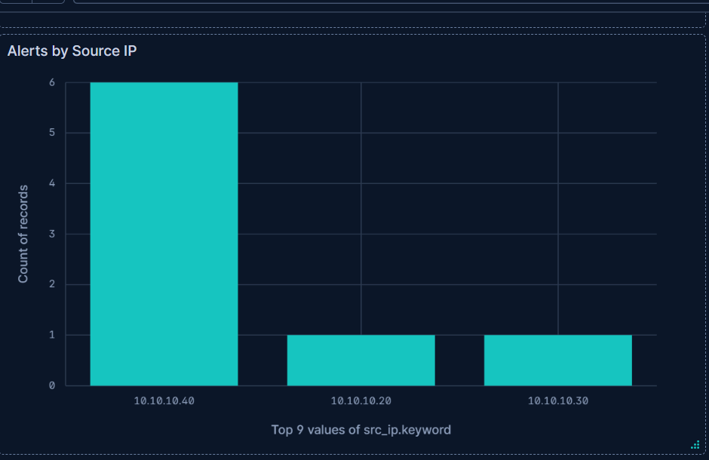

12.4 ALERTS BY DESTINATION PORT
A bar chart was created using the destination port field.
- Horizontal Axis: dst_port
- Vertical Axis: Count of records
This helps identify the destination ports associated with detected security events.
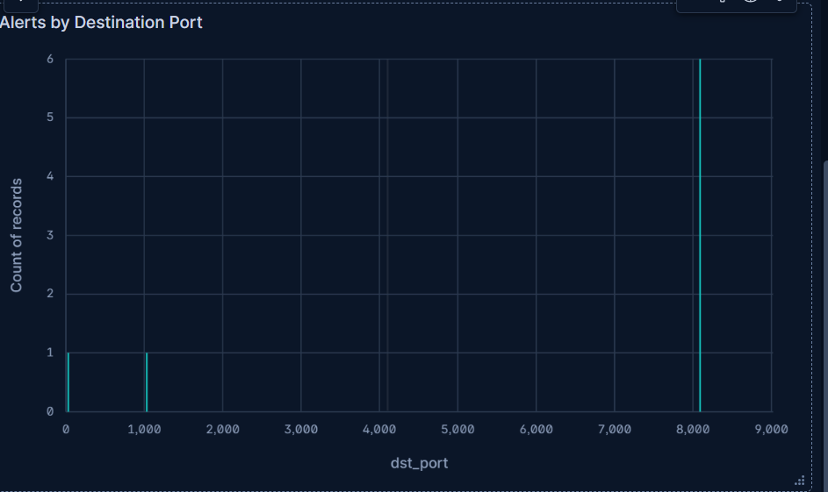

12.5 RECENT SNORT ALERTS
A table visualization was created to provide a detailed view of the indexed Snort alerts.
The visualization provides structured information from the Snort alert records and supports detailed analysis of individual events.
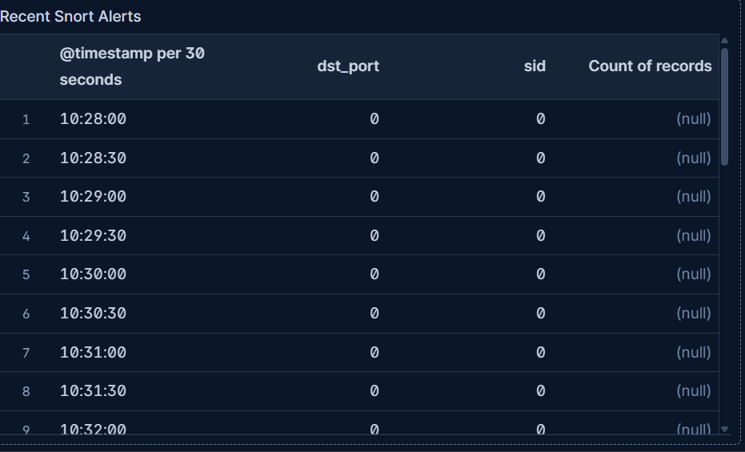

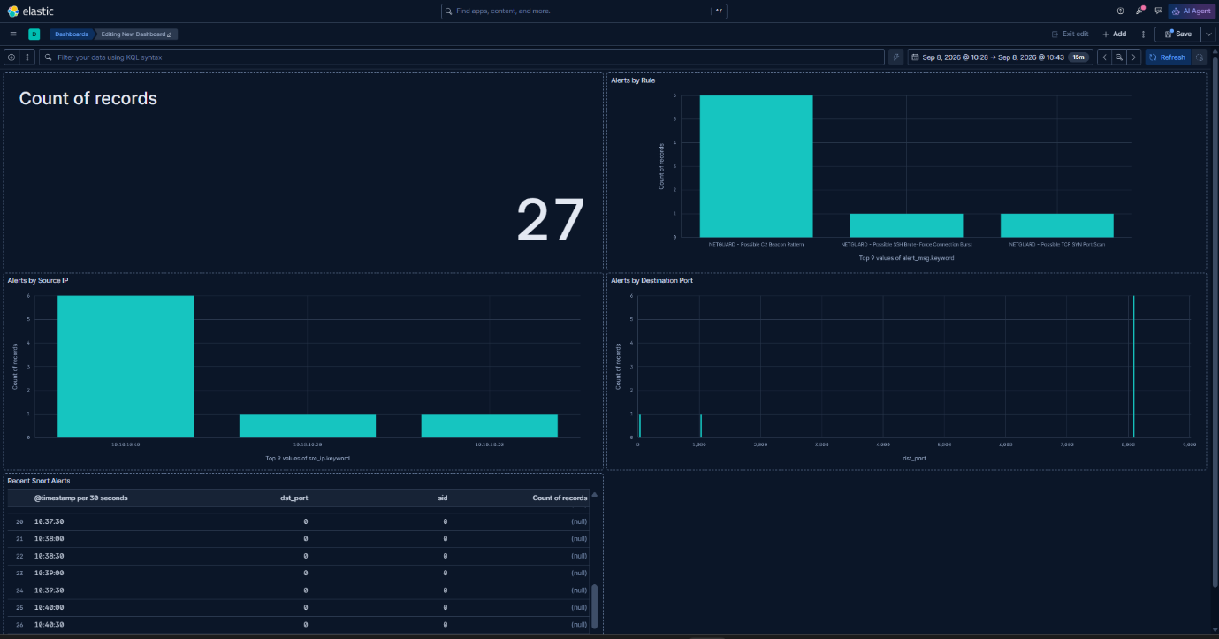NetGuard Threat Monitoring Dashboard
13. OBSERVATIONS
The following observations were made:
- Snort alert logs were successfully collected from the Week 2 detection tests.
- Logstash successfully read the Snort log files.
- The Snort alert messages were successfully parsed into structured fields.
- The parsed events were successfully indexed in Elasticsearch.
- A total of 27 Snort alert records were verified.
- Kibana successfully displayed the indexed Snort fields.
- Multiple dashboard visualizations were created.
- The dashboard provides centralized visibility into Snort security events.
- Alerts can be analyzed based on detection rules, source IP addresses and destination ports.

14. RESULT
The Week 3 SIEM Log Integration task was successfully completed.
The Snort alerts generated during Week 2 were successfully:
Collected → Parsed → Indexed → Visualized
The ELK Stack successfully provided centralized monitoring of the Snort IDS alerts through the NetGuard Threat Monitoring Dashboard.

15. CONCLUSION
In Week 3, the NetGuard project was extended with a centralized SIEM monitoring layer using the ELK Stack.
Logstash successfully collected and parsed the Snort alert logs. Elasticsearch stored and indexed the security events, while Kibana provided visualization through the NetGuard Threat Monitoring Dashboard.
The completed SIEM pipeline provides centralized visibility into detected network security events and establishes the foundation for the next phase of the project, Incident Response Simulation & Final Release.

