Week 4 – Incident Response & Network Security Report
Project: NetGuard – Network Intrusion Detection System (NIDS) & Log Analysis Engine
Intern: Bhima Geethika Sai
Internship: TechSkillHub Cyber Security Internship
Intern ID: TSH/F0E7D424
Week: 4 – Incident Response Simulation & Final Release

1. OBJECTIVE
The objective of Week 4 was to simulate controlled network attack vectors, verify that Snort generated alerts and that the alerts reached the centralized SIEM, and document an incident-response workflow using NIST-aligned phases.
All testing was performed in an authorized and controlled lab environment.

2. PROJECT ARCHITECTURE
The NetGuard workflow implemented during the internship is:
Controlled Test Traffic / PCAP
↓
Snort IDS + Custom Rules
↓
Snort Alert Logs
↓
Logstash
↓
Elasticsearch
↓
Kibana Discover & Threat Monitoring Dashboard
↓
Incident Analysis & Response Documentation

3. CONTROLLED ATTACK SIMULATIONS
3.1 ICMP Sweep Simulation
- Source IP: 10.10.10.10
- Destination range: 10.10.10.x
- Detection Rule: SID 1000001
- Alert: NETGUARD - Possible ICMP Sweep
The simulation generated multiple ICMP packets from the same source to different destinations. Snort successfully detected the activity.
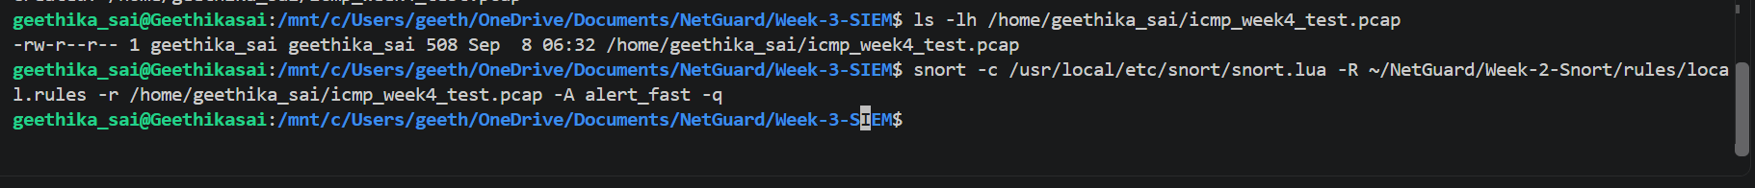Figure 3.1: Snort detection of simulated ICMP sweep

3.2 TCP SYN Port Scan Simulation
- Source IP: 10.10.10.20
- Destination IP: 10.10.10.1
- Destination ports: 1000–1020
- Detection Rule: SID 1000002
- Alert: NETGUARD - Possible TCP SYN Port Scan
A controlled PCAP containing multiple TCP SYN packets was replayed through Snort. The custom rule successfully generated a TCP SYN scan alert.
Figure 3.2: Snort detection of simulated TCP SYN port scan

3.3 SSH Brute-Force Connection Burst Simulation
- Source IP: 10.10.10.30
- Destination IP: 10.10.10.1
- Destination Port: 22
- Detection Rule: SID 1000003
- Alert: NETGUARD - Possible SSH Brute-Force Connection Burst
Multiple TCP SYN connection attempts to SSH port 22 were generated from the same simulated source. Snort successfully detected the connection burst.
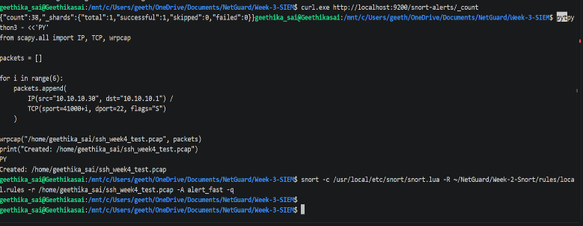
Figure 3.3: Snort detection of simulated SSH brute-force connection burst

4. SIEM VERIFICATION
The Snort alert logs generated during the controlled simulations were copied to the SIEM log directory and processed by Logstash.
The configured pipeline was:
Snort Logs → Logstash → Elasticsearch → Kibana
The Elasticsearch index used for the alerts was:
snort-alerts
The final verification showed:
Indexed Records: 62
Because the Logstash configuration uses sincedb_path => /dev/null, restarting Logstash can cause existing log files to be read again. Therefore, 62 is reported as the number of indexed records, not the number of unique incidents.
4.1 ICMP Alert in SIEM
The ICMP alert was searched in Kibana Discover.
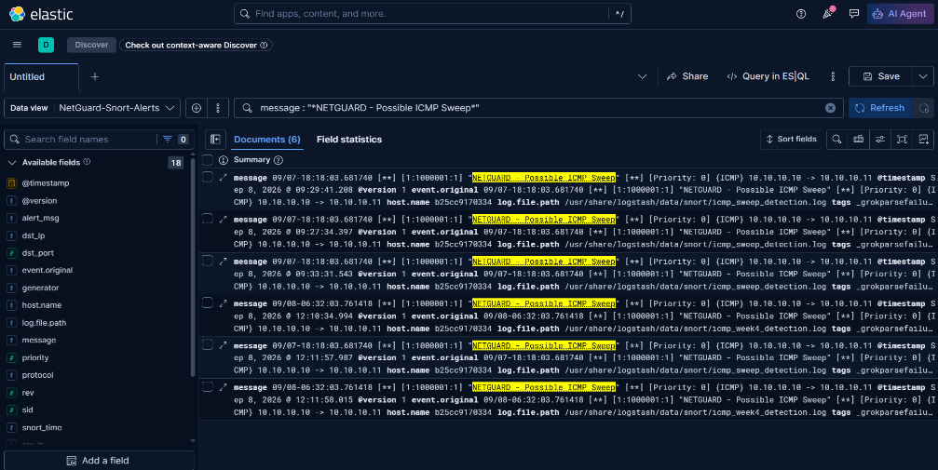
Figure 4.1: ICMP sweep alert displayed in Kibana SIEM

4.2 TCP SYN Alert in SIEM
The TCP SYN alert was searched in Kibana Discover.
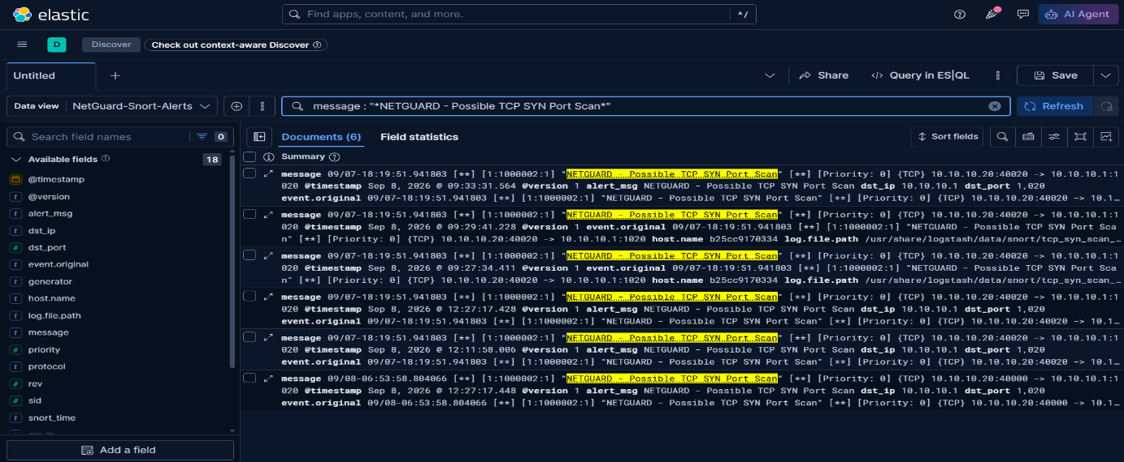Figure 4.2: TCP SYN port scan alert displayed in Kibana SIEM

4.3 SSH Alert in SIEM
The SSH alert was searched in Kibana Discover.
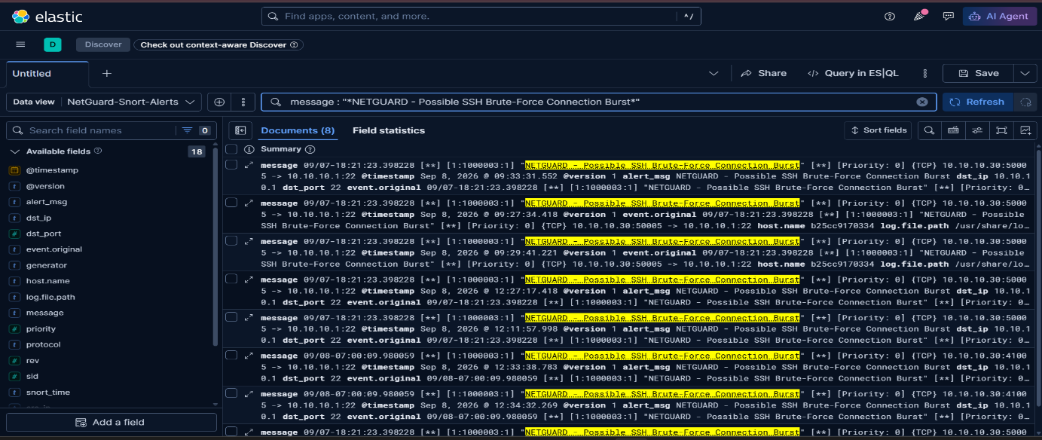Figure 4.3: SSH brute-force alert displayed in Kibana SIEM

5. INCIDENT RESPONSE – NIST-ALIGNED WORKFLOW
5.1 Preparation
The following components were prepared before the incident simulations:
- Snort IDS
- Custom Snort rules
- local.rules
- ELK Stack
- Logstash configuration
- Elasticsearch
- Kibana
- NetGuard SIEM Data View
- Controlled PCAP test files

5.2 Detection and Analysis
During the controlled simulations, Snort detected:
- Possible ICMP Sweep
- Possible TCP SYN Port Scan
- Possible SSH Brute-Force Connection Burst
The generated Snort alerts were forwarded to the centralized SIEM.
Kibana Discover was used to investigate:
- Source IP
- Destination IP
- Destination Port
- Protocol
- Alert Message
- Snort SID
- Original Event Message

5.3 Detailed Incident Analysis
The SSH incident was selected for detailed analysis.
Incident: Possible SSH Brute-Force Connection Burst
Source: 10.10.10.30
Destination: 10.10.10.1:22
Protocol: TCP
Snort SID: 1000003
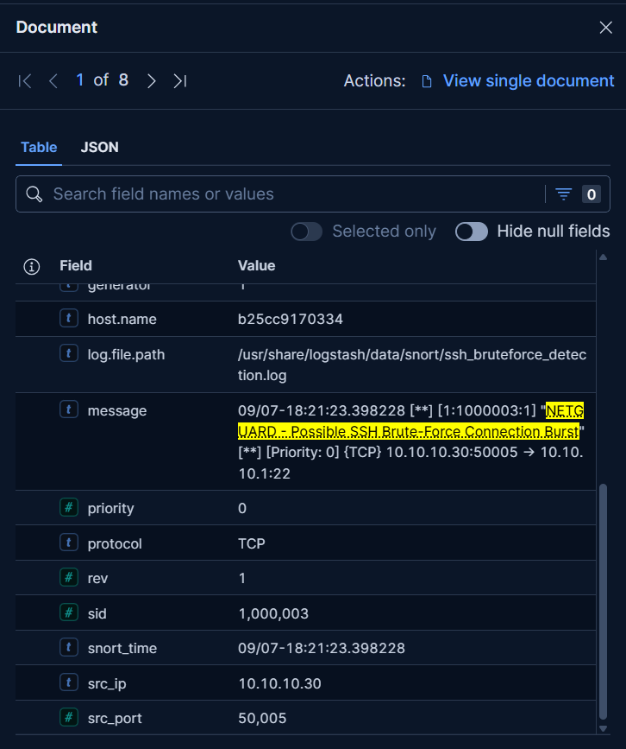
Figure 5.1: Expanded SSH alert event in Kibana for incident analysis

5.4 Containment
The simulated source IP:
10.10.10.30
was treated as an untrusted source after the SSH brute-force alert was detected.
In a real incident, the source would be isolated or blocked from further SSH access while preserving relevant evidence.
Lab Action
No real network blocking was performed.
Containment was documented as a controlled incident-response simulation.
Containment Status: Simulated Successfully
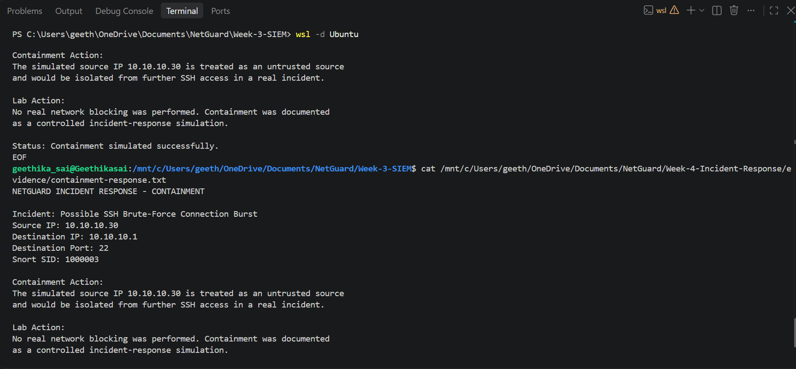Figure 5.2: Documented containment response for simulated SSH incident
5.5 Eradication and Recovery
The Week 4 activity was a controlled detection simulation. No malware or persistent compromise was established.
Therefore, no real malware eradication was claimed.
The recovery process focused on:
- Verifying the detection rule
- Verifying SIEM ingestion
- Analyzing the event
- Documenting the response
- Preserving evidence
5.6 Post-Incident Activity
After the simulated incident:
- Snort alert evidence was reviewed.
- SIEM ingestion was verified.
- The SSH event was analyzed in Kibana.
- Containment actions were documented.
- Evidence screenshots were captured.
- Incident details were included in the final report.
- The final SIEM dashboard was verified.
6. INCIDENT RECORD
Field | Details
Incident | Possible SSH Brute-Force Connection Burst
Source IP | 10.10.10.30
Destination IP | 10.10.10.1
Destination Port | 22
Protocol | TCP
Snort SID | 1000003
Environment | Controlled Lab Simulation
Response | Simulated Source Isolation
7. FINAL SIEM DASHBOARD
The NetGuard Week 4 Incident Monitoring Dashboard was used as the final threat-monitoring view.
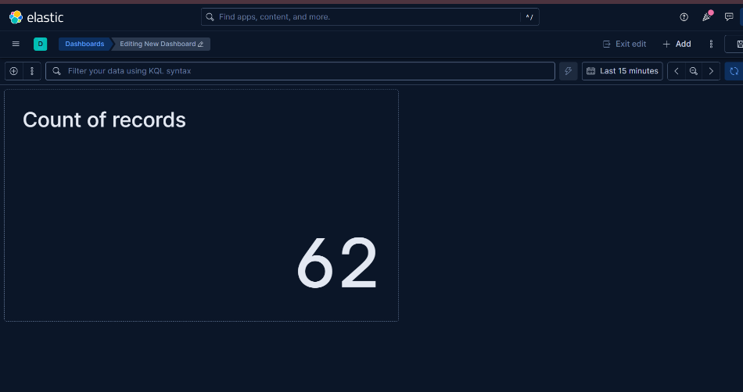
Figure 7.1: Final NetGuard Week 4 Threat Monitoring Dashboard

8. WEEK 4 DASHBOARD CREATION
The Week 4 dashboard was created in Kibana to provide centralized visibility into the indexed Snort alerts.
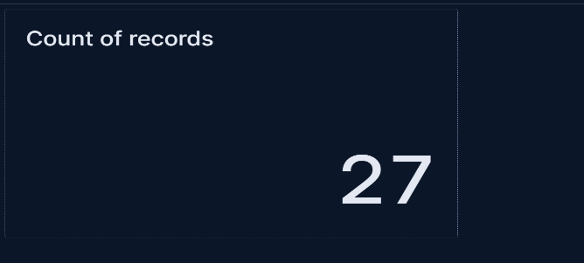
Figure 8.1: NetGuard Week 4 Incident Monitoring Dashboard
9. RESULT
The Week 4 controlled simulations successfully exercised the NetGuard detection and SIEM pipeline.
Snort generated alerts for:
- ICMP sweep simulation
- TCP SYN port scan simulation
- SSH brute-force connection burst simulation
The generated alerts were forwarded to Elasticsearch through Logstash and successfully analyzed using Kibana.
The incident-response workflow was documented using NIST-aligned phases.

10. CONCLUSION
NetGuard demonstrated an end-to-end Network Intrusion Detection and SIEM workflow.
The project successfully connected:
Network Event Simulation → Snort IDS → Alert Logs → Logstash → Elasticsearch → Kibana → Incident Analysis → Response Documentation
The Week 4 implementation provides evidence of controlled attack simulation, alert verification, centralized monitoring, and incident-response documentation.

