**Steps followed**

1) Fork branch out of main branch

2) clone the repository in local machine using visual studio

3) setup workspace in visual studio

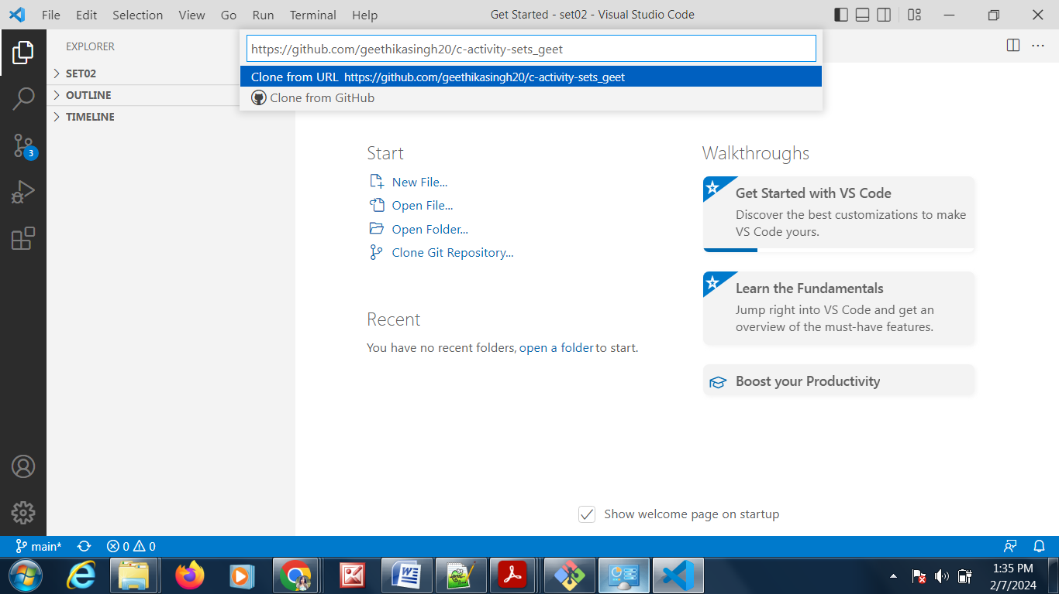

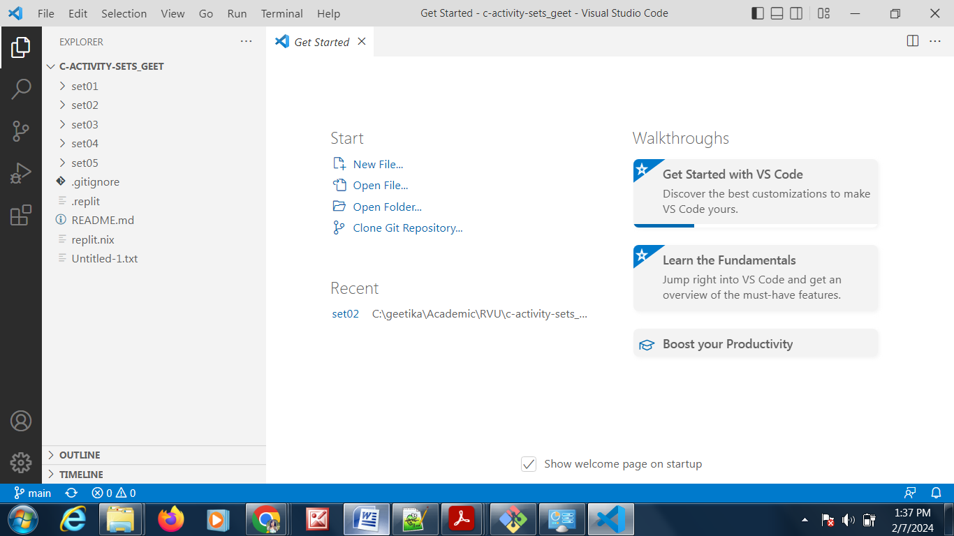

Install c extension

Install c compiler gnw

Open the problem01.c in set05 in visual studio as it is already cloned in workspace and available directly as shown above.

Write the code

Go to terminal , navigate to the directory containing the code

PS C:\geetika\Academic\RVU\Bsc\c-activity-sets_geet\set05>

Compile using below command

PS C:\geetika\Academic\RVU\Bsc\c-activity-sets_geet\set05> gcc .\problem01.c -o problem01

Execute

PS C:\geetika\Academic\RVU\Bsc\c-activity-sets_geet\set05> .\problem01.exe

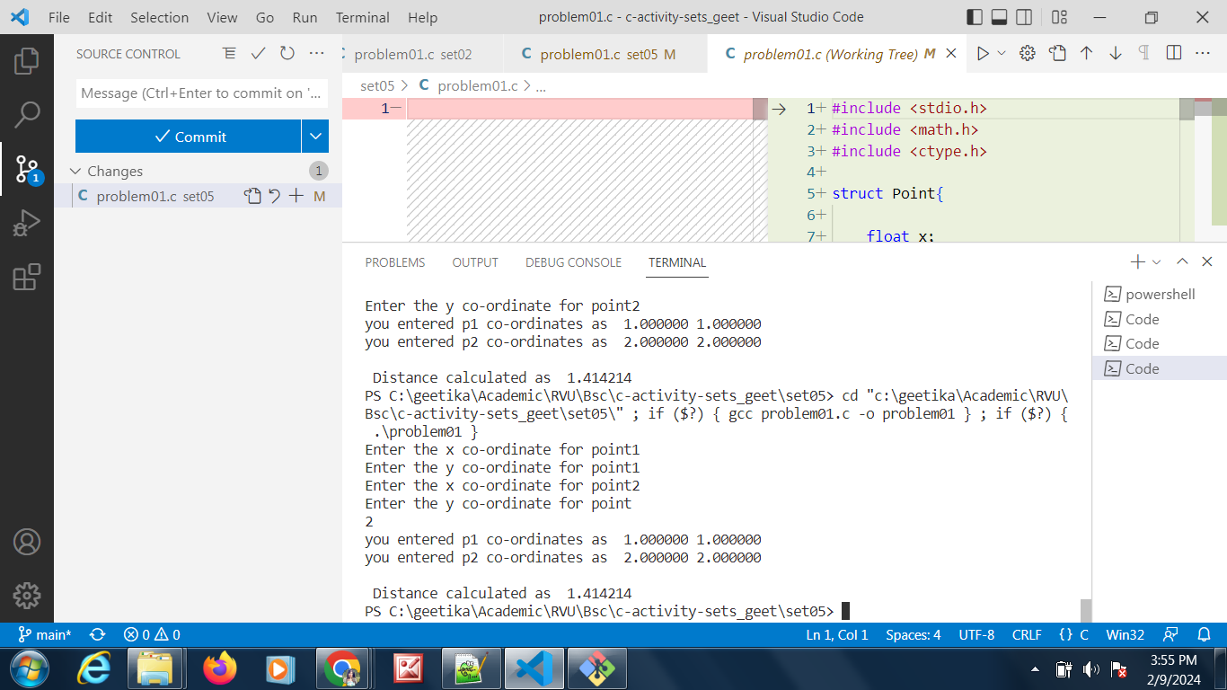

Stage the changes or add the changes ; alternatively one can type the command in git bash

>git add problem01.c

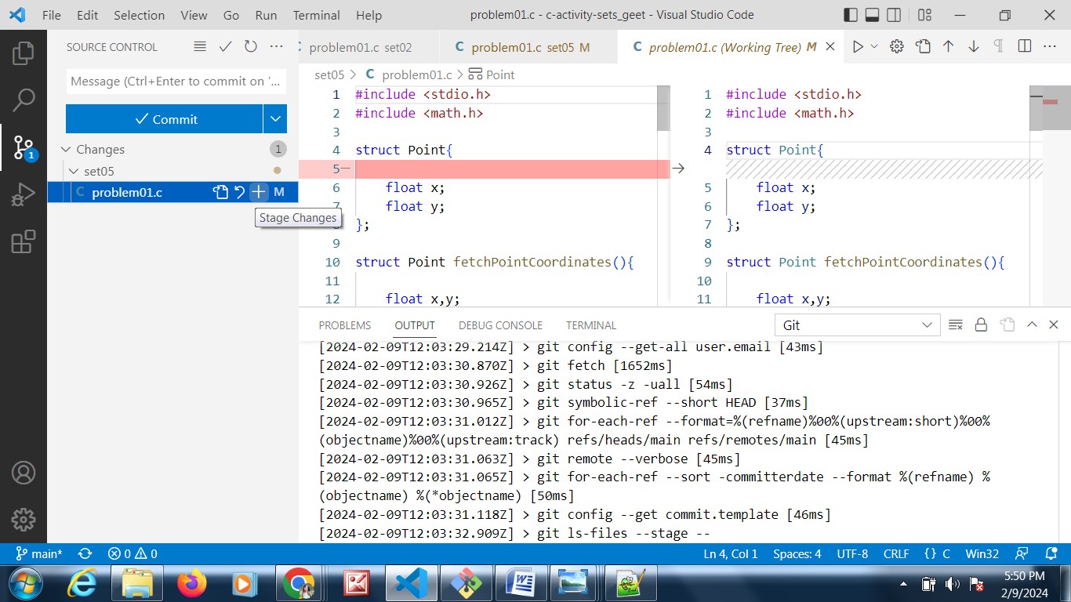

Commit the code by providing an appropriate message as shown below or type below in git bash terminal

Git commit –m “Find distance between two points”

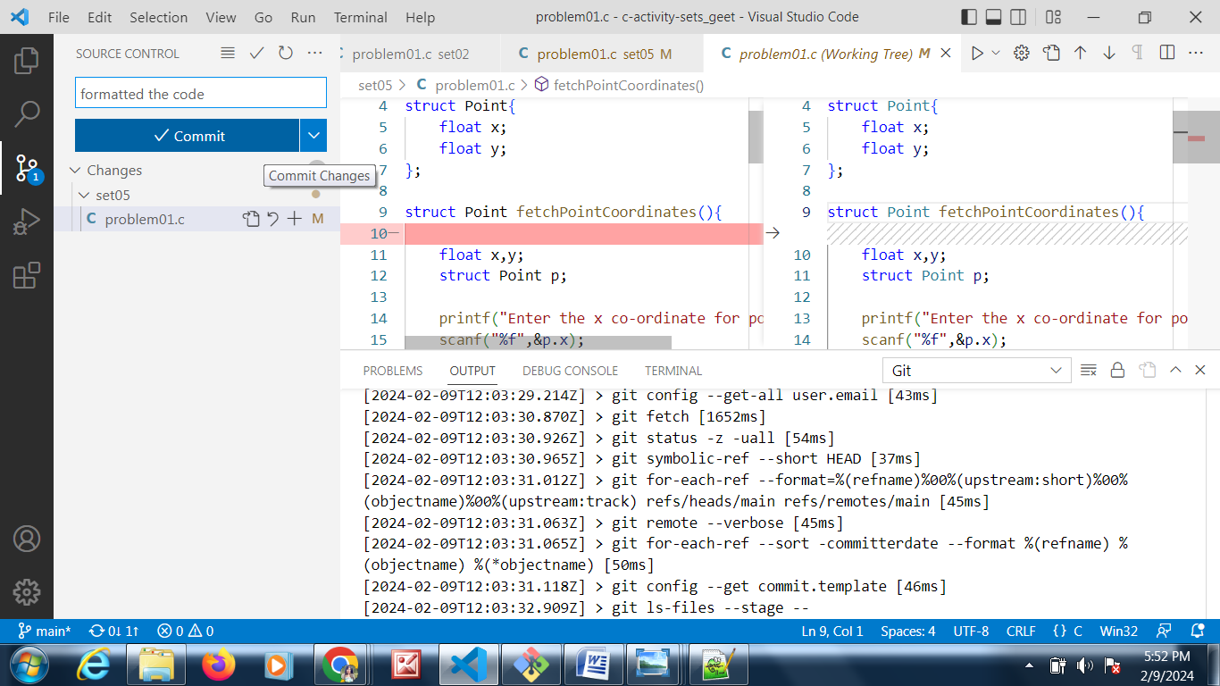

Push the changes by clicking Sync changes or clicking on Push option , alternatively type below command in git bash terminal

>git push

One will be prompted for username and password.

One can already sign in github account using visual studio in order to avoid being prompted again and again or run below command

git config --global user.email "geethika.singh20@gmail.com"

