WAREHOUSE INVENTORY SYSTEM
A Project Report Submitted in the partial fulfillment of the requirements for the award of the degree of
BACHELOR OF TECHNOLOGY
in
DEPARTMENT OF COMPUTER SCIENCE ENGINEERING
by
GEETHIKA CHOWDARY : 2520030354
G SAMPREETHI : 2520030358
M NEHA REDDY : 2520030360
Under the Guidance of
Dr. S. Vinay Kumar
Associate Professor
Department of Computer Science and Engineering
2026-27

DEPARTMENT OF COMPUTER SCIENCE ENGINEERING
Declaration
The Project Report entitled “Warehouse Inventory System” is a record of bonafide work of GEETHIKA CHOWDARY – 2520030354, G SAMPREETHI – 2520030358, and M NEHA REDDY – 2520030360 submitted in partial fulfillment for the award of B. Tech in Computer Science and Engineering. The work presented in this report is based on the implementation and study of advanced algorithms for warehouse inventory, text analytics, matching, similarity, allocation, scheduling, primality testing, and related demonstrations. The results embodied in this report have not been copied from any other department, University, or Institute.
GEETHIKA CHOWDARY – 2520030354
G SAMPREETHI – 2520030358
M NEHA REDDY – 2520030360

DEPARTMENT OF COMPUTER SCIENCE ENGINEERING
CERTIFICATE
This is to certify that the mini project based report entitled “Warehouse Inventory System” is a bonafide work done and submitted by GEETHIKA CHOWDARY – 2520030354, G SAMPREETHI – 2520030358, and M NEHA REDDY – 2520030360 in partial fulfillment of the requirements for the award of the degree of BACHELOR OF TECHNOLOGY in Department of Computer Science Engineering, during the academic year 2026-27.
Signature of the Guide Signature of the HOD
(Dr. S. Vinay Kumar)

ACKNOWLEDGEMENT
We express our sincere gratitude to our project guide, Dr. S. Vinay Kumar, Associate Professor, Department of Computer Science and Engineering, for his valuable guidance, encouragement, and continuous support throughout the development of the Warehouse Inventory System.
We also thank Dr. P. Venkateshwara Rao, Associate Professor and Head of the Department of Computer Science and Engineering, for providing academic support and facilities required to complete this project. We are grateful to the faculty members and classmates for their suggestions and encouragement during implementation and testing.
Finally, we thank our team members for their cooperation in designing, implementing, testing, and documenting the advanced-algorithm components of the system.
GEETHIKA CHOWDARY – 2520030354
G SAMPREETHI – 2520030358
M NEHA REDDY – 2520030360

Abstract
The Warehouse Inventory System is an algorithm-oriented software system designed to demonstrate how advanced data structures and algorithms can be applied to practical warehouse and inventory-management problems. The project combines a working text-analytics engine with inventory operations and demonstrations of string algorithms, dynamic programming, network flow, approximation algorithms, and randomized algorithms.
The system provides query-driven demonstrations including pattern search, fuzzy matching using edit distance, document similarity, citation-flow analysis, project-scheduling demonstrations, and large-prime primality testing. These functions allow users to observe algorithmic results before studying the internal implementation. The system follows the course constraint that core algorithms are hand-built rather than delegated to java.util.* algorithmic utilities.
TEXT-ANALYTICS QUERY PROCESSING FLOW
User Query | Identify Query Type | Select Algorithm | Process Data | Display Result
Pattern / fuzzy /  similarity / flow | Classify request | String / DP / Flow /  Randomized | Run selected method | Matches / score /  decision

Module 1 establishes the TextHack-style system interface and advanced-algorithm question bank. Module 2 focuses on string algorithms such as KMP, Z-function, Rabin-Karp, Aho-Corasick, suffix arrays, and LCP. Module 3 covers dynamic programming including edit distance, sequence alignment, interval DP, bitmask DP, tree DP, and SOS DP. Module 4 studies maximum flow, Ford-Fulkerson, Edmonds-Karp, Dinic, min-cut, and matching. Module 5 covers NP-completeness and approximation, while Module 6 introduces randomized and parallel algorithm concepts including Miller-Rabin and parallel primitives.
The project therefore acts as both a warehouse-oriented inventory application and an advanced-algorithm demonstration platform, connecting theoretical concepts with practical search, similarity, allocation, scheduling, and computational decision-making.

Table of Contents
Acknowledgement ........................................................
Abstract ........................................................
Table of Contents ........................................................
List of Figures ........................................................
1 Introduction ........................................................
1.1 Overview ........................................................
1.2 Problem Statement ........................................................
1.3 Scope of the Project ........................................................
1.4 Objectives ........................................................
2 System Requirements ........................................................
2.1 Functional Requirements ........................................................
2.2 Non-Functional Requirements ........................................................
3 System Design ........................................................
3.1 High-Level Architecture ........................................................
3.2 Description of Each Layer ........................................................
4 Implementation ........................................................
4.1 Module-wise Implementation ........................................................
4.2 String Algorithms ........................................................
4.3 Advanced Dynamic Programming ........................................................
4.4 Network Flow ........................................................
4.5 NP-Completeness and Approximation ........................................................
4.6 Randomised and Parallel Algorithms ........................................................
5 Results ........................................................
6 Challenges & Limitations ........................................................
6.1 Issues Faced During Development ........................................................
6.2 Solutions Applied ........................................................
6.3 Limitations of the System ........................................................
7 Conclusion & Future Work ........................................................
7.1 Conclusion ........................................................
7.2 Future Work ........................................................
7.3 Skills Learned During Development ........................................................
References ........................................................

List of Figures
1.1 High-Level Architecture of Warehouse Inventory System
1.2 Text-Analytics Query Processing Flow
1.3 String Matching and Similarity Processing
1.4 Dynamic Programming Workflow
1.5 Network Flow Model for Inventory Allocation
1.6 Approximation and Scheduling Workflow
1.7 Randomized Primality Testing Workflow

1. INTRODUCTION
1.1 Overview
Warehouse operations involve product search, inventory updates, stock allocation, document processing, similarity analysis, and scheduling decisions. A conventional inventory application can perform basic operations, but this project demonstrates how advanced algorithms can solve computationally demanding tasks associated with warehouse information.
The Warehouse Inventory System provides a working software environment in which users issue queries and observe results. It combines warehouse inventory operations with a text-analytics corpus and maps each query class to an appropriate advanced-algorithm family.
1.2 Problem Statement
Basic linear searches and elementary data-structure techniques are insufficient for several practical tasks. Large text collections require efficient substring search; product descriptions may require fuzzy matching and similarity measurement; capacity-constrained stock allocation can be represented as a flow problem; scheduling may contain NP-hard structures; and large-prime testing benefits from randomized techniques.
1.3 Scope of the Project
• Provide a working text-analytics engine for pattern search, fuzzy matching, document similarity, citation-flow analysis, scheduling demonstrations, and primality testing.
• Support warehouse inventory operations such as listing, adding, updating, deleting, searching, and allocation-oriented demonstrations.
• Implement and demonstrate advanced string, dynamic-programming, network-flow, approximation, randomized, and parallel-algorithm concepts.
• Select algorithms using asymptotic-cost analysis.
• Follow the course constraint against java.util.* implementations for core algorithms.
1.4 Objectives
• Develop a working Warehouse Inventory System using Java.
• Map practical query types to advanced algorithm families.
• Implement efficient string-processing and matching techniques.
• Apply dynamic programming to fuzzy matching, alignment, scheduling, and subset problems.
• Use network flow for capacity-constrained allocation and matching.
• Understand NP-completeness and demonstrate approximation strategies.
• Apply randomized algorithms to primality testing and hashing-oriented tasks.
• Analyze correctness, runtime, and practical limitations.

2. SYSTEM REQUIREMENTS
2.1 Functional Requirements
• Load and process warehouse/corpus data.
• List inventory records and display product information.
• Add, update, and delete inventory records.
• Search text using pattern-matching algorithms.
• Perform fuzzy matching using edit distance.
• Compare documents or product descriptions using similarity algorithms.
• Analyze citation relationships using graph/flow concepts.
• Demonstrate project scheduling and stock-allocation problems.
• Test large prime candidates using randomized primality testing.
• Provide self-test or demonstration execution for algorithm verification.
2.2 Non-Functional Requirements
• Correctness of algorithm outputs.
• Efficient asymptotic performance.
• Simple and understandable interaction.
• Modular and maintainable implementation.
• Execution in a standard Java environment.
• Robust handling of invalid inputs.
• Educational transparency between query and algorithm.

3. SYSTEM DESIGN
3.1 High-Level Architecture
The system is organized into five logical layers: input/query layer, inventory and corpus layer, algorithm engine, result-processing layer, and output layer. User requests enter the query layer and are routed to inventory operations or advanced algorithm modules. Results are processed and displayed to the user.
Figure 1.1: High-Level Architecture of Warehouse Inventory System

SYSTEM ARCHITECTURE
USER / QUERY INPUT | INVENTORY & CORPUS DATA | ALGORITHM ENGINE | RESULT PROCESSING | OUTPUT
Menu selections  Search requests | Products  Text corpus | String • DP • Flow  Approximation • Randomized | Matching  Scoring • Allocation | Records  Matches • Results

3.2 Description of Each Layer
• Input and Query Layer: accepts menu selections, search patterns, product operations, and demonstration requests.
• Inventory/Data Layer: maintains product information and corpus documents.
• Algorithm Engine: contains hand-built string, DP, flow, approximation, and randomized algorithms.
• Processing Layer: performs intermediate computations such as DP tables, residual capacities, suffix processing, and similarity calculations.
• Output Layer: displays inventory records, search matches, allocation results, similarity scores, scheduling results, and primality decisions.

4. IMPLEMENTATION
4.1 Module-wise Implementation
The implementation follows six modules corresponding to the advanced-algorithm portion of the course. The system begins with a working query engine and connects each query type to a suitable algorithmic family.
Module-1 (TextHack as a System — The Advanced-Algorithm Question Bank)
• Working text-analytics engine over an Indian-language Wikipedia corpus.
• Pattern search, fuzzy matching with edit distance, document similarity, citation-flow analysis, project-scheduling demonstrations, and large-prime primality testing.
• Mapping of query classes to string algorithms, DP, suffix structures, max-flow, approximation, and randomized algorithms.
• Motivation for advanced algorithms beyond linear and basic tree/graph techniques.
• Reading the algorithms canon and the public API before implementation.
• Core engine constraint: java.util.* is not used to supply the required algorithms.
• Initial design includes algorithm choice and asymptotic cost.
Module-2 (String Algorithms)
• Naive O(nm) pattern matching as the baseline.
• KMP failure function and linear-time matching.
• Z-function in linear time.
• Rabin-Karp polynomial rolling hash and double hashing.
• Aho-Corasick trie with failure links at intuition level.
• Suffix arrays and conceptual SA-IS construction; practical O(n log² n) implementation.
• Kasai LCP construction in linear time.
• Preview of suffix automata and suffix trees.
Module-3 (Advanced Dynamic Programming)
• Levenshtein, Damerau-Levenshtein, and weighted edit distance using Wagner-Fischer.
• Needleman-Wunsch global and Smith-Waterman local sequence alignment.
• Interval DP for matrix-chain multiplication and optimal BST.
• Bitmask DP for TSP and Hamiltonian-path detection.
• Tree DP, diameter/centroid ideas, and rerooting.
• SOS DP for sum-over-subsets.
• Recognizing when DP is the wrong tool.
Module-4 (Network Flow)
• Source, sink, capacity, and conservation.
• Ford-Fulkerson with residual augmenting paths.
• Edmonds-Karp using BFS and O(VE²).
• Dinic's level graph and blocking flow.
• Min-cut as the dual of max-flow.
• Bipartite matching and assignment.
• Min-cost max-flow at intuition level and practical reductions.
Module-5 (NP-Completeness and Approximation)
• Decision versus optimization problems and polynomial reductions.
• P, NP, and co-NP through verification.
• Cook-Levin intuition and SAT.
• Reduction chain including 3-SAT, CLIQUE, INDEPENDENT-SET, VERTEX-COVER, SUBSET-SUM, KNAPSACK, HAM-CYCLE, and TSP.
• NP-hardness recognition checklist.
• Vertex-cover 2-approximation through maximal matching.
• PTAS, FPTAS, APX and parameterized complexity at preview level.
Module-6 (Randomised and Parallel Algorithms)
• Las Vegas versus Monte Carlo algorithms.
• Randomized quicksort and expected-time analysis.
• Miller-Rabin primality testing and witness construction.
• Universal/randomized hashing.
• Reservoir sampling for streaming data.
• Work, span, T1, T∞ and Brent's theorem.
• Parallel reduce, scan/prefix-sum, and parallel sorting at intuition level.
4.2 String Algorithms
String algorithms support pattern search, fuzzy matching, and similarity-oriented processing. KMP uses a failure function to avoid unnecessary comparisons; the Z-function computes matching prefixes efficiently; Rabin-Karp uses rolling hashes; suffix arrays and LCP support advanced substring queries.
STRING MATCHING AND SIMILARITY
Text / Product Description | Pattern or Query | String Algorithm | Match / Similarity Result
Corpus or inventory data | Search term | KMP • Z • Rabin-Karp  Suffix array / LCP | Locations / score

4.3 Advanced Dynamic Programming
Dynamic programming is used when subproblems overlap and optimal substructure exists. Edit distance is especially relevant to fuzzy matching because it measures the minimum edits required to transform one sequence into another. Alignment, interval, bitmask, tree, and SOS DP demonstrate different state-space designs.
DYNAMIC PROGRAMMING WORKFLOW
Define State | Set Base Cases | Compute Subproblems | Combine Results | Final Answer
Problem representation | Initial values | Memoization / table | Optimal substructure | Distance / alignment /  subset result

4.4 Network Flow
Inventory allocation can be modeled as a capacity-constrained network. Warehouses, products, outlets, or demands can be vertices, while shipment possibilities become directed edges with capacities. Ford-Fulkerson, Edmonds-Karp, and Dinic demonstrate maximum-flow computation and bottleneck identification.
NETWORK FLOW MODEL FOR INVENTORY ALLOCATION
Source  Warehouse | Capacity Edges  Shipment Routes | Destination  Outlet / Demand
Available stock | Ford-Fulkerson /  Edmonds-Karp / Dinic | Allocated quantity

4.5 NP-Completeness and Approximation
Some scheduling and allocation problems become computationally difficult as input size increases. The project therefore emphasizes recognizing NP-hard structures and using approximation where appropriate rather than assuming an exact polynomial-time solution exists.
APPROXIMATION AND SCHEDULING WORKFLOW
Define Problem | Check Complexity | Choose Strategy | Evaluate Solution
Scheduling / allocation | Exact vs. NP-hard | Exact method or  approximation | Feasibility / quality

4.6 Randomised and Parallel Algorithms
Randomized algorithms introduce controlled probability into computation. Miller-Rabin demonstrates practical large-prime testing using witnesses. Parallel concepts are introduced through work/span analysis and primitives such as reduce and scan.
RANDOMIZED PRIMALITY TESTING WORKFLOW
Prime Candidate | Choose Random Witness | Miller-Rabin Test | Repeat / Decide
Input integer | Probabilistic check | Pass or composite witness | Likely prime or composite

5. RESULTS
• Inventory records can be listed, added, updated, searched, and deleted.
• Pattern-search queries demonstrate efficient string matching.
• Fuzzy matching demonstrates edit-distance-based comparison.
• Document/product-description similarity demonstrates advanced string processing.
• Flow demonstrations show capacity-constrained allocation.
• Scheduling demonstrations illustrate exact-versus-approximate optimization.
• Large-prime testing demonstrates randomized primality testing.
• Self-test/demo execution supports algorithm validation.
The major result is the successful mapping of practical warehouse and text-analytics queries to suitable advanced-algorithm families.

6. CHALLENGES & LIMITATIONS
6.1 Issues Faced During Development
• Combining multiple advanced algorithm families in one system.
• Maintaining correctness while implementing algorithms manually.
• Processing corpus and inventory data.
• Connecting theoretical models with warehouse scenarios.
• Handling edge cases in matching, DP, flow, and randomized tests.
6.2 Solutions Applied
• Separated the project into logical algorithmic modules.
• Tested algorithms with small examples before integration.
• Used asymptotic analysis for algorithm selection.
• Used self-test/demo execution for validation.
• Kept core algorithms independent of java.util.* utilities.
6.3 Limitations of the System
• Academic demonstration rather than a production warehouse platform.
• Some advanced topics are conceptual or demonstration-level rather than industrially optimized.
• Parallel algorithms are introduced mainly for understanding; GPU/distributed execution is outside the scope.
• Approximation does not guarantee optimal solutions for NP-hard problems.
• Randomized algorithms require probabilistic interpretation.

7. CONCLUSION & FUTURE WORK
7.1 Conclusion
The Warehouse Inventory System brings advanced algorithms into a unified practical setting. It connects string algorithms, dynamic programming, network flow, NP-completeness, approximation, randomized algorithms, and parallel concepts with search, similarity, allocation, scheduling, and inventory scenarios.
The project demonstrates that algorithm selection depends on problem structure: efficient pattern search needs specialized string algorithms; fuzzy matching maps naturally to dynamic programming; capacity-constrained allocation can be modeled as network flow; difficult scheduling problems motivate approximation; and large-prime testing can use randomized algorithms.
7.2 Future Work
• Add a graphical/web interface.
• Add persistent database storage and transaction management.
• Support larger real-world warehouse datasets and live inventory feeds.
• Extend similarity search with richer indexing structures.
• Add min-cost flow for cost-aware shipment allocation.
• Add more scheduling approximations and parameterized algorithms.
• Explore parallel execution for large workloads.
• Add performance dashboards comparing algorithms.
7.3 Skills Learned During Development
• Advanced string algorithms and complexity analysis.
• Dynamic-programming state design.
• Graph modeling, max-flow, min-cut, and matching.
• NP-completeness, reductions, approximation, and parameterized complexity.
• Randomized algorithm design and probabilistic reasoning.
• Java implementation, modularization, testing, and debugging.
• Connecting DSA theory with practical system requirements.

REFERENCES

[1] T. H. Cormen, C. E. Leiserson, R. L. Rivest, and C. Stein, Introduction to Algorithms, MIT Press.
[2] J. Kleinberg and É. Tardos, Algorithm Design, Pearson.
[3] J. Erickson, Algorithms, open textbook.
[4] Course-provided Module-1 to Module-6 advanced-algorithm question-bank and project specification.
[5] Java Platform documentation for Java language syntax, compilation, and execution.
[6] Indian-language Wikipedia corpus data used for text-analytics demonstrations.

TECHNICAL SUPPLEMENT
A.1 End-to-End System Workflow
This supplement expands the design explanation and supporting diagrams for the Warehouse Inventory System. It documents the relationship between user requests, inventory and corpus data, algorithm selection, computation, and result presentation. It does not replace the original module descriptions; it makes the design easier to review and test.
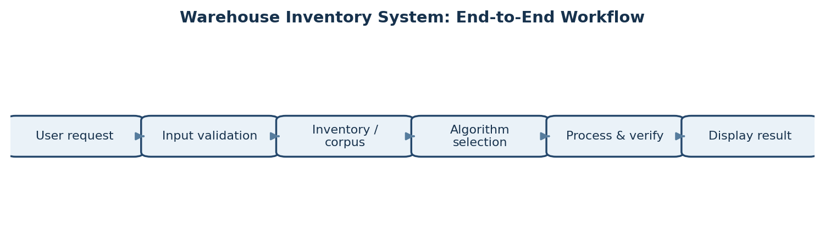
Figure A.1: End-to-end request processing workflow.
Workflow stages
• Request capture: the user chooses an inventory operation or a text-analytics / algorithm demonstration.
• Input validation: the system checks required values, accepted formats, and basic boundary conditions before computation.
• Data access: the relevant inventory records or corpus documents are selected for the operation.
• Algorithm selection: the query type is mapped to a suitable algorithmic family, considering correctness and expected input size.
• Processing and verification: the module performs the computation and, where available, checks results through demonstration or self-test cases.
• Result presentation: the system displays the result in a form that helps the user connect the output with the underlying algorithm.
The workflow is intentionally modular. A change to one algorithm should not require rewriting unrelated inventory operations, provided the module interface and expected inputs and outputs remain stable.

A.2 Logical Data Flow and Module Boundaries
The architecture separates the user-facing request from data access, algorithm execution, and result formatting. This separation improves readability and helps isolate defects: an incorrect result can be investigated by checking the input, the selected data, the algorithm module, and the formatting stage independently.
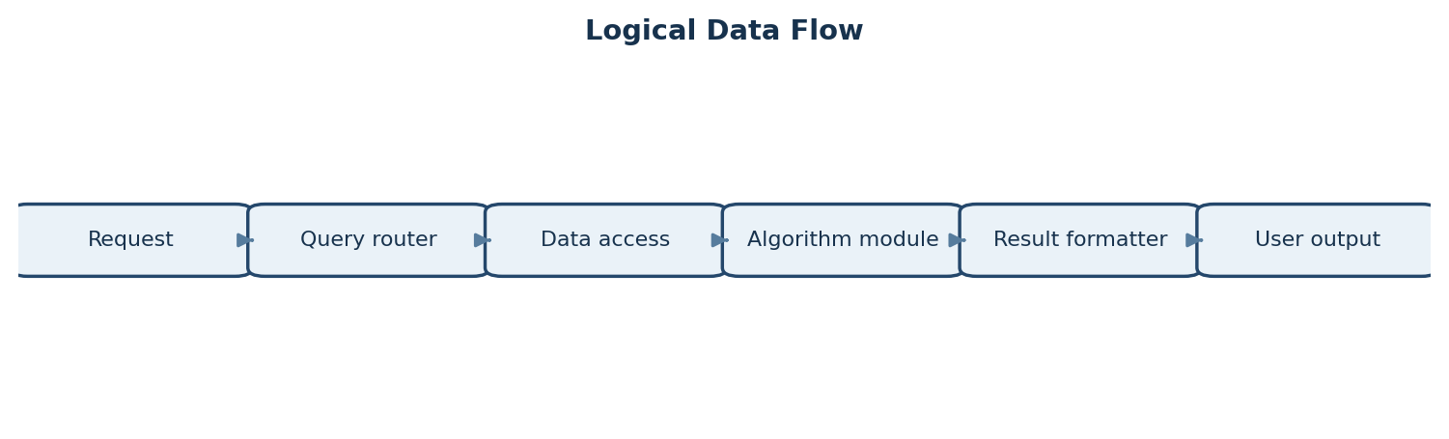
Figure A.2: Logical data flow from request to output.
Responsibilities at each boundary
Component | Primary responsibility | Example input / output
Request interface | Collect the requested operation and its parameters. | Search pattern / operation choice
Query router | Identify the operation and select the appropriate module. | Query class / module identifier
Data access | Provide inventory records or corpus documents needed for the task. | Record set or document collection
Algorithm module | Perform matching, similarity, flow, DP, approximation, or randomized computation. | Algorithm result and supporting values
Result formatter | Convert the result into readable output without changing its meaning. | Matches, score, allocation, or decision
Validation / test support | Check expected behaviour for representative and edge-case inputs. | Pass/fail notes or observed result

Design principles
• Single responsibility: each module should have a clearly defined task.
• Explicit inputs and outputs: module contracts should state required parameters and returned results.
• Traceability: a result should be traceable to the original query and the algorithm selected.
• Graceful invalid-input handling: errors should be reported clearly rather than producing misleading output.
• Algorithm independence: core algorithms are implemented as learning objectives rather than delegated to ready-made algorithm utilities.

A.3 Inventory Record Lifecycle and Use Cases
Inventory operations form the practical entry point to the system. The lifecycle below illustrates the logical sequence for creating, validating, storing, searching, revising, and deleting a record. The exact storage mechanism depends on the project implementation; persistent database storage is identified as future work in the original report.
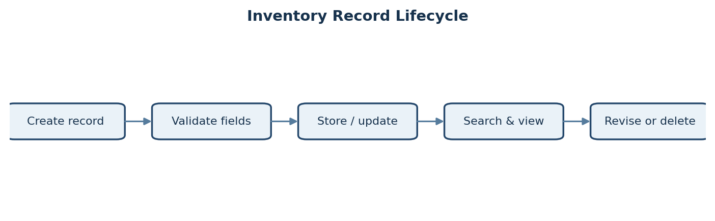
Figure A.3: Logical lifecycle of an inventory record.
Core use cases
Use case | User goal | Expected system behaviour
List inventory | Review available records. | Display the records currently loaded by the application.
Add inventory | Introduce a new product record. | Validate the supplied fields and add the record if accepted.
Update inventory | Correct or revise product information. | Locate the target record and apply the requested changes.
Delete inventory | Remove an obsolete record. | Identify the selected record and remove it from the active inventory.
Search inventory | Find a product or related description. | Return relevant matches based on the chosen search operation.
Run algorithm demo | Understand an advanced algorithm. | Accept the demonstration input and display the computed result.

Illustrative record fields
A warehouse record commonly needs a stable product identifier, product name or description, quantity, and any category or location fields supported by the implementation. These are logical examples for design discussion, not a claim that every field is already present in the current code. A stable identifier is especially useful for update and delete operations because names may not be unique.
A useful validation rule is to reject missing identifiers and malformed quantities before the record is changed. Where quantity is represented as a count, negative values should be treated as invalid unless the project explicitly models backorders or adjustments.

A.4 Algorithm Selection Guide
The system demonstrates that different query classes require different algorithmic approaches. Selection should be based on the structure of the problem, the size of the input, the required output, and the trade-off between implementation complexity and runtime.
Problem / query class | Suitable method in the project | Why it fits
Exact pattern search | Naive matching; KMP; Z-function; Rabin–Karp | Finds occurrences of a pattern in a text; advanced methods reduce repeated work.
Multiple-pattern search | Aho–Corasick | Processes a set of patterns using a trie and failure links.
Repeated substring queries | Suffix array with LCP support | Indexes suffixes and supports efficient substring-related queries.
Fuzzy product / text matching | Levenshtein or weighted edit distance | Measures edits needed to transform one sequence into another.
Document similarity | Sequence alignment or other implemented similarity measure | Compares text beyond exact equality.
Capacity-constrained allocation | Maximum flow and min-cut | Represents supply, capacity limits, and demand as a network.
Hard scheduling / optimization | Approximation methods and complexity analysis | Recognizes when exact optimization may be computationally expensive.
Large-prime candidate testing | Miller–Rabin randomized test | Uses modular arithmetic and repeated witnesses for probabilistic primality testing.

Selection checklist
• Define the output precisely: exact match, approximate match, similarity value, feasible allocation, or a decision.
• Identify constraints such as text length, number of patterns, graph size, capacities, and required accuracy.
• Choose an algorithm whose assumptions match the problem.
• Consider worst-case and expected runtime, memory use, and implementation complexity.
• Validate the chosen method against small cases where the expected result can be checked manually.
The methods above reflect the algorithm families described in the main report. The exact method available for a particular menu option depends on the implementation connected to that option.

A.5 Complexity Analysis and Performance Considerations
Asymptotic analysis describes how resource requirements grow as input size increases. It is not a substitute for measurement, but it helps compare candidate algorithms and explain why a specialized method may be preferable to a simple baseline.
Algorithm / task | Typical time complexity | Key variables / notes
Naive pattern matching | O(nm) | n = text length; m = pattern length. Simple baseline.
Knuth–Morris–Pratt (KMP) | O(n + m) | Preprocessing and matching are linear in text and pattern lengths.
Z-function | O(n) for a string of length n | Computes matching-prefix lengths across the string.
Rabin–Karp | Expected near O(n + m) per pattern in typical use | Hash collisions require verification; worst cases can be slower.
Aho–Corasick | O(total pattern length + text length + matches) | Useful when searching for many patterns in one text.
Levenshtein edit distance | O(nm) time; O(nm) table space in basic form | Space can be reduced when only the distance is required.
Edmonds–Karp maximum flow | O(VE²) | BFS finds augmenting paths in the residual network.
Miller–Rabin | Depends on number size and rounds | More rounds reduce the probability of a composite passing; not a deterministic proof for arbitrary large integers.

How to evaluate performance
• Use several input sizes rather than timing a single example.
• Keep test inputs consistent when comparing two methods.
• Record input size, algorithm choice, result correctness, and elapsed time.
• Repeat timing runs where practical and report approximate values rather than implying exact hardware-independent performance.
• Separate setup or data-loading time from the algorithm runtime when the purpose is to compare algorithms.
Performance claims should be based on observed runs. This report describes the algorithms and their expected complexity; it does not claim benchmark results that have not been recorded.

A.6 Testing and Validation Plan
Testing is important because several core algorithms are implemented manually. Verification should include ordinary inputs, boundary cases, invalid inputs, and regression cases. The following plan is a practical test matrix for reviewing the application and can be used during demonstration preparation.
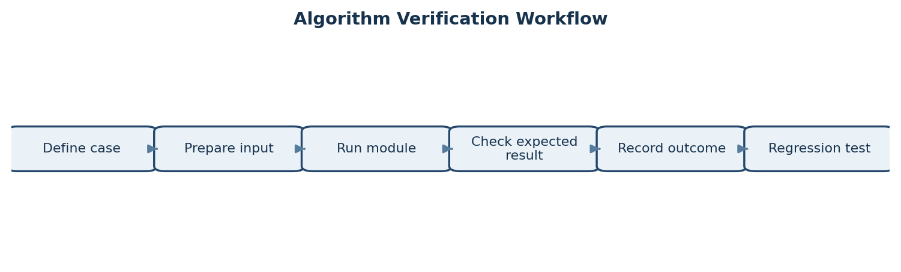
Figure A.4: Repeatable algorithm verification workflow.
Test area | Example test | Expected check
Inventory listing | Run with a populated inventory. | All loaded records appear without unintended duplication.
Add / update / delete | Perform each operation on a known record. | Only the intended record changes; subsequent listing reflects the operation.
Exact pattern search | Pattern exists once, several times, or not at all. | Returned positions or match messages are consistent with the input.
Pattern boundaries | Empty pattern, pattern longer than text, or match at final position. | Boundary behaviour is handled consistently and does not crash.
Edit distance | Identical strings, one-character change, and empty-string comparison. | Distance agrees with the chosen edit-distance definition.
Maximum flow | Small network with known capacities and bottleneck. | Flow respects capacities and conservation; no augmenting path remains at completion.
Primality demonstration | Known small prime and known composite inputs. | Output is consistent with the method and its probabilistic limitations.
Invalid input | Missing or incorrectly formatted values. | Clear error handling; no misleading success result.

Evidence to retain
For a formal demonstration, keep a small set of reproducible inputs and their outputs. Include a screenshot or console capture only when it reflects an actual execution. For each test, note the purpose, input, expected behaviour, observed behaviour, and whether the test passed. This creates a compact evidence trail without making unsupported claims about performance or completeness.

A.7 Illustrative Problem Scenarios
The following scenarios explain how the project’s algorithm families relate to warehouse-oriented tasks. They are illustrative examples for explaining the design; they should not be read as evidence that a particular real warehouse dataset or external service is connected.
Scenario 1: Finding a product description
A user searches a corpus or product-description collection for a phrase. Exact pattern matching is suitable when the phrase must occur exactly. KMP avoids rechecking text characters unnecessarily, while Rabin–Karp uses rolling hashes and verifies candidate matches. For a query involving several terms or patterns, a multi-pattern method such as Aho–Corasick can be appropriate.
Scenario 2: Handling spelling differences
A product description may contain a spelling variation. Edit distance estimates the minimum number of insertions, deletions, or substitutions needed to transform one string into another. A smaller distance indicates a closer spelling under the selected distance definition, but it does not automatically establish that two products are the same. The final interpretation should consider product identifiers and context.
Scenario 3: Allocating limited stock
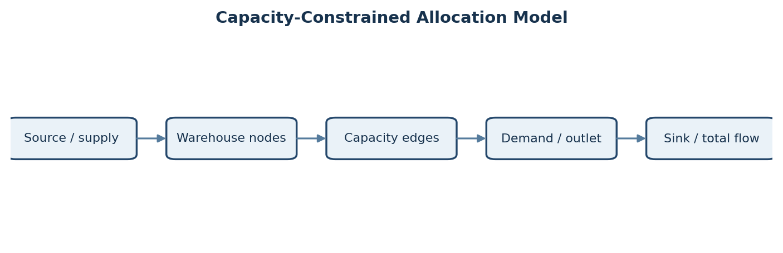
Figure A.5: Example abstraction of supply, capacities, demand, and total flow.
A flow network can represent supply as a source, outlets or demand points as destinations, and shipment limits as edge capacities. Maximum flow calculates the greatest amount that can be routed under the modelled constraints. Min-cut analysis helps identify a bottleneck. Real shipment planning may also require costs, distances, priorities, and other constraints beyond basic maximum flow.
Scenario 4: Scheduling and hard optimization
When a scheduling problem has many interacting constraints, finding an exact optimum may become expensive. Complexity analysis helps identify the problem class; approximation algorithms may provide a feasible solution with a stated guarantee where the selected method supports one. A result should be described as approximate rather than optimal unless optimality has been established.

A.8 Reliability, Limitations, and Development Roadmap
Reliability and maintainability considerations
• Input validation: check required fields and numeric ranges before starting a computation.
• Consistent errors: report invalid input and unavailable operations in understandable language.
• Modular design: keep inventory handling separate from algorithm implementations and output formatting.
• Regression testing: rerun known test cases after changing a module.
• Data integrity: use stable identifiers and avoid accidental updates to unrelated records.
• Clear algorithm labels: identify whether a result is exact, approximate, or probabilistic.
Security and data-handling considerations
The current report describes an academic software demonstration. If the system is extended for real warehouse use, access control, authentication, audit logs, input sanitization, backup and recovery, and protection of commercially sensitive inventory information should be designed and tested. These are recommendations for future development, not claims that the current prototype already implements them.
Suggested development roadmap
Stage | Proposed enhancement | Completion evidence
1. Usability | Add a graphical or web interface. | Users can complete core operations through documented screens.
2. Persistence | Connect a database with transactions and validation. | Records remain available after restart and updates are consistent.
3. Scale | Evaluate larger datasets and indexed search. | Benchmark results are recorded for increasing input sizes.
4. Optimization | Add cost-aware flow and richer scheduling models. | Test cases demonstrate constraints and explain solution quality.
5. Observability | Add logs and an algorithm comparison dashboard. | Runs show selected algorithm, input size, runtime, and outcome.

Requirement-to-evidence traceability
The original report’s objectives can be linked to observable evidence: inventory operations to operation tests; string algorithms to known pattern cases; fuzzy matching to edit-distance examples; allocation to small flow networks; scheduling and approximation to clearly labelled demonstrations; and randomized primality testing to prime/composite examples with a note about probabilistic behaviour. This traceability makes the final presentation more precise and helps distinguish completed functionality from planned improvements.
End of technical supplement. The original project description, team details, module names, conclusion, and references remain part of the report.

