CSA IMPORTANT DUMPS

DUMPS - 1

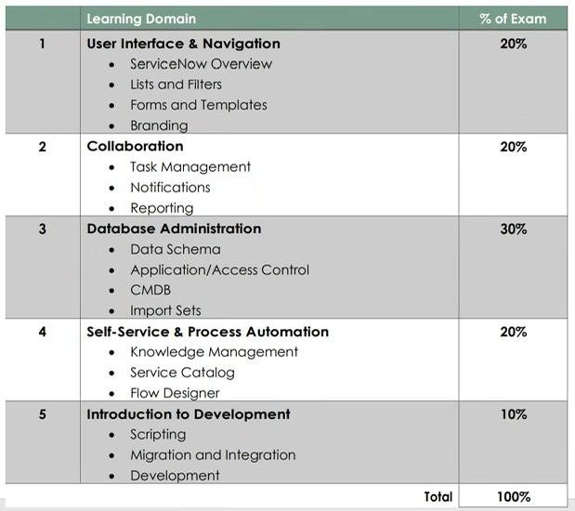
section on a task record would you use to see the most recent update made to a record?
- Journal
- Timeline
- update log
- audit log
- diary
1.
What

- activity
- What are examples of UI actions, relating to lists? choose four answers?--doubt
  - List buttons
  - list context menu
  - list choices
  - list links
  - list control
  - lists overwrite
- which feature allows you to automate business logic for a particular application or process such as approvals, task, notifications, and record Operations?
  - Flows
  - Action sequence
  - Flow diagrams
  - action sets
  - task flows
- when a Flow runs an action, it generates a runtime value, which stays the same for the duration of the flow. what is the name of that runtime value?
  - data pill runtime value
  - sequence runtime value

  - starting runtime value
  - trigger runtime value
  - input runtime value
- the employee on-boarding team has asked for a way for managers to order computers, monitors, business cards, and cell phones for new employees. how would you proceed to meet this requirement?
  - create order guide
  - create requested item
  - create record producer
  - create on boarding bot
- which resource would you use to determine if a specific user could contribute to a particular knowledge base?
  - User criteria diagnostics
  - Sn_kb_author role
  - User criteria job log
  - knowledge author group
  - KB author group
- If a knowledge base has no access details specified. what users are able to read articles in that knowledge base?
  - no users
  - itil users
  - users with kb_user role
  - any user with an articles for permalink
  - any active user
- while showing a customer their incident form, they ask to change the priority field title to display their internal terminology Pvalue. how would you do that? choose two answers?
  - right click on priority and select configure dictionary
  - right click on priority and select configure label
  - right click on priority and select configure display settings
  - right click on priority and select configure column
- what access does a user need to be able to import articles to a knowledge base?
  - Sn_Knowledge_import
  - Sn_knowledge_contribute
  - can contribute
  - sn_knowledge_write
  - can write

  - can import
- what controls the publishing and retiring process for knowledge articles?
  - workflow designer
  - workflows
  - state life cycle
  - approval policies
  - approval definitions
- what is an advantage of defining relationship types between ci classes?
  - Improves data quality, as the CIs will automatically be related when CMDB is activated.
  - it prevents users from relating CIs incorrectly.
  - it automates the loading of the ci dependency view.
  - makes relating CIs easier, because predefined relationship suggests which type of CIs should be
- when using the CI dependency view, how would you view the relationship between one CI and another CI?
  - right click, view relationship
  - Click on the plus to expand cluster
  - click down arrow, view relationship
  - Hover on connection line
- Of the Ci tables, which is a base table of the CMDB hierarchy?

ECMDB
  - Cmdb_rel_ci
  - Cmdb_ci
  - cmdb
  - Ecmdb_rel_ci
  - Ecmdb_ci
- what table acts as a staging area for records imported from a data source?
  - staging table
  - temp table
  - transform table
  - import set row table
- which field (or fields) is used as a unique key during imports?
  - Sys IDs
  - match fields
  - coalesce fields

  - key fields
- what module enables an administrator to define destinations for imported data on any ServiceNow table?
  - field transform
  - schema map
  - import map
  - transform map
- the customer wants all users to have access to the records in the offerings table. what setting on access control definition would you use to grant access to all of the offering table records?
  - Offering. None
  - None. Offering
  - Offering. Name
  - Offering
- a manager wants to review a snapshot of month end sales performance data, as compared to sales target. in addition, the manager wants to able to see those monthly numbers trended overtime and forecasted into the future. what capability do you suggest for this manager?
  - schedule reports, accustoms snapshot table and projection report
  - scheduled reports, a custom snapshot table and a trend report.
  - performance analytics.
  - scheduled reports and excel
  - key performance indicators.
- which component of a table contains a piece of data for one record?
  - Field
  - Factor
  - data point
  - item
  - element
- what do you click when you have made modifications to your report, and you want to see the results without saving?
  - Run
  - Execute
  - Test
  - Preview
  - try it
- The report designer contains different sections for configuring your report. which section is used to specify grouping and calculations to be run against the data?

  - Data
  - Format
  - Configure
  - Style
  - group by
- what section on the notes tab shows the history of the work documented on the record?
  - Journal
  - Activity
  - Timeline
  - audit log
  - diary
- Your customer wants to update a notification, so it is sent to the caller and also to the manager of the caller. how would you approach this requirement?
  - Set who will receive to subscribable
  - on the send to tab, add caller field, dot walk to caller’s manager to add manager.
  - Create workflow and include a notification in the workflow
  - on who will receive tab, select copy manager checkbox.
  - on who will receive tab, add caller field, dot walk to caller’s Manager to add managers.
- An IT User calls the service desk Because they need to work on task records. all they can see his self-service on their homepage when they log into the service now instance. what issue could explain this? choose two answers?
  - their user record was not approved by their managers
  - that user account does not belong to any group which contains the ITIL role.
  - their user account is not logged in property
  - their user account does not have itil role
  - That user account failed LDAP authentication
- What type of rules specify which user groups are responsible to work on different types of tasks?
  - On call
  - Assignment
  - Routing
  - Calendar
  - Escalation
- using the module. system properties> my company. what branding options are available?
  - banner image, banner text, colour scheme
  - company name, company logo

  - banner image, banner text
  - company name, company logo, colour scheme
- From form designer, how would you define a section, so it displays as a tab?
  - Click the gear and check the tab option
  - Click context menu > configure tabs
  - add .tab to the end of the section name
  - add _tap to the end of the section name
  - name the section
- When looking at a long list of records, you want to quickly filter, to show only those which have category of hardware. How might you do that?
  - on breadcrumbs, click > icon, type hardware and click enter
  - right click on the magnifier, type hardware and click enter
  - click funnel icon, type hardware and click enter.
  - on the list, locate and right click on the value Hardware, select show matching
  - on the category column header, right click and select show > hardware.
- groups are defined at what?
  - An escalation pod
  - a collection of subject matter experts
  - a department
  - A team of users
  - A correction of users
- what is the best way to learn about performance analytics?
  - use the ServiceNow wiki
  - schedule a demo with ServiceNow sales team
  - take a service now performance analytics course on now learning
  - activate the plugin on your production environment and start the default data collectors.
- A subject matter expert routinely receives task which have been worked by first and level support before receiving the assignment. what could you suggest, to make it easier for the expert to read only the work notes in the activity log?
  - click contexts menu > work notes view
  - click funnel icon and select only work notes
  - click Context menu > history
  - click personalise icon and select activity stream
  - right click form header > form layout > add work note section

- for a customer’s inventory application, several inventory applications fields on a needed-on inventory ticket. this ticket will be assigned to inventory support team members. how would you start to implement this requirement?
  - create inventory table as a new base table. then add inventory specification fields as needed.
  - create inventory table with the inventory specification fields. in create view between the inventory and task table.
  - create the inventory table with the inventory specification fields. then create many to many relationships between the inventory and the task table.
  - create inventory table as an extended table from the task table. then add the inventory specification fields, as needed.
- when using the report designer, it is best practice to make copy of an existing report then make modification to your copy of that report. when viewing the report inside the designer, how would you make a copy of the report?
  - click on the paper icon and select create new.
  - click on the down triangle and select insert and stay
  - click on the properties tab and select save as
  - click on context menu and select insert and stay
  - click on the funnel icon and create copy
- your customer has a human resource knowledge base, which is only accessible to members of the human resource department. A new procedure regarding employee quarterly reviews needs to be published to the knowledge base but should be only visible to HR manager. how would you meet this requirement?
  - on the knowledge base, add user criteria with the manager can read script to the can read list, publish article to any category.
  - on the knowledge article, add an access control for HR manager group on the can read list, then publish article to any category
  - on the knowledge base, create an HR manager category, add user criteria for HR manager group on the categories can read list, then publish the article to that category.
  - on the knowledge article, add user criteria for HR manager group on the can read list, then publish article to any category
- while testing a catalog item for ordering an expensive computer, the mandatory approval is being skipped for requester Bob Smith, but not for any of the other requests. what could explain the issue?
  - the manager does not have a delegate assigned
  - there is a business rule, excluding bob Smith with from any approvals
  - the Bob Smith user account, does not have a manager specified-Anjali
  - Bob Smith is a VIP
  - Bob Smith does not have a delegate set up on his account
- what module do you use to access the report that are available to you?

  - self-service> my reports
  - reports> overview
  - report's> home page
  - report's> view/run
  - self-service> my dashboards
- Why is it recommended that you Limit update sets to maximum of 100 records? Choose 2 answers?
  - Comply with ISO audit requirements
  - smaller update sets can be imported to production during business hours
  - reduce potential conflicts
  - improve ability to troubleshoot issues with the default update set
  - make it easier to identify and review changes
  - keeps update set logs shorter
  - Make it easier for developers to organise their work
- which flow components allow you to specify when a flow should be run?
  - Trigger and condition
  - trigger and condition pill
  - condition and table
  - scope and trigger condition
  - trigger criteria and clock
- a customer has asked for the following updates to a form: make resolution code mandatory, when state is changed to resolved, hide major incident checkbox, unless logged in user as major incident manager role. what type of rules would you use to implement this requirement?
  - field Lipper
  - UI policy and actions
  - UI design
  - dictionary design
  - form constraint
- what utility enables process owners to other cross enterprise workflows within a single unified process?
  - Flow editor
  - floor designer
  - workflow manager
  - process owner dashboard
  - process workflow designer
  - process automation designer

  - process flow manager
- which type of script runs in the browser?
  - flow designer actions
  - script includes
  - business rules
  - ACL scripts
  - transform maps
  - UI policies and client scripts
- the wait time for end user is based on the round trip between the client and the server. What activities are included in the round trips?
  - Submit+ query
  - request+ response
  - insert+ verify
  - save+ update
  - write+ read
- What instance resource allows you to access guided tours, information about actions, and instruction on how to use inputs and outputs in your flow?
  - Getting started
  - Wiki
  - help panel (question mark Icon)
  - Docs
  - user guide
  - community
- here is as example of the criteria set for a knowledge base: Companies: ACME North America, department: HR, groups: ACME MANAGERS, Match all: yes. in this example, what user would have access to this knowledge base?
  - members of the acme managers group, and HR department, regardless of geography.
  - Employees of the ACME North America, who are members of HR department or the ACME managers group
  - members of the ACME Manager group, who are also members of HR departments and part of ACME North America
  - users which are members of either ACME North America, or HR department or ACME Managers group
- What is a set of condition applied to a table list to show as subset of the data?
  - Mask
  - Divisor
  - Filter

  - Funnel
  - Query
- what are the different ways you can create a favourite for a particular record? Choose two answers?
  - from the record related links, click add favourites
  - from the record form header, click the star icon
  - from the record form header, click additional action menus and select create favourite
  - from list, click the star icon
  - from list, drag record number to favourites on the navigator.
  - from the record form header, click paperclip icon.
- if you have the impersonate role, what type of user are you not able to impersonate?
  - Extended security admin
  - security desk users
  - special agents
  - government customers
  - security incident response users
- on a list, what part of the table, does each column show?
  - an element
  - a relationship
  - a record
  - a attribute
  - a Field
- Which type of field allows you to enter freely using letters, numbers, and special characters?
  - multi line text
  - single line text
  - open text
  - text
  - string
- To quickly return to your instances home page, what item would you click?
  - star icon
  - shortcuts icon
  - navigation header
  - gear icon
  - instance logo
  - user menu

- Which admin role is required to make changes to high security setting?
  - Ad_admin
  - High_sec_admin
  - Sn_ad_admin
  - Admin
  - Security_admin
- with the admin role, a user would have access to all platform features, functions, and data with what exceptions?
  - High security and human resources
  - human resources and security operations
  - employee personality identification information and security operations
  - human resource and enterprise CMDB
  - security operations and vulnerability response
- from the my approval module, you want to quickly authorize a request. how can you do this quickly from the list view?
  - right click on the requested state, select approve
  - right click on the approval number, select approve
  - select approval record by checking box, click on green check
  - right click on the approval number, select approved, click green check
- what attributes you can manage using system properties> basic configuration UI16? Choose five answers?
  - default calendar
  - default region
  - base theme
  - preferred browser
  - font style
  - banner image
  - start-up sound
  - browser tab title
  - animation style
  - user photo icon on/off
  - module text colour
  - header background colour
  - default homepage
- What module do you use to access the full screen view of connect?

  - Connect> dashboard
  - Connect> workspace
  - Connect> connect chat
  - Connect> tools> workspace
  - Connect> agent workspace
- A new employee joins the IT department and needs to perform work assigned to network and Hardware groups. how would you set up their access? Choose 3 answers?
  - add user account to hardware group
  - add user account to ACL
  - add user account to itil group
  - Create user account
  - add user account to IT knowledge base
  - add user account to network group
- when would you use the following steps? i) Homepage admin > pages ii) Right click on homepage record iii) select unload portal page
  - to add a homepage to an update set
  - to delete homepage
  - to publish a homepage to the portal
  - to retire homepage
- On a business rule, when setting determines at what points the rule executes. what are the options for specifying that timing?
  - Prior to, synchronous, on update
  - Insert, update, delete, query
  - Before, synchronous, schedule job, views
  - Before, after, Async, display
- what is the language used for scripting in the ServiceNow?
  - Perl
  - Python
  - JavaScript

C++
  - PHP
  - Glide
- which script can run when a record is displayed, inserted, updated, deleted or when a table is queried?
  - client script
  - business rule

  - UI script
  - scheduled job
  - record rule
- what process allows user to create, categorise, review, approve and browse important information in a centralised location that is shared by the entire organization?
  - Self-service management
  - Knowledge-centered management
  - knowledge management
  - business information management
  - information portal management
- Which storefront is a single location for accessing prebuilt spokes, to quickly integrate with 3rd party services to build and share content?
  - integration portal
  - integration store
  - service now spoke store
  - integration one stop
  - ServiceNow store
  - integration spoke hub
  - spoke store
- which role can manage multiple knowledge bases?
  - Sn_kb_admin
  - Kb_Admin
  - Knowledge_admin
  - Knowledge_base_admin
- You are creating a catalog item for ordering a new desktop computer. The computer have these options: colour: black or silver, ram: 32 MB or 64 MB, keyboard: standard or economic, monitor: 24 inch or 32 inch. how would you add this option to the catalog item form?
  - add choices
  - add UI options
  - add variables
  - add fields
- A service catalog project will involve building 80 catalog items. for each of the catalog items, the following fields will be mandatory on the forms:
  - requested for
  - requested by
  - approving manager

  - delivery instructions
all of the other variables will be specific to the individual catalog item. what features would you use when designing the catalog item form?
    - create an order guide which includes all variables; then copy and hide variables as needed.
    - create one variable set for the four variables; then add the variable set to each of the eighty catalog items
    - create a variable set template; they apply to all of the catalog items
    - create a record producer that contains the four fields; then add to the record producer related list on the catalog items
    - create a floor designer action, with variable set data pill; then apply flow to all of the eighty catalog items

- what is the best practice regarding data imports?
  - plan time before your import to remove obsolete or inaccurate data.
  - use extremely large import sets, instead of multiple large import sets.
  - adjust your transform maps, after the data is loaded into the target table
  - create a new import set table for each new data load
  - monitor data quality and clean imported data using the data scrub workspace
- which service now resource can be used as a blueprint to map your IT services to service now?
  - Configuration management database (CMDB)
  - now learning
  - service now wiki
  - service mapping guided setup
  - common service data model (CSDM)
  - IT service management (ITSM)
- What are the steps for importing data using an import set?
  - Identify source: import transform map; run transformer; verify import
  - Load the data; create transform map; transform data; clean up import table
  - select source file; run auto map; transform data; clean up target table
  - set up LDAP; run auto map; transform data; clean up target table
- you have been asked to create a way for users to order a new iPhone, but only if they get two levels of approval. the approvers and users should be automatically notified at each approval level. what feature would you use to manage the approvals and notification?
  - Flows
  - approval criteria

  - approval chains
  - approval delegates
  - parent child approvers
- when importing data, what happens to imported rows, if no coalesce field is specified?
  - all rows are treated as new records, but error will be flagged in the import log
  - duplicate rows are rejected from the import
  - all rows are treated as new records. no existing records were updated
  - all rows or rejected from the import, as coalesce field is required
- what tool allows you to drag and drop to specify links between source fields on an import set table and destination fields on any service now table?
  - Mapping assist utility
  - import workspace
  - data source map
  - import designer
  - transform designer
  - transform dashboard
- when importing data from a spreadsheet which step defines where the incoming data columns will be written in the receiving tables?
  - schedule transform
  - select data source
  - field mapping
  - load data
  - create transform app
- to quickly return to a homepage you were using 5 minutes ago, which item would you click?
  - gear icon
  - clock icon
  - right click history
  - homepage icon
  - history module
  - start icon
- what is the most important thing to remember about activating a plugin?
  - install dependent plugins first
  - tick the box for adding demo data
  - plugins once installed cannot be uninstalled
  - submit HI ticket to get Authorization

  - plugins are prohibited in personal developer instances
- Certain tables have a prefix like HR_. which kind of tables has a name that starts with a custom prefix?
  - excluded table
  - scooped application table
  - system table wrong
  - explanation table
  - Xray search table
- within the report library, there are many baseline reports that can be used for learning about reports. what could you search for to locate ITIL best practice indicator reports?
  - KPI
  - ITSM
  - ITIL
  - PA
  - Sn_itil
- while on an incident record, how would you add a tag for” special Handling” To the record?
  - click on the context menu, select add tag, type special handling, press enter
  - on the special handling field, check the box
  - on the tag field, select special handling from the choice list
  - click on the hamburger icon, click add tag, type special handling, press enter
- when using context menu on list, form, and column headings, what are the quick way to access the menus? choose two answers?
  - right click on the list, form, or column heading
  - click on context menu icon
  - shift click on the list, form, or column heading
  - double click on the list, form, or column heading.
  - Ctrl M
- which icon in the banner do you use to turn on the application picker and the update set picker?
  - Magnifier
  - check box
  - question mark
  - Gear
  - chat bubbles
- A new service desk employee in Latin America Complaints that the create dates and time are incorrect on their incident list. what would you suggest to fix this issue?
  - use the system properties to correct the instance time zone

  - have them correct the time zone on their computer
  - recommend they use Chrome instead of explorer
  - Have them use the gear icon to set the employees time zone
  - have them clear their cache
- A department uses SLA data extensively to run reports. they keep asking for help with building reports off of the same set of tables. they seem to be conducted by dot walking. What could you do to make it easier for them to build their reports?
  - System table flow house their reporting data
  - write knowledge articles explaining how to do dot walking
  - create a data source for them and show them how to use it
  - send a team member to a reporting class knock out any untrained users
  - show them how to export to excel format
- what are examples of core tables in the ServiceNow platform?
  - Team, party, awards
  - User, task, incident
  - Work, caller, timecard
  - base configuration item, configuration item, base task
- What are the benefits of assigning work tasks to a group, rather than to an individual? choose five answers?
  - group members can avoid task which are nearing SLA breach
  - group members can pick task based on the SLA urgency
  - Site support members can pick task based on location
  - groups can assign task to users based on on-call schedules
  - group can assign task to users based on skills
  - groups can assign task to user based on availability
  - group members can pick task, based on highest priority
  - group members can choose their preferred task from my groups works
- what sections on the CI form, can you find information about the other CIs associated with your CI?
  - related list
  - related items
  - affected CI tab
  - related links
  - child CI tab

- A manager wants to run a report showing how many service requests have been fulfilled for business cards since the beginning of the year. what table would they select for building this report?
  - Request[sc_req]
  - requested item[sc_req_item]
  - task[task]
  - catalog item[sc_cat_item]
  - catalog task[sc_task]
  - service catalog[sc_catalog]
- your customer requires that they be able to monitor which users are performing impersonation in their instance. what would you do to meet that requirement?
  - add the role log write[sn_Log_write] to the impersonator group
  - activate the glide.sys.log_impersonation script
  - create user update set for impersonation tracking
  - on the impersonator role record, right click and select create log
  - from the user icon, select elevate roles
- sections on a form can appear as: one or two columns, tabs. From form designer, how do you define a section, so it displays as a tab?
  - name the section
  - add_tab to the end of the section name
  - add. tab to the end of the section name
  - click context menu> configure tabs
  - click the gear and check the tab option
- a manager is complaining that they can't get the data then they need on a report, because the data resides in two different tables. this data is used for many different reports in their department. you have checked to see if dot walking will meet the requirement and it is not possible. what else might you try to help this manager?
  - create a database view
  - create a report source
  - create a custom table
  - export the tables to spreadsheet
  - create a report template
- tables can be characterised in multiple ways. which of this combination is impossible? choose 2 answers?
  - custom and core
  - customer and child
  - base and parent

  - custom and parent
  - core and base
  - child and core
  - custom and base
  - parent and child
- What are advantages of using flow designer? choose three answers?
  - supports legacy workflows
  - less manual scripting
  - enables complicated scripting
  - reduces technical debt
  - supports advanced developers
  - compliments the integration store
  - smooth integration with 3rd party systems
- what policies are applied to all data entered into the platform via form (UI), import sets or web services?
  - data submission policies
  - data quality policies
  - data integrity policies
  - data policies
  - write policies
- You have been asked to configure form so an Employee could order a tablet and select the standard accessory options to purchase with it. these Standard options are carrying case, screen cleaner, tablet stand, and screen protector. what approach would you take? choose three answers?
  - on shopping cart configuration, select options to show the add accessories button
  - create one catalog item for each: tablet, carrying case, screen cleaner, tablet stand, and screen protector
  - create catalog item for the tablet and add a variable set to the form for the accessory options
  - Create a record producer and on the form, add a checkbox variable for each accessory options.
  - create catalog item for the tablet, and on the form, add a checkbox variable for each accessory option
- when moving a homepage or dashboard between instances, what must you remember?
  - they are automatically added to the updates set
  - create a separate update set for them
  - they can be moved using zip files

  - they cannot be moved via XML
  - manually add them to the update set
  - they cannot be moved via updates set
- when be set up with many to many relationships. what is a classic example of a scenario where the tables could have many to many relationships?
  - A task can trigger many workflows and workflow can trigger many tasks
  - vendors can sell multiple products and products can be sold by multiple vendors
  - request can contain many items and items can be any item from the catalogs
  - a configuration item can belong to multiple classes and classes can contain multiple configuration items
- Your customer wants to add the company’s email banner to each customer Facing email notification. how would you approach this requirement?
  - create a company HTTP email wrapper
  - create a company email template
  - create a company CSS package for emails
  - create a company email header and footer
- what catalog tool would you use to create a catalog item or record producer?
  - catalog formatter
  - catalog flow builder
  - catalog builder
  - catalog designer
  - variable designer
  - form designer
  - workflow designer
- On a form header, what icon would you Click to access template features?
  - paper clip
  - stamp
  - context menu
  - more options (….)
- Which tab on the knowledge base record, would you use to identify the set of users who are able to read articles in that knowledge base?
  - can read
  - access list
  - accessible to
  - can access

- when adding a related list to a form, you choose the related list from the list collector. what is an example of a related list you might see on the list collector? choose 3 answers?
  - Outages > Task number
  - catalog task> parent
  - HR case> parent
  - Problem== parent
  - release phase== parent
- in flow designer, where is the data from an action stored so it can be used in subsequent actions in the flow?
  - Data pill
  - data trigger
  - data element
  - field icon
  - field value
- Which module would you use to create a new automation of business logic such as approvals, task and notifications?
  - Process Automation> active flows
  - process automation> flow administration
  - process automation> process flow
  - process automation> workflow editor
  - process automation> flow designer
- what are the different types of data sources, which may be imported into service now? Choose 4 answers?
  - implementation spoke
  - JDBC connection
  - DataHub
  - network server
  - LDAP connection
  - local sources (i.e., XML, CSV, excel)
- What are the examples of UI actions relating to forms? Choose three answers?
  - form context menu
  - form columns
  - form links
  - form buttons
  - form View

- Which icon would you double Click to expand and collapse the list of all applications and modules?
  - Funnel
  - Clock
  - Application
  - Star
- on what part of the service now instance, would you find the option to impersonate user?
  - content frame
  - module
  - application navigator
  - banner
- what are the main components of the form design interface? Choose 3 answers?
  - field picker
  - field layout
  - form layout
  - page header
  - field navigator
- what features are available in knowledge management to support continuous improvement on the knowledge articles? Choose 4 answers?
  - flag article
  - tag as helpful
  - submit KB Errata
  - click frowning icon
  - Add comments
  - rate with stars
- when a custom table is created, which access control rules are automatically created? Choose 4 answers?
  - Update
  - Execute
  - Create
  - Read
  - Delete
  - Write
- when you set a policy that is applied to all data entered into the platform (UI, import sets, or web services). where does this policy required the Default?
  - Network

  - Server
  - Client
  - Browser
- Which tool is used to define relationship between fields in an imports Set table and a target table?
  - schema map
  - transform schema
  - transform map
  - field transformer
- How would you navigate to the schema map for a table?
  - system definitions> tables. select table. Go to related links and click show schema map
  - system dictionary> show schema map. select table
  - system definition> dictionary. select table. go to related links and click show schema map
  - system definition> show schema map. select table
- what feature allows you to limit users able to contribute or read knowledge within a knowledge base?
  - Roles
  - user criteria
  - categories
  - groups
- What does natural language query allow you to do on a list?
  - set list filter, using audible commands
  - filter list by typing in a phrase
  - predict the filter desired by the user
  - Speak to the condition builder
  - automatically select a filter based on keywords
- your customer has a human resource knowledge base, which is only accessible to members of the human resource department. A new procedure regarding employee quarterly reviews needs to be published to the knowledge base but should be only visible to HR manager. how would you meet this requirement?
  - Add user criteria for HR manager group on the can read list of the article
  - add user criteria for HR manager group on the categories can read list*(right)
  - on the knowledge article, add an access control for HR manager group on the can read list, then publish article to any category.
  - On the knowledge base, add user criteria with a manager can read script to the can read list, publish articles to any category
- What type of entitles can receive task assignments, in service now? choose two answers?

  - Groups
  - Departments
  - Teams
  - Users
- what capability allows user to create dashboards with big widgets to visualise data over time in order to identify areas of improvement?
  - Reporting
  - scheduled reports
  - analytics reports
  - performance analytics
- which would you follow when testing a catalogue item that has a manager approval flow? Choose three answers?
  - make sure the latest flows are activated.
  - use the instance Incognito settings to quickly toggle between requester and approval
  - use your admin account, so you can approve the items quickly
  - impersonate the requester to ensure the form works
  - make sure the requesters user record as manager specified
  - Create and select your testing update set before starting the test cases.
- when designing a flow, how do you reference data from a record, in that flow?
  - Use the condition builder to specify the desired values
  - drag the data pill onto the flow definition
  - add the table reference using the slush bucket
  - specify the source table on the data pill related list
  - drag the table icon onto the flow definition
- after finishing your work on high security setting, what is a possible way to return to normal admin security levels?
  - Select global update set
  - end impersonation
  - use system administration> normal security module
  - select normal role
  - logout and back in
- access controls are evaluated in this order: 1. Match Object against table ACL 2. Match The object against field ACL. Within step one above, what order are the table ACLs evaluated?
  - general to specific: table ACL, table.field ACL, parent table. field ACL
  - specific to general: table.field ACL, parent table.field ACL, * Field ACL
  - top to bottom: wildcard table ACL, parent table ACL, table ACL

  - bottom to top: table ACL, table. field ACL, parent table. field ACL
  - specific to general: table ACL, parent table ACL, wildcard(*) ACL
- When selecting the target table for an import, which table can you select? choose three answers?
  - related tables, using dot walk
  - tables outside of servicenow
  - tables within the existing application scope
  - tables within the global scope
  - tables which allow write access to other applications
- A user wants to create a set of filter conditions, where they want to show records which satisfy two conditions: 1. incidents where the state is closed, 2. incidents where assignment group is network. after clicking the funnel icon, what should the user do?
  - define the first condition; click AND button; define second condition; click run
  - define the first condition; click OR button; define second condition; press enter
  - define the first condition; click> icon on breadcrumb, define second condition; press enter
  - define the first condition; click> icon on breadcrumb, define second condition; click run
  - define the first condition; click AND button; define second condition; press enter
- What import utility does the system use when the field names on the import set match the name of the fields on the target table?
  - scheme mapping
  - mapping assist tool
  - automatic mapping
  - mapping dashboard
- Report designer contains different sections for configuring your report which section is used to adjust the look of your report, including colours, titles and legend layout?
  - Format
  - Configure
  - Layout
  - Style
- Which statement correctly describes the difference between a client script and a business rule?
  - Client scripting executes before a record is loaded and a business rule executes after a record is loaded
  - a client script executes on the server and a business rule executes on the client
  - a client script executes before a record is loaded and a business rule executes after a record is updated
  - a client script executes on the client and a business rule executes on the server

- What are the advantages of using flow designer? choose three answers?
  - reduces technical debt
  - enables complicated scripting
  - less manual scripting
  - smooth integration with 3rd party system
  - supports advanced developers
- What tool is used to import data from various data sources and map that data into service now tables?
  - Update set
  - data pack
  - import set
  - transform set
- How would you distinguish between a base class table and a parent class table?
  - extended tables can be extended from parent tables or base tables; but they cannot be extended from both.
  - base class table is not extended from another table. parent class tables may be extended from another table
  - base class tables always have tables extended from them. parent tables do not have tables extended from them
  - extended tables are always extended from parent tables. extended tables are usually extended from base tables
- What are three security modules often used by the System Administrator? choose three answers?
  - system security> security
  - system properties> security
  - system security> high security settings
  - self-service> my access
  - system security> access control (ACL)
- On a filter condition, which component is always a choice list?
  - Operator
  - filter criteria
  - match criteria
  - operation
- Many actions are included with the flow designer, what are some frequently used core- actions? choose four answers?
  - look for update
  - wait for condition

  - create record
  - look up record
  - ask for approval
  - wait for match
- For your implementation, the following tables are extended from each other. 1) Incident table is extended from task table 2) super incident table is extended from incident table. in this situation, which tables are parent, child and base tables? choose five answers?
  - super incident table is a parent table
  - super incident table is a child table
  - task table is a child table
  - super incident table is a base table
  - task table is a parent table
  - incident table is a base table
  - task table is a base table
  - incident table is a parent table
  - incident table is a child table
- Which is the most efficient way to move large amount of data between instances?
  - Update sets
  - export to data package
  - export to zip
  - export to XML
- Which service now utility gives a service desk agent the ability to trace from a service Having an issue, to see which Cis supporting that service have active issues?
  - CI health dashboard
  - event management homepage
  - service dashboard
  - CI dependency view
- When importing spreadsheet data into service now, what is the first step in the process?
  - select coalesce
  - select import set
  - define data source
  - run data scrabber
  - load data
- when managing tags, you can adjust who is able to see it. what are the visibility options? choose three answers?
  - Everyone

  - groups and users
  - me
  - Admins
  - Roles and permissions
- which modules can you use to create a new table? choose two answers?
  - tables and columns
  - dictionary
  - schema map
  - tables
- What service now feature allows you to include data from a secondary related table on a report?
  - outer join
  - joins

SQL
  - dot walking
- which of the following are not included in an update set by default? Choose 3 Answers?
  - Business rules
  - Schedules
  - scheduled jobs
  - transcripts
  - home pages
  - data
- what options can you see, when you right click on a CI, from the CI dependency view map? choose three answers?
  - view affected Cis
  - view cases
  - view related tasks
  - view recent outages
  - view knowledge
- you have heard about a new application released by service now. you want to try it out, to see if it might be useful for your company’s service now implementation. what would be the best way to get hands on experience with the new application?
  - active the application plug in, on your personal dev instance
  - check the latest release notes on docs.servicenow.com
  - search the wiki for sales demo request form
  - Activate the application plug in, on your company’s production instance.

- On a filter condition, there is an element, which is based on the table, the user access rights, and column on the table. what is this element called?
  - Column
  - Field
  - data element
  - attribute
  - label
- which module would you use to customize your instance banner image, text and colours?
  - service portal> portals> branding
  - system properties> basic configuration UI16
  - system UI> UI pages> branding
  - home page admin> pages> branding
  - system properties> branding
- Which service now capability provides assistance to help users obtain information, make decisions and perform common work task via messaging interface?
  - Knowledge chat
  - virtual agent
  - now support
  - chat box
  - agent workspace
- service now contains over 25 different report types. what are some of the types? choose five answers?
  - Semi-donut
  - Speedometer
  - Donut
  - Thermometer
  - Pie
  - Horizontal Bar
  - Odometer
- On the CI dependency view, what enables you to trace from an infrastructure item, like a server, to the server that dependent on that server?
  - Transform app
  - Relationships
  - automapping utility
  - service tracer
- which one statement correctly describes access control rule evalution?

  - roles are evaluated from the general to specific, so a table rule must be active to continue.
  - if a row level rule and a field level rule exist, both rules must be true before an operation is allowed
  - rules are evaluated using roles. the role with the most permissions evaluates the rules first
  - if more than one rules applies to a row, the older rule is evaluated first
- Which one of the following describe the primary operations performed against tables in the service now platform?
  - create, read, upload, delete
  - capture, rate, write, develop
  - create, rate, update, delete
  - create, read, write, delete
what are advantages of using spokes for integration? Choose 3 answers?
148.
- free spokes are available in the ServiceNow store
- reduces the need for code
- features scale and control mechanism
- ensures discoverability and reuse
- automated event management
- when looking at a long list of records, you want to quickly filter, to show only those which have short description containing email. how might you do that?
  - on search box, select text, type email, click enter
  - click list magnifier to expand column search, on short description, type email, click enter
  - click list magnifier to expand column search, on short description, type %email, click enter
  - click list magnifier to expand column search, on short description, type *email, click enter
- a task worker asks how they can monitor any updates occurring to records assigned to him, like responses from customers. what do you suggest?
  - on my work list, select activity stream icon to show a frame with live updates
  - select service desk> my work dashboard
  - open an agent workspace tab for each record he wants to monitor
  - click on the eyeglass icon to expand the monitor frame
- you have an existing customer, who is using workflows for their catalog item. Existing purchasing policies to require approval for any request that totals over $1000. However, management wants to change the approval threshold to $1500. which workflow would you update to make this change?
  - service approval processing
  - purchasing process flow
  - service catalog request
  - service catalog item request

- after you create a new table, what is the best practice regarding the navigation pane? Choose 2 answers?
  - create application menu with the same name as the table label
  - set the font style on both the application menu and the module
  - specify which roles are able to see the module
  - set the filter condition on the application module
  - Create module with the plural of the table label
  - specify which roles are able to see the application menu
- What Icon do you use to change the label on your favorite?
  - Triangle
  - Star
  - Clock
  - Pencil
- What is the platform name for the group table?
  - Group
  - Sys_user_group
  - Sys_group
  - Sys_groups
- from a form, what would you Click to modify the order of the fields on the form? Choose 2 answers?
  - context menu> configure> form layout
  - context menu> configure> form designer
  - right click on header> configure> form design
  - contexts menu> form> layout
  - right click on header> configure>UX dashboard
- On access control definitions, what are ways you can set the permissions on a table? Choose 3 answers?
  - Groups
  - Roles
  - script that sets the answer variable to true or false

CRUD
  - conditional expressions

DUMPS - 2

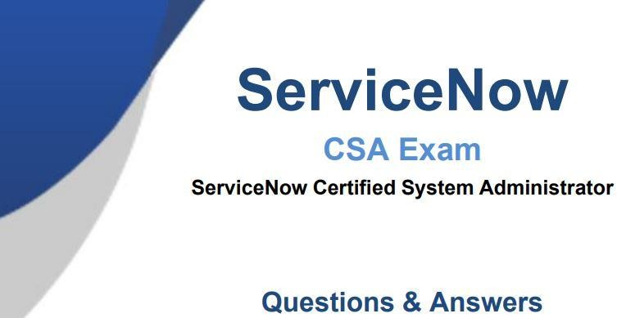

QUESTION 1
A Service Catalog may include which of the following components?

- Order Guides, Exchange Rates, Calendars
- Order Guides, Catalog Items, and Interceptors
- Catalog Items, Asset Contracts, Task Surveys
- Record Producers, Order Guides, and Catalog Items

Correct Answer: D Section: (none) Explanation

Explanation/Reference:

QUESTION 2
Which one of the following statements applies to a set of fields when they are coalesced during an import?

- If a match is found using the coalesce fields, the existing record is updated with the information being imported
- If a match is not found using the coalesce fields, the system does not create a Transform Map
- If a match is found using the coalesce fields, the system creates a new record
- If a match is not found using the coalesce fields, the existing record is updated with the information being imported

Correct Answer: A Section: (none) Explanation
Explanation/Reference:

QUESTION 3
As it relates to ServiceNow reporting, which of the following statements describes what a metric can do?

- A metric is a report gauge used on homepages to display real-time data
- A metric is a time measurement used to report the effectiveness of workflows and SLAs
- A metric is used to measure and evaluate the effectiveness of IT service management processes
- A metric is a comparative measurement used to report the effectiveness of flows and SLAs.

Correct Answer: C Section: (none) Explanation

Explanation/Reference:

QUESTION 4
The display sequence is controlled in a Service Catalog Item using which of the following?

- The Default Value field in the Catalog Item form
- The Sequence field in the Catalog Item form
- The Order field in the Variable form

- The Choice field in the Variable form
Correct Answer: C Section: (none)

Explanation Explanation/Reference:

QUESTION 5
Reports can be created from which different places in the platform? (Choose two.)

- List column heading
- Metrics module
- Statistics module
- View / Run module

Correct Answer: AD Section: (none) Explanation

Explanation/Reference:

QUESTION 6
Knowledge Base Search results can be sorted by which of the following? (Choose three.)

- Most recent update
- Popularity
- Relevancy
- Manager assignment
- Number of views

Correct Answer: ACE Section: (none) Explanation

Explanation/Reference:

QUESTION 7
What is the path an Administrator could take to view the fulfillment stage task list for an order placed by a user?

- RITM (Number)>REQ (Number)>PROCUREMENT (Number)
- REQ (Number)>RITM (Number)>PROCUREMENT (Number)
- REQ (Number)>RITM (Number)>TASK (Number)
- FULFILLMENT (Number)>RITM (Number)>TASK (Number)

Correct Answer: C Section: (none) Explanation

Explanation/Reference:

QUESTION 8
Which term refers to application menus and modules which you may want to access quickly and often?

- Breadcrumb
- Favorite
- Tag
- Bookmark

Correct Answer: B Section: (none) Explanation

Explanation/Reference:

QUESTION 9
What is generated from the Service Catalog once a user places an order for an item or service?

- A change request
- An Order Guide
- A request
- An SLA

Correct Answer: C Section: (none) Explanation

Explanation/Reference:

QUESTION 10
From the User menu, which actions can a user select? (Choose three.)

- Send Notifications
- Log Out ServiceNow
- Elevate Roles
- Impersonate Users
- Order from Service Catalog
- Approve Records

Correct Answer: BCD Section: (none) Explanation
Explanation/Reference:

QUESTION 11
Buttons, form links, and context menu items are all examples of what type of functionality?

- Business Rule
- UI Action
- Client Script
- UI Policy

Correct Answer: B Section: (none) Explanation

Explanation/Reference:

QUESTION 12
Which of the following is true of Service Catalog Items in relation to the Service Catalog?

- They run behind the scenes.

- They are the building blocks.
- They are optional.
- They provide options.

Correct Answer: B Section: (none) Explanation

Explanation/Reference:

QUESTION 13
Table Access Control rules are processed in the following order:

- any table name (wildcard), parent table name, table name
- table name, parent table name, any table name (wildcard)
- parent table name, table name, any table name (wildcard)
- any table name (wildcard), table name, parent table name

Correct Answer: B Section: (none) Explanation

Explanation/Reference:

QUESTION 14
What is the platform name for the User table?

- u_user
- sys_users
- x_users
- sys_user

Correct Answer: D
Section: (none) Explanation
Explanation/Reference:

QUESTION 15
A REQ number in the Service Catalog represents…

- the order number.
- the stage.
- the task to complete.
- the individual item in the order.

Correct Answer: A Section: (none) Explanation

Explanation/Reference:

QUESTION 16
Which would NOT appear in the History section of the Application Navigator?

- Records
- UI Pages
- Lists
- Forms

Correct Answer: B Section: (none) Explanation

Explanation/Reference:

QUESTION 17
Which one of the following statements is a recommendation from ServiceNow about Update Sets?

- Avoid using the Default Update set as an Update Set for moving customizations from instance to instance
- Before moving customizations from instance to instance with Update Sets, ensure that both instances are different versions
- Use the Baseline Update Set to store the contents of items after they are changed the first time
- Once an Update Set is closed as “Complete”, change it back to “In Progress” until it is applied to another instance

Correct Answer: A Section: (none) Explanation

Explanation/Reference:

QUESTION 18
Which of the following is used to initiate a flow?

- A Trigger
- Core Action
- A spoke
- An Event

Correct Answer: A Section: (none) Explanation

Explanation/Reference:

QUESTION 19
For Administrators creating new Service Catalog items, what is a characteristic they should know about Service Catalog variables?

- Service Catalog variables can only be used in Record Producers
- Service Catalog variables can only be used in Order Guides
- Service Catalog variables cannot affect the order price
- Service Catalog variables are global by default

Correct Answer: D Section: (none) Explanation
Explanation/Reference:

QUESTION 20
Which one of the following statements is true about Column Context Menus?

- It displays actions such as creating quick reports, configuring the list, and exporting data
- It displays actions related to filtering options, assigning tags, and search
- It displays actions related to viewing and filtering the entire list
- It displays actions such as view form, view related task, and add relationship

Correct Answer: A Section: (none) Explanation

Explanation/Reference:

QUESTION 21
Which ServiceNow products can be used to discover and populate the CMDB? (Choose two.)

- Discovery
- IntegrationHub ETL
- Finder
- CMDB Plug-in
- CMDB Integration Dashboard

Correct Answer: AB Section: (none) Explanation

Explanation/Reference:
Reference: https://docs.servicenow.com/bundle/rome-servicenow-platform/page/product/configuration- management/concept/c_OptionsToPopulateCMDB.html

QUESTION 22
When using the Load Data and Transform Map process, what is the Mapping Assist used for?

- Mapping fields using the Import Log
- Mapping fields using Transform History
- Mapping fields using an SLA
- Mapping fields using a Field Map

Correct Answer: D Section: (none) Explanation

Explanation/Reference:

QUESTION 23
Which one of the following statements describes the contents of the Configuration Management Database (CMDB)?

- The CMDB contains data about tangible and intangible business assets
- The CMDB contains the Business Rules that direct the intangible, configurable assets used by a company
- The CMDB archives all Service Management PaaS equipment metadata and usage statistics
- The CMDB contains ITIL process data pertaining to configuration items

Correct Answer: A Section: (none) Explanation

Explanation/Reference:

QUESTION 24
In what order should filter elements be specified?

- Field, Operator, then Value
- Field, Operator, then Condition
- Operator, Condition, then Value
- Value, Operator, then Field

Correct Answer: A Section: (none) Explanation

Explanation/Reference:

QUESTION 25
Which statement is true about business rules?

- A business rule must run before a database action occurs
- A business rule can be a piece of Javascript
- A business rule must not run before a database action occurs
- A business rule monitors fields on a form

Correct Answer: B Section: (none) Explanation

Explanation/Reference:

QUESTION 26
Which of the following are a type of client scripts supported in ServiceNow? (Choose four.)

- onSubmit
- onUpdate
- onCellEdit
- onLoad
- onEdit
- onChange
- onSave
Correct Answer: ACDF Section: (none) Explanation

Explanation/Reference:

QUESTION 27
Which type of tables may be extended by other tables, but do not extend another table?

- Base Tables
- Core Tables
- Extended Tables
- Custom Tables

Correct Answer: A Section: (none) Explanation

Explanation/Reference:

QUESTION 28
Which of the following statement describes the purpose of an Order Guide?

- Order Guides restrict the number of items in an order to only one item per request
- Order Guide provide a list of guidelines for Administrators on how to set up item variables
- Order Guide provide the ability to order multiple, related items as one request
- Order Guides take the user directly to the checkout without prompting for information
Correct Answer: C Section: (none) Explanation

Explanation/Reference:

QUESTION 29
Which tool is used to have conversations with logged-in users in real-time?

- Connect Chat
- Now Messenger
- User Presence
- Comments

Correct Answer: A Section: (none) Explanation

Explanation/Reference:

QUESTION 30
Which of the following concepts are associated with the ServiceNow CMDB? (Choose four.)

- Service Processes
- User Permissions
- Tables and Fields
- A Database
- The Dependency View

Correct Answer: ACDE Section: (none) Explanation
Explanation/Reference: QUESTION 31

What is a formatter? Select one of the following.

- A formatter allows you to configure applications on your instance
- A formatter is a form element used to display information that is not a field in the record
- A formatter allows you to populate fields automatically
- A formatter is a set of conditions applied to a table to help find and work with data

Correct Answer: B Section: (none) Explanation
Explanation/Reference:

QUESTION 32
When searching using the App Navigator search field, what can be returned? (Choose four.)

- Names of Applications and Modules
- Names of Modules
- Names of Applications
- Favorites
- History Records
- Titles of Dashboard Gauges

Correct Answer: ABCD Section: (none) Explanation

Explanation/Reference:

QUESTION 33
Which technique is used to get information from a series of referenced fields from different tables?

- Table-Walking
- Sys_ID Pulling
- Dot-Walking
- Record-Hopping

Correct Answer: C Section: (none) Explanation

Explanation/Reference:

QUESTION 34
What is a schema map?

- A schema map enables administrators to define records from specific tables as trouble sources for Configuration Items
- A schema map graphically organizes the visual task boards for the CMDB
- A schema map graphically displays the Configuration Items that support a business service
- A schema map displays the details of tables and their relationships in a visual manner, allowing administrators to view and easily access different parts of the database schema

Correct Answer: D Section: (none) Explanation

Explanation/Reference:

QUESTION 35
Which one of the following statements best describes the purpose of an Update Set?

- An Update Set allows administrators to group a series of changes into a named set and then move this set as a unit to other systems
- By default, an Update Set includes customizations, Business Rules, and homepages
- An Update Set is a group of customizations that is moved from Production to Development
- By default, the changes included in an Update Set are visible only in the instance to which they are applied

Correct Answer: A Section: (none) Explanation

Explanation/Reference:

QUESTION 36
Which of the following can be customized through the Basic Configuration UI 16 module? (Choose three.)

- Banner Image
- Record Number Format
- Browser Tab Title
- System Date Format
- Form Header Size

Correct Answer: ACD Section: (none) Explanation

Explanation/Reference:

QUESTION 37
What is the function of user impersonation?

- Testing and visibility
- Activate verbose logging
- View custom perspectives
- Unlock Application master list

Correct Answer: A Section: (none) Explanation

Explanation/Reference:

QUESTION 38
What information does the System Dictionary contain?

- The human-readable labels and language settings
- The definition for each table and column
- The information on how tables relate to each other
- The language dictionary used for spell checking

Correct Answer: B Section: (none) Explanation

Explanation/Reference:

QUESTION 39
When working on a form, what is the difference between Insert and Update operations?

- Insert creates a new record and Update saves changes, both remain on the form
- Insert creates a new record and Update saves changes, both exit the form
- Insert saves changes and exits the form, Update saves changes and remains on the form
- Insert saves changes and remains on the form, Update saves changes and exits the form

Correct Answer: B Section: (none) Explanation
Explanation/Reference:

QUESTION 40
How is the Event Log different from the Event Registry?

- Event Log contains generated Events, the Event Registry is a table of Event definitions
- Event Log is formatted in the Log style, the Event Registry displays different fields
- Event Log lists Events that were triggered by integrations, the Event Registry lists the Events that were triggered during the day (24-hour period)
- Event Log is the same as the Event Registry

Correct Answer: A Section: (none) Explanation
Explanation/Reference:

QUESTION 41
What is a Dictionary Override?

- A Dictionary Override is an incoming customer update in an Update Set which applies to the same objects as a newer local customer update
- A Dictionary Override is the addition, modification, or removal of anything that could have an effect on IT services
- A Dictionary Override is a task within a flow that requests an action before the flow can continue
- A Dictionary Override sets field properties in extended tables

Correct Answer: D Section: (none) Explanation

Explanation/Reference:

QUESTION 42
Which group of permissions is used to control Application and Module access?

- Access Control Rules

- UI Policies
- Roles
- Assignment Rules

Correct Answer: C Section: (none) Explanation

Explanation/Reference:

QUESTION 43
What is a Record Producer?

- A Record Producer is a type of Catalog Item that is used for Requests, not Services
- A Record Producer creates user records
- A Record Producer is a type of Catalog Item that provides easy ordering by bundling requests
- A Record Producer is a type of a Catalog Item that allows users to create task-based records from the Service Catalog

Correct Answer: D Section: (none) Explanation

Explanation/Reference:

QUESTION 44
Create Incident, Password Reset, and Report outage: what do these services in the Service Catalog have in common?

- They direct the user to a record producer
- They direct the user to a catalog property
- They direct the user to a catalog UI policy
- They direct the user to a catalog client script

Correct Answer: A Section: (none) Explanation

Explanation/Reference:

QUESTION 45
What is the Import Set Table?

- A table where data will be placed, post-transformation
- A table that determines relationships
- A staging area for imported records
- A repository for Update Set information
Correct Answer: C Section: (none) Explanation

Explanation/Reference:

QUESTION 46
What is a characteristic of importing data into ServiceNow?

- An existing Transform Map can be used one time on the same import set
- Coalesce fields are used only after running Transform
- Any user can manage and set up import sets
- An existing Transform Map can be used multiple times on the same import set

Correct Answer: D Section: (none) Explanation

Explanation/Reference:

QUESTION 47
What module in the Service Catalog application does an Administrator access to begin creating a new item?

- Maintain Categories
- Maintain Items
- Content Items
- Items

Correct Answer: B Section: (none) Explanation

Explanation/Reference:

QUESTION 48
Which of the following allows a user to edit field values in a list without opening the form?

- Data Editor
- Edit Menu
- List Editor
- Form Designer

Correct Answer: C Section: (none) Explanation
Explanation/Reference:

QUESTION 49
Which three Variable Types can be added to a Service Catalog Item?

- True/False, Multiple Choice, and Ordered
- True/False, Checkbox, and Number List
- Number List, Single Line Text, and Reference
- Multiple Choice, Select Box, and Checkbox

Correct Answer: D Section: (none) Explanation

Explanation/Reference:

QUESTION 50
How are Workflows moved between instances?

- Workflows are moved using Update Sets
- Workflows are moved using Transform Maps
- Workflows are moved using Application Sets
- Workflows cannot be moved between instances

Correct Answer: A Section: (none) Explanation

Explanation/Reference:

QUESTION 51
The baseline Service Catalog homepage contains links to which of the following components?

- Record Producers, Order Guides, and Catalog Items
- Order Guides, Item Variables, and flows
- Order Guides, Catalog Items, and flows
- Record Producers, Order Guides, and Item Variables

Correct Answer: A Section: (none) Explanation

Explanation/Reference:

QUESTION 52
Which of the following statements is true when a new table is created by extending another table?

- The new table archives the parent table and assumed its roles in the database
- The new table inherits all of the Business Rules, Client Scripts, and UI Policies of the parent table, but none of the existing fields
- The new table inherits all of the fields of the parent table and can also contain new fields unique to itself
- The new table inherits all of the fields, but does not inherit Access Control rules, Client Scripts, and UI Policies of the parent table

Correct Answer: C Section: (none) Explanation

Explanation/Reference:

QUESTION 53
Where can Admins check which release is running on an ServiceNow instance?

- Memory Stats module
- Stats module
- System.upgraded table
- Transactions log

Correct Answer: B Section: (none) Explanation

Explanation/Reference:

QUESTION 54
A knowledge article must be which of the following states to display to a user?

- Published
- Drafted
- Retired
- Reviewed

Correct Answer: A Section: (none) Explanation

Explanation/Reference:

QUESTION 55
What is the name of the conversational bot platform that provides assistance to help users obtain information, make decisions, and perform common tasks?

- Answer Agent
- live Feed
- Virtual Agent
- Connect Chat

Correct Answer: C Section: (none) Explanation

Explanation/Reference:

QUESTION 56
What is the purpose of a Related List?

- To create a one-to-many relationship
- To dot-walk to a core table
- To present related fields
- To present related records

Correct Answer: D Section: (none) Explanation

Explanation/Reference:

QUESTION 57
Which one of the following statements describes the purpose of a Service Catalog flow?

- A Service Catalog flow generates three basic components: item variable types, tasks, and approvals
- Although a Service Catalog flow cannot send notifications, the flow drives complex fulfillment processes
- A Service Catalog flow is used to drive complex fulfillment processes and sends notifications to defined users or groups
- A Service Catalog flow generates three basic components: item variable types, tasks, and notifications Correct Answer: C

Section: (none) Explanation

Explanation/Reference:

QUESTION 58
Which term best describes something that is created, has worked performed upon it, and is eventually moved to a state of closed?

- report
- flow
- event
- task

Correct Answer: D Section: (none) Explanation
Explanation/Reference:

QUESTION 59
Which are valid Service Now User Authentication Methods? (Choose three.)

- XML feed
- Local database

LDAP
- SSO
- FTP authentication

Correct Answer: BCD Section: (none) Explanation

Explanation/Reference:

QUESTION 60
Access Control rules may be defined with which of the following permission requirements? (Choose three.)

- Roles
- Conditional Expressions
- Assignment Rules
- Scripts
- User Criteria
- Groups

Correct Answer: ABD Section: (none) Explanation

Explanation/Reference:

QUESTION 61
Which section of the ServiceNow UI allows you to perform a global search?

- Application Navigator

- Banner frame
- List pane
- Content frame

Correct Answer: B Section: (none) Explanation

Explanation/Reference:

QUESTION 62
How do you make a list filter available to everyone?

- Make active, assign a name, and save
- Assign a group, set visibility, and save
- Assign a name, set visibility, and save
- Make active, set visibility, and save
Correct Answer: C Section: (none) Explanation

Explanation/Reference:

QUESTION 63
What would NOT appear in the Application Navigator if “service” is typed into the filter field?

- Configuration > Business Services
- Self-Service > Knowledge
- Service Portal > Widgets
- Incident > Assigned to me

Correct Answer: D Section: (none) Explanation
Explanation/Reference:

QUESTION 64
Which of the following is used to categorize, flag, and locate records?

- Search
- Favorites
- Tags
- Bookmarks

Correct Answer: C Section: (none) Explanation
Explanation/Reference:

QUESTION 65
Which tool should be used to populate commonly used fields in a form?

- Template
- Reference Qualifier
- Formatter
- Assignment Rule

Correct Answer: A Section: (none) Explanation

Explanation/Reference:

QUESTION 66
How is a group defined in ServiceNow?

- A group is one record stored in the Group Type [sys_user_group_type] table
- A group is one record stored in the Group [sys_user_group] table
- A group defines a set of users that share the same location
- A group defines a set of users that share the same job title

Correct Answer: B Section: (none) Explanation

Explanation/Reference:

QUESTION 67
What is a role in ServiceNow?

- A role is one record in the Role [user_sys_role] table
- A role is a set of modules for a particular application
- A role is one record in the Role [sys_user_role] table
- A role is a persona used in Live Feed Chat

Correct Answer: C Section: (none) Explanation

Explanation/Reference:

QUESTION 68
What is a Notification?

- A new Knowledge article created by a Business Rule
- A tool for alerting users that events that concern them have occurred
- A message through Connect related to a Change Request
- An email file attachment

Correct Answer: B Section: (none) Explanation

Explanation/Reference:

QUESTION 69
Which one of the following is NOT a type of Visual Task Board?

- Flexible
- Freeform
- Feature
- Guided boards

Correct Answer: C Section: (none) Explanation

Explanation/Reference:

QUESTION 70
What is (are) best practice(s) regarding users/groups/roles? (Choose two.)

- You should never assign roles to groups.
- You should assign roles to users.
- You should add users to groups.
- You should assign roles to groups.

Correct Answer: CD Section: (none) Explanation

Explanation/Reference:

QUESTION 71
What are two ways to generate an Event? (Choose two.)

- Business Rule
- Workflow
- Log entry
- Knowledge article publication

Correct Answer: AB Section: (none) Explanation

Explanation/Reference:

QUESTION 72
Which core table in the ServiceNow platform provides a series of standard fields used on each of the tables that extend it, such as the Incident [incident] and Problem [problem] tables?

- Task [task]
- Assignment [assignment]
- Service [service]
- Workflow [workflow]

Correct Answer: A Section: (none) Explanation

Explanation/Reference:

QUESTION 73
Which of the following statements describes how data is organized in a table?

- A column is a field in the database and a record is one user
- A column is one field and a record is one row
- A column is one field and a record is one column
- A column contains data from one user and a record is one set of fields

Correct Answer: B Section: (none) Explanation
Explanation/Reference:

QUESTION 74
What is a sys_id?

- Unique 32-character identifier that is assigned to every record
- A client-side Business Rule
- A server-side Business Rule
- Unique 64-character identifier that is assigned to every record

Correct Answer: A Section: (none) Explanation
Explanation/Reference:

QUESTION 75
When creating a global custom table named “abc”, what is the table name that is automatically assigned by the platform?

- snc_abc
- abc
- u_abc
- sys_abc

Correct Answer: C Section: (none) Explanation
Explanation/Reference:

QUESTION 76
Access Control rules may provide access security for which of the following database objects?

- For a specific role, group, or user
- For a specific row, column, or table
- For specific groups
- For a specific CMDB Configuration item

Correct Answer: B Section: (none) Explanation
Explanation/Reference:

QUESTION 77
What is the primary application used to load data into ServiceNow?

- Service Level Management
- Configuration
- System Import Sets
- System Update Sets

Correct Answer: C Section: (none) Explanation

Explanation/Reference:

QUESTION 78
Which of the following steps can be used to import new data into ServiceNow from a spreadsheet?

- Select Data Source, Schedule Transform
- Load Data, Create Transform Map, Run Transform
- Define Data Source, Select Transform Map, Run Transform
- Select Import Set, Select Transform Map, Run Transform

Correct Answer: B Section: (none) Explanation

Explanation/Reference:

QUESTION 79
Which tool is used for creating dependencies between configuration items in the CMDB?

- CI Relationship Editor
- CMDB Builder
- CI Service Manager
- Cl Class Manager

Correct Answer: D Section: (none) Explanation

Explanation/Reference:

QUESTION 80
What is the difference between a UI Policy and Data Policy?

- Data Policies run when data is entered through the form, by an Import Set, or by web services, while UI Policies are set only by web services
- Data Policies can be converted into UI Policies, but UI Policies cannot be converted into Data Policies
- Data Policies run regardless of how data is entered into ServiceNow, while UI Policies are used for form interactions
- Data Policies run only after UI Policies run successfully

Correct Answer: C Section: (none)

Explanation Explanation/Reference:

QUESTION 81
Which one of the following is an accurate list of changes that are captured in an Update Set?

- Changes made to: tables, forms, schedules, and client scripts
- Changes made to: tables, forms, Business Rules, and data records
- Changes made to: tables, forms, groups, and configuration items (CIs)
- Changes made to: table, forms, views, and fields

Correct Answer: D Section: (none) Explanation

Explanation/Reference:

QUESTION 82
What are the steps to retrieve an Update Set?

- Verify Update Set is Complete, Retrieve, Preview, Apply
- Verify Update Set is Complete, Test Connection, Apply
- Verify Update Set is Complete, Test Connection, Commit
- Verify Update Set is Complete, Retrieve, Preview, Commit

Correct Answer:D Section: (none) Explanation

Explanation/Reference:

QUESTION 83
IntegrationHub enables execution of third-party APIs as a part of a flow. These integrations are referred to as

- an action
- a spoke
- a connection
- an integration step

Correct Answer: B Section: (none) Explanation

Explanation/Reference:

QUESTION 84
Which of the following protects applications by identifying and restricting access to available files and data?

- Application Configuration
- Verbose Log
- Access Control Rules
- D. Application Scope

Correct Answer: D Section: (none) Explanation

Explanation/Reference:

QUESTION 85
Which one statement correctly describes Access Control rule evaluation?

- Table access rules are evaluated from the general to the specific
- If more than one rule applies to a record, the older rule is evaluated first
- If a row level rule and a field level rule exist, both rules must be true before an operation is allowed
- The role with the most permissions evaluates the rules first.

Correct Answer: C Section: (none) Explanation

Explanation/Reference:

QUESTION 86
ServiceNow contains a resource which provides the following:
A standard and shared set of service related definitions across ServiceNow products and platform that will enable and support true service level reporting.
A CMDB framework across our products and platform that will enable and support multiple configuration strategies.

What resource do these statements describe?

- Common Services Data Model (CMDB)
- Information Technology Service Management (ITSM)
- Configuration Management Database (CMDB)
- Information Technology Infrastructure Library (ITIL)

Correct Answer: A Section: (none) Explanation

Explanation/Reference:
Reference:
https://www.servicenow.com/content/dam/servicenow-assets/public/en-us/doc-type/resource-center/ solution-brief/sbr-servicenow-common-service-data-model.pdf

QUESTION 87
An IT manager is responsible for the Network and Hardware assignment groups, each group contains 5 team members. These team members are working on many tasks, but the manager cannot see any tasks on the Service Desk > My Groups Work list. What could explain this?
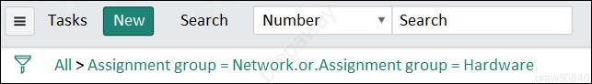

- The Service Desk > My Groups Work list shows active work tasks that are not yet assigned.
- The manager does not have the itil role.
- The manager is not a member of the Service Desk group.
- The manager is not a member of the Network and Hardware groups.

- The Assignment Group manager field is empty.

Correct Answer: B Section: (none) Explanation

Explanation/Reference:
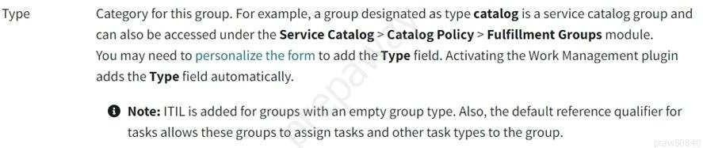
Reference: https://docs.servicenow.com/bundle/rome-platform-administration/page/administer/users-and- groups/task/t_CreateAGroup.html

QUESTION 88
What do you need to do before you can use an Application-based trigger in your flow?

- Activate application trigger spoke
- Activate trigger security rules
- Activate application spoke, and plug-ins as needed
- Assign Application trigger role [sn_app_trigger_write] to SME
- Activate application plugins only

Correct Answer: B Section: (none) Explanation

Explanation/Reference:

QUESTION 89
The ServiceNow platform includes which types of interfaces? (Choose three.)

- Now Mobile Apps
- Agent Control Center
- Back Office Dashboard
- Service Portals
- Now Platform® User Interfaces or next navigation unified experience
- Field Service Taskboard

Correct Answer: ADE Section: (none) Explanation

Explanation/Reference:

QUESTION 90
Which of the following are not included in an Update Set, by default? (Choose four.)

Homepages
- Data
- Published Workflows
- Business Rules
- Schedules
- Database Changes

- Related Lists
- Report Definitions
- Scheduled Jobs
- Client Scripts
- Views

Correct Answer: ABEI Section: (none) Explanation

Explanation/Reference:
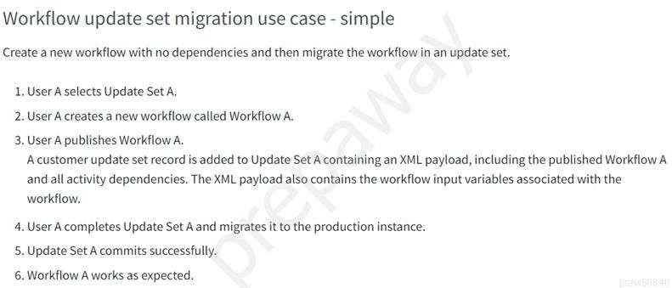
Reference: https://docs.servicenow.com/bundle/paris-servicenow-platform/page/administer/workflow- administration/concept/c_WorkflowMovementWithUpdateSets.html

QUESTION 91
You are showing your customer a new form that you have created for their new application. They would like to add a field to the form. Where could you do that? (Choose two.)

- Select Fields and Columns module
- Right click on form header, select Configure > Form Layout
- Click on context menu, select Configure > Form Designer
- Select Field Class Manager module

Correct Answer: AB Section: (none) Explanation

Explanation/Reference:
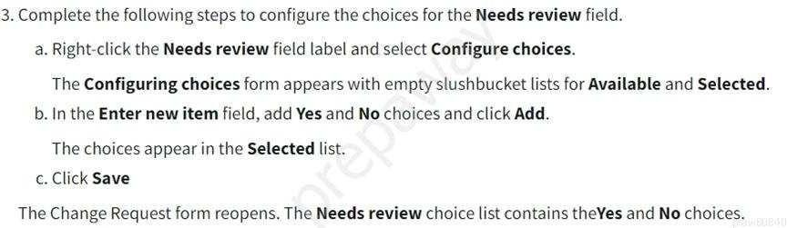
Reference: https://docs.servicenow.com/bundle/rome-it-service-management/page/product/change- management/task/t_CreateCustomField.html

QUESTION 92
Which ServiceNow resource is a framework that ensures the data your ServiceNow application requires maps correctly to the appropriate CMDB tables?

- Common Service Data Model (CSDM)
- Service Mapping Utility (SMU)
- Service Schema Map (SSM)
- CMDB Class Manager (CMDBCM)
- CI Class Manager (CICM)

Correct Answer: A Section: (none) Explanation

Explanation/Reference:
Reference: https://docs.servicenow.com/bundle/paris-servicenow-platform/page/product/csdm- implementation/concept/csdm-basics.html
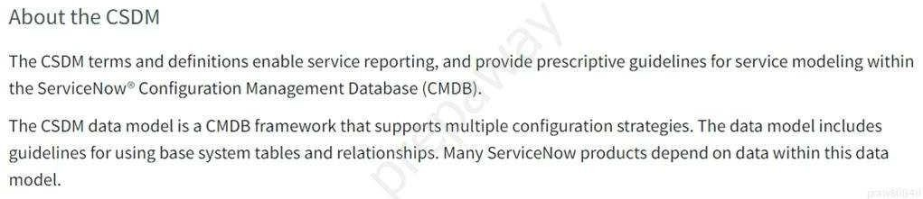

QUESTION 93
What do you activate when you want to add applications or functionality within your development instance?

- App Package
- Updated Pack
- Patch
- Plugin
- App Updated Set

Correct Answer: D Section: (none) Explanation

Explanation/Reference:
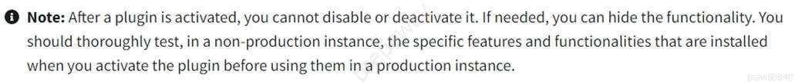
Reference: https://docs.servicenow.com/bundle/rome-platform-administration/page/administer/plugins/ concept/c_ServiceNowPlugins.html

QUESTION 94
What field contains a record’s 32-character, unique identifier?

- sn_rec_id
- rec_id
- u_id
- sys_id
- sn_gu_id
- sn_sys_id
- id

Correct Answer: D Section: (none) Explanation

Explanation/Reference:
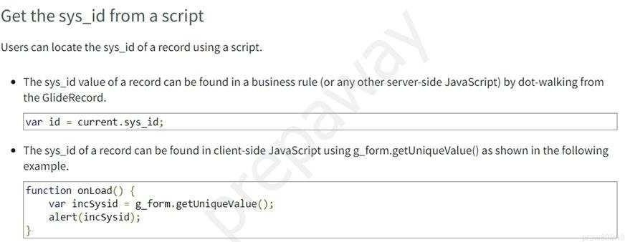
Reference: https://docs.servicenow.com/bundle/rome-platform-administration/page/administer/table- administration/concept/c_UniqueRecordIdentifier.html

QUESTION 95
Your company is giving all first line workers a special T-shirt as a recognition for their hard work. Management team wants a way for employees to order the T-shirt, with the ability to specify the preferred size and color. How would you ensure that only first line workers (non-managers) can submit the order?

- Create Record Producer and use the Available For list to specify First Line [sn_first_line] role
- Create Catalog Item and use the Not Available list to specify the Manager Group
- Create Catalog Item and use the Available For list to specify ITIL [itil] role
- Create Order Guide and use the User Criteria list to specify First Line [sn_first_line] role

Correct Answer: B Section: (none) Explanation

Explanation/Reference:
Reference: https://docs.servicenow.com/bundle/orlando-it-service-management/page/product/service- catalog-management/task/t_AppUserCritItemsCat.html
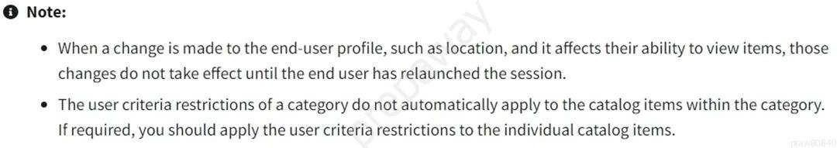

QUESTION 96
What is used frequently to move customizations from one instance to another?

- Update Sets
- Code Sets
- Update Packs
- Configuration Logs
- Remote Sets
- Local Sets
- Code Packs Correct Answer: A

Section: (none) Explanation

Explanation/Reference:
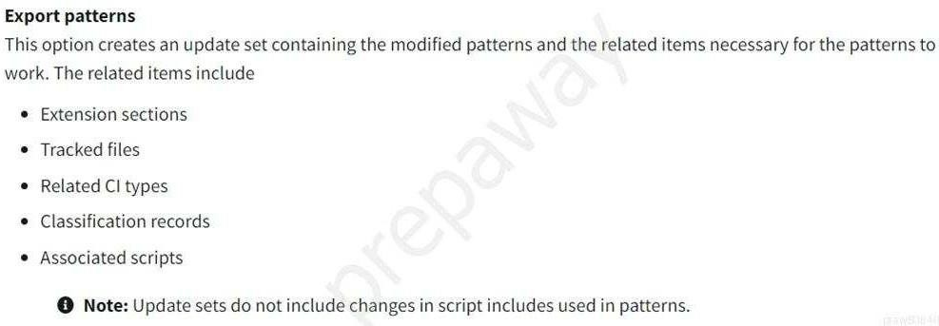
Reference: https://docs.servicenow.com/bundle/rome-it-operations-management/page/product/service- mapping/task/export-patterns.html

QUESTION 97
What icon do you use to change the label on a Favorite?

- Clock
- Hamburger
- Pencil
- Three dots
- Triangle.
- Star

Correct Answer: C Section: (none) Explanation

Explanation/Reference:
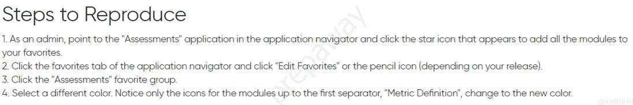
Reference: https://support.servicenow.com/kb?id=kb_article_view&sysparm_article=KB0781451

QUESTION 98
What needs to be specified, when creating a Business Rule? (Choose four.)

- UI action
- Table
- Fields to update
- Who can run
- Script to run
- Application scope
- Update set
- Timing
- Condition to evaluate

Correct Answer: BEFI Section: (none)

Explanation

Explanation/Reference:
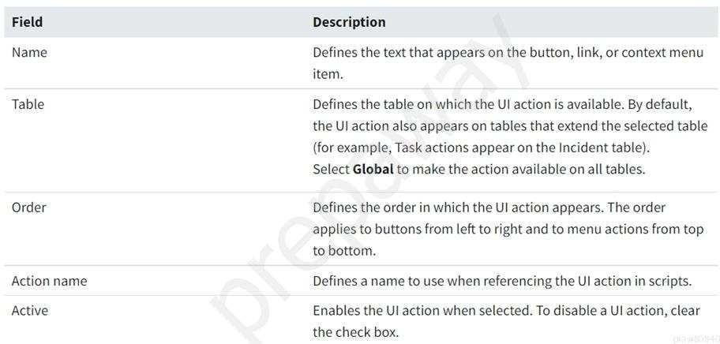
Reference: https://docs.servicenow.com/bundle/rome-platform-administration/page/administer/list- administration/task/t_EditingAUIAction.html

QUESTION 99
What feature can track the amount of time that a task has been open, to ensure that tasks are completed within an allotted time?
- Task Escalation Clock
- Service Level Agreements
- Inactivity Monitor
- Response Time Clock
- Business Time Remaining

Correct Answer: B Section: (none) Explanation

Explanation/Reference:
Reference: https://docs.servicenow.com/bundle/rome-platform-administration/page/administer/task-table/ reference/r_ToolsForDrivingTasks.html#:~:text=Service%20level%20agreements%20can% 20track,completed%20within%20an%20allotted%20time.&text=Inactivity%20monitors%20ensure%20that% 20tasks,a%20predefined%20period%20of%20time
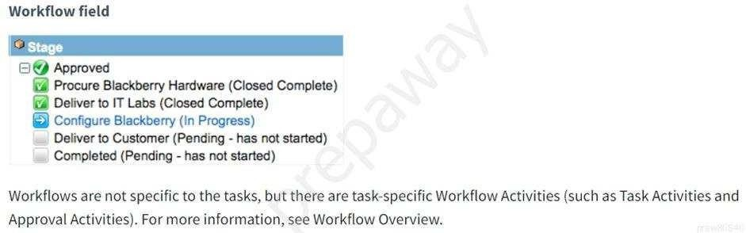

QUESTION 100
What is a quick way to create a report from a list view?

- Click on filter breadcrumb, drag and drop on the Report > Create New module

- Click Funnel, define filter conditions, click Create Report
- Click Context Menu, select Create Report
- Apply filter, right click on column header, select Bar Chart
- Apply filter, right click on column header, select Create Report

Correct Answer: D Section: (none) Explanation

Explanation/Reference:
Reference: https://ut.service-now.com/sp?id=kb_article&number=KB0014148
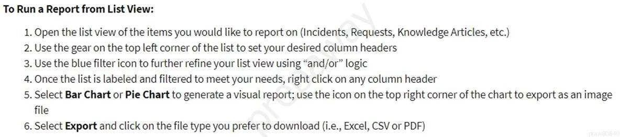

QUESTION 101
What import utility do you use when the field names on the import set match the name of the fields on the Target table?

- Schema Mapping
- Automatic Mapping
- Mapping Assist
- Mapping Dashboard

Correct Answer: B Section: (none) Explanation

Explanation/Reference:
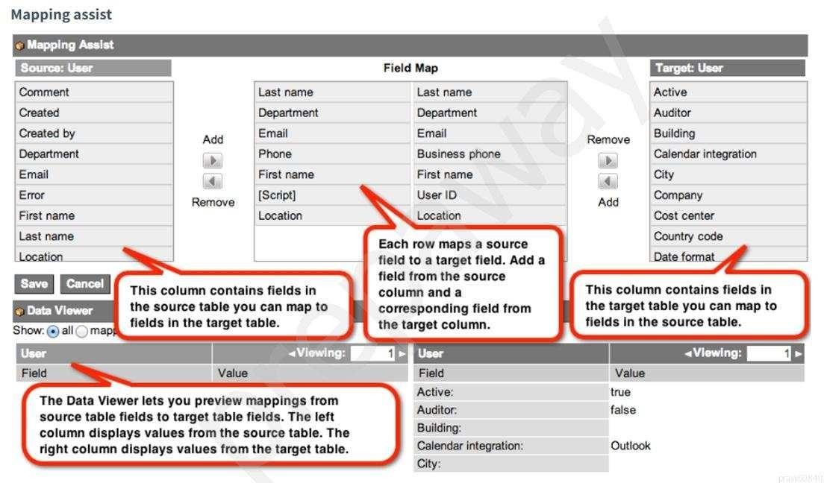
Reference: https://docs.servicenow.com/bundle/rome-platform-administration/page/script/server-scripting/ concept/c_MappingOptions.html

QUESTION 102
As an IT employee what interface would you use, if you wanted to browse internal IT documentation, like troubleshooting scripts and FAQs?

- Knowledge
- ServiceNow Wiki
- Knowledge Now
- SharePoint
- Stack Overflow

Correct Answer: A Section: (none) Explanation

Explanation/Reference:
Reference: https://support.servicenow.com/kb?id=kb_article_view&sysparm_article=KB0547260

QUESTION 103
A new Service Desk employee in Latin America complains that the create dates and times are incorrect on their Incident list. What would you suggest to fix this issue?

- Have them clear their cache.
- Have them use the gear icon to set the employee’s time zone.
- Recommend they use Chrome, instead of Explorer.
- Use the system properties to correct the instance’s time zone.
- Have them correct the time zone on their computer.

Correct Answer: E Section: (none) Explanation

Explanation/Reference:
Reference: https://support.servicenow.com/kb?id=kb_article_view&sysparm_article=KB0659171
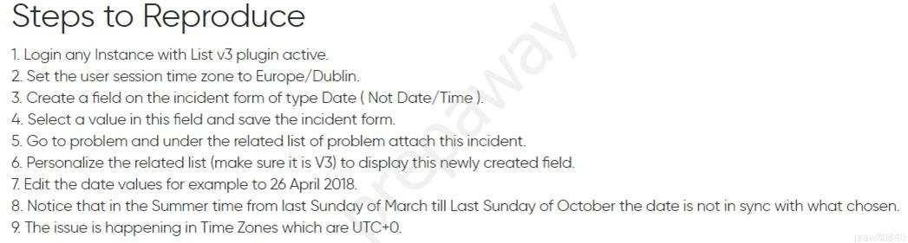

QUESTION 104
What are three security modules often used by the System Administrator? (Choose three.)

- System Properties > Security
- Utilities > Migrate Security
- System Security > Security
- Self-Service > My Access
- System Security > Access Control (ACL)
- Password Management > Security Questions
- System Security > High Security Settings

Correct Answer: AEG Section: (none) Explanation

Explanation/Reference:
Reference: https://docs.servicenow.com/bundle/rome-platform-administration/page/administer/security/ reference/r_GeneralSecuritySettings.html
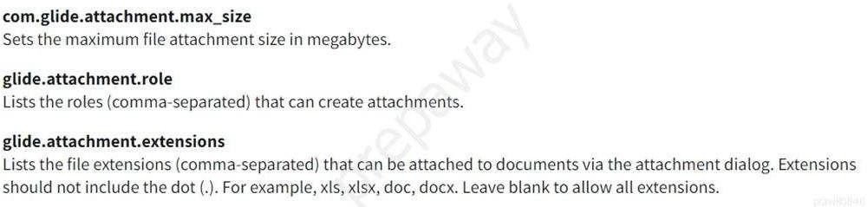

QUESTION 105
When testing a catalog item, having a manager approval flows, which of these best practices would you follow? (Choose three.)

- Make sure the latest flows are activated.
- Use the instance Incognito setting to quickly toggle between requester and approver.
- Impersonate the requester to ensure the form works.
- Make sure the requester's user record has a manager specified.

Correct Answer: ACD Section: (none) Explanation

Explanation/Reference:

QUESTION 106
What is a no-code approach to control the mandatory or read-only state of a form field?

- UI Action
- Client Script
- UI Script
- UI RuIe
- UI Policy

Correct Answer: E Section: (none) Explanation

Explanation/Reference:
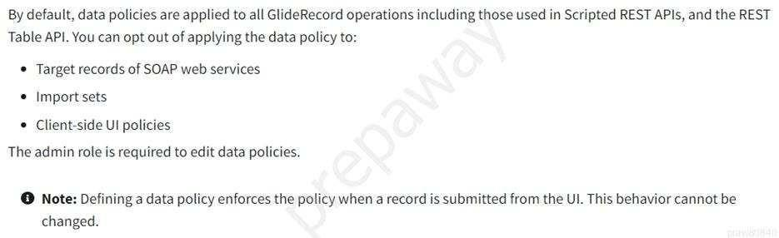
Reference: https://docs.servicenow.com/bundle/rome-platform-administration/page/administer/field- administration/concept/c_DataPolicy.html

QUESTION 107
When moving multiple update sets at one time, what might you do to facilitate the move?

- Batch
- Verify
- Test
- Preview

Correct Answer: A Section: (none) Explanation

Explanation/Reference:
Reference: https://www.servicenowelite.com/blog/2016/8/7/update-sets
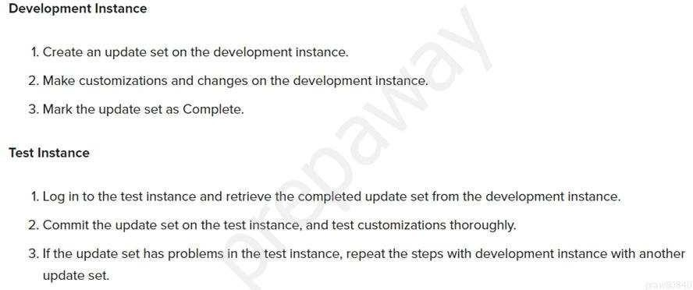

QUESTION 108
What is specified in an Access Control rule?

- Groups, Conditional Expressions and Workflows
- Table Schema, CRUD, and User Authentication
- Object and Operation being secured; Permissions required to access the object
- security_admin

Correct Answer: C Section: (none) Explanation

Explanation/Reference:
Reference: https://www.servicenowelite.com/blog/2019/10/2/access-controls#:~:text=An%20instance% 20uses%20access%20control,object%20and%20operation%20being%20secured

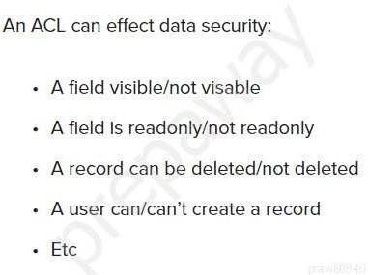

QUESTION 109
Which icon would you double click, to expand and collapse the list of all Applications and Modules?
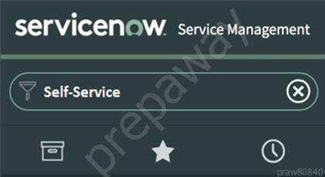

- Star
- Clock
- Application
- Funnel

Correct Answer: C Section: (none) Explanation

Explanation/Reference:
Reference: https://docs.servicenow.com/bundle/rome-platform-user-interface/page/administer/navigation- and-ui/task/ui16-navigator-tasks.html

QUESTION 110
What do you call any component that needs to be managed in order to deliver services?

- CSDM Items

CMDB
- Configuration item
- Service Offerings
- Asset

Correct Answer: C Section: (none) Explanation

Explanation/Reference:
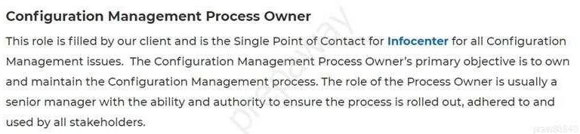
Reference: https://infocenter.io/servicenow-cmdb-implementation/

QUESTION 111
A new service catalog item is being developed, but should only be visible to managers inside the HR Department. What method would you use to fulfill this requirement?

- Specify the Dept_Mgr role on the catalog content block
- Add the Department Manager group to the catalog item’s user criteria
- Add the Department Manager group to the catalog item’s ACL
- Only publish the item in the HR service catalog
- Use a Dept_Mgr ACL on the HR service catalog

Correct Answer:B Section: (none) Explanation

Explanation/Reference:

QUESTION 112
A user wants to create a set of filter conditions, where they want to show records which satisfy two conditions:
Incidents where the state is Closed
Incidents where Assignment Group is Network

After clicking the Funnel icon, what should the user do?

- Define the first condition; click AND button; define second condition; click Run
- Define the first condition; click AND button; define second condition; press enter
- Define the first condition; click OR button; define second condition; press enter
- Define the first condition; click > icon on breadcrumb, define second condition; click Run
- Define the first condition; click > icon on breadcrumb, define second condition; press enter

Correct Answer: A Section: (none) Explanation

Explanation/Reference:

QUESTION 113
Access Control rules are applied to a specific table, like the Incident table. What is the object name for a rule that is specific to the Incident table and the Major Incident field?

- Incident.Major_Incident

- incident=>major_incident
- incident<=>major_incident
- incident||major_incident
- incident.major_incident

Correct Answer: E Section: (none) Explanation

Explanation/Reference:
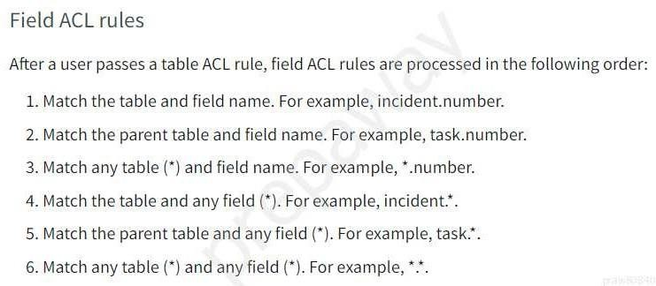
Reference: https://docs.servicenow.com/bundle/rome-platform-administration/page/administer/contextual- security/concept/acl-rule-types.html

QUESTION 114
Two departments (HR Onboarding and Facilities) have come to you, asking for a way for employees to request event room set up services. The requirements are the same for the form and the task routing to the Facilities’ assignment group.
For HR, the item will be used primarily for the Onboarding coordinators, for employee orientation sessions.
For Facilities, the item will be used for anyone in the company who needs room set up services.

However, both departments have their own service catalogs. What do you do, to support these requirements?

- Create one Catalog Item for HR Event Room Set Up and one for Facilities Event Room Set Up; then publish each to the appropriate Catalog.
- Create one Catalog Item for Event Room Set Up; then publish to both Catalogs.
- Create one Catalog Item for Event Room Set Up; then publish to the Parent Catalog, which is accessible to both HR and Facilities.
- Create one Catalog Item for Event Room Set Up; then use ACLs to control access.

Correct Answer: C Section: (none) Explanation

Explanation/Reference:

QUESTION 115
After finishing your work on High Security Settings, what do you do to return to normal admin security levels?

- Select Normal role
- Log out and back in

- Use System Administration > Normal Security module
- Select Global Update Set
- End Impersonation

Correct Answer: B Section: (none) Explanation

Explanation/Reference:
Reference: https://docs.servicenow.com/bundle/rome-platform-administration/page/administer/security/ concept/c_HighSecuritySettings.html
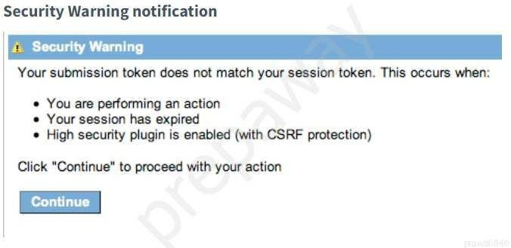

QUESTION 116
What type of field allows you to look up values from one other table?

Reference
- Verity
- Options
- Selections
- Dot walk
- Lookup

Correct Answer: A
Section: (none) Explanation

Explanation/Reference:
Reference: https://support.microsoft.com/en-us/office/create-or-delete-a-lookup-field-87e84cbd-d60c-4473- 8a98-3e391c42f239#:~:text=A%20lookup%20field%20can%20display,order%20in%20the%20Orders% 20table

QUESTION 117
Which module would you use to create a new automation of business logic such as approvals, tasks, and notifications?
- Process Automation > Flow Designer
- Process Automation > Flow Administration
- Process Automation > Workflow Editor
- Process Automation > Process Flow
- Process Automation > Active Flows

Correct Answer:A
Section: (none) Explanation

Explanation/Reference:
Reference: https://docs.servicenow.com/bundle/rome-servicenow-platform/page/administer/process- automation-designer/concept/getting-started-process-automation.html
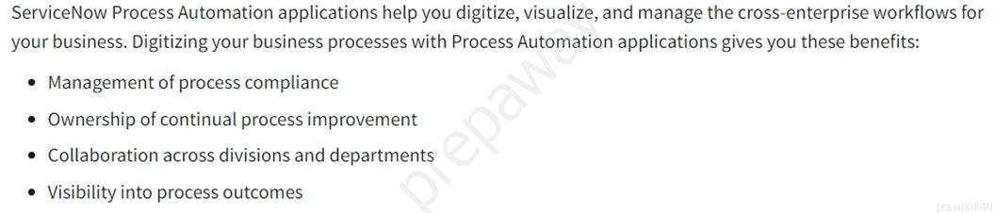

QUESTION 118
A department manager asks an analyst to build some reports. Where do you recommend the analyst start?

- Report Dashboard > Create New
- Reports > Getting Started
- Performance Analytics > Reports
- Self-Service > eports
- Reports > Create New

Correct Answer: E Section: (none) Explanation

Explanation/Reference:
Reference: https://kstate.service-now.com/kb_view.do?sysparm_article=KB12492
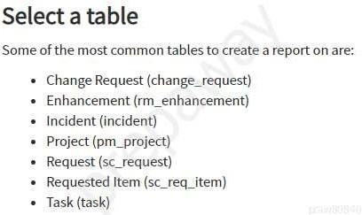

QUESTION 119
What are the steps for applying an update set to an instance?

- Retrieve, Preview, Commit
- Specify, Transform, Apply
- Retrieve, Assess, Apply
- Get, Test, Push
- Pull, Review, Push Correct Answer: A

Section: (none) Explanation

Explanation/Reference:
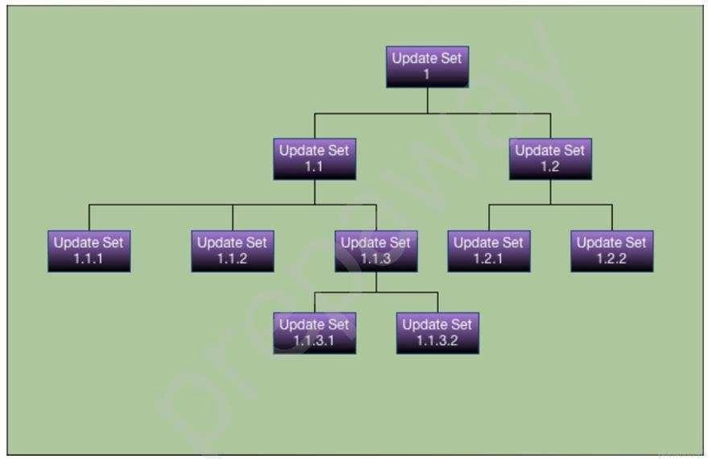
Reference: https://docs.servicenow.com/bundle/rome-application-development/page/build/system-update- sets/hier-update-sets/concept/us-hier-overview.html#us-hier-overview

QUESTION 120
When importing spreadsheet data into ServiceNow, in which step does the data get written to the receiving table?

- Run Transform
- Run Import
- Import Dataset
- Execute Transform
- Schedule Transform

Correct Answer: A Section: (none) Explanation

Explanation/Reference:
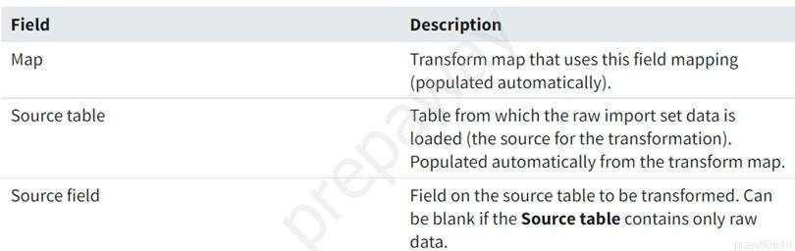
Reference: https://docs.servicenow.com/bundle/paris-platform-administration/page/script/server-scripting/ task/t_CreatingAFieldMap.html

QUESTION 121
What would you do, on a list, if you wanted to show the records in groups, based on the column category? (Choose two.)

- On list Context Menu, select Group By > Category
- On the Filter Menu, select Group By > Category
- Click Group On icon, select Category
- On Navigator Filter, type tablename.group.category and press enter
- On the Category column title, click Context menu > Group By Category

Correct Answer: AE Section: (none) Explanation

Explanation/Reference:
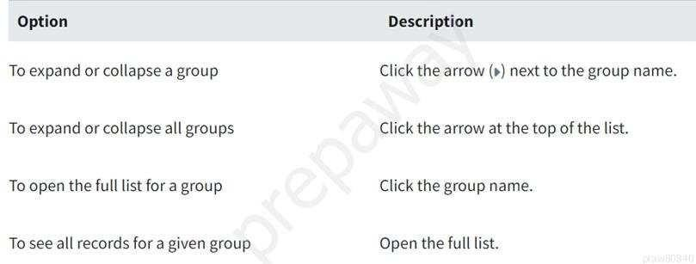
Reference: https://docs.servicenow.com/bundle/rome-platform-user-interface/page/use/using-lists/concept/ c_GroupedLists.html

QUESTION 122
Which collaboration tool is available from the banner, using the bubble icon?


- Now Messenger
- Agent Chat
- Connect Chat
- Collaborate Now
- Live Feed

Correct Answer: C Section: (none) Explanation
Explanation/Reference:

QUESTION 123
On the knowledge base record, which tab would you use to define which users are not able to write articles to the knowledge base?
- Can Contribute
- Cannot Author

- Cannot Contribute
- Cannot Write
- Read Only

Correct Answer: C Section: (none) Explanation

Explanation/Reference:
Reference: https://docs.servicenow.com/bundle/rome-servicenow-platform/page/product/knowledge- management/task/t_SelectUserCriteria.html

QUESTION 124
Which features allow you to update multiple records at one time? (Choose two.)

- List Editor
- Field Update Action
- Bulk Record Update
- Data Remediation Dashboard
- Update Selected Action

Correct Answer: AE Section: (none) Explanation

Explanation/Reference:
Reference: https://docs.servicenow.com/bundle/rome-platform-user-interface/page/use/using-lists/task/ t_EditMultRecUsingListEditor.html

QUESTION 125
Categories in the knowledge base, by default, can be created and edited by which knowledge workers? (Choose two.)

- Knowledge Authors
- Knowledge Contributors
- Knowledge Controller
- Knowledge Managers
- Knowledge Category Managers
- Knowledge Submitters
- Knowledge Owners
- Knowledge Taxonomy Owner

Correct Answer: BD Section: (none) Explanation

Explanation/Reference:
Reference: https://docs.servicenow.com/bundle/rome-servicenow-platform/page/product/knowledge- management/task/t_DefineAKnowledgeCategory.html#:~:text=In%20addition%20to%20using% 20categories,categories%20when%20editing%20an%20article

QUESTION 126
Which collaboration tool opens a sidebar and allows you to create new conversations with other ServiceNow users?

- Skype Now
- Collaborate Now
- Agent Messenger
- Agent Chat

- Connect Chat

Correct Answer: E Section: (none) Explanation

Explanation/Reference:
Reference: https://itsm.ucsf.edu/servicenow-connect-chat

QUESTION 127
What module would you use if you wanted to view a list of all of the fields on the Incident table? (Choose two.)

- Tables & Columns
- Dictionary
- Data Class Manager
- Dictionary Dashboard
- Database View
- Schema

Correct Answer: AB Section: (none) Explanation

Explanation/Reference:
Reference: https://docs.servicenow.com/bundle/rome-platform-administration/page/administer/table- administration/concept/c_TableAdministration.html

QUESTION 128
What component causes a flow to run after a record has been created or updated?

- Date-based trigger
- On-change trigger
- Record-based trigger
- Application-based trigger
- Updated-date trigger

Correct Answer: C Section: (none) Explanation

Explanation/Reference:
Reference: https://docs.servicenow.com/bundle/rome-servicenow-platform/page/administer/flow-designer/ reference/flow-triggers.html

QUESTION 129
What type of field is Boolean and appears as a check box?

- Yes/No
- True/False
- On/Off
- Binary
- 0/1

Correct Answer: B Section: (none) Explanation

Explanation/Reference:

Reference: https://community.servicenow.com/community? id=community_question&sys_id=d195d21adbd6d414a08a1ea668961993

QUESTION 130
Which module is used to access the knowledge bases which are available to you?

- Knowledge > Home
- Self Service > Knowledge
- Knowledge > All
- Knowledge > Knowledge Bases
- Knowledge > Overview

Correct Answer: D Section: (none) Explanation

Explanation/Reference:
Reference: https://docs.servicenow.com/bundle/rome-servicenow-platform/page/product/knowledge- management/concept/user-access-knowledge.html

QUESTION 131
A customer requests the following data quality measures be added:
Incident numbers should be read only, on all lists and forms, for all users.
Short Description field should be mandatory, on all records, across all applications, on Insert. Which type of policy would you use to meet this requirement?
- Data Quality Policy
- Dictionary Design Policy
- UI Data Policy
- UI Policy
- Field Criteria Policy
- Data Policy

Correct Answer: D Section: (none) Explanation

Explanation/Reference:
Reference: https://support.servicenow.com/kb?id=kb_article_view&sysparm_article=KB0813271

QUESTION 132
What type of user (persona) has clearly defined paths and workflows in the platform and have one or more roles (ie itil and approver_user)?

- Workflow User
- Request Fulfiller
- ITSM User
- Approving Manager
- Service Desk User
- Process User

Correct Answer: D Section: (none) Explanation

Explanation/Reference:

QUESTION 133
Which module would you use to customize your instances banner image, text and colors?

- System UI > UI Pages > Branding
- Service Portal > Portals > Branding
- System Properties > Basic Configuration UI16
- System Properties > Branding
- Homepage Admin > Pages > Branding

Correct Answer: C Section: (none) Explanation

Explanation/Reference:
Reference: https://docs.servicenow.com/bundle/rome-platform-user-interface/page/administer/navigation- and-ui/reference/customizing-instance-appearance.html

QUESTION 134
Which database provides a logical model of your company infrastructure by identifying, controlling, maintaining and verifying CIs that exist?

- IMDB
- ITSM
- CSDM
- CMDB
- LDAP

Correct Answer: D Section: (none) Explanation

Explanation/Reference:
Reference: https://qualiti7.com/wp-content/uploads/2018/11/D2-1D-HGC-TECHNOLOGIES-DESIGN- YOUR-CMDB.pdf

QUESTION 135
Which module is used as the first step for importing data?

- Coalesce Data
- Transform Data
- Import Data
- Load Data

Correct Answer: D Section: (none) Explanation

Explanation/Reference:
Reference: https://docs.servicenow.com/bundle/paris-platform-administration/page/administer/import-sets/ concept/c_ImportDataUsingImportSets.htm

QUESTION 136
When you need to orchestrate business processes across services with little technical user knowledge, which utility would you use?

- Flow Manager
- Flow Designer
- Flow Editor
- Workflow Editor

- Workflow Designer

Correct Answer: B Section: (none) Explanation

Explanation/Reference:
Reference: https://docs.servicenow.com/bundle/rome-servicenow-platform/page/product/orchestration/ reference/r-orchestration-introduction.html

QUESTION 137
When a user reports that they are not able to see modules on the application navigator, what can you do, to see what modules are visible to them?

- Look up their password, so you can login with their account
- Initiate a Connect Chat session
- Install the Bomgar plug-in
- Impersonate the user
- Launch a NowChat window

Correct Answer: B Section: (none) Explanation

Explanation/Reference:

QUESTION 138
What is a key difference between Reporting and Performance Analytics?

- Performance Analytics contains snapshots of data taken over time; Reporting shows only the data as it is, at the moment the report is run.
- Performance Analytics can show trends; Reports cannot.
- Reports can be run on a scheduled basis; Performance Analytics cannot.
- Performance Analytics data can be published to Dashboards; Reports cannot.
- Performance Analytics shows KPIs; Reporting does not.

Correct Answer: A Section: (none) Explanation

Explanation/Reference:

QUESTION 139
While showing a customer their incident form, they ask to change the Priority values to display their internal terminology P1, P2, P3, P4. They want it to be consistent across all Tasks. How would you do that?

Right click on Priority and select what?

- Configure Lists
- Show Options
- Configure Task
- Show Choices
- Show Choice List
- Configure Options

Correct Answer: F Section: (none)

Explanation Explanation/Reference:

QUESTION 140
Your customer would like to create a new template to notify users who are affected by network outages at their site. Which module would you use to create a new notification?

- System Notification > Email > Notifications
- Administration > Notification Overview
- System Properties > Email > Settings
- User Preferences > Email > Notifications
- Click Gear > Notifications > New

Correct Answer: A Section: (none) Explanation

Explanation/Reference:
Reference: https://docs.servicenow.com/bundle/rome-servicenow-platform/page/administer/notification/ task/t_CreateANotification.html

QUESTION 141
When designing a flow, how do you reference data from a record, in that flow?

- Drag the table icon onto the flow definition
- Use the condition builder to specify the desired values
- Specify the source table on the data pill relatedlist
- Drag the data pill onto the flow definition
- Add the table reference using the slush bucket

Correct Answer: D Section: (none) Explanation

Explanation/Reference:
Reference: https://developer.servicenow.com/dev.do#!/learn/learning-plans/paris/citizen_developer/ app_store_learnv2_flowdesigner_paris_using_flow_variables

QUESTION 142
On the Reports page, what sections allow you to see which reports are visible to different audiences? (Choose four.)

- Group
- Department
- My reports
- Team
- Dashboards
- Global
- Admin
- Analytics
- All
- Company

Correct Answer: ACFI Section: (none) Explanation

Explanation/Reference:
Reference: https://docs.servicenow.com/bundle/rome-now-intelligence/page/use/reporting/task/ t_ShareASetting.html

QUESTION 143
Which tool is used to define relationships between fields in an import set table and a target table?

- Transform Schema
- Schema Map
- Dictionary Map
- Transform Map
- Field Transformer
- Import Designer

Correct Answer: D Section: (none) Explanation

Explanation/Reference:
Reference: https://docs.servicenow.com/bundle/rome-platform-administration/page/administer/import-sets/ concept/c_ImportSetsKeyConcepts.html

QUESTION 144
Which ServiceNow capability provides assistance to help users obtain information, make decisions, and perform common work tasks via a messaging interface?

- Agent Workspace
- Chat bot
- Virtual Agent
- Knowledge Chat
- Now Support

Correct Answer: C Section: (none) Explanation

Explanation/Reference:

QUESTION 145
Which feature allows you to automate business logic for a particular application or process such as approvals, tasks notifications, and record operations?

- Flows
- Action Sequences
- Action Sets
- Task Flows
- Flow Diagrams

Correct Answer: A Section: (none) Explanation

Explanation/Reference:
Reference: https://docs.servicenow.com/bundle/rome-servicenow-platform/page/administer/flow-designer/ concept/flow-designer.html#:~:text=the%20following%20components%3A-,Flows,a%20particular% 20application%20or%20process

QUESTION 146
From a form, what would you click to add additional fields to the form? (Choose two.)

- Context Menu > Form > Layout
- Context Menu > Configure > Form Layout
- Context Menu > Configure > Form Design
- Right click on header > Add > Field
- Context Menu > Form > Designer
- Right click on header > Configure > UX Dashboard

Correct Answer: BC Section: (none) Explanation

Explanation/Reference:
Reference: https://docs.servicenow.com/bundle/rome-it-service-management/page/product/change- management/task/t_CreateCustomField.html

QUESTION 147
What is the name of the table relationship, where two or more tables are related in a bi-directional relationship, so that the related records are visible from both tables in a related list?

- Database View
- Many to Many
- One to Many
- Extended

Correct Answer: B Section: (none) Explanation

Explanation/Reference:
Reference: https://docs.servicenow.com/bundle/rome-platform-administration/page/administer/managing- data/concept/c_DataManagement.html

QUESTION 148
On a Form header, what is the three bar icon called?

- Pancake icon
- Additional Actions or Context Menu
- Hamburger icon
- Cake icon

Correct Answer: B Section: (none) Explanation

Explanation/Reference:
Reference: https://docs.servicenow.com/bundle/rome-platform-user-interface/page/use/using-forms/ concept/c_FormContextMenu.html

QUESTION 149
Group records are stored in which table?

- Group [sn_user_group]
- Group [sys_user_group]
- Group [s_sys_group]
- Group [u_sys_group]

Correct Answer: B Section: (none) Explanation

Explanation/Reference:
Reference: https://support.servicenow.com/kb?id=kb_article_view&sysparm_article=KB0832548

QUESTION 150
What function do you use to add buttons, links, and context menu items on forms and lists?

- UI Policies
- UI Settings
- UI Actions
- UI Config

Correct Answer: C Section: (none) Explanation

Explanation/Reference:
Reference: https://docs.servicenow.com/bundle/rome-platform-administration/page/administer/list- administration/concept/c_UIActions.html

QUESTION 151
On a Business Rule, the When setting determines at what point the rule executes. What are the options for specifying that timing?

- Before, After, Async, Display
- Prior to, Synchronous, on Update
- Insert, Update, Delete, Query
- Before, Synchronous, Scheduled Job, View

Correct Answer: A Section: (none) Explanation

Explanation/Reference:
Reference: https://docs.servicenow.com/bundle/rome-application-development/page/script/business-rules/ reference/r_HowBusinessRulesWork.html

QUESTION 152
What are different types of Data Sources, which may be imported into ServiceNow? (Choose four.)

- Local Sources (i.e. XML, CSV, Excel)
- Implementation Spoke
- DataHub
- JDBC Connection
- Network Server
- LDAP Connection

Correct Answer: ADEF Section: (none) Explanation

Explanation/Reference:
Reference: https://developer.servicenow.com/dev.do#!/learn/learning-plans/quebec/ servicenow_administrator/app_store_learnv2_importingdata_quebec_data_sources

QUESTION 153
What are the components that make up a filter condition? (Choose three.)

- Operator
- Match Criteria
- Value
- Column
- Field

Correct Answer: ACE Section: (none) Explanation

Explanation/Reference:
Reference: https://docs.servicenow.com/bundle/rome-platform-user-interface/page/use/using-lists/concept/ c_Filters.html

QUESTION 154
When impersonating a user for testing purposes, what is the best way to return the instance, logged in with your user account?

- Turn your computer off and on again
- Clear browser cache
- End Impersonation
- Log out and back in

Correct Answer: D Section: (none) Explanation

Explanation/Reference:
Reference: https://docs.servicenow.com/bundle/rome-platform-administration/page/administer/users-and- groups/concept/c_ImpersonateAUser.html

QUESTION 155
What controls the publishing and retiring process for knowledge articles?

- Approval Policies
- Approval Definitions
- Workflow Designer
- Workflows
- State Lifecycle

Correct Answer: D Section: (none) Explanation

Explanation/Reference:
Reference: https://docs.servicenow.com/bundle/rome-servicenow-platform/page/product/knowledge- management/reference/r_KnowledgeWorkflows.html

QUESTION 156
What type of query allows you to filter list data using normal words, instead of the condition builder?

- Natural Language Query
- Alexa Query
- Machine Learning Query
- Predictive Intelligence Query
- Auto-suggest Query Correct Answer: A

Section: (none) Explanation

Explanation/Reference:

QUESTION 157
Tables may have a One to Many relationships. From the Service Catalog, what are examples of tables having a one to many relationships? (Choose three.)

- One Approval can have many Requests
- One Request can have many Requested Items
- One Requested Item can have many Approvals
- One Requested Item can have many Catalog Tasks
- One Cart can have many Requests

Correct Answer: BDE Section: (none) Explanation

Explanation/Reference:

QUESTION 158
On a filter condition, which component is always a choice list?

- Operator
- Filter Criteria
- Operation
- Match Criteria

Correct Answer: A Section: (none) Explanation

Explanation/Reference:
Reference: https://docs.servicenow.com/bundle/rome-platform-user-interface/page/use/common-ui- elements/concept/c_ConditionBuilder.html

QUESTION 159
A Role is defined as what?

- A collection of permissions
- A set of user access policies
- A Persona in a workflow
- A set of access control rules

Correct Answer: A Section: (none) Explanation

Explanation/Reference:
Reference: https://docs.servicenow.com/bundle/rome-platform-administration/page/administer/roles/ concept/c_Roles.html

QUESTION 160
A user is complaining that they are seeing a blank page, when they click Create New, from your custom Inventory application. You have confirmed that they can see the Inventory application, and the Create New module on the application navigator. What could be the cause of this issue?

- Create New module has a broken link
- Known intermittent issue with U115
- User should be using Chrome instead of Explorer for their browser
- User has read role, but not the write role on the Inventory table
- User session has timed out

Correct Answer: E Section: (none) Explanation

Explanation/Reference:

QUESTION 161
What resource can you use to view details of the tables and configuration items (CIs) associated with a particular use case?

- Scenario Dashboard
- CI Use Case Modeler
- CMDB Use Case Modeler
- Common Service Data Model (CSDM) product view

Correct Answer: D Section: (none) Explanation

Explanation/Reference:
Reference: https://docs.servicenow.com/bundle/quebec-servicenow-platform/page/product/csdm- implementation/reference/cmdb-use-case.html

QUESTION 162
A manager wants to view a snapshot of month-end Sales performance data, as compared to Sales targets. In addition, the manager wants to be able to see those monthly numbers trended over time, and forecasted into the future. What capability do you suggest for this manager?

- Scheduled Reports, a custom snapshot table, and a Trend report
- Scheduled Reports and Excel
- Scheduled Reports, a custom snapshot table, and a Projection report
- Performance Analytics
- Key Performance Indicators

Correct Answer: D Section: (none) Explanation

Explanation/Reference:
Reference: https://docs.servicenow.com/bundle/rome-now-intelligence/page/use/performance-analytics/ concept/c_ForecastingData.html

QUESTION 163
What are advantages of using Flow Designer? (Choose three.)

- Supports advanced developers
- Enables complicated scripting
- Reduces technical debt
- Less manual scripting
- Smooth integration with 3rd party systems Correct Answer: CDE

Section: (none) Explanation

Explanation/Reference:

QUESTION 164
Your customer requires that they be able to monitor which users are performing impersonations in their instance. What would you do to meet that requirement?

- Add the role Log Write [sn_log_write] to the Impersonator Group
- Create user update set for impersonation tracking
- Activate the glide.sys.log_impersonation prop
- From User icon, select Elevate Roles
- On the Impersonator role record, right click and select Create Log

Correct Answer: C Section: (none) Explanation

Explanation/Reference:
Reference https://support.servicenow.com/kb?id=kb_article_view&sysparm_article=KB0717055

QUESTION 165
When a flow runs an action, it generates a runtime value, which stays the same for the duration of the flow. What is the name of this runtime value?

- Trigger runtime value
- Sequence runtime value
- Starting runtime value
- Data pill runtime value
- Input runtime value

Correct Answer: D Section: (none) Explanation

Explanation/Reference:
Reference: https://docs.servicenow.com/bundle/rome-servicenow-platform/page/administer/flow-designer/ concept/data-population.html

QUESTION 166
The wait time for end users is based on the round-trip between the client and the server. What activities are included in the round-trips?

- Request + Response
- Save + Update
- Write + Read
- Submit + Query
- Insert + Verify

Correct Answer: A Section: (none) Explanation

Explanation/Reference:
Reference: https://docs.servicenow.com/bundle/rome-application-development/page/script/client-scripts/ concept/client-script-best-practices.html

QUESTION 167

When importing data, what happens to imported rows, if no coalesce field is specified?

- All rows are rejected from the import, as coalesce field is required.
- All rows are treated as new records. No existing records are updated.
- Duplicate rows are rejected from the import.
- All rows are treated as new records, but errors will be flagged in the import log.

Correct Answer: B Section: (none) Explanation

Explanation/Reference:
Reference: https://developer.servicenow.com/dev.do#!/learn/learning-plans/quebec/new_to_servicenow/ app_store_learnv2_importingdata_quebec_coalescing

QUESTION 168
What is the most common role that has access to almost all platform features, functions, and data?

- Security Admin [security_admin]
- Sys Admin sys_admin]
- Admin [sn_admin]
- System Administrator [admin]
- Base Admin [base_admin]

Correct Answer: D Section: (none) Explanation

Explanation/Reference:
Reference: https://developer.servicenow.com/dev.do#!/guides/quebec/now-platform/glossary/developer- glossary

QUESTION 169
What feature do you use to specify which users are able to access a Service Catalog Item?

- Can Read Role
- Catalog User Role
- Can Order Tab
- User Criteria

Correct Answer: D Section: (none) Explanation

Explanation/Reference:
Reference: https://docs.servicenow.com/bundle/rome-servicenow-platform/page/product/service-catalog- management/task/t_AppUserCritItemsCat.html

QUESTION 170
Which component of a table contains a piece of data for one record?

- Factor
- Field
- Datapoint
- Element
- Item

Correct Answer: B Section: (none)

Explanation

Explanation/Reference:
Reference: https://docs.servicenow.com/bundle/rome-platform-administration/page/administer/managing- data/concept/c_DataDictionaryTables.html

QUESTION 171
What type of field has a drop down list, from which you can pick from pre-defined options?

- Choice
- Picker
- Drop down
- Option

Correct Answer: A Section: (none) Explanation

Explanation/Reference:
Reference: https://support.servicenow.com/kb?id=kb_article_view&sysparm_article=KB0538947

QUESTION 172
User records are stored in which table?

- User [sys_user]
- User [sn_user]
- User [u_sys_user]
- User [s_user]

Correct Answer: A Section: (none) Explanation

Explanation/Reference:
Reference: https://docs.servicenow.com/bundle/rome-platform-user-interface/page/administer/navigation- and-ui/concept/c_UserPreferences.html

QUESTION 173
What ServiceNow feature can be triggered by events, and is used to inform users about activities or updates in ServiceNow?

- Notifications
- Alerts
- Texts
- Events
- Emails

Correct Answer: A Section: (none) Explanation

Explanation/Reference:
Reference: https://docs.servicenow.com/bundle/rome-platform-administration/page/administer/platform- events/concept/events.html

QUESTION 174
Which ServiceNow capability allows you to provide knowledge articles, via a conversational messaging interface?

- Agent Assist

- Virtual Agent
- Now Messenger
- Connect Agent

Correct Answer: B Section: (none) Explanation

Explanation/Reference:
Reference: https://docs.servicenow.com/bundle/rome-release-notes/page/release-notes/analytics- intelligence-reporting/virtual-agent-rn.html

QUESTION 175
Which role can manage multiple knowledge bases?

- knowledge_base_admin
- kb_admin
- sn_kb_admin
- knowledge_admin

Correct Answer: D Section: (none) Explanation

Explanation/Reference:
Reference: https://docs.servicenow.com/bundle/rome-servicenow-platform/page/product/knowledge- management/reference/r_KnowledgeRoles.html

QUESTION 176
Which statement correctly describes the differences between a Client Script and a Business Rule?

- A Client Script executes before a record is loaded and a Business Rule executes after a record is loaded
- A Client Script executes on the server and a Business Rule executes on the client
- A Client Script executes on the client and a Business Rule executes on the server
- A Client Script executes before a record is loaded and a Business Rule executes after a record is updated

Correct Answer: C Section: (none) Explanation

Explanation/Reference:
Reference: https://community.servicenow.com/community? id=community_question&sys_id=77a80361db5cdbc01dcaf3231f9619d9#:~:text=The%20major% 20difference%20between%20of,deleted%2Fqueried%20from%20data%20base.&text=After%20that%2C% 20the%20Client%20scripts,Client%20scripts%20that%20work%20onSubmit

QUESTION 177
What are benefits of assigning work tasks to a group, rather than to an individual? (Choose four.)

- Group members can choose their tasks from My Groups Work
- Groups can assign tasks to users based on on-call schedules
- Site support members can pick tasks, based on Location
- Groups can assign tasks to users based on skills
- Group members can avoid tasks, which are nearing SLA breach
- Groups can assign tasks to users based on availability Correct Answer: BCDF

Section: (none) Explanation

Explanation/Reference:

QUESTION 178
What ServiceNow feature allows you to include data from a secondary related table on a report?

SQL
- Dot Walking
- Outer Join
- Joins

Correct Answer: B Section: (none) Explanation

Explanation/Reference:
Reference: https://docs.servicenow.com/bundle/rome-now-intelligence/page/use/reporting/concept/ c_HowToAccessRelatedTables.html

QUESTION 179
What attributes can you manage, using System Properties > Basic Configuration UI16? (Choose five.)

- Browser tab title
- Module text color
- Preferred browser
- Base theme
- Font style
- Animation style
- Header background color
- Banner Image

Correct Answer: ABDGH Section: (none) Explanation

Explanation/Reference:
Reference: https://docs.servicenow.com/bundle/rome-platform-user-interface/page/administer/navigation- and-ui/task/t_ConfigureLogoColorsSysDfltsUI16.html

QUESTION 180
Which field (or fields) is used as a unique key during imports?

- Match Fields
- Coalesce Fields
- Key Fields
- Sys IDs

Correct Answer: B Section: (none) Explanation

Explanation/Reference:
Reference: https://developer.servicenow.com/dev.do#!/learn/learning-plans/quebec/new_to_servicenow/ app_store_learnv2_importingdata_quebec_coalescing

QUESTION 181

You are asked to create an option in the Service Catalog, which will allow a user to click Get Help and describe the issue they are having. These forms should create incident records, which are automatically routed to the Service Desk. Which method would you use?

- Create Record Producer
- Create Catalog Item
- Create Order Guide
- Create Content Item

Correct Answer: A Section: (none) Explanation

Explanation/Reference:
Reference: https://docs.servicenow.com/bundle/orlando-it-service-management/page/product/service- catalog-management/concept/request-fulfillment.html

QUESTION 182
What is the result of the order in which access controls are evaluated?

- Ensures user has access to the fields in a table, before considering their access to the table
- Ensures user can get to work as quickly as possible
- Ensures user has access to the application, before evaluating access to a module within the application
- Ensures user has access to a table, before evaluating access to a field in the table

Correct Answer: D Section: (none) Explanation

Explanation/Reference:
Reference: https://support.servicenow.com/kb?id=kb_article_view&sysparm_article=KB0541355

QUESTION 183
Which tool graphically displays an infrastructure view for a configuration item (CI) and its relationship with other CIs?

- Schema Map
- Dependency View
- Dependency Map
- Database View

Correct Answer: B Section: (none) Explanation
Explanation/Reference:
Reference: https://docs.servicenow.com/bundle/rome-servicenow-platform/page/product/business-service- management-map-ng/concept/c_BusinesssServiceManagementMaps.html

QUESTION 184
What are examples of Core tables in the ServiceNow platform?

- Configuration, Connect, Chat
- Team, Party, Awards
- User, Task, Incident
- Work, Caller, Timecard

Correct Answer: C Section: (none)

Explanation

Explanation/Reference:
Reference: https://www.basicoservicenowlearning.in/2019/12/create-table-in-servicenow.html

QUESTION 185
Which tab on the knowledge base record, would you use to identify the sets of users who are able to read articles in that knowledge base?
- Access List
- Can Access
- Accessible to
- Can Read

Correct Answer: D Section: (none) Explanation

Explanation/Reference:
Reference: https://docs.servicenow.com/bundle/rome-servicenow-platform/page/product/knowledge- management/task/t_SelectUserCriteria.html

QUESTION 186
What are the main components of the Form Design interface? (Choose three.)

- Field Layout
- Page Header
- Field Navigator
- Field Picker
- Form Layout

Correct Answer: BCE Section: (none) Explanation

Explanation/Reference:
Reference: https://docs.servicenow.com/bundle/rome-platform-administration/page/administer/form- administration/concept/c_FormDesign.html

QUESTION 187
What is used to determine user access to knowledge bases or a knowledge article?

- sn_kb_read, sn_article_read
- Privacy Settings
- Read Access Flag
- User Criteria

Correct Answer: D Section: (none) Explanation

Explanation/Reference:
Reference: https://docs.servicenow.com/bundle/rome-servicenow-platform/page/product/knowledge- management/concept/user-access-knowledge.html

QUESTION 188
What are the three key tables in an enterprise CMDB? (Choose three.)

- cmdb
- sn_cmdb_bak

- cmdb_rel_ci
- sn_cmdb
- cmdb_bak
- cmdb_ci
- sn_cmdb_ci

Correct Answer: ACF Section: (none) Explanation

Explanation/Reference:
Reference: https://community.servicenow.com/community? id=community_question&sys_id=7ab22ad5dbf20498d82ffb2439961938

QUESTION 189
What is the best practice related to using the Default Update Set for moving customizations between instances?

- Merge Default update sets before moving between instances
- Submit Default update set to application repository
- You should not use the Default Update sets for moving between instances
- Keep Default update set to maximum of 20 records, for troubleshooting purposes

Correct Answer: C Section: (none) Explanation

Explanation/Reference:
Reference: https://docs.servicenow.com/bundle/rome-application-development/page/build/system-update- sets/reference/default-update-sets.html

QUESTION 190
On what part of the ServiceNow instance, would you find the option to Impersonate User?

- Module
- Content Frame
- Application Navigator
- Banner

Correct Answer: D Section: (none) Explanation

Explanation/Reference:
Reference: https://docs.servicenow.com/bundle/rome-platform-administration/page/administer/users-and- groups/concept/c_ImpersonateAUser.html

QUESTION 191
Which application is used primarily to load data into ServiceNow?

- Import Hub
- System Import Sets
- Data Import Configuration
- Import Management

Correct Answer: B Section: (none) Explanation

Explanation/Reference:
Reference: https://docs.servicenow.com/bundle/rome-platform-administration/page/administer/import-sets/ reference/import-sets-landing-page.html

QUESTION 192
If a knowledge base has no access details specified, what users are able to read articles in that knowledgebase?
- itil users
- Any user with an article's permalink
- Any active user
- No users
- Users with kb_user role

Correct Answer: CSection:
(none) Explanation Explanation/Reference:

QUESTION 193
ServiceNow is a single instance multiple tenant architecture
- True
- False
Correct Answer: B

Section: (none) Explanation
Explanation/Reference QUESTION 194
What are the two aspects of LDAP integration

- Data population
- Data integration
- Authorisation
- Authentication Correct Answer : AD
Section: (none) Explanation
Explanation/Reference QUESTION 195
What are the main components of servicenow platform

- Banner navigator
- Banner frame
- Application frame
- Application navigator
- Content menu
- Content frame Correct Answer : BDF
Section: (none) Explanation Explanation/Reference

QUESTION 196
is. Computer program running as a service: a physical computer dedicated to running one or more

services or system running a database
Correct Answer: Server

Section: (none) Explanation Explanation/Reference

QUESTION 197
What is the purpose of flagging an article in a knowledge base?
- To mark an article to read later
- Allow a user to submit feedback about an article
- Reporting an error Correct Answer: B
Section: (none) Explanation Explanation/Reference
QUESTION 198
What are the methods available for user authentication?

- Local Database
- Multifactor
- LDAP
- SAML 2.0
- OAUTH 2.0
- Digest Token
Correct Answer: ABCDEF QUESTION 199
What refers to an application or system that accesses a remote service or another computer system, known as a server?

- Server
- Client
- Script
- Policies Correct Answer: B

QUESTION 200
What defines conditions that are evaluated against users to determine which users can Create, Read, Write, and retire knowledge articles.
  - User conditions
  - User info
  - User criteria
  - User Permissions Correct Answer: C

QUESTION 201
ServiceNow uses what term to describe all the data saved within a particular form?
- Fields
- Form
- Record
- Lists Correct Answer: C

QUESTION 202
Where would you go in ServiceNow to order services and products offered by various departments?
- Service catalog
- Self service
- Service Department
- Customer service Correct Answer: A

QUESTION 203
Configuration will not affect what others see on their forms
- True
- False Correct Answer: B

QUESTION 204
Data policy can enforce mandatory data on import.

- True
- False Correct Answer: A

QUESTION 205
What displays a set of records from a table?
- View
- Dashboard
- Panel
- List Correct Answer: D

QUESTION 206
What are the two pathways to view feedback left on a published article?
- Knowledge > Articles > My Flagged
- Knowledge base > My Knowledge > Flagged Articles
- Knowledge > My Articles > Flagged
- Knowledge > Articles > Published Correct Answer: A, D
QUESTION 207
Business rules are used to enforce mandatory data on a form
- True
- False Correct Answer: B

QUESTION 208
Each knowledge bases can have unique lifecycle workflows, user criteria, category structures, and management assignments.
- True

- False Correct Answer: A
QUESTION 209
Multiple choice, single line text, and select box are what type of elements in ServiceNow?

- Order guides
- Request Types
- Variable Types
- Related lists Correct Answer: C

QUESTION 210
Which of the following is not workflow editor component?

- Title bar
- Activity Tab
- Palette
- Canvas Correct Answer: B

QUESTION 211
Favorites and shortcuts can be managed from mobile UI?

- True
- False Correct Answer: A

DUMPS - 3

NO.1 Which would NOT appear in the History section of the Application Navigator?
- Records
- UI Pages
- Lists
- Forms

NO.2 What module in the Service Catalog application does an Administrator access to begin creating a new item?
- Maintain Categories
- Maintain Items
- Content Items
- Items
NO.3 Which term refers to application menus and modules which you may want to access quickly and often?
- Breadcrumb
- Favorite
- Tag
- Bookmark

NO.4 Which term best describes something that is created, has worked performed upon it, and is eventually moved to a state of closed?
- report
- workflow
- event
- task
NO.5 Which of the following are a type of client scripts supported in ServiceNow? (Choose four.)
- onSubmit
- onUpdate
- onCellEdit
- onLoad
- onEdit
- onChange
- onSave
NO.6 What is a formatter? Select one of the following.
- A formatter allows you to configure applications on your instance

- A formatter is a form element used to display information that is not a field in the record
- A formatter allows you to populate fields automatically
- A formatter is a set of conditions applied to a table to help find and work with data

NO.7 Which one of the following statements describes the contents of the Configuration Management Database (CMDB)?
- The CMDB contains data about tangible and intangible business assets
- The CMDB contains the Business Rules that direct the intangible, configurable assets used by a company
- The CMDB archives all Service Management PaaS equipment metadata and usage statistics
- The CMDB contains ITIL process data pertaining to configuration items
NO.8 Which one of the following statements describes the purpose of a Service Catalog workflow?
- A Service Catalog workflow generates three basic components: item variable types, tasks, and approvals
- Although a Service Catalog workflow cannot send notifications, the workflow drives complex fulfillment processes
- A Service Catalog workflow is used to drive complex fulfillment processes and sends notifications to defined users or groups
- A Service Catalog workflow generates three basic components: item variable types, tasks, and notifications
NO.9 Which of the following statement describes the purpose of an Order Guide?
- Order Guides restrict the number of items in an order to only one item per request
- Order Guide provide a list of guidelines for Administrators on how to set up item variables
- Order Guide provide the ability to order multiple, related items as one request
- Order Guides take the user directly to the checkout without prompting for information
NO.10 Which type of interface enables you to display multiple performance analytics, reporting and other widgets on a single screen?
- Form
- List
- Dashboard
- Timeline
NO.11 What is a Dictionary Override?
- A Dictionary Override is an incoming customer update in an Update Set which applies to the same objects as a newer local customer update

- A Dictionary Override is the addition, modification, or removal of anything that could have an effect on IT services
- A Dictionary Override is a task within a workflow that requests an action before the workflow can continue
- A Dictionary Override sets field properties in extended tables
NO.12 Record numbers have to be manually incremented
- True
- False

NO3 ServiceNow is a single-instance, multiple tenant architecture?
- True
- False
NO.14 Which of the following concepts are associated with the ServiceNow CMDB? (Choose four.)
- Service Processes
- User Permissions
- Tables and Fields
- A Database
- The Dependency View
NO.15 UI Policy can make fields read-only, mandatory, or hidden.
- True
- False
NO.16 What are the two aspects to LDAP Integration?
- Data Population
- Data formatting
- Authorization
- Authentication
NO.17 Buttons, form links, and context menu items are all examples of what type of functionality?
- Business Rule
- UI Action
- Client Script
- UI Policy

NO.18 Which one of the following statements is
from ServiceNow about Update Sets?

- Avoid using the Default Update set as an Update Set for moving customizations from instance to instance
a recommendation
- Before moving customizations from instance to instance with Update Sets, ensure that both instances are different versions
- Use the Baseline Update Set to store the contents of items after they are changed the first time
- Once an Update Set is closed as "Complete", change it back to "In Progress" until it is applied to another instance
NO.19 What are the four knowledge workflows available in the ServiceNow base instance?
- Approval publish: Request approval from a manager of the knowledge base before moving the article it the publish state
- Instant Publish: Immediately publishes a draft article without requiring an approval
- Instant Retire: Immediately retires a published article without requiring an approval
- Retire Knowledge: Moves a knowledge article to the retired state.
NO.20 Which three Variable Types can be added to a Service Catalog Item?
- True/False, Multiple Choice, and Ordered
- True/False, Checkbox, and Number List
- Number List, Single Line Text, and Reference
- Multiple Choice, Select Box, and Checkbox
NO.21 How is the Event Log different from the Event Registry?
- Event Log contains generated Events, the Event Registry is a table of Event definitions
- Event Log is formatted in the Log style, the Event Registry displays different fields
- Event Log lists Events that were triggered by integrations, the Event Registry lists the Events that were triggered during the day (24-hour period)
- Event Log is the same as the Event Registry
NO.22 What are the three components of a filter condition?
- Table
- Value
- Field
- Operator
NO.23 There are common types of Interfaces (Numeric Value)

6: There are six common types of interfaces
- Homepage: Consists of navigational elements, functional controls, and platform information.
- List: Display records from a data table, as well as allow you to edit the record information using the List Editor functionally.
- Form: Data is entered into ServiceNow through forms
- Dashboard: Enable you to display multiple performance analytics, reporting and other widgets on a single screen.
- Maps: Display ServiceNow data graphically on a Google map
- Timelines: Used to track tasks or projects
Answer: C

NO.24 What is the purpose of a Related List?
- To create a one-to-many relationship
- To dot-walk to a core table
- To present related fields
- To present related records
NO.25 For Administrators creating new Service Catalog items, what is a characteristic they should know about Service Catalog variables?
- Service Catalog variables can only be used in Record Producers
- Service Catalog variables can only be used in Order Guides
- Service Catalog variables cannot affect the order price
- Service Catalog variables are global by default
NO.26 Which are valid Service Now User Authentication Methods? (Choose three.)
- XML feed
- Local database
- LDAP
- SSO
- FTP authentication

NO.27 Which tool is used to have conversations with logged-in users in real-time?
- Connect Chat
- Now Messenger
- User Presence
- Comments
NO.28 Which of the following allows a user to edit field values in a list without opening the form?
- Data Editor

- Edit Menu
- List Editor
- Form Designer
NO.29 In what order should filter elements be specified?
- Field, Operator, then Value
- Field, Operator, then Condition
- Operator, Condition, then Value
- Value, Operator, then Field

NO.30 What is a Record Producer?
- A Record Producer is a type of Catalog Item that is used for Requests, not Services
- A Record Producer creates user records
- A Record Producer is a type of Catalog Item that provides easy ordering by bundling requests
- A Record Producer is a type of a Catalog Item that allows users to create task-based records from the Service Catalog

NO.31 Which one of the following statements is true about Column Context Menus?
- It displays actions such as creating quick reports, configuring the list, and exporting data
- It displays actions related to filtering options, assigning tags, and search
- It displays actions related to viewing and filtering the entire list
- It displays actions such as view form, view related task, and add relationship
NO.32 Which of the following is true of Service Catalog Items in relation to the Service Catalog?
- They run behind the scenes.
- They are the building blocks.
- They are optional.
- They provide options.
NO.33 What are the main UI component(s) of the ServiceNow Platform?
- Banner Navigator
- Banner Frame
- Application Frame
- Application Navigator
- Content Menu
- Content Frame

NO.34 The
baseline Service Catalog homepage contains links
Record Producers, Order Guides, and Catalog Items
- Order Guides, Item Variables, and Workflows
- Order Guides, Catalog Items, and Workflows
- Record Producers, Order Guides, and Item Variables
to which of the following components?

NO.35 Access Control rules may be defined with which of the following permission requirements? (Choose three.)
- Roles
- Conditional Expressions
- Assignment Rules
- Scripts
- User Criteria
- Groups
NO.36 Which are states that you can make a field on a form using UI Policy?
- read-only
- write-only
- Necessary
- Mandatory
- Empty
- Hidden
NO.37 Which of the following can be customized through the Basic Configuration UI 16 module? (Choose three.)
- Banner Image
- Record Number Format
- Browser Tab Title
- System Date Format
- Form Header Size
NO.38 database live at the Data Center.
- True
- False
NO.39 SERVER is a computer program running as a service; a physical computer dedicated to running one or more services, or a system running a database.
S

NO.40 Which one of the following statements applies to a set of fields when they are coalesced during an import?
- If a match is found using the coalesce fields, the existing record is updated with the information being imported
- If a match is not found using the coalesce fields, the system does not create a Transform Map
- If a match is found using the coalesce fields, the system creates a new record
- If a match is not found using the coalesce fields, the existing record is updated with the information being imported
NO.41 What information does the System Dictionary contain?
- The human-readable labels and language settings
- The definition for each table and column
- The information on how tables relate to each other
- The language dictionary used for spell checking
  - NO.42 What is the Import Set Table?
- A table where data will be placed, post-transformation
- A table that determines relationships
- A staging area for imported records
- A repository for Update Set information
NO.43 What is the name of the conversational bot platform that provides assistance to help users obtain information, make decisions, and perform common tasks?
- Answer Agent
- live Feed
- Virtual Agent
- Connect Chat
NO.44 Reports can be created from which different places in the platform? (Choose two.)
- List column heading
- Metrics module
- Statistics module
- View / Run module
NO.45 Which one of the following statements best describes the purpose of an Update Set?
- An Update Set allows administrators to group a series of changes into a named set and then move this set as a unit to other systems

- By default, an Update Set includes customizations, Business Rules, and homepages
- An Update Set is a group of customizations that is moved from Production to Development
- By default, the changes included in an Update Set are visible only in the instance to which they are applied
NO.46 When using the Load Data and Transform Map process, what is the Mapping Assist used for?
- Mapping fields using the Import Log
- Mapping fields using Transform History
- Mapping fields using an SLA
- Mapping fields using a Field Map
NO.47 The display sequence is controlled in a Service Catalog Item using which of the following?
- The Default Value field in the Catalog Item form
- The Sequence field in the Catalog Item form
- The Order field in the Variable form
- The Choice field in the Variable form
NO.48 A group is stored in which table?
- Group[user group]
- Group[sys_user]
- Group[sys_user_group]
- Group[sys_user_group_profile]
NO.49 When working on a form, what is the difference between Insert and Update operations?
- Insert creates a new record and Update saves changes, both remain on the form
- Insert creates a new record and Update saves changes, both exit the form
- Insert saves changes and exits the form, Update saves changes and remains on the form
- Insert saves changes and remains on the form, Update saves changes and exits the form

NO.50 What is the purpose of flagging an article in a knowledge base?
- To mark an article to read later.
- Allow a user to submit feedback about an article
- Reporting an error
NO.51 What is the master table that contains a record for each table in the database?
- [sys_master_db]
- [sys_db_object]

- [sys_master_object]
- [sys_object_db]
NO.52 Which technique is used to get information from a series of referenced fields from different tables?
- Table-Walking
- Sys_ID Pulling
- Dot-Walking
- Record-Hopping
NO.53 Which one of these applications is available to all users?
- Change
- Incident
- Facilities
- Self-Service
NO.54 Tables are made up of which of the following?
- lists
- forms.
- Fields
- records

NO.55 A knowledge article must be which of the following states to display to a user?
- Published
- Drafted
- Retired
- Reviewed
NO.56 What are the 6 methods available for user authentication?
- Local Database: The user name and password in their user record in the instance database.
- Multifactor: The user name and password in the database and passcode sent to the user's mobile device that has Google Authenticator installed
- LDAP: The user name and password are accessed via LDAP in the corporate directory, which has a matching user account in the database.
- SAML 2.0: The user name and password configured in a SAML identity provider account, which has a matching user account in the database.
- OAuth 2.0: The user name and password of OAuth identity provider, which has a matching user account in the database.

- Digest Token: An encrypted digest of the user name and password in the user record.
NO.57 Knowledge articles within a knowledge base are grouped by category.
- True
- False
NO.58 A REQ number in the Service Catalog represents...
- the order number.
- the stage.
- the task to complete.
- the individual item in the order.
NO.59 As it relates to ServiceNow reporting, which of the following statements describes what a metric can do?
- A metric is a report gauge used on homepages to display real-time data
- A metric is a time measurement used to report the effectiveness of workflows and SLAs
- A metric is used to measure and evaluate the effectiveness of IT service management processes
- A metric is a comparative measurement used to report the effectiveness of workflows and SLAs.
NO.60 Knowledge Base Search results can be sorted by which of the following? (Choose three.)
- Most recent update
- Popularity
- Relevancy
- Manager assignment
- Number of views
NO.61 Which of the following statements is true when a new table is created by extending another table?
- The new table archives the parent table and assumed its roles in the database
- The new table inherits all of the Business Rules, Client Scripts, and UI Policies of the parent table, but none of the existing fields
- The new table inherits all of the fields of the parent table and can also contain new fields unique to itself
- The new table inherits all of the fields, but does not inherit Access Control rules, Client Scripts, and UI Policies of the parent table
NO.62 What is the path an Administrator could take to view the fulfillment stage task list for an

order placed by a user?
- RITM (Number)>REQ (Number)>PROCUREMENT (Number)
- REQ (Number)>RITM (Number)>PROCUREMENT (Number)
- REQ (Number)>RITM (Number)>TASK (Number)
- FULFILLMENT (Number)>RITM (Number)>TASK (Number)

NO.63 What refers to an application or system that accesses a remote service or another computer system, known as a server?
- Server
- Client
- Script
- Policies

NO.64 Which one statement correctly describes Access Control rule evaluation?
- Rules are evaluated using roles. The role with the most permissions evaluates the rules first
- If more than one rule applies to a row, the older rule is evaluated first
- If a row level rule and a field level rule exist, both rules must be true before an operation is allowed
- Rules are evaluated from the general to the specific, so a table rule must be active to continue
NO.65 When searching using the App Navigator search field, what can be returned? (Choose four.)
- Names of Applications and Modules
- Names of Modules
- Names of Applications
- Favorites
- History Records
- Titles of Dashboard Gauges
NO.66 How are Workflows moved between instances?
- Workflows are moved using Update Sets
- Workflows are moved using Transform Maps
- Workflows are moved using Application Sets
- Workflows cannot be moved between instances
NO.67 A Service Catalog may include which of the following components?
- Order Guides, Exchange Rates, Calendars
- Order Guides, Catalog Items, and Interceptors
- Catalog Items, Asset Contracts, Task Surveys

- Record Producers, Order Guides, and Catalog Items
NO.68 Which application is used to change the number format per table?
- Number Maintenance
- System Maintenance
- Table Maintenance
- Record Maintenance
NO.69 What is a way that you can mark a knowledge article for review?
- Flag article
- Review
- Bookmark
- On Hold
NO.70 What are the 5 provided Roles by ServiceNow?
- System Administrator: The admin role provides access to all platform features, applications, functions and data.
- Specialized Administrator: Specialized administrator roles manage specific functions or applications, such as Assignment Rules, Knowledge base, reports, or web services
- Fulfiller: Users with the ITIL role may fulfill ITIL activities associated with the ITIL workflow, including Incident and Change management.
- Approver: Users with the Approver user role can perform all requester actions and may view or modify approval records directed to the approver
- Requester: Also known as Employee Self Service (ESS) users, these users have no roles but can submit and manage their own requests, access public pages, etc.
NO.71 UI Action can prompt that an Incident has been successfully submitted.
- True
- False
NO.72 What defines conditions that are evaluated against users to determine which users can create, read, write, and retire knowledge articles.
- User conditions
- User info
- User Criteria
- User permissions

NO.73 What is a schema map?
- A schema map enables administrators to define records from specific tables as trouble sources for Configuration Items
- A schema map graphically organizes the visual task boards for the CMDB
- A schema map graphically displays the Configuration Items that support a business service
- A schema map displays the details of tables and their relationships in a visual manner, allowing administrators to view and easily access different parts of the database schema
NO.74 What is the function of user impersonation?
- Testing and visibility
- Activate verbose logging
- View custom perspectives
- Unlock Application master list
NO.75 What is the platform name for the User table?
- u_users
- sys_users
- x_users
- sys_user
NO.76 A User is stored in which table?
- User [sys_user]
- User [ sys_user_group]
- User [ syst_user_profile]
- User [user_profile]
NO.77 What is the difference between UI Policy and UI Action?
- UI Action can make fields read-only, mandatory, or hidden. while UI Policy can make a save button visible for appropriate users.
- UI Policy can make fields read-only, mandatory, or hidden. while UI Action can make a save button visible for appropriate users.

NO.78 Where can Admins check which release is running on an ServiceNow instance?
- Memory Stats module
- Stats module
- System.upgraded table
- Transactions log

NO.79 Which group of permissions is used to control Application and Module access?
- Access Control Rules
- UI Policies
- Roles
- Assignment Rules
NO.80 What is generated from the Service Catalog once a user places an order for an item or service?
- A change request
- An Order Guide
- A request
- An SLA
NO.81 Which type of tables may be extended by other tables, but do not extend another table?
- Base Tables
- Core Tables
- Extended Tables
- Custom Tables
NO.82 ServiceNow uses what term to describe all the data saved within a particular form?
- Fields
- Form
- Record
- Lists
NO.83 Where would you go in ServiceNow to order services and products offered by various departments?
- Service Catalog
- Self Service
- Service Department
- Customer Service
NO.84 Table Access Control rules are processed in the following order:
- any table name (wildcard), parent table name, table name
- table name, parent table name, any table name (wildcard)
- parent table name, table name, any table name (wildcard)
- any table name (wildcard), table name, parent table name

NO.85 Configuration will not affect what others see on their forms.
- True
- False
NO.86 Data Policy can enforce mandatory data on import.
- True

- False
NO.87 What displays a set of records from a table?
- View
- Dashboard
- Panel
- List

NO.88 A role is recorded in which table?
- Role[sys_user]
- Role[sys_user_profile]
- Role[sys_user_record]
- Role[sys_user_role]
NO.89 Which of the following is used to initiate a flow?
- A Trigger
- Core Action
- A spoke
- An Event
NO.90 What are the two pathways to view feedback left on a published article?
- Knowledge > articles > My Flagged
- Knowledge base > my knowledge > flagged articles
- Knowledge > My articles > Flagged
- Knowledge > articles > published
NO.91 Create Incident, Password Reset, and Report outage: what do these services in the Service Catalog have in common?
- They direct the user to a record producer

- They direct the user to a catalog property
- They direct the user to a catalog UI policy
- They direct the user to a catalog client script
NO.92 From the User menu, which actions can a user select? (Choose three.)
- Send Notifications
- Log Out ServiceNow
- Elevate Roles
- Impersonate Users
- Order from Service Catalog
- Approve Records
NO.93 Business Rules are used to enforce mandatory data on a form.
- True
- False
NO.94 What is a characteristic of importing data into ServiceNow?
- An existing Transform Map can be used one time on the same import set
- Coalesce fields are used only after running Transform
- Any user can manage and set up import sets
- An existing Transform Map can be used multiple times on the same import set
NO.95 Each knowledge bases can have unique lifecycle workflows, user criteria, category structures, and management assignments.
- True
- False
NO.96 Which statement is true about business rules?
- A business rule must run before a database action occurs
- A business rule can be a piece of Javascript
- A business rule must not run before a database action occurs
- A business rule monitors fields on a form

DUMPS – 4


SERVICENOW CERTIFIED SYSTEM ADMINISTRATOR
ADDITIONAL QUESTIONS

QUESTION 1
Which application menu is used in capturing and moving changes from one instance to other?

  - Update Set
  - Import Set
  - Change
  - None

QUESTION 2
Which type of interface enables you to display multiple performance analytics, reporting and other widgets on a single screen?

- Form
- List
- Dashboard
- Timeline

QUESTION 3
What do requesters see when they go to the service catalog?

- Homepage
- Record

- Self-service items
- News

QUESTION 5
What does the banner frame contain?

- Logo and global navigation control
- Task [task] and configuration item
- Self-service items
- It is one set of table fields

QUESTION 7
What are possible import sources? (Select all that Apply)

- HTTP
- CSV
- EXCEL
- JDBC
- NETWORK
- SFTP

QUESTION 8
Base table for storing SLA records is?

- task_sla
- contract_sla
- sla
- sla_definition

QUESTION 9
Which of the following are captured in update set (Select all that Apply)

- Group Creation
- Incident Creation
C. Field Creation
D. Table Creation

QUESTION 10
How do you deactivate an application?

A. System diagnostics > upgrade history
B. System applications > applications > Open the app record and uncheck the active check box
C. The existing record will be updated with the new information
D. Click on the pencil icon next to the Application name in the Application Navigator and Uncheck Active

QUESTION 11
Basic Knowledge publishing workflow stages are?

A. Start > Process > End
B. Created > Reviewed >Deployed
C. Draft > Review > Published > Retire
D. None

QUESTION 12
What tables can't be deleted?

A. Semaphores control the number of user transactions that can be run in parallel. It makes sure there aren't too many things running at once
B. Approvals, conditions, notifications, tasks, timers, utilities
C. To automate a sequence of activities
D. Base tables, e.g., task, cmdb_ci

QUESTION 13
Select Correct statements (Select all that Apply)

A. Metric is used to measure and evaluate the effectiveness of ITSM process
B. Metric can gather data as the data is updated
C. Metric measures data over time to show past history
D. Metric definition provides a declarative way of defining metrics and once defined, the data for the metric is gathered and occurrences of the metric are calculated and stored

QUESTION 14
What are the ways to Create CMDB data? (Select all that Apply)

A. Import Set
B. Discovery
C. Manual
D. Help the Help Desk

QUESTION 15
How to manage record numbering (like INC0000777)

A. None
B. System Definition > Number maintenance
C. Number field > Number
D. System Definition > Numbers

QUESTION 16
When a workflow is checked out, who do the changes apply to? Answer: The user who checked out the workflow

QUESTION 17
How do you create CI relationships? Answer: Using CI Relationship editor

QUESTION 18
What is related to High Security Plugin in ServiceNow?

A. Impersonation feature
B. security_admin role for elevated privilege
C. ACL

QUESTION 20
Banner Color can be personalized from?

- Not Possible
- Themes section
- Navigation Pane
- Developer Section

QUESTION 21
What do you have to do to edit a workflow?

- Assign roles to groups
- You need to check it out, to prevent errors
- With a reference lookup Icon, think of the caller field, you can look the up
- Create a new table or edit an existing table, create a new application or browse existing application, delete all records from a table

QUESTION 22
What is the search engine used while doing the global search in ServiceNow?

- Zing
- Zenn
- Google Search

TRX

QUESTION 23
ServiceNow automatically provides numbers for which tables?

- Incident, Problem
- Incident, Change, Knowledge
- Incident, Problem, Request
- All of the above

QUESTION 24
If we make the short description field on incident table as mandatory at the dictionary level?

- Nothing happens
- Short description will be mandated on incident table only
- Short description will be mandated on all the tables which are extending task table

QUESTION 25
What is a Workflow?

A. Can manage all form and list Changes
B. It's a virtual representation of activities consisting of connected steps planned out in a sequential manner C. It’s a static representation of activities of connected steps planned out in a chronological manner, which cannot be change or modified
D. None of the above

QUESTION 26
Agreement between departments to meet service level requirements is?

A. None
B. SLA
C. OLA
D. UC

QUESTION 27
What are the major workflow activities?

A. Approvals, Conditions, Notifications
B. Approval conditions, Notification, Tasks
C. Approvals, Conditions, Notifications, Tasks, Timers, Utilities
D. None of the above

QUESTION 28
Which term best describes something that is created, has worked performed upon it, and is eventually moved to a state of closed?

A. Report
B. Workflow
C. Event
D. Task

QUESTION 29
What does the attachment functionality in a kb article do?

A. It will take you to a blank incident form
B. Read only data that is not editable on this form
C. It provides a choice of adding documents as attachments
D. Allow you to attach any other existing record in ServiceNow

QUESTION 30
What is the purpose of the import set table?

A. Used to import user’s data only
B. It acts as a staging area for records imported
C. A new application in ServiceNow

QUESTION 31
What purpose the record producer be used for?

A. Workflow based things request emergency change, wizards, etc
B. Virtual representation of activities consisting of connected steps planned out in a sequential manner
C. Valuing, depreciating, determining, cost allocation strategy
D. Memory, response time & available semaphores

QUESTION 32
How are users and groups related?

A. Many to Many
B. One to one
C. One to Many
D. All to All

QUESTION 33
What is a schema map?

A. It's JavaScript configured to run when a record is displayed, inserted, updated, deleted, or when a table is queried
B. It's a gear icon located in top left-hand side every list. It allows you to add columns (via slush bucket) to the current list you are on
C. Graphical representation that shows the referenced, referencing, extended, and extending tables D. None of the above

QUESTION 34
To access knowledge articles without login, the knowledge article must be?

A. Set to public
B. Set to review
C. Set to Private
D. Set to retire

QUESTION 35
What can you do with a service catalog item once it's built?

A. Publish it in the service catalog
B. Group in an order guide
C. Show users questions and choices
D. All of the above

QUESTION 36
Which of the following is not a field?

A. Duration
B. Split
C. Script
D. Suggestion

QUESTION 37
Where would you go to see if an admin impersonated another user?

A. Tables
B. Base Class
C. System Log
D. User Administration

QUESTION 38
Multiple Choice, Single Line Text, and Select Box are what type of elements in ServiceNow?

A. Order Guides
B. Request Types
C. Variable Types
D. Related Lists

QUESTION 39
What is the language used for scripting in ServiceNow?

A. Java
B. AngularJS
C. JavaScript
D. Jelly

QUESTION 40
Regarding update sets, Customer updates/payload is stored in _ table?

A. update_set
B. sys_update_xml
C. sys_customer_update

QUESTION 41
Can be used to join two tables.

A. Link Tables
B. Database Views
C. Views

QUESTION 42
What is a Service Now event?

A. Business rules, client scripts, fields, forms and form sections, reports, tables, views and workflows
B. Create a new table and fill out he extend table field
C. It is an indication to the ServiceNow processes that something notable has occurred, e.g., approving a request, workflow, etc.
D. Semaphores, which control the number of user transactions that can be run in parallel. It makes sure there aren't too many things running at once.

QUESTION 43
onCellEdit() client script is executed when?

A. Any field is modified
B. A particular field is modified on Form
C. A particular field is modified on List

QUESTION 44
How do you get to the categories on an incident and other table?

A. Go to system definition > choice list
B. In the task SLA form
C. Base Class
D. Go to social it > feed administration > messages

QUESTION 45
At which location are the records saved?

A. Form
B. List
C. Table
D. All the Above

QUESTION 46
How are referenced fields identified in ServiceNow?

A. From Base Class
B. From Blue Book
C. From Reference lookup Icon
D. None of the above

QUESTION 47
Which of the following belongs to Service Catalog? (Select all that Apply)

A. Catalog Items
B. Record Producers
C. Variables
D. Change tasks

QUESTION 48
Who does a condition builder format looks like?

A. None
B. Field > Operator > Value
C. Field > Condition > Operator
D. Field > Operator > Name

QUESTION 49
What are the ways you can bring users into your ServiceNow instance?

A. SSO
B. LDAP
C. Manual Import
D. All of the above

QUESTION 50
How do you change the sort sequence of fields or tasks?

A. Modify the order field
B. Arrange in Alphabetical Order
C. Modify Field Types
D. Variable Set

QUESTION 51

Which one of the following is a definition for transform maps in ServiceNow?

A. A map that is used to store the history of the incident records
B. A map used to add data to encrypted fields
C. A map used to trigger Business Rules before the data is queued in the outbound Web Service
D. A map to determine relationships between fields displaying in an Import Set to fields in an existing table

QUESTION 52
What is not related to Workflow?

A. Transitions
B. Versions
C. Activities
D. Categories

QUESTION 53
What is not part of Workflow Editor User Interface?

A. Canvas
B. Palette
C. Activity Tab
D. Title bar

QUESTION 56
What triggers and event? (Select Multiple)

A. Business Rules
B. Client Script
C. UI Page
D. Workflow

QUESTION 58
Which is not Related to UI Action?

A. Form Button
B. Form Link
C. Search
D. List Link

QUESTION 59
What application is available to all users?

A. Change
B. Incident
C. Facilities
D. Self-Service

QUESTION 60
After high security plugin is activated, a ‘security_admin’ privilege is created. What is an
elevated privilege?

A. Elevated privilege is used to promote extension tables
B. Used to enable the ITIL role to have an Admin type access
C. A role that has special permissions for the duration of the log in session
D. D. Users with the Admin role

QUESTION 61
In an SLA definition, which one of the following is a condition that will trigger an SLA?

A. Begin Condition, Stop Condition, and Pause Condition
B. Start Condition, Stop Condition and Reset Condition
C. Start Condition, End Condition and Pause Condition
D. Start Condition, Stop Condition and Pause Condition

QUESTION 62
Multiple Choice, Single Line Texts and Select Box are what type of elements in Service Now?

A. Order Guides
B. Request Types
C. Variable Types
D. Related Lists

QUESTION 63
By default in ServiceNow, (Select Multiple)

A. Changes made to data
B. Changes made to a form
C. Changes made to a schedule
D. Changes made to a homepage

Answer: Changes made to a form; changes made to a homepage

QUESTION 64
What is a Transform Map in ServiceNow?

A. A map that is used to store the history of the incident records
B. A map used to add data to encrypted fields
C. A map used to trigger Business rules before the data is queued in the outbound Web Service
D. A map to determine relationships between fields displaying an import set to fields in an existing table

QUESTION 65
How are users related to roles or groups?

A. 1 to many relationships
B. Many to 1 relationship
C. 1 to 1 relationship
D. Many to many relationship Answer:

QUESTION 66
Which table stores roles?

A. user_role
B. sys_user_role
C. imp_user
D. sys_role

QUESTION 67
Assign Role, Manager, Incidents, Problems and Change? (Select Multiple)

A. ITIL/Fulfiller
B. System Administrator
C. Approver
D. ESS User/End User

QUESTION 68
Out of the below listed applications, which will not run natively on smartphones?

A. Workflow
B. User Administration
C. Self-Service
D. Service Catalogue

QUESTION 69
What are the steps in SLA?

A. Start, Pause, Stop
B. Start, Hold, Stop
C. Start, Pause, Stop, End
D. Start, Hold, Stop, End

QUESTION 70
Gauge is added to:

A. User Profile
B. Change Request
C. Home Page
D. Favorites

QUESTION 71
Which of the following is not a valid field type (for Incident Table)?

A. Currency
B. Long String
C. Suggestion

QUESTION 73
If prefix of incident needs to be changed, where can one refer?

A. System Definition->Number Maintenance

B. Right click on Incident Number->Personalize Dictionary
C. Both A. & B.
D. None

QUESTION 75
In which of the following requirements we cannot ‘Scheduled Jobs’?

A. To update the old records
B. To check the conditions every day at specific time
C. For form validation at client side every day
D. To send an email notification on demand of user wish

QUESTION 76
What is an SSO?

A. Sign-On Single
B. Single Sign-On
C. Sign Single-On
D. None of the Above

QUESTION 77
If several update sets have modified the same object, like a form, which change will be the one moved to the new, merged update set?

Answer: The most recent one

QUESTION 78
What are exempt in upgrades? Answer: Customizations

QUESTION 79

UI Policies run on which side? Answer: Client Side

QUESTION 81
What are the Workflow States? Answers: Checkout, Published

QUESTION 82
How are events triggered?

Answer: Event are triggered through user actions, scripts, business rules and workflows.

QUESTION 83
A table that is not extending another table but is itself extended is called what? Answer: Base Table

QUESTION 84
If user personalize the list, then who does it affect? Answer: It will only affect the user who personalized it.

QUESTION 85
What is displayed in left side filter navigator? Answer: Applications and Modules

QUESTION 86

When submit button appears on the form? Answer: New Record

QUESTION 87
What are the main areas of User interface? Answer: App Navigator, Banner, Content Frame.

QUESTION 88
What is recorded in the activity stream? Answer: Record history/ updates of users.

QUESTION 89
What are key cmdb tables? Answer: Cmdb_ci, cmdb_rel_ci

QUESTION 90
Name of the string that displays the filter criteria. Answer: Breadcrumbs.

QUESTION 91
What role is used for adding or removing fields from the list? Answer: Personalize_list.

QUESTION 92
Incident number is already prefixed with INCT. Can it be changed to INC using which option below?

Answer: Number maintenance.

QUESTION 93
What are the two most commonly used core tables? Answer: Task [task] and Configuration item [cmdb_ci]

QUESTION 94
If several update sets have modified the same object, like a form, which change will be the one moved to the new, merged update set?
Answer: The most recent one QUESTION 95
Which is true about ACL?

Answer: ACL rule should pass column level and Should pass row level

QUESTION 96
What is the table ACL rule execution order?

Answer: table name, parent table name, match any table name (wild card)

QUESTION 97
Where can we write ACL? Answer: Column, Row, Table

QUESTION 98
Which is correct way of migrating updates sets?

Answer: Check update set is completed, Retrieve, Preview, Commit.

QUESTION 99
Can roles contain other roles?

Answer: Yes, a role may contain other roles and any access granted to one role is automatically granted to any role that contains it.

QUESTION 100
What data records are captured in an update set? Answer: Data is not captured in an update set.

QUESTION 101
To generate task-based records through service request which is the correct option below? Answer: Record producer.

QUESTION 102
What is the purpose of mapping assist? Answer: Mapping done at field level

QUESTION 103
What are the main areas of User interface? Answer: App Navigator, Banner, Content Frame

QUESTION 104
Is sla applicable only for task tables? Answer: Yes

QUESTION 105
Steps for loading data through transform map

Answer: Load data -> Create transform map -> Run transform

QUESTION 106
How do you create CI relationships? Answer: Using CI Relationship Editor

QUESTION 107
What are the major components of the Service Catalog?

Answer: Items, Record Producers, Variables, Variable Sets, Workflows

QUESTION 108
What three ways can ACL’s be defined?

Answer: Roles, conditional expressions, and scripts

QUESTION 109
When should you coalesce fields on an import? Answer: Before data transform

QUESTION 110
What is an SLA?

Answer: A record which defines a set amount of time for a task to reach a certain condition.

QUESTION 111

What kinds of fields are typically on a form? Answer: String, choice, true/false, reference

QUESTION 112
What categories are in the Settings Menu?

Answer: General, Theme, Notifications, Lists, Forms and Developer

QUESTION 113
Variables are global by default? Answer: False

QUESTION 114
What are the four knowledge workflows available in the ServiceNow base instance?

- Instant Publish: Immediately publishes a draft article without requiring an approval
- Instant Retire: Immediately retires a published article without requiring an approval
- Approval publish: Request approval from a manager of the knowledge base before moving the article it the publish state
- Retire Knowledge: Moves a knowledge article to the retired state.

QUESTION 115
UI Policy can make fields read-only, mandatory, or hidden.

- True
- False Answer: True

QUESTION 116
Record numbers have to be manually incremented

- True
- False Answer: False

QUESTION 117
Application menu has the details about the upgrades in the system.

- Upgrades
- Documentation
- Upgrade History

QUESTION 118
Who can access to schema maps, tables and column module?

- ITIL User
- End User
- Approver
- Administrator

QUESTION 119
When you have subject filled on email notification as well as on the notification template, which one will appear on the sent email?

- Both the subjects are concatenated
- Subject from Email Notification
- Subject from Template
- Blank

QUESTION 120
What is not captured in an update set?

Answer: The data which is entered by user is not captured. For examples: data entered in incident, problem or in any other user form, modified CIs, data records, new data records, users and groups data, Schedules and scheduled jobs etc.

QUESTION 121
What happens if two merged update sets are modifying the same object? Answer: The newest one takes precedence

QUESTION 122
What's in the data dictionary table?

Answer: It defines every table and field in the system. It contains information about a field's data type, character limit, default value, dependency and other attributes

QUESTION 123
There are 25type of report available among which choose 5

  - Pie
  - Odometer
  - Speedometer
  - Thermometer
  - Donut
  - Semidonut
  - Horizontal bar Answer : ACEFG

QUESTION 124
What is Display business rule objective?

The primary objective of display rules is to use a shared scratchpad object, g_scratchpad, which is also sent to the client as part of the form.

QUESTION 125

tags sharing levels ?
Me, Groups and Users and Everyone QUESTION 126
Client scripting ?

- Business rules
- UI actions and client scripts
- script include

Correct Answer : B

QUESTION 127
CRWD operations

Ans : Create, Read, Write, Delete

QUESTION 128
Who can Import a Word document to a knowledge base?

- can read
- can contribute

QUESTION 129
If a group manager want to see only work notes in task activity what would you suggest ? (scenario based ) Select the filter at the right hand side and uncheck all other fields except Work notes

QUESTION 130
Many-to-many relationships in ServiceNow ?

- Vendors can sell products and also products can be sold by multiple vendors. B. Req can have req item and req item can have many catalog task

QUESTION 131
Where can you see the latest updates of task records?

  - Audit log
  - activity

QUESTION 132
What feature that enables you, as a business process owner, to edit Flow Designer content into unified and digitized cross-enterprise processes.

- Process Automation Designer
- workflow editor
- flow designer

QUESTION 133
A company want to change the approval amount for their employees, new threshold amount is
$1500 ,old threshold amount is $1000what flow would you use to change the Price value in cart of service catalog ? (Flow Logic ) Service catalog request

QUESTION 134
If servicenow release any latest feature or functionalities and you want to try that feature to verify that feature will help for your company's works or not. What would you do to get experience?

- activate plugin in my prod instance
- activate plugin in my personal developer instance
- read the Application Management release notes

QUESTION 135
CI has a dependent view in the infrastructure item like server that has to track the service of the ci which is dependent...

  - Automatic mapping
  - dependency view
  - Data class manager

QUESTION 136
On the whole list u want to view only the category = hardware how will u search this?

- Ryt click on hardware> show matching
- Click the funnel >type hardware
- On the magnifying glass >type hardware
- On the list under category>show>hardware

QUESTION 137
In a datapill how will u use dotwalking ?

- Cntrl C and Cntrl V
- Shift F4 and Shift F5
- Pluse and minus
- Arrow
- <,>

QUESTION138
What are the advantage of having spokes?

QUESTION 139
After creating a new table what are rules are automatically given to that table Ans : Create, Delete, Read, Write

QUESTION 140
What are the modules u can create a table?

table
tables & column

QUESTION 141
What are the option available in related list?(choose 3)

A. Add
- Edit
- Publish
- Manage
- New
- Batch

QUESTION 142
What options can you see when you right-click on a CI from the CI dependency view map?(choose 4)

- View affected CIs
- Add relationship
- Modify relationship
- View related task
- View related outage

QUESTION 143
Access Controls always first evaluate at Table-Level then at the Field-Level

QUESTION 144
How do you define access control for a user with ITIL role to create incidents

- Name - incident.none ; Operation - Create ; Role – ITIL
- Name - incident.* ; Permission - Write ; Role – ITIL
- Name – incident.all ; Operation – Write ; Permission - ITIL
- Name – incident.a* ; Operation – Write ; Prmission – ITIL

QUESTION 145
How to view a schema map of a table?

  - System definition-> Dictionary -> table->view Schema map
  - System definition->Select table->view Schema map
  - System Definition > Tables & Columns

QUESTION 146

How to access template in a form? Definition > Templates > New

QUESTION 147
In knowledge article Data is visible to HR department. Quarterly results released and that category should be visible only to HR managers.

- Add HR manager group to user criteria script can read and publish all category.
- Add HR manager to access control script and publish all category. C. Add HR manager group to user criteria and make it can read

QUESTION 148
In an incident form how you will create a tag specifying “special attention”

Banner > More Options > Add tag

QUESTION 149
Which is the most efficient way to move large amount of data between instances in ServiceNow?

- Importing XML
- importing data packages.
- Update set
- Importing as zip

QUESTION 150
While importing data policy such as UI,update set where does these policies apply by default.

- client
- server
- network
- Browser

QUESTION 151

What Unload homepage option do?

- Add homepage
- Delete homepage
- Retire homepage
- Update homepage

QUESTION 152
In which part of servicenow you will find application with name as incident management?

- application navigator
- self service portal

QUESTION 153
When a task is created who will get notified(Choose 2)?

- user
- group
- team
- Department

QUESTION 154
Which of the following are the different ways an end-user can leave feedback about an article? Select 4 Answers from the below options.

- Give star
- leave comment
- frowning icon
- Flag an article as incorrect or inappropriate.
- Provide a rating value for the article.
- Mark an article as helpful or not helpful.
- View comments, add a new comment, or reply to existing comments.

QUESTION 155
What are the four access control rules that the system creates by default when a custom table is created? (Choose 4)

- create
- read

- write
- delete
- update
- access

QUESTION 156
Where to choose colors, title in report?

- configure
- style
- type

QUESTION 157
A request is created with mandatory manager approval. But for Ben the approval is getting skipped. What can be the reason?

- For Ben user, manager is not specified
- Business rule is created specially for ben

QUESTION 158
Where to view what has happened in a task?

- activity
- timeline

QUESTION 159
Natural Language query does to a list?

- Automatically fill the filter
- speak to command builder
- filter list using phrases
- filter list using keywords
- filter list using audible command.

QUESTION 160
Data which is represented through widgets over a time and also, we can view the area of improvement

- Schedule report
- email report
- Reporting
- Performance analytics

THANK YOU
- ALL THE BEST FOR UR EXAM---------------------

