database design for Fire department

CS/SE 6360.002 FINAL PROJECT

Table of Contents

Requirements 2

Services offered by Fire Department 2

• Emergency Services 2

• Non-Emergency services 2

Department Structure 2

Employee Structure and Minimum Wage Act 2

Incidences 3

Equipment and Classification 3

Apparatus 3

Compensation for LOD 4

Modeling of Requirements as ER-Diagram 5

Mapping of ERD in Relational Schema 7

SQL Statements to create Relations in DB and Add Constraints 9

PL/SQL – Triggers 14

Trigger-I INVENTORY 14

Trigger-II LODENTRY 15

Trigger-III: Minimum Wage & Salary Constraints 15

PL/SQL- Procedures 18

Procedure-I Calculating DIC 18

Procedure-II Auxiliary 19

Procedure-III Reporting and Analysis 19

# Requirements

Services offered by Fire Department

Numerous services are offered by the department which can broadly be classified into two categories – Emergency and Primary Non-Emergency.

* Emergency Services include –
  + Fire Suppression
  + Advanced Life Support Medical Treatment
  + and Patient Transportation
  + Specialized Rescue Operations
  + Hazardous Material Incident Mitigation
  + Response to Weather-Related Emergencies
* Non-Emergency services include –
  + Fire Prevention Inspections
  + Public Fire Safety Education Programs
  + Support of Numerous Community Events
  + Recreational Activities
  + HR and Recruitment
  + Research & Development

Department Structure

Each department has a unique department number and are located on various locations across the city. Fire offices can be called 24x7 on helpline numbers to report an emergency or to request services. Some departments like Development Services, Finance, Water Customer Service etc. have working hours while most others like Fire Department works 24x7. A various number of services are offered by city fire department which spans a couple of counsels/districts of the metropolitan area. A department can utilize multiple equipment for various purposes.

Employee Structure and Minimum Wage Act

Each department will employ several people which can be on various designations like Fire Fighter, Manager, Fire Technician, Health Professionals- doctors, nursing staff etc., Fire Truck Driver, Combustibles Professional etc. Department of Data and Statistics, USAGov shows that the lower 25 percentile employees in fire departments earned up to $15.24 per hour or $31,690 per year. “An employee working in fire services is entitled to get a compensation corresponding to more than the minimum 25th percentile salary per annum” (Fair Minimum Wage Act, 2013 amending Fair Labor Standards Act, 1938)

Incidences

Several Incidences are dealt with by the department during the course of the year and the department keeps track of information –

* + Incidence Type: Wildfire, Urban Fire, Explosion, Industrial, Training and Research etc.
  + Cause: Lightening, Chemical explosives, Under Investigation, Unknown, Electricity, Intentional, Education etc.
  + The date of origin, the action taken, the current status of the incidence, equipment used to deal with it, the impact zone and estimated containment date.

Equipment and Classification

Multiple types of Equipment are available at the fire department’s disposal which can be broadly classified into water, gas, aerosol and other types depending on the type of suppressing agent it contains. All the equipment come with detailed handling and hazard information.

Apparatus

Multiple types of apparatus are employed by the fire department during incidences which classify as one of the categories of equipment procured among which there is a primary. The department keeps track of its manufacturer, procurement date, expiry date and the quantity procured. The apparatus may also come with additional hazard and handling instructions which must be documented. Once an incidence is resolved, all apparatus it utilized must be marked available.  
  
Line of Duty Death

Following the traditions of honoring the fighters died during active line of duty, the department keeps track of all those brave souls who have sacrificed their lives during active duty and pay homage to those men on regular basis. A monthly Dependency & Indemnity Compensation (DIC) is calculated in accordance with the employee type & is paid as a compensation to the family member of the deceased.  
  
Employee Compensation

The compensation the employees get can be computed as per the following rule supplied by the HR department and in accordance with FLSA –

* If the employee is a department manager, the compensation amounts to 4.0x of minimum wage.
* If the employee is a supervisor, the compensation amounts to 3.5x of minimum wage.
* If the employee is a fire fighter, the compensation amounts to 3.3x of minimum wage.
* If the employee is an accountant, the compensation amounts 3.3x to of minimum wage.
* If the employee is some health personnel, the compensation amounts to 3.3x of minimum wage.
* If the employee is a driver, the compensation amounts to 3.0x of minimum wage.
* If the employee is a temporary employee, the compensation amounts to 2.5x of minimum wage.
* If the employee is the chief executive officer (CEO), the compensation amounts to 4.5x of minimum wage.

Compensation for LOD

computed as per the following rule supplied by the HR department –

* If the deceased was a department manager, the compensation amounts to 40% of his salary.
* If the deceased was a supervisor, the compensation amounts to 35% of his salary.
* If the deceased was a fire fighter, the compensation amounts to 33% of his salary.
* If the deceased was an accountant, the compensation amounts 33% to of his salary.
* If the deceased was some health personnel, the compensation amounts to 33% of his salary.
* If the deceased was a driver, the compensation amounts to 30% of his salary.
* If the deceased was a temporary employee, the compensation amounts to 25% of his salary.
* If the deceased was the chief executive officer (CEO), the compensation amounts to 45% of his salary.

Modeling of Requirements as ER-Diagram:

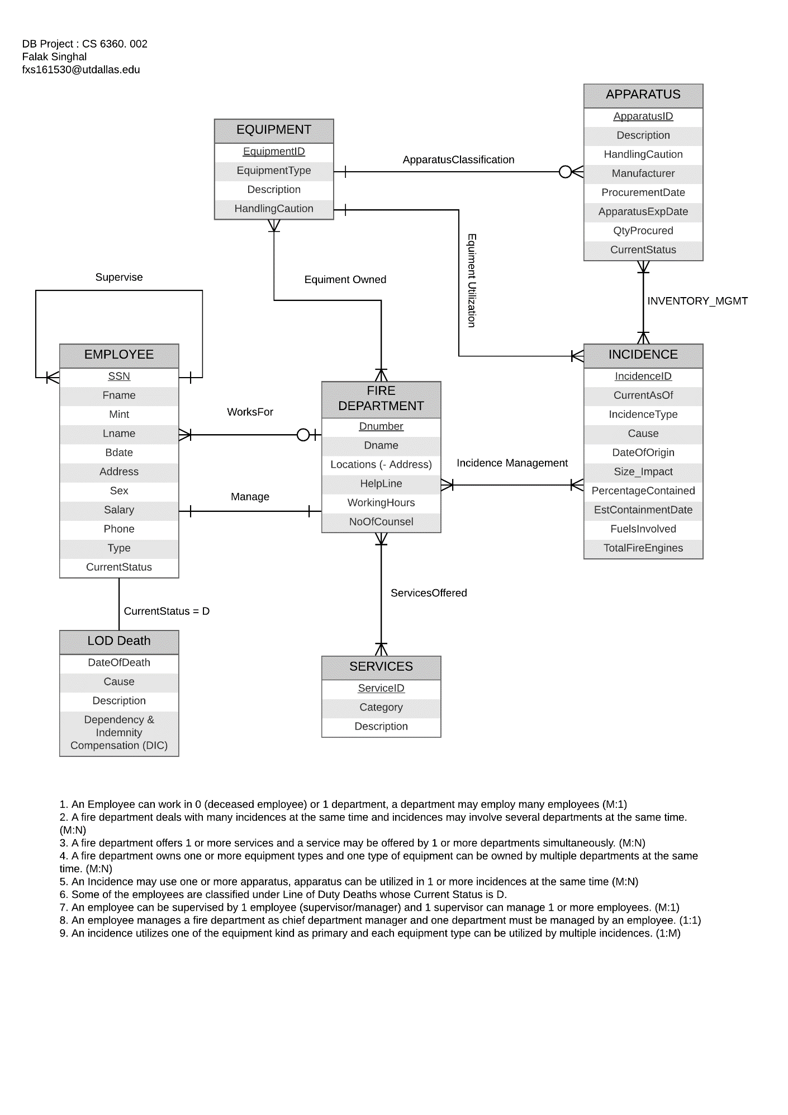

The requirements can be summarized/ derived from ERD as –

1. An Employee can work for 0 (deceased employee) or 1 department, a department may employ many employees (M:1)
2. A fire department deals with many incidences at the same time and incidences may involve several departments at the same time. (M:N)
3. A fire department offers 1 or more services and a service may be offered by 1 or more departments simultaneously. (M:N)
4. A fire department owns one or more equipment types and one type of equipment can be owned by multiple departments at the same time. (M:N)
5. An Incidence may use one or more apparatus; apparatus can be utilized in 1 or more incidence (M:N)
6. Some of the employees are classified under Line of Duty Deaths whose Current Status is D.
7. An employee can be supervised by 1 employee (supervisor/manager) and 1 supervisor can manage one or more employees. (M:1)
8. An employee manages a fire department as chief department manager and one department must be managed by an employee. (1:1)
9. An incidence utilizes one of the equipment kind as primary and each equipment type can be utilized by multiple incidences. (1:M)

Mapping of ERD in Relational Schema

1. EMPLOYEE





* Primary Key : SSN
* Foreign Keys : FOREIGN KEY (SUPERVISORSSN) REFERENCES EMPLOYEEP(SSN), FOREIGN KEY (DNO) REFERENCES FIREDEPARTMENT(DNUMBER)

1. FIREDEPARTMENT



* Primary Key : DNUMBER
* Foreign Keys : FOREIGN KEY (MANAGERSSN) REFERENCES EMPLOYEEP(SSN)

1. EQUIPMENT



* Primary Key : EQUIPMENTID
* Foreign Keys : None

1. APPARATUS



* Primary Key : APPARATUSID
* Foreign Keys : FOREIGN KEY (EQUIPID) REFERENCES EQUIPMENT(EQUIPMENTID)

1. INCIDENCE

 

* Primary Key : INCIDENCEID
* Foreign Keys : FOREIGN KEY (EQUIPID) REFERENCES EQUIPMENT(EQUIPMENTID)

1. SERVICES

*   
  Primary Key : SERVICEID
* Foreign Keys : None

1. DEPARTMENT LOCATIONS



* Primary Key : DNO, DLOCATION
* Foreign Keys : FOREIGN KEY (DNO) REFERENCES FIREDEPARTMENT(DNUMBER)

1. EQUIPMENT OWNED



* Primary Key : EQUIPID, DNO
* Foreign Keys : FOREIGN KEY (EQUIPID) REFERENCES EQUIPMENT(EQUIPMENTID), FOREIGN KEY (DNO) REFERENCES FIREDEPARTMENT (DNUMBER)

1. INCIDENCE MANAGEMENT



* Primary Key : DNO, INCID
* Foreign Keys : FOREIGN KEY (DNO)REFERENCES FIREDEPARTMENT(DNUMBER), FOREIGN KEY (INCID)REFERENCES INCIDENCE(INCIDENCEID)

1. SERVICES OFFERED



* Primary Key : DNO, SERVID
* Foreign Keys : FOREIGN KEY (DNO)REFERENCES FIREDEPARTMENT(DNUMBER), FOREIGN KEY (SERVID)REFERENCES SERVICES(SERVICEID)

1. LODDEATH



* Primary Key : LSSN
* Foreign Keys : FOREIGN KEY (LSSN)REFERENCES EMPLOYEEP(SSN)

1. INVENTORY_MGMT



* Primary Key : SERIAL
* Foreign Keys : FOREIGN KEY (INCID) REFERENCES INCIDENCE(INCIDENCEID), FOREIGN KEY (APPRATID) REFERENCES APPARATUS(APPARATUSID)

SQL Statements to create Relations in DB and Add Constraints

CREATE TABLE FIREDEPARTMENT(

DNUMBER VARCHAR(50),

DNAME VARCHAR(50),

HELPLINE NUMBER(12) NOT NULL,

WORKINGHOURS VARCHAR(50) DEFAULT '24x7',

NOOFCOUNSEL NUMBER(12),

MANAGERSSN INTEGER,

CONSTRAINT FIREDEPARTMENT_PK PRIMARY KEY (DNUMBER));

CREATE TABLE INEVNTORY_MGMT (

SERIAL NUMBER(10),

INCID VARCHAR(50),

APPRATID VARCHAR(50),

TOTALQTY NUMBER(12),

CONSTRAINT INEVNTORY_MGMT_PK PRIMARY KEY(SERIAL),

CONSTRAINT INEVNTORY_MGMT_FK_INCID FOREIGN KEY (INCID) REFERENCES INCIDENCE(INCIDENCEID),

CONSTRAINT INEVNTORY_MGMT_FK_APPARTID FOREIGN KEY (APPRATID) REFERENCES APPARATUS(APPARATUSID)

);

CREATE TABLE EMPLOYEEP(

SSN INTEGER,

FNAME VARCHAR(50) NOT NULL,

MINT VARCHAR(10) DEFAULT '',

LNAME VARCHAR(50),

BDATE DATE,

ADDRESS VARCHAR(300),

SEX VARCHAR(10),

SALARY NUMBER(12,2),

PHONE NUMBER(12),

CURRENTSTATUS VARCHAR(50),

SUPERVISORSSN INTEGER,

DNO VARCHAR(50),

CONSTRAINT EMPLOYEE_PK PRIMARY KEY (SSN),

CONSTRAINT EMPLOYEE_FK2 FOREIGN KEY (DNO)

REFERENCES FIREDEPARTMENT(DNUMBER) ON DELETE SET NULL,

CONSTRAINT SALARYCHK CHECK (SALARY >31690)

);

-- RUN AFTER ADDING TUPLES

ALTER TABLE EMPLOYEEP ADD CONSTRAINT EMPLOYEE_FK1 FOREIGN KEY (SUPERVISORSSN) REFERENCES EMPLOYEEP(SSN) ON DELETE SET NULL;

ALTER TABLE EMPLOYEEP ADD CONSTRAINT EMPLOYEE_FK2 FOREIGN KEY (DNO) REFERENCES FIREDEPARTMENT(DNUMBER) ON DELETE SET NULL;

ALTER TABLE EMPLOYEEP ADD ETYPE VARCHAR(50) DEFAULT 'TEMPORARY';

ALTER TABLE FIREDEPARTMENT ADD CONSTRAINT FIREDEPARTMENT_FK1 FOREIGN KEY (MANAGERSSN) REFERENCES EMPLOYEEP(SSN) ON DELETE SET NULL;

CREATE TABLE EQUIPMENT(

EQUIPMENTID VARCHAR(50),

EQUIPMENTTYPE VARCHAR(50),

DESCRIPTION VARCHAR(300),

HANDLINGCAUTION VARCHAR(300),

CONSTRAINT EQUIPMENT_PK PRIMARY KEY (EQUIPMENTID)

)

CREATE TABLE INCIDENCE(

INCIDENCEID VARCHAR(50),

CURRENTASOF DATE DEFAULT TRUNC(SYSDATE),

INCIDENCETYPE VARCHAR(50),

CAUSE VARCHAR(100) DEFAULT 'Under Investigation',

DATEOFORIGIN DATE,

SIZE_IMPACT VARCHAR(100),

PERCENTAGECONTAINED NUMBER(5,2) DEFAULT 0.00

CHECK (PERCENTAGECONTAINED>=0.0 AND PERCENTAGECONTAINED <=100),

ESTCONTAINMENTDATE DATE,

FUELINVOLVED VARCHAR(50) DEFAULT 'Unknown',

TOTALFIREENGINE NUMBER(5),

EQUIPID VARCHAR(50),

CONSTRAINT INCIDENCE_PK PRIMARY KEY (INCIDENCEID)

);

ALTER TABLE INCIDENCE ADD CONSTRAINT INCIDENCE_FK1 FOREIGN KEY (EQUIPID) REFERENCES EQUIPMENT(EQUIPMENTID) ON DELETE SET NULL;

CREATE TABLE APPARATUS(

APPARATUSID VARCHAR(50),

DESCRIPTION VARCHAR(300),

HANDLINGCAUTION VARCHAR(300),

MANUFACTURER VARCHAR(100),

PROCUREMENDATE DATE,

EXPIREDATE DATE,

QTYPROCURED NUMBER(12),

CURRENTSTATUS VARCHAR(50) DEFAULT 'IN USE',

EQUIPID VARCHAR(50),

CONSTRAINT APPARATUS_PK PRIMARY KEY (APPARATUSID)

);

ALTER TABLE APPARATUS ADD CONSTRAINT APPARATUS_FK1 FOREIGN KEY (EQUIPID) REFERENCES EQUIPMENT(EQUIPMENTID) ON DELETE SET NULL;

CREATE TABLE SERVICES(

SERVICEID VARCHAR(50),

SCATEGORY VARCHAR(50),

DESCRIPTION VARCHAR(300),

CONSTRAINT SERVICES_PK PRIMARY KEY (SERVICEID)

)

CREATE TABLE DEPARTMENTLOCATIONS(

DNO VARCHAR(50),

DLOCATION VARCHAR(1000),

ADDRESS VARCHAR(300) NOT NULL,

CONSTRAINT DEPARTMENTLOCATIONS_PK PRIMARY KEY (DNO,DLOCATION),

CONSTRAINT DEPARTMENTLOCATIONS_FK1 FOREIGN KEY (DNO) REFERENCES FIREDEPARTMENT(DNUMBER) ON DELETE SET NULL

)

CREATE TABLE EQUIPMENTOWNED(

EQUIPID VARCHAR(50),

EQUIPTYPE VARCHAR(50),

DNO VARCHAR(50),

CONSTRAINT EQUIPMENTOWNED_PK PRIMARY KEY (EQUIPID,DNO)

)

ALTER TABLE EQUIPMENTOWNED ADD CONSTRAINT EQUIPMENTOWNED_FK2 FOREIGN KEY (EQUIPID) REFERENCES EQUIPMENT(EQUIPMENTID) ON DELETE CASCADE;

ALTER TABLE EQUIPMENTOWNED ADD CONSTRAINT EQUIPMENTOWNED_FK1 FOREIGN KEY (DNO) REFERENCES FIREDEPARTMENT(DNUMBER) ON DELETE CASCADE,

CREATE TABLE INCIDENCEMANAGEMENT(

DNO VARCHAR(50),

INCID VARCHAR(50),

CONSTRAINT INCIDENCEMANAGEMENT_PK PRIMARY KEY (DNO,INCID),

CONSTRAINT INCIDENCEMANAGEMENT_FK1 FOREIGN KEY (DNO)REFERENCES FIREDEPARTMENT(DNUMBER) ON DELETE CASCADE,

CONSTRAINT INCIDENCEMANAGEMENT_FK2 FOREIGN KEY (INCID)REFERENCES INCIDENCE(INCIDENCEID) ON DELETE CASCADE

)

CREATE TABLE SERVICESOFFERED(

DNO VARCHAR(50),

SERVID VARCHAR(50),

CONSTRAINT SERVICESOFFERED_PK PRIMARY KEY (DNO,SERVID),

CONSTRAINT SERVICESOFFERED_FK1 FOREIGN KEY (DNO)REFERENCES FIREDEPARTMENT(DNUMBER) ON DELETE CASCADE,

CONSTRAINT SERVICESOFFERED_FK2 FOREIGN KEY (SERVID)REFERENCES SERVICES(SERVICEID) ON DELETE CASCADE

)

CREATE TABLE LODDEATH(

LSSN INTEGER,

DATEOFDEATH DATE DEFAULT TRUNC(SYSDATE),

CAUSE VARCHAR(50) DEFAULT 'Under Investigation',

DESCRIPTION VARCHAR(300) DEFAULT 'Line of duty death',

DIC NUMBER(12,2) DEFAULT 10000.00,

CONSTRAINT LODDEATH_PK PRIMARY KEY (LSSN),

CONSTRAINT LODDEATH_FK1 FOREIGN KEY (LSSN)REFERENCES EMPLOYEEP(SSN)

)Normalization of Relational Schema

The following Functional Dependencies exists in the relational schema –

1. EMPLOYEE {SSN -> Fname, Mint, Lname, Bdate, Address, Sex, Salary, Phone, EType, Current-Status, Supervisor_ssn, Dno}
2. FIREDEPARTMENT {Dnumber -> Dname, HelpLine, WorkingHours, NoOfCounsel}
3. EQUIPMENT {EquipmentID -> EquipmentType, Description, HandlingCaution}
4. APPARATUS {ApparatusID -> Description, HandlingCaution, Manufacturer, ProcurementDate, ApparatusExpDate, QtyProcured, CurrentStatus}
5. INCIDENCE {IncidenceID -> CurrentAsOf, IncidenceType, Cause, DateOfOrigin, Size_Impact, PercentageContained, EstContainmentDate, FuelsInvolved, TotalFireEngines}
6. SERVICES {ServiceID -> Category, Description}
7. LODDEATH {DateOfDeath, Cause, Description, DIC}
8. DEPARTMENT LOCATIONS {Dno, Location -> Address}
9. INVENTORY_MGMT {Serial -> IncID, AppartID, TotalQty}

The above functional dependencies cause the schema to be in third normal form.

# PL/SQL – Triggers

The following triggers are used to implement various requirements –

## Trigger-I INVENTORY

Whenever there is an incidence an entry is made in the inventory_mgmt table requesting particular qty of an apparatus

--Check if the qty is available before allocating

* Procedure Called : CHK_QTY()
* Parameters passed : Apparatus ID, Quantity

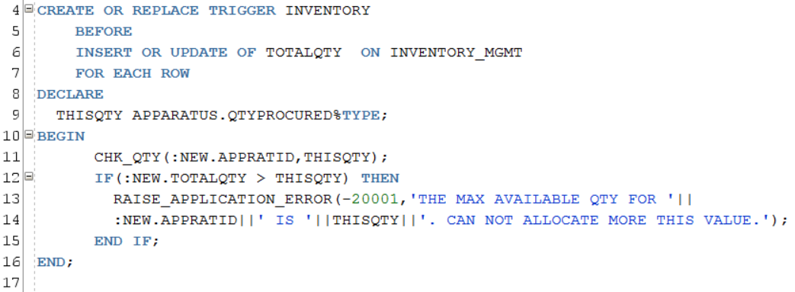

* Negative Test Case SQL:

INSERT INTO INVENTORY_MGMT VALUES (1,'INC00002','APR0005',9999);

* 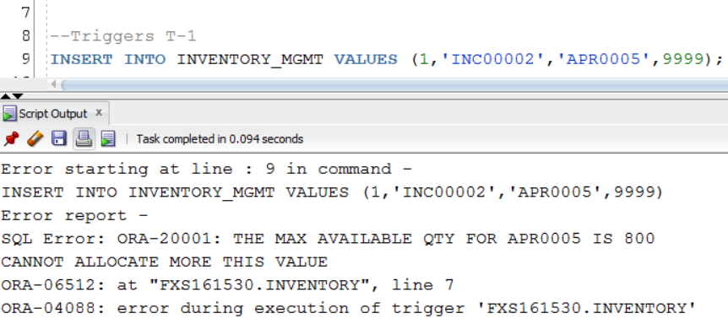Negative Test Case Output:

## Trigger-II LODENTRY

Whenever status of an employee is updated as ‘LODD' meaning line of duty death, a record in his name is inserted automatically in Loddeath table with default values.

* Procedure Called: None

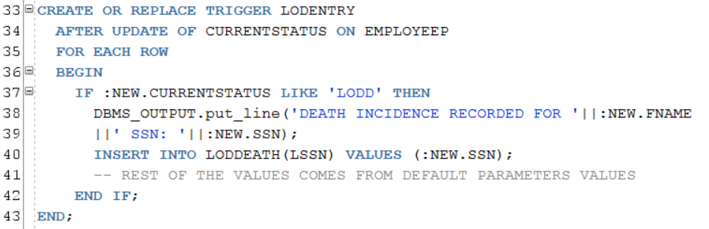

* Triggering SQL:

UPDATE EMPLOYEEP SET CURRENTSTATUS='LODD' WHERE EMPLOYEEP.SSN=123456107;

## Trigger-III: Minimum Wage & Salary Constraints

The above constraint is implemented using a trigger to check the salary if it is in accordance with FLSA with additional min salary requirement provided by Fire Department HR Dept.

If the salaries are found to be not complying with FLSA, the trigger prevents the inserting of record by raising an application level error. (PTO)

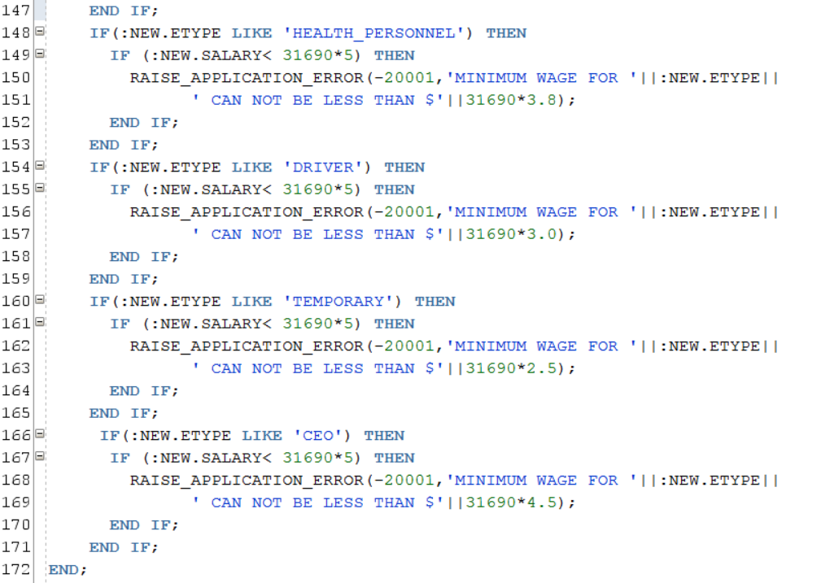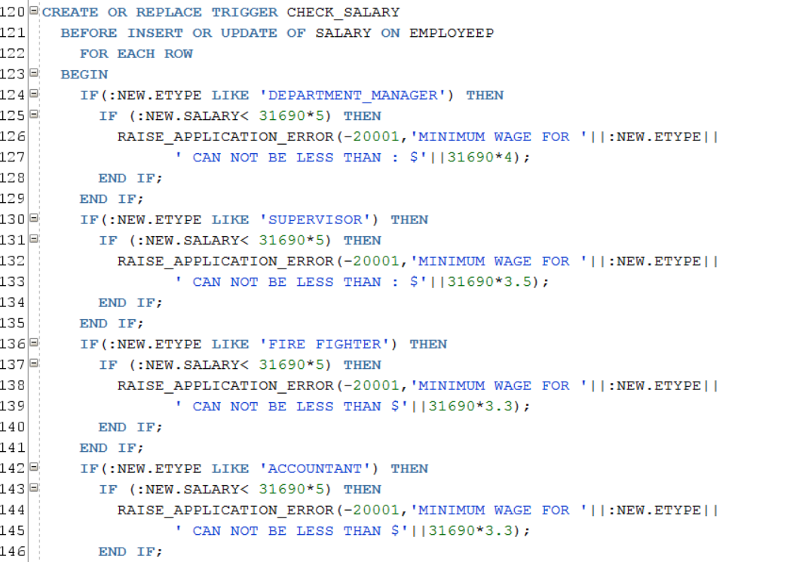

* Negative Test Case SQL:

INSERT INTO EMPLOYEEP VALUES (987123010,'Falak','','Singhal','17-JAN-92','demo,

Dallas','Male',1000,'456789515','ACTIVE',123456999,'HR002','DEPARTMENT_MANAGER');

* 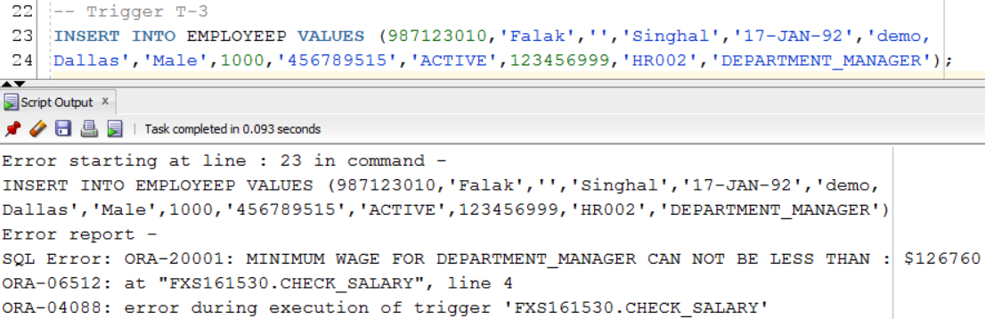Negative Test Case Output:

# PL/SQL- Procedures

## Procedure-I Calculating DIC

This procedure calculates the DIC compensation upon the death of the employee based on employee type.

* 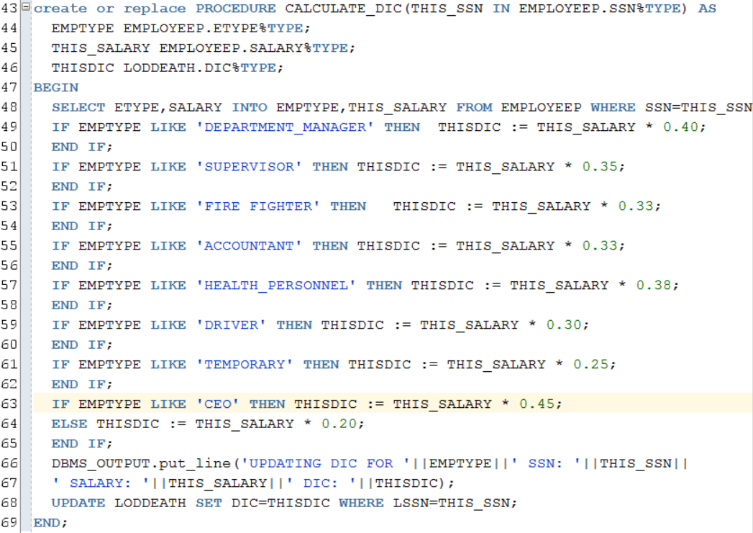Arg: (Employee SSN IN)
* Test Case SQL:

DECLARE

THIS_SSN NUMBER;

BEGIN

THIS_SSN := 123456107;

CALCULATE_DIC(

THIS_SSN => THIS_SSN

);

END;

* Output:  
  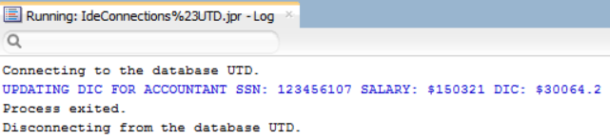

Procedure-II Auxiliary (helper Procedure for Trigger -1)

When an entry for apparatus request in the inventory_mgmt table is made, check if qtyalloted is less than or equal to Apparatus.qtyprocured

* Args : (Apparatus ID IN, Quantity OUT)

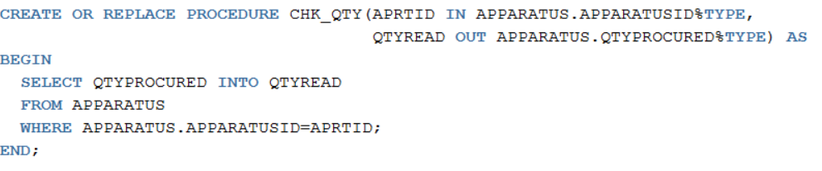

## Procedure-III Reporting and Analysis

Print the details of those incidences which are yet to be contained such that the estimated containment time takes 10 days or more. Also display the name and the department number of the department handling those incidences along with the impact region and type of primary equipment it is utilizing.

* 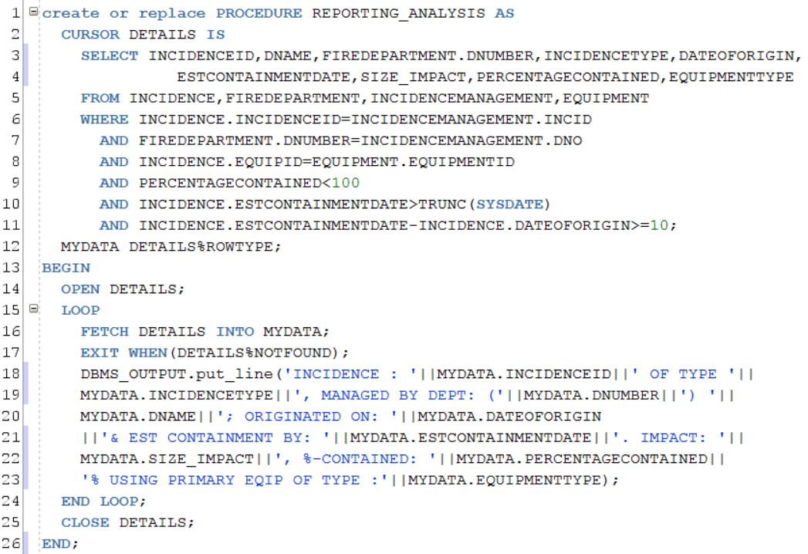Arg: None
* Test Case SQL:

BEGIN

REPORTING_ANALYSIS();

--rollback;

END;

* SQL Output:

Connecting to the database UTD.

INCIDENCE : INC00001 OF TYPE Wildfire, MANAGED BY DEPT: (FR001) FIRE; ORIGINATED ON: 23-NOV-16& EST CONTAINMENT BY: 03-DEC-16. IMPACT: 4347 Acres, %-CONTAINED: 95% USING PRIMARY EQIP OF TYPE :Water and Foam

INCIDENCE : INC00005 OF TYPE Industrial Fire, MANAGED BY DEPT: (FR001) FIRE; ORIGINATED ON: 27-NOV-16& EST CONTAINMENT BY: 07-DEC-16. IMPACT: 1523 Acres, %-CONTAINED: 95% USING PRIMARY EQIP OF TYPE :Dry Powder

INCIDENCE : INC00010 OF TYPE Wildfire, MANAGED BY DEPT: (FR001) FIRE; ORIGINATED ON: 16-NOV-16& EST CONTAINMENT BY: 10-DEC-16. IMPACT: 158 Acres, %-CONTAINED: 20% USING PRIMARY EQIP OF TYPE :Water and Foam

INCIDENCE : INC00011 OF TYPE Wildfire, MANAGED BY DEPT: (FR001) FIRE; ORIGINATED ON: 14-NOV-16& EST CONTAINMENT BY: 10-DEC-16. IMPACT: 529 Acres, %-CONTAINED: 36% USING PRIMARY EQIP OF TYPE :Water and Foam

INCIDENCE : INC00012 OF TYPE Homefire, MANAGED BY DEPT: (FR001) FIRE; ORIGINATED ON: 23-NOV-16& EST CONTAINMENT BY: 10-DEC-16. IMPACT: 30 Acres, %-CONTAINED: 97% USING PRIMARY EQIP OF TYPE :Dry Powder

INCIDENCE : INC00013 OF TYPE Wildfire, MANAGED BY DEPT: (FR001) FIRE; ORIGINATED ON: 10-NOV-16& EST CONTAINMENT BY: 10-DEC-16. IMPACT: 851 Acres, %-CONTAINED: 99% USING PRIMARY EQIP OF TYPE :Water and Foam

INCIDENCE : INC00014 OF TYPE Wildfire, MANAGED BY DEPT: (FR001) FIRE; ORIGINATED ON: 21-NOV-16& EST CONTAINMENT BY: 10-DEC-16. IMPACT: 654 Acres, %-CONTAINED: 95% USING PRIMARY EQIP OF TYPE :Water and Foam

Process exited.

Disconnecting from the database UTD.