LAB EXPERIMENT 2

----------------------------------------------------------------------------------------------
NAME: Geetika Nebhani
CLASS: D10B
ROLL NO: 44
----------------------------------------------------------------------------------------------
AIM: The aim of this project is to design and implement a web-based tra ic light simulation using HTML, CSS, and JavaScript that demonstrates the use of a variable to maintain the current state of the tra ic signal, if–else control statements to determine the next signal in sequence, and event handling to change the active light on a button click, ensuring that only one tra ic light is active at any given time.
----------------------------------------------------------------------------------------------
Problem Statement
To create a simple web page that simulates a traffic light system with three lights—Red, Yellow, and Green—where only one light is active at a time. The system should include a button that cycles the lights in the sequence Red → Yellow →green →Red. The project must use a variable to track the current light, control statements (if-else) to determine the next light, and event handling to change the light when the button is clicked.
----------------------------------------------------------------------------------------------

THEORY:
A traffic light system works on predefined rules where signals change in a fixed sequence to control traffic flow. In this project, the behaviour of a real traffic signal is implemented using JavaScript.
A variable named currentLight stores the active signal, and if–else control statements determine the next signal in sequence. When the button is clicked, an event handler updates the signal and changes its visual state.
HTML is used to create the structure of the application, while CSS styles the tra ic lights and highlights the active signal. Together, these technologies make the simulation simple, interactive, and effective.

- Difference between var, let, and const
Feature | var | let | const
Scope | Function scope | Block scope | Block scope
Redeclaration | Allowed | Not allowed | Not allowed
Reassignment | Allowed | Allowed | Not allowed
Hoisting | Hoisted and initialized as undefined | Hoisted but not initialized | Hoisted but not initialized
Use case | Old JavaScript code | Variables that change | Constant values

Explanation:
var is the older way of declaring variables and can cause scope-related issues. let is preferred for variables whose values may change, while const is used for fixed values that should not be reassigned.

- Difference between for, while, and do-while loops

Loop | Condition Check | Minimum Executions | Use Case
for | Before loop starts | 0 times | When number of iterations is known
while | Before loop starts | 0 times | When iterations depend on condition
Do-while | After loop runs | At least 1 time | When loop must execute once

Explanation:
A for loop is generally used when the number of iterations is known beforehand. A while loop executes as long as the condition remains true. A do-while loop executes at least once even if the condition is false.

- What is an Event in JavaScript?

An event in JavaScript is an action or occurrence that happens in the browser, triggered either by the user or the system. JavaScript can detect these events and execute code in response to them.
Examples of events:
- Clicking a button (click)
- Pressing a key (keydown)
- Moving the mouse (mouseover)
- Loading a web page (load)
In the traffic light project, clicking the button is an event that changes the tra ic signal.

4. Difference between Inline Event Handling and External Event Handling
Feature | Inline Event Handling External Event Handling
Definition | Event code written inside Event handled using JavaScript file or  HTML tag script
Example | button.addEventListener("click", onclick="changeLight()" changeLight)
Code  structure | Mixes HTML and JavaScript Separates HTML and JavaScript
Readability | Less readable More readable and maintainable
Usage | Simple, small programs Professional applications

Explanation:
Inline event handling is easy to use for small programs but is not recommended for large projects. External event handling keeps code organized and is considered a best practice in professional development.

OUTPUT:

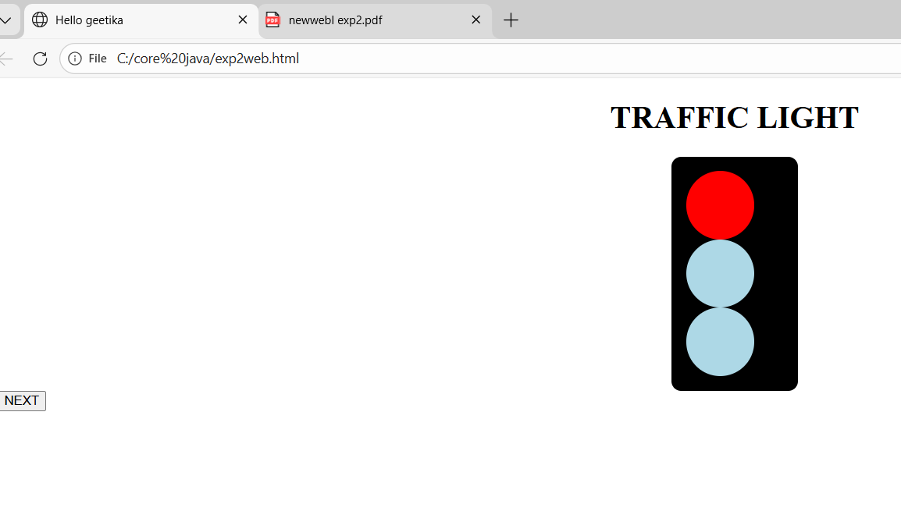

GITHUB LINK: https://github.com/geetikanebhani/geetikanebhani5
Conclusion
The Traffic Light Simulation project successfully demonstrates the practical use of HTML, CSS, and JavaScript to model a real-life system. It effectively shows how variables, conditional logic, and event handling can be used to control program flow and user interaction. The project enhances understanding of basic web development concepts and provides a strong foundation for developing more advanced interactive applications in the future.

