Science Qtech Employee Performance Mapping

Description

Problem scenario:

ScienceQtech is a startup that works in the Data Science field. ScienceQtech has worked on fraud detection, market basket, self-driving cars, supply chain, algorithmic early detection of lung cancer, customer sentiment, and the drug discovery field. With the annual appraisal cycle around the corner, the HR department has asked you (Junior Database Administrator) to generate reports on employee details, their performance, and on the project that the employees have undertaken, to analyze the employee database and extract specific data based on different requirements.

Objective:

To facilitate a better understanding, managers have provided ratings for each employee which will help the HR department to finalize the employee performance mapping. As a DBA, you should find the maximum salary of the employees and ensure that all jobs are meeting the organization's profile standard. You also need to calculate bonuses to find extra cost for expenses. This will raise the overall performance of the organization by ensuring that all required employees receive training.

Note: You must download the dataset from the course resource section in LMS and create a table to perform the above objective.

Dataset description:

emp_record_table: It contains the information of all the employees.

EMP_ID – ID of the employee

FIRST_NAME – First name of the employee

LAST_NAME – Last name of the employee

GENDER – Gender of the employee

ROLE – Post of the employee

DEPT – Field of the employee

EXP – Years of experience the employee has

COUNTRY – Country in which the employee is presently living

CONTINENT – Continent in which the country is

SALARY – Salary of the employee

EMP_RATING – Performance rating of the employee

MANAGER_ID – The manager under which the employee is assigned

PROJ_ID – The project on which the employee is working or has worked on

Proj_table: It contains information about the projects.

PROJECT_ID – ID for the project

PROJ_Name – Name of the project

DOMAIN – Field of the project

START_DATE – Day the project began

CLOSURE_DATE – Day the project was or will be completed

DEV_QTR – Quarter in which the project was scheduled

STATUS – Status of the project currently

Data_science_team: It contains information about all the employees in the Data Science team.

EMP_ID – ID of the employee

FIRST_NAME – First name of the employee

LAST_NAME – Last name of the employee

GENDER – Gender of the employee

ROLE – Post of the employee

DEPT – Field of the employee

EXP – Years of experience the employee has

COUNTRY – Country in which the employee is presently living

CONTINENT – Continent in which the country is

Ques 1

Create a database named employee, then import data_science_team.csv proj_table.csv and emp_record_table.csv into the employee database from the given resources.

* First I have created a database named employee using the command

**Create database employee;**

* To check the database I have used the command

**Show databases;**

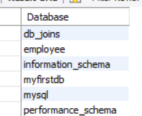

* Right click on the table and select Table Data Import wizard.
* Next Browse the file path.

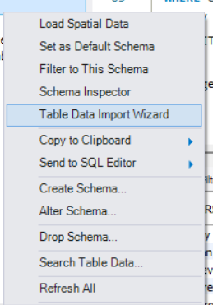

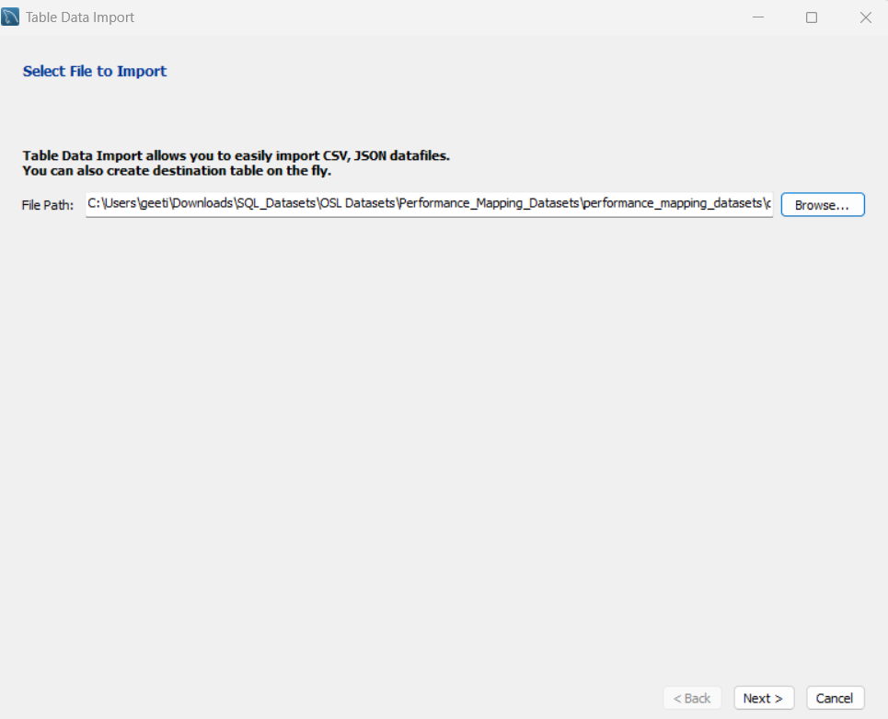

* Click on next and select destination.

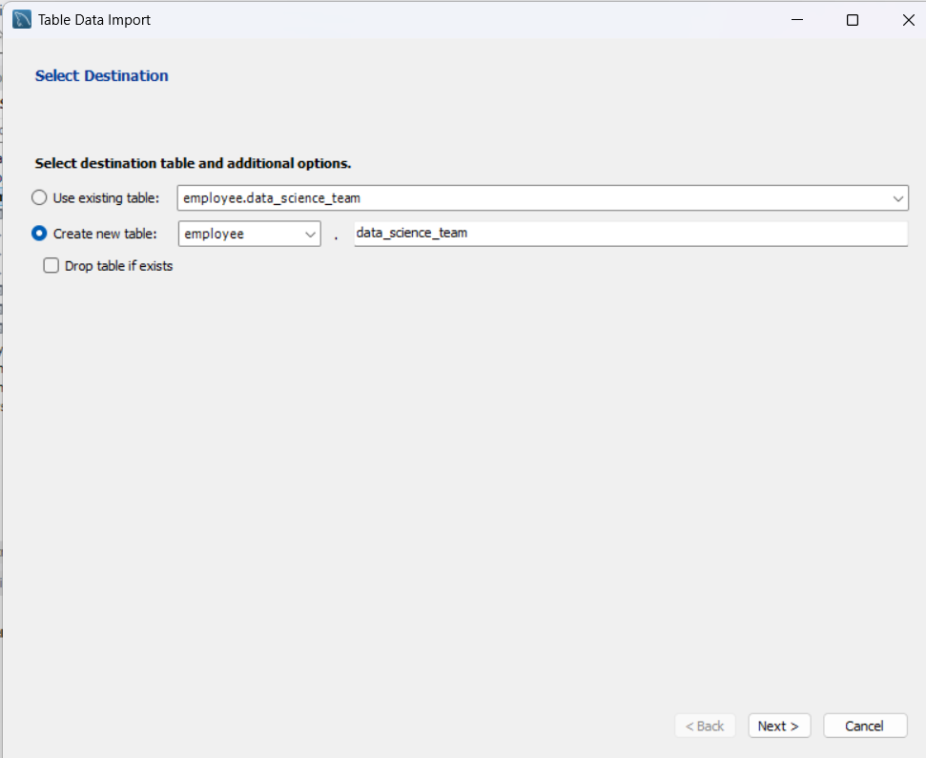

* Click on next import data.

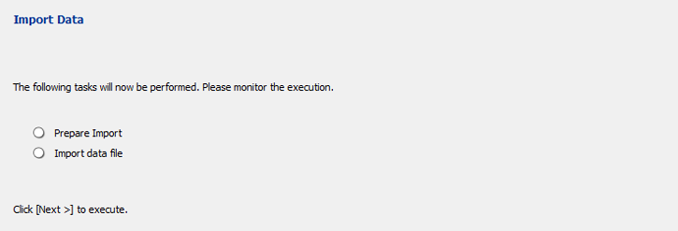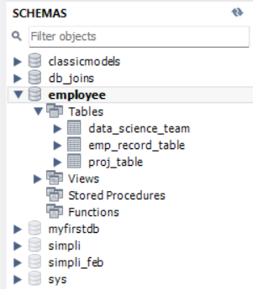

* When task is done we can refresh the schemas and double click on employee or we can use the command **use employee**; to activate the database.
* Then to verify the data is present or not we can use the following commands.

**select * from data_science_team;**

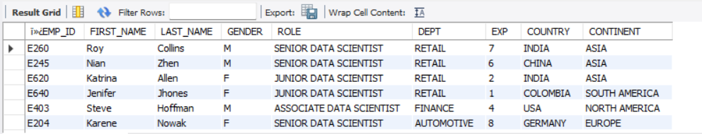



**select * from emp_record_table;**

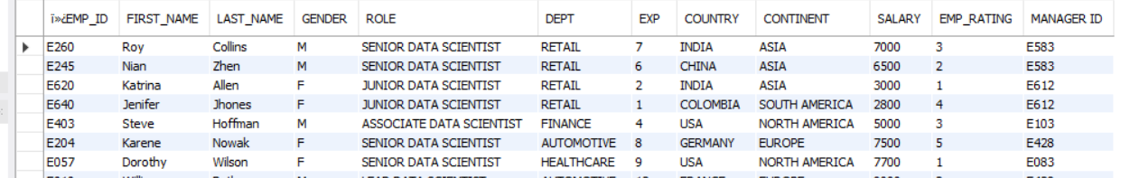



**select * from proj_table;**

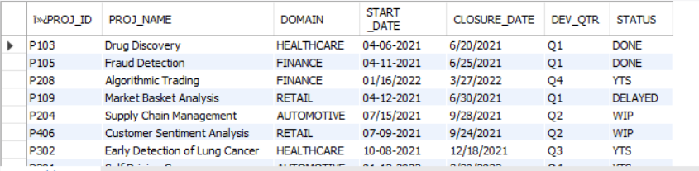



Ques 2

Create an ER diagram for the given employee database.

* I have used the following steps to build an ER diagram.

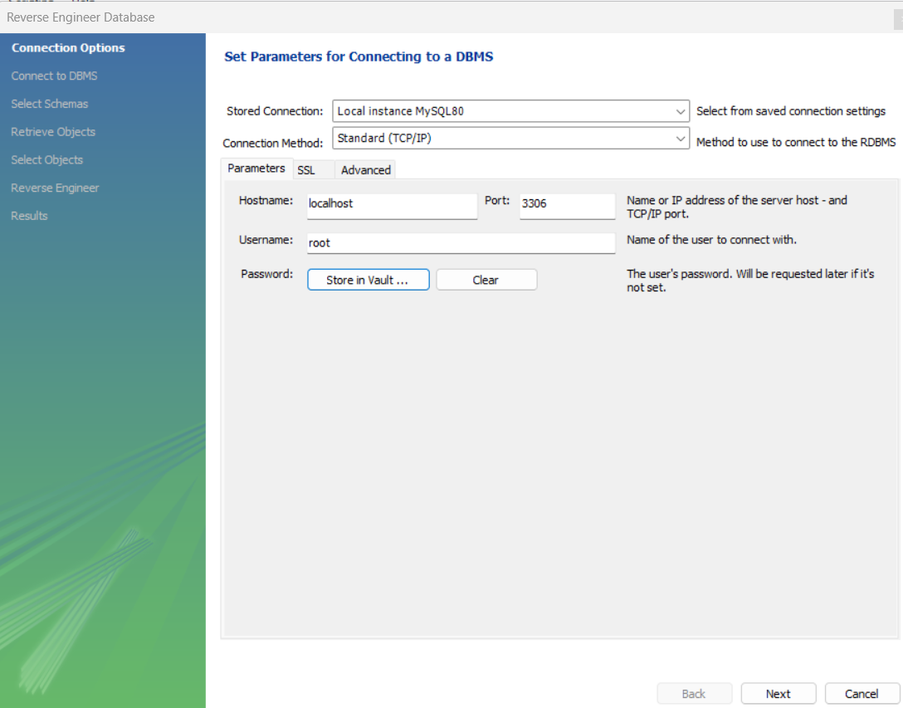

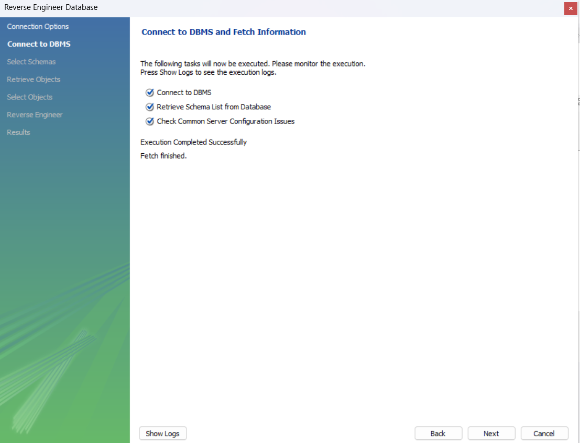

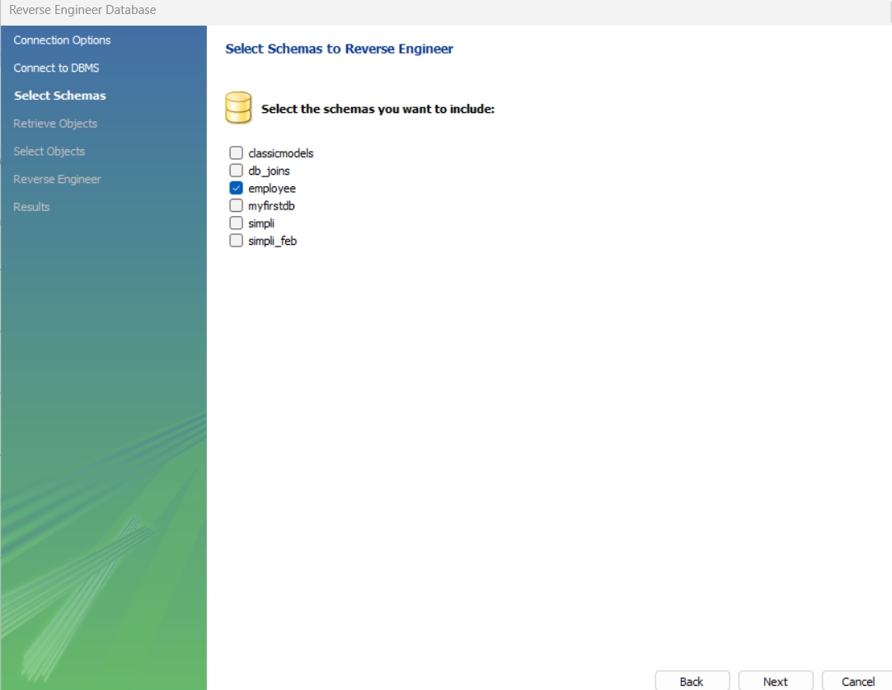

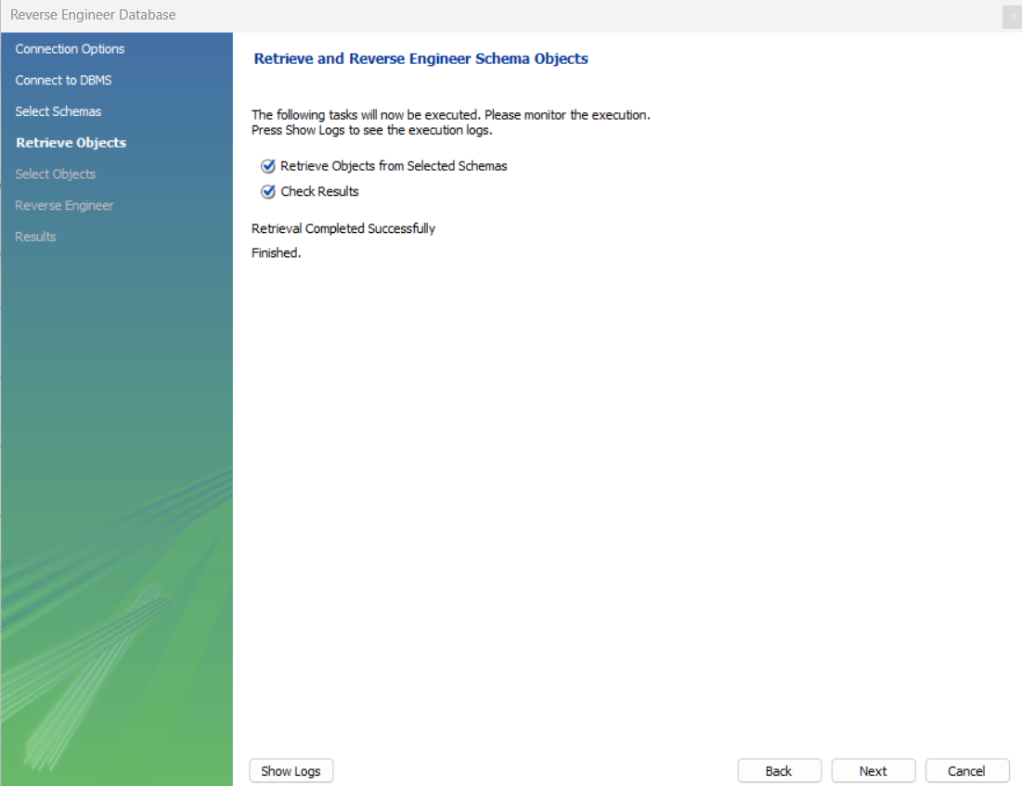

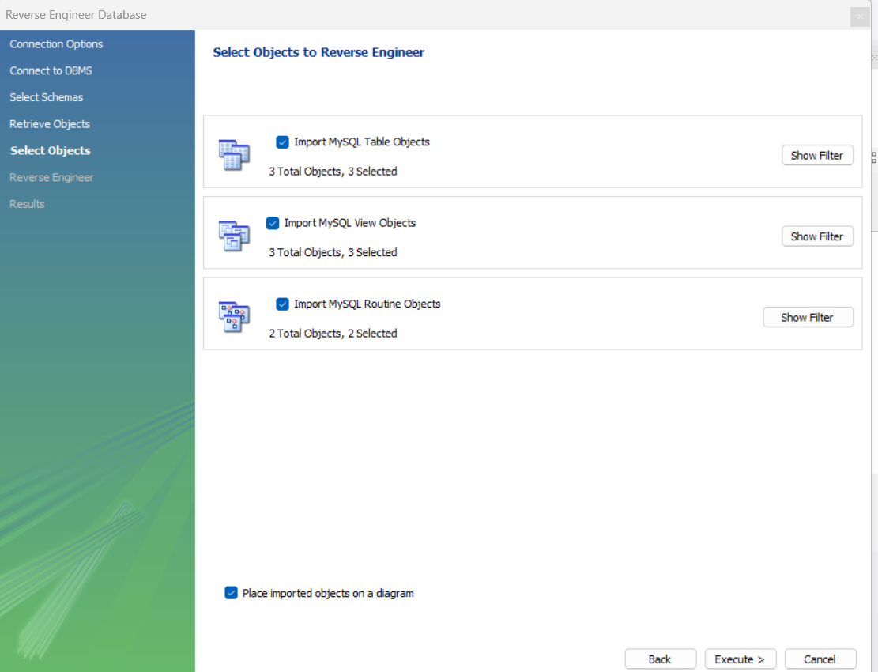

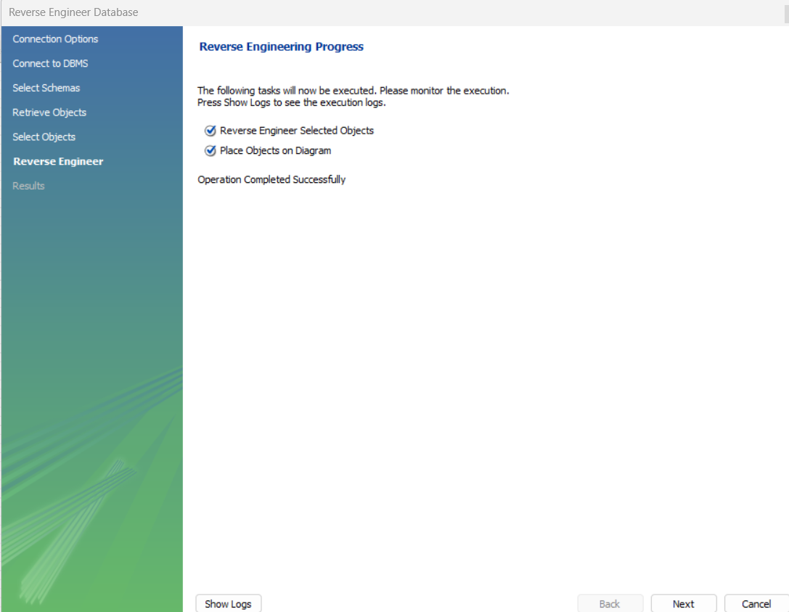

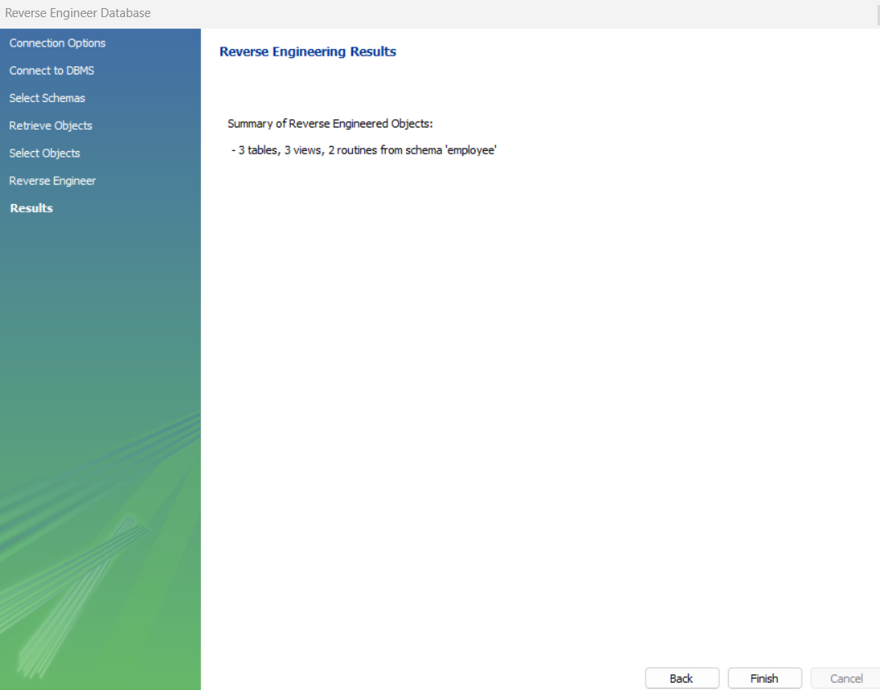

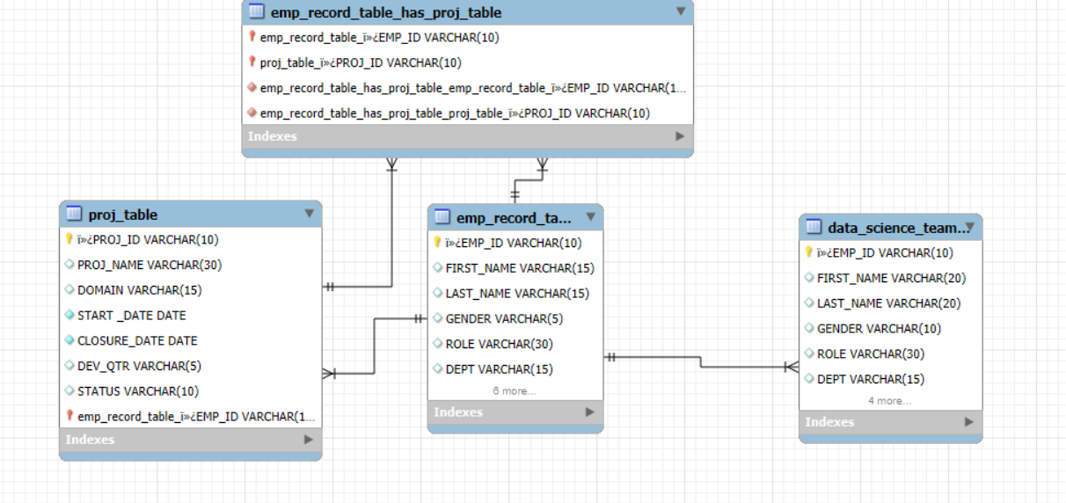

Ques 3

Write a query to fetch EMP_ID, FIRST_NAME, LAST_NAME, GENDER, and DEPARTMENT from the employee record table, and make a list of employees and details of their department.

**Select ï»¿EMP_ID, FIRST_NAME, LAST_NAME, GENDER, DEPT from emp_record_table;**

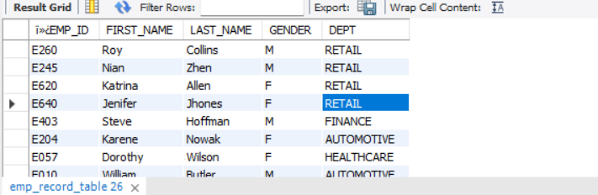

Ques 4

Write a query to fetch EMP_ID, FIRST_NAME, LAST_NAME, GENDER, DEPARTMENT, and EMP_RATING if the EMP_RATING is:

less than two

greater than four

between two and four

**Select ï»¿EMP_ID, FIRST_NAME, LAST_NAME, GENDER, DEPT , EMP_RATING from emp_record_table where EMP_RATING < 2;**

**Select ï»¿EMP_ID, FIRST_NAME, LAST_NAME, GENDER, DEPT , EMP_RATING from emp_record_table where EMP_RATING > 4;**

**Select ï»¿EMP_ID, FIRST_NAME, LAST_NAME, GENDER, DEPT , EMP_RATING from emp_record_table where EMP_RATING between 2 and 4;**

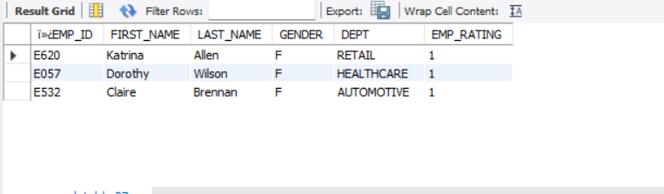

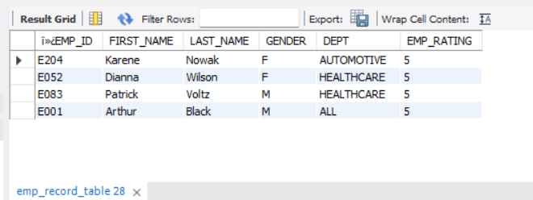

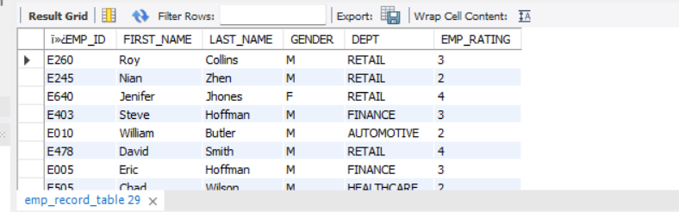

Ques 5

Write a query to concatenate the FIRST_NAME and the LAST_NAME of employees in the Finance department from the employee table and then give the resultant column alias as NAME.

**select CONCAT(FIRST_NAME,' ',LAST_NAME) fullname**

**from emp_record_table**

**where dept = 'FINANCE';**

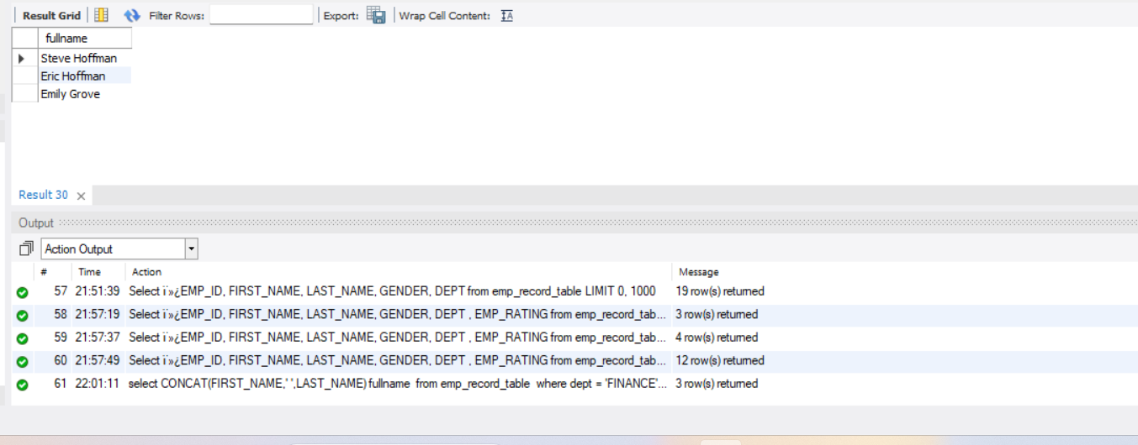

Ques 6

Write a query to list only those employees who have someone reporting to them. Also, show the number of reporters (including the President).

**select e.ï»¿EMP_ID,e.FIRST_NAME,m.ï»¿EMP_ID as ManagersID, m.FIRST_NAME as ManagerName**

**from employee.emp_record_table e JOIN employee.emp_record_table m ON e.`MANAGER ID`= m.ï»¿EMP_ID;**

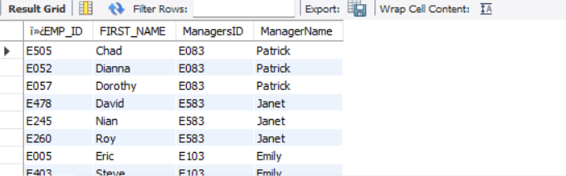

Ques 7

Write a query to list down all the employees from the healthcare and finance departments using union. Take data from the employee record table.

**select * from emp_record_table**

**where dept = 'Finance'**

**Union**

**select * from emp_record_table**

**where dept = 'Healthcare';**

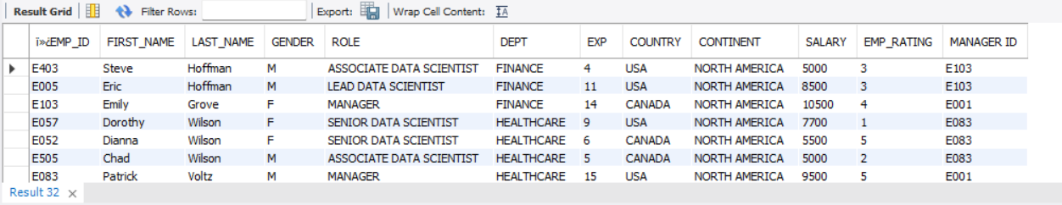

Ques 8

Write a query to list down employee details such as EMP_ID, FIRST_NAME, LAST_NAME, ROLE, DEPARTMENT, and EMP_RATING grouped by dept. Also include the respective employee rating along with the max emp rating for the department.

**select ï»¿EMP_ID, first_name, last_name, role, dept, emp_rating,**

**max(emp_rating) over (partition by dept order by emp_rating desc) as Maximum_Rating**

**from emp_record_table;**

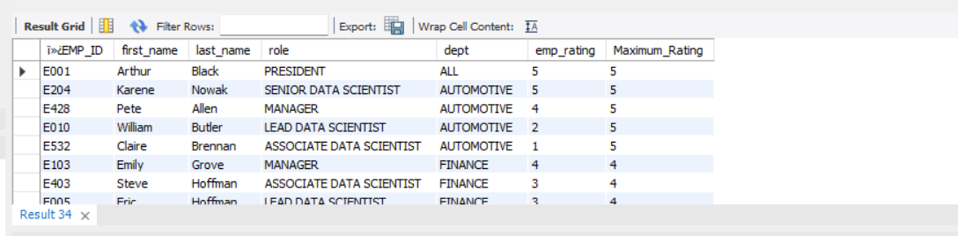

Ques 9

Write a query to calculate the minimum and the maximum salary of the employees in each role. Take data from the employee record table.

**select role, salary, min(salary) over (partition by role) as Minimum_Salary,**

**max(salary) over (partition by role) as Maximum_Salary**

**from emp_record_table;**

Ques 10

Write a query to assign ranks to each employee based on their experience. Take data from the employee record table.

**select ï»¿EMP_ID, first_name, last_name, exp,**

**dense_rank() over (order by exp desc) as Dense_Ranking**

**from emp_record_table;**

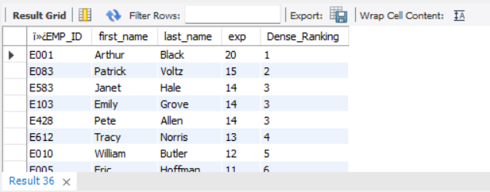

Ques 11

Write a query to create a view that displays employees in various countries whose salary is more than six thousand. Take data from the employee record table.

**CREATE VIEW get_salary_max AS**

**SELECT ï»¿EMP_ID,FIRST_NAME, LAST_NAME, COUNTRY, SALARY**

**FROM emp_record_table**

**WHERE SALARY > 6000;**

**SELECT * FROM get_salary_max;**

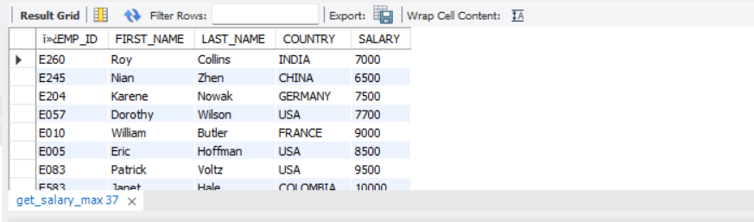

Ques 12

Write a nested query to find employees with experience of more than ten years. Take data from the employee record table.

**select ï»¿EMP_ID, first_name, last_name, role from**

**(select * from emp_record_table where exp > 10) as Exp_10;**

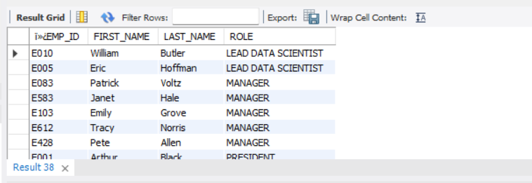

Ques 13

Write a query to create a stored procedure to retrieve the details of the employees whose experience is more than three years. Take data from the employee record table.

**CREATE PROCEDURE get_emp_exp_details()**

**BEGIN**

**SELECT * FROM emp_record_table**

**WHERE exp > 3;**

**END //**

**DELIMITER ;**

**call get_emp_exp_details();**

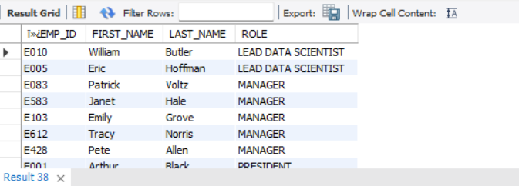

Ques 15

Create an index to improve the cost and performance of the query to find the employee whose FIRST_NAME is ‘Eric’ in the employee table after checking the execution plan.

**create index First_name on emp_record_table(first_name);**

**show indexes from emp_record_table;**

**select * from emp_record_table where first_name = 'Eric';**



Ques 16

Write a query to calculate the bonus for all the employees, based on their ratings and salaries (Use the formula: 5% of salary * employee rating).

**select ï»¿EMP_ID, first_name, last_name, salary,emp_rating, round((0.05 * salary * emp_rating),0) as Bonus**

**from emp_record_table;**

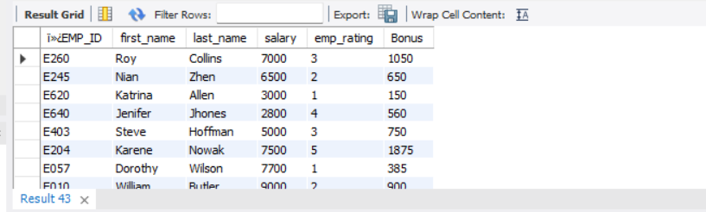

Ques 17

Write a query to calculate the average salary distribution based on the continent and country. Take data from the employee record table.

**select ï»¿EMP_ID, first_name, last_name, country, continent,**

**round(avg(salary) over (partition by continent order by country),0) as Average_Salary**

**from emp_record_table;**

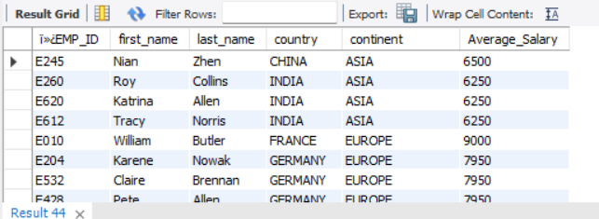

--end--