**Team Name: Keyboard crackers**

**Problem Statement: Efficient Farming**

**Solution: Android App**

**Features of App:**

1) Allows user to register and login through phone as well as email address.

2) OTP verification and email verification for account registration.

3) Reset password if user forgets password through email.

4) User can operate as a seller or buyer.

5) Seller:

* Can upload products with details like model, available dates for renting, price per day, safety cost (deposit) etc.
* Can see previous and current orders.

6) Buyer:

* Can search items according to need.
* Can view previously ordered items.

7) Common features for buyer and seller:

* Can chat with each other for the deal.
* Will rate each other and buyer can rate the products on the deal.

8) Bilingual (English, Hindi) for farmer friendly usage.

9) Awareness Portal: Farmers will get to know

* Soil types and crop types with their characteristics.
* Information about new technologies and machineries in agricultural sector.
* Contacts to NGO’s, Govt. Loan policies, Weather Report and other farmer friendly schemes.

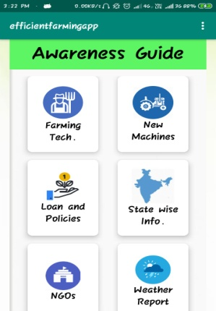 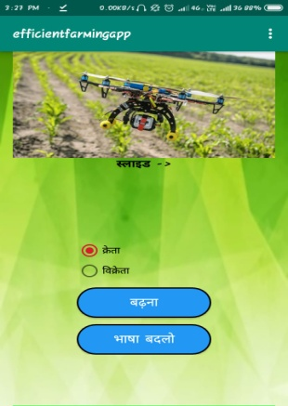 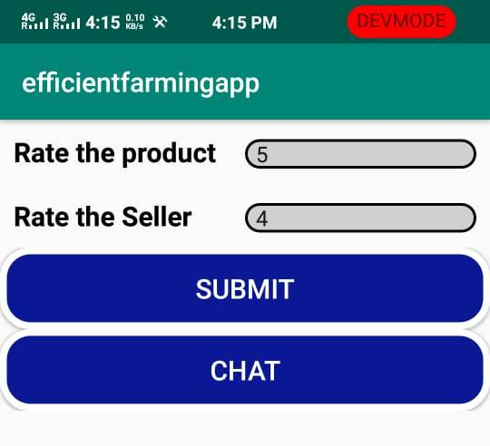

Compilation of app: Import in Android Studio.

Technology Stack: Android Studio, Java SDK 11.0.2, Firebase(Database).

**Seller Portal:**

1. Seller can add product, provide description and upload it’s image.
2. Can see previous orders.
3. Can rate the sellers they sell to.

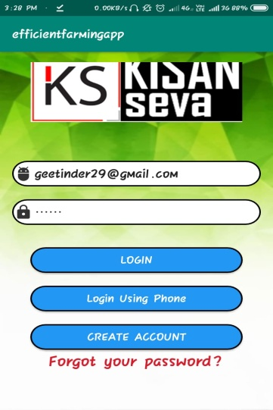 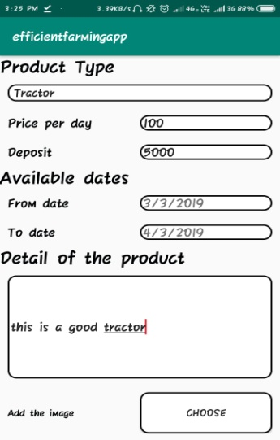 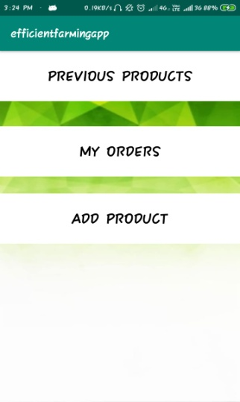 **Buyer Portal:**

1. Can search, see description and accordingly choose the product.
2. Previous orders can be seen.
3. Will receive order receipt showing order details along with ratings.
4. Can rate products that they buy.

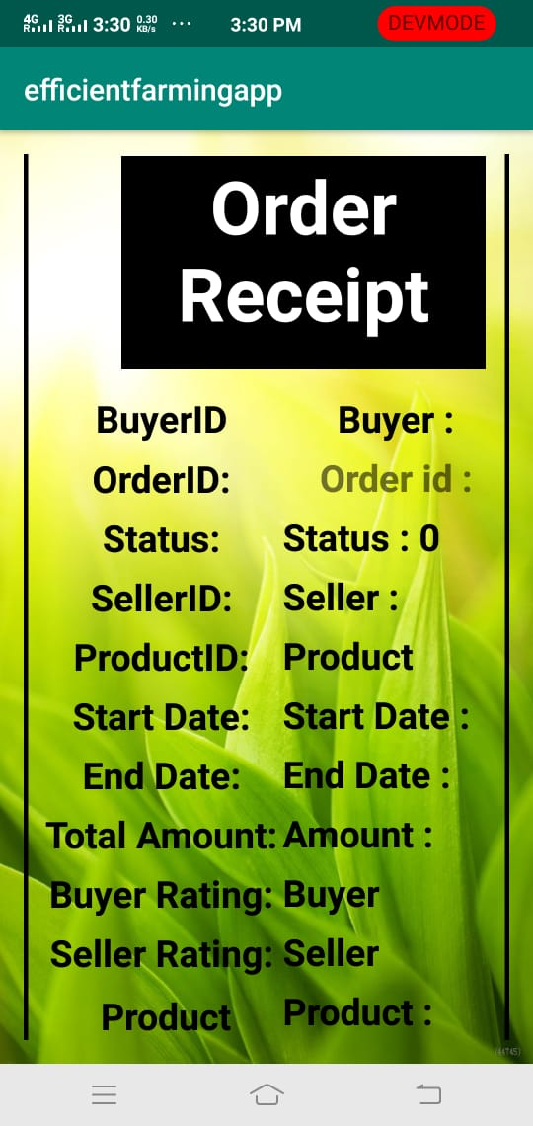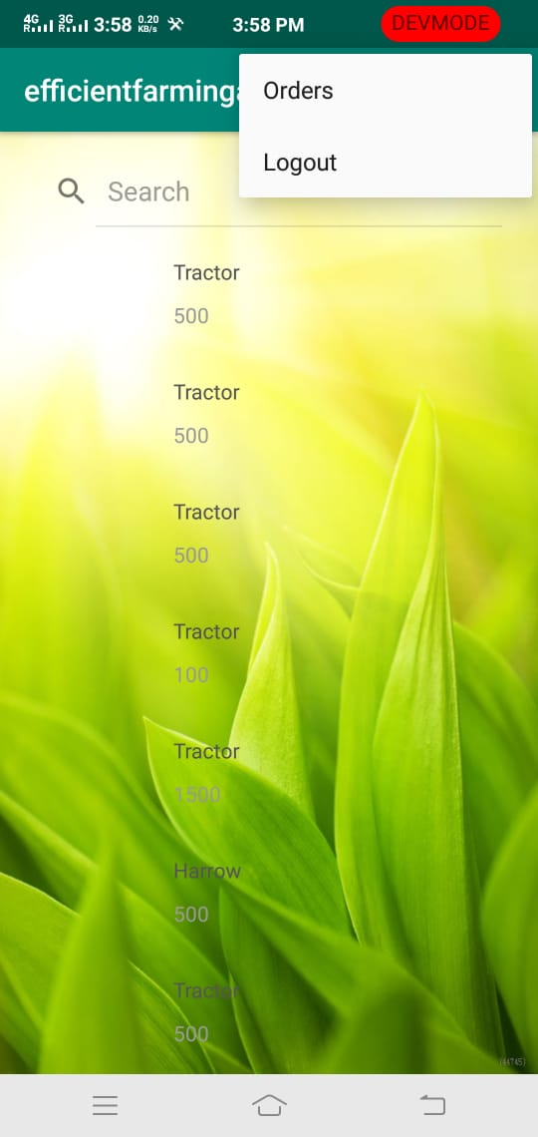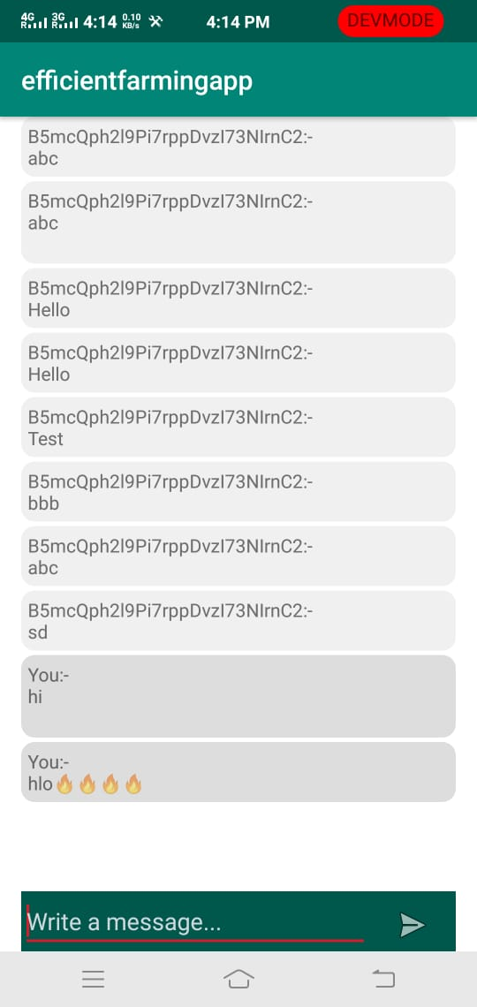

**Future Possibilities:**

* Even small and medium level farmers can provide to large scale farmers and earn

1. As manpower and labourers in idle time.
2. Through tools and livestock when not in use.

* Buyer can request multiple sellers; seller can accept multiple request for a single item and whosoever pays first gets the deal.
* Both parties can negotiate rental and safety deposits on a new portal as on Quikr App.
* Product Safety:

1. Third party system, that is app provides the platform for the deal where third party will verify products by uploading images on app at seller and buyer ends
2. Seller and buyer can themselves visit each other carry out the deal.
3. Help centres provided by the app in various villages.