**User Manual**

1. Login and Register.

1. Registration Form

1. Login Form

1. Home Page

1. Notification Pop Up

1. Admin Login

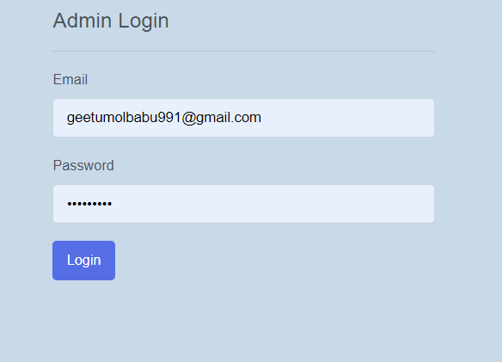

1. Admin home page

