Welcome to BAMAZON!

BAMAZON is an online store where customers can order different products on the inventory provided.

Here is the screenshot once the program is initiated:

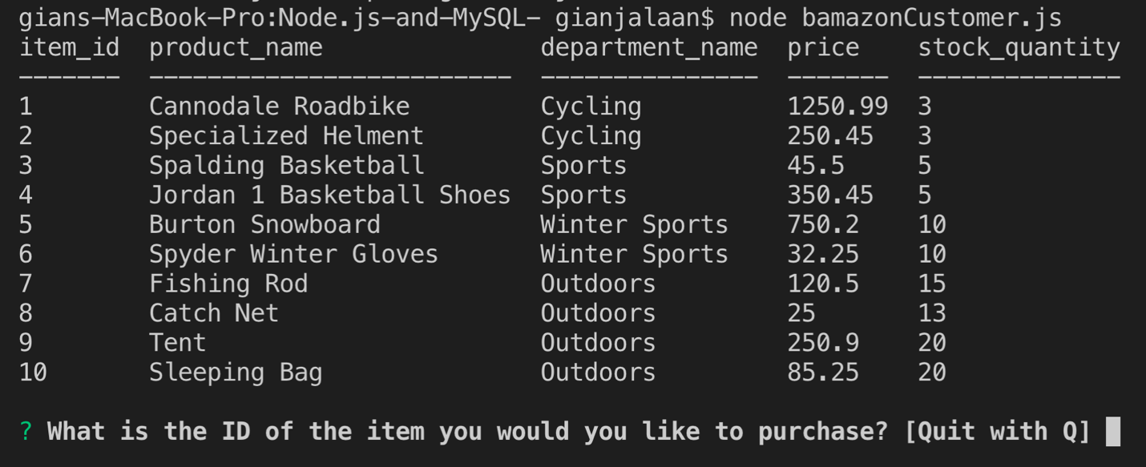

Customer orders 1 Cannondale Road bike:

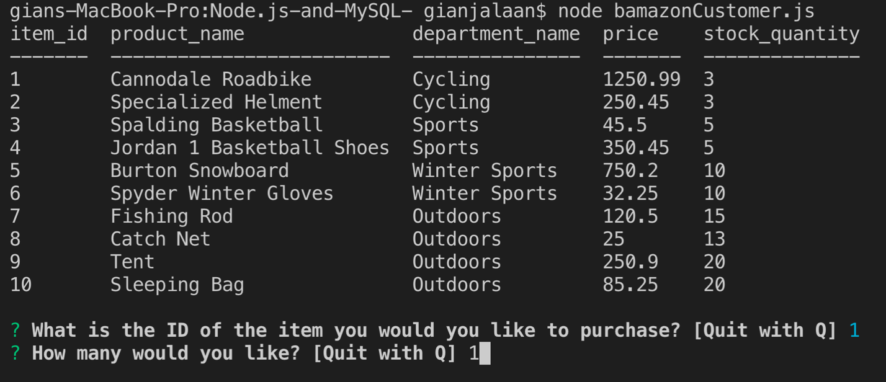

After successful transaction has been completed with item deducted:

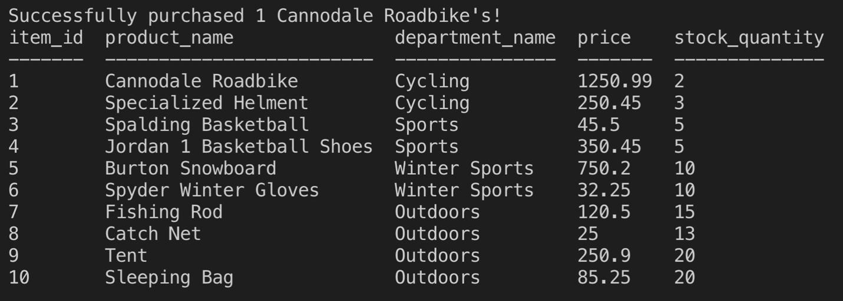

Customer tried to order products that are insufficient:

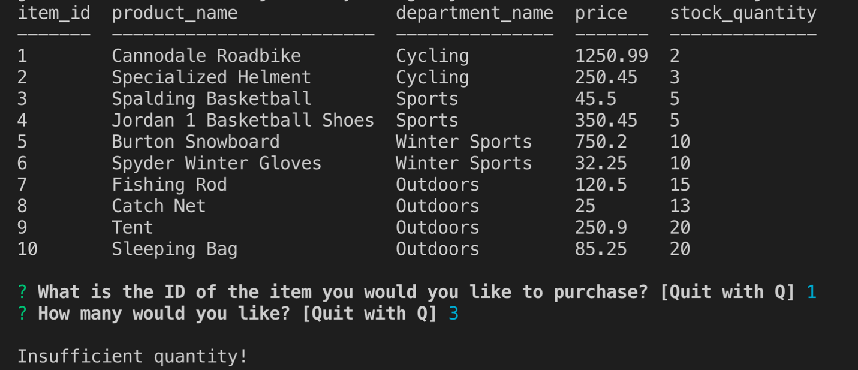

Customer exits the program:

