

A Project Report on

ShopEase

:

Online Shopping Platform

Submitted to Manipal University, Jaipur

Towards the partial

fulfillment

for the Award of the Degree

of

BACHELOR OF TECHNOLOGY

In Computers Science and Engineering

2022

-

2023

By

Geetangi Sharma

229301746

Under the guidance of

Anil Kumar Pawar

**Department of Computer Science and**

**Engineering**

**School of Computer Science and**

**Engineering Manipal University Jaipur**

**Jaipur, Rajasthan**



Introduction

"ShopEase: Advanced Online Shopping Platform" is an innovative endeavor aimed at revolutionizing the digital shopping experience. In a world increasingly reliant on e-commerce, ShopEase offers a comprehensive solution catering to diverse consumer needs. With its robust database architecture and user-friendly interface, ShopEase stands as a pinnacle of efficiency and convenience in the online retail landscape.

One of ShopEase's key features is its advanced user authentication system, prioritizing the security and privacy of customer information. With encrypted passwords and secure session management, users can shop with confidence, knowing that their personal data is safeguarded at every step.

Moreover, ShopEase goes beyond mere transactions, fostering a dynamic community of users through features like product reviews and ratings. Customers can share their experiences, offer insights, and contribute to a vibrant ecosystem of informed purchasing decisions.

With its commitment to excellence and innovation, ShopEase emerges as a beacon of convenience in the ever-evolving landscape of online commerce. Whether seeking the latest tech gadgets, trendy fashion essentials, or timeless literary classics, shoppers can rely on ShopEase to deliver a superior shopping experience tailored to their preferences and needs.

# **Motivation**

The motivation behind "ShopEase: Advanced Online Shopping Platform" stems from a deep-seated desire to redefine the digital shopping experience, addressing the evolving needs and expectations of modern consumers. In an era characterized by rapid technological advancement and shifting consumer behaviors, there exists a compelling opportunity to create a platform that transcends traditional online retail paradigms.

Furthermore, the motivation behind ShopEase is rooted in a desire to address the pain points and inefficiencies inherent in traditional online shopping experiences. From cumbersome navigation interfaces to concerns regarding data security and authenticity, ShopEase seeks to alleviate these challenges, offering a seamless and trustworthy platform where users can shop with confidence.

Ultimately, the driving force behind ShopEase is a passion for innovation and a commitment to enhancing the lives of consumers worldwide. By reimagining the online shopping experience and embracing the possibilities afforded by technology, ShopEase aims to set a new standard of excellence in the realm of ecommerce, enriching the lives of users and fostering a more connected and vibrant digital marketplace.

# **Objective**

The primary objective of "ShopEase: Advanced Online Shopping Platform" is to provide a cutting-edge e-commerce solution that enhances the shopping experience for users while simultaneously addressing the evolving needs of the digital marketplace. Through a comprehensive approach encompassing innovative features, user-centric design, and robust security measures, ShopEase aims to achieve the following objectives:

Enhanced User Experience: ShopEase seeks to streamline the online shopping process, making it more intuitive, efficient, and enjoyable for users of all backgrounds. By offering a user-friendly interface, personalized recommendations, and seamless navigation, ShopEase aims to create a frictionless shopping journey that exceeds customer expectations

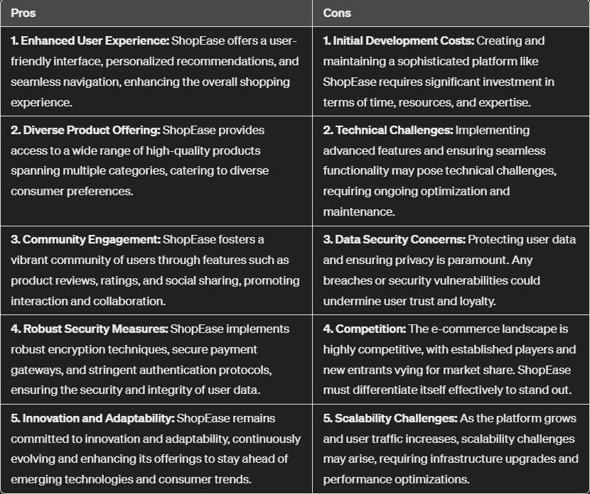

# The ER diagram

The ERD in the image shows the relationships between several entities in a database system, including users, products, orders, order details, payments, reviews, discounts, and categories.

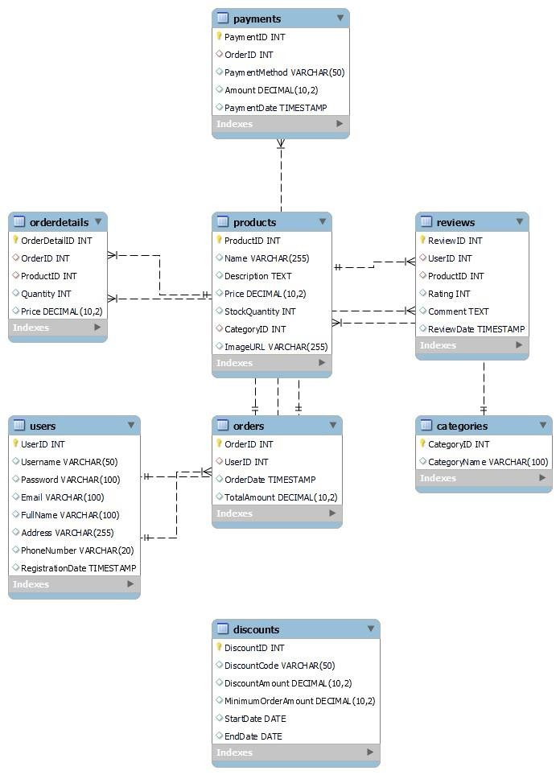

# Queries

CREATE

DATABASE

ShopEase; use

ShopEase;

-- Users Table

CREATE TABLE Users (

UserID INT AUTO_INCREMENT PRIMARY KEY,

Username VARCHAR(50) UNIQUE,

Password VARCHAR(100),

Email VARCHAR(100) UNIQUE,

FullName VARCHAR(100),

Address VARCHAR(255),

PhoneNumber VARCHAR(20),

RegistrationDate TIMESTAMP DEFAULT CURRENT_TIMESTAMP

);

-- Products Table

CREATE TABLE Products (

ProductID INT AUTO_INCREMENT PRIMARY KEY,

Name VARCHAR(255), Description TEXT,

Price DECIMAL(10, 2),

StockQuantity INT,

CategoryID INT,

ImageURL VARCHAR(255),

FOREIGN KEY (CategoryID) REFERENCES Categories(CategoryID)

);

-- Categories Table

CREATE TABLE Categories (

CategoryID INT AUTO_INCREMENT PRIMARY KEY,

CategoryName VARCHAR(100) UNIQUE

);

-- Orders Table

CREATE TABLE Orders (

OrderID INT AUTO_INCREMENT PRIMARY KEY,

UserID INT,

OrderDate TIMESTAMP DEFAULT

CURRENT_TIMESTAMP,

TotalAmount DECIMAL(10, 2),

FOREIGN KEY (UserID) REFERENCES Users(UserID)

);

-- OrderDetails Table

CREATE TABLE OrderDetails (

OrderDetailID INT AUTO_INCREMENT PRIMARY KEY,

OrderID INT,

ProductID INT,

Quantity INT,

Price DECIMAL(10, 2),

FOREIGN KEY (OrderID) REFERENCES

Orders(OrderID),

FOREIGN KEY (ProductID) REFERENCES

Products(ProductID)

);

-- Payments Table

CREATE TABLE Payments (

PaymentID INT AUTO_INCREMENT PRIMARY KEY,

OrderID INT,

PaymentMethod VARCHAR(50),

ReviewDate TIMESTAMP DEFAULT

Amount DECIMAL(10, 2),

CURRENT_TIMESTAMP,

PaymentDate TIMESTAMP DEFAULT

FOREIGN KEY (UserID) REFERENCES Users(UserID),

CURRENT_TIMESTAMP,

FOREIGN KEY (ProductID) REFERENCES

FOREIGN KEY (OrderID) REFERENCES

Products(ProductID)

Orders(OrderID)

);

);

-- Discounts Table

CREATE TABLE Discounts (

-- Reviews Table

DiscountID INT AUTO_INCREMENT PRIMARY KEY,

CREATE TABLE Reviews (

DiscountCode VARCHAR(50) UNIQUE,

ReviewID INT AUTO_INCREMENT PRIMARY KEY,

DiscountAmount DECIMAL(10, 2),

UserID INT,

MinimumOrderAmount DECIMAL(10, 2),

ProductID INT,

StartDate DATE,

Rating INT,

EndDate DATE

Comment TEXT,

);

# SCHEMA

|  |  |
| --- | --- |
| * **Users**:     UserID (Primary Key)  FirstName (VARCHAR)  LastName (VARCHAR)  Email (VARCHAR)     * **Products**:     ProductID (Primary Key)  ProductName (VARCHAR)  Description (TEXT)  Price (DECIMAL) | * **Orders:**     OrderID (Primary Key)  UserID (Foreign Key references Users.UserID)  OrderDate (DATETIME)  PaymentID (Foreign Key references Payments.PaymentID)     * **OrderDetails:**     OrderDetailID (Primary Key)  OrderID (Foreign Key references Orders.OrderID)  ProductID (Foreign Key references Products.ProductID) Quantity (INT) |

**Schema :**

CategoryID (Foreign Key references Categories.CategoryID) UnitPrice (DECIMAL)

Discount (DECIMAL) **Reviews:**

ReviewID (Primary Key)

ProductID (Foreign Key references Products.ProductID)

|  |  |  |
| --- | --- | --- |
| • | Rating (INT)  ReviewText (TEXT)  ReviewDate (DATETIME)    • **Discounts:**    DiscountID (Primary Key)  DiscountCode (VARCHAR)  DiscountPercentage (DECIMAL)  **OrderDiscounts (Junction Table)**: | PaymentID (Primary Key)  PaymentMethod (VARCHAR)  PaymentAmount (DECIMAL)  PaymentDate (DATETIME)  • **Categories:**    CategoryID (Primary Key)  CategoryName (VARCHAR) |

UserID (Foreign Key references Users.UserID) • **Payments:**

OrderID (Foreign Key references Orders.OrderID)

DiscountID (Foreign Key references Discounts.DiscountID)

# HARDWARE & SOFTWARE requirements

For the "ShopEase" project, both software and hardware requirements are essential to ensure the smooth development, deployment, and operation of the online shopping platform.

Software Requirements:

Database Management System (DBMS): A relational database management system such as MySQL or PostgreSQL is required to store and manage the data efficiently. MySQL Workbench or similar tools can be used for database design and administration.

Web Development Framework: A web development framework like Django, Ruby on Rails, or Laravel may be utilized for building the backend logic and APIs of the platform.

Additionally, frontend frameworks like React, Angular, or Vue.js can be employed for creating interactive user interfaces.

Programming Languages: Proficiency in programming

Security Measures: Implementing security measures such as languages such as Python, JavaScript, HTML, and CSS is firewalls, encryption protocols, and necessary for backend and frontend development.

regular software updates is crucial to protect the platform from

cyber threats and ensure data privacy and integrity.

Version Control System: Version control systems like Git are indispensable for collaboration among team members, tracking changes to the codebase, and managing project versions.

Integrated Development Environment (IDE): IDEs such as Visual Studio Code, PyCharm, or Sublime Text provide comprehensive tools for coding, debugging, and project management.

Development Devices: Developers require desktop or laptop computers with suitable specifications to develop, test, and debug the application code.

Hardware Requirements:

Server Infrastructure: Adequate server infrastructure is required to host the web application and database. This may include physical servers or cloud-based services like Amazon Web Services (AWS), Microsoft Azure, or Google Cloud Platform (GCP).

Computing Resources: Sufficient computing resources such as CPU, RAM, and storage are necessary to handle the application's workload, database operations, and user requests effectively.

Networking Infrastructure: A stable internet connection with adequate bandwidth is essential for seamless communication between clients and servers, as well as for accessing cloudbased services.

# bibliography

MySQL Tutorial: (https://www.mysqltutorial.org/) - Guides and Database Systems: Design, Implementation, & Management by examples for MySQL. Database Design Articles: Search for Coronel, Morris, and Rob. A comprehensive textbook covering articles on database normalization, relationships, and indexing database design principles, SQL, normalization, and database on reputable tech websites. administration.

Khan Academy: Relational Databases: MySQL Documentation. (n.d.). Retrieved from

(https://www.khanacademy.org/computing/computerprogrammi https://dev.mysql.com/doc/ ng/sql) Free interactive lessons and explanations on database

concepts and SQL usage. W3Schools. (n.d.). SQL Tutorial. Retrieved from Vertabelo Database Modeler Blog: https://www.w3schools.com/sql/

(https://www.vertabelo.com/blog/) Features articles on database design best practices, modeling techniques, and data optimization.

TutorialsPoint - Database Design: ([invalid URL removed]) A collection of tutorials covering database fundamentals, SQL, ER diagrams, and more.

THANK YOU!!

*MADE BY:*

*GEETANGI SHARMA*