Ethiopic Manuscript Unicode Font Initiative
         

The Ethiopic Manuscript Unicode Font Initiative is a new effort launched at the start of 2011(EC) to draw together scholars and font designers to address the remaining gaps to fully digitize Ethiopic manuscripts as regular text that can be searched, typed, copied, and pasted while preserving the visual appearance of the original artifact.

The EMUFI project draws inspiration from, and indeed is modeled after, the successful “Mediaeval Unicode Font Initiative” (MUFI) for Latin (western) script. Digitizing manuscripts as text opens the doors to further research possibilities where text analytics and data mining approaches become applicable. Manuscript content also becomes keyword searchable and more readily managed by web and eBook software.

A simple survey finds some 300 letters forms, numeral variants, punctuation and zaima notation in need of expert review to reach a consensus on which symbols should be supported in a font and ultimately promoted in computing standards. Many more symbols from “Manuscript Ethiopic” remain to be surveyed.

Your help is needed! Please join the mail list and review the developing inventory document to help assure that your experience, views and digital needs can inform the effort and applicable international standards.

EMUFI web address: https://emufi.geez.org
Public email List: http://tiny.cc/emufi

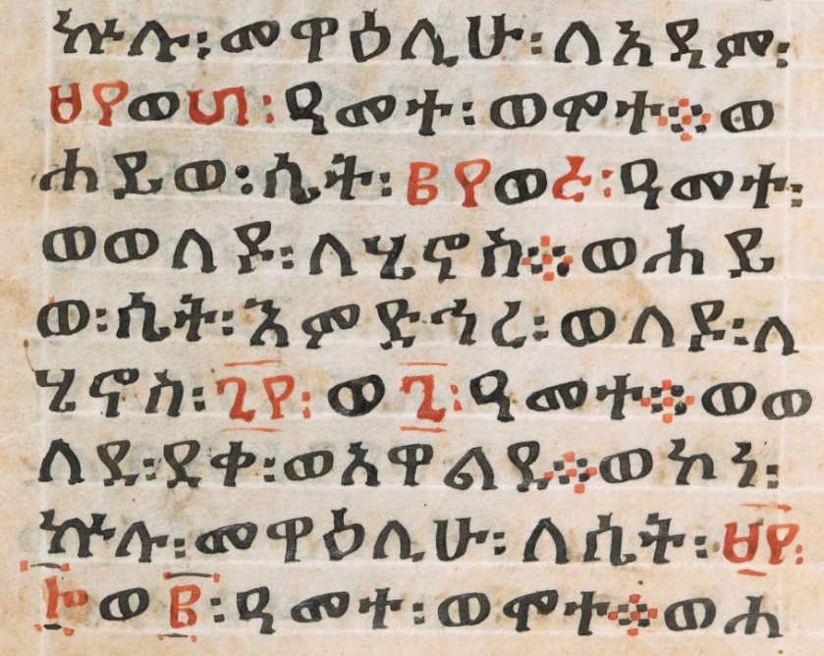 | ኵሉ፡መዋዕሊሁ፡ለአዳም፡  ወ፡ዓመተ፡ወሞተወ  ሐይወ፡ሴት፡ወ፡ዓመተ፡  ወወለዶ፡ለሄኖስወሐይ  ወ፡ሴት፡እምድኅረ፡ወለዶ፡ለ  ሄኖስ፡፡ወ፯፡ዓመተወወ  ለደ፡ደቀ፡ወአዋልደወኮነ፡  ኵሉ፡መዋዕሊሁ፡ለሴት፡  ወ፡ዓመተ፡ወሞተወሐ
Image sample from f.5v of ኦሪት The Octateuch, (Genesis, Exodus, Leviticus, Numbers, Deuteronomy, Joshua, Judges, Ruth). (14th - 15th Century). Unpublished manuscript, The British Library, London. Retrieved February 25, 2018, from http://www.bl.uk/manuscripts/Viewer.aspx?ref=or_480_f005v | 100% regular text typed in MS Word with the EMUFI development font. Copy, paste, search and analyze with standard corpora and data mining tools.

