Zurbano Gene Paolo T.

CPE 204 – CPE22S2

Schematic Diagram

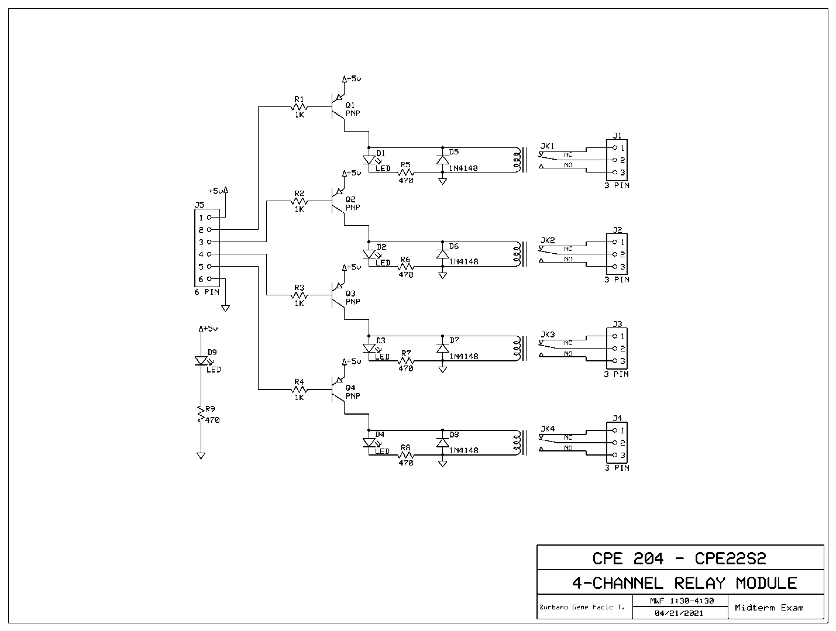

Top Copper Layer

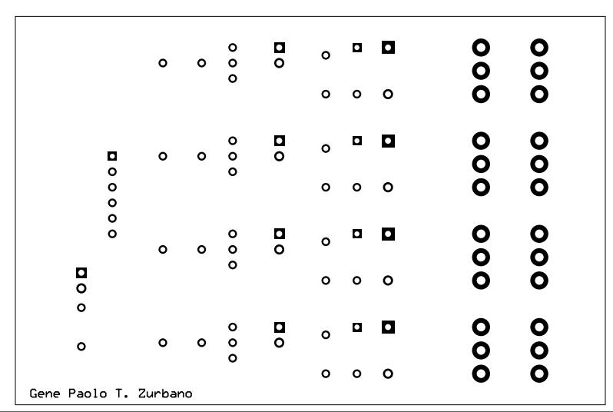

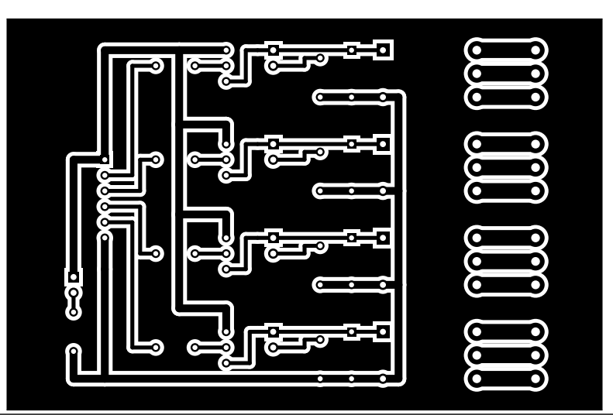Bottom Layer

Silkscreen Layer

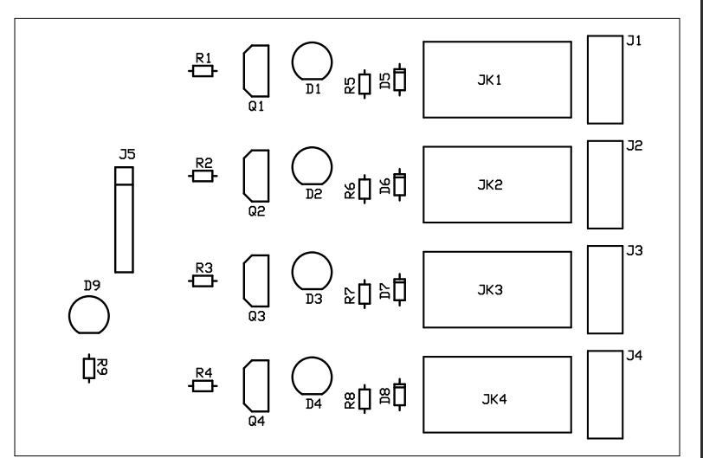

Silkscreen and Pads

