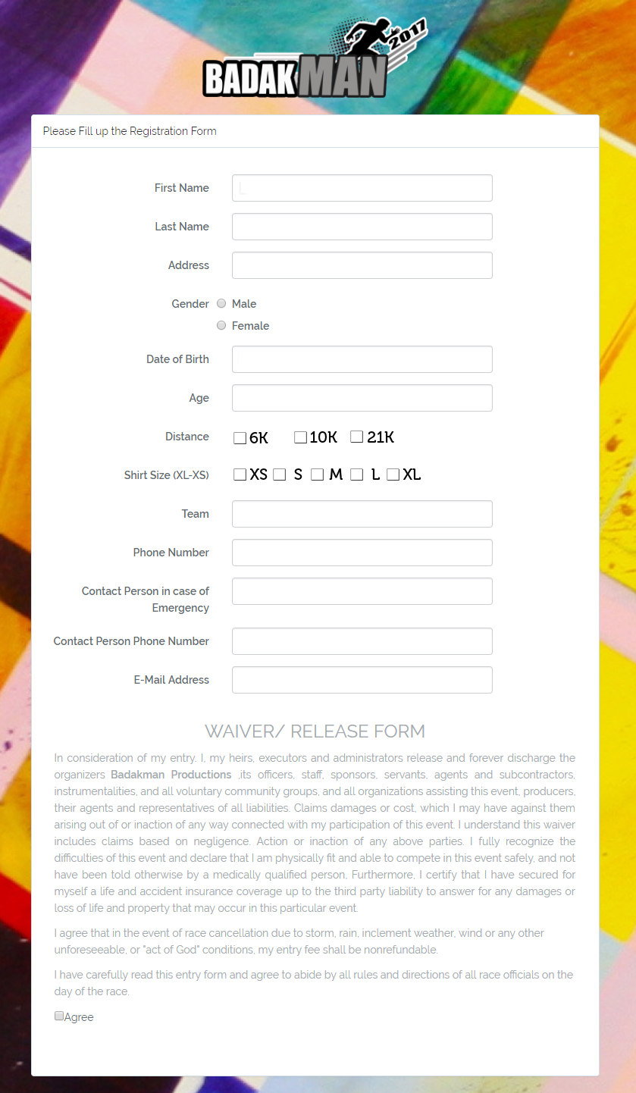

------------------------------------------------------------------------------------------------------------------------------------------  
Payment Confirmation  
  
Reference No: _______________________  
  
*Note: Please show this form for claiming your race kit on October 1-14 at ATP Caltex Station, Nat’l Highway, San Jose, Aurora, Zamboanga Del Sur*