1. Karyawan

POST {{host}}/v1/idstar/karyawan/save
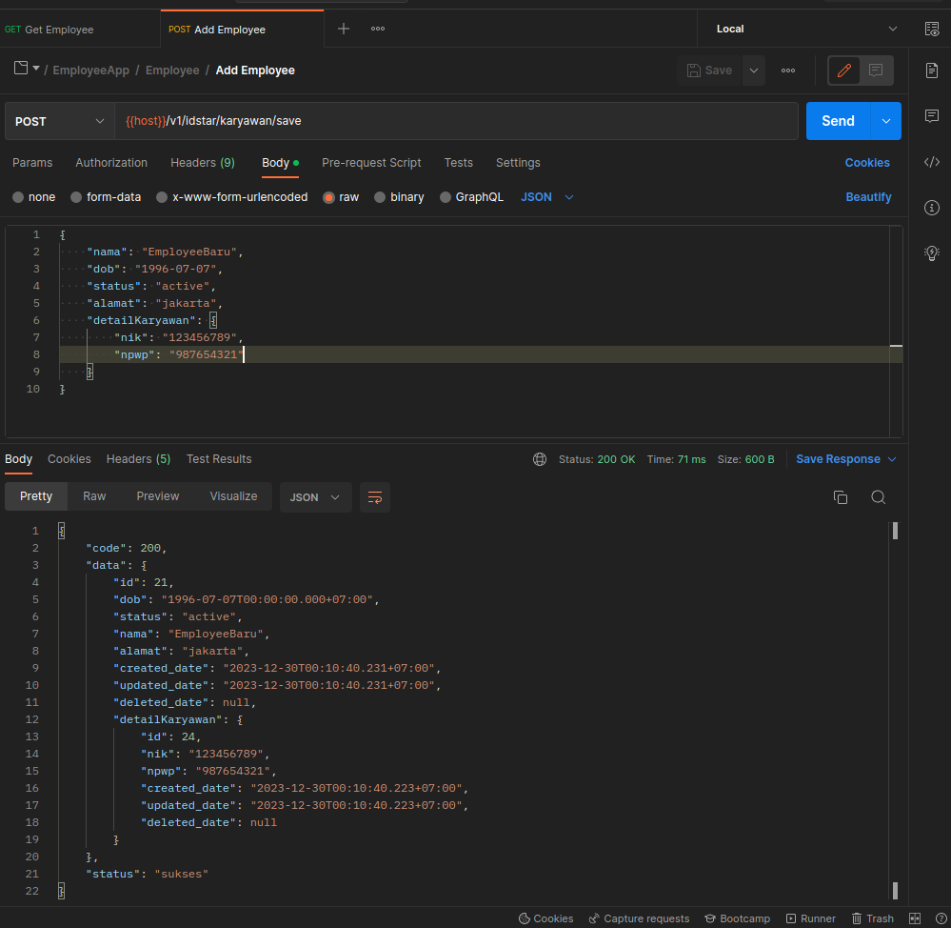

GET {{host}}/v1/idstar/karyawan/:id

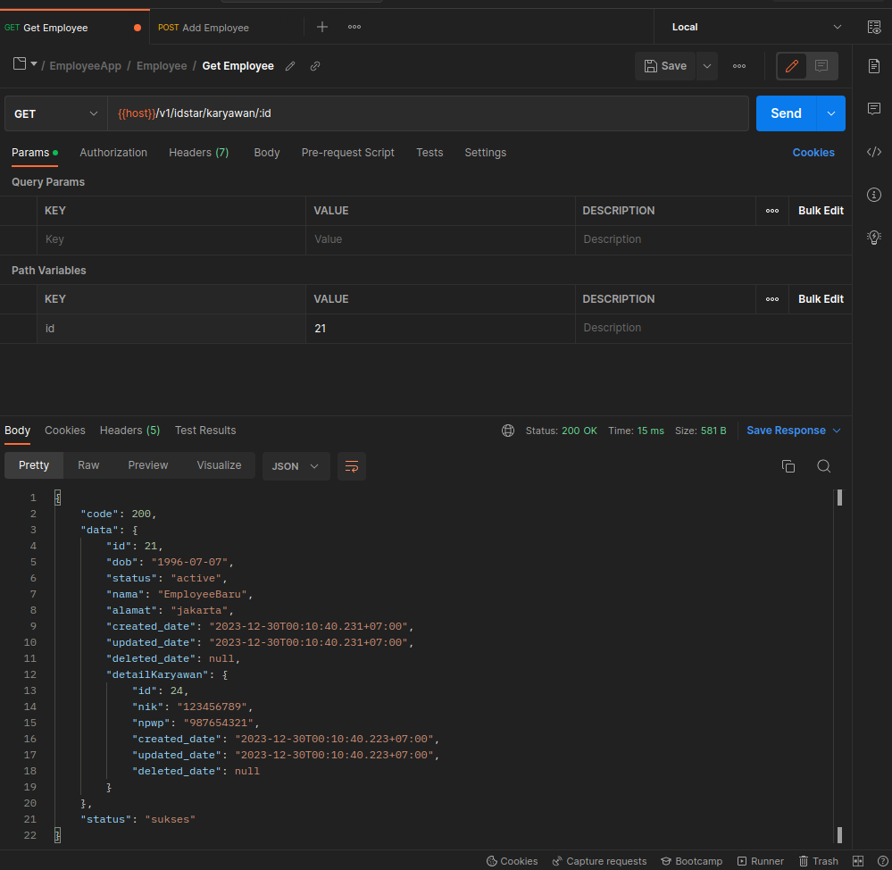

GET {{host}}/v1/idstar/karyawan/list?page=0&size=3

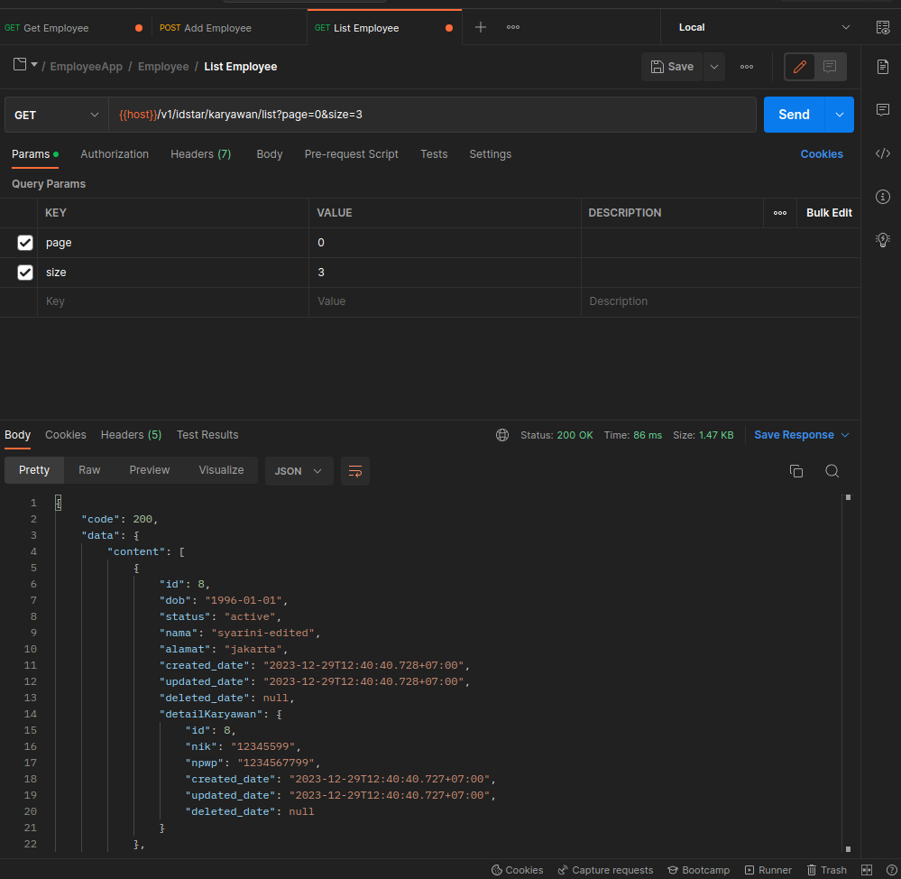

{
"code": 200,
"data": {
"content": [
{
"id": 8,
"dob": "1996-01-01",
"status": "active",
"nama": "syarini-edited",
"alamat": "jakarta",
"created_date": "2023-12-29T12:40:40.728+07:00",
"updated_date": "2023-12-29T12:40:40.728+07:00",
"deleted_date": null,
"detailKaryawan": {
"id": 8,
"nik": "12345599",
"npwp": "1234567799",
"created_date": "2023-12-29T12:40:40.727+07:00",
"updated_date": "2023-12-29T12:40:40.727+07:00",
"deleted_date": null
}
},
{
"id": 9,
"dob": "1996-01-01",
"status": "active",
"nama": "syarini-edited",
"alamat": "jakarta",
"created_date": "2023-12-29T12:41:07.139+07:00",
"updated_date": "2023-12-29T12:41:07.139+07:00",
"deleted_date": null,
"detailKaryawan": {
"id": 9,
"nik": "12345599",
"npwp": "1234567799",
"created_date": "2023-12-29T12:41:07.139+07:00",
"updated_date": "2023-12-29T12:41:07.139+07:00",
"deleted_date": null
}
},
{
"id": 19,
"dob": "1996-01-01",
"status": "active",
"nama": "syarini-edited2",
"alamat": "jakarta",
"created_date": "2023-12-29T17:11:07.221+07:00",
"updated_date": "2023-12-29T17:11:07.221+07:00",
"deleted_date": null,
"detailKaryawan": null
}
],
"pageable": {
"pageNumber": 0,
"pageSize": 3,
"sort": {
"sorted": false,
"empty": true,
"unsorted": true
},
"offset": 0,
"paged": true,
"unpaged": false
},
"last": false,
"totalPages": 3,
"totalElements": 8,
"size": 3,
"number": 0,
"sort": {
"sorted": false,
"empty": true,
"unsorted": true
},
"first": true,
"numberOfElements": 3,
"empty": false
},
"status": "sukses"
}

PUT {{host}}/v1/idstar/karyawan/update
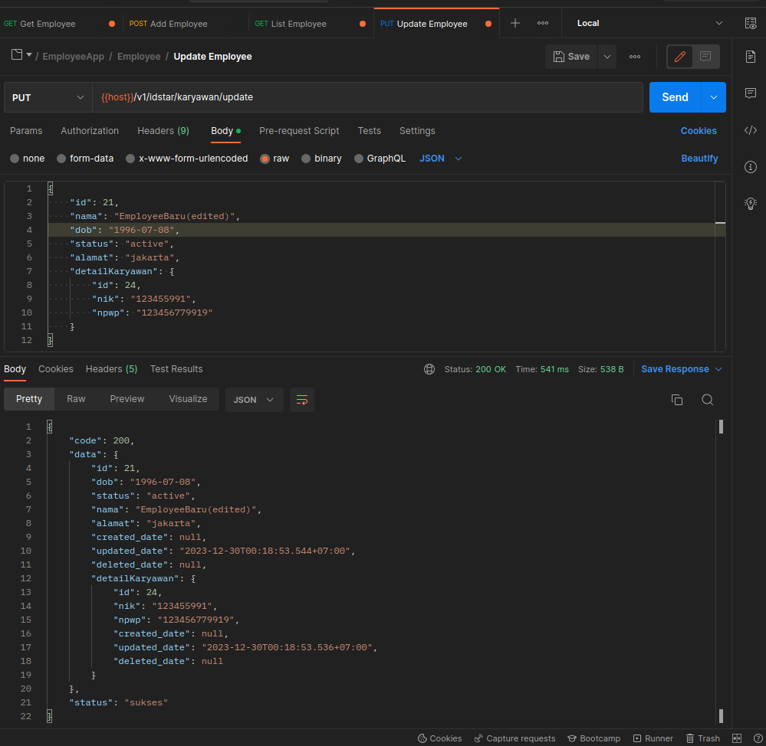

DELETE {{host}}/v1/idstar/karyawan/delete

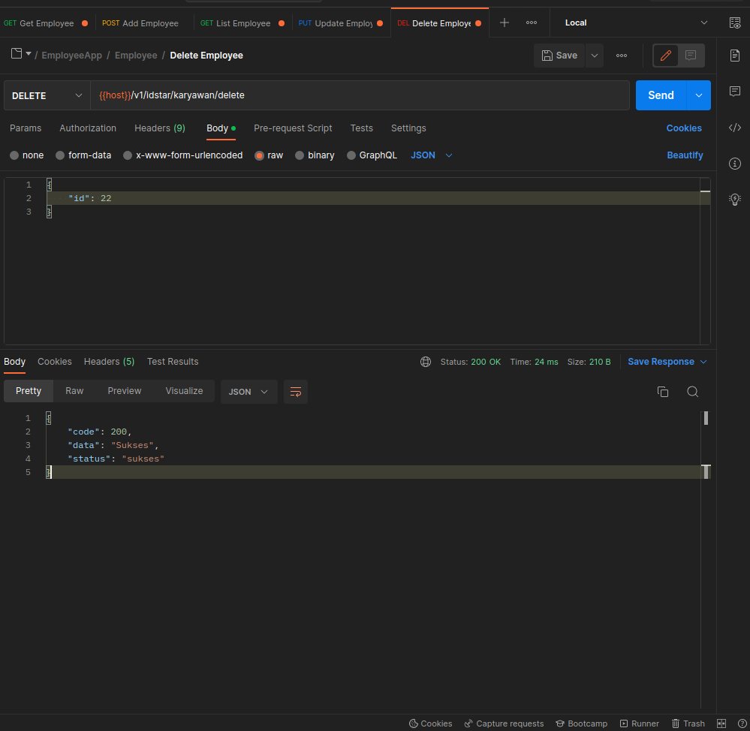

2. Rekening

POST {{host}}/v1/idstar/rekening/save

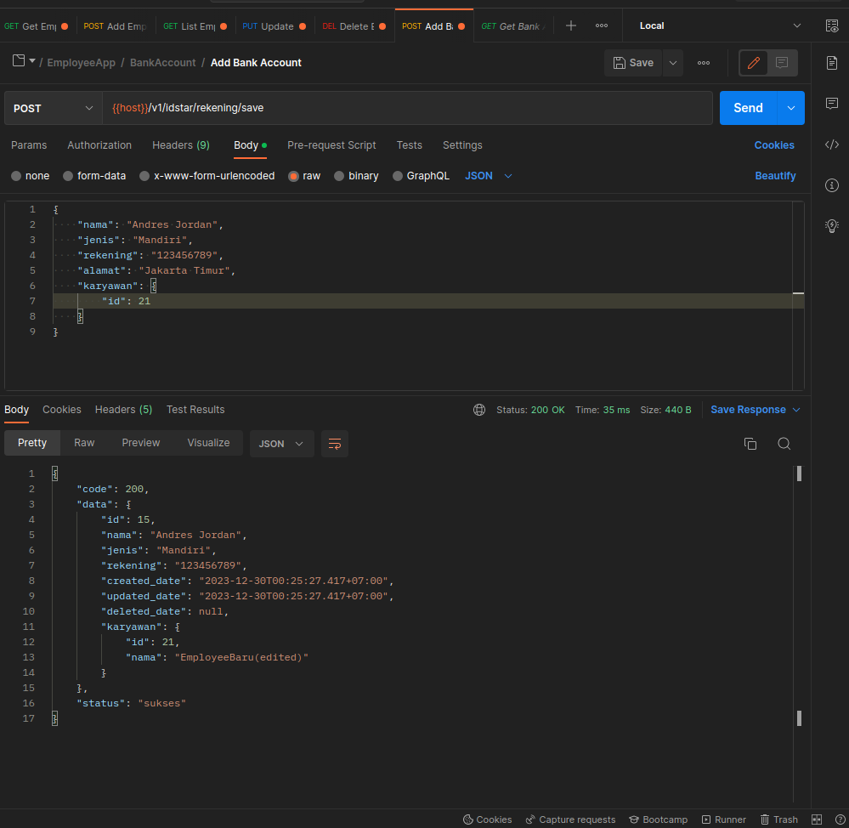

GET {{host}}/v1/idstar/rekening/:id

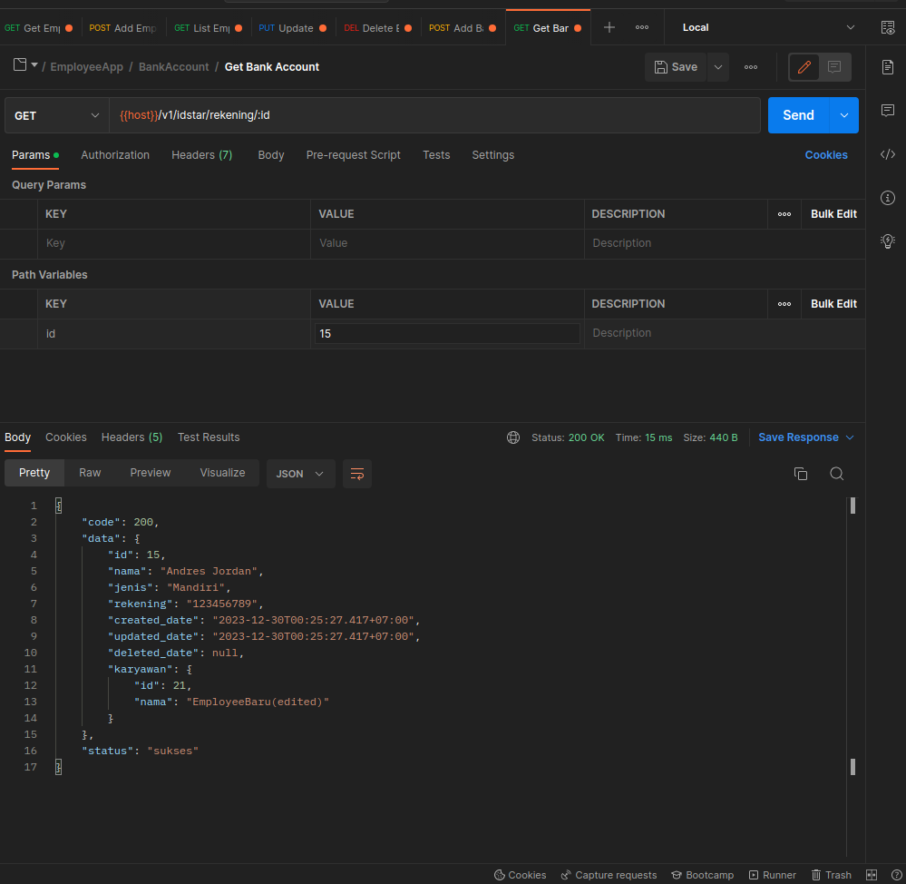

LIST {{host}}/v1/idstar/rekening/list?page=0&size=3

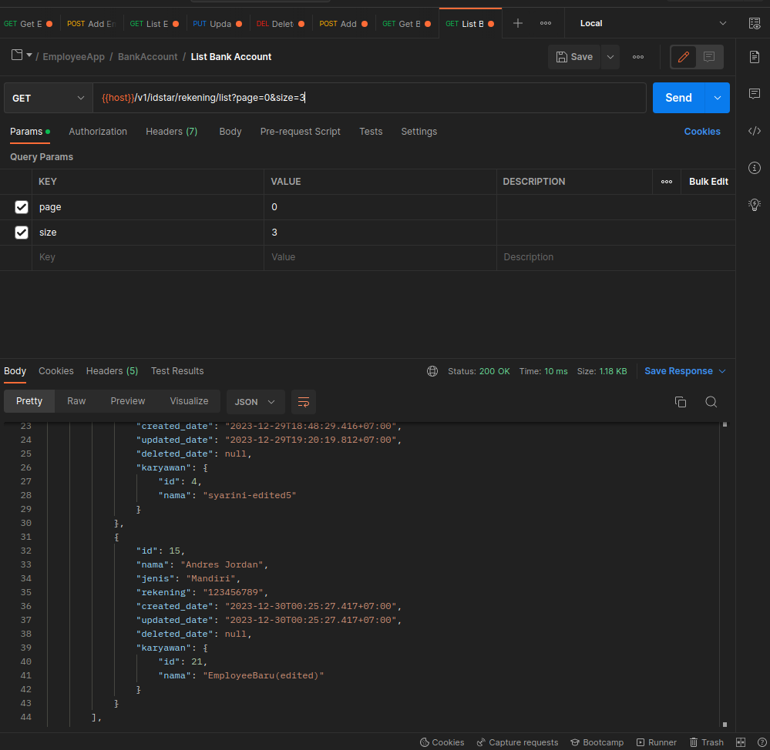

{
"code": 200,
"data": {
"content": [
{
"id": 9,
"nama": "Riki Aldi Pare",
"jenis": "BCA",
"rekening": "123456789",
"created_date": "2023-12-29T18:22:12.737+07:00",
"updated_date": "2023-12-29T18:22:12.737+07:00",
"deleted_date": null,
"karyawan": {
"id": 6,
"nama": "syarina"
}
},
{
"id": 13,
"nama": "Riki Aldi Pari",
"jenis": "BCA",
"rekening": "12345678",
"created_date": "2023-12-29T18:48:29.416+07:00",
"updated_date": "2023-12-29T19:20:19.812+07:00",
"deleted_date": null,
"karyawan": {
"id": 4,
"nama": "syarini-edited5"
}
},
{
"id": 15,
"nama": "Andres Jordan",
"jenis": "Mandiri",
"rekening": "123456789",
"created_date": "2023-12-30T00:25:27.417+07:00",
"updated_date": "2023-12-30T00:25:27.417+07:00",
"deleted_date": null,
"karyawan": {
"id": 21,
"nama": "EmployeeBaru(edited)"
}
}
],
"pageable": {
"pageNumber": 0,
"pageSize": 3,
"sort": {
"sorted": false,
"empty": true,
"unsorted": true
},
"offset": 0,
"paged": true,
"unpaged": false
},
"totalPages": 1,
"totalElements": 3,
"last": true,
"size": 3,
"number": 0,
"sort": {
"sorted": false,
"empty": true,
"unsorted": true
},
"numberOfElements": 3,
"first": true,
"empty": false
},
"status": "sukses"
}

PUT {{host}}/v1/idstar/rekening/update

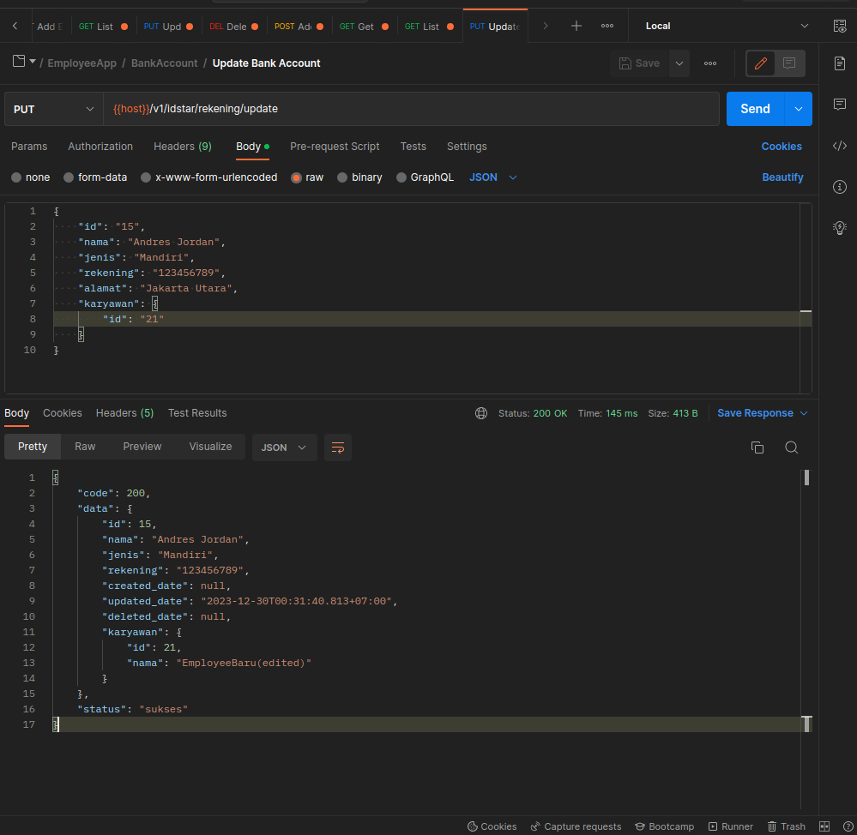

DELETE {{host}}/v1/idstar/rekening/delete

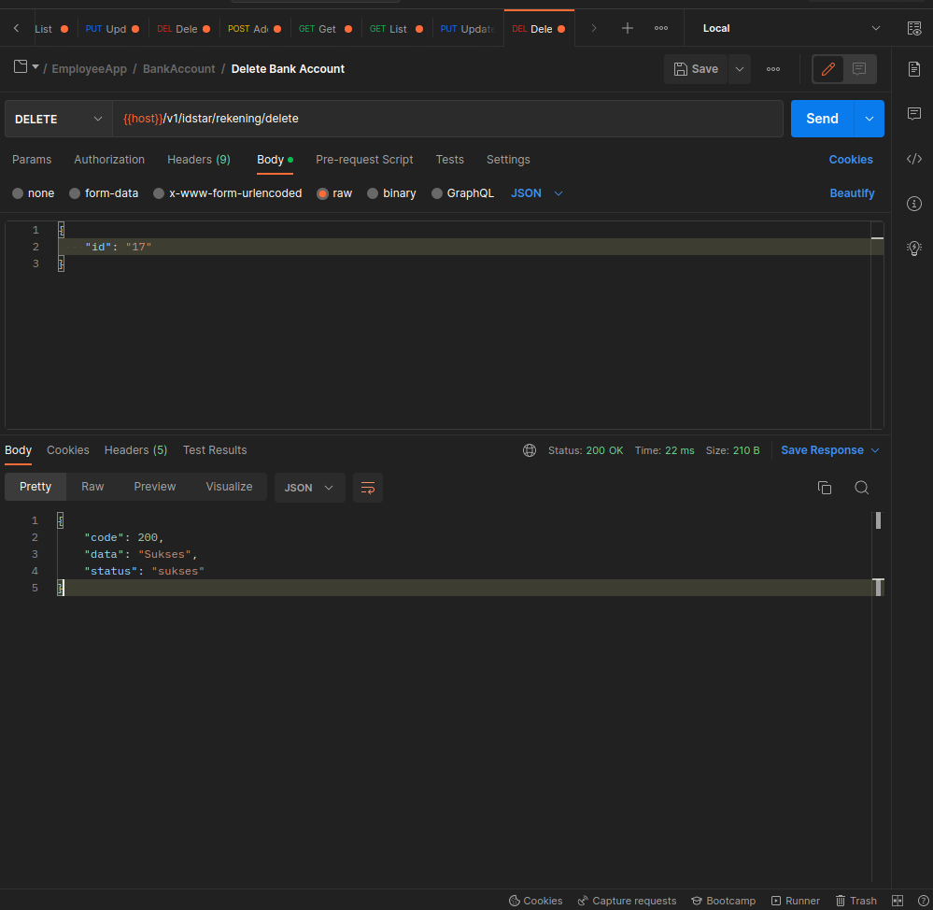

3. Training

GET {{host}}/v1/idstar/training/save

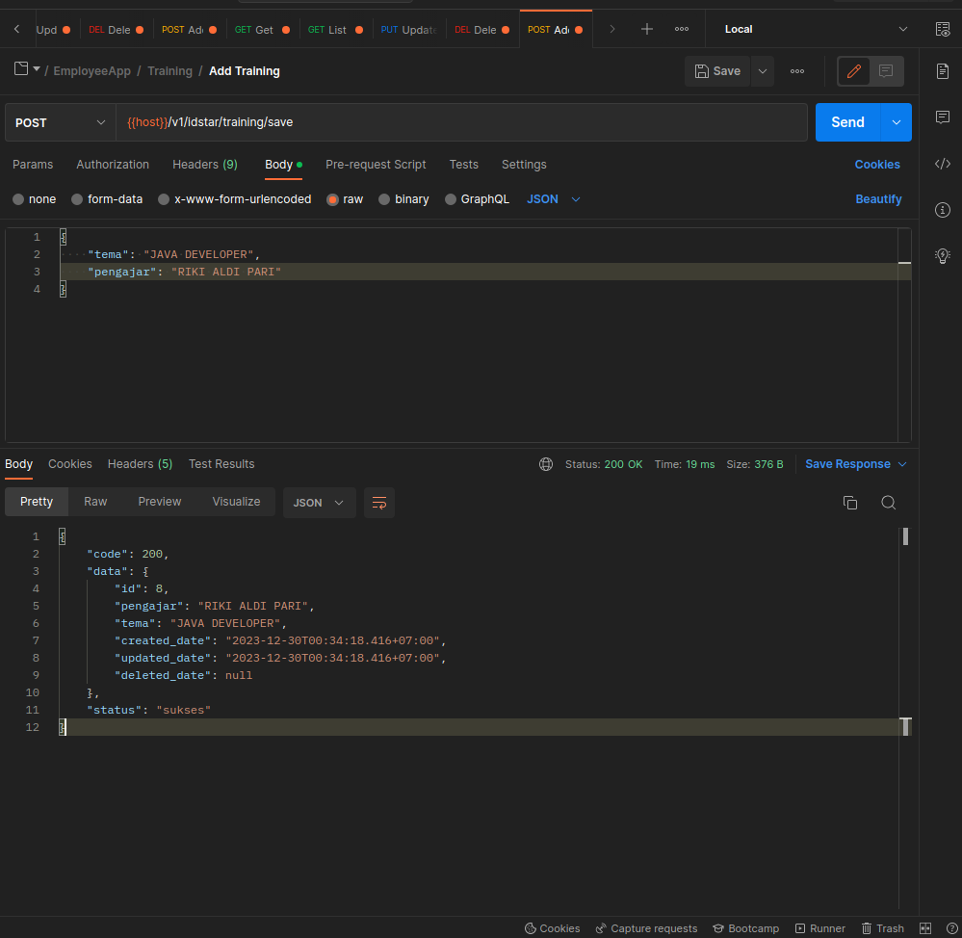

GET {{host}}/v1/idstar/training/:id

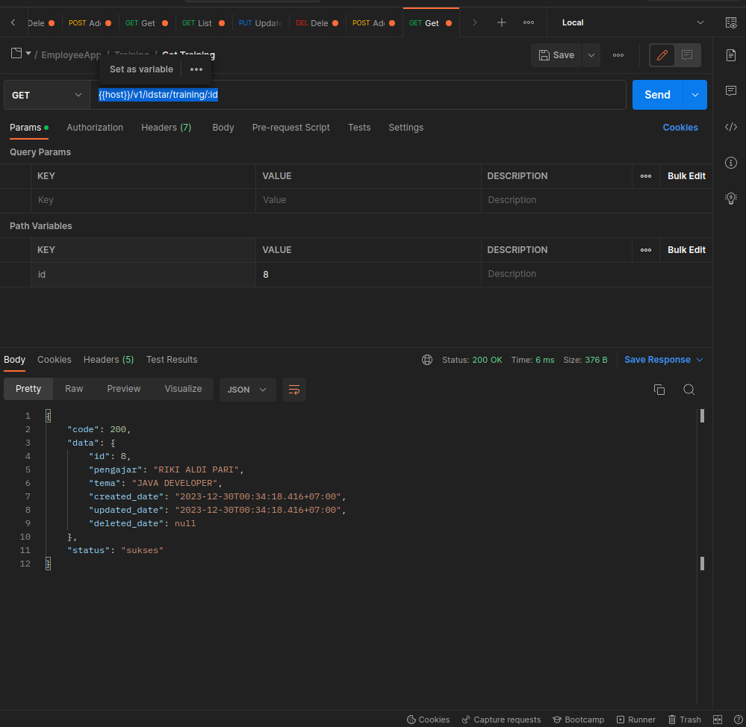

GET {{host}}/v1/idstar/training/list?page=0&size=3

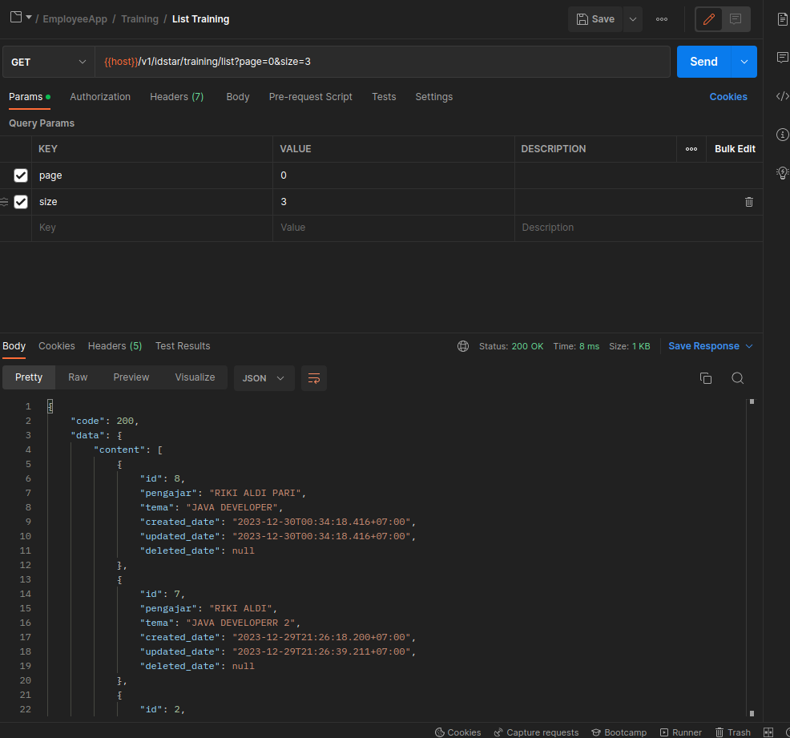

{
"code": 200,
"data": {
"content": [
{
"id": 8,
"pengajar": "RIKI ALDI PARI",
"tema": "JAVA DEVELOPER",
"created_date": "2023-12-30T00:34:18.416+07:00",
"updated_date": "2023-12-30T00:34:18.416+07:00",
"deleted_date": null
},
{
"id": 7,
"pengajar": "RIKI ALDI",
"tema": "JAVA DEVELOPERR 2",
"created_date": "2023-12-29T21:26:18.200+07:00",
"updated_date": "2023-12-29T21:26:39.211+07:00",
"deleted_date": null
},
{
"id": 2,
"pengajar": "RIKI",
"tema": "JAVA DEVELOPERR",
"created_date": "2023-12-29T20:43:16.131+07:00",
"updated_date": "2023-12-29T21:03:48.745+07:00",
"deleted_date": null
}
],
"pageable": {
"pageNumber": 0,
"pageSize": 3,
"sort": {
"sorted": false,
"empty": true,
"unsorted": true
},
"offset": 0,
"paged": true,
"unpaged": false
},
"totalPages": 1,
"totalElements": 3,
"last": true,
"size": 3,
"number": 0,
"sort": {
"sorted": false,
"empty": true,
"unsorted": true
},
"numberOfElements": 3,
"first": true,
"empty": false
},
"status": "sukses"
}

PUT {{host}}/v1/idstar/training/update

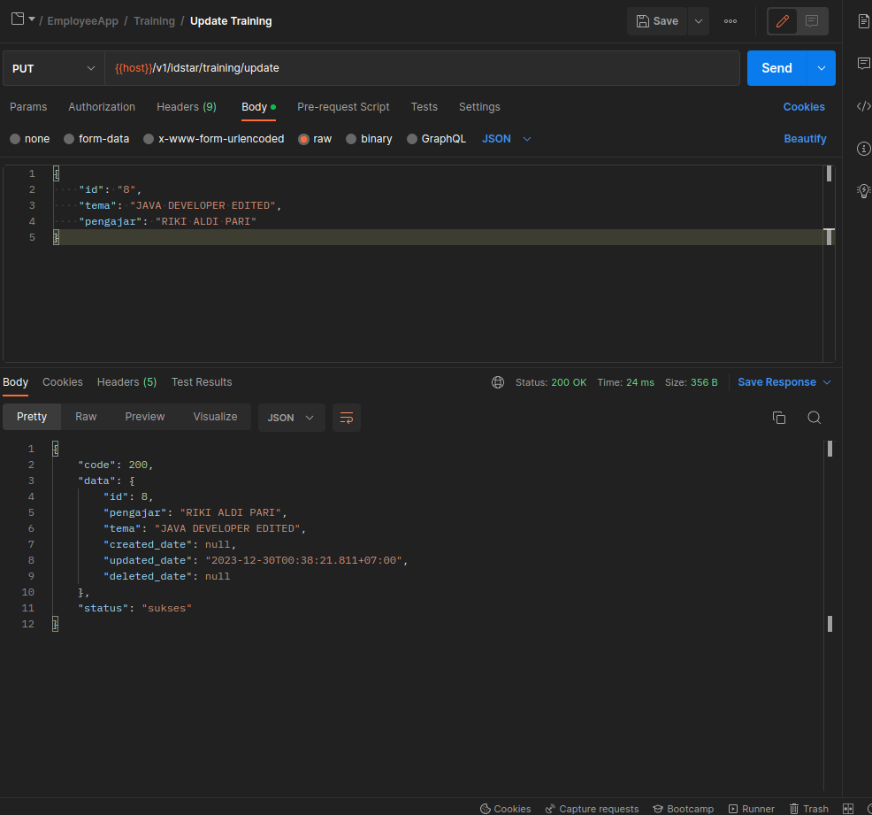

DELETE {{host}}/v1/idstar/training/delete

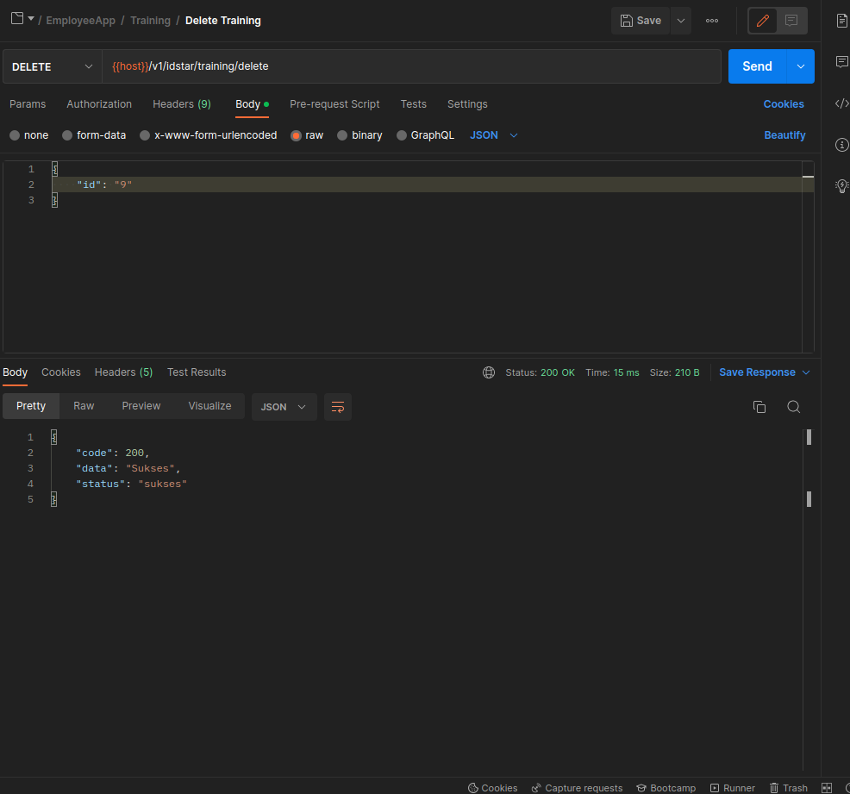

4. Karyawan-Training

POST {{host}}/v1/idstar/karyawan-training/save

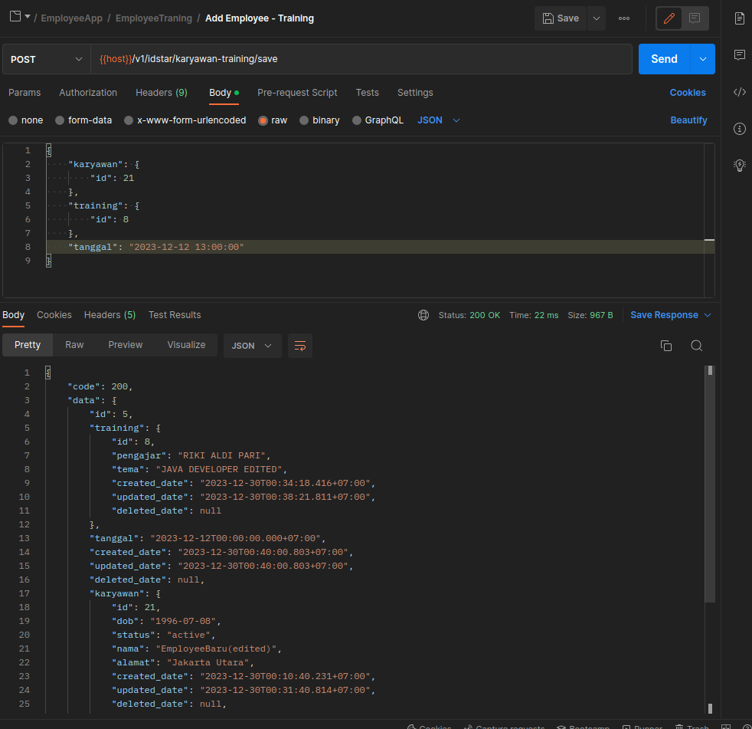

{
"code": 200,
"data": {
"id": 5,
"training": {
"id": 8,
"pengajar": "RIKI ALDI PARI",
"tema": "JAVA DEVELOPER EDITED",
"created_date": "2023-12-30T00:34:18.416+07:00",
"updated_date": "2023-12-30T00:38:21.811+07:00",
"deleted_date": null
},
"tanggal": "2023-12-12T00:00:00.000+07:00",
"created_date": "2023-12-30T00:40:00.803+07:00",
"updated_date": "2023-12-30T00:40:00.803+07:00",
"deleted_date": null,
"karyawan": {
"id": 21,
"dob": "1996-07-08",
"status": "active",
"nama": "EmployeeBaru(edited)",
"alamat": "Jakarta Utara",
"created_date": "2023-12-30T00:10:40.231+07:00",
"updated_date": "2023-12-30T00:31:40.814+07:00",
"deleted_date": null,
"detailKaryawan": {
"id": 24,
"nik": "123455991",
"npwp": "123456779919",
"created_date": "2023-12-30T00:10:40.223+07:00",
"updated_date": "2023-12-30T00:18:53.536+07:00",
"deleted_date": null
}
}
},
"status": "sukses"
}

GET {{host}}/v1/idstar/karyawan-training/:id

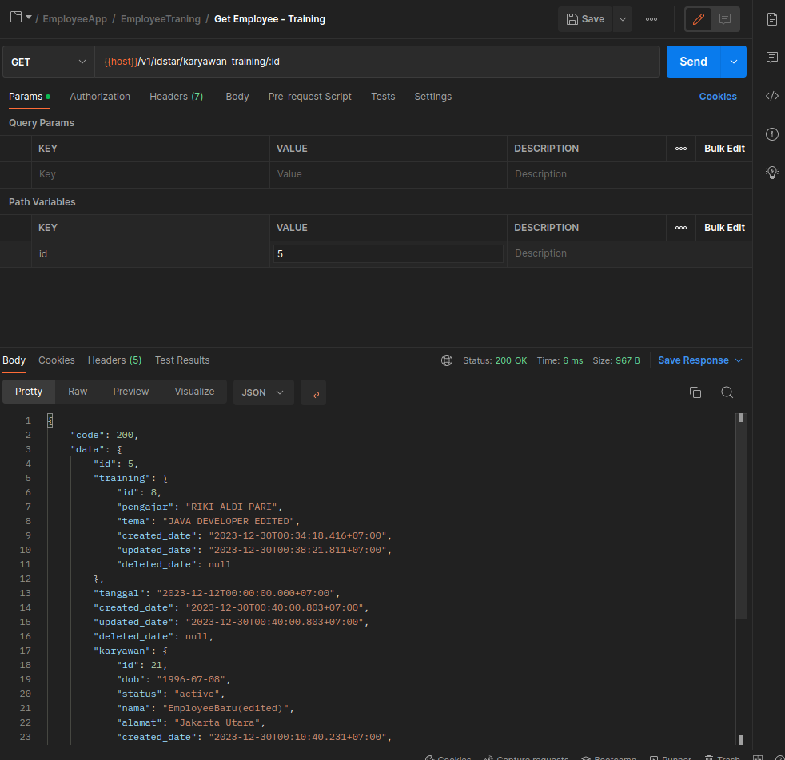

{
"code": 200,
"data": {
"id": 5,
"training": {
"id": 8,
"pengajar": "RIKI ALDI PARI",
"tema": "JAVA DEVELOPER EDITED",
"created_date": "2023-12-30T00:34:18.416+07:00",
"updated_date": "2023-12-30T00:38:21.811+07:00",
"deleted_date": null
},
"tanggal": "2023-12-12T00:00:00.000+07:00",
"created_date": "2023-12-30T00:40:00.803+07:00",
"updated_date": "2023-12-30T00:40:00.803+07:00",
"deleted_date": null,
"karyawan": {
"id": 21,
"dob": "1996-07-08",
"status": "active",
"nama": "EmployeeBaru(edited)",
"alamat": "Jakarta Utara",
"created_date": "2023-12-30T00:10:40.231+07:00",
"updated_date": "2023-12-30T00:31:40.814+07:00",
"deleted_date": null,
"detailKaryawan": {
"id": 24,
"nik": "123455991",
"npwp": "123456779919",
"created_date": "2023-12-30T00:10:40.223+07:00",
"updated_date": "2023-12-30T00:18:53.536+07:00",
"deleted_date": null
}
}
},
"status": "sukses"
}

GET {{host}}/v1/idstar/karyawan-training/list?page=0&size=2

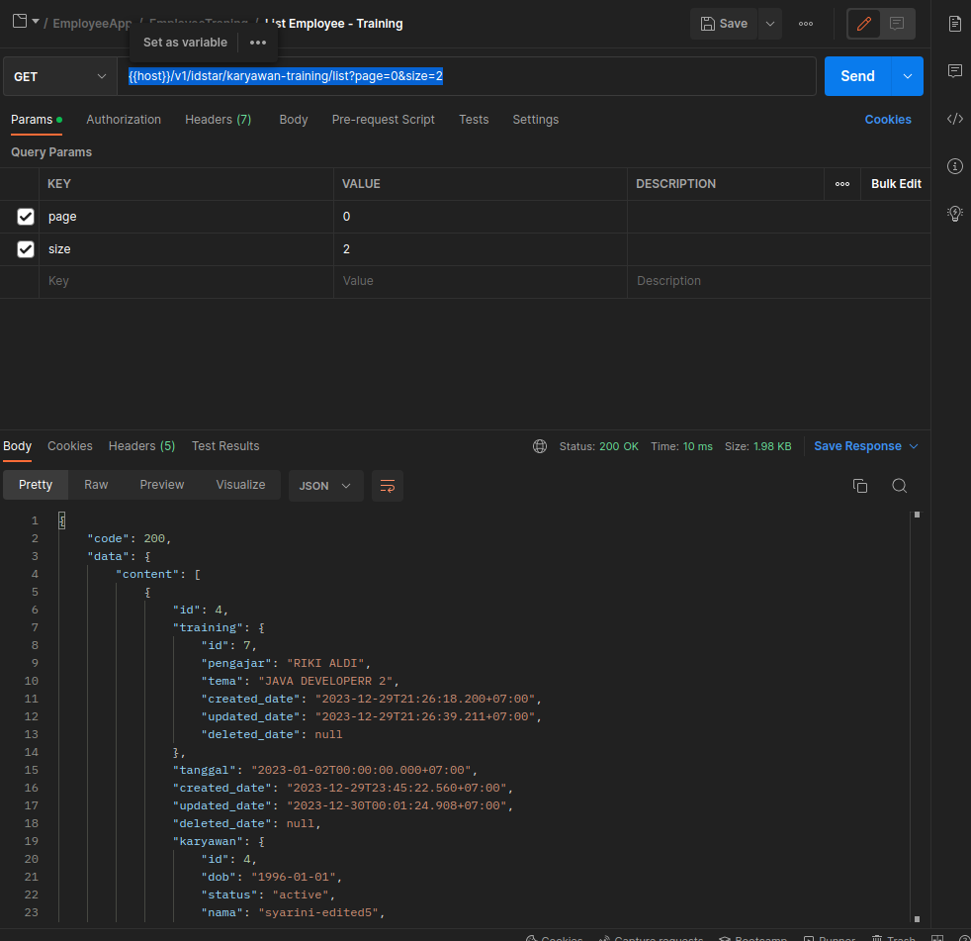

{
"code": 200,
"data": {
"content": [
{
"id": 4,
"training": {
"id": 7,
"pengajar": "RIKI ALDI",
"tema": "JAVA DEVELOPERR 2",
"created_date": "2023-12-29T21:26:18.200+07:00",
"updated_date": "2023-12-29T21:26:39.211+07:00",
"deleted_date": null
},
"tanggal": "2023-01-02T00:00:00.000+07:00",
"created_date": "2023-12-29T23:45:22.560+07:00",
"updated_date": "2023-12-30T00:01:24.908+07:00",
"deleted_date": null,
"karyawan": {
"id": 4,
"dob": "1996-01-01",
"status": "active",
"nama": "syarini-edited5",
"alamat": "jakartii",
"created_date": "2023-12-29T11:25:49.574+07:00",
"updated_date": "2023-12-29T19:20:19.818+07:00",
"deleted_date": null,
"detailKaryawan": {
"id": 15,
"nik": "12345599",
"npwp": "123456779911",
"created_date": "2023-12-29T13:34:41.435+07:00",
"updated_date": "2023-12-29T13:34:41.435+07:00",
"deleted_date": null
}
}
},
{
"id": 5,
"training": {
"id": 8,
"pengajar": "RIKI ALDI PARI",
"tema": "JAVA DEVELOPER EDITED",
"created_date": "2023-12-30T00:34:18.416+07:00",
"updated_date": "2023-12-30T00:38:21.811+07:00",
"deleted_date": null
},
"tanggal": "2023-12-12T00:00:00.000+07:00",
"created_date": "2023-12-30T00:40:00.803+07:00",
"updated_date": "2023-12-30T00:40:00.803+07:00",
"deleted_date": null,
"karyawan": {
"id": 21,
"dob": "1996-07-08",
"status": "active",
"nama": "EmployeeBaru(edited)",
"alamat": "Jakarta Utara",
"created_date": "2023-12-30T00:10:40.231+07:00",
"updated_date": "2023-12-30T00:31:40.814+07:00",
"deleted_date": null,
"detailKaryawan": {
"id": 24,
"nik": "123455991",
"npwp": "123456779919",
"created_date": "2023-12-30T00:10:40.223+07:00",
"updated_date": "2023-12-30T00:18:53.536+07:00",
"deleted_date": null
}
}
}
],
"pageable": {
"pageNumber": 0,
"pageSize": 2,
"sort": {
"sorted": false,
"empty": true,
"unsorted": true
},
"offset": 0,
"paged": true,
"unpaged": false
},
"totalPages": 1,
"totalElements": 2,
"last": true,
"size": 2,
"number": 0,
"sort": {
"sorted": false,
"empty": true,
"unsorted": true
},
"numberOfElements": 2,
"first": true,
"empty": false
},
"status": "sukses"
}

PUT {{host}}/v1/idstar/karyawan-training/update

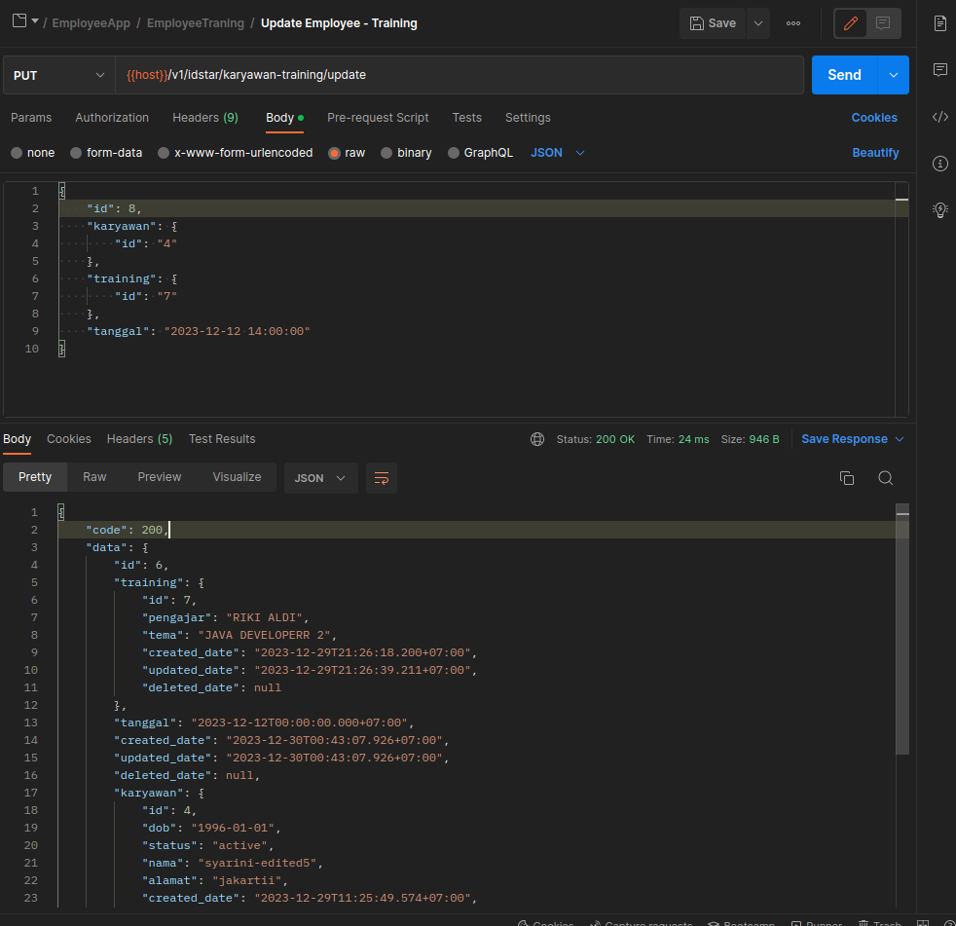

DELETE {{host}}/v1/idstar/karyawan-training/delete

