

GUIDE

MAIN WINDOW
Click to discover each section
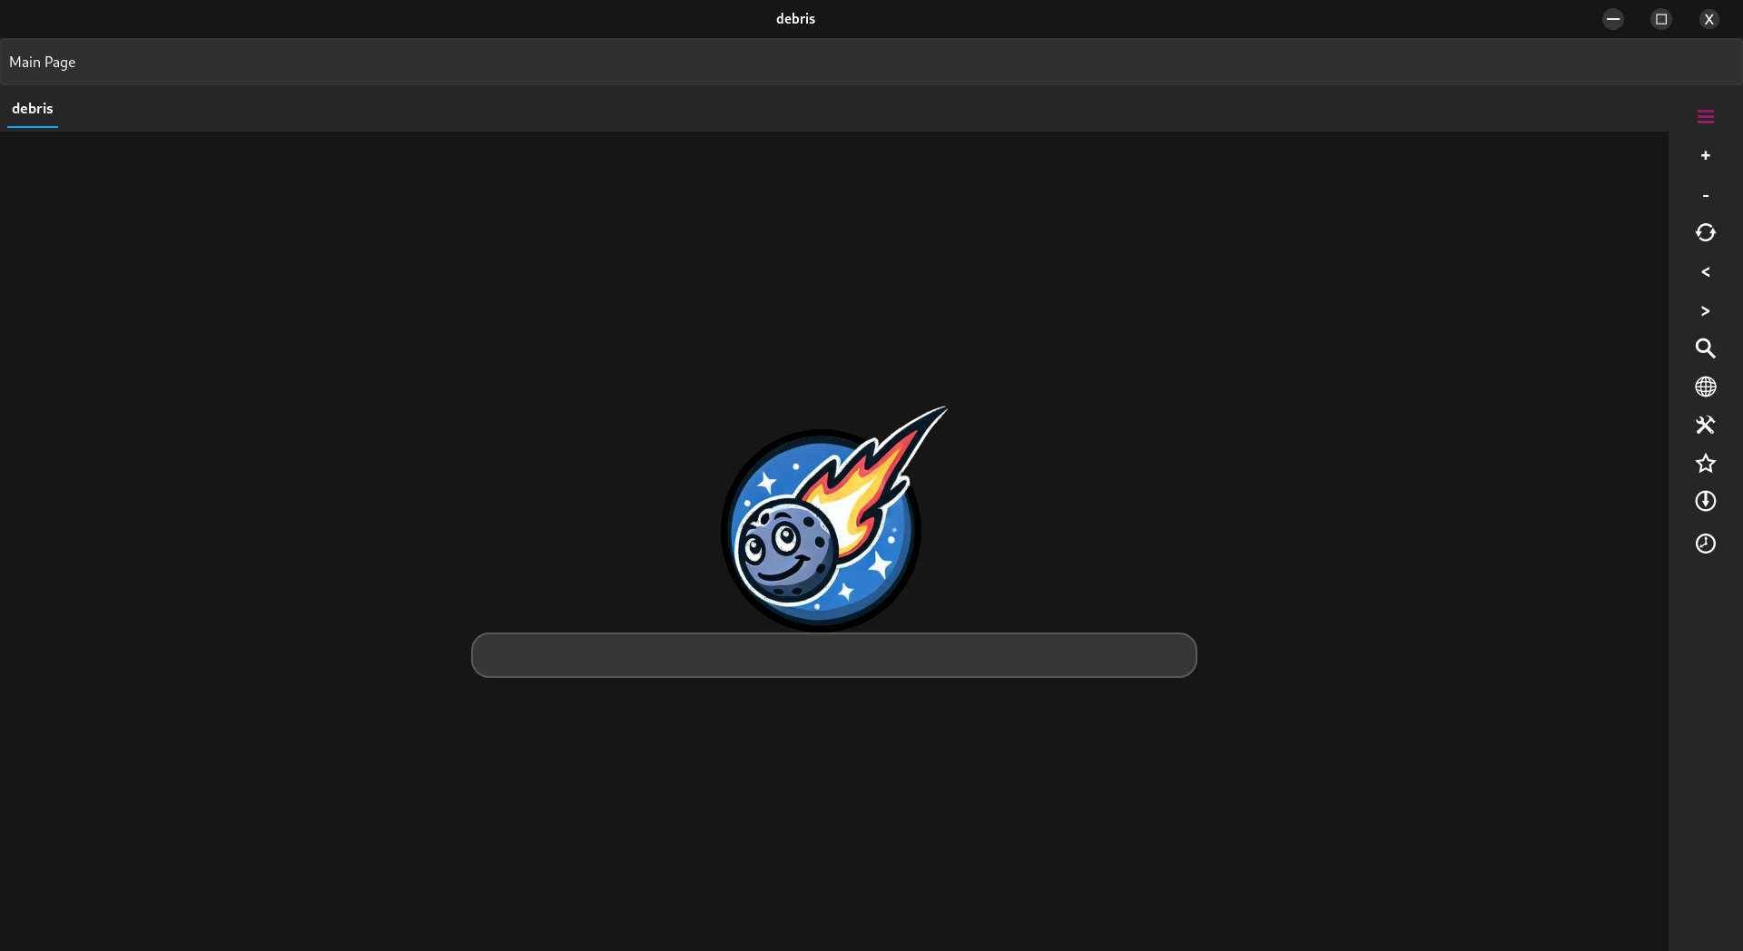

TOP SECTION

In the top section, you'll find the header bar, address bar, and tab bar. The header bar contains controls for minimizing, maximizing, and closing the program window .

Additionally, by holding down the left mouse button on the bar and moving the mouse, you can reposition the window as desired.


The address bar displays the web page's URL you're viewing or the path of the file if you're working with a local file. You can also use this bar to access the desired website by typing its URL and pressing Enter on the keyboard. Thanks to the button located in the toolbar, you can also hide the address bar to allocate more space to the content you're viewing.


The tab bar, on the other hand, is a tool that allows you to keep track of the pages you're viewing and easily switch between them with a single click. Each tab displays the name of the site or document being viewed along with a colored line: blue for the active page and red for inactive pages. This makes navigation highly intuitive and efficient.

SEARCH BAR



The search bar allows you to find anything you need on the web effortlessly. Simply type the word or phrase you'd like to search for, then press Enter on your keyboard. From the general menu you can select your preferred search engine to use for your queries. You can choose from a list of options tailored to your browsing experience.

Search engine available:

 |  |  |  |  | 
Bing | DuckDuckGo | Google | Wikipedia | Yahoo | WolframAlpha

TOOLBAR

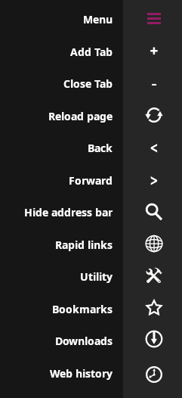
MENU
This section serves as the central hub for controlling the app and navigating its features. At the top, you'll find the menu button. Clicking on it opens the main menu, where you can perform various actions such as opening files, deleting bookmarks and browsing history, selecting the search engine for the search bar, and customizing the appearance by choosing from five themes or three accessibility-focused themes.
Additionally, the menu provides options to consult the user guide and access information about the software version via the "About" button. This intuitive layout ensures that all essential functions are easily accessible, making the app both user-friendly and versatile.

ADD TAB

Tap this button to instantly open a new tab in the web view, enabling you to explore additional pages without leaving your current session. This feature ensures seamless multitasking and an enhanced browsing experience.

CLOSE TAB

Use this button to effortlessly close the currently selected tab, keeping your browsing session organized and streamlined.

RELOAD PAGE

Refresh the content of the active tab instantly with a single click, ensuring you have the most up-to-date version of the page.

BACK

Navigate effortlessly to the previous page in the active tab, retracing your steps with ease.

FORWARD

Move forward to the next page in your browsing history with just one click, returning seamlessly to previously viewed content.

HIDE ADDRESS BAR

Click on it to hide or to show the address bar.

RAPID LINKS

By clicking, a menu will open, providing you with links to a variety of websites organized into four categories: Search, News, Video, and Education. This feature allows you to quickly explore the latest updates and trends with a global perspective. It also offers access to engaging videos and high-quality educational materials to support learning and discovery.

This streamlined menu is designed to enhance your browsing experience, offering easy navigation and quick access to relevant content. Whether you're researching, staying informed, or seeking entertainment and educational resources, this tool empowers you to explore the web efficiently and effortlessly.

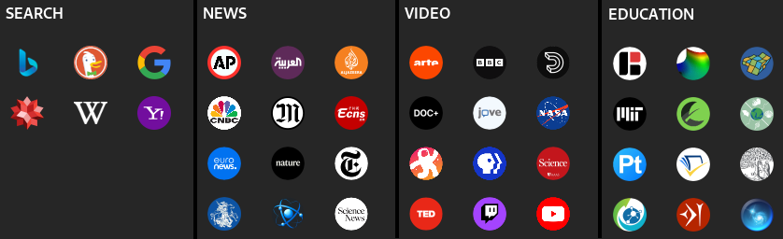

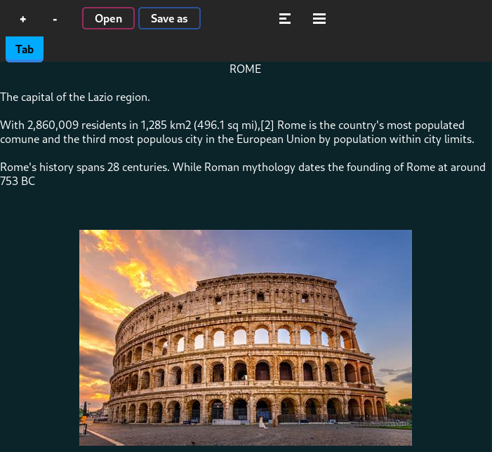
UTILITY

This section offers a suite of useful tools tailored for various tasks, including:
- Notebook: A versatile tool for note-taking and idea organization. It can also be used to display code, with syntax highlighting that makes code structure clear and easy to understand—perfect for programmers or anyone working with technical scripts.

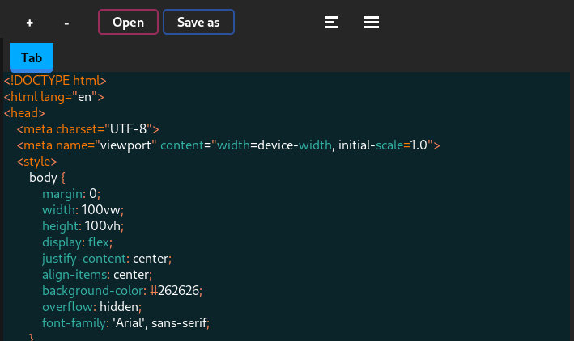
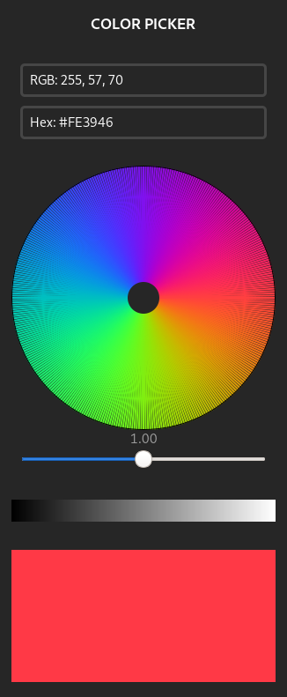
- Calculator: A fast and reliable solution for performing calculations, ranging from basic operations to more advanced functions.
- Console: A browser web console that provides advanced functionalities for inspecting web elements, debugging scripts, and analyzing web page behavior. An indispensable tool for developers working with websites.
- Network Speed Test: Allows you to measure your internet speed in real-time, ensuring smooth connectivity and helping troubleshoot any issues.
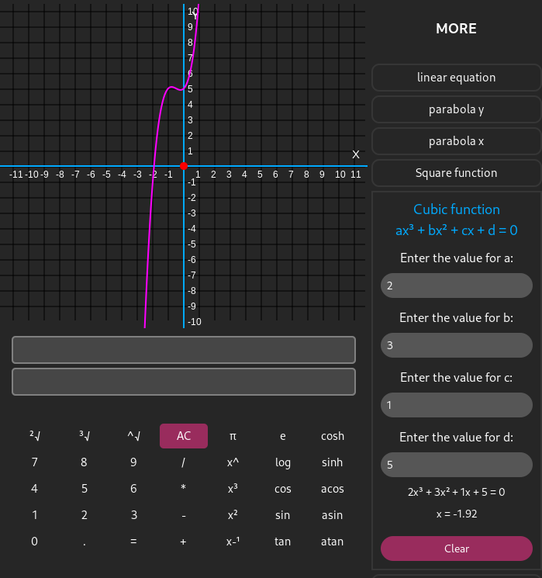
- Color Picker: An essential tool for designers and creatives, enabling precise identification and selection of color codes.

These tools are carefully designed to optimize productivity and enhance your workflow.

BOOKMARKS

The bookmarks section allows you to save all your favorite web pages, ensuring you can access them quickly and effortlessly anytime. This feature is designed to streamline your browsing experience by keeping all your important links organized and easily reachable. Whether you're revisiting frequently used sites or preserving pages for future reference, the bookmarks section offers a convenient and intuitive solution.

DOWNLOADS

The download bar provides access to not only the files downloaded through the browser but also the entire contents of your download folder. From here, you can conveniently open files directly without navigating to the folder manually. This feature is designed to simplify file management, ensuring that your downloads are always easily accessible and ready to use.

WEB HISTORY

The web history section offers an innovative way to keep track of the pages you've visited. It saves web addresses intelligently, organizing them in a manner that makes it effortless to revisit your favorite sites or retrace your steps. With a sleek design and smart categorization, this feature helps you find relevant links quickly, whether you're resuming research, exploring past discoveries, or simply curious to revisit a previously visited website. Its intuitive approach to storing and managing web history ensures that navigation remains smooth and efficient, saving you time and enhancing your browsing experience.

