Introduction

Fox and Goose
[[Elidee]] and [[Rircin]] go to the [Fox and Goose]
- They're going in disgsed to a meeting point inside the [[City of the South]]
- [[Emlanor Stormwind]] drops their desguise and reveals themselves to Elidee.
  - Emlanor warns of potential dangers to them
  - Emlanor informs them that a half-ling is watching over them in the bar
    - Rircin has his mount
- The crew leaves via back alleys of the City of the South.
  - Crew #roll-perception 20 & 4
    - Initially, Emlanor is taking them via back alleys on a seemingly different direction than the way of the Fox and Goose
    - Elidee is excited to meet her mom.
- Rircin and Elidee goes to get Rircin's horse
  - Elidee turns into a Mouse and gets into Rircin's pocket.
  - Rircin hasn't named his horse yet
    - Elidee thinks that it would be nice to ask the horse for their name
- Emlanor guides them hastly through the alleys of the city
  - Crew #roll-perception 23 & 16
    - Elidee notices that a person is running interferance along their current path in near alleys
      - The person is wearing [[Blue and Green]] colors similar to the city folks
    - Rircin is informed of this and recognizes the colors and tells them to be careful
- The crew slows down as they get to the outer walls
  - Crew #roll-survival 18 | 3
    - The crew reaches a crossing
    - There's a large fast cart coming at their direction
    - 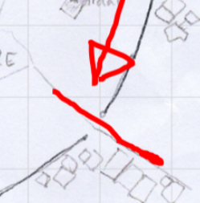
    - Elidee saves Rircin
  - Crew #roll-investigation X | 5
    - Emlanor is standing still on the other side of the road.
    - Elidee doubts if Emlanor is real or an illusion
    - Elidee #roll-investigation 14
      - Emlanor is real and the person they've been following
  - Rircin standing away from Elidee and Emlanor #roll-investigation 16
    - Rircin notices that from the other side of the street, the person tracking them in Blue and Green is approaching quickly.
    - Behind him, also more people in Blue and Green are also approaching.
  - Elidee #roll-insight 23
    - Notices strange behavior from Emlanor
    - Elidee #cast bright flash and horse noise to confuse the people around the street. Goal is to confuse, not for a stampede
  - Elidee tries to blend into the crowd
- Parties seem to be converging into the crew
  - 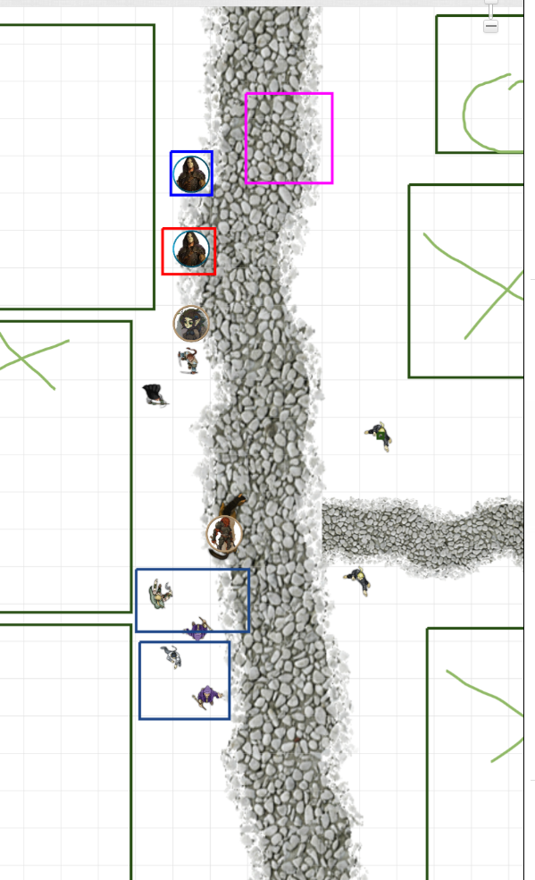
  - Elidee thinks that they should trust Emlanor on this, as he said that he'd take care of it
  - The guards are stopping
    - They seem to be looking for trouble with Emlanor

