Machine Learning Project Documentation
Project Cover Sheet
Faculty: Computer science Helwan uni
Course Name: ML
Team Number: 6
Team Members:
- Gehad Abdelaziz Ibrahim
- Aliaa Mohamed
- Ghada Saeed
- Fatema badawy
- A’laa kamal
- Ayat-Allah

Model 1: K-Nearest Neighbors (KNN) - Insurance Cost Prediction
A. General Information on Dataset
Dataset Name: Insurance Cost Dataset
Number of Classes: Regression task (continuous target variable)
Class Labels: Not applicable (regression task predicting insurance charges)
Total Samples: 1,338
Sample Features:
- Age (numerical)
- Sex (categorical: male, female)
- BMI (numerical)
- Children (numerical: 0-5)
- Smoker (categorical: yes, no)
- Region (categorical: northeast, northwest, southeast, southwest)
- Charges (target variable - continuous)
Data Split:
- Training samples: 1,070 (80%)
- Testing samples: 268 (20%)
- Validation: Not used separately (cross-validation applied)
B. Implementation Details
Feature Extraction Phase:
- Number of features extracted: 6 features
- Feature names: age, sex (encoded), bmi, children, smoker (encoded), region (encoded)
- Feature dimensions: 6-dimensional feature vector after encoding categorical variables
- Encoding method: Label Encoding for categorical variables (sex, smoker, region)
Cross-Validation:
- Cross-validation used: Yes
- Number of folds: 5
- Training/Validation ratio per fold: 80%/20%
- Mean CV R² Score: 0.7266 (±0.0334)
Hyperparameters:
- Model: K-Nearest Neighbors Regressor
- Initial K value: 5
- Optimal K value: 8 (determined through grid search from K=1 to K=30)
- Distance metric: Euclidean (default)
- Weights: Uniform (default)
- Feature scaling: StandardScaler applied
C. Results Details (on Testing Data)
Best Model Performance (K=8):
- Test MAE: $3,888.39
- Test RMSE: $5,638.87
- Test R² Score: 0.7898
Training Performance (K=8):
- Train MAE: $3,271.27
- Train RMSE: $5,127.19
- Train R² Score: 0.8047
Model Evaluation Visualizations:
- K vs R² Score curve showing optimal K selection
- Actual vs Predicted scatter plots for train and test sets
- Residual plots showing prediction errors
- Metrics comparison bar char

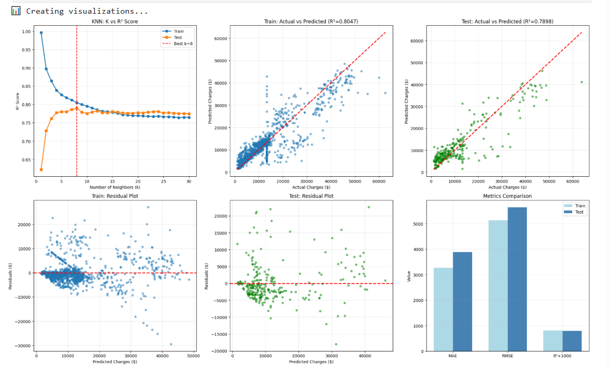

Model 2: K-Means Clustering - Malaria Cell Detection
A. General Information on Dataset
Dataset Name: Malaria Cell Images Dataset
Number of Classes: 2
Class Labels:
- Class 0: Parasitized (infected cells)
- Class 1: Uninfected (healthy cells)
Total Samples: 10,000 images (sampled from full dataset)
Sample Size: 96×96 pixels (grayscale images)
Data Distribution:
- Parasitized: 5,000 samples (50%)
- Uninfected: 5,000 samples (50%)
Note: All 10,000 samples used for unsupervised clustering (no train/test split for clustering phase)
B. Implementation Details
Feature Extraction Phase:
- Total features extracted: 8,157 features per image
- Feature types:
  - HOG (Histogram of Oriented Gradients):
    - Orientations: 9
    - Pixels per cell: (8, 8)
    - Cells per block: (3, 3)
    - Block normalization: L2-Hys
  - LBP (Local Binary Patterns):
    - Two scales: P=8,R=1 (10 bins) and P=16,R=2 (18 bins)
    - Total LBP features: 28
  - GLCM (Gray Level Co-occurrence Matrix):
    - Distances: [1, 2]
    - Angles: [0, π/4, π/2]
    - Properties: contrast, dissimilarity, energy, ASM
    - Total GLCM features: 24
  - Statistical features: Mean, Std, Range, Skewness, Kurtosis (5 features)
- Feature dimensions after extraction: 8,157 features
- Dimensionality reduction: PCA applied
- Features after PCA: 50 components
- Variance explained by PCA: 35.87%
Cross-Validation:
- Cross-validation used: No (unsupervised clustering)
- Validation method: Silhouette Score and Elbow Method used to determine optimal clusters
Hyperparameters:
- Model: K-Means Clustering
- Number of clusters (K): 2
- Initialization method: K-means++ (default)
- Number of initializations (n_init): 20
- Maximum iterations: 300 (default)
- Random state: 42
- Optimal K determined by: Silhouette Score (highest at K=2)
C. Results Details (on Full Dataset)
Clustering Performance:
- Overall Accuracy: 70.44% (after mapping clusters to ground truth labels)
- Silhouette Score: 0.0676
Classification Report:
Precision Recall F1-Score Support
Parasitized 0.6811 0.7686 0.7222 5000
Uninfected 0.7345 0.6402 0.6841 5000

Accuracy 0.7044 10000
Macro Avg 0.7078 0.7044 0.7032 10000
Model Evaluation Visualizations:
- Elbow Method curve (Inertia vs K)
- Silhouette Analysis curve (Silhouette Score vs K)
- 2D PCA visualization of clusters with true labels
- Confusion Matrix
- ROC Curve (AUC = 0.70)
- Cluster distribution bar chart

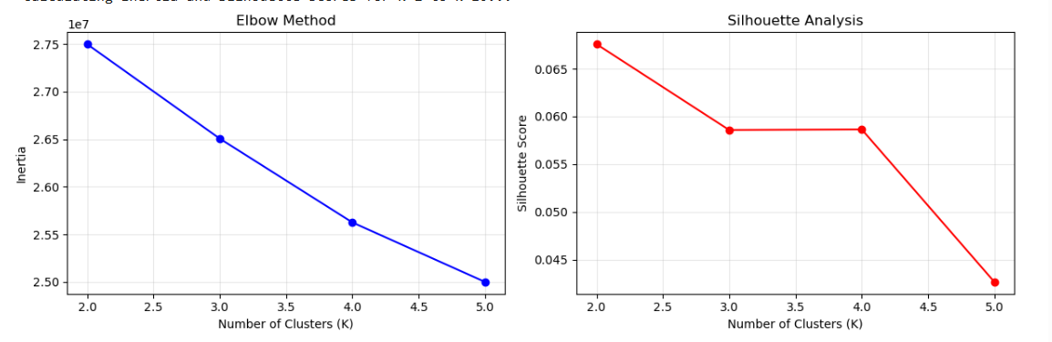
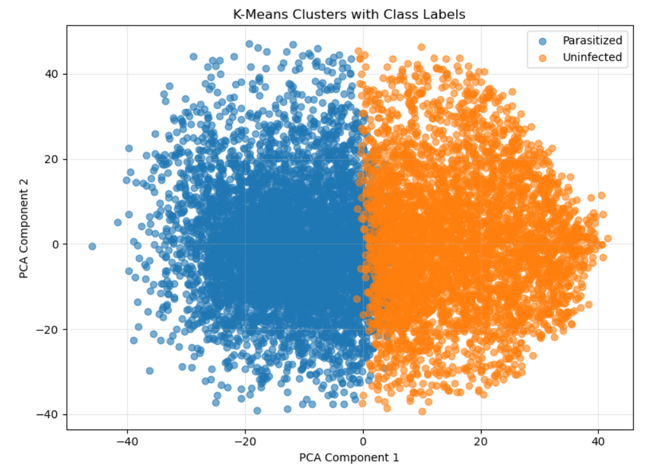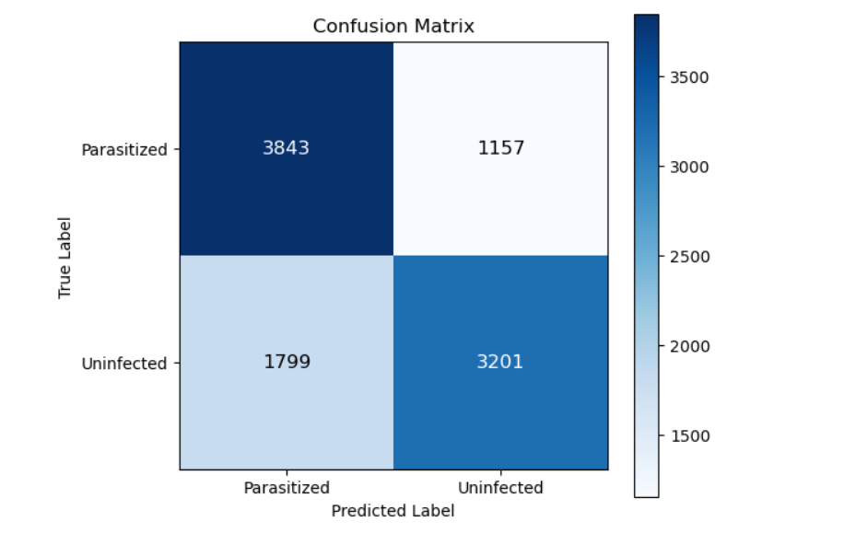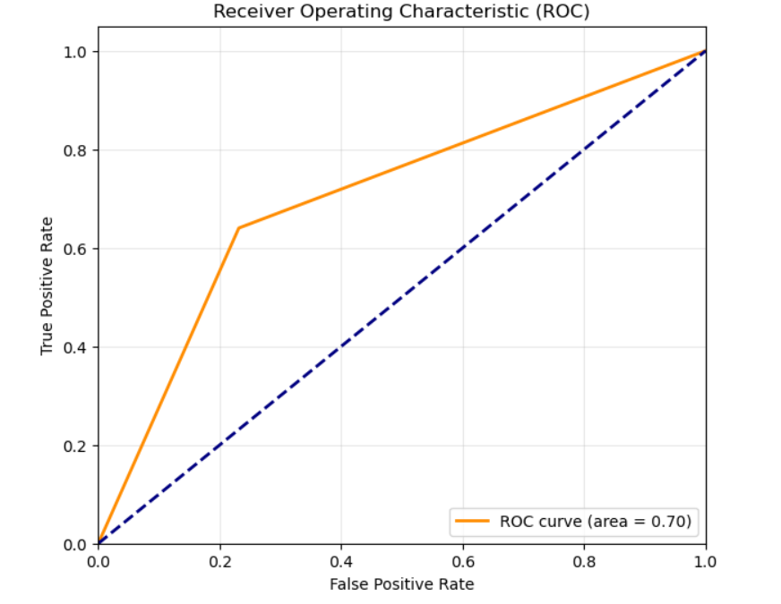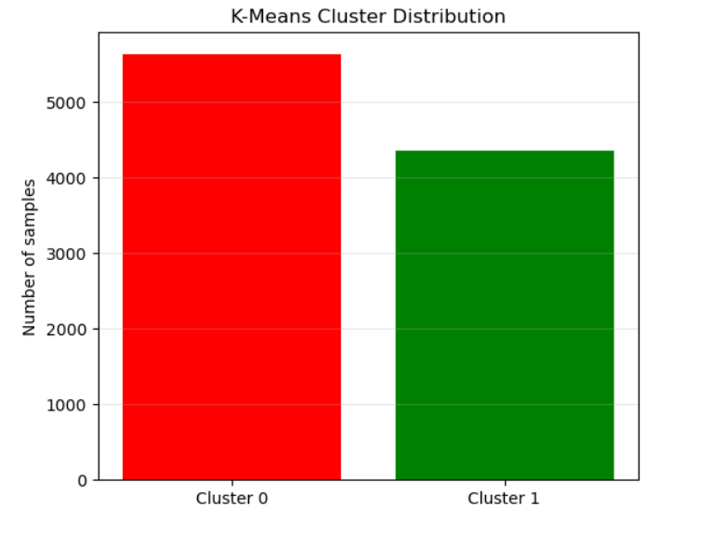
Model 3: Logistic Regression - Malaria Cell Detection
A. General Information on Dataset
Dataset Name: Malaria Cell Images Dataset
Number of Classes: 2
Class Labels:
- Class 0: Uninfected (healthy cells)
- Class 1: Parasitized (infected cells)
Total Samples: 27,558 images
Sample Size: 80×80 pixels (RGB color images)
Data Split:
- Training samples: 19,290 (70.0%)
- Validation samples: 4,134 (15.0%)
- Testing samples: 4,134 (15.0%)
Data Distribution (Balanced):
- Parasitized: 13,779 samples
- Uninfected: 13,779 samples
B. Implementation Details
Feature Extraction Phase:
- Image preprocessing:
  - CLAHE (Contrast Limited Adaptive Histogram Equalization) on L channel
  - Gamma correction (γ = 1.4)
  - Sharpening filter applied
- Features extracted:
  - Image pixel features: 19,200 features (80×80×3 flattened)
  - Color statistical features: 102 features
    - Mean and Std for each RGB channel (6 features)
    - Color histograms (32 bins × 3 channels = 96 features)
- Total features before PCA: 19,302 features
- Dimensionality reduction: PCA with 800 components
- Variance explained by PCA: 76.09%
- Final feature dimensions: 902 (800 PCA + 102 color features)
Cross-Validation:
- Cross-validation used: No (separate validation set used)
- Training/Validation/Test split: 70% / 15% / 15%
Hyperparameters:
- Model: Logistic Regression
- Solver: SAGA
- Regularization: L2 (Ridge)
- Regularization parameter (C): 1.0
- Maximum iterations: 2,000 (20 steps × 100 iterations per step)
- Learning rate: Adaptive (SAGA solver)
- Tolerance: 1e-4
- Warm start: True
- Random state: 42
C. Results Details (on Testing Data)
Test Set Performance:
- Test Accuracy: 89.24%
- Test ROC-AUC Score: 0.9536
Detailed Classification Metrics:
Precision Recall F1-Score Support
Uninfected (Class 0) 0.8683 0.9250 0.8958 2067
Parasitized (Class 1) 0.9198 0.8597 0.8887 2067

Accuracy 0.8924 4134
Additional Metrics:
- Sensitivity (Recall for Parasitized): 85.97%
- Specificity: 92.50%
- Precision: 91.98%
Training Performance:
- Final Training Accuracy: 91.54%
- Final Training Loss: 0.2434
- Final Validation Accuracy: 88.70%
- Final Validation Loss: 0.2989
Model Evaluation Visualizations:
- Loss Curve (Training and Validation loss vs iterations)
- Accuracy Curve (Training and Validation accuracy vs iterations)
- Confusion Matrix with detailed counts
- ROC Curve (AUC = 0.9536)
- Decision Boundary visualization (2D PCA projection)
- Sigmoid curve for logistic function
- Predicted probability distribution

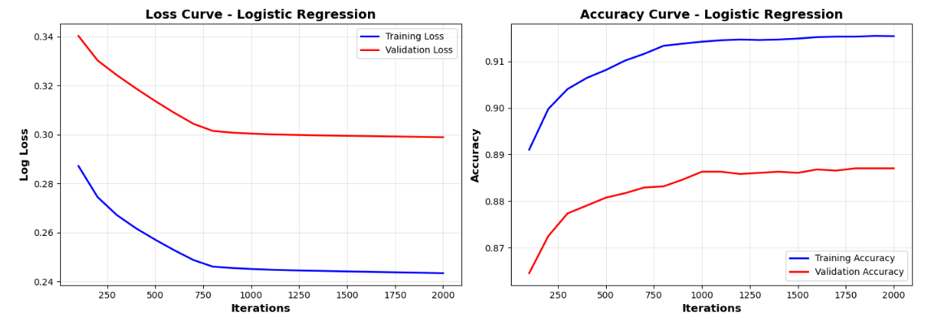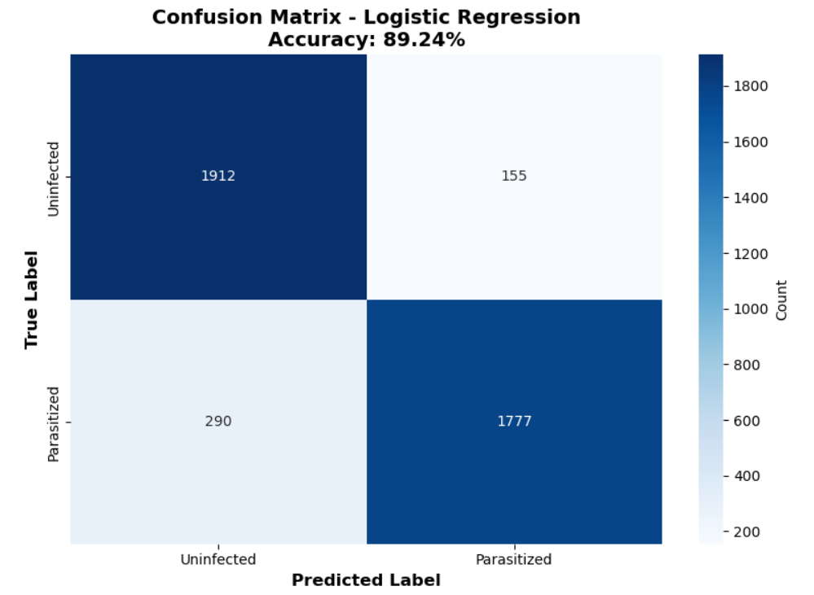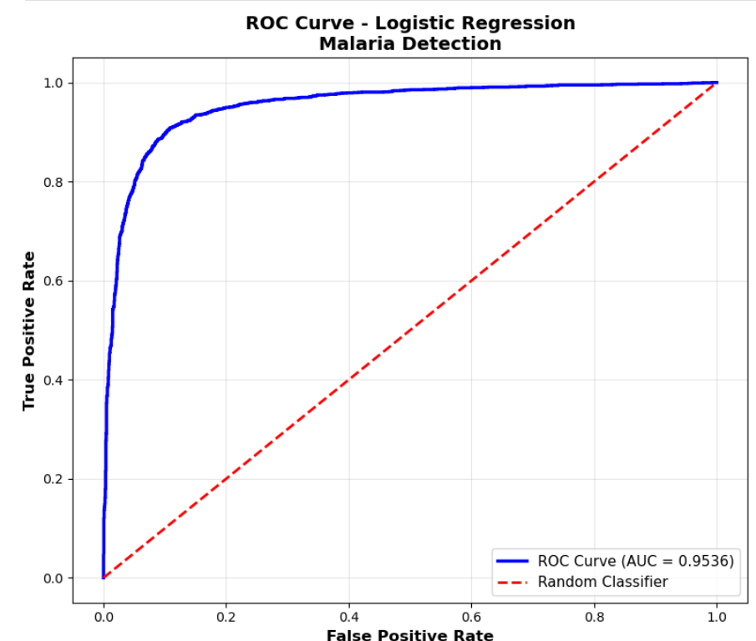
Model 4: Lasso Regression - Insurance Cost Prediction
A. General Information on Dataset
Dataset Name: Insurance Cost Dataset
Number of Classes: Regression task (continuous target variable)
Class Labels: Not applicable (regression - predicting insurance charges)
Total Samples: 1,338
Sample Features:
- Age (numerical)
- Sex (categorical: male, female)
- BMI (numerical)
- Children (numerical: 0-5)
- Smoker (categorical: yes, no)
- Region (categorical: northeast, northwest, southeast, southwest)
- Charges (target variable - continuous)
Data Split:
- Training samples: 1,070 (80%)
- Testing samples: 268 (20%)
- Validation: Not used separately
B. Implementation Details
Feature Extraction Phase:
- Original features: 6 features (age, sex, bmi, children, smoker, region)
- Preprocessing steps:
  - Missing value imputation using IterativeImputer (10 iterations)
  - One-Hot Encoding for categorical variables (sex, smoker, region) with drop='first'
  - StandardScaler for numerical features
  - Polynomial features generation (degree=2, no bias term)
- Features after preprocessing: Multiple polynomial features generated
- Feature dimension: Expanded through polynomial transformation
Cross-Validation:
- Cross-validation used: No (single train-test split)
- Alternative training approach: SGD (Stochastic Gradient Descent) with 100 epochs for loss curve visualization
Hyperparameters:
Lasso Regression:
- Regularization parameter (alpha): 0.01
- Maximum iterations: 10,000
- Solver: Coordinate Descent (default for Lasso)
- Random state: 42
SGD Regression (for loss curves):
- Loss function: Squared Error
- Penalty: L2
- Learning rate: Constant
- Initial learning rate (eta0): 0.001
- Max iterations per epoch: 1
- Warm start: True
- Total epochs: 100
C. Results Details (on Testing Data)
Lasso Regression Performance:
- Test MAE: $3,125.69
- Test RMSE: $4,719.92
- Test R² Score: 0.8541
Training Performance:
- Train MAE: $3,001.96
- Train RMSE: $4,850.88
- Train R² Score: 0.8359
Comparison with KNN (on same dataset):
- KNN Test MAE: $4,163.72
- KNN Test RMSE: $6,524.16
- KNN Test R² Score: 0.7213
Key Finding: Lasso Regression outperforms KNN on this dataset with better accuracy and lower error rates.
Model Evaluation Visualizations:
- Actual vs Predicted scatter plot
- Residuals plot showing prediction errors
- Residuals distribution histogram
- Training vs Testing metrics comparison
- Loss curve for SGD training (100 epochs)
- Lasso vs KNN performance comparison

Summary and Conclusions
Model Performance Overview:
Model | Task | Dataset | Accuracy/R² | Key Strength
KNN | Regression | Insurance | R²=0.7898 | Simple, interpretable
K-Means | Clustering | Malaria | 70.44% | Unsupervised learning
Logistic Regression | Classification | Malaria | 89.24% | High accuracy, good AUC
Lasso Regression | Regression | Insurance | R²=0.8541 | Best regression performance
Key Observations:
- Insurance Cost Prediction:
  - Lasso Regression achieved the best performance (R² = 0.8541)
  - KNN performed well but was outperformed by Lasso (R² = 0.7898)
  - Polynomial features significantly improved model performance
- Malaria Cell Detection:
  - Logistic Regression achieved 89.24% accuracy with excellent AUC (0.9536)
  - K-Means clustering achieved 70.44% accuracy in unsupervised setting
  - Feature engineering (HOG, LBP, GLCM) was crucial for performance
  - PCA effectively reduced dimensionality while retaining important information
- Feature Engineering Impact:
  - Advanced preprocessing (CLAHE, gamma correction) improved image classification
  - Polynomial features enhanced regression model performance
  - PCA successfully reduced high-dimensional data while maintaining performance

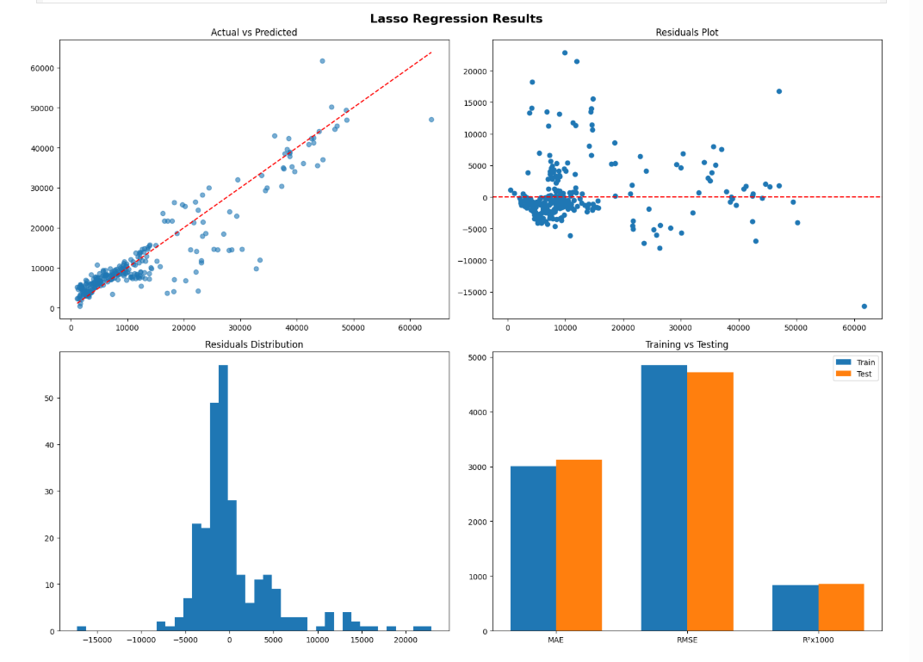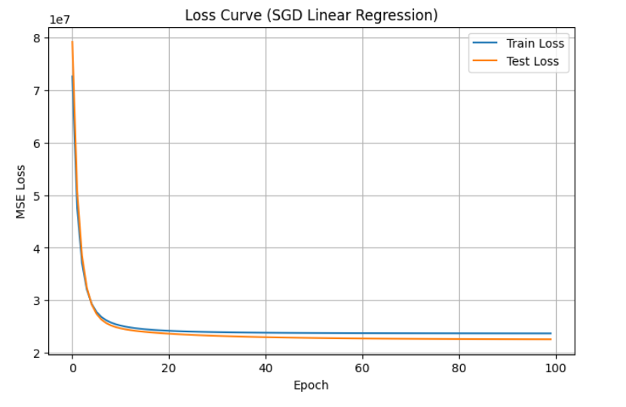
End of Documentation

