* Is the data normally distributed?

No the data are not normally distributed,

* How many DEGs do you had ? (using the criteria logFC >1.5, P.adjusted <0.05)

3689 differentially expressed genes

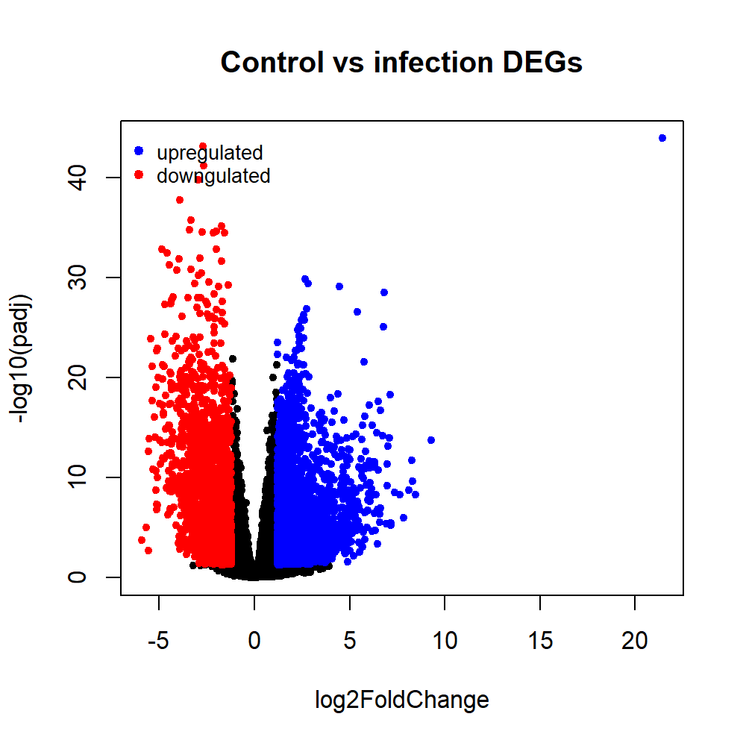**Volcano Plot**

**Heat Map**

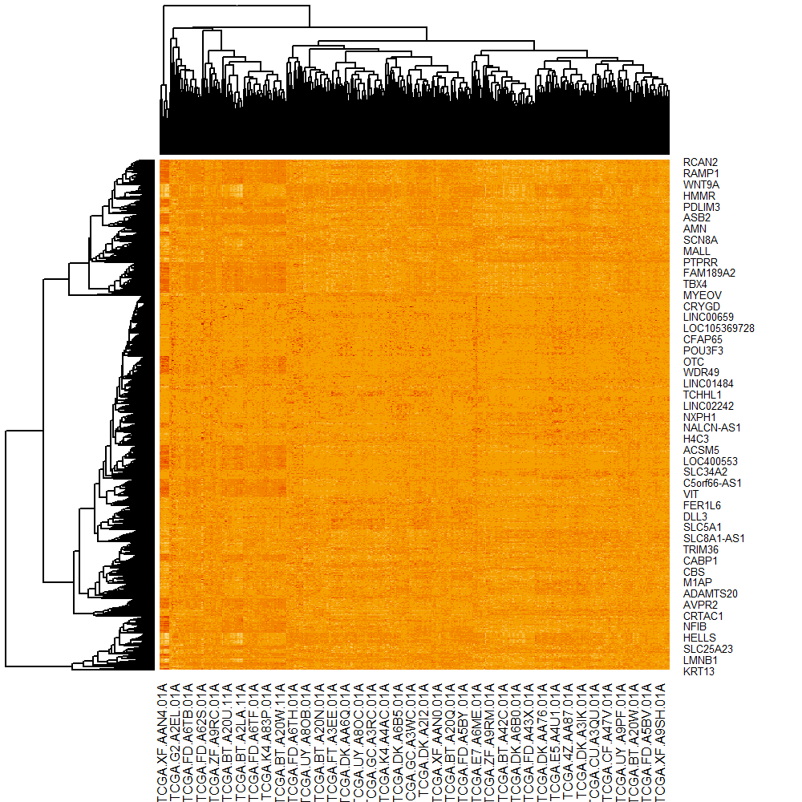

Top 5 KEGG pathways are:

1-Neuroactive ligand-receptor interaction

2-Calcium signaling pathway

3-Circadian entrainment-

4-cAMP signaling pathway

5-Hypertrophic cardiomyopathy