SMARTAQUA PRO: IOT-BASED AQUARIUM MONITORING AND AUTOMATION
SYSTEM


Presented to the
Institute of Computing
Davao del Norte State College
Panabo City, Davao del Norte
In Partial Fulfillment of the Requirements for the Degree
BACHELOR OF SCIENCE IN INFORMATION TECHNOLOGY
Wendyl Ziv S. Arellano
Dennis Mark L. Jamero
Gian Carlo R. Marin
JUNE 2026
CHAPTER 1
INTRODUCTION

Background of Study
Regular checks of the water quality and equipment used in the aquarium are essential to ensure a stable aquatic environment. Feeding, accumulation of waste material, evaporation, algal growth and decay, filtration effectiveness, maintenance, and loss of power can all result in changes in aquarium conditions. The water temperature, pH level, turbidity, total dissolved solids, ammonia level, and water level are all parameters that are measurable and can provide information about the aquarium condition. If these parameters change and are not noticed in time, maintenance procedures might be delayed, and the aquarium may develop conditions that are unsuitable for fish [1]–[3].
Manual observation and scheduled checking are traditionally used for aquarium maintenance. The responsibilities of the user are to personally check the aquarium, observe water clarity, monitor equipment operation, check water levels, feed fish, and determine if maintenance is required. However, manual monitoring can become irregular if users are unavailable, responsible for more than one aquarium, or unable to notice gradual changes in aquarium water parameters. Manual checking also provides limited historical data because observations may not be consistent. These limitations create the need for a system that can continuously gather aquarium condition data, store information, and present it in an accessible manner.
The Internet of Things (IoT) has become a practical approach for continuous environmental and water quality monitoring. A typical IoT system consists of sensors, microcontrollers, communication networks, cloud databases, and software applications that collect and exchange data in real time. Previous studies have demonstrated the capability of IoT systems to monitor parameters such as water temperature, pH, turbidity, total dissolved solids, dissolved oxygen, and water levels. These systems allow users to remotely access readings while maintaining historical records that enable faster detection of abnormal conditions compared with conventional manual monitoring [4]–[7].
In recent years, various aquaculture monitoring approaches have also demonstrated the use of sensor-based data collection to support more timely and informed water management decisions.
Although real-time monitoring provides valuable information, it does not always provide users with guidance on what actions should be taken after an abnormal reading or alert is detected. For example, when turbidity exceeds acceptable levels, the system may display a warning, but the operator must still determine whether to inspect the filtration system, remove accumulated waste, review recent feeding activities, or perform a partial water change. A monitoring system that only identifies whether a condition is normal or abnormal remains primarily descriptive because it reports the current situation without directly supporting maintenance decisions.
This limitation can be addressed through the use of prescriptive analytics, which interprets aquarium conditions and provides recommended maintenance actions. The prescriptive analytics process in SmartAqua Pro will utilize built-in IF-THEN rules that consider current sensor readings, condition levels, aquarium profiles, equipment status, and estimated bioload. The system determines whether a condition is NORMAL, WARNING, or CRITICAL and provides corresponding recommendations. For example, when turbidity reaches a warning level, the system may recommend inspection of the filtration system and checking for visible food waste accumulation. If the water level becomes low, the system may recommend checking for evaporation or leakage before adding properly prepared water. This rule-based approach provides transparency because recommendations are generated from defined conditions and corresponding actions rather than relying on unexplained predictions. Previous studies have demonstrated that integrating water quality data with recommendation functions in IoT-based systems can assist users in decision-making rather than only measuring environmental conditions [8].
Multiple users and multiple aquarium units may also be involved in aquarium monitoring. Without proper data separation, sensor readings, alerts, recommendations, and maintenance activities may become associated with the wrong aquarium. Therefore, a centralized system is necessary to store user profiles, register individual aquariums, and associate each collected reading with the appropriate user and aquarium unit. This approach allows users to receive accurate updates, condition alerts, and maintenance recommendations for their respective aquariums. It also supports reliable reporting of abnormal conditions and corresponding maintenance actions performed.
Aquarium management is applicable in households, schools, laboratories, and small facilities for recreation, education, demonstration, and research purposes. However, for small-scale aquarium environments, an accessible system that integrates continuous monitoring, alerts, maintenance recommendations, automation, historical records, equipment status monitoring, and remote access may not always be available. The proposed SmartAqua Pro project at Davao del Norte State College demonstrates how information and communication technologies and Internet of Things (IoT) concepts can be applied to monitor aquarium conditions and support small-scale aquatic management. The project also contributes to Sustainable Development Goal 14 (Life Below Water) by promoting improved monitoring and responsible maintenance of aquatic environments.
Furthermore, SmartAqua Pro aligns with national and institutional research and development priorities that promote sustainable innovation, digital transformation, and technology-driven aquatic management. The project supports the Commission on Higher Education (CHED) A.C.H.I.E.V.E. Agenda 2025–2030, particularly its Harmonized
SDG-Based Research and Innovation and Integrated Real-Time Data Collection and Analytics System thrusts, through the use of IoT-based monitoring, data analytics, and evidence-based decision support for aquatic environments (Commission on Higher Education [CHED], 2025). It also aligns with the Department of Science and Technology Harmonized National Research and Development Agenda (DOST-HNRDA) 2022–2028, specifically under the Agriculture, Aquatic, and Natural Resources (AANR) Research and Development Agenda, by applying emerging technologies for sustainable aquatic resource monitoring and management (Department of Science and Technology [DOST], 2022). Moreover, the project supports the Davao del Norte State College (DNSC)
Research, Development, and Extension (RDE) Agenda 2026–2030, particularly the Accelerate Agri-Aqua (A3) Agenda and Innovation and Inclusion (I2) Agenda, through the development of an IoT-enabled solution that promotes innovation and digital applications in the agri-aqua sector (Davao del Norte State College [DNSC], 2026). These alignments highlight the relevance of SmartAqua Pro as a research initiative that contributes to sustainable aquatic practices, technological advancement, and community-oriented innovation.
To address this, this study has been designed to present a prescriptive analytics-based SmartAqua Pro: System for Monitoring and Automating Aquariums Using an IoT Platform. The system will track aquarium variables such as water temperature, pH, turbidity, total dissolved solids, ammonia level, water level, filtration status, and power status. It will analyze collected readings against reference values, determine the aquarium condition as “normal,” “warning,” or “critical,” and provide real-time alerts and maintenance recommendations. Records of aquarium-specific values, sensor readings, recommendations, maintenance activities, and equipment controls supported by the system will also be stored and made available through a web-based dashboard and mobile application.
Goldfish will be used as the selected ornamental fish in the prototype. Fish type, number of fish, tank size, and filter configuration will be included as part of the aquarium profile and will be used in establishing the appropriate rules. The study will not focus on biological growth, behavior, reproduction, disease, and/or health evaluation of goldfish. Instead, it will focus on monitoring aquarium conditions and delivering maintenance recommendations to users through clear instructions based on predefined rules.
With SmartAqua Pro, users will be able to view the current aquarium status, review aquarium history, receive aquarium-specific alerts, and obtain recommendations on appropriate maintenance actions based on predefined rules. The proposed system enables real-time monitoring and prescriptive analytics aimed at improving the consistency, availability, and responsiveness of small-scale aquarium management.

Objectives of the Study

General Objective
To design and develop SmartAqua Pro, an IoT-based aquarium monitoring and automation system with prescriptive analytics that monitors aquarium conditions and provides appropriate maintenance recommendations.

Specific Objectives
1. Develop an IoT-based monitoring component that collects real-time data on water temperature, pH, turbidity, total dissolved solids, total ammonia nitrogen, water level, filtration performance, equipment operation, and power status. 2. Assess aquarium conditions using predefined aquarium- and species appropriate parameter thresholds and generate maintenance recommendations based on the severity of identified deviations.
3. Manage aquarium profiles containing aquarium type, dimensions, operational water volume, filtration configuration, stocked fish species and quantity, and estimated bioload to support context-specific monitoring and analysis. 4. Provide web and mobile access to real-time aquarium conditions, alerts, historical monitoring records, and authorized controls for the feeder, filtration system, and lighting system.
5. Summarize water-quality trends, condition assessments, alerts, maintenance recommendations and completed actions, equipment status, and power interruption events through monitoring reports.

Significance of Study
The proposed SmartAqua Pro: IoT-Based Aquarium Monitoring and Automation System with Prescriptive Analytics is expected to improve the monitoring and maintenance of small-scale aquarium environments. The system provides real-time sensor readings, aquarium condition classification, alerts, maintenance recommendations, automation support, and historical records through web and mobile platforms.
Aquarium Owners and Hobbyists. The system will help aquarium owners monitor water conditions remotely and receive recommended maintenance actions when abnormal readings are detected. This may support more consistent aquarium care and quicker responses to changes in water quality.
Aquarium Caretakers. Caretakers will be provided with live readings, alerts, and prescriptive recommendations that will assist them in carrying out appropriate activities such as checking the filtration system, removing surplus waste, returning to feeding activities, and implementing a partial water change.
Multiple System Users. Authorized users will be allowed to monitor an aquarium that is linked to their accounts. This way they will maintain a user-separated monitoring of aquarium readings, alerts, recommendations, and monitoring records.
Schools and Academic Institutions. The project can operate as a useful tool for education, demonstration, and research purposes in the field of IoT, sensor technologies, aquarium monitoring, data logging, automation, and rule-based decision-making.
Researchers and Future Developers. The study can serve as a basis for new IoT-based environmental monitoring projects, prescriptive analytics, aquarium automation, multi user systems, and water quality management in the future.

Scope and Limitation
This work describes the creation and implementation of SmartAqua Pro- a monitoring and management system utilizing IoT in managing small freshwater aquariums. The system will check the following parameters: pH value, turbidity, total dissolved solids, temperature, ammonia content, water volume, filter status, appliance status and power status. The system will be able to classify the state of the aquarium as normal, warning or critical and provide recommendations on taking specific measures.
The system will keep information about the aquarium whatever tank type it is and its size, volume of water, filtration system, fish type, number of fish and estimated bioload. Very important feature is that the user will be able to use remote access through web-based interface or mobile application what allows to receive messages and recommendations, investigate historical data, manage sensors and provide reports. It is planned to test two aquariums with goldfish as they will demonstrate different users’ access types and responses of sensors in normal and simulated abnormal conditions.
The research will be confined to small freshwater aquariums with goldfish as the ornamental fish being studied. It will not take into account marine aquariums, commercial aquaculture systems or other species of fish where the parameters have not been verified. The research will not include predictive modeling, machine learning, reinforcement learning and water quality assessment and it will not evaluate the growth, behavior, reproduction, health or stress levels of the fish. The model will not automatically ensure proper pH level in the water either, as this is a process that will be completed by the user. Some of the factors that might affect the functionality of the model include the state of health and wellness of the hardware involved, the condition of the internet connection and the power supply and the accuracy of the pre-established regulations used to study the fish.

Review of Related Literature
Aquarium water should be monitored correctly, as the process of feeding, waste build-up, filtration, evaporation, and functioning of equipment poses an impact on aquarium conditions. Visual inspection or the results of a reading from only one sensor are not enough to assess water quality. Water quality can be analyzed by means of measuring a number of physical and chemical parameters, by which it is possible to estimate the levels and the types of chemical substances dissolved into the water, solids suspended in the water, waste build-ups, and whether the acted water conditions meet the needs of aquatic living organisms. It can be stated that the most usual parameters to be measured are pH, temperature of water, turbidity, dissolved solids, amount of ammonia, level of dissolved oxygen, and the water level of the aquarium itself [1], [4], [7].
Therefore, constant monitoring of the aquarium will allow through the findings made by the sensors to make analysis of water and any changes that may have occurred in the process of filtration, make necessary adjustments concerning feeding or making water replacement. SmartAqua Pro will, therefore, supply the users with the possibility to assess and analyze water quality according to the bits of information concerning behavior of every sensor and shall not give information about the purity of the water used in the aquarium. Size of the aquarium, its working capacity, filtration capacity, amount of fish in it, and bioload will influence the process of water quality change and shall be taken into consideration as a part of aquarium profile [1]-[3][23].
The Internet of Things allows instruments, microcontrollers, communication networks, databases, and software programs to constantly gather and share data related to aquariums. Monitoring systems based on IoT technology can measure parameters like pH value, water temperature, turbidity level, total dissolved solids, amount of dissolved oxygen, total ammonia, and water level and transmit information to web or mobile platforms for controlling the devices from a distance and studying historic data regarding water quality. The research of Jais et al., Shete et al., Chen et al., Lin et al., and Sung et al. proves that this technology can provide real-time monitoring of water quality, control
devices, and practically instantly identify the unusual situations occurring in water, thus
justifying the use of IoT technology in SmartAqua Pro [4]–[7], [10]–[12], [21].
The success of an aquarium monitoring system depends on how accurate and reliable the devices providing readings are. Cheap sensors are fine for experiences, yet their readings are subject to impact by calibration, sensor location, pollution, temperature, and noise. Previous studies prove that it is necessary to calibrate and validate sensors before their readings can be used in decisions concerning water quality. Thus, SmartAqua
Pro will develop the system allowing for sensor calibration, validation of their readings, and registration of dates when entries are entered, while values that are missing, impossible, or invalid will be considered potential sensor failures instead of triggering recommendations regarding any maintenance [5], [6], [12].
The rule-based threshold evaluation technique checks the sensor data collected against the standards established previously and assigns an appropriate level of seriousness based on the conditions of the aquarium. In case the reading is higher than or less than the threshold, the alarm is triggered, and action is due. It is suitable for SmartAqua Pro because it is straightforward to understand and can be validated better in comparison to other approaches based on machine learning. The user knows exactly what has happened with a certain piece of sensor reading that has activated the rule and why the aquarium has been put under the specific category [4], [6], [21].
Prescriptive analytics improves monitoring by giving the user an advice in case an unusual situation occurs. For instance, in case high turbidity is registered the system may prompt the user to check filters, clean and remove the waste and check for the recent feeding, while in case of low water level it may suggest checking the evaporation or any possible leakage before filling the tank. Thus, for the SmartAqua Pro system purposes the advices will be based on certain parameters: sensor reading, gravity of the problem, aquarium type, filtration mode and bio load [8].
Aquarium maintenance must not be performed solely on a timing basis since the rate at which water changes may vary. Readings from sensors and records of maintenance performed can show whether the user needs to clean the filter, dispose of
waste accumulated, investigate the feeding process, and/or partially change the water. The presence of SmartAqua Pro will not allow for forecasting dates of future water changes as it is not a predictive tool. Rather, it will make condition-based recommendations based on current readings, without assuming that a value that deviated is caused by a single problem. [8].
Also, a multiple-user aquarium monitoring system should ensure the accuracy of associations between sensor readings, notifications, recommendations, equipment status, and maintenance history to an appropriate user account and the aquarium it refers to. The design of SmartAqua Pro permits only authorized individuals to monitor the aquarium assigned to them, which prevents information from various aquariums being mixed. The roles principle allows for maintaining proper access rights based on user roles while separating aquarium-specific information. [31].
Cloud computing technology assists IoT systems by offering centralized data storage, synchronization of information in real time, authentication of users, and remote access. Just like IoT allows the values received through sensors to be stored and used by web and mobile applications, the service will use cloud platform to manage the app. Specifically, SmartAqua Pro will utilize Firebase service to manage user accounts, aquarium profiles, information from sensors, notifications, recommendations, equipment status and monitoring history. Yet internet access, secure authentication, and correct equipment configuration [24]–[26] are the basic prerequisite for remote access.
Data logging is used to record the information about the sensors’ performance, alerts, recommendations, equipment usage, and user activities. Thus, the accumulated history provides the opportunity to analyze previous conditions of the aquarium, consider what maintenance was performed and compile reports. In the context of SmartAqua Pro, historical data will create the possibility of testing the system, as well as generating reports and providing accountability.
According to the literature reviewed, IoT systems provide support for real-time monitoring of water quality, remote access, cloud storage, issuing alerts, logging historical data, and controlling devices, while the method of recommendation can
facilitate users in making better maintenance decisions [4]–[8], [10]–[12], [21]. At the same time, it can be noted that the existing systems are mainly limited to reading display, issuing alerts, feeding automatically or predictive approaches. Consequently, there is a missing link for the aquarium system, which will combine all the features mentioned above in one small system. At the same time, SmartAqua Pro provides a solution to this gap by turning actual generated readings into clear maintenance recommendations through prescriptive analytics based on predefined rules.

Related Works
Various IoT-based aquarium and aquaculture systems have been developed to support real-time water-quality monitoring, remote access, alerts, data storage, and equipment control. Olanubi et al. developed a cloud-connected system that monitored temperature, pH, and turbidity, provided a web interface, sent WhatsApp notifications, and controlled water pumps through automatic and manual modes [4]. Jais et al. focused on improving the accuracy of low-cost sensors and displayed real-time data through ThingSpeak and the Virtuino application [5]. Shete et al. developed an IoT method for real-time monitoring of temperature, pH, and dissolved oxygen, with emphasis on sensor calibration and data-driven water-quality assessment [6]. AquaBot combined real-time pond monitoring, Firebase storage, web and mobile interfaces, and machine-learning based fish-species recommendations [8]. Chen et al. developed a system for several fish ponds that supported real-time monitoring through web and mobile devices, abnormal
condition notifications, and automated sensor measurement and cleaning [10].
Table 1. Comparison table of existing system vs. the proposed system.
System | Real-Ti me  Monitori ng | Web/mobi  le remote access | Alerts or notifica  ti  ons | Autom  at ion or device control | Cloud or stored records | Power interrupti on monitorin g
Olanubi et  al. [4] | ✓ | ✓ | ✓ | ✓ | ✓
Jais et al.  [5] | ✓ | ✓
Shete et al. [6] | ✓
IAquaBot by Hemal  et al. [8] | ✓ | ✓ | ✓
Chen et  al. [10] | ✓ | ✓ | ✓ | ✓ | ✓
SmartAq  ua Pro  (Propos ed  System) | Planned | Planned | Planned | Planned | Planned | Planned

Definition of Terms
The following terms are operationally defined according to their use in the SmartAqua Pro system:
Alert – A system notification generated when an aquarium parameter, device status, or power status reaches a predefined warning or critical condition.
Ammonia Level – The measured concentration of ammonia in the aquarium water, used by the system as one of the indicators of aquarium condition.
Aquarium Condition Classification – The process of categorizing the current aquarium condition as normal, warning, or critical based on predefined threshold rules.
Aquarium Profile – System records contain aquarium information, including tank type, tank size, operating water volume, filtration system, fish species, fish amount, and estimated bioload of the aquarium.
Assigned Aquarium – The aquarium linked with the authorized user-monitoring account for reading, alerts, recommendation, and historical records.
Automation – The function that enables the execution of supported equipment (e.g., feeder, filter, light) based on the schedule, existing rules, or user commands.
Bioload – Estimated volume of biological waste generated in an aquarium based on the fish species, number of fish, approximate size of the fish, feeding frequency, and volume of the aquarium.
Dashboard – Either the web or mobile interface displaying readings, current state of the aquarium, notifications, recommendations, equipment status, and monitoring history.
Data Logging – Recording of sensor data, alerts, recommendations, equipment behavior, and activities of users, along with their respective time stamps.
Goldfish – The freshwater ornamental fish for the prototype aquarium; while mentioned in the aquarium profile for rule setting, the study does not analyze its biology, behavior or health.
Internet of Things (IoT) – A network of connected sensors, microcontrollers, communication services, databases, and applications for collecting, transmitting, storing, and displaying aquarium information.
Maintenance Recommendation – This is the system-generated recommendation to fix the issue in the aquarium including inspection of filter, figuring out the problem of over feeding, removing waste and undertaking partial water change.
Mobile Application – This is the application through which authorized users can keep a check on their aquariums, receive alerts and suggestions, maintain records and use supported functions.
Multiple-User Access – The component of the system that allows different users to log in and monitor their respective aquariums.
Power Interruption Monitoring – The system feature for checking power outage that disrupts the equipment related to aquarium and sends alerts to users.
Prescriptive Analytics – This is an analysis technique that is able to identify the most suitable action to be performed based on aquarium conditions and mentioned decision rules.
Real-Time Monitoring – The continuous collection, transmission, and display of aquarium sensor readings as they are received by the system.
Prescriptive Analytics – An analytical approach that evaluates the current aquarium condition and identifies an appropriate maintenance action. In SmartAqua Pro, prescriptive analytics is implemented using predefined IF-THEN rules based on sensor readings, equipment status, aquarium profile, and estimated bioload.
Sensor – A hardware component that measures aquarium parameters such as pH level, total dissolved solids, turbidity, water temperature, ammonia level, water level, filtration status, or power status.
SmartAqua Pro – The IoT-based aquarium monitoring and automation system developed in this study that integrates real-time sensing, prescriptive analytics, alerts, multiple-user access, data logging, and supported equipment control.
Threshold – A predefined minimum or maximum value used to determine whether an aquarium parameter is within a normal, warning, or critical condition.
Total Dissolved Solids (TDS) – The measured amount of dissolved substances in aquarium water, usually expressed in parts per million, and used as one indicator of aquarium condition.
Turbidity – The level of cloudiness in aquarium water caused by suspended particles and measured by the system as an indicator of water clarity.
Water Level Monitoring – The process of measuring the amount or percentage of water present in the aquarium to identify low or excessive water levels.
Working Water Volume – The concept of working water volume refers to the amount of water after considering factors such as the empty space, equipment, gravel, and decorations in the aquarium.
Web Application – Web application refers to the internet-based application that enables the users to check the status of their assigned aquarium, alerts, and recommendations, and some other aspects.
CHAPTER 2
METHODOLOGY
This research follows a hybrid project management approach that brings together the Waterfall model that can be described in terms of its strict and successive stages in combination with the methods of the Agile project management method. The combination of these models is suitable for SmartAqua Pro as this system has specific requirements for monitoring the aquarium conditions with usage of prescriptive analytics and multiple access for users. The project requires the use of the integrations of the systems, and devices that as a consequence make it necessary to make multiple iterations of development, testing, and improvement. While Waterfall model will be a framework for the planning phase, the Agile practice will be used during the implementation, testing, and improvement stages.
During the Planning Phase, the proponents will establish the project scope, objectives, timeline, available resources, hardware requirements, software requirements, and expected outputs. The main features of the system will include real-time aquarium monitoring, aquarium-condition classification, rule-based maintenance recommendations, multiple-user access, alert generation, data logging, power interruption monitoring, and selected automation for the feeder, filtration system, and lighting system. The proponents will also identify the required sensors, microcontrollers, aquarium equipment, development platforms, reference instruments, testing materials, and budget.
During the Analysis Phase, the proponents will gather and finalize the functional and non-functional requirements of SmartAqua Pro by reviewing related literature, examining existing aquarium-monitoring systems, and identifying the monitoring and maintenance needs of users. The analysis will determine the required water-quality parameters, hardware components, software platforms, user functions, data requirements, and system limitations. Systems based on IoT will offer constant collection and transfer of the data related to the quality of water, which makes it possible for users to monitor state of the water and react to abnormal readings [4], [6], [7].
The profile of the aquarium will consist of the name of the aquarium, type of tank, dimensions of the tank, working water volume, type of filtration, type of fish, its quantity and bioload. Goldfish will be the ornamental fish used to create aquarium profile and monitor rules of parameters. Nevertheless, the emphasis of the approach will be made on the condition of the aquarium itself and its maintenance rather than on the biological evaluation of the fish. The amount of users is not limited. All the users authorized will be given access to aquarium observations, where access will be regulated by the principles of role-based access [31].
During the design phase, the requirements that have been collected till that moment will be converted into the architecture of the system, database design, hardware design, number and location of sensors, web dashboard design, and user interface design as well as workflow of the whole system. System diagrams such as Use Case diagram, Context flow diagram, Level 1 Data flow diagram and Firebase JSON schema diagram will be the tools for showing the types of aquarium records, number of users who will be given permission to access data, rules of evaluation of conditions, the process of issuing alerts, recommendations for services, and controlling equipment.
Cloud Firestore will be the database that will store data in a structured form including user accounts, aquarium profiles, sensor readings, alerts and recommendations, records of maintenance operations. Firebase Realtime Database will be responsible for providing knowledge about data related to devices that have to be maintained in an updated state, i.e. instruction for device, settings, telemetries, equipment condition, and history of devices. Cloud services allow keeping data stored in one place and synchronizing it with the help of cloud-based platforms and taking it from the IoT devices and applications.
Structured application data, including user accounts, aquarium profiles, sensor readings, alerts, suggestions, maintenance records, and monitoring reports will be stored in Cloud Firestore. Device data that need real-time updates, such as commands, settings, telemetry, the state of equipment, and history of devices will be handled by Firebase Realtime Database. The cloud platforms allow centralized storage, real-time synchronization, and remote access between IoT devices and software applications.
Also, during this stage the design of the prescriptive analytics module will be started.
[24], [26].
The sensor readings will be compared with the predefined ranges of the desired parameters of the aquarium and determined as normal, warning or critical. Each type of classification will be linked to the corresponding maintenance recommendation according to the IF-THEN rules. Each IF-THEN rule will define monitored parameter, condition of triggering, severity level, recommended activities, justification of the recommendation and actions needed from the user before providing the recommendation. The rules will be based on the approved ranges of aquarium parameters and approved procedures of aquarium maintenance.
The Implementation Phase will start with the development either hardware and software components in using Agile sprints. Each sprint will include work on specific task: collection of details and data validation, transmission of information, Firebase integration, user authentication, access to the assigned aquarium, development of the dashboard and mobile application, classification of the aquarium state, generation of recommendations, notifications about alerts, control of details and their history.
The data from the aquarium will be obtained using the sensors and an ESP32 microcontroller. Information that will be measured also includes parameters like pH level, total dissolved solids, turbidity level, water temperature, ammonia level, as well as water height. It should also be mentioned that the status of filters, devices, and power supply will be detected as well. However, before obtaining the results from the analysis process, data sets must be checked for possible missing, invalid, or impossible values. Once readings are validated, they must be linked to the right aquarium and assigned user.
The validation process must apply the rule-based approach to provide the required threshold evaluation and prescriptive analytics. The reading obtained is going to be analyzed against the pre-established limits kept for a certain aquarium. Once abnormal conditions are detected, the system shall determine how critical the situation is; besides, alerts shall be sent to users, providing suitable maintenance suggestions. The rule-based
approach shall be applicable for the prototype as it does not require complex and high data preparation costs. [4], [6], [21].
For example, in case of obtaining a warning level turbidity parameter the system will recommend checking filtration and monitoring the amounts of the food provided and removing any visible pollution. In case of a low water level in the aquarium, the system shall recommend checking where leaks may take place or if there is evaporation before new water is added.
A Risk Mitigation Procedure will be applied throughout the development process. Possible risks include sensor malfunction, inaccurate readings, incorrect calibration, data loss, network interruption, power interruption, hardware incompatibility, database errors, delayed notifications, and incorrect aquarium-to-user association. Preventive measures will include regular sensor calibration, repeated integration testing, backup copies of important system files, database monitoring, user-access validation, device-connection checking, and documentation of identified issues and corrective actions.
During the Testing Phase, the hardware and software components will be evaluated to determine whether SmartAqua Pro meets its functional and non-functional requirements. Two aquariums and two independent user accounts will be used in order to demonstrate aquarium-specific monitoring and mult-user access schemes. One aquarium will reflect appropriate aquarium conditions and another aquarium will be used to mimic abnormal aquarium conditions for testing sensors’ behavior, alerts, classifications and recommendations. The creation of harmful aquarium conditions will not be done with live fish present in the tank.
To assess the system functionality, the results obtained from the sensors will be analyzed to determine whether the readings were attributed to the correct aquarium, and whether each client is able to access the fish tank associated with the account. The testing will also confirm whether the system is able to distinguish among the fish tank conditions and properly classifies them into the normal, warning, or critical group, thereby providing the relevant maintenance instructions based on the existing conditions met by the aquarium system. In addition, the proponents will assess whether alerts and
recommendations are delivered to the correct user, whether supported equipment
controls respond properly to authorized commands and predefined rules, and whether monitoring records, maintenance activities, alerts, recommendations, and device actions are stored accurately in the database.
The assessment of the system is going to be made according to the level of accuracy of the sensors, reaction time of the system, usability, functionality, reliability, efficiency of the recommendations, safety, compatibility, and correctness of recommendations. The information received from sensors will be compared to the measurements received from relevant reference equipment, and the correctness of the system suggestions will be checked against the set of rules endorsed by the institution.
In the maintenance stage, the developers will monitor the entire work of the system that has been built recalibrating the sensors if there is such a need, checking z`the information, resolving technical issues, updating the documentation as well as modifying the rules based on findings. Maintenance operations will also incorporate the following aspects: checking the assignments of users and aquariums, delivery of notifications, connection of devices, backups, security policy, and validity of data concerning aquariums.
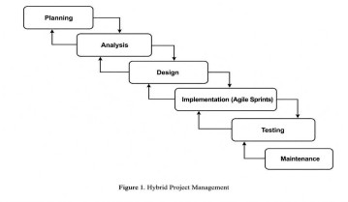
Figure 1. Integrated Hybrid Project Management Approach. SYSTEM PLANNING

Project Team Organization
In order to facilitate the adequate allocation of tasks in line with the progress of SmartAqua Pro invention, a project team has been established. The Adviser is responsible for providing academic and technical expertise and making sure that the project adheres to the set standards. The project manager has to supervise the schedule, manage the activities performed by the team, keep track of the overall development progress, and be in charge of the implementation of different assignments. The role of the System Developer and Documentation specialist is to carry out the work related to the development of applications, integration of the database, installation of predictive analytics module, and creation of all required documentation for the system. The role of the IoT engineer and System analyst involves work with hardware aspects of the project, sensor integration, ESP32 installation, connection of aquarium devices, modeling of system requirements, and validation of sensor readings. By organizing the project team, the company is able to ensure the effectiveness of the implementation process of the project, integration of tank monitoring system, testing procedures and provision of documentation.
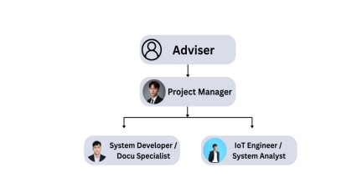
Figure 2. Project Management Team Organization

Work Breakdown Structure
According to Figure 3 of the project plan for SmartAqua Pro, there are six phases in the implementation of the project: Planning, Analysis, Design, Implementation, Testing, and Maintenance. The planning phase covers all aspects of the project definition, including the scope, aims, schedule, resources utilized, project team, and budget. During the analysis phase, functional and non-functional requirements of the system are identified, as well as the information on similar technologies, the main parameters to be monitored in the aquarium, user roles and access requirements. The design stage comprises all important aspects of the system development: architecture, database structure, management of the sensors of the system, development of the user interface, system flowcharts, and analytic rules. The implementation stage includes all hardware work, software development and integration. The phase of testing checks the accuracy of the sensors and of the response time of the system as well as user access to the aquarium as well as provision of various recommendations regarding its condition. The maintenance phase is aimed at checking the performance of the developed system over time. The construction of the schedule enables the authors of the project to assign all tasks to the team members as well as to follow the progress of the process development.
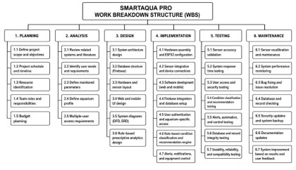
Figure 3. Work Breakdown Structure

Gantt Chart
The Gantt chart in Figure 4 illustrates the project timeline of SmartAqua Pro development according to the six phases of the Hybrid Project Management Methodology. The Planning phase covers the definition of project scope, objectives, resources, teams, budget, and schedule. The Analysis phase involves reviewing existing similar systems, determining the user/system requirements, choosing the monitored parameters in the aquarium, developing the aquarium profiles, and defining the ways for the multiple users to access the system. During the Design phase, the system design is developed, including the system architecture, the database architecture, the positioning of hardware components and sensors, developing the web and mobile interface, and drawing the necessary diagrams and logical conclusions. During the Implementation phase, hardware assembly takes place, the ESP32 microcontroller and sensors are integrated, software solutions are developed, users are identified and their database created, and features of aquarium controlling are implemented. The aim of the Testing stage is to find out whether the sensors function accurately, quickly, and allow multiple users to enter and distinguish the conditions for operation. At first, regular revising is carried out, which consists of the processes of recalibrating the sensors, overseeing the operation, and bug fixing. In addition, the Gantt chart will help the authors manage the resources in a timely manner.
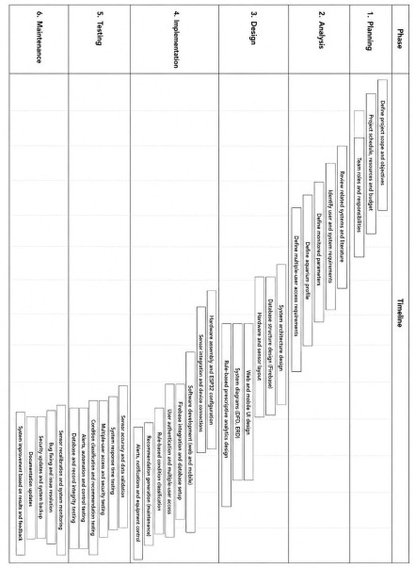
Figure 4. Gantt Chart of the system SYSTEM ANALYSIS

System Architecture
The structure of SmartAqua Pro system includes the basic components, namely hardware, software, communication, and data that are functioning together to provide real-time monitoring of the aquarium conditions, prescriptive analytics, alert generation, equipment control, multiple user access, and saving the historical data. There are four levels of the architecture: Hardware and IoT Layer, Communication and Processing Layer, Data Layer, and Application Layer. The multi-layer structure allows separating physical sensing devices and data processing and storage from the user access making the system easier to construct, check, maintain, and upgrade.
The Hardware and IoT Layer is made of modules of aquarium sensors, ESP32 microcontrollers, components for monitoring power and connected devices of aquarium. Each aquarium that is connected will have unique aquarium ID and device ID ensuring that results from each aquarium are distinct. The sensors will register data on pH level, total dissolved solids, turbidity, water temperature, ammonia level, and water level. The layer will also check for filtration, equipment, and power statuses. The devices that can be used include feeder or filtration system or lighting. The aquarium profile will describe the type of aquarium and its measurements, the filtration system, and fish characteristics. The fish used will be the goldfish and the monitoring focus will be on the aquarium condition.
The Communication and Processing Layer takes the responsibility of getting the readings from the sensors, which the ESP32 sends through a proper channel. When working with the incoming readings, it runs a procedure of checking out possible errors to make sure there are no errors in the readings and they also correspond with the relevant aquarium and user. Only those readings that are verified go through the corresponding rule-based module that gets the data, compares it with predefined reasonable limits of normal, warning, and serious states. In case those abnormal readings have been found, the prescriptive analytics part of the system will automatically activate the relevant rule and give a proper recommendation for observing the condition as well.
A corresponding alerting and notification service will provide the user assigned to the tank with the necessary data. The command processing layer will perform all authorized operations, including executing manual commands and working out the processes that can be performed in normal automated mode. In its turn, rule-based procedures perfectly go along with all the procedures performed in the system since it deals only with clear and easy predefined conditions and does not require any previous experience
[4], [6], [21].
As for the Data Layer, Firebase will be used in its work. It will serve as a storage for the documentation which contains the information about the system. Therefore, it will contain data about the users’ accounts and aquariums, sensor readings, prescriptive rules that require implementing of necessary recommendations, various alerts, and the activities of monitoring in the system as well. If there is a need for the latest device information, it will be given via Firebase Realtime Database. It means that there will be all instant messages regarding devices, such as messages about orders, order rates, telemetry, system view, and the history of devices that belong to a customer. Every reading will either contain the information about the aquarium‘s ID, or the user connected to a particular tank [24], [26].
The web dashboard and mobile application constitute the Application Layer. The authorized users will log in to the systems and monitor the aquariums associated with their user accounts. Users will be allowed to check sensor readings, aquarium condition classification, alerts and notifications, maintenance suggestions, equipment status, monitoring history, and maintenance updates. Users will also utilize available controls for the feeder and filtration and lighting systems based on their access levels.
The process of data flow within the system will start at the moment of acquiring aquarium readings by the sensors and passing it to the ESP32. The readings will be sent to the communications and processing segment of the system where they will go through validation, association with the aquarium, and inference into Firebase. The system will compare the readings with the normative set of rules and report the aquarium condition as normal, warning, or critical. When the aquarium condition is determined to be in a
warning state, the SmartAqua Pro will notify about the condition and provide
maintenance recommendations.
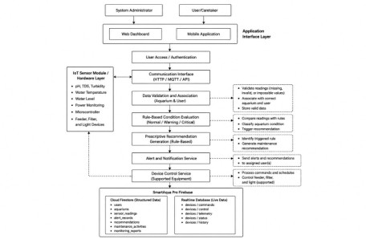
Figure 5. System architecture of the project

Functional and Non-functional Requirements
The functional and non-functional requirements of SmartAqua Pro indicate its expected properties and quality attributes. Functional requirements specify the functions performed by the system, namely monitoring of the aquarium conditions, verifying sensor readings, classifying the conditions based on rules, making recommendations, allowing multiple users to access, providing alerts, controlling selected devices, and recording historical data. The quality requirements are defined by the non-functional ones in this case.
- Aquarium data shall be gathered and displayed in real-time such as pH, total dissolved solids, turbidity, water temperature, ammonia level, water level, filtering status, equipment status, and power status.
- Valid sensor data shall be validated and linked to the proper aquarium and user.
- Aquarium profiles shall be maintained with details of the aquarium, filtration setup, fish type, fish count and estimated bioload.
- The system should use pre-defined rules to classify aquarium conditions as normal, warning or critical.
- Generates recommendations for maintenance based on rules for warning and critical conditions.
- Alerts and recommendations shall be sent out to the assigned user for the specific aquarium.
- The system shall support multiple-user access, allowing each user to monitor only the aquarium assigned to their account.
- The system shall provide web and mobile access to current readings, alerts, recommendations, equipment status, and historical records.
- The system shall support selected automation and control functions for the feeder, filtration system, and lighting system.
10.The system shall record sensor readings, alerts, recommendations, maintenance actions, equipment activities, and power-interruption records in Firebase. 11.The system shall generate aquarium-specific monitoring reports that summarize sensor readings, aquarium-condition classifications, alerts, maintenance recommendations, maintenance actions, equipment status, and power-interruption records.
Non-functional Requirements
The following are the system's non-functional requirements:
- Performance Efficiency. The system must do some processing, synchronization, and displaying of sensor readings, alerts, recommendations, and equipment status with time delay.
- Reliability. The system shall consistently collect, transmit, store, and display aquarium data while generating the correct rule-based condition classification and recommendation.
- Usability. he web dashboard and mobile application should provide a straightforward, clear, and usable interface for monitoring the aquarium conditions.
- Security. The system must authenticate users and limit the access of users to their assigned aquarium only.
- Accuracy. The system should provide the readings from the correctly calibrated sensors with an acceptable error.
- Data Integrity. he system should store information about sensor readings, alerts, recommendations, and maintenance records in the respective aquarium account.
- Compatibility. he system should work on the supported desktop computers, laptops, tablets, and smartphones using the web dashboard and mobile application.
- Maintainability. The system should allow developers to recalibrate the sensors, change them, update rule-based recommendations, correct the errors, and modify software components without redesigning the system completely.

Use Case Diagram
The Use Case Diagram in Figure 6 presents the functions directly accessible to the System Administrator and User/Caretaker in SmartAqua Pro. The actors are positioned outside the system boundary, while the use cases are placed inside the boundary to represent the functions provided by the system. Each use case is independently associated with the corresponding actor, and the diagram does not connect one use case to another as a sequence of system processing.
The System Administrator can log in and perform authorized administrative and monitoring functions. These include managing users and roles, managing aquarium records, configuring system settings, managing threshold rules, viewing the monitoring dashboard, and viewing system logs and reports. These functions support multiple-user access, aquarium-specific record management, monitoring configuration, and system administration. Role-based access is important because SmartAqua Pro is designed to maintain appropriate user privileges and keep aquarium-specific information associated with the correct authorized account [31].
The User/Caretaker can also log in through the system and access the aquarium assigned to the account. The user can view the assigned aquarium profile, real-time sensor readings, aquarium condition, alerts and notifications, maintenance recommendations, equipment status, and monitoring history. The User/Caretaker can also record completed maintenance actions and control supported devices, including the feeder, filtration system, and lighting system. Previous IoT-based aquarium and aquaculture studies support the use of web and mobile platforms for real-time water-quality monitoring, remote access, alerts, historical records, and supported device control [4]–[7], [10]–[12], [21].
The maintenance-recommendation function is supported by SmartAqua Pro's prescriptive analytics approach. The system evaluates current sensor readings and aquarium conditions using predefined rules and provides corresponding maintenance recommendations when warning or critical conditions are identified. This allows the system to support maintenance decision-making rather than only presenting the measured aquarium condition [8].
The Use Case Diagram focuses on the functions directly accessed by the human actors. Internal operations such as validating sensor readings, associating sensor data with the appropriate aquarium, evaluating threshold conditions, classifying the aquarium condition, generating recommendations, issuing alerts, and storing monitoring records are processing activities performed within SmartAqua Pro. Therefore, these activities are not connected as sequential use cases in Figure 6 and are described in the succeeding system-processing diagrams.

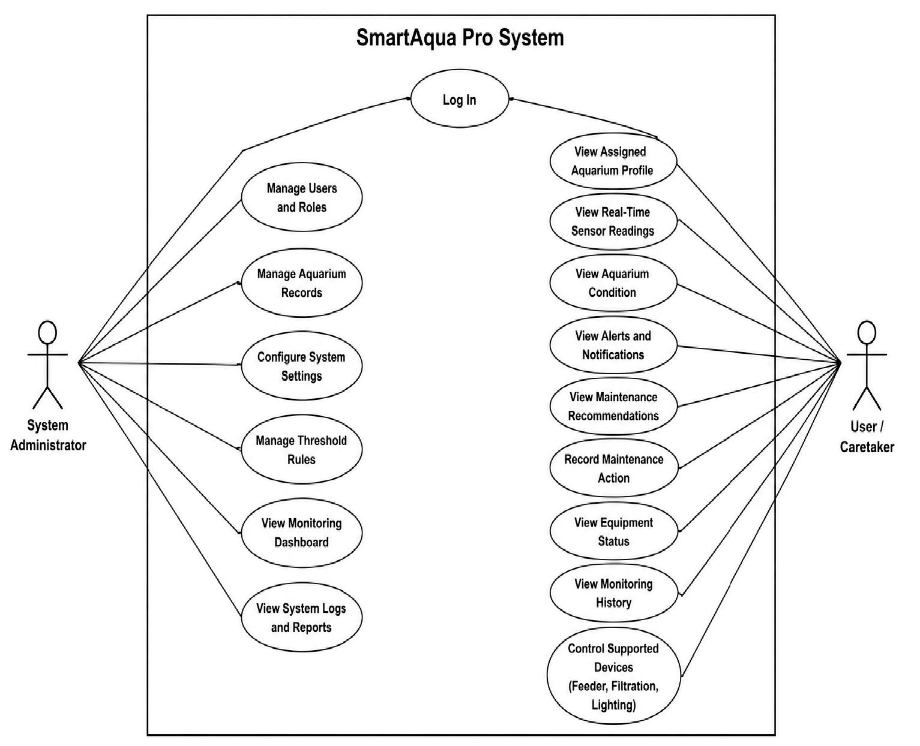
Figure 6. Use Case Diagram of the system

Context Flow Diagram
The Context Flow Diagram in Figure 7 offers an overview of SmartAqua Pro and displays how the system transfers messages to its surrounding environment. The external elements include the System Administrator, User/Caretaker, and IoT Device/Sensor Module. Each user account is connected to an assigned aquarium, allowing the system to keep aquarium readings, alerts, recommendations, equipment status, and monitoring records separate.
The sensor module sends information such as water pH, total dissolved solids
amount, turbidity, temperature, ammonium content, water level, filtration or appliances condition state, and electricity condition to the SmartAqua Pro appliance. In addition, the sensor module obtains commands for controlling devices from the SmartAqua Pro. The information received from the sensors is used for real-time monitoring, aquarium parameter classification, warning notifications, and appliance management.
The user provides information about the login credentials, monitoring requirements, requests for appliance control, and records of maintenance activities to the SmartAqua. The answer information provided includes a profile created for a given aquarium, up-to-date information from the sensors, parameter classification, state of the appliances, alerts, recommendations on maintenance activity, sensor activity records, alert records, and monitoring records.
The system administrator gets all the necessary data about aquarium monitoring, dashboard information, alerts, appliance state, logs, and reports according to the access rights assigned in the system. From the Context Flow Diagram, the ways how the respective information about aquarium, the queries made by a user, suggestions, alerts, service data, power state, and messages about the controlling of the appliances are being exchanged between SmartAqua Pro and other parts acknowledged.
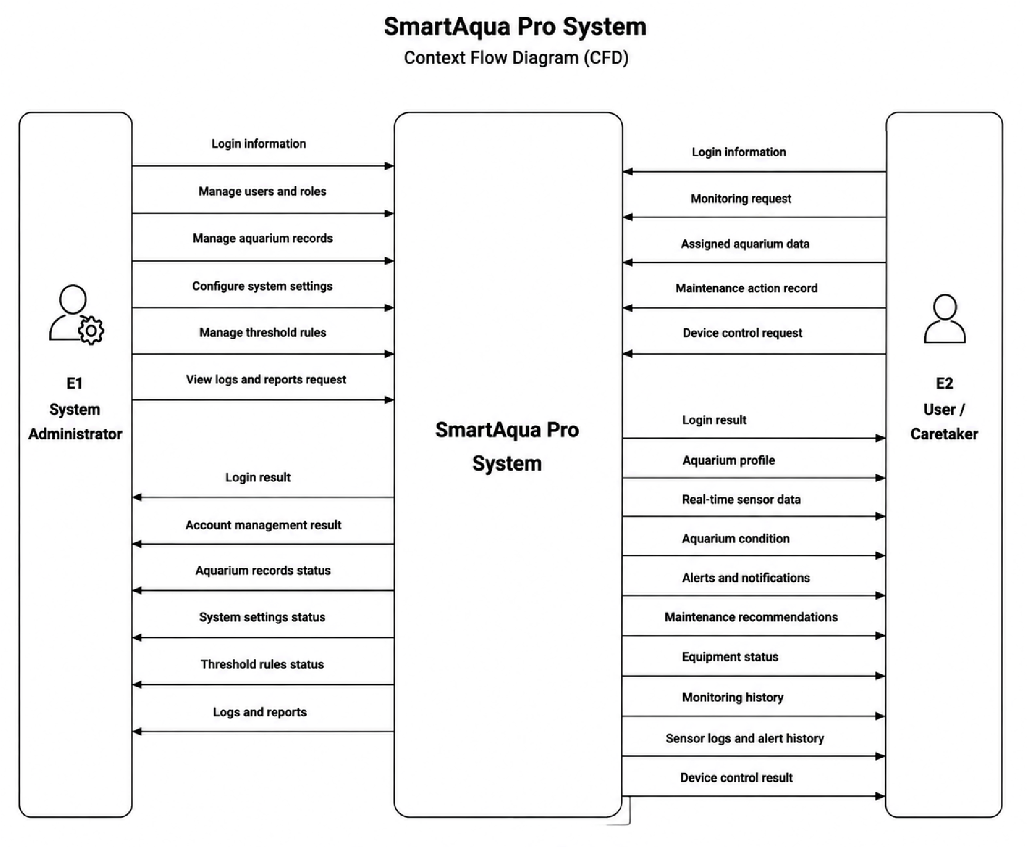
Figure 7. Context flow diagram of the system

Data Flow Diagram
The illustration in the form of Level 1 Data Flow Diagram created in Figure 8 displays data flows of SmartAqua Pro. This Level 1 Data Flow Diagram is based on Context Flow Diagram whereby it shows volume of data transfers taking place among various parties i.e. System Administrator, User/Caretaker, IoT Device/Sensor Device, system processing components and Firebase data repositories. Some of the issues addressed in the diagram include user access management, aquarium profile management, data verification of data from sensors, identification of the aquarium related to the user, classification of situations, generation of prescriptive recommendations, control of alerts and devices, documentation of maintenance activity and maintaining record of data. The Data Flow Diagram consists of seven main processes where Process 1.0 (Manage User Access) logs in the credentials and identifies the specific aquarium connected every authorized user account. Process 2.0, Manage Aquarium Profile, handles aquarium information such as the tank type, tank dimensions, working water
volume, filtration setup, fish type, fish count, and estimated bioload. Process 3.0, Process and Validate Sensor Data, receives aquarium readings and device status from the IoT module, checks for missing or invalid values, and connects valid readings to the correct aquarium and user.
Process 4.0, Classify Aquarium Condition, compares validated readings with predefined rules and identifies the aquarium condition as normal, warning, or critical. Process 5.0, Generate Prescriptive Recommendations, identifies the activated rule and produces an appropriate aquarium-maintenance recommendation. Process 6.0, Manage Alerts and Device Control, sends aquarium-specific alerts and recommendations to the assigned user and processes supported commands for the feeder, filtration system, and lighting system. Process 7.0, Manage Logs and Reports, records sensor readings, condition classifications, alerts, recommendations, equipment activities, maintenance actions, and historical monitoring information.
The IoT Device/Sensor Module will send pH, total dissolved solids, turbidity, water temperature, ammonia level, water level, equipment status, and power status to Process 3.0. Valid readings will be stored and passed to the condition-classification process. When a warning or critical condition is detected, the system will generate a rule-based recommendation and alert. The User/Caretaker may submit login information, monitoring requests, device-control requests, and completed maintenance actions. In return, the user will receive assigned-aquarium information, current readings, aquarium-condition classifications, alerts, recommendations, equipment status, and monitoring history.
Firebase will support the system’s data stores. Cloud Firestore will contain user accounts, aquarium profiles, assigned-aquarium information, historical sensor readings, prescriptive rules, alerts, recommendations, maintenance activities, and reports. Moreover, Firebase Realtime Database is supposed to consist of telemetry, status of the device, commands, parameters of control and history of the device.
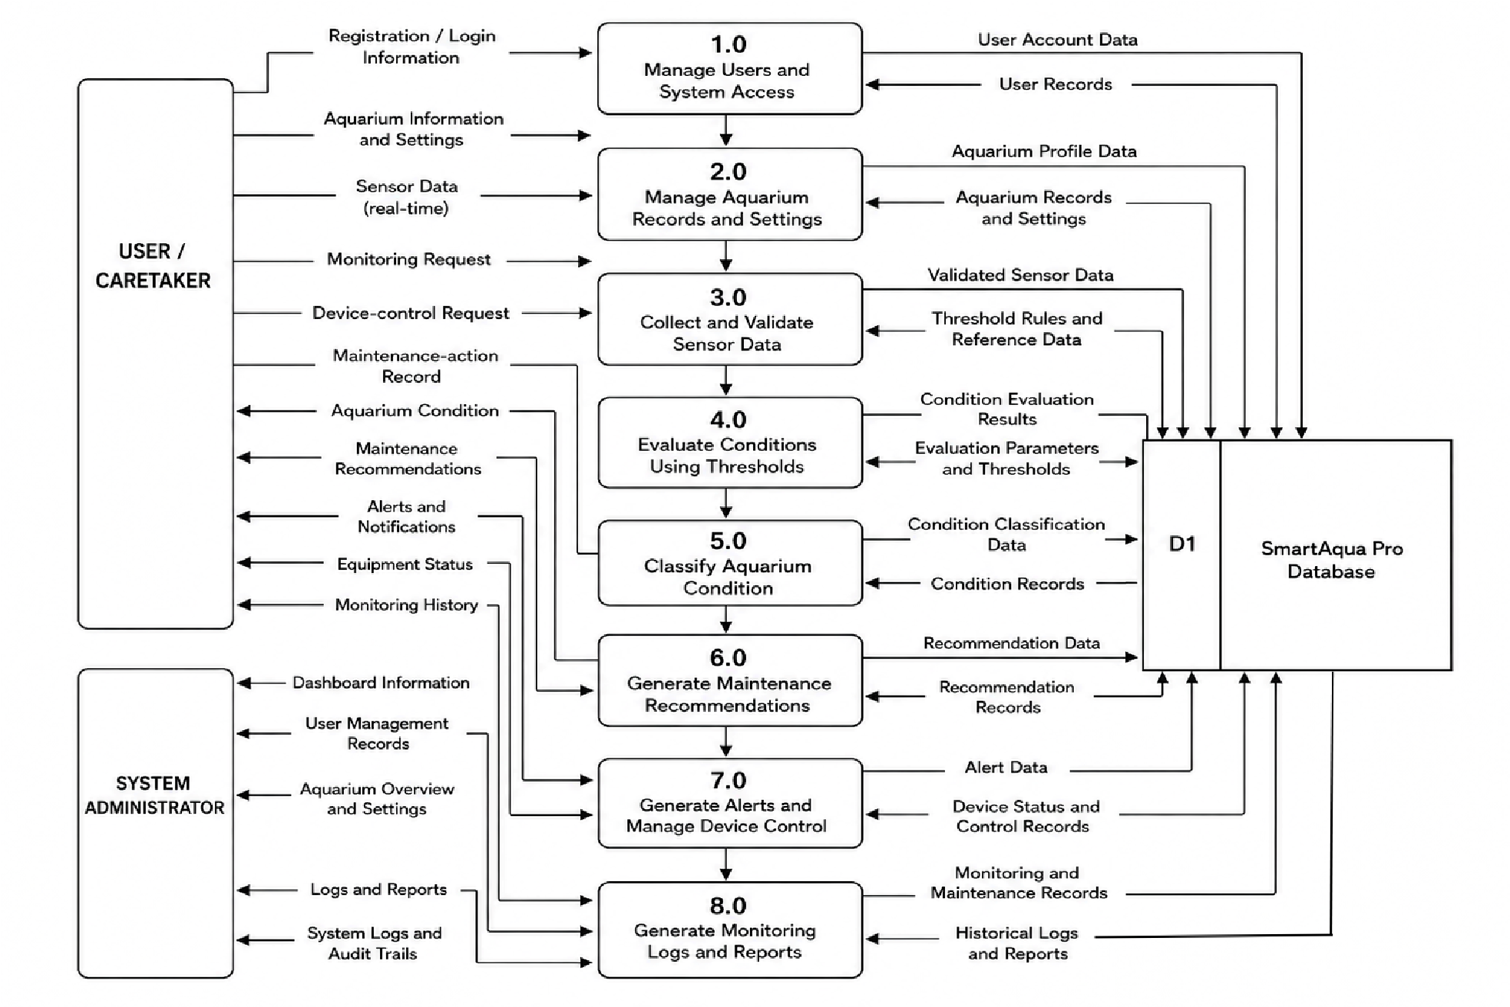
Figure 8. Data flow diagram of the system

SYSTEM DESIGN

JSON Schema Diagram
The JSON Schema Diagram reflects the way SmartAqua Pro uses the Cloud Firestore and Firebase Realtime Database to store and manage its data. The Cloud Firestore keeps records in form of data structures such as user accounts, aquarium profiles, ownership data and assignments, information on aquatic species, configuration of tanks, readings of sensors, thresholds, prescriptive rules, data about alerts, recommendations for users, logs of maintenance works, and reports about monitoring. Every sensor reading, alert, recommendation, maintenance entry, and record of devices has the correct identification of aquariums and assignments of users to avoid mixing up data from aquariums.
Aquarium records include tank type, tank dimensions, water that the tank operates with, filtration system, fish species, number of fish, expected bioload, and status of the tank. The tank configuration along with the fish species information give extra information about the aquarium conditions. The prescriptive rules include monitored indicators, their ranges, classifications, severity levels, and respective recommendations on maintenance. The Firebase Realtime Database contains current information about devices such as values of telemetry, status of the equipment, commands, control settings, and history of the device. The schema contains the monitored parameters the same as water temperature, the level of water, TDS, pH, turbidity, ammonia, and current condition of power rather than being based on the whole percentage of water quality.
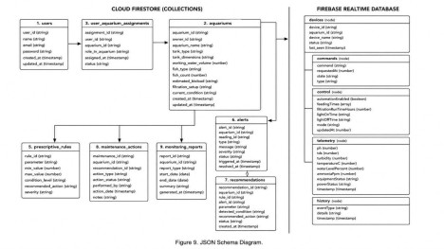
Figure 9. JSON Schema Diagram

Data Dictionary
SmartAqua Pro has its own database that includes many core collections and nodes such as users, aquariums, sensor_readings, threshold_settings, alert_records, device_controls, feeder_logs, filtration_logs, and other relevant nodes. The functions these collections and nodes provide include user access, aquarium management, profile configuration for fish and tanks, real-time monitoring, and power status monitoring.
Table 1. Users Collection
The users collection stores information about individuals who can access the SmartAqua Pro system. This includes administrators, aquarium owners, and caretakers. The collection supports user authentication, role-based access control, and account management. Each user document contains the user’s identification, name, email, role, account status, and account creation timestamp.
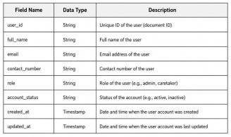
Table 2. Aquariums Collection
The aquariums collection stores information about each registered aquarium in the system. It connects an aquarium to its assigned owner or caretaker through the owner ID. The aquarium record management, bioload adjustment, condition tracking, and monitoring setup are provided by this collection of data. This collection consists of information that the system needs to analyze the readings from sensors and set issues of threshold, alert and automation.
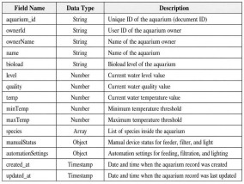
Table 3. Sensor Readings Collection
The sensor_readings collection holds data that is collected from the IoT sensors in real-time at each aquarium. In this collection there is data on the pH, TDS, turbidity, water temperature, water level and power status. The system utilizes this collection to enable real-time monitoring, historical tracking, visualization of data on the dashboard, mobile application access and threshold evaluation based on rules. The power_status field shows whether also a device is working or whether there was a power interruption.
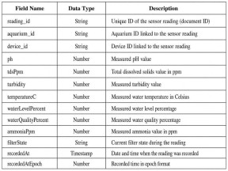
Table 4. Alert Records Collection
The alert_records collection includes alerts that are triggered when the readings taken become too high or when the power interruption happens. Each document in the collection contains information about what aquarium and the device has triggered the alert. This collection assists the system to keep the historical data on alerts and send notifications about them on dashboard and mobile phones.
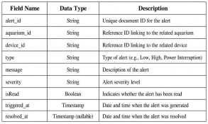
Table 5. Monitoring Reports Collection
The collection of monitoring reports is responsible for the archival of the information that is collected from sensor data and alerts for later use in terms of analytics or report formation. Each document corresponds to one aquarium and contains information on the reporting time, sensor summaries, alerts, and user information underwriting the report.
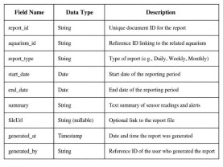
Table 6. Fish Species Collection
Information about the fish species is stored in the Fish Species Collection in the database. This collection contains the species details, quantity, and preferred water parameters, which are used for aquarium monitoring and generating appropriate maintenance recommendations.

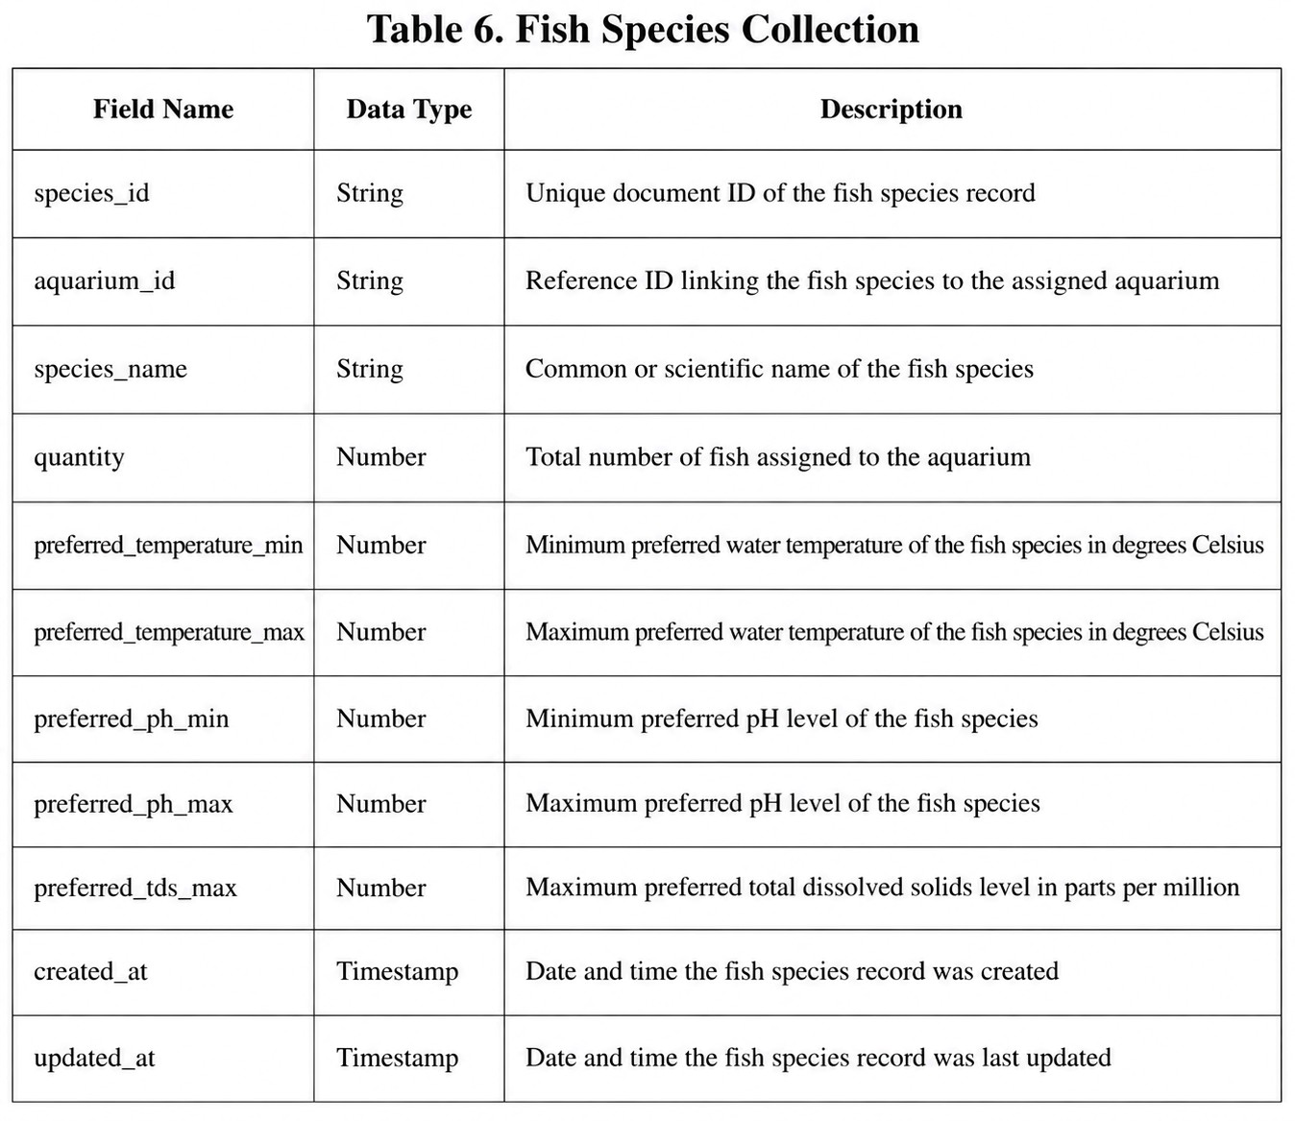

Table 7. Tank Configuration Collection
Stores information regarding fish type/species for each aquarium.
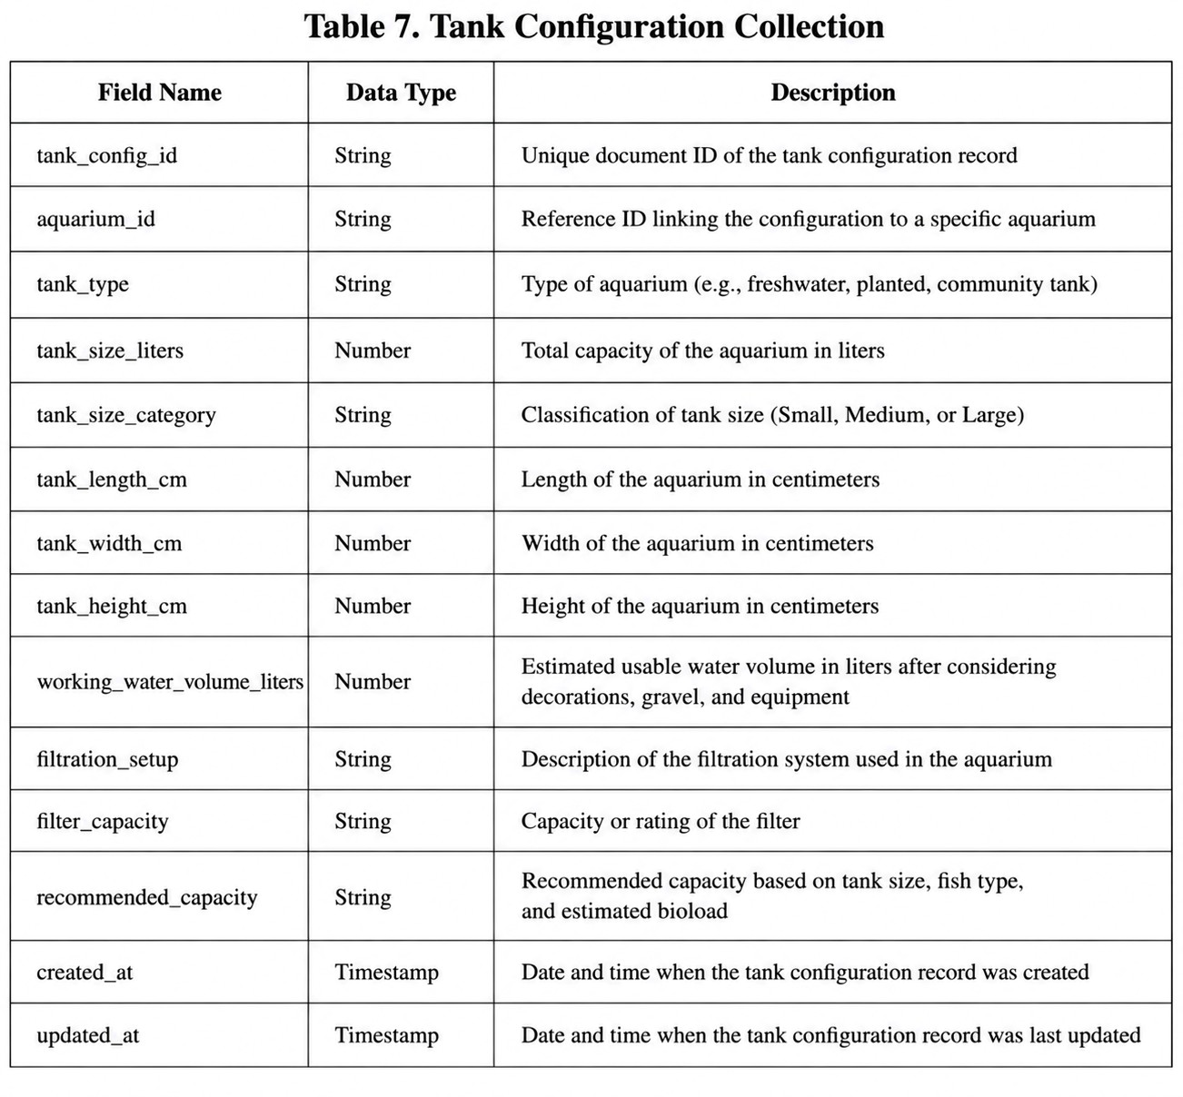
Table 8. Prescriptive Recommendations Collection
Stores recommendations generated by the system with regards to the readings from the sensors, size of the tank, fish type, alerts, and thresholds.
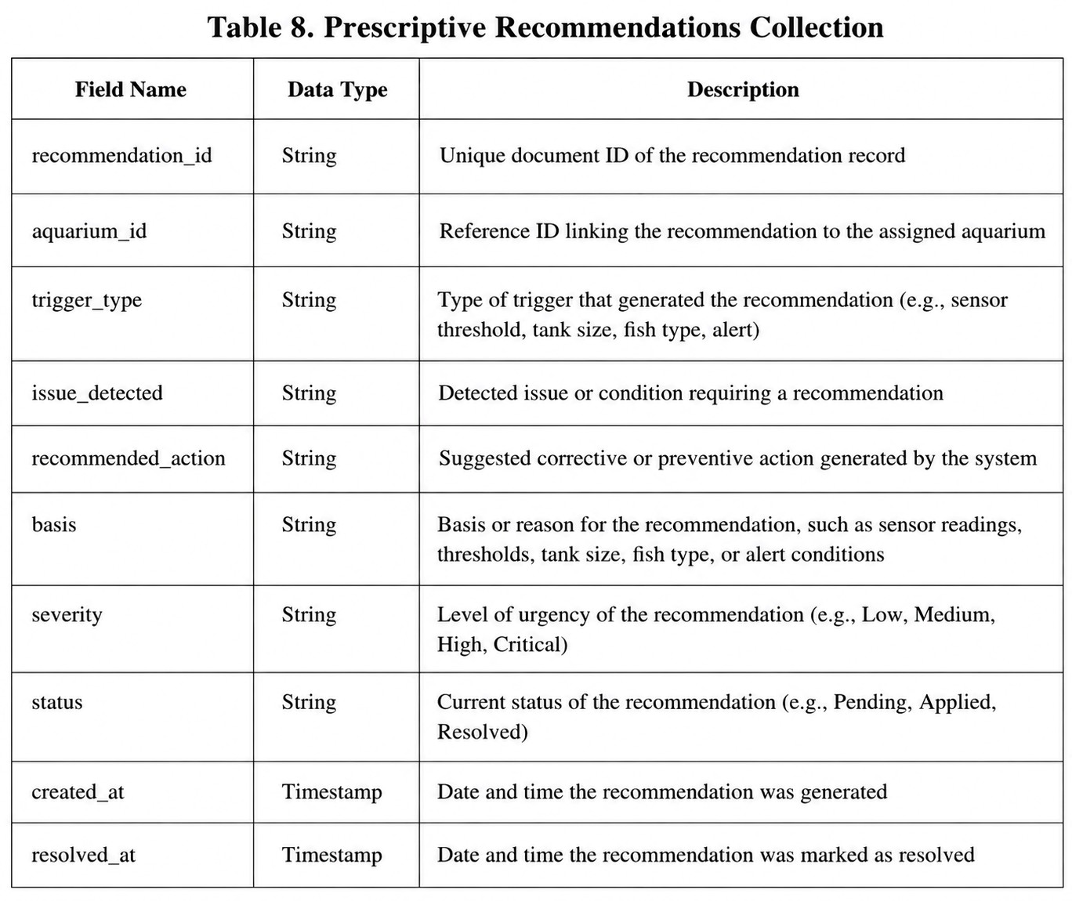
Table 9. Device Control Collection
Information on the devices is stored in the devices node in the Firebase Realtime Database. The node contains information about the commands, the settings of the devices, telemetry readings, as well as the history of the device.
Stores recommendations generated by the system with regards to the readings from the sensors, size of the tank, fish type, alerts, and thresholds.
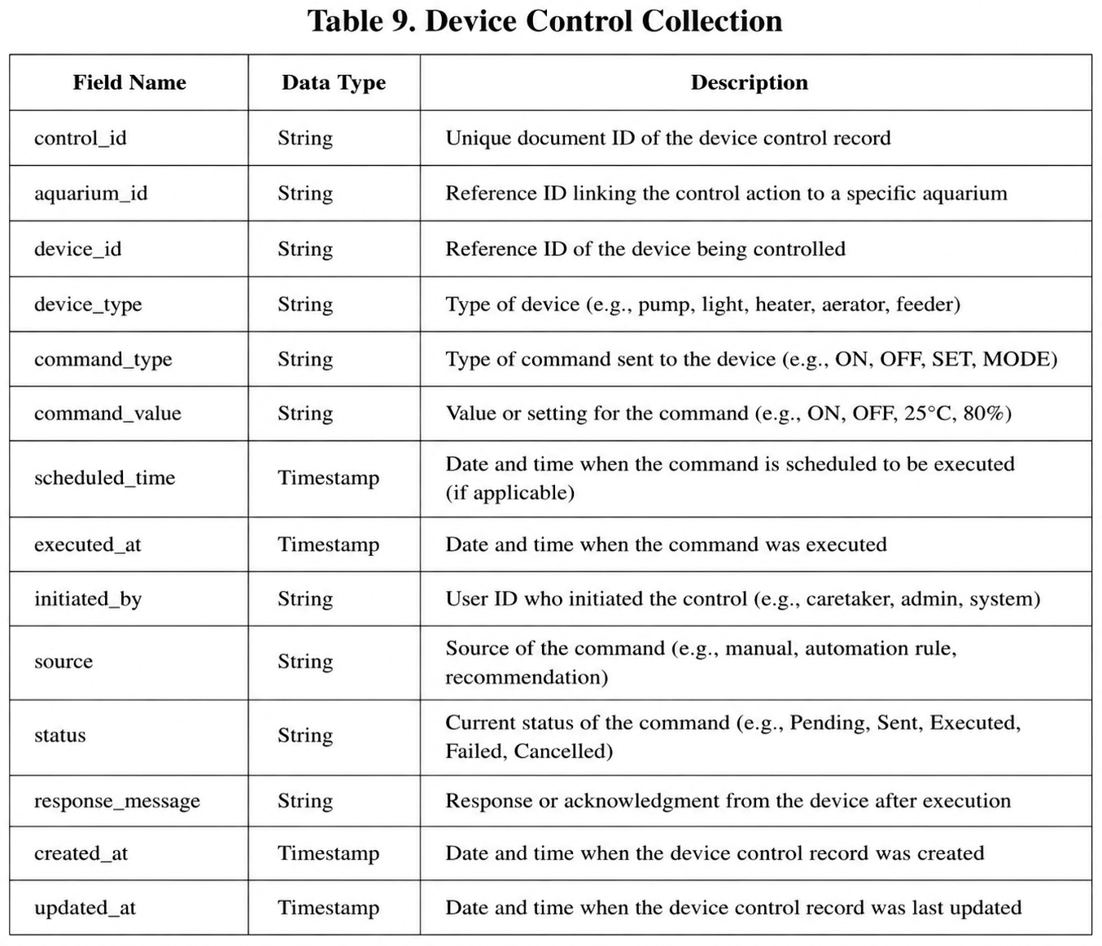

Technologies, Concepts, and Theories
This part of the paper explains the different technologies, ideas, and theories that have been used to create SmartAqua Pro: IoT-Based Aquarium Monitoring and Automation System. It can be described as a tool for remote monitoring and management using a combination of web technology, mobile applications, and sensors. SmartAqua Pro incorporates the Internet of Things (IoT) sensors along with a powerful microcontroller, Firebase Cloud Firestore, Firebase Real-time Database rules, and many other pieces of equipment for measuring the pH level of the water and analyzing its state of condition without the use of advanced technologies like artificial intelligence or machine learning.

Data Collection
The data is collected through IoT sensors that are integrated into the aquarium
system. They can gather information about water parameters such as pH levels, turbidity,
temperature, power status, and other important information concerning the quality of the water. The information from the IoT Sensor Module is then sent to the microcontroller, which converts it into a format that will enable the transmission of data to Firebase. As a result, SmartAqua Pro is capable of obtaining the data necessary for monitoring the aquarium state in real-time and collecting background information on it. [1], [3], [7].

Data Transmission and Firebase Synchronization
SmartAqua Pro transmits data from the microcontroller to Firebase through HTTP,
MQTT, or API-based communications. Firebase is the primary database for the system. The application data is stored in Cloud Firestore via the users collection, the aquariums collection, the sensor_readings collection, the alert_records collection, and the monitoring_reports collection. The users collection contains information about user accounts while the aquariums collection contains information related to aquariums, owners, species, bioload, threshold values, manual device status, and automation settings. The other three collections store data related to monitoring, alerts, and reports.
In addition to using Firebase, SmartAqua Pro uses Firebase Realtime Database for those data needing continuous updates like the devices information. The Realtime Database includes a devices node with commands, control, telemetry, and history. The commands node stores the commands for devices, control node is for manual and automated control settings, telemetry node holds the most up-to-date readings and status of devices, while history node keeps records of devices and sensor activities in a chronological order. [24], [26].

Data Pre-processing
The system gathers and processes data for storage and monitoring before assessments are made based on the sensor readings. Data pre-processing involves formatting the sensor data, validating the readings, linking readings to the corresponding aquarium and device, and recording the times of the readings for historical monitoring. This process makes sure the readings shown on the web dashboard and the mobile application are accurate, organized and ready for evaluation using the rules [6, 12].

Feature Identification
Feature identification is the selection of the important aquarium parameters that need to be monitored by the system. The features detected on SmartAqua Pro are pH value, total dissolved solids, turbidity, water temperature, water level, water quality, ammonia level, filter status, power on/off status, and controlled/uncontrolled status. The features are chosen to influence the state of the aquarium and to aid in decision making of alerts, monitoring and selected automation [1, 3, 7].

Rule-Based Threshold Evaluation
The system uses the rule-based threshold evaluation to decide if the aquarium conditions are normal or abnormal. The aquariums collection contains the aquarium documents, including sensor readings, threshold value and automation value. If the value is outside of the limits or if a power outage or device problem is detected, an alert is given and the aquarium status is updated. This method is suitable for a prototype system because it is easy, transparent, and does not need to be trained or requires complex prediction models [4, 6, 21].

Alert Generation and Selected Automation
A warning is generated when the sensor value deviates from normal, the power turns off or there are any problems with the devices. The system generates an alert record in the alert_records collection and alerts users via the web dashboard and mobile application. Selected automation and device control is also supported with
SmartAqua
Pro via the devices node in Firebase Realtime Database. The system can enable feeder, filtration and light control according to user inputs or pre-programmed controls, and can provide telemetry readings and history logs [6, 7, 21].

Web Dashboard and Mobile Application
SmartAqua Pro's primary user interfaces are the web dashboard and mobile application. These platforms enable users to access actual sensor data, aquarium status,
alerts, sensor logs, reports, and device status in real-time. The user can also control the aquarium, and retrieve the aquarium history, as well as control requests for supported devices, such as feeder, filter and light. Using both web and mobile platforms provides better access to aquarium systems, enabling users to monitor and manage the aquarium remotely [7] [21].

Theoretical Basis of the System
The system adopts the real-time monitoring, threshold decision-making, and IoT intelligent automation. Real-time monitoring enables the user to see the aquarium conditions as data is being gathered. By means of threshold-based decision making, the system can determine abnormal conditions, by comparing with the set acceptable values. With IoT enabled automation, sensors and micro-controllers are able to communicate with Firebase, web dashboards, mobile apps, and controlled devices as a single unified system. The following concepts contribute to the vision behind making SmartAqua Pro a real-life monitoring and automation system for small aquarium systems.
Technologies Used in the System

Internet of Things (IoT)
The SmartAqua Pro system is mostly based on Internet of Things (IoT) technology, allowing the aquarium environment to be monitored and automated over time. The system is composed of sensors that are interconnected in each aquarium, and provides key data including water temperature, water level, pH, turbidity and total dissolved solids (TDS).
They are real-time sensors that send the data to the central processing system to be evaluated and decisions made. Efficient, reliable, and low latency data communication between the sensors and the central system is managed via lightweight protocol like MQTT or HTTP. With the help of utilizing IoT, SmartAqua Pro can also log on to other functions such as monitoring water quality, getting real-time alerts when parameters are breached, etc., and switching on filtration and feeding automatically. Real-time monitoring plays a huge role in managing aquariums as it allows intervention in a timely manner and provides necessary aquatic conditions.

Figure

10.

IoT

Web and Mobile Applications
It's designed as a web app and a mobile app as well, providing different people (admin, aquarium owner, aquarium caretaker) with access to a central system and dashboard from a variety of platforms. These are the apps that enable users to monitor the conditions within the aquarium, receive automatic alerts, view past data and examine the efficiency of their system. The mobile Application will allow the user to get the system information even when not at the physical aquarium locations, allowing them to respond in time when they are not there. This will be easier to access, more accessible and more convenient and will assist in efficient aquarium management and maintenance, across multiple platforms.
Figure

11.

Web

and

Mobile

Application

Cloud Firebase Management
In SmartAqua Pro, Firebase is used as a cloud-based solution to synchronize data in real-time and access it remotely. If rapid and frequent changes are required, such as in a real-time aquarium monitoring app, then notifications and system status monitoring are required. Data passing and updating is extremely fast and easy with Firebase, since it is talking to a lot of IoT sensors and the web/mobile interface, and not setting up and running a complex server.
It enables real-time monitoring, provides water quality, water level and water temperature readings from the system interface, and allows users, like administrators or aquarium owners or caretakers, to monitor the readings. Additionally, Firebase can be utilized for user authentication, cloud data storage, and notification services, ensuring secure access, reliable data management, and timely alerts within the SmartAqua Pro system.

Figure

12
.

Firebase

ESP32 Microcontroller
SmartAqua Pro is mainly controlled and communicated by the ESP32 microcontroller. This is the link between the Aquarium Sensors, power monitoring component and devices supported like the feeder, filter and light system.
The ESP32 gathers data from the aquarium sensors: pH, total dissolved solids (TDS), turbidity, water temperature, water level and power status. It also filters device data prior to sending them to system for monitoring and storage. The ESP32 sends real time sensor readings and telemetry data wirelessly to the Firebase database, web dashboard, and mobile app.
It also sends command control messages to the devices via the same wireless connection. The ESP32 acts as the bridge between the physical aquarium setup and the software platform, real-time syncing data, updating the dashboard, triggering alerts, power outage detection and controlling compatible devices remotely. The ESP32 acts as the bridge between the physical aquarium setup and the software platform, real-time syncing data, updating the dashboard, triggering alerts, power outage detection and controlling compatible devices remotely.

SYSTEM TESTING AND IMPLEMENTATION
During the system testing and implementation phase, the focus is on ensuring that the SmartAqua Pro: IoT-Based Aquarium Monitoring and Automation System will function properly and fulfill the required specifications. In this stage, full testing is performed to ensure the system parts are connected and functional such as the IoT sensors, data transfers, data processing, automation capabilities, alerts and data logging. The testing process involves assessing various aspects of the system, including its accuracy, response time, and reliability, to ensure that the system is functioning properly and can be used to monitor the conditions in the aquarium and respond to any changes that occur. Test cases will be created to simulate normal use of the aquarium system and abnormal conditions including stable aquarium conditions, temperature changes, low water levels, and poor water quality.

SYSTEM MAINTENANCE
System Maintenance aims to maintain, ensure reliability, and enhance the SmartAqua Pro: IoT-Based Aquarium Monitoring and Automation System following deployment. This stage includes performance tracking, troubleshooting, and updating the system for improved functionality and adaptability. The maintenance activities involve the periodic review of the system, updating of software elements and components, calibration of the IoT sensors as required, enhancement of system capabilities, like monitoring, automation, alerts, given user feedback and evaluation results.

System Security Plan
A System Security Plan will be adopted for the SmartAqua Pro: IoT-Based Aquarium Monitoring and Automation System to ensure the security of the system data, user accounts, IoT devices and system resources. To minimize unauthorized access to the system, the system will implement user authentication, role-based access control, and multi-factor authentication. System features will only be made available to the users based on the roles assigned to them, for example, administrator or caretaker.
Secure communication protocols like HTTPS, TLS or MQTT with TLS will be used to transmit data between the IoT device, the Firebase/backend service, and dashboard built on Web. Access control, data encryption, and data backup are used to ensure the security of stored data, such as user, aquarium, sensor log, threshold, and alert records.
There will also be regular procedures to audit the security use of the system to check activities by users, security access logs, security system events, and potential security issues. Security audits will help determine if there is an attempt to access the systems without permission, if there are system changes that are not normal, or if there are weaknesses in the systems configuration. Furthermore, penetration testing will be performed on login functions, access control, database rules and web-based dashboard security, among other areas, during testing and evaluation to uncover potential vulnerabilities.
A security incident escalation process will be used in case of security incidents. Minor incidents will be logged and rectified by development team and serious incidents like unauthorised access, system compromise etc. shall be reported immediately to the project adviser or authorised person for appropriate action. These security measures will ensure the safe and reliable operation of SmartAqua Pro, while ensuring the system's confidentiality, integrity, and availability.
The table below shows the System Security Plan (according to the ISO/IEC
27001 standard). These controls ensure that SmartAqua Pro implements structured security controls to safeguard the user data, aquarium records, sensor logs, alert records and connected IoT components.
Table 11. System Security Plan
Security Domain  (ISO 27001) | Control Area | Description / Implementation in the System
A.5 Information Security Policies | Security Policy | The system will be used in accordance with formal security policies to ensure appropriate handling of data, access to data, system use, and aquarium monitoring record handling.
A.6 Organization of Information Security | Roles and  Responsibilities | System roles such as  Administrator and User/Caretaker will be clearly defined. Each role will have specific access privileges based on system responsibilities.
A.9 Access Control | User Access  Management | The system will implement role based access control (RBAC) to restrict access to features like user management, aquarium records, threshold settings, logs and alerts.
A.9 Access Control | Authentication  Mechanism | The system will have secure logon credentials and multi factor authentication (MFA) to enhance security of accounts and minimize unauthorized logon.
A.10 Cryptography | Data Encryption | Secure protocols like HTTP, TLS, or MQTT with TLS will be used to transfer data between the IoT device, Firebase/backend service, and web dashboard as applicable.

A.12 Operations Security to guarantee data records during data Data Processing Integrity accuracy from the sensor, processing. Input validation and user inputs, threshold error-handling will be used settings, and aquarium

A.12 Operations  Security | Logging and  Monitoring | The system will maintain audit logs to track user activities, login attempts, system events, sensor updates, alert records, and possible security incidents.
A.12 Operations  Security | Security Audit  Procedures | Regular security audits will be conducted to review access logs, user activities, database rules, system configuration, and possible vulnerabilities.
A.13  Communications  Security | Network Security | Data will be securely transmitted between the IoT device,  Firebase/backend service and the dashboard. Only approved  connections will be allowed to be connected to the network.
A.11 Physical and  Environmental  Security | Device Protection | IoT devices, sensors, and microcontrollers will be installed in secure locations to prevent unauthorized physical access, accidental damage.
A.17 Information Security Aspects of  Business Continuity | Data Backup and Recovery | Regular data backups will be performed to ensure data availability and recovery in case of system failure.

A.16 Information Security Incident resolved through a defined response
Management process to minimize damage and
Incident Response Security incidents will restore normal system operation. be documented, investigated, and

A.14 System  Acquisition,  Development, and  Maintenance | Secure  Development | The development and maintenance will be done using secure coding practices, input validation, access control checking, and regular system updates.
A.18 Compliance | Legal and  Regulatory  Compliance | The system will comply with the relevant data privacy, institutional and information security policies, ensuring that the data information of the user and the system are handled responsibly.

System Maintenance Plan
A System Maintenance Plan will be developed to assure the on-going support, monitoring and improvement of the implementation of SmartAqua Pro: IoT Based Aquarium Monitoring and Automation System. When in place, this plan will ensure the reliability, security, efficiency and usability of the system. This will cover tasks that are scheduled, such as: system monitoring, software updates, checking Firebase/database, calibrating sensors, performing security updates, backing up, optimizing performance etc.
The maintenance plan also details the troubleshooting, bug fixing, error handling, and system improvement methods. Any delay in sensor update, incorrect sensor data, failure to receive alerts, incorrect sensor readings on the dashboard, difficulty logging in and connection failure will be noted, reviewed and addressed. Also, maintenance documentation will be retained for reporting system changes, updates, issues identified, corrective actions taken to address violations and future recommendations for system
improvements.
The System Maintenance Plan in Table 5 is similar to the quality attributes defined in ISO/IEC 25010. To assure reliability, efficiency, security, maintenance, compatibility and adaptability of Small Scale Aquarium Monitoring and Automation with SmartAqua Pro.
Table 12. System Maintenance Plan.
ISO 25010  Attribute | Maintenance  Activity | Description | Frequency
Reliability | System  Monitoring | Monitor system uptime, dashboard updates, alert functions, Firebase synchronization, and device connection status. | Daily
Reliability | Sensor Calibration | and adjust IoT  sensor readings to ensure  accurate pH, TDS, turbidity, water temperature and water level readings. | Monthly
Performance  Efficiency | Performance  Optimization | Improve dashboard loading time, data synchronization speed, and sensor data processing performance. | As needed
Performance  Efficiency | Database/Fireb as e  Optimization | Check the sensor logs, alert records, aquarium records and monitoring reports; delete unwanted data and sort records for quick retrieval. | Weekly

Usability Interface navigation, readability, and Periodically
Improvement user experience based on
Improve dashboard layout, user feedback.

Security | Security Updates | Apply security patches, update authentication settings, review Firebase rules, and strengthen access control. | Regularly
Security | Security Audit | Review user activity logs, login attempts, access permissions, database rules, and possible security issues. | Monthly
Maintainability | Bug Fixing and  Debugging | Identify, document, and resolve system errors such as sensor update delays, alert failures, login errors, and dashboard issues. | As needed
Maintainability | System  Documentation | Record system updates, maintenance actions, bug fixes, configuration changes, and future improvement notes. | Every update
Compatibility | System Updates | Ensure that the web dashboard works properly on supported browsers and devices such as desktops, laptops, tablets, and smartphones. | Periodically
Availability | Backup and  Recovery | Create backup copies of important data such as  user | Weekly

data, aquarium records, sensor logs, threshold settings, and alert records.
Availability | Escalation  Procedure | Escalate unresolved technical issues, major system failures, data loss, or security incidents to the  project adviser or authorized personnel for immediate action. | As needed
Scalability | System  Enhancement  Review | Review possible future improvements such as adding more sensors, additional aquariums, improved automation, or enhanced reporting features. | Periodically

REFERENCES
- J. Colt, “Water quality requirements for reuse systems,” Aquacultural Engineering, vol. 34, no. 3, pp. 143–156, 2006, doi: 10.1016/j.aquaeng.2005.08.011.
- M. Badiola, O. Mendiola, and J. Bostock, “Recirculating aquaculture systems (RAS) analysis: Main issues on management and future challenges,” Aquacultural Engineering, vol. 51, pp. 26–35, 2012, doi: 10.1016/j.aquaeng.2012.07.004.
- C. I. M. Martins, E. H. Eding, M. C. J. Verdegem, L. T. N. Heinsbroek, O. Schneider, J. P. Blancheton, E. R. d’Orbcastel, and J. A. J. Verreth, “New developments in recirculating aquaculture systems in Europe: A perspective on environmental sustainability,” Aquacultural Engineering, vol. 43, no. 3, pp. 83–93, 2010, doi:
10.1016/j.aquaeng.2010.09.002.
- O. O. Olanubi, T. T. Akano, and O. S. Asaolu, “Design and development of an IoT based intelligent water quality management system for aquaculture,” Journal of Electrical Systems and Information Technology, vol. 11, article 15, 2024, doi: 10.1186/s43067-024- 00139-z.
- N. A. M. Jais, A. F. Abdullah, M. S. M. Kassim, M. M. A. Karim, Abdulsalam M., and N. A. Muhadi, “Improved accuracy in IoT-based water quality monitoring for aquaculture tanks using low-cost sensors: Asian seabass fish farming,” Heliyon, vol. 10, no. 8, article e29022, 2024, doi: 10.1016/j.heliyon.2024.e29022.
- R. P. Shete, A. M. Bongale, and D. Dharrao, “IoT-enabled effective real-time water quality monitoring method for aquaculture,” MethodsX, vol. 13, article 102906, 2024, doi: 10.1016/j.mex.2024.102906.
- F. Jan, N. Min-Allah, and D. Düştegör, “IoT based smart water quality monitoring:
Recent techniques, trends and challenges for domestic applications,” Water, vol. 13, no.
13, article 1729, 2021, doi: 10.3390/w13131729.
- M. M. Hemal, A. Rahman, Nurjahan, F. Islam, S. Ahmed, M. S. Kaiser, and M. R. Ahmed, “An integrated smart pond water quality monitoring and fish farming recommendation AquaBot system,” Sensors, vol. 24, no. 11, article 3682, 2024, doi:
10.3390/s24113682.
- I. Arasu M., S. Rani S., T. K., and A. A., “AQUASENSE: Aquaculture water quality monitoring framework using autonomous sensors,” Aquaculture International, vol. 32, pp. 9119–9135, 2024, doi: 10.1007/s10499-024-01606-0.
- C. H. Chen, Y. C. Wu, J. X. Zhang, and Y. H. Chen, “IoT-based fish farm water quality monitoring system,” Sensors, vol. 22, no. 17, article 6700, 2022, doi:
10.3390/s22176700.
- J. Y. Lin, H. L. Tsai, and W. H. Lyu, “An integrated wireless multi-sensor system for monitoring the water quality of aquaculture,” Sensors, vol. 21, no. 24, article 8179, 2021, doi: 10.3390/s21248179.
- Y. Singh and T. Walingo, “Smart water quality monitoring with IoT wireless sensor networks,” Sensors, vol. 24, no. 9, article 2871, 2024, doi: 10.3390/s24092871.
- M. C. Chiu, W. M. Yan, S. A. Bhat, and N. F. Huang, “Development of smart aquaculture farm management system using IoT and AI-based surrogate models,” Journal of Agriculture and Food Research, vol. 9, article 100357, 2022, doi: 10.1016/j.jafr.2022.100357.
- H. C. Li, K. W. Yu, C. H. Lien, C. Lin, C. R. Yu, and S. Vaidyanathan, “Improving aquaculture water quality using dual-input fuzzy logic control for ammonia nitrogen management,” Journal of Marine Science and Engineering, vol. 11, no. 6, article 1109, 2023, doi: 10.3390/jmse11061109.
- S. K. Nagothu, P. B. Sri, G. Anitha, S. Vincent, and O. P. Kumar, “Advancing aquaculture: Fuzzy logic-based water quality monitoring and maintenance system for precision aquaculture,” Aquaculture International, vol. 33, article 32, 2025, doi: 10.1007/s10499-024-01701-2.
- R. Baena-Navarro, Y. Carriazo-Regino, F. Torres-Hoyos, and J. Pinedo-López, “Intelligent prediction and continuous monitoring of water quality in aquaculture: Integration of machine learning and Internet of Things for sustainable management,” Water, vol. 17, no. 1, article 82, 2025, doi: 10.3390/w17010082.
- G. Dharmarathne, A. M. S. R. Abekoon, M. Bogahawaththa, J. Alawatugoda, and D. P. P. Meddage, “A review of machine learning and Internet-of-Things on the water quality assessment: Methods, applications and future trends,” Results in Engineering, vol. 26, article 105182, 2025, doi: 10.1016/j.rineng.2025.105182.
- E. Eze, S. Kirby, J. Attridge, and T. Ajmal, “Aquaculture 4.0: Hybrid neural network multivariate water quality parameters forecasting model,” Scientific Reports, vol. 13, article 16129, 2023, doi: 10.1038/s41598-023-41602-7.
- J. Yang, L. Jia, Z. Guo, Y. Shen, X. Li, and Z. Mou, “Prediction and control of water quality in recirculating aquaculture system based on hybrid neural network,” Engineering Applications of Artificial Intelligence, vol. 121, article 106002, 2023, doi:
10.1016/j.engappai.2023.106002.
- S. Kouadri, A. Elbeltagi, S. Islam, and I. Kateb, “A review of the application of artificial intelligence in water quality prediction,” Applied Water Science, vol. 11, article 184, 2021, doi: 10.1007/s13201-021-01505-2.
- W. T. Sung, S. C. Tsai, and S. J. Hsiao, “Aquarium monitoring system based on Internet of Things,” Intelligent Automation & Soft Computing, vol. 32, no. 3, pp. 1649– 1666, 2022.
- M. A. Al Mamun Hridoy, C. Bordin, A. Masood, and K. Masood, “Predictive modelling of aquaculture water quality using IoT and advanced machine learning algorithms,” Results in Chemistry, vol. 16, article 102456, 2025.
- J. H. Kwon, S. H. Park, and J. H. Lee, “Water quality monitoring in recirculating aquaculture systems,” Water Biology and Security, vol. 3, no. 2, pp. 113–131, 2024.
- M. A. Al-Fuqaha, M. Guizani, M. Mohammadi, M. Aledhari, and M. Ayyash, “Internet of Things: A survey on enabling technologies, protocols, and applications,” IEEE Communications Surveys & Tutorials, vol. 17, no. 4, pp. 2347–2376, 2015, doi: 10.1109/COMST.2015.2444095.
- J. Gubbi, R. Buyya, S. Marusic, and M. Palaniswami, “Internet of Things (IoT): A vision, architectural elements, and future directions,” Future Generation Computer Systems, vol. 29, no. 7, pp. 1645–1660, 2013, doi: 10.1016/j.future.2013.01.010.
- A. Botta, W. de Donato, V. Persico, and A. Pescapé, “Integration of cloud computing and Internet of Things: A survey,” Future Generation Computer Systems, vol. 56, pp.
684–700, 2016, doi: 10.1016/j.future.2015.09.021.
- M. Chiang and T. Zhang, “Fog and IoT: An overview of research opportunities,” IEEE Internet of Things Journal, vol. 3, no. 6, pp. 854–864, 2016, doi:
10.1109/JIoT.2016.2584538.
- M. A. Alsheikh, S. Lin, D. Niyato, and H. P. Tan, “Machine learning in wireless sensor networks: Algorithms, strategies, and applications,” IEEE Communications Surveys & Tutorials, vol. 16, no. 4, pp. 1996–2018, 2014, doi:
10.1109/COMST.2014.2320099.
- L. A. Zadeh, “Fuzzy sets,” Information and Control, vol. 8, no. 3, pp. 338–353, 1965, doi: 10.1016/S0019-9958(65)90241-X.
- T. Cover and P. Hart, “Nearest neighbor pattern classification,” IEEE Transactions on Information Theory, vol. 13, no. 1, pp. 21–27, 1967, doi: 10.1109/TIT.1967.1053964.
- D. F. Ferraiolo and D. R. Kuhn, “Role-Based Access Controls,” in Proceedings of the 15th National Computer Security Conference, Baltimore, Maryland, 1992, pp.
554–563.
- Commission on Higher Education. (2025). CHED A.C.H.I.E.V.E. Agenda 2025–2030: Delivering the promise of a Bagong Pilipinas. Commission on Higher Education.
- Department of Science and Technology. (2022). Harmonized National Research and Development Agenda (HNRDA) 2022–2028. Department of Science and Technology.

[34] Davao del Norte State College. (2026). Research, Development, and Extension (RDE) Agenda 2026–2030: DNSC SAILS (Sustaining gains in Agri-Aqua to accelerate
Innovation and Inclusion Leading to Secured Futures). Davao del Norte State College.

