**B.M.S College of Engineering**

**Bull Temple Road**

**Bangalore-560009**

**DEPARTMENT OF INFORMATION SCIENCE & ENGINEERING**



**Data Structures with C [15IS3DCDSC]**

PROGRAMMING ASSIGNMENT

**PROCTEE DETAILS**

Aug - Dec 2017

**CONTENTS**

1. Team Details
2. Question (Problem Statement)
3. Assumptions
4. Data Structure used
5. Algorithms used
6. Code
   1. Part 1
   2. Part 2
7. Snapshots of the Output

**TEAM DETAILS:**

1. Gehna Anand – [1BM16IS034]
2. Kohsheen Tiku – [1BM16IS045]
3. Jayshree Maloo –[1BM16IS042]
4. Aishwarya Ramesh –[1BM16IS008]

**QUESTION:**

With the details of proctees listed in a text file, implement a program to do the following:

1. Categorize Days Scholars and Hostelites
2. List the contact details of a particular student
3. List the process in alphabetical order of their names

**ASSUMPTIONS:**

We assumed the details of 10 proctees consisting of their name, contact number and their residing status.

**DATA STRUCTURE:**

Linked List is the Data Structure used because we can maintain a lot of fields in it and traversal is easily.

**ALOGITHMS USED:**

**1.To Categorize Day Scholar and Hostelite**

Categorise(LIST)

STEP 1: Traverse the entire linked list

STEP 2: IF (list->status = =’h’)

PRINT Hostelite

Else IF(list->status = = ‘d’)

PRINT Day Scholar

STEP 3: END

**2. To List the Contact details of a particular students**

Search( name1,list)

STEP1:Tranverse the entire linked list

STEP2:Compare string ‘name1’ and ‘list->name’

IF (name1 = = list->name )

PRINT list->name list->contact

ELSE

PRINT No student with that name Exists

STEP 3: END

**3. To list the Proctees in Alphabetical Order**

Used bubble sort algorithm to arrange elements in list in alphabetical order .

Sort (list)

STEP 1:Traverse the entire linked list

STEP 2: We compare the first and the second element of the list. Print the smaller element and compare the first element with the next element in the list (third element, fourth element……). Next compare the second element with the rest of the elements in the list.

Continue to do so until all the elements are compared with each other i.e last element = = NULL

STEP 3: END

**CODE**

Part 1: To write the proctee details into the file

#include<stdio.h>

#include<stdlib.h>

#include<string.h>

structnode

{

longint contact;

char s;

char name[20];

structnode*link;

}ob1;

void main()

{

FILE*fp;

fp=fopen("input.txt","w"); //Writing into a file

int n,i;

printf("Enter the no. of students\n");

scanf("%d",&n);

for(i=0;i<n;i++)

{

printf("Enter name, contact, status \n");

scanf("%s %ld %c",ob1.name,&ob1.contact,&ob1.s);

fprintf(fp,"%s %ld %c\n",ob1.name,ob1.contact,ob1.s);

}

printf("\n");

fclose(fp); //Closing the file

}

Part 2: Main code for the user to execute

#include<stdio.h>

#include<stdlib.h>

#include<string.h>

structnode

{

longint contact;

char s;

char name[20];

structnode*link;

}ob1,*start=NULL;

structnode*create()

{

FILE *fp; //Reading the file

fp=fopen("input.txt","r");

if(fp==NULL)

printf("Error\n");

while(fscanf(fp,"%s %ld %c",ob1.name,&ob1.contact,&ob1.s)!=EOF)

{

structnode*p,*last;

p=(structnode*)malloc(sizeof(structnode));

*p=ob1;

p->link=NULL;

if(start==NULL){

start=p;

last=p;

}

else

{

last->link=p;

last=p;

}

}return start;

}

void display(structnode*start)

{

structnode*p;

if(start==NULL)

printf("Empty\n");

else

{

p=start;

printf("\n----------------- Proctee List -----------------\n");

printf("Name\t\t Contact\t Residing Status\n");

printf("------------------------------------------------\n");

while(p!=NULL)

{

printf("%s\t\t %ld\t\t %c \n",p->name,p->contact,p->s);

p=p->link;

}

}

}

void categorise(structnode*start) //To categorize between hostellites and day scholars

{

structnode*p;

if(start==NULL)

printf("Empty\n");

else

{ p=start;

while(p!=NULL)

{

if(p->s=='h'||p->s=='H')

{

printf("%s - Hostelite\n",p->name);

p=p->link;

}

elseif(p->s=='d'||p->s=='D')

{

printf("%s - Day Scholar\n",p->name);

p=p->link;

}

}

if(p==NULL)

return;

}

}

void search(charname1[],structnode*start) //To print the contact of a particular student

{

structnode*p;

if(start==NULL)

printf("Empty\n");

else

{ p=start;

while(p!=NULL)

{

if(strcmp(p->name,name1)==0)

{

printf("%s %ld\n ",p->name, p->contact);

break;

}

p=p->link;

}

if(p==NULL)

printf("No student with that name exists\n");

}

}

structnode* sort(structnode*start) //To sort in alphabetical order and display the list

{

structnode*p,*q;

char temp[20]="";

if(start==NULL)

return NULL;

else

{

for(p = start; p->link!= NULL; p = p->link)

{

for(q=p->link; q!= NULL; q=q->link)

{

if(strcmp(p->name,q->name)>0)

{

strcpy(temp, p->name);

strcpy(p->name, q->name);

strcpy(q->name, temp);

}

}

}

p=start; //Display

while(p!=NULL)

{

printf("%s\n",p->name);

p=p->link;

}

returnstart;

}

}

int main()

{

char name1[20];

start=create();

display(start);

int m;

for(;;)

{

printf("\n Enter\n 1.To categorize between hostelites and day scholars\n 2.To print the contact of a particular student\n 3.To sort names in aphabetical order\n 4.To exit\n");

scanf(" %d",&m);

switch(m)

{

case 1: categorise(start);

break;

case 2: printf("Enter the student name \n\n");

scanf("%s",name1);

search(name1,start);

break;

case 3: printf("The sorted list is \n\n");

start=sort(start);

break;

default:exit(0);

}

}

return 0;

}

**SNAP SHOTS**

Proctee details in the text file “Input.txt”

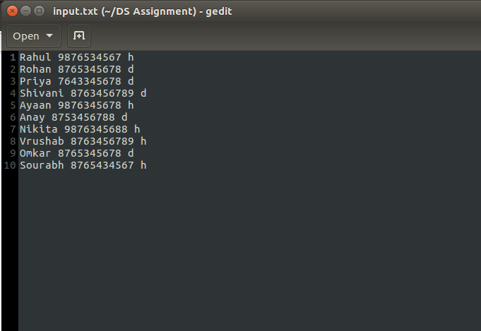

When we enter option ‘1’

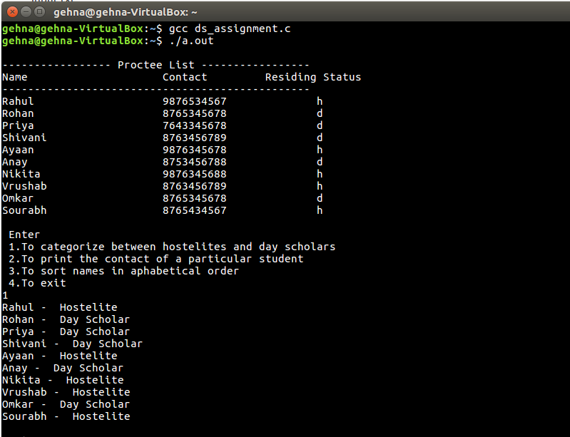

When we enter option ‘2’

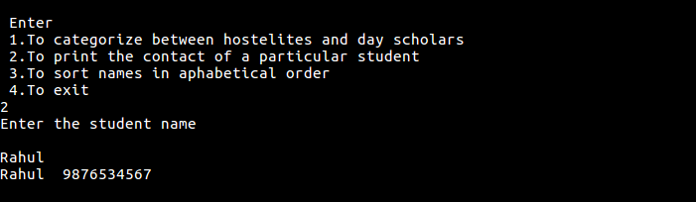

When we enter option ‘3’

