Docgen
Reference
Version: 1.0

Contents
Contents 2
Abstract 4
1. Source documentation format 4
1.1. Documentation source format 4
1.2. Format basics 4
1.2.1. Tags and attributes 4
1.3. Text formatting 5
1.3.1. Paragraphs 5
1.3.2. BBcode 5
1.3.3. Managing BBcode transformation (@transform attribute) 6
1.3.4. Formatting tags 6
1.3.5. list and list-item tags 7
1.3.6. table, row and col tags 7
1.3.7. example and tab tag 8
1.3.8. headline 9
1.4. Documentation objects 10
1.4.1. Basic Documentation structure. 10
1.4.2. Documentation for APIs, formats and structures 11
1.4.3. group tag 11
1.4.4. article tag 11
1.4.5. class tag 12
1.4.6. member tag 12
1.4.7. declaration tag 12
1.4.8. param tag 13
1.5. Conditional compilation (@if attribute) 13
2. Project file 14
2.1. Project file and documentation compilation 14
2.2. Source section 14
2.3. Output section(s) 14
3. Output templates 15
3.1. Html output template 15
3.1.1. Adding template to the project file 15
3.1.2. Configuring template 15
3.1.3. HTML Help specifics 15
3.1.4. Web Help specifics 15
3.1.5. Class grouping 15
3.1.6. Member grouping 15
3.1.7. Member declarations 15
3.2. XMLDoc template 15
3.3. Null template 15
3.4. Special templates 15
3.4.1. Null transformation template 15
3.4.2. Sandcastle to docsource autogeneration template 15
3.4.3. Doxygen to docsource autogeneration template 16
4. Creating your own output template 16
4.1. Source DOM 16
4.2. Docgen XSLT extensions 17
4.2.1. XSLT Variables 17
4.2.2. Multiple templates and multiple output files 17
4.2.3. Managing XML Documents 17
4.2.4. Regular Expressions 18
4.2.5. Text handling 18
4.2.6. Debugging and Validation 18
5. Integration with XCE 18
6. Diagrams 19
Diagram 1. DS formatting syntax 19
Diagram 2. DS formatting syntax 20
Diagram 3. DS formatting syntax 20
Diagram 4. DS formatting syntax 21
Diagram 5. DS formatting syntax 21
Diagram 6. Structure tags model 22
Diagram 7. Project Model 23
Diagram 8. Compiled XML Model Part 1 – Structural Tags Scheme 24
Diagram 9. Compiled XML Model Part 2 – Doc Item Scheme 26

Abstract
Properties
Document name | Docgen
Author (Name, Position, email)
Document status
Document version | 1.0
Document kind | Reference
Project
References
Reference # | Description (Name, data, author, short resume)
History
Date/Version | Description (data, author, short resume)
- Source documentation format
  - Documentation source format
The documentation source format is designed to allow:
- Describe complex structured matters, including user documentation, programmatic API and data structures;
- Provide rich text formatting abilities;
- Keep all documentation source independent from final format (e.g. CHM, Web documentation, PDF);
- Keep all documentation source is plain text files.

Note: while documentation source can be modified in any text editor, using of XCE.NET is highly recommended because XCE.NET provides syntax highlighting, on-the-fly syntax validation and basic intellisense features.

There is no special requirements how exactly documentation is organized inside the text files.
  - Format basics
    - Tags and attributes
Document source tag is a basic form of the organization information inside the documentation. Absolutely everything should be located one of documentation tags.

The documentation tags starts with the line with @ character (must be the first non-space character in the line) followed by the tag name. The line with tag name cannot consist of any other text.
The documentation tags ends with the line with @ character followed by the end keyword. The line with tag end cannot consist of any other text.

The tag may consist of:
- Attribute
- Text
- Other tags

The attributes are specified one per line. The line must start with @ character (must be the first non-space character in the line), followed by the attribute name, then = character and finally the value. Space characters around = character are ignored.

Tags could be structure tag (which defines content and structure of the documentation) or formatting tag (which defines the formatting and organization of text inside documentation elements).

The text is an arbitrary text. See 1.3 for details about text and text formatting.

Below is a simplified example of a tag
@article
@name=My Article
@key=_myarticle

The first paragraph of the text.
Still the first paragraph of the text.

The next paragraph of the text.

@seealso
@title=Additional information
@key=_my_other-article
The paragraphs(s) of detailed description of the see-also link.
@end
@end

Refer to the certain tag description to see which values and which tags it can consist and whether it can consist of a text or not.
  - Text formatting
The formatting syntax in form of Virth’s diagrams is shown on diagrams Diagram 1 trough Diagram 5.
    - Paragraphs
As said above, the text can be an arbitrary text. End-of-line characters are considered as a whitespace, so
Line1
Line2
will be considered as Line1 Line 2.
The paragraphs should be separated by an empty line.
Also, the paragraphs are split in case a tag, not matter structure or formatting tag, is used.
Whitespace at the beginning of the line and at the end of the line are also trimmed out. If you need to create a line that starts from a whitespace (for example to indent lines of the code in the example block) use ! character at the beginning of the line. The ! character will be stripped out, but all whitespaces after it will be saved.
    - BBcode
BBcode is a simple formatting language widely used in various internet-communities. BBcode is a set of tags, the tags are enclosed into square brackets ([]) which are used to specify format of the enclosed text. For example
Normal text [b]Bold text[/b] again normal text [b]Bold [i]and italic text[/i][/b]
Will be formatted as
Normal text Bold text again normal text Bold and italic text
As it is easy to see, the tag name in square bracket starts the formatted text and then the slash followed by the tag name in square brackets – ends the formatted text.

Note that BBcodes are handled by the output templates so the result will depend on which output template is used. Traditionally, the most comprehensive support of bbcodes is in HTML template.

There is the list of BBcodes supported by the current version of HTML template.
[b]text[/b] | Bold (here and after text means bb-coded text, i.e. tag can contain enclosed tags)
[i]text[/i] | Italic
[u]text[/u] | Underline
[s]text[/s] | Strike trough
[c]text[/c] | Code (monospaced)
[sup]text[/sup] | Super index
[sub]text[/sub] | Sub index
[size=n]text[/size] | Size of the text (could be relative using +n or –n)
[red]text[/red] | Red color
[green]text[/green] | Green color
[blue]text[/blue] | Blue color
[gray]text[/gray] | Gray color
[color=#bbggrr]text[/color] | Specified color in html-format, where bb, gg, and rr are color component, in 0-255₁₀ range in hexadecimal system
[link=keyword]text[/link] | Link to the specified key
[clink=keyword]text[/clink] | Link to the specified key + [c]
[img=ref] | Reference to image (does not have closing tag!)
[url=url]text[/url] | Link to the specified url, opens in the same window
[eurl=url]text[/eurl] | Link to the specified url, opens in the new window
[br] | Link break. (does not have closing tag!)
[nil] | Tag producing nothing. Is useful, for example, in code examples, where constructions like [i] can appear as a part of the example. In that case you can add [nil] tag inside [i] to avoid recognizing [i] as a bbcode: [[nil]i]
[var=VarName] | The tag allows to include a custom text that is defined in the project file.  VarName is a name of the variable the value of which must be defined using define tag in the help project.

Some tags, such as [img], [br], [nil] or [var] do not have a closing tag.

While BBcode itself does not require that tags are correctly closed or nested, it is strictly recommended to close and nest all tags correctly in order to prevent any further incompatibilities with new output formats, especially which are xml-based.

The examples of wrong and proper nesting are below. Let say, we want to get the following format abcd.
This is a wrong (but still working in html output template) way to do it. Problems: tag are improperly nested, one tag isn’t properly closed.
[b]a[i]bc[/b]d
Now this is the right (properly nested and closed) way to do it. The added bbcodes are underlined:
[b]a[/b][i][b]bc[/b]d[/i]
    - Managing BBcode transformation (@transform attribute)
To have BBcode transformed into formatting tags of output format (if output support formating), the author should specify @transform attribute.
This attribute can have on of the following values:
- def Default rules apply. Default rules are rules of the higher level object (e.g class for member). For the whole project default value is no. This value can be overridden by default-transform parameter of the output format in the documentation project file.
- yes BBcodes will be transformed into formatting code.
- no BBcodes will not be transformed into formatting code. This value is default to provide backward compatibility with older versions of the documentation which are formatted using HTML tags rather than BBcode.
    - Formatting tags
There are also docsource tags which are used to make a more complex structure of the text than simple paragraphs. These tags are:
- Lists
- Tables
- Examples
- Headlines
    - list and list-item tags
@list tag is used to enclosed bulleted or numbered lists.
The @list tag has following attribute(s)
@type | type of the list. Use dot for bulleted list or num for numbered

@list tag can consist @list-item tags or another @list tag (for next-level list) only.

@list-item tag can consists of only bb-coded text. For HTML output all text will be joined into one paragraph. @list-item tag can be used only inside @list tag.

Example
@list
@type=dot
@list-item
First item
@end
@list-item
Second item
@end
@list
@list-item
Second-level list item
@end
@end
@list-item
third item
@end
@end
Creates a list like this one:
- First item
- Second item
  - Second-level list item
- Third item
    - Simplified Syntax for Lists
If a common property simplified-text-syntax is set in the project, a simplified syntax may be used for one-level lists.
Simply start each line of the list from - or * (for bullet list), or # (for number list).
Note: You do NOT have to separate single-line list item with an empty line
Example:
My List

- Item 1
- Item 2
- Item 3

My Another List

- Item 1. this is a long item
At multiple lines

- Item 2. This is another long Item
At multiple lines

    - table, row and col tags
@table tag is used to make a table.
@table tag can have the following attributes:
@width | the width of the table. It can be specified either in pixels or in percents. By default the table with is “auto” i.e. depends on the best way to layout the content.
@table tag can consist only @row tags.

@row tag describes one row of a table.
@row tag can have the following attributes:
@header | the attribute indicates whether the row is formatted as a header row (yes) or as a regular row (no, default value).
@row tag can consist only @col tags. @row tag can be used only inside of @table tag.

@col tag describes one column in a row of a table.
@col tag can have the following attributes:
@width | the width of the column. It can be specified either in pixels or in percents. By default the column with is “auto” i.e. depends on the best way to layout the content.
@col tag can consist any formatted text, with any number of parameters and any formatting attributes. @col tag can be used only inside of @row tag.
Example
@table
@row
@header=yes
@col
Header 1
@end
@col
Header 2
@end
@end
@row
@col
Cell 1,1
@end
@col
@list
@list-item
Cell 1,2 first
@end
@list-item
Cell 1,2 second
@end
@end
@end
@end
@row
@col
[b]Cell 2,1 first para[/b]

Cell 2,1 second para
@end
@col
Cell 2,2
@end
@end
@end

Creates a list like this one:
Header 1 | Header 2
Cell 1,1 | - Cell 1,2 first  - Cell 1,2 second
Cell 2,1 first para  Cell 2,1 second para | Cell 2,2
    - Simplified Tables
If a common property simplified-text-syntax is set in the project, a simplified syntax may be used for tables that contain just one line of text in each cell.
Simply Enclose each table line into | characters and separate columns with | character.
Note: you do NOT have to separate rows with an empty line
Example:
|{header,30%}name|value|
|[c]value1[/c]|description|
|[c]value2[/c]|description|
    - example and tab tag
@example tag is used to insert collapsible (if possible) block demonstrating a piece of code or other technical information, or, alternatively, to put optional explanatory notes or images to the text so the reader can collapse them.

@example tag has following attributes
@title | The title for the example. Title is displayed even if the example is collapsed.
@highlight | Turn syntax highlighting on. The parameter is the language name: c, cpp, cs, cshtml, java, lua, python, xml, html…  please note that syntax highlighting won’t be displayed inside chm files, only in web content
@transform | Transformation flag yes or no. If flag is yes – the bbcodes are converted into the text, if no – they are left as is.
@show | Flag indicating whether the example should be displayed by default (yes) or collapsed (no, default value).
@gray | Flag indicating whether the background of the example block background should be grayed-out (yes, default value).
@tabs | Flag indicating that there will be tabs used inside the example to put multiple version of content (for example in different programming languages. If flag is yes the nested @tab tags are expected. Otherwise the formatted text body of the @example tag will used as a example text. Default value is no.

Example
@example
@title=A piece of my code
@transform=no
@show=yes
! if (I am bored)
! Have Some Bear();
! else
! For More();
@end

@tab tag is used inside the example in order to provide different views of the same examples, for example a piece of the same code in different programming languages. The view of the tag highly depends on the output format.

@tab tag has following attributes
@title | The title for the example. Title is displayed on the tab which is used to select the version of example
@example
@title=Hello phrase
@tab
@title=English
Hello!
@end
@tab
@title=Fransais
Bon jour!
@end
@tab
@title=Русский
Привет!
@end
@tab
@title=中国话
你好吗[br]
(Ni hao ma)
@end
@end
    - headline
The tag @headline creates a headline inside the text (e.g. section title).
@headline tag has the following attribute(s)
@level | The level of headline (number, 1 to 6).

@headline tag can consist any formatted text.
  - Documentation objects
Please refer to Diagram 6 to model of the objects that defines the documentation structure.
    - Basic Documentation structure.
Documentation is structured into parts.
Each part shall be identified by a unique key.
The major element of the documentation is an article. The article is supposed to describe one topic and be presented in output documentation as one basic element (e.g. lowest level content element in documentation or a page in the HTML).
Articles are grouped into “groups”, usually by similarity of the topics.
Groups may be hierarchically organized, i.e. a group can contain articles and/or other groups.
One group should always exist and should have key “index”. This is the start point of the documentation.
And example of the structure for a user guide is shown below:
- Group: Index
Article: Introduction
Article: License and End-User Agreement
Group: Installing Application
Article: Prerequisites
Article: Downloading and installing application
Article: First start and initial configuration
Group: Day-by-day operations
…
Note that you do not need to put an @article or @group tag into another @group to have in included into that group. This approach, while it seems to be logical, would require to keep all text in one file which is not the most convenient way, especially if multiple writers works on the same documentation. Instead we just refer the group to include our article into using the unique key and @ingroup attribute.

I.e. we do NOT put articles into a group this way:
@group
@title=My Group
@key=mygroup
@article
@title=My Article 1
…
@end
@article
@title=My Article 2
…
@end
@end

We do it this way, so articles can be put into different files
@group
@title=My Group
@key=mygroup
@end

@article
@title=My Article 1
@ingroup=mygroup
…
@end

@article
@title=My Article 2
@ingroup=mygroup
…
@end

    - Documentation for APIs, formats and structures
Often, the documentation needs to describe specific design or programming objects such as library, classes, interfaces, tables, structures or schemes.
In this case special kind of the documentation object shall be used a class. Don’t be confused between programmer’s meaning of a class which is a special way of organization of the source code of a program and a class in the documentation. In docgen “class” is used in pure OOA (Object oriented analysis) meaning which means a group of objects described by a set of properties and which can be used via methods. Of course, programmer’s class is a special case of OOA class. From this point of view, let’s say an XML tag is also a class which has properties – its attributes. As an XML tag is a pure content container, it is an “entity” so it simply does not have any methods.
Each class is also related to one of groups, the same way as an article.
But in addition to the text, the class consists of members, which could be properties, (table or class) fields, methods, constructors.
    - group tag
The group tag describes structure of the document. Each group can consist of other groups, articles or classes. However, it is a pure tree structure, where each element can be consisted in only one group and one group is a “root” of that tree. The key of that group should always be “index”.
The group contains formatted text.
The group tag has following attributes
@title | The title (name) of the group to be displayed in content or before the group text.
@brief | The brief description of the group. Usually is put as a first paragraph of the group text and is displayed in the lists of groups.
@key | An unique key of the group. The key should consist of only English characters, numbers, an underscore (_) character.
@ingroup | The key of the group into which this group is included.
@order | if value is “sort”, the articles and groups are listed separately, in two consequent lists. If value is custom – the articles and groups are listed together, in the order of their appearance.
@sortarticles | yes (default) to sort articles by their name in ascending alphabetical order, no to show them in the order in appearance in the documentation.
@sortgroups | yes (default) to sort groups by their name in ascending alphabetical order, no to show them in the order in appearance in the documentation.
@sortclasses | yes (default) to sort classes by their name in ascending alphabetical order, no to show them in the order in appearance in the documentation.
HTMLHelp-specific attributes. These attributes are used to add HTMLHelp source documentation into the project.
@importhhc | The attribute is used to append HtmlHelp content description to the group content.
@importhhk | The attribute is used to append HtmlHelp keyword list description to the group content.
    - article tag
The article describes one explanatory element of the documentation. The article contains formatted text and the following attributes.
@title | The title (name) of the article to be displayed in content or before the group text.
@brief | The brief description of the article. Usually is put as a first paragraph of the article text and is displayed in the lists of articles.
@key | An unique key of the article. The key should consist of only English characters, numbers, an underscore (_) character.
@ingroup | The key of the group into which this group is included.
      - class tag
The class is used to describe objects related to programming, program structures and APIs, such as classes, interfaces, structures, tables, tags and so on.
The class description contains formatted text.
The class tag has following attributes:
@name | Name of the class. Usually the class name is specified without namespace.
@key | Unique key which is used for the class. Usually it is the class name with namespace.
@sig | Signature of the class. The signature meaning depends on the type of the object and programming language. For example, C# types shall have xmldoc class signatures here.
@brief | A brief description of the class. Usually is put as a first paragraph of the article text and is displayed in the lists of articles.
@type | A type of the class. Typical values are class or interface. However this value is passed to the template and can be used to change formatting of the class documentation page. For example HTML template supports following types: for programming languages: interface, class, struct, enum, functions (e.g. for function library in C++), js_object (for java script), xml-schema for describing XML schemas or sql for describing SQL tables
@declname | A name of the class to be used in declaration (if a name different from @name value should be used)
@ingroup | The key of the group into which this group is included.
The tags what described the content of the class (fields, properties and methods) are included directly into the class body. These class members are described using a @member tag.
The class (for example generic/template class) can also have @param tags.
Notes on partial class definitions:
Class definition may appear multiple times, but:
- The class description will be taken from the first appearance of the class definition
- Each class occurrence may contain members with the same key, but only first occurrence of such method will be used.
This allows the author to use documentation automatically generated from source code comments to be used as a base of the documentation using the following procedure:
- Create auto-generated documentation and include it into the project
- Create manual documentation and include it into the project so it is BEFORE the auto-generated documentation
- Redefine classes and methods for which auto-generated description needs to be overridden.
    - member tag
The @member tag describes a member (field, property, method) of a class. The meaning of the type depends on the type of the class, e.g. field for a class with sql type will be recognized as a database column.
The member description contains formatted text and the following attributes:
@name | Name of the member. Usually the class name is specified without namespace.
@key | Unique key which is used for the member. By default it is the class name with namespace plus name of the method. You may want to overwrite the default value in case of multiple methods that has the same name.
@sig | Signature of the member. The signature meaning depends on the type of the object and programming language. For example, C# types shall have xmldoc class signatures here.
@type | A type of the member: field, property, function, constructor, method.
@visibility | Visibility of the member: private, protected, package or public. Default visibility is public.
@scope | Scope of the member: class or instance. Default scope is instance.
@divisor | Custom divisor between class name and member for title and declaration (default divisor is dot (.))
@index | Additional index key(s) (in addition to “class name” “divisor” “member name” key)
@custom | Custom type of the member in addition to one specified in @type and used to provide additional grouping.
The member can also contain @declaration, @param and @exception tags.
    - declaration tag
Declaration tag is designed to display one spec of the method made in a particular programming language and/or data format.
The declaration is based on:
- The member information (e.g. class, name, divisor, visibility, scope)
- The declaration additional information (e.g. return value, parameter string)
- The template-based format for the language (see section 3.1.7 for more details about declaration templates)
The declaration tag has the following attributes:
@language | The programming language. The template will be chosen on the base of the method type (e.g. method, property) and the programming language.
@name | The name of the member
@prefix | The text to be put before the declaration. Can be used for example to add virtual qualifier or attributes.
@suffix | The text to be put after the declaration. Can be used for example to add get; set; or =0 specifiers.
@name-suffix | The interpretation of this information depends on the template.
@return | The datatype of the return value.
@params | The parameters string
@custom | The interpretation of this information depends on the template.
    - param tag
The tag describes one parameter. All the parameters are usually listed at the output right after declarations.
The tag has only attribute - @param and consists of formatted text with the description of the parameter.
  - Conditional compilation (@if attribute)
Elements of the documentation can be included only by condition. It is useful, for example, if two versions of the documentation (e.g. User and Admin) is created by the same source. In this case an @if attribute can be used.
The following rules apply:
- If there is no @if attribute, the element will be included into the documentation.
- If there is @if attribute in the element, this element will be included only when the variable with the name specified in the value of @if attribute is specified for the output template.
Example of documentation source
@article
@title=Common article for all versions
…
@end
@article
@title=Article for admin version only
@if=admin
…
@end
@article
@title=Article for user version only
@if=user
…
@end
Example of project file
<dg:output template="%docgen%\template\html\main.xsl"
file="dst-user/null-file" encoding="utf-8" >
…
<dg:define name="user" value="yes" />
</dg:output>
<dg:output template="%docgen%\template\html\main.xsl"
file="dst-admin/null-file" encoding="utf-8" >
…
<dg:define name="admin" value="yes" />
</dg:output>
Note: The value of the variable does not matter from point of view of conditional compilation, only the fact of presence or absence of the variable matters.
Note for template developers: Conditional compilation don’t need to handled by the template. The objects which aren’t required to be included into the source by conditional compilation will not be included into the XML document provided to the template.
Following tags can be attributed for conditional compilation:
- group
- article
- class
- member
- declaration
- param
- table
- tablerow
- seealso
- example
- Project file
  - Project file and documentation compilation
The rules for compiling documentation sources and writing back the result is described in a project file. The project file is described by project compiler schema (the schema URI is http://www.gehtsoft.com/docgen/project, don’t try to open it as an URL, it is not stored anywhere in the interned, it is just a schema NAME. The actual schema is stored inside the compiler). Typically, the schema is referenced to be used with the prefix dg.

The structure of the project file is show on Diagram 7.

In other words, the project file must be ALWAYS started as the following:
<?xml version="1.0" encoding="utf-8"?>
<dg:help-project xmlns:dg="http://www.gehtsoft.com/docgen/project">
… project description here …
</dg:help>
To compile the documentation simply run docgen.exe specifying the project file name as a parameter.
  - Source section
The source tag describes files and/or folders that contains the documentation source and need to be compiled.
The section consists of one or more following tags:
- file name="…" encoding=""
and/or
- folder name="…" encoding="" mask="" recursive="true|false"
where name is the absolute or relative (to the project file) name of the file or folder and encoding is the name of the encoding. Please note that
The encoding is typically:
- windows-1252 or us-ascii for the texts in English
- windows-1251 for the texts in Russian
- utf-8 for the multilingual texts stored in Unicode.
For the folder additionally two attributes may be specified:
- mask the regular expression which filters out the file name(s) to be processed. By default the mask is * .+\.ds that means any name which ends with ds extenstion.
- recursive true or false flag indicating whether the compiler should look for the source files in the subfolders of the specified folder. By default the value of the attribute is false (take files from the specified folder only, do not look in subfolders).
  - Output section(s)
The output section causes one execution of one template. Multiple output sections can be listed in the project file in order to run one template with different parameter and/or to run multiple templates.
The output tag has the following attributes:
template | The name of the xslt template (or a main template in complex output templates). The name can be an absolute path, a relative path to the project file location or can consist of environment variables in form of %varname%.
file | The output file to be created. In case the template creates more than one files, this file is used to determine to output folder, but it still need to be a file name, e.g. you should specify .\outputfolder\nullfile instead of just .\outputfolder.
encoding | The encoding for output files.  The encoding is typically:  - windows-1252 or us-ascii for the texts in English  - windows-1251 for the texts in Russian  - utf-8 for the multilingual texts stored in Unicode.
The output section can consists of one or more define tags. Define tag defines on variable which will be passed to the output template. The define tag has two attributes:
name | The name of the value
value | The value.
The set of the values defined in the template is specified in the template description.
If some values need to be used in multiple templates, put them under common tag and place common tag before source tag.
- Output templates
  - Html output template
    - Adding template to the project file

    - Configuring template

    - HTML Help specifics

    - Web Help specifics

    - Class grouping

    - Member grouping

    - Member declarations

  - XMLDoc template

  - Null template

  - Special templates
    - Null transformation template
Null transformation template simply writes DOM model (see 4.1) into an XML file specified in the file attribute.
Null transformation tables is located in template\null\null.xsl file inside docgen folder.
    - Sandcastle to docsource autogeneration template
When documentation is created for .NET API, Sandcastle utility may be used to collect meta information about the API and then resulting XML file can be used to create a template for the documentation in DocSource format.
- Run sandcastle on the assemblies you want to have documented:
MrefBuilder.exe your-assembly /out:metadata.xml
Then create the docsource project.
Create one dummy group (as docsource project MUST have at least one group) with the following content and save it to dummy.ds file:
@group
@title=index
@key=index
@ingroup=
@brief=
@end
Create a project file
<dg:help-project xmlns:dg="http://www.gehtsoft.com/docgen/project">
<dg:source>
<dg:file name="null.ds" encoding="windows-1252" />
</dg:source>
<dg:output template="%docgen%\template\sandcastle2ds\main.xsl" file="src/null-file"
encoding="windows-1252" >
<dg:define name="src-file" value="metadata.xml" />
<dg:define name="group" value="index" />
<dg:define name="visibility" value="public,family" />
</dg:output>
</dg:help-project>
Now the template will read metadata file created by the SandCastle and will create a file with class description and all its members in the folder specified in file attribute of the template.
Parameters of the template:
src-file | The name of the XML file created by SandCastle.
group | The group key to which all namespaces will be put.
visibility | Visibility of the classes to be included into the documentation.
    - Doxygen to docsource autogeneration template
To create C++ documentation from Doxygen source:
- Create Doxygen project and set output format to XML:
GENERATE_XML = YES
XML_OUTPUT = xml
- Follow the procedure of the project creation described in 3.4.2, but use template\doxigen2ds\main.xsl instead. Also use the values listed below to configure the doxygen to docsource template.
file-list | An XML file which consists of list of the doxygen files to be handled.  Example:  <files>  <file name="classgstool3_1_1_a_thread" />  <file name="classgstool3_1_1_mutex" />  …  </files>
xml-path | The folder where Doxygen XML output is located.
group | The group key to which all namespaces will be put.
- Creating your own output template
  - Source DOM
The input of the template is a DOM model which represents the compiled source files in form of XML document. The content and structure of the DOM model pretty much reproduces the structure of the documentation source.
Refer to Diagram 8 and Diagram 9 for structural model of the DOM.
Use null template (see 3.4.1) in order to get an XML file with DOM model of the documentation.
Please note that you don’t need to handle the conditional compilations. The elements which aren’t supposed to be placed into the documentation due to conditional compilation (@if tag) are not placed into DOM.
  - Docgen XSLT extensions
The template format is heavily based on XSLT style sheet format with a few extensions for in XPATH expressions which allows to perform more complex logic. Nowadays a lot of these are incorporated into XSLT 2.0, however already developed templates are based on XSLT 1.1 and porting them to XSLT 2.0 does not seem to be feasible at this moment.
The template author is supposed to know how to use XSLT 1.1 and XPATH.
All extensions are references via urn:gehtsoft-exslt namespace
    - XSLT Variables
First category of the functions is related to provide variables to the XSLT. The variables and parameters in XSLT 1.1 specifications are not true variables as they can be assigned only once during lifetime of a templates.
To operate “true” variable use the following extension functions:
let(name, value) | Sets the local variable to the value specified.
letglobal(name, value) | Sets the global variable to the value specified.
get(name) | Gets the variable. If there is a local variable with the name specified, its value will be returned. Otherwise, if there is a global variable with the name specified, its value will be returned. If no variable with such name exists, an error will be raised.
get(name, value) | Gets the variable. If there is a local variable with the name specified, its value will be returned. Otherwise, if there is a global variable with the name specified, its value will be returned. If no variable with such name exists, a value specified in the second parameter of the function will be returned.
exist(name) | Checks whether the variable exists. The function returns true if a local or a global variable with such name exists.
caller(name) | Gets the local variable of the calling template. If there is no such variable in the caller template, an error will be raised. See 4.2.2 for details about template calling.
    - Multiple templates and multiple output files
In order to organize code of a complex template (for example HTML output template consists of over 100kb of the source code), the author can split it into multiple files. Then the author can call these templates using extension function call. Depending on the way how function is called, the result of the transformation will be either saved to a new file (which is convenient to create a complex output, for example HTML documentation) or to a string variable.
There is no such thing as arguments provided to the called template; however called template may use caller function in order to read local variables of the calling template.
call(template, node) | Call template located in the file name template and apply it on the specified node. Return the result as a string.
call(template, node, output-file, encoding) | Call template located in the file name template and apply it on the specified node. Save the result into file output-file with the specified encoding

    - Managing XML Documents
The following functions are used to handle additional XML documents.
node xmlgetdocument(filename) | Reads the specified XML document and returns it as DOM model.
node-id xmlcreate(docname, root-tag-name) | Creates a new XML document with the root tag. Returns the identifier of the root tag for further reference.
node-id xmladdelement(docname, parent-node-id, tag-name) | Adds a tag to the tag specified. Returns the identifier of the new tag.
xmladdattribute(docname, parent-node-id, attr-name, attr-value) | Adds an attribute to the tag specified.
xmladdtext(docname, parent-node-id, text) | Adds text to the tag specified.
xmladdcdata(docname, parent-node-id, text) | Adds cdata text to the tag specified.
The XML files created using xmlcreate will be automatically saved when template is finished.
    - Regular Expressions
The Regular Expression syntax is documented in MSDN.
At the moment of creation of the document the link was
https://msdn.microsoft.com/en-us/library/az24scfc(v=vs.110).aspx
If it does not work at the moment of reading of the document, search for “Regular Expression Language” in MSDN.
match(pattern, text) | Checks whether the text matches the pattern.
node parse(pattern, text) | Parses the text using the pattern specified. The returned value is a DOM model:  <result>  <match>  <text>whole match text</text>  <group><text>group match text</text></group>  … for each matched group in the regular expression…  <group><text>group match text</text></group>  </match>  … for each match in the text …  </result>

    - Text handling
Following functions are provided for advanced text processing.
node parsebbcode(text) | Parses BB code and returns DOM. The root tag of dom is R. All texts are enclosed into <t> tag and bbcodes are also converted into XML tags, i.e. hello my [b]friend[/b] will be converted into <r><t>hello my </t><b><t>friend</t></b></r>.
upper(text) | Converts text to uppercase
lower(text) | Converts text to lowercase
strcmp(text1, text2) | Compares to string. Returns 0 if strings are equal, -1 if the first string precedes the second string in alphabetic order, and 1 if the first string follows the second string in alphabetic order. The order is case sensitive, i.e. A-Z and then a-z.
stricmp(text1, text2) | Compares to string. Returns 0 if strings are equal, -1 if the first string precedes the second string in alphabetic order, and 1 if the first string follows the second string in alphabetic order. The order is case insensitive, i.e. AaBb-Zz.
removehtml(text) | Removes HTML tags from the text
replaceentity(text) | Replaces HTML entities with their codes.
writeBase64(filename, base64string, length) | Converts provided base64 into binary and writes it into the file.

    - Debugging and Validation

trace(text) | Writes output to the console.
error() | Stops execution of the template
registerkey(key) | Registers when a key object is created.
registerlink(key) | Registers when a key object is referenced to by a link
checkkeys() | Checks whether keys aren’t registered more than once and there is no links that points to a key which is not created. Usually is called at the very end of the template handling.

- Integration with XCE
The colorer schema is needed to syntax color highlighting of the DocSource in XCE text editor.
To properly install color schema:
1) copy ds.hrc file to colorer\hrc\xce\ subfolder of the XCE file editor
2) add the following definition to the colorer\proto.hrc file. Look for other prototype tags to find out the proper location. There is a lot of them in the file.
<prototype name="ds" group="xce" description="Documentation Source">
<location link="xce/ds.hrc"/>
<filename>/\.(ds)$/i</filename>
</prototype>
3) Add filetype to xce.ini file (right in XCE folder)
[filetype]
mask = /^.+\.(ds)$/i
encoding = windows-1252
ignore-bom = false
trim-eol-space = true
tab-size = 4
auto-indent = true
default-spellchecker = en_US
spellcheck-regions = ds:text (null)
If you did everything right, the text will be colored.
Now place the xce-project.ini file into the root folder of your documentation project. Put following content there (replace project.xml to your project file name if it is different):
[project]
doc-project=project.xml
Now intellisense is also working:
- It offers you auto-complete options when you type [ and @.
- It offers you key when you type = after link, clink and ingroup.
- It allow you to navigate using F12/ctrl-F12
Please note that intellisense only recognizes:
- The content of the file you are currently edit
- The content of the other files in the project as they was at the moment when the current window is opened. I.e. if you have two files opened at a time, and both are modified – each of the files will not see modifications made on the other files, even if they are saved. You need to close the file and open it again to pick up modifications in other files of the project.
- Diagrams
- DS formatting syntax
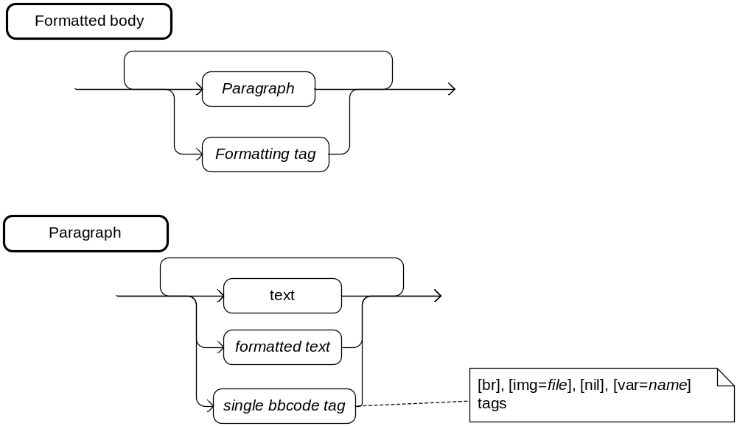
- DS formatting syntax
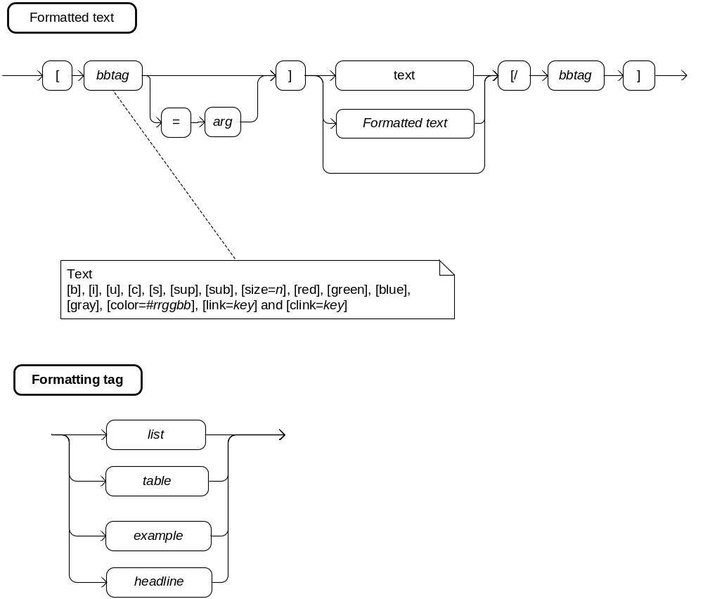
- DS formatting syntax
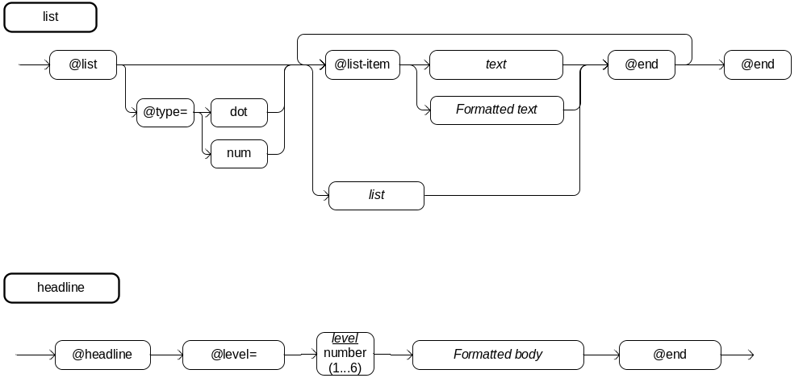
- DS formatting syntax
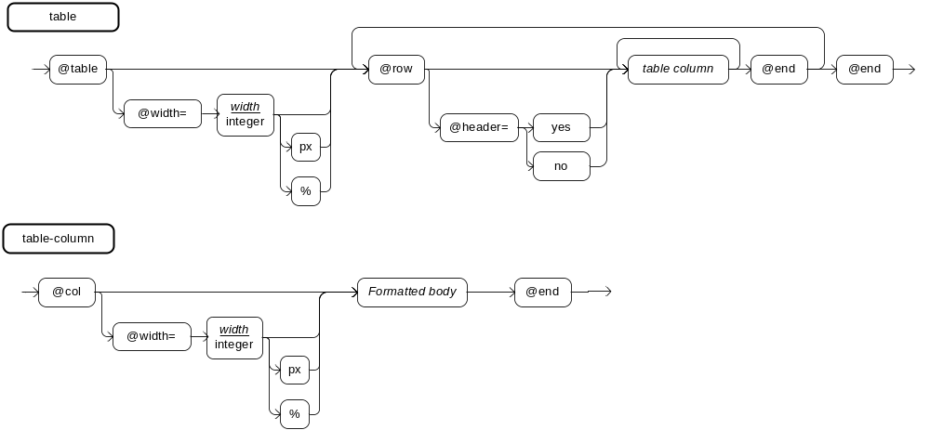
- DS formatting syntax
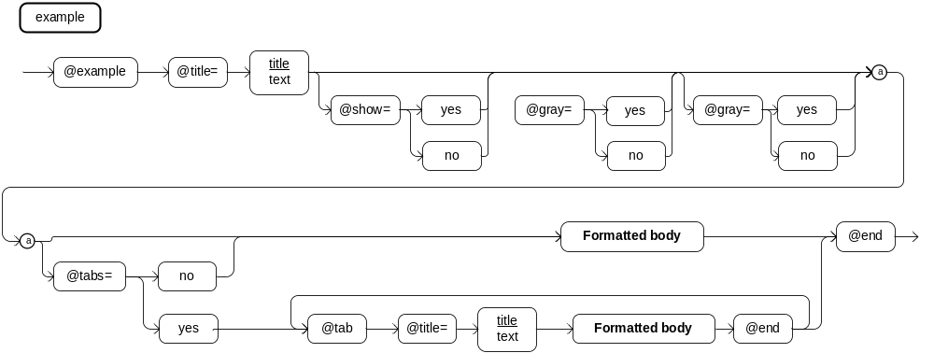
- Structure tags model
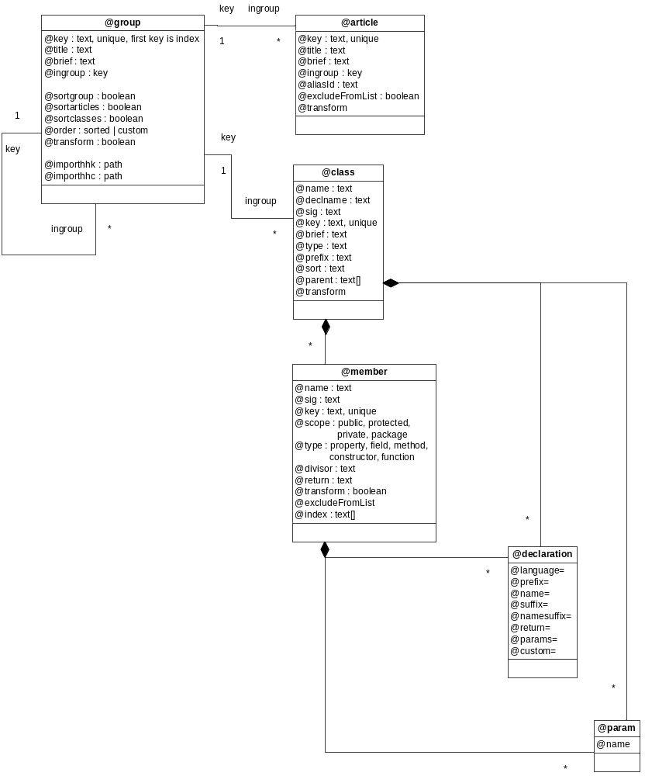
- Project Model
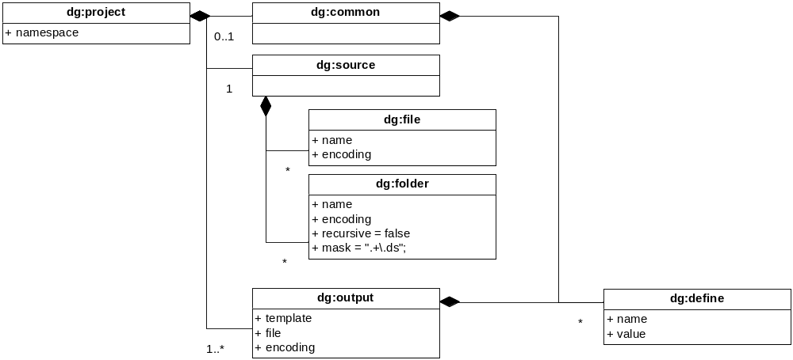

- Compiled XML Model Part 1 – Structural Tags Scheme
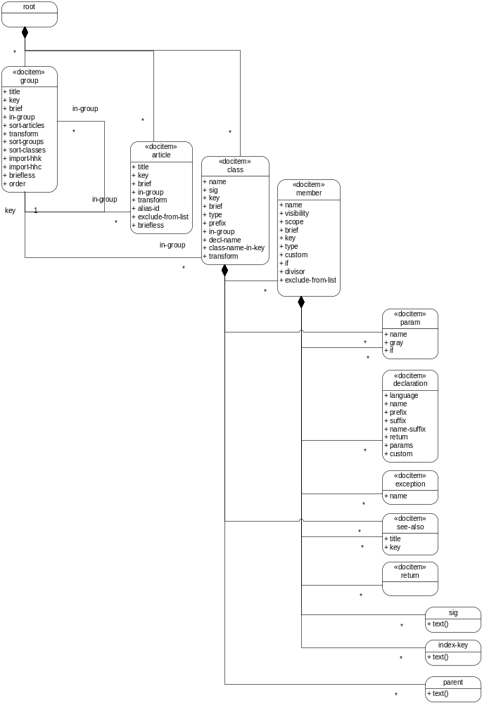
- Compiled XML Model Part 2 – Doc Item Scheme
