- Content
1. Content 1
2. Introduction 1
3. Command Line 1
4. Project file. 1
5. Help Source Format 3
5.1. Group 3
5.2. Article 4
5.3. Class 5
5.4. Member 6
5.5. Declaration 7
5.6. Parameter 8
5.7. Return 8
5.8. Exception 8
5.9. See Also 9
5.10. In-text tags 9
5.10.1. Table 9
5.10.2. TableRow 9
5.10.3. TableCol 9
5.10.4. Example 10
5.10.5. list and list-item 10
5.10.6. Headline 10
5.11. BB-coded content 10
6. Template 11
6.1. EXSLT extensions 11
7. XML format 13
7.1. Documentation structure. 13
7.2. Documentation items 14

- Introduction
The docgen application is intended to generate html files and hhc/hhk files for the Html Help Compiler or any other text format (depending on the template).
- Command Line
Command line is very simple: docgen projectfile
- Project file.
The project file is an XML file. The root tag shall be <help-project>. The namespace of the project file is http://www.gehtsoft.com/docgen/project. The recommended prefix for the namespace is dg.

The help-project tag consists of the following tags:
Optional common tag which consists of definitions for all existing outputs.
Required source tag which describes the source files.
One or more output tags which describes outputs.

Tag common can consist one or more define tag.

Tag define defines one string value and has two attributes:
required attribute name
optional attribute value

Tag source consists one or more file or folder tags.

Tag file describes one source file to be parsed. Tag has following attributes:
required attribute name
optional attribute encoding. Default encoding is windows-1252

Tag folder describes one folder with source files to be parsed. Tag has following attributes:
required attribute name
optional attribute mask. Regular expression to find the files. Default value is ^.\.ds$.
optional attribute recursive. True|false, Default value is false.
optional attribute encoding. Default encoding is windows-1252

Tag output describes execution of one template to generate one output. Despite the output file is specified in the tag, the template can create additional files using XSLT extensions (see below). Tag output can contains zero or more define tags to define properties specific for this particular output. Attributes:
Required template Defines the main xslt template to be executed.
Required file Defines the file to which the main template output will be written.
Optional encoding Defines the main output file encoding. Default encoding is windows-1252.
The schema is below:
<?xml version="1.0"?>
<xs:schema xmlns:xs="http://www.w3.org/2001/XMLSchema"
targetNamespace="http://www.gehtsoft.com/docgen/project"
xmlns:dg="http://www.gehtsoft.com/docgen/project"
elementFormDefault="qualified" >

<xs:complexType name="Output">
<xs:sequence minOccurs="0" maxOccurs="unbounded">
<xs:element name="define" type="dg:Define"/>
</xs:sequence>
<xs:attribute name="template" type="xs:string" use="required" />
<xs:attribute name="file" type="xs:string" use="required" />
<xs:attribute name="encoding" type="xs:string" default="windows-1252" />
</xs:complexType>

<xs:complexType name="Define">
<xs:attribute name="name" type="xs:string" use="required" />
<xs:attribute name="value" type="xs:string" default="" />
</xs:complexType>

<xs:complexType name="Common">
<xs:sequence minOccurs="1" maxOccurs="unbounded">
<xs:element name="define" type="dg:Define"/>
</xs:sequence>
</xs:complexType>

<xs:complexType name="SourceFile">
<xs:attribute name="name" type="xs:string" use="required" />
<xs:attribute name="encoding" type="xs:string" default="windows-1252" />
</xs:complexType>

<xs:complexType name="SourceFolder">
<xs:attribute name="name" type="xs:string" use="required" />
<xs:attribute name="mask" type="xs:string" default="^.+\.ds$" />
<xs:attribute name="recursive" type="xs:boolean" default="false" />
<xs:attribute name="encoding" type="xs:string" default="windows-1252" />
</xs:complexType>

<xs:complexType name="Source">
<xs:sequence minOccurs="1" maxOccurs="unbounded">
<xs:choice>
<xs:element name="file" type="dg:SourceFile"/>
<xs:element name="folder" type="dg:SourceFolder"/>
</xs:choice>
</xs:sequence>
</xs:complexType>

<xs:complexType name="Project">
<xs:sequence>
<xs:element name="common" type="dg:Common" minOccurs="0" maxOccurs="1" />
<xs:element name="source" type="dg:Source"/>
<xs:sequence minOccurs="1" maxOccurs="unbounded">
<xs:element name="output" type="dg:Output"/>
</xs:sequence>
</xs:sequence>
</xs:complexType>

<xs:element name="help-project" type="dg:Project"/>
</xs:schema>
- Help Source Format
The documentation is described as a set of the documentation objects. Each object has it’s own rules of the translation into the html code and hhc/hhk files.
  - Group
A group can consist of the other groups, articles or classes, so groups defines a tree structure of the documentation. The root group with the key index must be declared in the documentation. A group is to be defined directly in the document (@group shall not be nested into other objects).
Declaration:
@group
@title=
@brief=
@ingroup=
@sortgroups=
@sortarticles=
@sortclasses=
@createcollectors=
@transform=
@if=
@order=
@import=
…text…
@end
Parameters:
@title=
The title of the group.
@brief=
The short description of the group.
@ingroup=
The key of the group this group enclosed to. For the group with the key index this parameter must be empty.
@ sortgroups =yes|no
The parameter indicates whether all groups included into this group must be sorted in the list. The parameter is optional. Default value is yes. In case the parameter is no, the articles will be put in the list in the same order in which the parser met a group during parsing.
@sortarticles=yes|no
The parameter indicates whether all articles included into this group must be sorted in the list. The parameter is optional. Default value is yes. In case the parameter is no, the articles will be put in the list in the same order in which the parser met an article during parsing.
@sortclasses=yes|no
The parameter indicates whether all classes included into this group must be sorted in the list. The parameter is optional. Default value is yes. In case the parameter is no, the articles will be put in the list in the same order in which the parser met a class during parsing.
@key=
The key of the group. The key is also used to make the file name which consists of the group.
@if=
The parameter specifies a symbol. In the case this parameter is used, the group will be included into the documentation only in case the symbol is defined.
@order=sort|custom
The parameter indicates the relative order of the sibling groups and articles (i.e. groups and articles placed in the same parent group). In case if the parameter value is custom, the articles and groups will be put in the list in the same order in which the parser met during parsing, possibly groups and articles will be mixed in this case, otherwise(in case of the sort value) all groups will be put in list before the articles. The parameter is optional. Default value is sort.
@transform=yes|no
(default=parent). In case transform is yes, the body of the object is recognized as bb-coded content. Transform also applies on all included objects.
@import=path
Imports contents subtree from the specified XML file and puts it under the group in the content.
The XML file must have the following structure:
<help-content>
<node name=”” local=””>
<node name=”” local=””>
Where name is a text to put into the content and local is an URL to the resource. Node tag can be enclosed into other node tag to reflect the tree of the content.

Contains: @see
  - Article
An article is a free-form part of explanatory text. An article is to be defined directly in the document (@group shall not be nested into other objects).
@article
@title=
@key=
@ingroup=
@brief=
@if=
@aliasId=
@excludeFromList=
@transform=

…text…
@end
Parameters:
@title=
Title of an article.
@key=
The key of the article. The key is also used to make the file name which consists of the article.
@ingroup=
The key of the group which contains the article
@brief=
The brief description of the article
@if=
The parameter specifies a symbol. In the case this parameter is used, the article will be included into the documentation only in case the symbol is defined.
@aliasId=
The associated context-help identifier. The parameter is optional. In the case this parameter is used and alias file is generated (see “/a” command line parameter description), information about the aliasId associated with this article will be added to the created alias file. This alias file can be included using the “ALIAS” tag into your HTML Help project file (*.hhp).
@excludeFromList=yes|no
The parameter indicates that the article shall not be listed in the group.
@transform=yes|no
(default=parent). In case transform is yes, the body of the object is recognized as bb-coded content. Transform also applies on all included objects. Transform also applies on the title.

Contains: @see
  - Class
Defines a class in OOP terms. A class is to be defined directly in the document (@class shall not be nested into other objects).
@class
@name=
@key=
@parent=
@sig=
@prefix=
@type=
@ingroup=
@if=
@sort=
@declname=
@transform=
@classnameinkey=

…text…
@end
@name=
The name of the class.
@key=
The key of the class. The key is also used to make the file name which consists of the class. In case key is not specified, the class name is used as a kay.
@parent=
The name of the parent class. Can be used multiple times.
@sig=
.NET class signature. Is used to generate .NET style XML doc file.
@prefix=
The prefix which must be used before the class name.
@type=
The type of the class. By default, the type is ref class. The type of the class affects:
- The name of the list in the group into which the class will be placed.
- The HTML template which is used to write class members.
See group-classes.xml in the templates for details.
Currently, the following types are supported:
ref class, enum, class, interface, functions
table
re-library
re-statements
@ingroup=
The key of the group which contains the class.
@if=
The parameter specifies a symbol. In the case this parameter is used, the class will be included into the documentation only in case the symbol is defined.
@sort=yes|no
The parameter indicates whether class members shall be sorted by the name.
@declname=
The name of the class to be used in the class declaration.
@classnameinkey=true|false|both
The property manages how the members of the class will be added into the keyword list of the help.
true (default) classname.membername will be added
flase membername will be added
both classname.membername and membername in classname will be added
@transform=yes|no
(default=parent). In case transform is yes, the body of the object is recognized as bb-coded content. Transform also applies on all included objects. Transform also applies on the name and parents.
Contains: @see, @member, @declaration, @param
  - Member
The member of the class. @member shall be used inside the @class.
Declaration:
@member
@name=
@visibility=
@scope=
@key=
@brief=
@type=
@custom=
@sig=
@if=
@divisor=
@transform=
@excludeFromList=
…text…
@end
Parameter:
@name=
The name of the member.
@visibility=public|protected|private
Visibility of the member. Default is “public”.
@scope=instance|class
Scope of the member. Default is “instance”.
@key=
The key of the member. By default the key is class key then dot then name of the member. Key is usually redefined in case the class has more than one member with the same name.
@brief=
Brief description of the member
@type=field|property|method|constructor
Type of the member.
@custom=
Custom type of the member. The members are grouped inside the HTML generated from the class according their scope, visibility, type and custom type. See class-body-memberlists.xml for the order and names of the group.
@sig=
.NET member signature. Is used to generate .NET style XML doc file.
@if=
The parameter specifies a symbol. In the case this parameter is used, the member will be included into the documentation only in case the symbol is defined.
@divisor=
The divisor to be used between the class name and the member in the html files. By default is dot
@excludeFromList=yes|no
The parameter indicates that the member shall not be listed in the class.
@transform=yes|no
(default=parent). In case transform is yes, the body of the object is recognized as bb-coded content. Transform also applies on all included objects and one the name.

Contains: @see, @member, @declaration, @param, @exception, @return
  - Declaration
Declaration of the class or of the member. Must be nested inside @class or @member. Consists parameters for the declaration template. The templates is chosen by the member type, the custom fields and the language. See declarations.xml in templates
@declaration
@language=
@name=
@prefix=
@suffix=
@custom=
@namesuffix=
@params=
@return=
@if=
… text …
@end
Parameters:
@language=
The language. Currently the following languages are supported:
cpp, cs, lua, vb, java, re, re1
@name=
The name to show in the declaration. By default is the name of the member.
@prefix=
Text to be written before the declaration.
@suffix=
Text to be written after the declaration.
@namesuffix=
Suffix to be added to the name.
@params=
Parameter’s string.
@custom=
The custom type for the declaration used for template selection.
@return=
Type of the return value.
@if=
The parameter specifies a symbol. In the case this parameter is used, the declaration will be included into the documentation only in case the symbol is defined.
  - Parameter
Description of the parameter. Must be used inside the @class or @member.
@param
@name=
@gray=
… text …
@end
Parameter
@name=
Name of the parameter
@gray=yes|no
Parameter indicating whether the text shall be shown in gray.
@if=
The parameter specifies a symbol. In the case this parameter is used, the parameter will be included into the documentation only in case the symbol is defined.
  - Return
Text for the “Returns” section of the member description. Must be nested in the @member.
@return
@end
  - Exception
Exceptions which can be thrown by the method. Must be nested in the @member.
@exception
@name=
… text …
@end
Parameters:
@name=
Name of the exception class.
  - See Also
See also references. May be nested in the @group, @article, @class, @member
Declaration:
@see
@key=
@title=
… text …
@end
Parameter
@key=
Key of the object to be referenced.
@title=
Title of the reference
@if=
The parameter specifies a symbol. In the case this parameter is used, the parameter will be included into the documentation only in case the symbol is defined.
  - In-text tags
The position for other tags is defined by the templates, but two kinds of the tags: @table and @example can be located anywhere in text and the position of the generated is the position of the tags.
    - Table
@table
@width=
@end
Parameters
@width=
Width of the table in points, pixels or percents (as in the width parameter of the table html tag).
@if=
The parameter specifies a symbol. In the case this parameter is used, the table will be included into the documentation only in case the symbol is defined.

The table tag may nest @row tags only.
    - TableRow
@row
@header=
@end
Parameters:
@header=yes|no
The parameter indicates whether row shall be formatted as a header row.
@if=
The parameter specifies a symbol. In the case this parameter is used, the row will be included into the documentation only in case the symbol is defined.
The table tag may nest @col tags only.
contains: @col
    - TableCol
@table
@width=
… text …
@end
@width=
Width of the column in points, pixels or percents (as in the width parameter of the td html tag).
    - Example
Example. Example is shown as a folding container. The text in the example could be started with exclamation signs (!) to avoid trimming of the leading spaces.
@example
@title=
@transform=
@gray=
@show=
… text …
@end

or
@example
@title=
@transform=
@gray=
@show=
@tabs=yes
@tab
@title=
@if=
… text …
@end
@tab
@title=
@if=
… text …
@end
@end

Parameters:
@title=
The title of an example
@transform=yes|no
(default=parent). In case transform is yes, the body of the object is recognized as bb-coded content.
@gray=yes|no
(default=yes). In case the flag is yes, the example is shown on a gray backgroup
@show=yes|no
(default=yes). In case the flag is yes, the example is shown by default. If the flag is no the example is collapsed by default.
@if=
The parameter specifies a symbol. In the case this example is used, the table will be included into the documentation only in case the symbol is defined.

@tabs=yes|no
(default=no). If the example is tabbed, it has a number of versions (tabs) which can be switched by tabs below the title of the example. Each version (tab) shall be enclosed into @tab/@end pair of tags. The title of the tab will be used as a link to switch the example to.

    - list and list-item
Declares a list. The list tag can contain ONLY list or list-item tags. list-item tag can contain only TEXT.
Parameters:
@type=
Type of the list. Can be either num or dot. By default – dot.
Example:
@list
@list-item
Item 1
@end
@list-item
Item 2
@end
@list
@list-item
Item 2.1
@end
@list-item
Item 2.2
@end
@end
@list-item
Item 3
@end
@end
    - Headline
Creates a headline. Tag can contain only TEXT.
Parameters:
@level=
The level of the head line (1-6).
  - BB-coded content
BB-code tags is an alternative for the direct HTML formatting inside the documentation sources. BB-code tags are translated into the XML tree, so, unlike HTML tags, they can be processed in any kind of the output documentation.
The following BB code tags are supported:
[b]text[/b] | Bold (here and after text means bb-coded text, i.e. tag can contain enclosed tags)
[i]text[/i] | Italic
[u]text[/u] | Underline
[s]text[/s] | Strike trough
[c]text[/c] | Code (monospaced)
[sup]text[/sup] | Super index
[sub]text[/sub] | Sub index
[size=n]text[/size] | Size of the text (could be relative using +n or –n)
[red]text[/red] | Red color
[green]text[/green] | Green color
[blue]text[/blue] | Blue color
[gray]text[/gray] | Gray color
[color=#XXXXXX]text[/color] | Specified color
[link=keyword]text[/link] | Link to the specified key
[clink=keyword]text[/clink] | Link to the specified key + [c]
[img=ref] | Reference to image (does not have closing tag!)
[url=url]text[/url] | Link to the specified url, opens in the same window
[eurl=url]text[/eurl] | Link to the specified url, opens in the new window
[br] | Link break. (does not have closing tag!)
[nil] | Tag producing nothing. Is useful, for example, in code examples, where constructions like [i] can appear as a part of the example. In that case you can add [nil] tag inside [i] to avoid recognizing [i] as a bbcode: [[nil]i]
[var=VarName] | The tag allows including custom text in an article.  VarName is a name of the variable the value of which must be defined in the “.xml” file of the help project. In that case, the article will contain the custom text (which is defined in the “.xml” file) instead of [var=VarName].
BB codes are currently supported by HTML template in:
1) Plain description text
2) Group and article titles
3) @parent tags
3) In member declaration, any keys
- Template
  - EXSLT extensions
Extension are located in the urn:gehtsoft-exslt namespace. The following functions are available:

document document(string name)
Loads the XML document. At first, the function looks for the document by the specified path. Then it looks for the document using main template base path and finally it tries to find the document using the path specified in the ‘parent-template’ property.

void let(string name, object value)
Assigns the template variable. The variable can be assigned any time.

void letglobal(string name, object value)
Assigns the global variable. The variable can be assigned any time.

object get(string name)
Gets value of the variable, property or global variable.
The property could be defined in the command line (see) or it could be one of the following properties:
base-xslt-path – path to the first called XSLT template
base-output-path – path to the output file of the first called XSLT template.
application-path – path to the docgen application.

object get(string name, object def)
Gets value of the variable, property or global variable.
Returns the specified def value in case the variable is not defined.

boolean exist(string name)
Checks whether variable or property exists.

object caller(string name)
Gets the variable of the calling template.

string call(string xslt, node doc)
Calls the template for the specified node and return the result of the template as a string. At first, the function looks for the xslt by the specified path. Then it looks for the xslt using main template base path and finally it tries to find the xslt using the path specified in the ‘parent-template’ property.

void call(string xslt, node doc, string output, string codepage)
Calls the template for the specified node and writes the result into text file. At first, the function looks for the xslt by the specified path. Then it looks for the xslt using main template base path and finally it tries to find the xslt using the path specified in the ‘parent-template’ property. If output path is relative, the result will be written to the same folder as specified for the first output file.

void trace(string output)
Print string to the output.

void error(string message)
Throw error.

boolean match(string pattern, string text)
Checks whether text matches to the regular expression pattern.

document parse(string pattern, string text)
Parses text using the specified regular expression patter and returns the result as an XML document:
Root tag is result.
The tag has the attribute count which specifies a number of the matches.
The match tag(s) are enclosed into the result tag. The text of the match tag is whole match. The result contains all matches in the text.
The group tag(s) are enclosed into the match tag. The text of the group tag is group value. Order of the tags is the same as the order of groups in the regular expressions.
The regular expression syntax could be found here:
http://msdn.microsoft.com/en-us/library/az24scfc.aspx

string removehtml(string text)
Removes html and bb-code tags from the text

int strcmp(string s1, string s2)
Compares two string

int stricmp(string s1, string s2)
Compares two string w/o case.

string upper(string)
Converts string to the upper case

string lower(string)
Converts string to the lower case

void registerlink(string)
Registers link to the key for the further check.

void registerkey(string)
Registers creation of a new key for the further check.

void checkkeys(string)
Checks links integrity. Writes the result to the console.

document parsebbcode(string text)
Parses text as a BB code container.
BB code tree has the following structure:
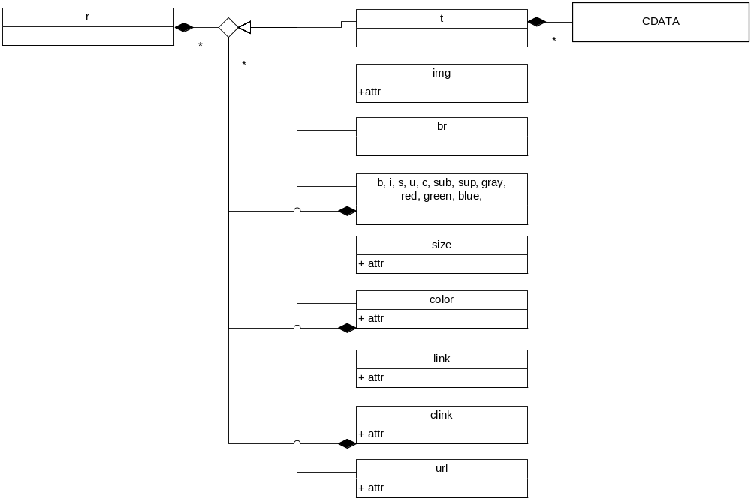

- XML format
  - Documentation structure.
Documentation structure is defined using so-called groups. Each group except the root (index) group must be folded into other group, so all groups forms the classic tree. Also, group can fold other top-level items such as articles and classes.
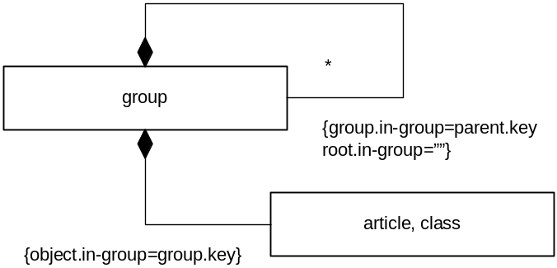
It is strongly recommended to have “index” key for the root group.
  - Documentation items
Almost all elements of the documentation could produce detailed description as formatted text. Formatted text can contain:
- paragraphs
- tables
- examples
Table has rows, each row has columns.
Row and column themselves can also produce the formatted text.
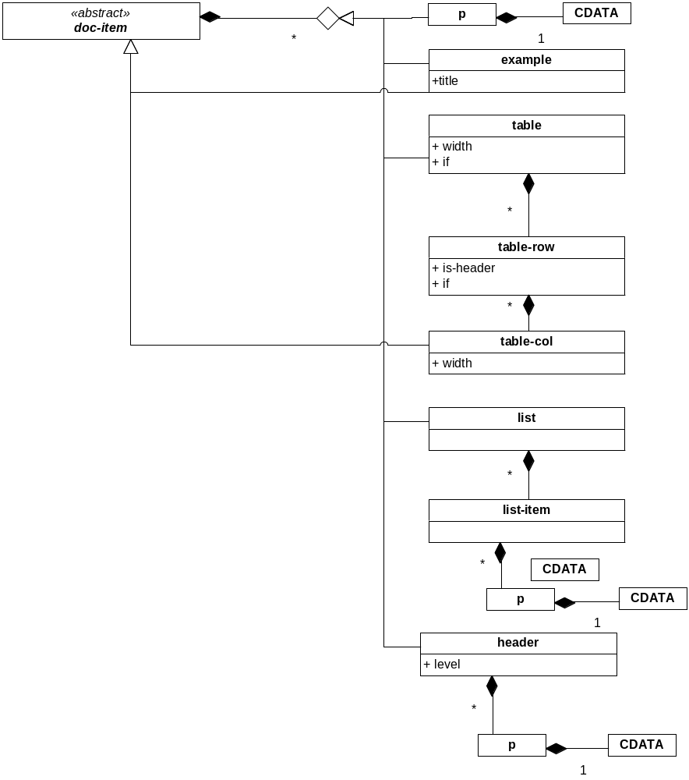
All items which can produce formatted text contains tag body. Such items are marked as “doc-item” on the next diagram, which describes the structure of the source XML:
