ANOVA cidadania ~ unidade

Geiser C. Challco [geiser@usp.br](mailto:geiser@usp.br)

* Report as Word format: <factorialAnova.docx>
* Report as LaTex format: <factorialAnova.tex>

## Initial Data and Preprocessing

R script: <factorialAnova.R> Inital data: <data.csv>

### Summary statistics of the initial data

get_summary_stats(group_by(dat, `unidade`), type ="common")

## # A tibble: 3 x 11  
## unidade variable n min max median iqr mean sd se ci  
## <fct> <chr> <dbl> <dbl> <dbl> <dbl> <dbl> <dbl> <dbl> <dbl> <dbl>  
## 1 UFAL A.C… cidadan… 241 1 4.83 2.5 1 2.50 0.727 0.047 0.092  
## 2 UFAL Ara… cidadan… 55 1.17 4.83 2.17 0.833 2.30 0.724 0.098 0.196  
## 3 UFAL CECA cidadan… 24 1.33 4.5 2.33 0.667 2.38 0.694 0.142 0.293

## Check Assumptions

### Identifying outliers

Outliers tend to increase type-I error probability, and they decrease the calculated F statistic in ANOVA resulting in a lower chance of reject the null hypothesis.

* Identified outliers using rstatix

identify_outliers(group_by(dat, `unidade`), `cidadania`)

## # A tibble: 3 x 5  
## unidade ID cidadania is.outlier is.extreme  
## <fct> <fct> <dbl> <lgl> <lgl>   
## 1 UFAL A.C. Simões Obs28 4.83 TRUE FALSE   
## 2 UFAL Arapiraca Obs322 4.83 TRUE FALSE   
## 3 UFAL CECA Obs166 4.5 TRUE FALSE

* Identified outliers through Boxplots

Boxplot(`cidadania` ~ `unidade`, data = dat, id = list(n = Inf))

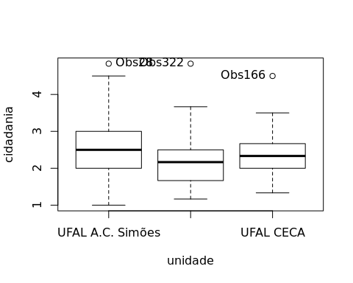

## [1] "Obs28" "Obs322" "Obs166"

### Removing outliers from the data

outliers <- c("Obs28","Obs166","Obs322")  
rdat <- dat[!dat[["ID"]] %in% outliers,] # table without outliers

Outliers table

|  |  |  |  |
| --- | --- | --- | --- |
|  | ID | unidade | cidadania |
| Obs28 | Obs28 | UFAL A.C. Simões | 4.833333 |
| Obs166 | Obs166 | UFAL CECA | 4.500000 |
| Obs322 | Obs322 | UFAL Arapiraca | 4.833333 |

### Normality assumption

**Observation**:

As sample sizes increase, ANOVA remains a valid test even with the violation of normality [1, 2]. According to the central limit theorem, the sampling distribution tends to be normal if the sample is large enough (n > 30). Therefore, we performed ANOVA with large samples as follows:

* In cases with the sample size greater than 30 (n > 30), we adopted a significance level of p < 0.01 instead a significance level of p < 0.05.
* For samples with n > 50 observation, we adopted D’Agostino-Pearson test that offers better accuracy for larger samples [3].
* For samples’ size between n > 100 and n <= 200, we ignored both tests (Shapiro and D’Agostino-Persons), and our decision of normality were based only in the interpretation of QQ-plots and histograms because these tests tend to be too sensitive with values greater than 200 [3].
* For samples with n > 200 observation, we ignore the normality assumption based on the central theorem limit, and taking only into account the homogeneity assumption.

#### Checking normality assumption in the residual model

mdl <- lm(`cidadania` ~ `unidade`, data = rdat)  
normality_test(residuals(mdl))

## n statistic method p p.signif normality  
## 1 317 9.428466 D'Agostino 0.00896674 * -

The QQ plot used to evaluate normality assumption

qqPlot(residuals(mdl))

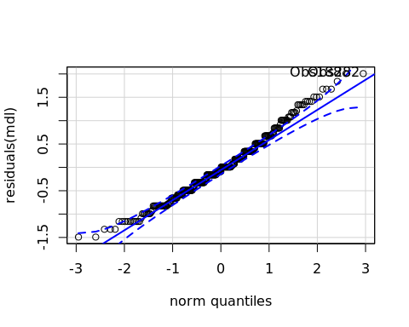

## Obs188 Obs282   
## 182 273

#### Checking normality assumption for each group

normality_test_at(group_by(rdat, `unidade`), "cidadania")

## variable unidade n statistic method  
## 1 cidadania UFAL A.C. Simões 240 5.8905450 D'Agostino  
## Omnibus Test cidadania UFAL Arapiraca 54 5.6331826 D'Agostino  
## 11 cidadania UFAL CECA 23 0.9701973 Shapiro-Wilk  
## p p.signif normality  
## 1 0.05258773 ns -  
## Omnibus Test 0.05980947 ns YES  
## 11 0.69372956 ns YES

* QQ plot in the **unidade**: “UFAL A.C. Simões”

qqPlot( ~ `cidadania`, data = rdat[which(rdat["unidade"] == "UFAL A.C. Simões"),])

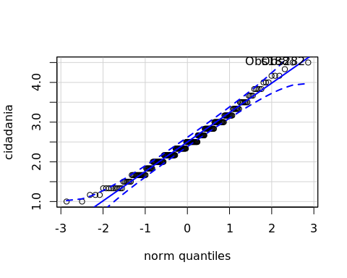

## Obs188 Obs282   
## 140 209

* QQ plot in the **unidade**: “UFAL Arapiraca”

qqPlot( ~ `cidadania`, data = rdat[which(rdat["unidade"] == "UFAL Arapiraca"),])

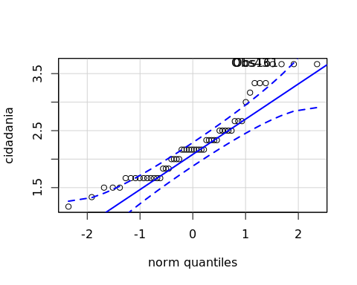

## Obs43 Obs161   
## 5 28

* QQ plot in the **unidade**: “UFAL CECA”

qqPlot( ~ `cidadania`, data = rdat[which(rdat["unidade"] == "UFAL CECA"),])

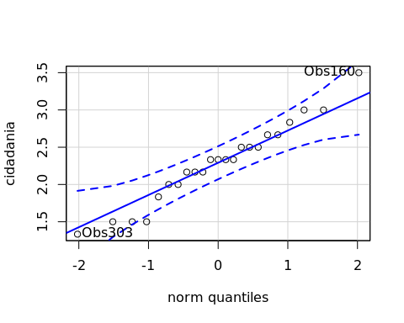

## Obs160 Obs303   
## 6 21

#### Removing data that affect normality

non.normal <- c("")  
sdat <- rdat[!rdat[["ID"]] %in% non.normal,] # table without non-normal and outliers

Non-normal data table

|  |  |  |
| --- | --- | --- |
| ID | unidade | cidadania |

#### Performing normality test without data that affect normality

mdl <- lm(`cidadania` ~ `unidade`, data = sdat)  
normality_test(residuals(mdl))

|  |  |  |  |  |  |
| --- | --- | --- | --- | --- | --- |
| n | statistic | method | p | p.signif | normality |
| 317 | 9.4285 | D’Agostino | 0.009 | * | - |

normality_test_at(group_by(sdat, `unidade`), "cidadania")

|  |  |  |  |  |  |  |  |
| --- | --- | --- | --- | --- | --- | --- | --- |
| variable | unidade | n | statistic | method | p | p.signif | normality |
| cidadania | UFAL A.C. Simões | 240 | 5.8905 | D’Agostino | 0.0526 | ns | - |
| cidadania | UFAL Arapiraca | 54 | 5.6332 | D’Agostino | 0.0598 | ns | YES |
| cidadania | UFAL CECA | 23 | 0.9702 | Shapiro-Wilk | 0.6937 | ns | YES |

QQ plot in the residual model without data that affect normality

qqPlot(residuals(mdl))



## Obs188 Obs282   
## 182 273

* QQ plot in the **unidade**: “UFAL A.C. Simões”

qqPlot( ~ `cidadania`, data = sdat[which(sdat["unidade"] == "UFAL A.C. Simões"),])



## Obs188 Obs282   
## 140 209

* QQ plot in the **unidade**: “UFAL Arapiraca”

qqPlot( ~ `cidadania`, data = sdat[which(sdat["unidade"] == "UFAL Arapiraca"),])



## Obs43 Obs161   
## 5 28

* QQ plot in the **unidade**: “UFAL CECA”

qqPlot( ~ `cidadania`, data = sdat[which(sdat["unidade"] == "UFAL CECA"),])



## Obs160 Obs303   
## 6 21

### Homogeneity of variance assumption

levene_test(sdat, `cidadania` ~ `unidade`)

|  |  |  |  |  |
| --- | --- | --- | --- | --- |
| df1 | df2 | statistic | p | p.signif |
| 2 | 314 | 2.025 | 0.1337 | ns |

From the output above, non-significant difference indicates homogeneity of variance in the different groups (Signif. codes: 0 **** 0.0001 *** 0.001 ** 0.01 * 0.05 ns 1).

## Computation ANOVA

res.aov <- anova_test(sdat, `cidadania` ~ `unidade`, type = 2, effect.size = 'ges', detailed = T)  
get_anova_table(res.aov)

## Coefficient covariances computed by hccm()

|  |  |  |  |  |  |  |  |  |
| --- | --- | --- | --- | --- | --- | --- | --- | --- |
| Effect | SSn | SSd | DFn | DFd | F | p | p<.05 | ges |
| unidade | 2.999 | 149.621 | 2 | 314 | 3.147 | 0.044 | * | 0.02 |

## Post-hoct Tests (Pairwise Comparisons)

* Estimated marginal means for **unidade**

(emm[["unidade"]] <- emmeans_test(sdat, `cidadania` ~ `unidade`, p.adjust.method = "bonferroni", detailed = T))

|  |  |  |  |  |  |  |  |  |  |  |  |
| --- | --- | --- | --- | --- | --- | --- | --- | --- | --- | --- | --- |
| .y. | group1 | group2 | estimate | se | df | conf.low | conf.high | statistic | p | p.adj | p.adj.signif |
| cidadania | UFAL A.C. Simões | UFAL Arapiraca | 0.2362 | 0.1040 | 314 | 0.0316 | 0.4408 | 2.2717 | 0.0238 | 0.0713 | ns |
| cidadania | UFAL A.C. Simões | UFAL CECA | 0.2025 | 0.1507 | 314 | -0.0940 | 0.4990 | 1.3440 | 0.1799 | 0.5398 | ns |
| cidadania | UFAL Arapiraca | UFAL CECA | -0.0337 | 0.1719 | 314 | -0.3719 | 0.3045 | -0.1960 | 0.8448 | 1 | ns |

## Descriptive Statistic and ANOVA Plots

get_summary_stats(group_by(sdat, `unidade`), type ="common")

|  |  |  |  |  |  |  |  |  |  |  |
| --- | --- | --- | --- | --- | --- | --- | --- | --- | --- | --- |
| unidade | variable | n | mean | median | min | max | sd | se | ci | iqr |
| UFAL A.C. Simões | cidadania | 240 | 2.492 | 2.500 | 1.000 | 4.500 | 0.713 | 0.046 | 0.091 | 1.000 |
| UFAL Arapiraca | cidadania | 54 | 2.256 | 2.167 | 1.167 | 3.667 | 0.641 | 0.087 | 0.175 | 0.833 |
| UFAL CECA | cidadania | 23 | 2.290 | 2.333 | 1.333 | 3.500 | 0.539 | 0.112 | 0.233 | 0.583 |

ggPlotAoV(sdat, "unidade", "cidadania", aov=res.aov, pwc=emm[["unidade"]], addParam=c("jitter"))

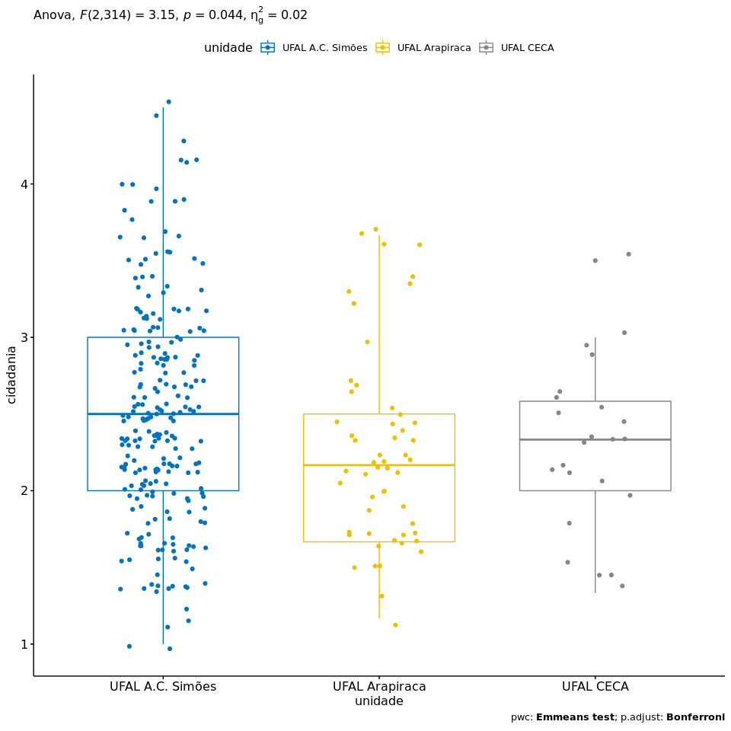

## References

[1]: Blanca, M. J., Alarcón, R., Arnau, J., Bono, R., & Bendayan, R. (2017). Non-normal data: Is ANOVA still a valid option?. Psicothema, 29(4), 552-557.

[2]: Ghasemi, A., & Zahediasl, S. (2012). Normality tests for statistical analysis: a guide for non-statisticians. International journal of endocrinology and metabolism, 10(2), 486.

[3]: Miot, H. A. (2017). Assessing normality of data in clinical and experimental trials. J Vasc Bras, 16(2), 88-91.