ANOVA desenvolvimento ~ unidade

Geiser C. Challco [geiser@usp.br](mailto:geiser@usp.br)

* Report as Word format: <factorialAnova.docx>
* Report as LaTex format: <factorialAnova.tex>

## Initial Data and Preprocessing

R script: <factorialAnova.R> Inital data: <data.csv>

### Summary statistics of the initial data

get_summary_stats(group_by(dat, `unidade`), type ="common")

## # A tibble: 3 x 11  
## unidade variable n min max median iqr mean sd se ci  
## <fct> <chr> <dbl> <dbl> <dbl> <dbl> <dbl> <dbl> <dbl> <dbl> <dbl>  
## 1 UFAL A.C… desenvo… 241 1 4.33 2.67 1.33 2.69 0.827 0.053 0.105  
## 2 UFAL Ara… desenvo… 55 1 5 2.67 1.17 2.62 0.871 0.117 0.236  
## 3 UFAL CECA desenvo… 24 1 4.67 2.67 1.08 2.71 0.939 0.192 0.397

## Check Assumptions

### Identifying outliers

Outliers tend to increase type-I error probability, and they decrease the calculated F statistic in ANOVA resulting in a lower chance of reject the null hypothesis.

* Identified outliers using rstatix

identify_outliers(group_by(dat, `unidade`), `desenvolvimento`)

## # A tibble: 1 x 5  
## unidade ID desenvolvimento is.outlier is.extreme  
## <fct> <fct> <dbl> <lgl> <lgl>   
## 1 UFAL Arapiraca Obs322 5 TRUE FALSE

* Identified outliers through Boxplots

Boxplot(`desenvolvimento` ~ `unidade`, data = dat, id = list(n = Inf))

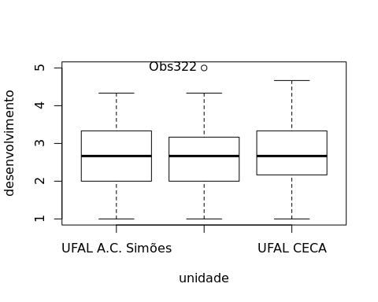

## [1] "Obs322"

### Removing outliers from the data

outliers <- c("Obs322")  
rdat <- dat[!dat[["ID"]] %in% outliers,] # table without outliers

Outliers table

|  |  |  |  |
| --- | --- | --- | --- |
|  | ID | unidade | desenvolvimento |
| Obs322 | Obs322 | UFAL Arapiraca | 5 |

### Normality assumption

**Observation**:

As sample sizes increase, ANOVA remains a valid test even with the violation of normality [1, 2]. According to the central limit theorem, the sampling distribution tends to be normal if the sample is large enough (n > 30). Therefore, we performed ANOVA with large samples as follows:

* In cases with the sample size greater than 30 (n > 30), we adopted a significance level of p < 0.01 instead a significance level of p < 0.05.
* For samples with n > 50 observation, we adopted D’Agostino-Pearson test that offers better accuracy for larger samples [3].
* For samples’ size between n > 100 and n <= 200, we ignored both tests (Shapiro and D’Agostino-Persons), and our decision of normality were based only in the interpretation of QQ-plots and histograms because these tests tend to be too sensitive with values greater than 200 [3].
* For samples with n > 200 observation, we ignore the normality assumption based on the central theorem limit, and taking only into account the homogeneity assumption.

#### Checking normality assumption in the residual model

mdl <- lm(`desenvolvimento` ~ `unidade`, data = rdat)  
normality_test(residuals(mdl))

## n statistic method p p.signif normality  
## 1 319 13.90795 D'Agostino 0.0009548309 ** -

The QQ plot used to evaluate normality assumption

qqPlot(residuals(mdl))

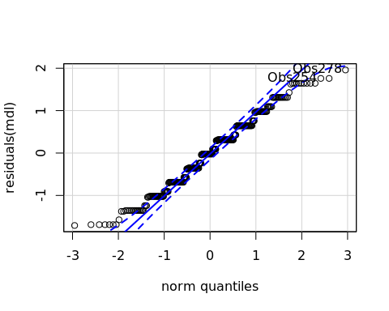

## Obs278 Obs254   
## 271 248

#### Checking normality assumption for each group

normality_test_at(group_by(rdat, `unidade`), "desenvolvimento")

## variable unidade n statistic method  
## 1 desenvolvimento UFAL A.C. Simões 241 12.1413615 D'Agostino  
## Omnibus Test desenvolvimento UFAL Arapiraca 54 2.1184303 D'Agostino  
## 11 desenvolvimento UFAL CECA 24 0.9780299 Shapiro-Wilk  
## p p.signif normality  
## 1 0.0023096 * -  
## Omnibus Test 0.3467278 ns YES  
## 11 0.8569623 ns YES

* QQ plot in the **unidade**: “UFAL A.C. Simões”

qqPlot( ~ `desenvolvimento`, data = rdat[which(rdat["unidade"] == "UFAL A.C. Simões"),])

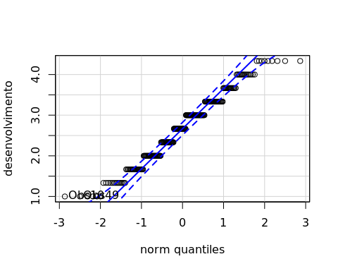

## Obs10 Obs49   
## 8 41

* QQ plot in the **unidade**: “UFAL Arapiraca”

qqPlot( ~ `desenvolvimento`, data = rdat[which(rdat["unidade"] == "UFAL Arapiraca"),])

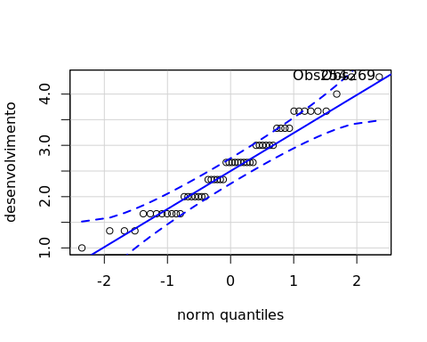

## Obs254 Obs269   
## 42 44

* QQ plot in the **unidade**: “UFAL CECA”

qqPlot( ~ `desenvolvimento`, data = rdat[which(rdat["unidade"] == "UFAL CECA"),])

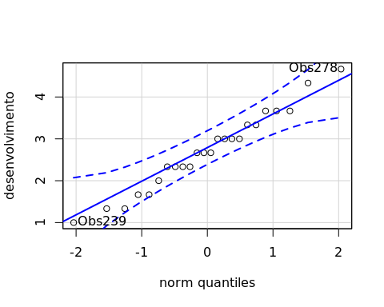

## Obs278 Obs239   
## 18 16

#### Removing data that affect normality

non.normal <- c("")  
sdat <- rdat[!rdat[["ID"]] %in% non.normal,] # table without non-normal and outliers

Non-normal data table

|  |  |  |
| --- | --- | --- |
| ID | unidade | desenvolvimento |

#### Performing normality test without data that affect normality

mdl <- lm(`desenvolvimento` ~ `unidade`, data = sdat)  
normality_test(residuals(mdl))

|  |  |  |  |  |  |
| --- | --- | --- | --- | --- | --- |
| n | statistic | method | p | p.signif | normality |
| 319 | 13.908 | D’Agostino | 0.001 | ** | - |

normality_test_at(group_by(sdat, `unidade`), "desenvolvimento")

|  |  |  |  |  |  |  |  |
| --- | --- | --- | --- | --- | --- | --- | --- |
| variable | unidade | n | statistic | method | p | p.signif | normality |
| desenvolvimento | UFAL A.C. Simões | 241 | 12.1414 | D’Agostino | 0.0023 | ** | - |
| desenvolvimento | UFAL Arapiraca | 54 | 2.1184 | D’Agostino | 0.3467 | ns | YES |
| desenvolvimento | UFAL CECA | 24 | 0.9780 | Shapiro-Wilk | 0.857 | ns | YES |

QQ plot in the residual model without data that affect normality

qqPlot(residuals(mdl))



## Obs278 Obs254   
## 271 248

* QQ plot in the **unidade**: “UFAL A.C. Simões”

qqPlot( ~ `desenvolvimento`, data = sdat[which(sdat["unidade"] == "UFAL A.C. Simões"),])



## Obs10 Obs49   
## 8 41

* QQ plot in the **unidade**: “UFAL Arapiraca”

qqPlot( ~ `desenvolvimento`, data = sdat[which(sdat["unidade"] == "UFAL Arapiraca"),])



## Obs254 Obs269   
## 42 44

* QQ plot in the **unidade**: “UFAL CECA”

qqPlot( ~ `desenvolvimento`, data = sdat[which(sdat["unidade"] == "UFAL CECA"),])



## Obs278 Obs239   
## 18 16

### Homogeneity of variance assumption

levene_test(sdat, `desenvolvimento` ~ `unidade`)

|  |  |  |  |  |
| --- | --- | --- | --- | --- |
| df1 | df2 | statistic | p | p.signif |
| 2 | 316 | 0.211 | 0.8099 | ns |

From the output above, non-significant difference indicates homogeneity of variance in the different groups (Signif. codes: 0 **** 0.0001 *** 0.001 ** 0.01 * 0.05 ns 1).

## Computation ANOVA

res.aov <- anova_test(sdat, `desenvolvimento` ~ `unidade`, type = 2, effect.size = 'ges', detailed = T)  
get_anova_table(res.aov)

## Coefficient covariances computed by hccm()

|  |  |  |  |  |  |  |  |  |
| --- | --- | --- | --- | --- | --- | --- | --- | --- |
| Effect | SSn | SSd | DFn | DFd | F | p | p<.05 | ges |
| unidade | 0.617 | 219.6 | 2 | 316 | 0.444 | 0.642 |  | 0.003 |

## Post-hoct Tests (Pairwise Comparisons)

* Estimated marginal means for **unidade**

(emm[["unidade"]] <- emmeans_test(sdat, `desenvolvimento` ~ `unidade`, p.adjust.method = "bonferroni", detailed = T))

|  |  |  |  |  |  |  |  |  |  |  |  |
| --- | --- | --- | --- | --- | --- | --- | --- | --- | --- | --- | --- |
| .y. | group1 | group2 | estimate | se | df | conf.low | conf.high | statistic | p | p.adj | p.adj.signif |
| desenvolvimento | UFAL A.C. Simões | UFAL Arapiraca | 0.1147 | 0.1255 | 316 | -0.1322 | 0.3617 | 0.9141 | 0.3614 | 1 | ns |
| desenvolvimento | UFAL A.C. Simões | UFAL CECA | -0.0195 | 0.1784 | 316 | -0.3706 | 0.3315 | -0.1095 | 0.9129 | 1 | ns |
| desenvolvimento | UFAL Arapiraca | UFAL CECA | -0.1343 | 0.2045 | 316 | -0.5366 | 0.2681 | -0.6565 | 0.5120 | 1 | ns |

## Descriptive Statistic and ANOVA Plots

get_summary_stats(group_by(sdat, `unidade`), type ="common")

|  |  |  |  |  |  |  |  |  |  |  |
| --- | --- | --- | --- | --- | --- | --- | --- | --- | --- | --- |
| unidade | variable | n | mean | median | min | max | sd | se | ci | iqr |
| UFAL A.C. Simões | desenvolvimento | 241 | 2.689 | 2.667 | 1 | 4.333 | 0.827 | 0.053 | 0.105 | 1.333 |
| UFAL Arapiraca | desenvolvimento | 54 | 2.574 | 2.667 | 1 | 4.333 | 0.815 | 0.111 | 0.222 | 1.000 |
| UFAL CECA | desenvolvimento | 24 | 2.708 | 2.667 | 1 | 4.667 | 0.939 | 0.192 | 0.397 | 1.083 |

ggPlotAoV(sdat, "unidade", "desenvolvimento", aov=res.aov, pwc=emm[["unidade"]], addParam=c("jitter"))

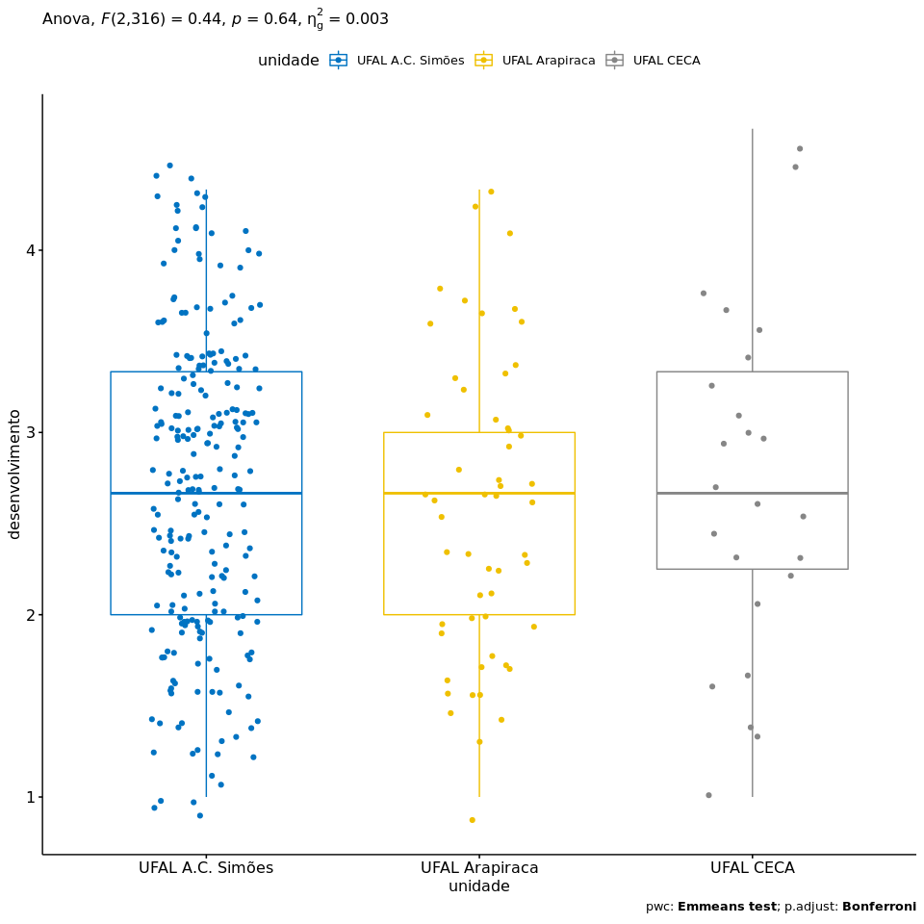

## References

[1]: Blanca, M. J., Alarcón, R., Arnau, J., Bono, R., & Bendayan, R. (2017). Non-normal data: Is ANOVA still a valid option?. Psicothema, 29(4), 552-557.

[2]: Ghasemi, A., & Zahediasl, S. (2012). Normality tests for statistical analysis: a guide for non-statisticians. International journal of endocrinology and metabolism, 10(2), 486.

[3]: Miot, H. A. (2017). Assessing normality of data in clinical and experimental trials. J Vasc Bras, 16(2), 88-91.