ANOVA pedagogica ~ unidade

Geiser C. Challco [geiser@usp.br](mailto:geiser@usp.br)

* Report as Word format: <factorialAnova.docx>
* Report as LaTex format: <factorialAnova.tex>

## Initial Data and Preprocessing

R script: <factorialAnova.R> Inital data: <data.csv>

### Visualization of data distribution

ggdensity(dat, x = "pedagogica", fill = "lightgray", title= "Density of pedagogica before transformation") +  
 stat_overlay_normal_density(color = "red", linetype = "dashed")

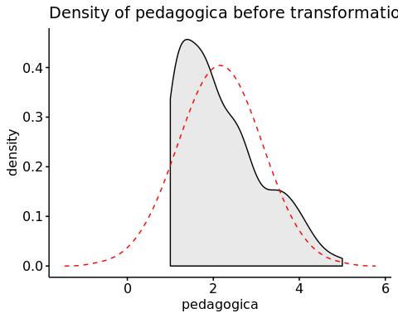

### Dealing with positive greater skewness in pedagogica

dat[["pedagogica"]] <- log10(dat[["pedagogica"]])

ggdensity(dat, x = "pedagogica", fill = "lightgray", title= "Density of pedagogica after transformation") +  
 stat_overlay_normal_density(color = "red", linetype = "dashed")

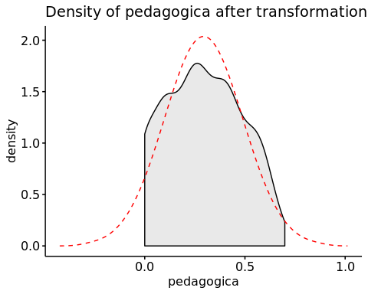

### Summary statistics of the initial data

get_summary_stats(group_by(dat, `unidade`), type ="common")

## # A tibble: 3 x 11  
## unidade variable n min max median iqr mean sd se ci  
## <fct> <chr> <dbl> <dbl> <dbl> <dbl> <dbl> <dbl> <dbl> <dbl> <dbl>  
## 1 UFAL A.C… pedagog… 241 0 0.699 0.301 0.342 0.302 0.191 0.012 0.024  
## 2 UFAL Ara… pedagog… 55 0 0.699 0.243 0.301 0.25 0.186 0.025 0.05   
## 3 UFAL CECA pedagog… 24 0.097 0.628 0.243 0.263 0.313 0.156 0.032 0.066

## Check Assumptions

### Identifying outliers

Outliers tend to increase type-I error probability, and they decrease the calculated F statistic in ANOVA resulting in a lower chance of reject the null hypothesis.

* Identified outliers using rstatix

identify_outliers(group_by(dat, `unidade`), `pedagogica`)

## [1] unidade ID pedagogica is.outlier is.extreme  
## <0 rows> (or 0-length row.names)

* Identified outliers through Boxplots

Boxplot(`pedagogica` ~ `unidade`, data = dat, id = list(n = Inf))

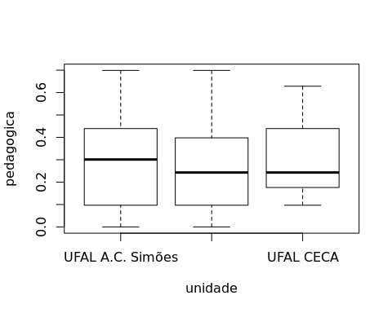

### Removing outliers from the data

outliers <- c("")  
rdat <- dat[!dat[["ID"]] %in% outliers,] # table without outliers

Outliers table

|  |  |  |
| --- | --- | --- |
| ID | unidade | pedagogica |

### Normality assumption

**Observation**:

As sample sizes increase, ANOVA remains a valid test even with the violation of normality [1, 2]. According to the central limit theorem, the sampling distribution tends to be normal if the sample is large enough (n > 30). Therefore, we performed ANOVA with large samples as follows:

* In cases with the sample size greater than 30 (n > 30), we adopted a significance level of p < 0.01 instead a significance level of p < 0.05.
* For samples with n > 50 observation, we adopted D’Agostino-Pearson test that offers better accuracy for larger samples [3].
* For samples’ size between n > 100 and n <= 200, we ignored both tests (Shapiro and D’Agostino-Persons), and our decision of normality were based only in the interpretation of QQ-plots and histograms because these tests tend to be too sensitive with values greater than 200 [3].
* For samples with n > 200 observation, we ignore the normality assumption based on the central theorem limit, and taking only into account the homogeneity assumption.

#### Checking normality assumption in the residual model

mdl <- lm(`pedagogica` ~ `unidade`, data = rdat)  
normality_test(residuals(mdl))

## n statistic method p p.signif normality  
## 1 320 54.94218 D'Agostino 1.173395e-12 **** -

The QQ plot used to evaluate normality assumption

qqPlot(residuals(mdl))

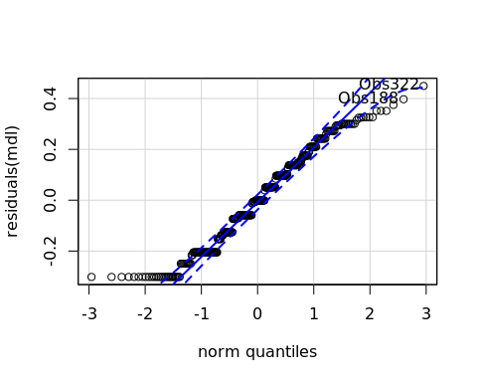

## Obs322 Obs188   
## 312 184

#### Checking normality assumption for each group

normality_test_at(group_by(rdat, `unidade`), "pedagogica")

## variable unidade n statistic method  
## 1 pedagogica UFAL A.C. Simões 241 57.5426659 D'Agostino  
## Omnibus Test pedagogica UFAL Arapiraca 55 2.8290093 D'Agostino  
## 11 pedagogica UFAL CECA 24 0.9156624 Shapiro-Wilk  
## p p.signif normality  
## 1 3.197442e-13 **** -  
## Omnibus Test 2.430460e-01 ns YES  
## 11 4.687579e-02 * NO

* QQ plot in the **unidade**: “UFAL A.C. Simões”

qqPlot( ~ `pedagogica`, data = rdat[which(rdat["unidade"] == "UFAL A.C. Simões"),])

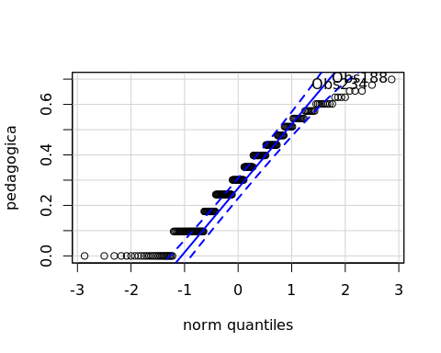

## Obs188 Obs234   
## 141 173

* QQ plot in the **unidade**: “UFAL Arapiraca”

qqPlot( ~ `pedagogica`, data = rdat[which(rdat["unidade"] == "UFAL Arapiraca"),])

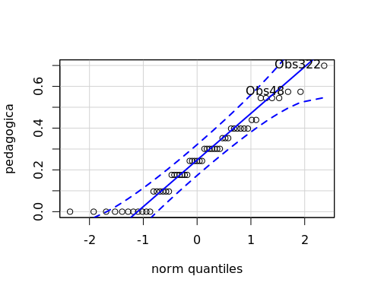

## Obs322 Obs48   
## 54 7

* QQ plot in the **unidade**: “UFAL CECA”

qqPlot( ~ `pedagogica`, data = rdat[which(rdat["unidade"] == "UFAL CECA"),])

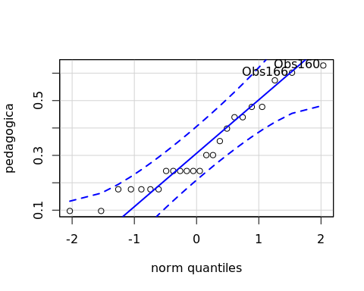

## Obs160 Obs166   
## 6 7

#### Removing data that affect normality

non.normal <- c("Obs111","Obs239")  
sdat <- rdat[!rdat[["ID"]] %in% non.normal,] # table without non-normal and outliers

Non-normal data table

|  |  |  |  |
| --- | --- | --- | --- |
|  | ID | unidade | pedagogica |
| Obs111 | Obs111 | UFAL CECA | 0.1760913 |
| Obs239 | Obs239 | UFAL CECA | 0.0969100 |

#### Performing normality test without data that affect normality

mdl <- lm(`pedagogica` ~ `unidade`, data = sdat)  
normality_test(residuals(mdl))

|  |  |  |  |  |  |
| --- | --- | --- | --- | --- | --- |
| n | statistic | method | p | p.signif | normality |
| 318 | 54.9806 | D’Agostino | < 0.0001 | **** | - |

normality_test_at(group_by(sdat, `unidade`), "pedagogica")

|  |  |  |  |  |  |  |  |
| --- | --- | --- | --- | --- | --- | --- | --- |
| variable | unidade | n | statistic | method | p | p.signif | normality |
| pedagogica | UFAL A.C. Simões | 241 | 57.5427 | D’Agostino | < 0.0001 | **** | - |
| pedagogica | UFAL Arapiraca | 55 | 2.8290 | D’Agostino | 0.243 | ns | YES |
| pedagogica | UFAL CECA | 22 | 0.9191 | Shapiro-Wilk | 0.0727 | ns | YES |

QQ plot in the residual model without data that affect normality

qqPlot(residuals(mdl))

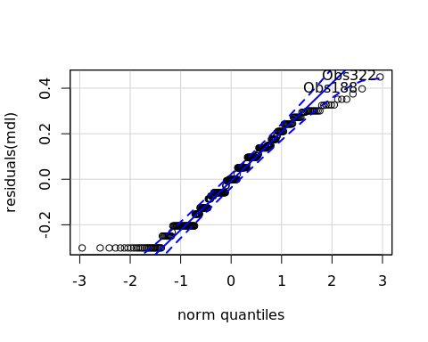

## Obs322 Obs188   
## 310 183

* QQ plot in the **unidade**: “UFAL A.C. Simões”

qqPlot( ~ `pedagogica`, data = sdat[which(sdat["unidade"] == "UFAL A.C. Simões"),])



## Obs188 Obs234   
## 141 173

* QQ plot in the **unidade**: “UFAL Arapiraca”

qqPlot( ~ `pedagogica`, data = sdat[which(sdat["unidade"] == "UFAL Arapiraca"),])



## Obs322 Obs48   
## 54 7

* QQ plot in the **unidade**: “UFAL CECA”

qqPlot( ~ `pedagogica`, data = sdat[which(sdat["unidade"] == "UFAL CECA"),])

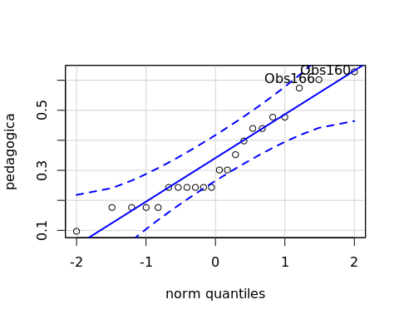

## Obs160 Obs166   
## 5 6

### Homogeneity of variance assumption

levene_test(sdat, `pedagogica` ~ `unidade`)

|  |  |  |  |  |
| --- | --- | --- | --- | --- |
| df1 | df2 | statistic | p | p.signif |
| 2 | 315 | 1.4606 | 0.2337 | ns |

From the output above, non-significant difference indicates homogeneity of variance in the different groups (Signif. codes: 0 **** 0.0001 *** 0.001 ** 0.01 * 0.05 ns 1).

## Computation ANOVA

res.aov <- anova_test(sdat, `pedagogica` ~ `unidade`, type = 2, effect.size = 'ges', detailed = T)  
get_anova_table(res.aov)

## Coefficient covariances computed by hccm()

|  |  |  |  |  |  |  |  |  |
| --- | --- | --- | --- | --- | --- | --- | --- | --- |
| Effect | SSn | SSd | DFn | DFd | F | p | p<.05 | ges |
| unidade | 0.151 | 11.142 | 2 | 315 | 2.135 | 0.12 |  | 0.013 |

## Post-hoct Tests (Pairwise Comparisons)

* Estimated marginal means for **unidade**

(emm[["unidade"]] <- emmeans_test(sdat, `pedagogica` ~ `unidade`, p.adjust.method = "bonferroni", detailed = T))

|  |  |  |  |  |  |  |  |  |  |  |  |
| --- | --- | --- | --- | --- | --- | --- | --- | --- | --- | --- | --- |
| .y. | group1 | group2 | estimate | se | df | conf.low | conf.high | statistic | p | p.adj | p.adj.signif |
| pedagogica | UFAL A.C. Simões | UFAL Arapiraca | 0.0523 | 0.0281 | 315 | -0.0030 | 0.1076 | 1.8606 | 0.0637 | 0.1912 | ns |
| pedagogica | UFAL A.C. Simões | UFAL CECA | -0.0277 | 0.0419 | 315 | -0.1101 | 0.0548 | -0.6602 | 0.5096 | 1 | ns |
| pedagogica | UFAL Arapiraca | UFAL CECA | -0.0799 | 0.0474 | 315 | -0.1733 | 0.0134 | -1.6850 | 0.0930 | 0.2789 | ns |

## Descriptive Statistic and ANOVA Plots

get_summary_stats(group_by(sdat, `unidade`), type ="common")

|  |  |  |  |  |  |  |  |  |  |  |
| --- | --- | --- | --- | --- | --- | --- | --- | --- | --- | --- |
| unidade | variable | n | mean | median | min | max | sd | se | ci | iqr |
| UFAL A.C. Simões | pedagogica | 241 | 0.302 | 0.301 | 0.000 | 0.699 | 0.191 | 0.012 | 0.024 | 0.342 |
| UFAL Arapiraca | pedagogica | 55 | 0.250 | 0.243 | 0.000 | 0.699 | 0.186 | 0.025 | 0.050 | 0.301 |
| UFAL CECA | pedagogica | 22 | 0.330 | 0.272 | 0.097 | 0.628 | 0.153 | 0.033 | 0.068 | 0.196 |

ggPlotAoV(sdat, "unidade", "pedagogica", aov=res.aov, pwc=emm[["unidade"]], addParam=c("jitter"))

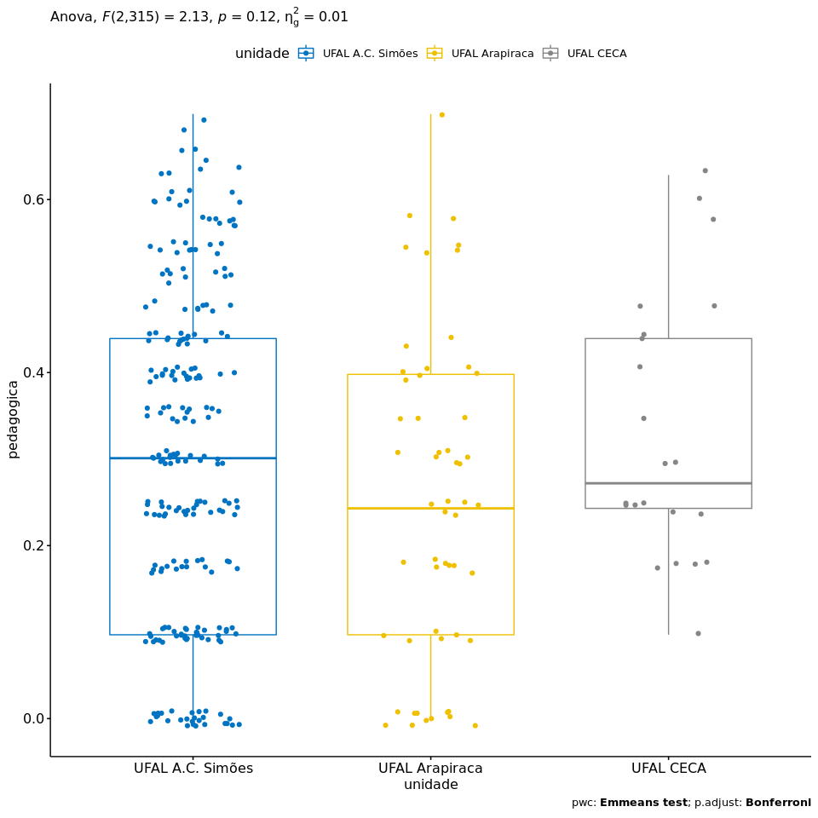

## References

[1]: Blanca, M. J., Alarcón, R., Arnau, J., Bono, R., & Bendayan, R. (2017). Non-normal data: Is ANOVA still a valid option?. Psicothema, 29(4), 552-557.

[2]: Ghasemi, A., & Zahediasl, S. (2012). Normality tests for statistical analysis: a guide for non-statisticians. International journal of endocrinology and metabolism, 10(2), 486.

[3]: Miot, H. A. (2017). Assessing normality of data in clinical and experimental trials. J Vasc Bras, 16(2), 88-91.