R Notebook for non-parametric analysis

Geiser C. Challco [geiser@alumni.usp.br](mailto:geiser@alumni.usp.br)

Table of Contents

## Install and Load Packages

## Identify the best pre-test and post-test regression

**Legend**:

* *irt.cc*: estimated ability using concurrent calibration (fixing IRT parameters)
* *irt.em.norm*: estimated ability using equation mode and normalizing these values - IRT parameters are calculated based on previous and current data

values = c("score","irt.cc","irt.em.norm")  
lvalues = as.list(values); names(lvalues) = values  
  
do.call(rbind, lapply(lvalues, FUN = function(x) {  
 md = summary(lm(as.formula(paste0("pos.",x,"~","pre.",x)), data = dat))  
 cbind(md$coefficients, `R2` = md$r.squared, `SSR` = sum(md$residuals^2))  
}))

## Estimate Std. Error t value Pr(>|t|) R2  
## (Intercept) 1.2039312 0.20159468 5.972039 9.369221e-09 0.2962425  
## pre.score 0.6028824 0.06279114 9.601393 1.921623e-18 0.2962425  
## (Intercept) 0.5731892 0.06553989 8.745654 5.943002e-16 0.1409836  
## pre.irt.cc 0.3955513 0.06597769 5.995228 8.289852e-09 0.1409836  
## (Intercept) 34.0749563 4.40025527 7.743859 3.537305e-13 0.3023324  
## pre.irt.em.norm 0.5487277 0.05632702 9.741820 7.346411e-19 0.3023324  
## SSR  
## (Intercept) 213.0825  
## pre.score 213.0825  
## (Intercept) 133.0921  
## pre.irt.cc 133.0921  
## (Intercept) 138924.3940  
## pre.irt.em.norm 138924.3940

**Normality test**

(do.call(rbind, lapply(c(paste0("pre.",values),paste0("pos.",values)), FUN = function(x) {  
 cbind(var=x, rshinystatistics::normality.test(dat[[x]]))  
})))

## var n skewness kurtosis symmetry statistic method  
## 1 pre.score 221 -0.8625141 -0.2446007 NO 0.8143814 Shapiro-Wilk  
## 2 pre.irt.cc 221 -0.3573667 -1.2965113 YES 0.8311238 Shapiro-Wilk  
## 3 pre.irt.em.norm 221 -0.6775788 -0.8864375 NO 0.8280888 Shapiro-Wilk  
## 4 pos.score 221 -1.0867700 0.1589015 NO 0.7831602 Shapiro-Wilk  
## 5 pos.irt.cc 221 -0.7323462 -0.8690881 NO 0.8012844 Shapiro-Wilk  
## 6 pos.irt.em.norm 221 -0.8558793 -0.3605587 NO 0.8128049 Shapiro-Wilk  
## p p.signif normality  
## 1 1.619025e-15 **** -  
## 2 9.097321e-15 **** -  
## 3 6.595034e-15 **** -  
## 4 8.547864e-17 **** -  
## 5 4.527435e-16 **** -  
## 6 1.384161e-15 **** -

**Note**: Based the linear regression “Y = a + bX,” the best measure that should be used to compare pre- and post-test data is “irt.em.norm”.

ggscatter(dat, x = "pre.score", y = "pos.score", size = 1, add = "reg.line") +  
 stat_regline_equation(  
 aes(label = paste(..eq.label.., ..rr.label.., sep = "~~~~"))  
 )

## Warning: The dot-dot notation (`..eq.label..`) was deprecated in ggplot2 3.4.0.  
## ℹ Please use `after_stat(eq.label)` instead.  
## ℹ The deprecated feature was likely used in the ggpubr package.  
## Please report the issue at <https://github.com/kassambara/ggpubr/issues>.  
## This warning is displayed once every 8 hours.  
## Call `lifecycle::last_lifecycle_warnings()` to see where this warning was  
## generated.

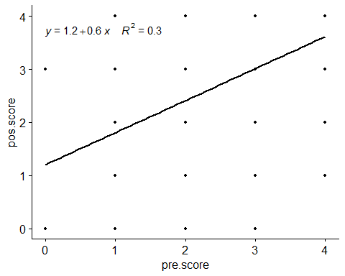

ggscatter(dat, x = "pre.irt.cc", y = "pos.irt.cc", size = 1, add = "reg.line") +  
 stat_regline_equation(  
 aes(label = paste(..eq.label.., ..rr.label.., sep = "~~~~"))  
 )

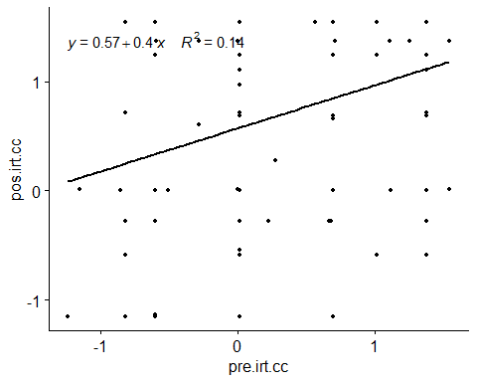

ggscatter(dat, x = "pre.irt.em.norm", y = "pos.irt.em.norm", size = 1, add = "reg.line") +  
 stat_regline_equation(  
 aes(label = paste(..eq.label.., ..rr.label.., sep = "~~~~"))  
 )

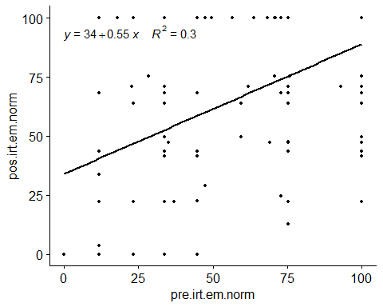

values = c("score","irt.em.norm")  
lvalues = as.list(values); names(lvalues) = values

## Evaluating H1a (null)

H1a (null): Students who participated in scenarios without our proposed ITS and without training (control group A) have the same mean score/ability in both the pre-test and post-test. **Note**: *Limoeiro - PE*

knitr::kable(df)

| group1 | group2 | n1 | n2 | estimate | statistic | p | p.signif |
| --- | --- | --- | --- | --- | --- | --- | --- |
| pos.score | pre.score | 27 | 27 | -0.9999705 | 36 | 0.980 | ns |
| pos.irt.em.norm | pre.irt.em.norm | 27 | 27 | -17.5199392 | 46 | 0.993 | ns |

knitr::kable(do.call(rbind, df.sum))

| time | variable | n | min | max | median | q1 | q3 | iqr | mad | mean | sd | se | ci |
| --- | --- | --- | --- | --- | --- | --- | --- | --- | --- | --- | --- | --- | --- |
| pre.score | value | 27 | 1.000 | 4 | 3.000 | 3.000 | 4 | 1.000 | 1.483 | 3.333 | 0.784 | 0.151 | 0.310 |
| pos.score | value | 27 | 0.000 | 4 | 3.000 | 2.500 | 4 | 1.500 | 1.483 | 2.889 | 1.121 | 0.216 | 0.443 |
| pre.irt.em.norm | value | 27 | 23.198 | 100 | 75.243 | 75.243 | 100 | 24.757 | 36.705 | 79.820 | 24.345 | 4.685 | 9.630 |
| pos.irt.em.norm | value | 27 | 0.000 | 100 | 70.801 | 55.682 | 100 | 44.318 | 40.427 | 68.692 | 28.823 | 5.547 | 11.402 |

plots$score

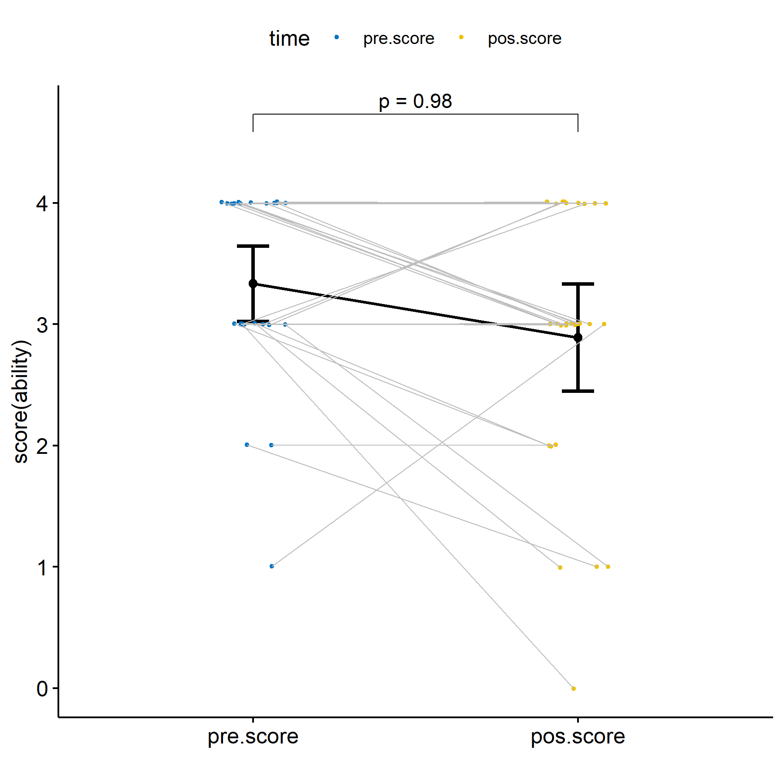

plots$irt.em.norm

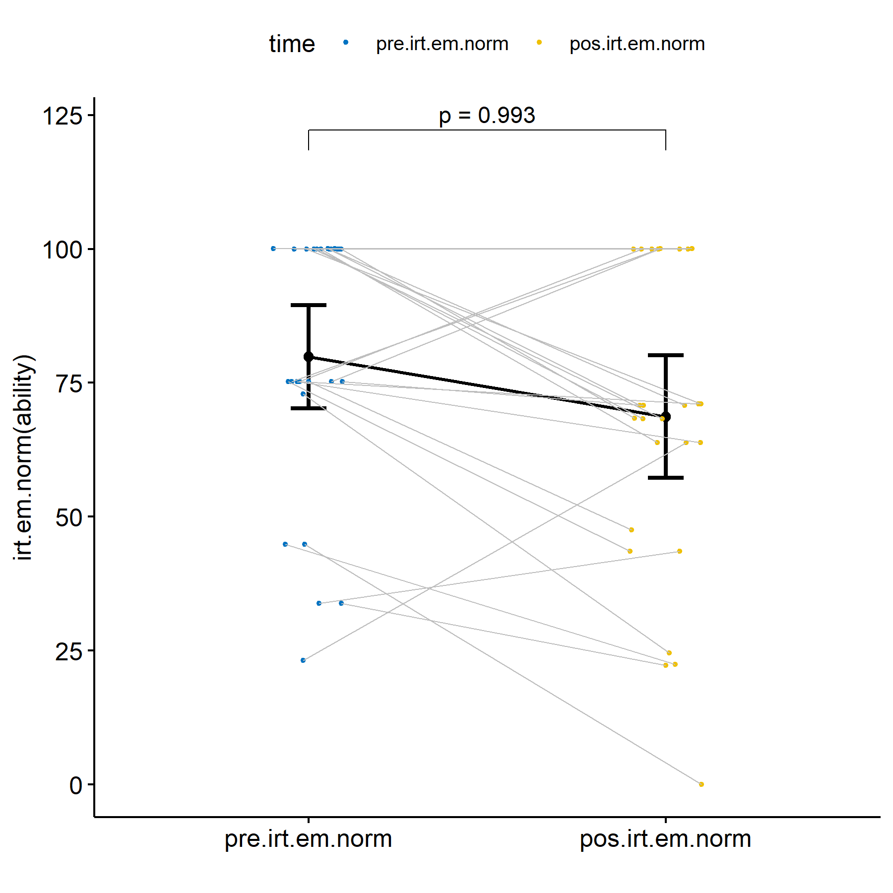

## Evaluating H1b (null)

H1b (null): Students who participated in scenarios without our proposed ITS and with training (control group B) have the same mean score/ability in both the pre-test and post-test.

knitr::kable(df)

| group1 | group2 | n1 | n2 | estimate | statistic | p | p.signif |
| --- | --- | --- | --- | --- | --- | --- | --- |
| pos.score | pre.score | 107 | 107 | 0.0000452 | 1163.0 | 0.1330 | ns |
| pos.irt.em.norm | pre.irt.em.norm | 107 | 107 | 7.1953446 | 2059.5 | 0.0491 | * |

knitr::kable(do.call(rbind, df.sum))

| time | variable | n | min | max | median | q1 | q3 | iqr | mad | mean | sd | se | ci |
| --- | --- | --- | --- | --- | --- | --- | --- | --- | --- | --- | --- | --- | --- |
| pre.score | value | 107 | 0 | 4 | 3.000 | 2.000 | 4 | 2.000 | 1.483 | 2.869 | 1.074 | 0.104 | 0.206 |
| pos.score | value | 107 | 0 | 4 | 3.000 | 2.000 | 4 | 2.000 | 1.483 | 2.991 | 1.225 | 0.118 | 0.235 |
| pre.irt.em.norm | value | 107 | 0 | 100 | 75.243 | 35.424 | 100 | 64.576 | 36.705 | 67.001 | 31.006 | 2.997 | 5.943 |
| pos.irt.em.norm | value | 107 | 0 | 100 | 70.801 | 49.610 | 100 | 50.390 | 43.290 | 72.305 | 31.462 | 3.042 | 6.030 |

plots$score

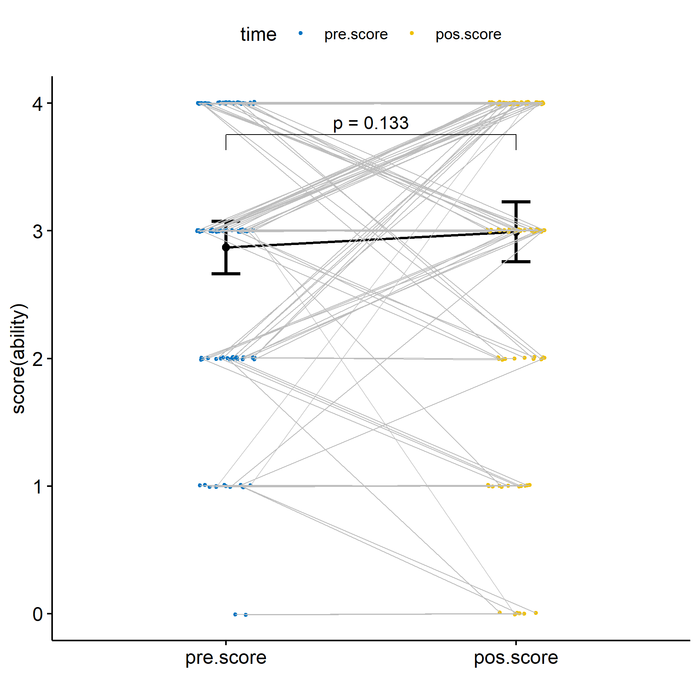

plots$irt.em.norm

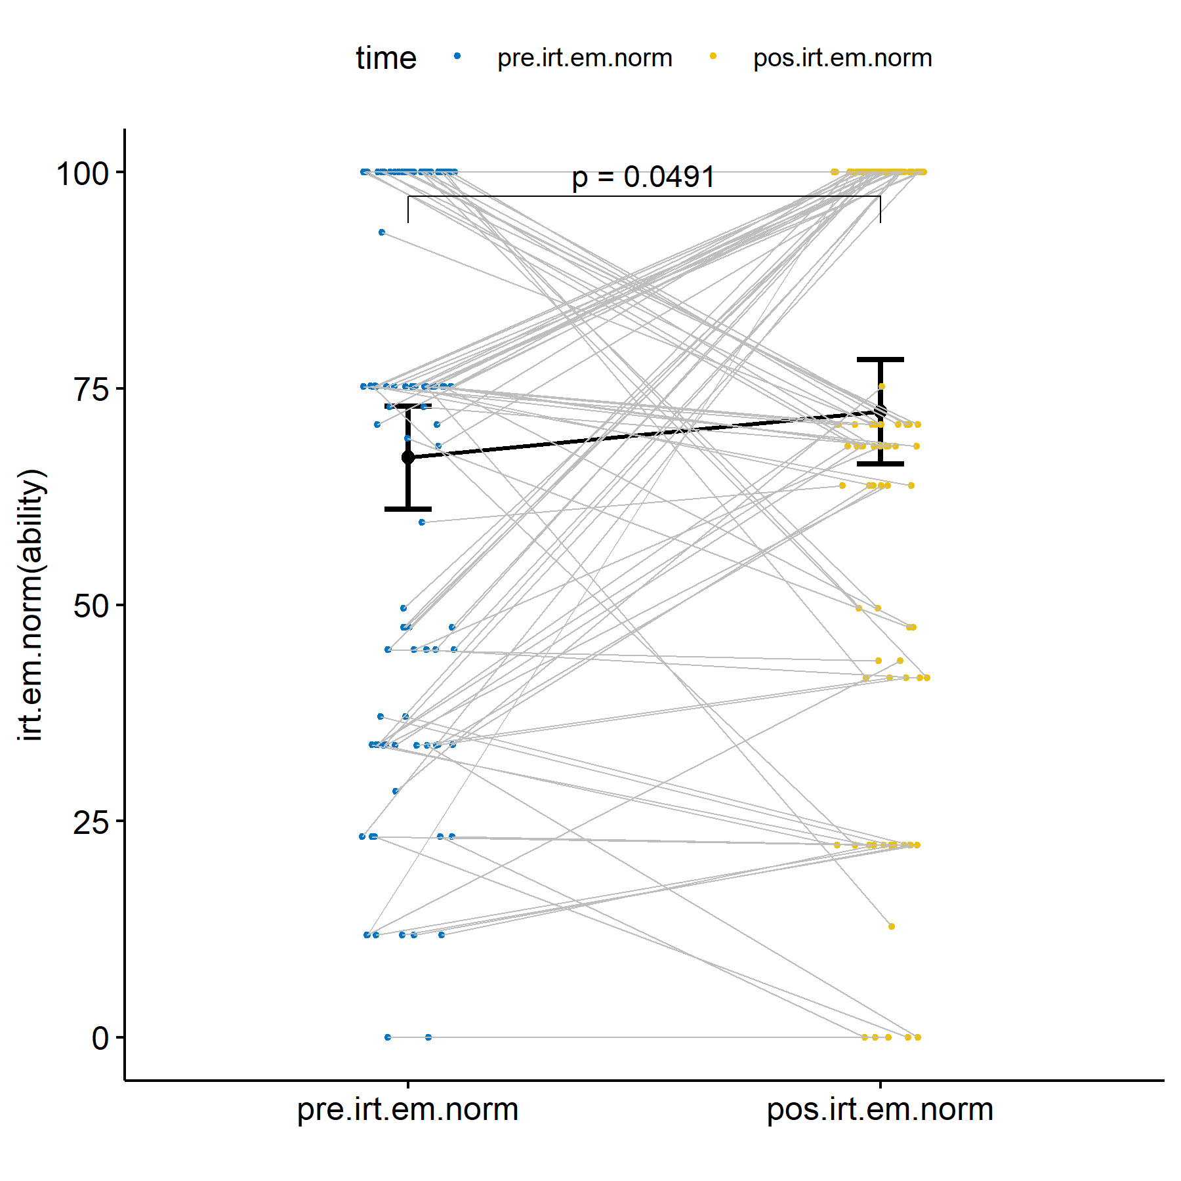

### Sorocaba - SP :: Evaluating H1b (null)

knitr::kable(df)

| group1 | group2 | n1 | n2 | estimate | statistic | p | p.signif |
| --- | --- | --- | --- | --- | --- | --- | --- |
| pos.score | pre.score | 47 | 47 | 0.5000835 | 344.5 | 0.0253 | * |
| pos.irt.em.norm | pre.irt.em.norm | 47 | 47 | 11.7207002 | 420.0 | 0.0432 | * |

knitr::kable(do.call(rbind, df.sum))

| time | variable | n | min | max | median | q1 | q3 | iqr | mad | mean | sd | se | ci |
| --- | --- | --- | --- | --- | --- | --- | --- | --- | --- | --- | --- | --- | --- |
| pre.score | value | 47 | 1.000 | 4 | 3.000 | 3.000 | 4 | 1.000 | 1.483 | 3.213 | 0.832 | 0.121 | 0.244 |
| pos.score | value | 47 | 1.000 | 4 | 4.000 | 3.000 | 4 | 1.000 | 0.000 | 3.553 | 0.717 | 0.105 | 0.210 |
| pre.irt.em.norm | value | 47 | 28.443 | 100 | 75.243 | 69.560 | 100 | 30.440 | 36.705 | 77.846 | 23.843 | 3.478 | 7.001 |
| pos.irt.em.norm | value | 47 | 22.210 | 100 | 100.000 | 70.801 | 100 | 29.199 | 0.000 | 87.034 | 19.951 | 2.910 | 5.858 |

plots$score

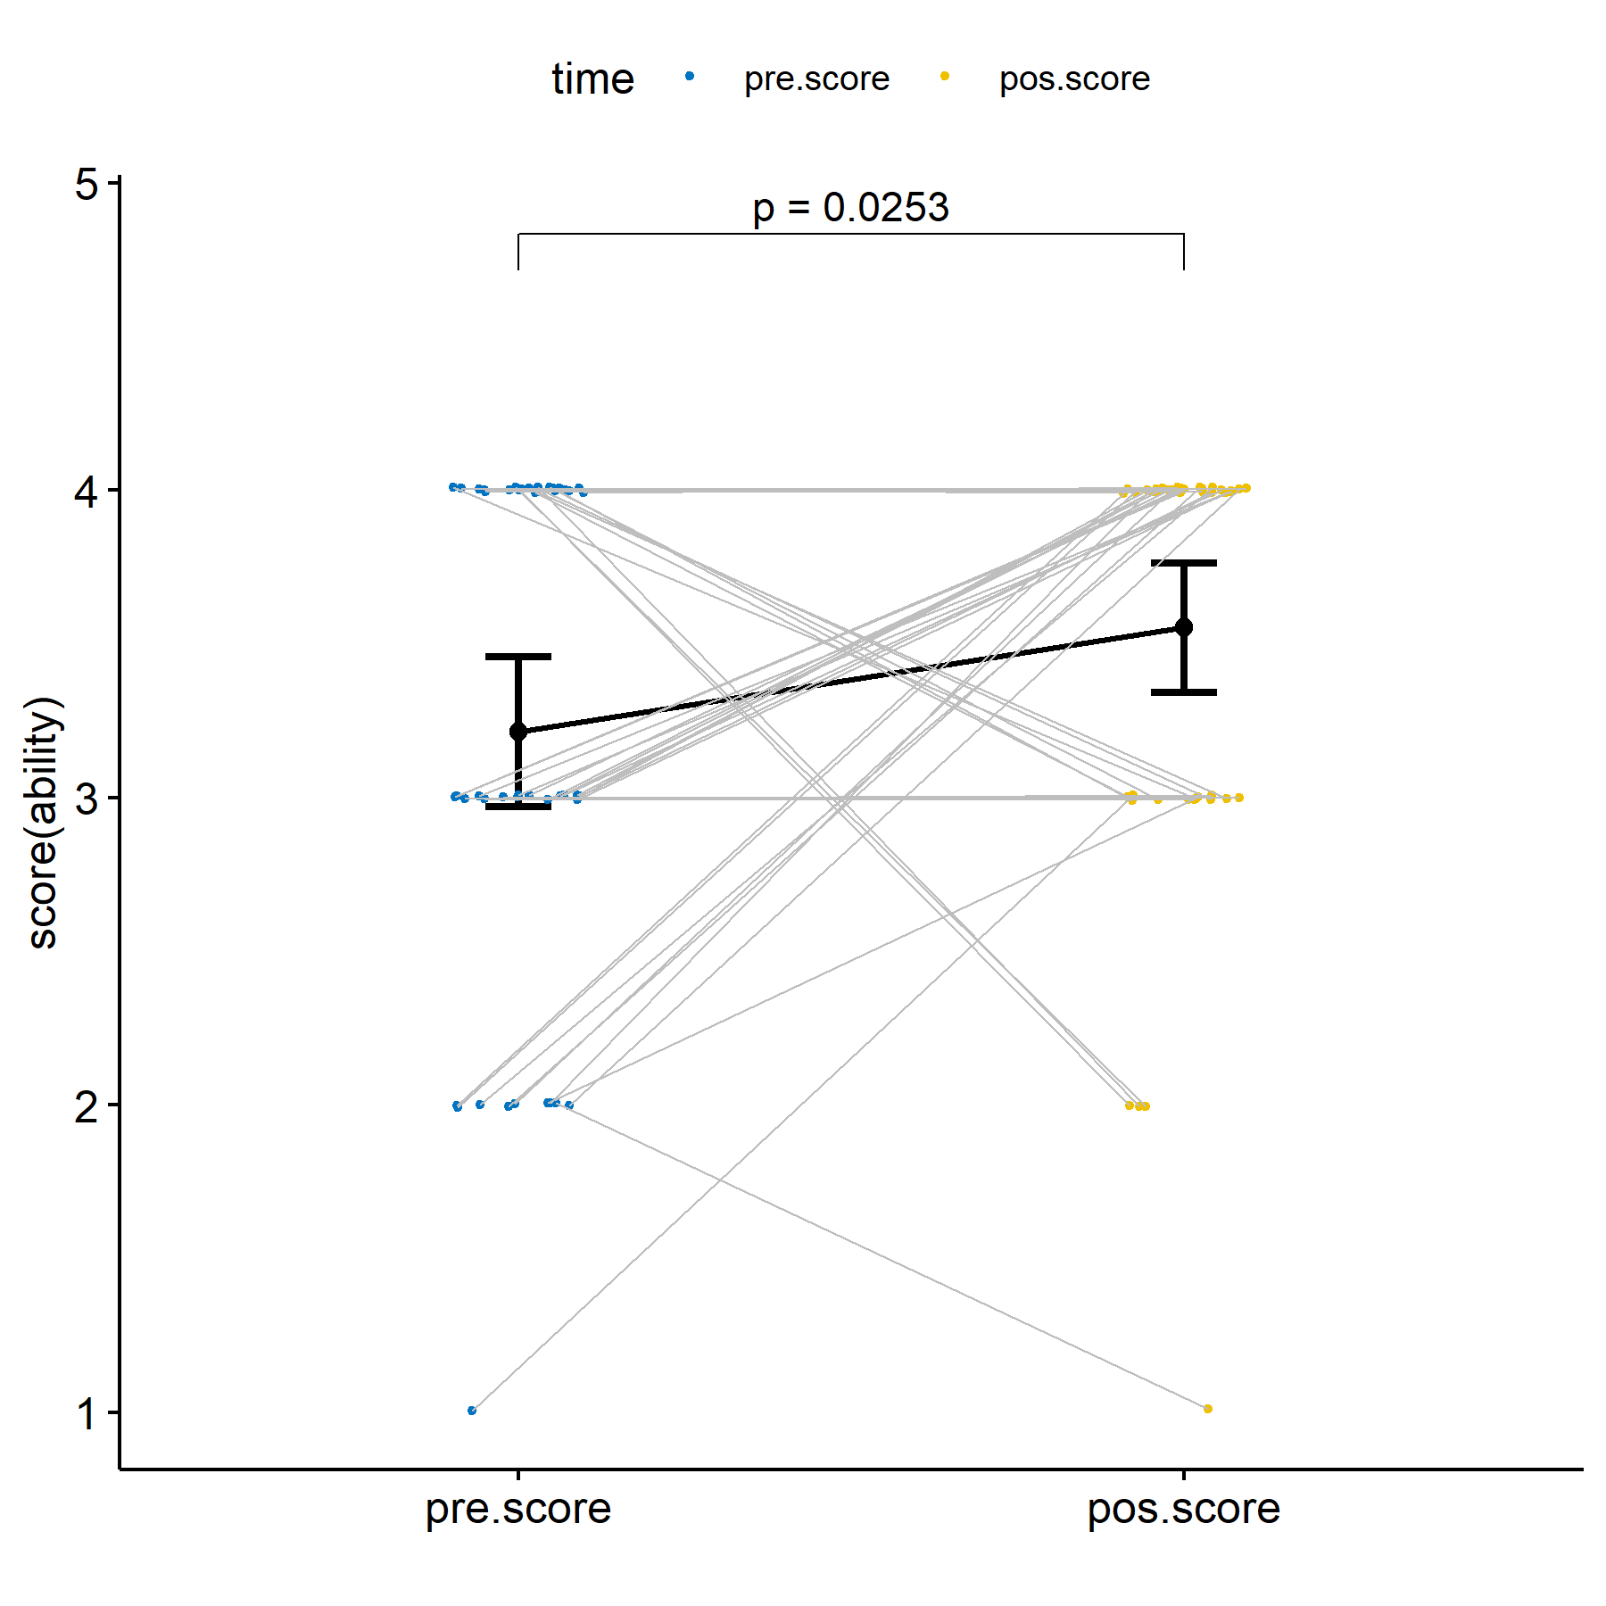

plots$irt.em.norm

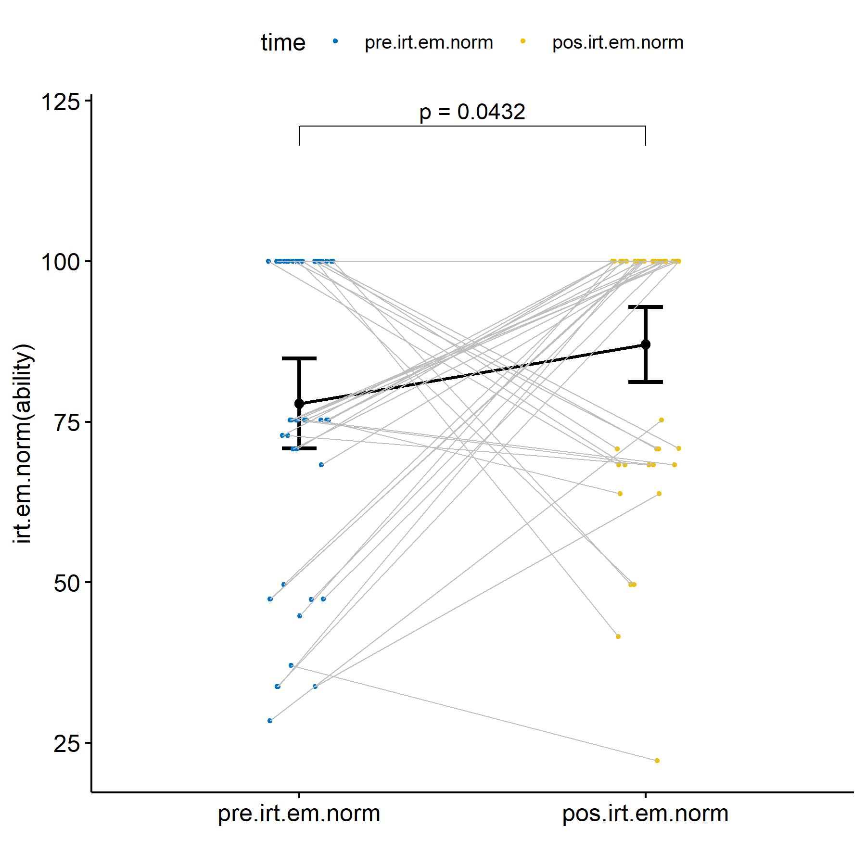

### Limoeiro - PE :: Evaluating H1b (null)

knitr::kable(df)

| group1 | group2 | n1 | n2 | estimate | statistic | p | p.signif |
| --- | --- | --- | --- | --- | --- | --- | --- |
| pos.score | pre.score | 60 | 60 | -0.0000785 | 237.5 | 0.706 | ns |
| pos.irt.em.norm | pre.irt.em.norm | 60 | 60 | 1.6317141 | 608.0 | 0.323 | ns |

knitr::kable(do.call(rbind, df.sum))

| time | variable | n | min | max | median | q1 | q3 | iqr | mad | mean | sd | se | ci |
| --- | --- | --- | --- | --- | --- | --- | --- | --- | --- | --- | --- | --- | --- |
| pre.score | value | 60 | 0 | 4 | 3.000 | 2.000 | 4 | 2.000 | 1.483 | 2.600 | 1.167 | 0.151 | 0.302 |
| pos.score | value | 60 | 0 | 4 | 3.000 | 1.000 | 4 | 3.000 | 1.483 | 2.550 | 1.358 | 0.175 | 0.351 |
| pre.irt.em.norm | value | 60 | 0 | 100 | 64.368 | 33.776 | 100 | 66.224 | 45.355 | 58.505 | 33.420 | 4.314 | 8.633 |
| pos.irt.em.norm | value | 60 | 0 | 100 | 68.318 | 22.210 | 100 | 77.790 | 46.971 | 60.767 | 34.057 | 4.397 | 8.798 |

plots$score

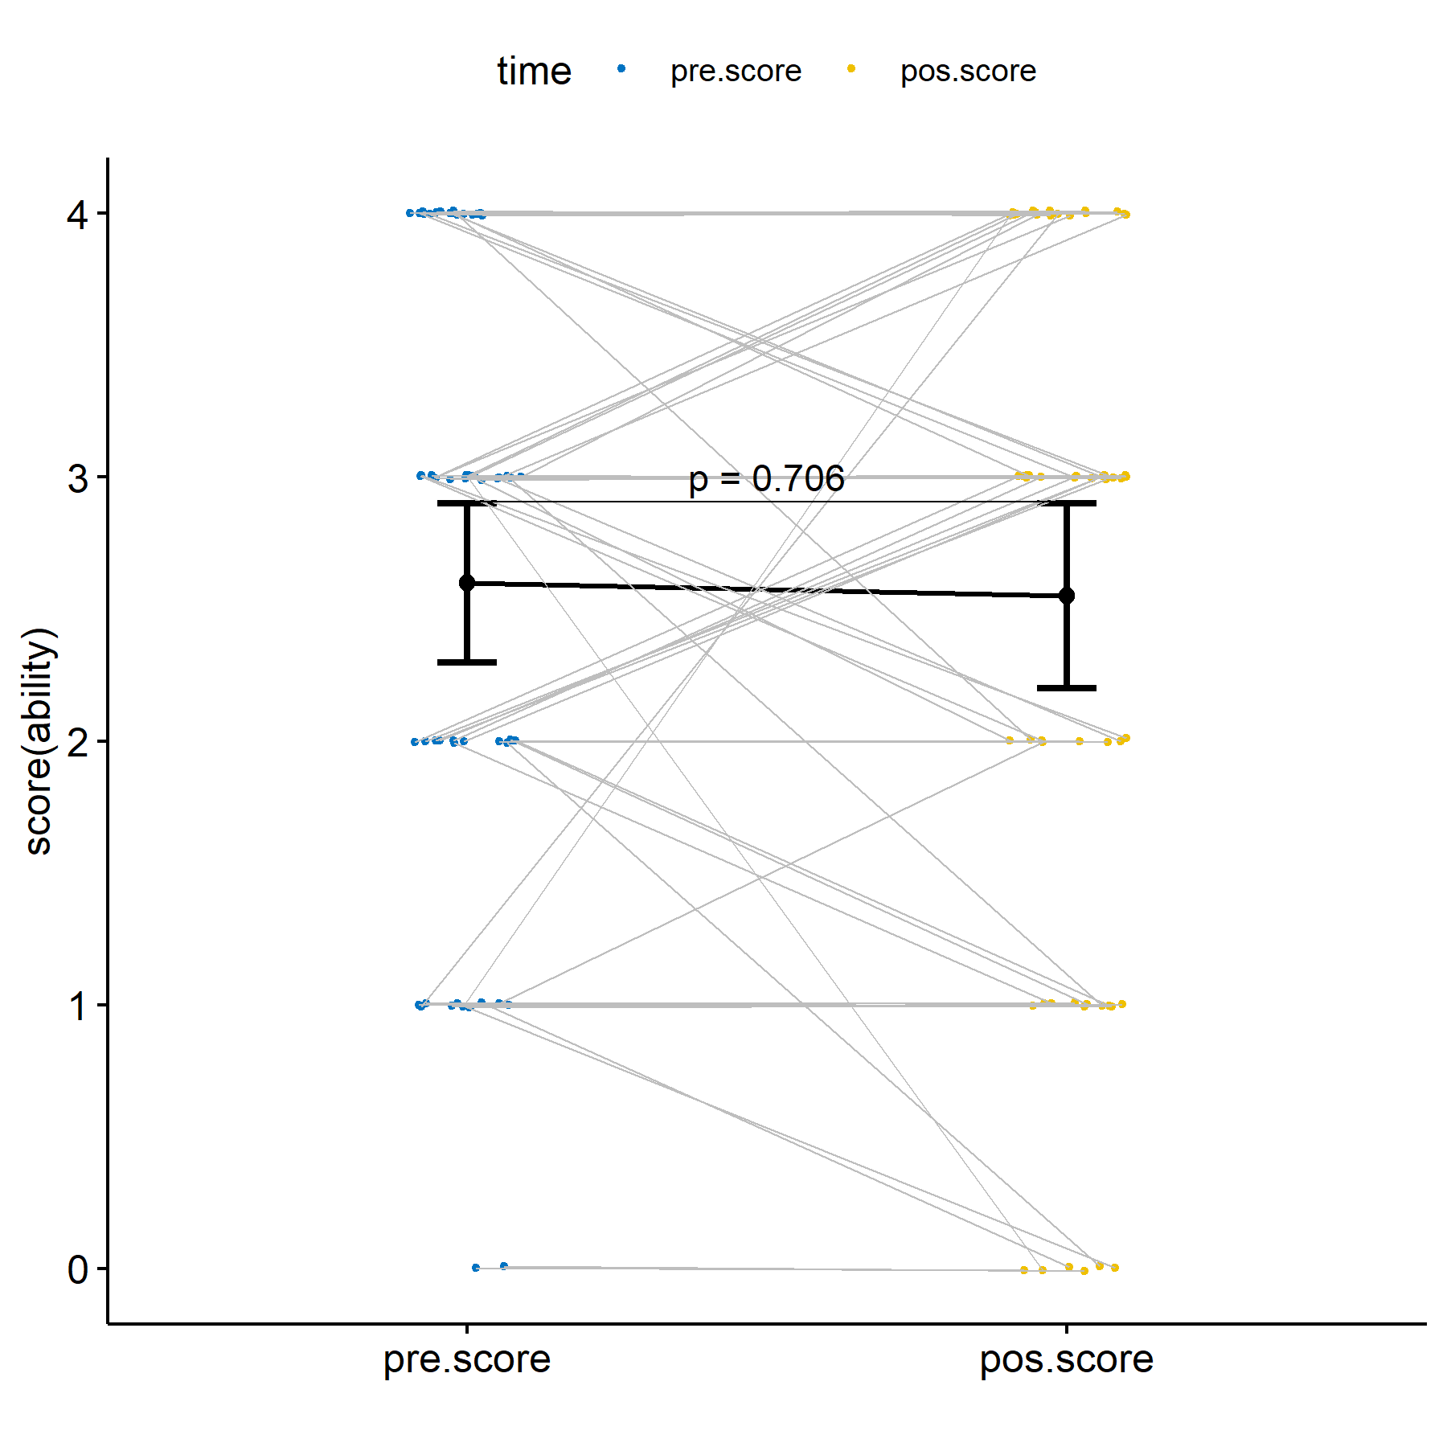

plots$irt.em.norm

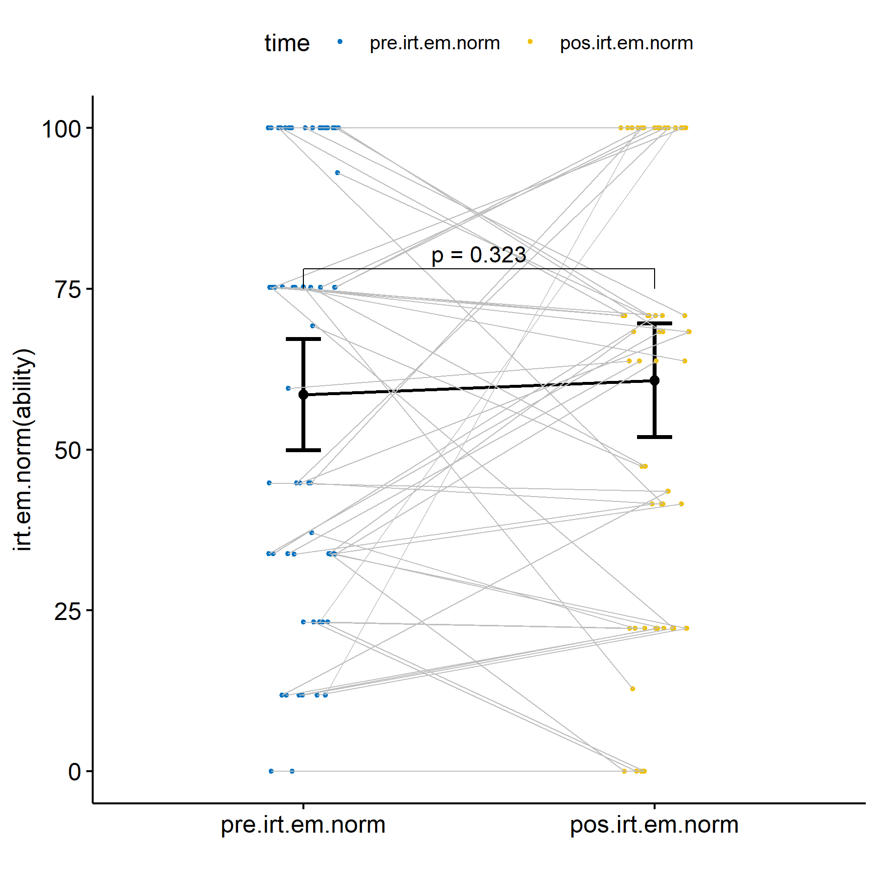

## Evaluating H2 (null)

H2 (null): Students who participated in scenarios with our proposed ITS and with training (experimental group) have the same mean score/ability in both the pre-test and post-test.

knitr::kable(df)

| group1 | group2 | n1 | n2 | estimate | statistic | p | p.signif |
| --- | --- | --- | --- | --- | --- | --- | --- |
| pos.score | pre.score | 87 | 87 | -3.10e-06 | 483 | 0.562 | ns |
| pos.irt.em.norm | pre.irt.em.norm | 87 | 87 | -3.59e-05 | 878 | 0.523 | ns |

knitr::kable(do.call(rbind, df.sum))

| time | variable | n | min | max | median | q1 | q3 | iqr | mad | mean | sd | se | ci |
| --- | --- | --- | --- | --- | --- | --- | --- | --- | --- | --- | --- | --- | --- |
| pre.score | value | 87 | 0.000 | 4 | 4 | 3.000 | 4 | 1.000 | 0 | 3.138 | 1.091 | 0.117 | 0.233 |
| pos.score | value | 87 | 0.000 | 4 | 4 | 3.000 | 4 | 1.000 | 0 | 3.126 | 1.129 | 0.121 | 0.241 |
| pre.irt.em.norm | value | 87 | 11.805 | 100 | 100 | 58.015 | 100 | 41.985 | 0 | 75.968 | 29.909 | 3.207 | 6.375 |
| pos.irt.em.norm | value | 87 | 0.000 | 100 | 100 | 66.055 | 100 | 33.945 | 0 | 76.809 | 28.708 | 3.078 | 6.118 |

plots$score

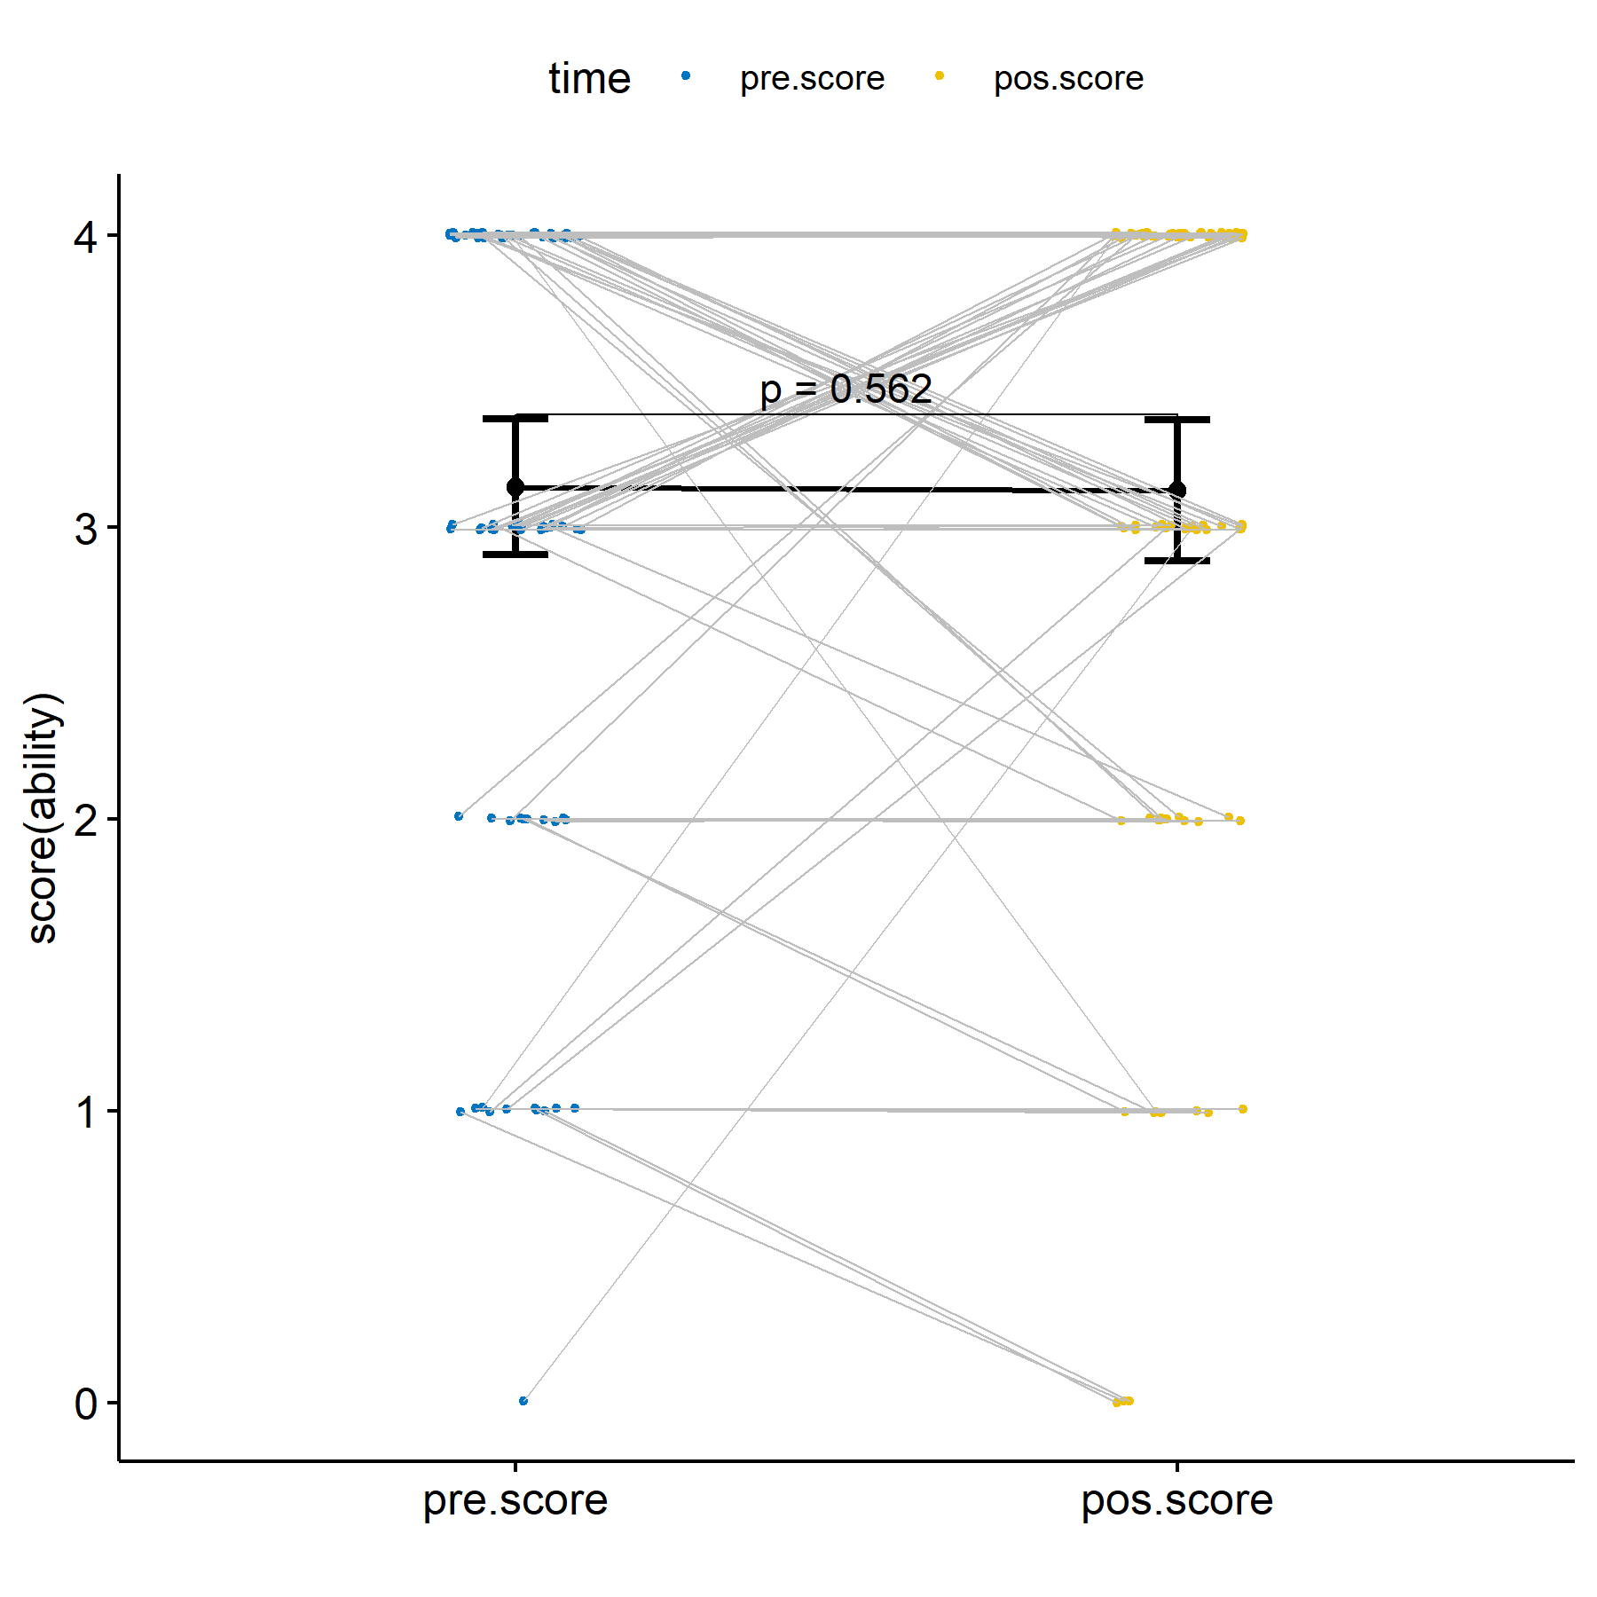

plots$irt.em.norm

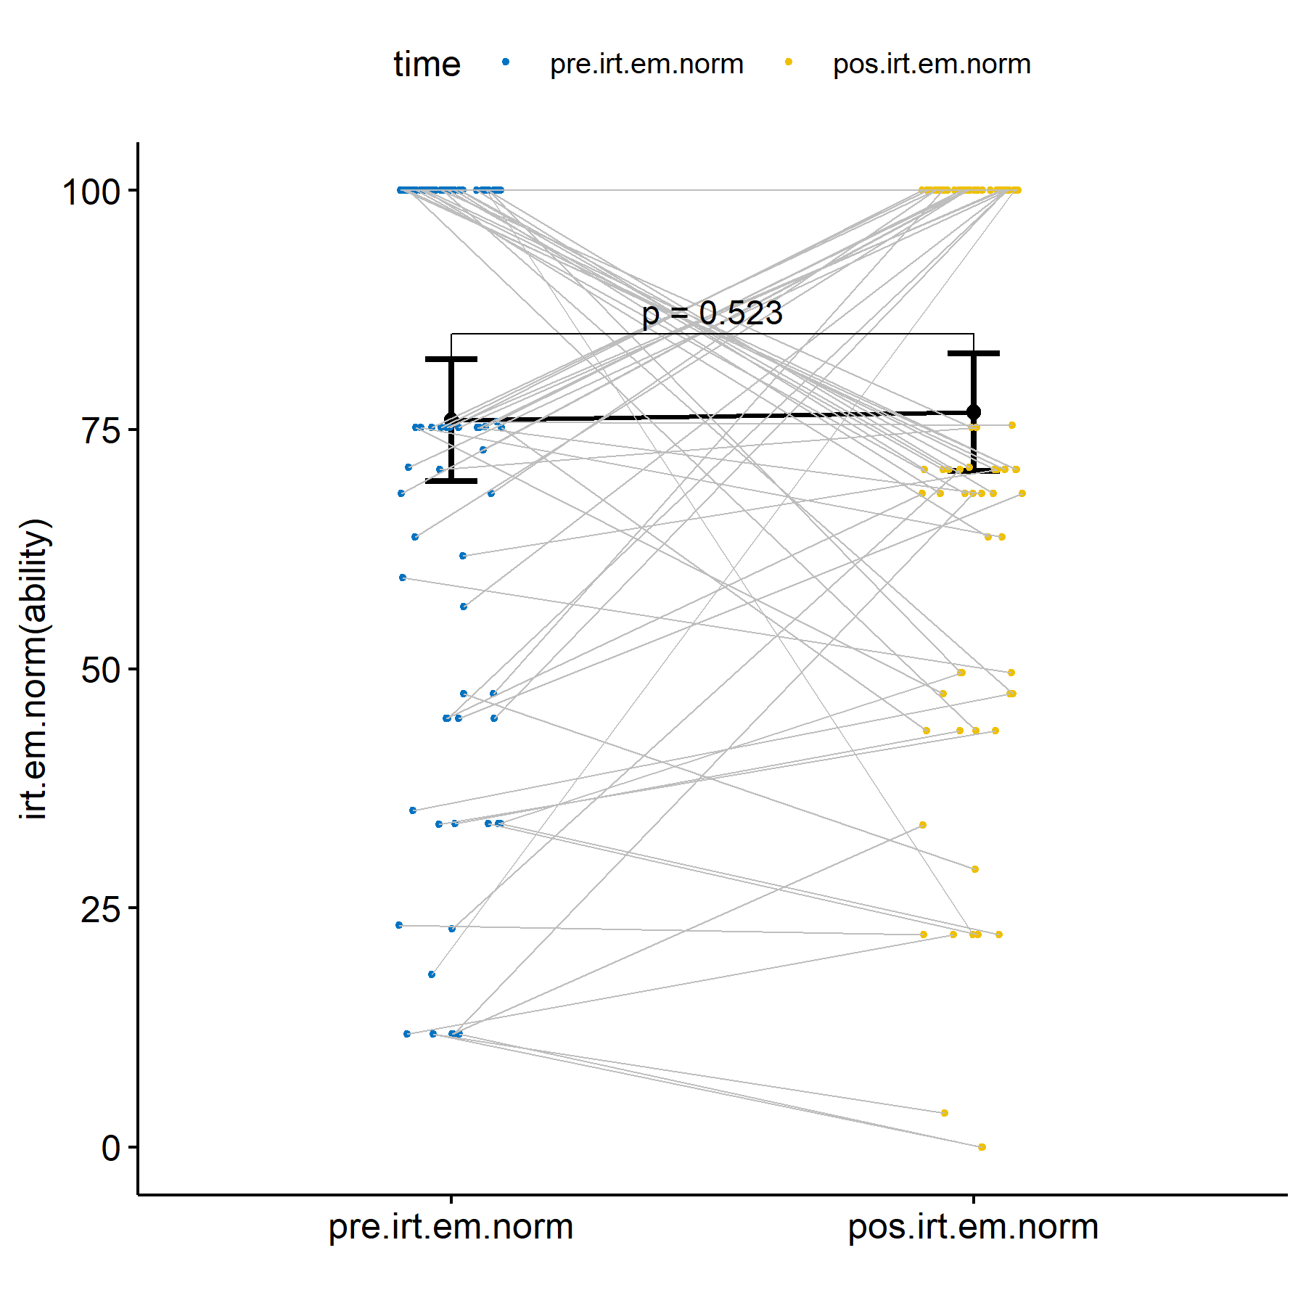

### Sorocaba - SP :: Evaluating H2 (null)

knitr::kable(df)

| group1 | group2 | n1 | n2 | estimate | statistic | p | p.signif |
| --- | --- | --- | --- | --- | --- | --- | --- |
| pos.score | pre.score | 34 | 34 | 0.0000629 | 83.0 | 0.208 | ns |
| pos.irt.em.norm | pre.irt.em.norm | 34 | 34 | 10.4789042 | 123.5 | 0.129 | ns |

knitr::kable(do.call(rbind, df.sum))

| time | variable | n | min | max | median | q1 | q3 | iqr | mad | mean | sd | se | ci |
| --- | --- | --- | --- | --- | --- | --- | --- | --- | --- | --- | --- | --- | --- |
| pre.score | value | 34 | 2.000 | 4 | 4 | 3.000 | 4 | 1.000 | 0 | 3.559 | 0.613 | 0.105 | 0.214 |
| pos.score | value | 34 | 2.000 | 4 | 4 | 3.250 | 4 | 0.750 | 0 | 3.676 | 0.589 | 0.101 | 0.205 |
| pre.irt.em.norm | value | 34 | 44.797 | 100 | 100 | 70.867 | 100 | 29.133 | 0 | 85.210 | 20.666 | 3.544 | 7.211 |
| pos.irt.em.norm | value | 34 | 29.058 | 100 | 100 | 81.432 | 100 | 18.568 | 0 | 90.477 | 17.834 | 3.059 | 6.223 |

plots$score

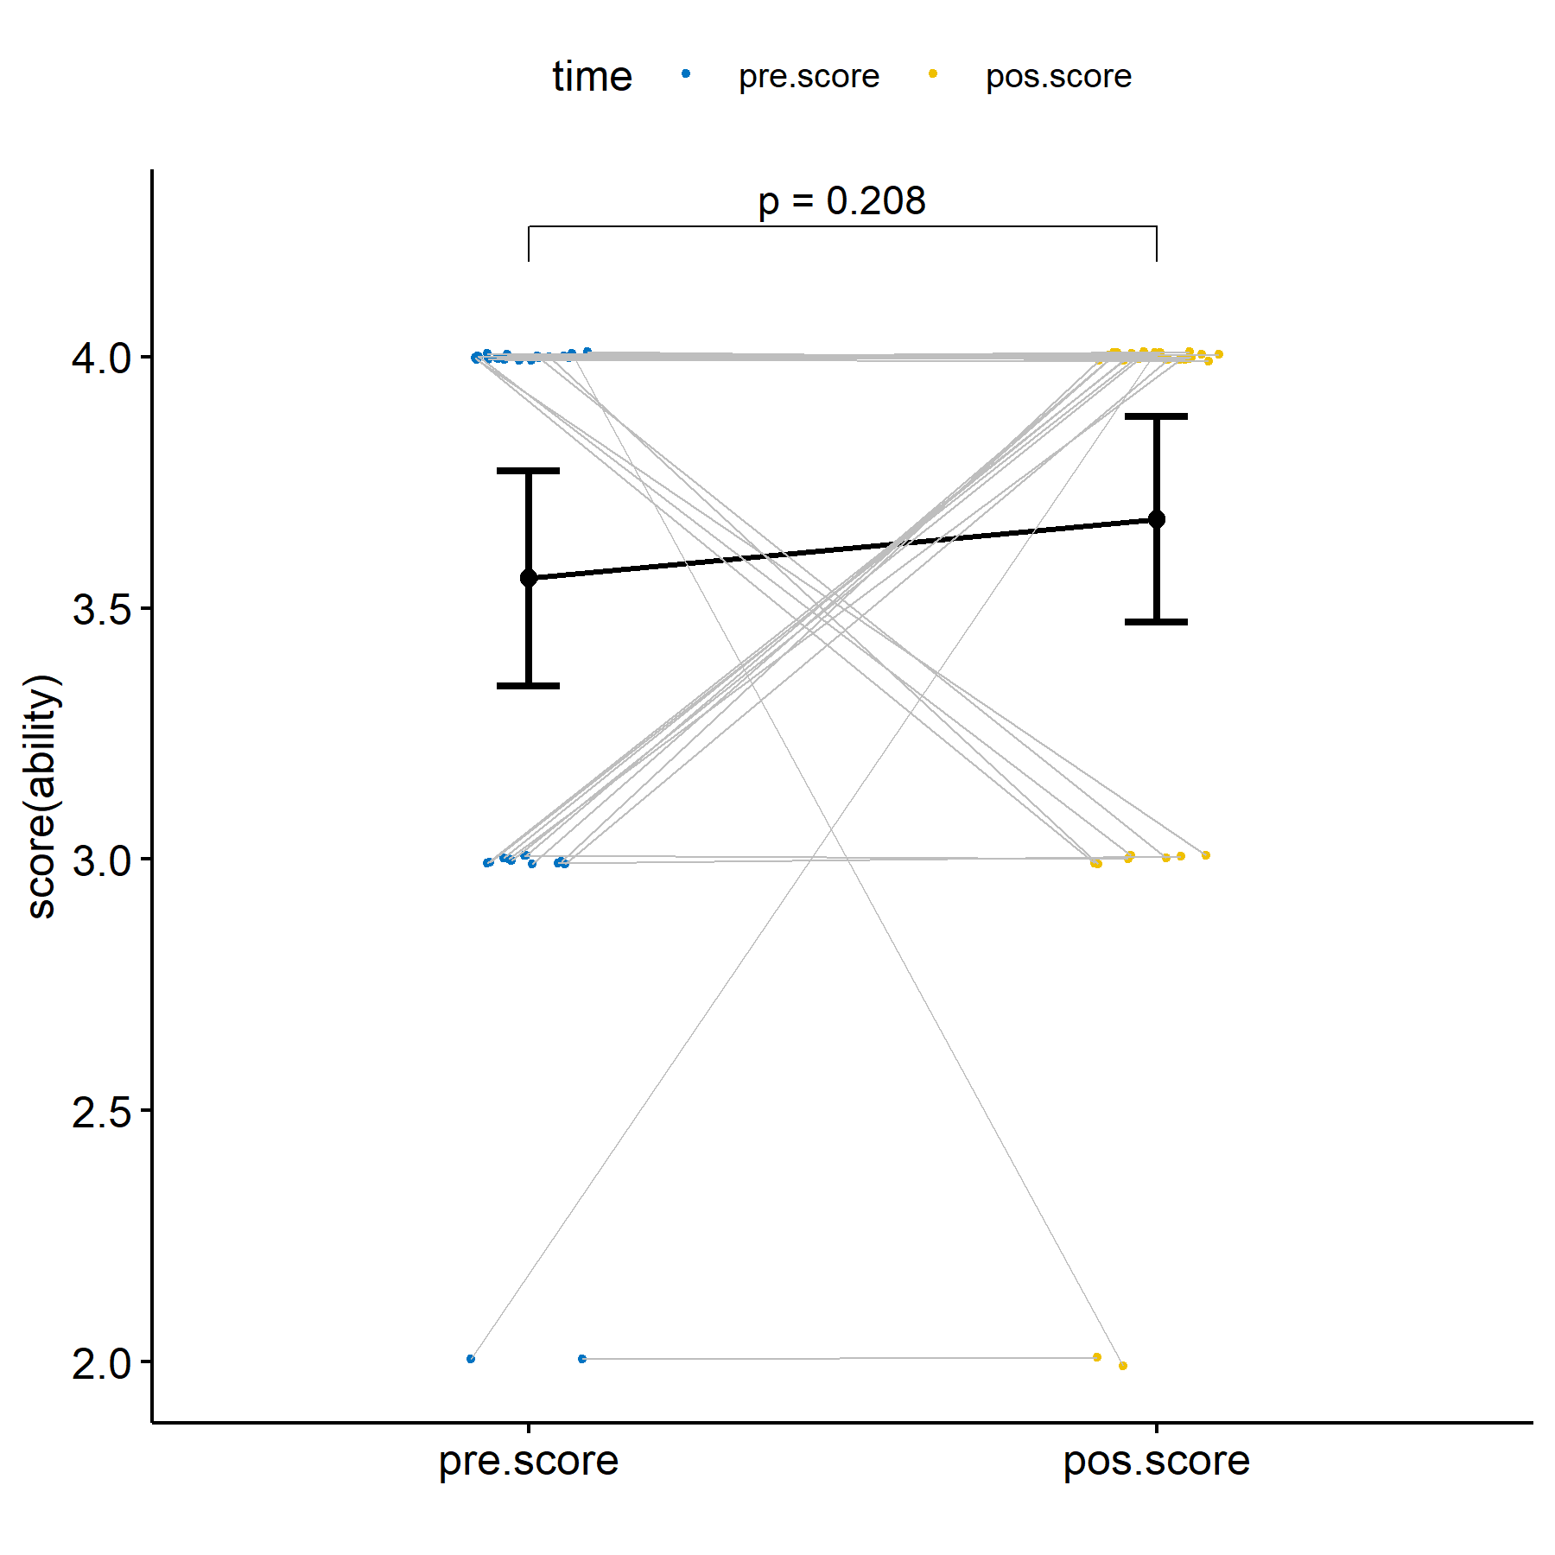

plots$irt.em.norm

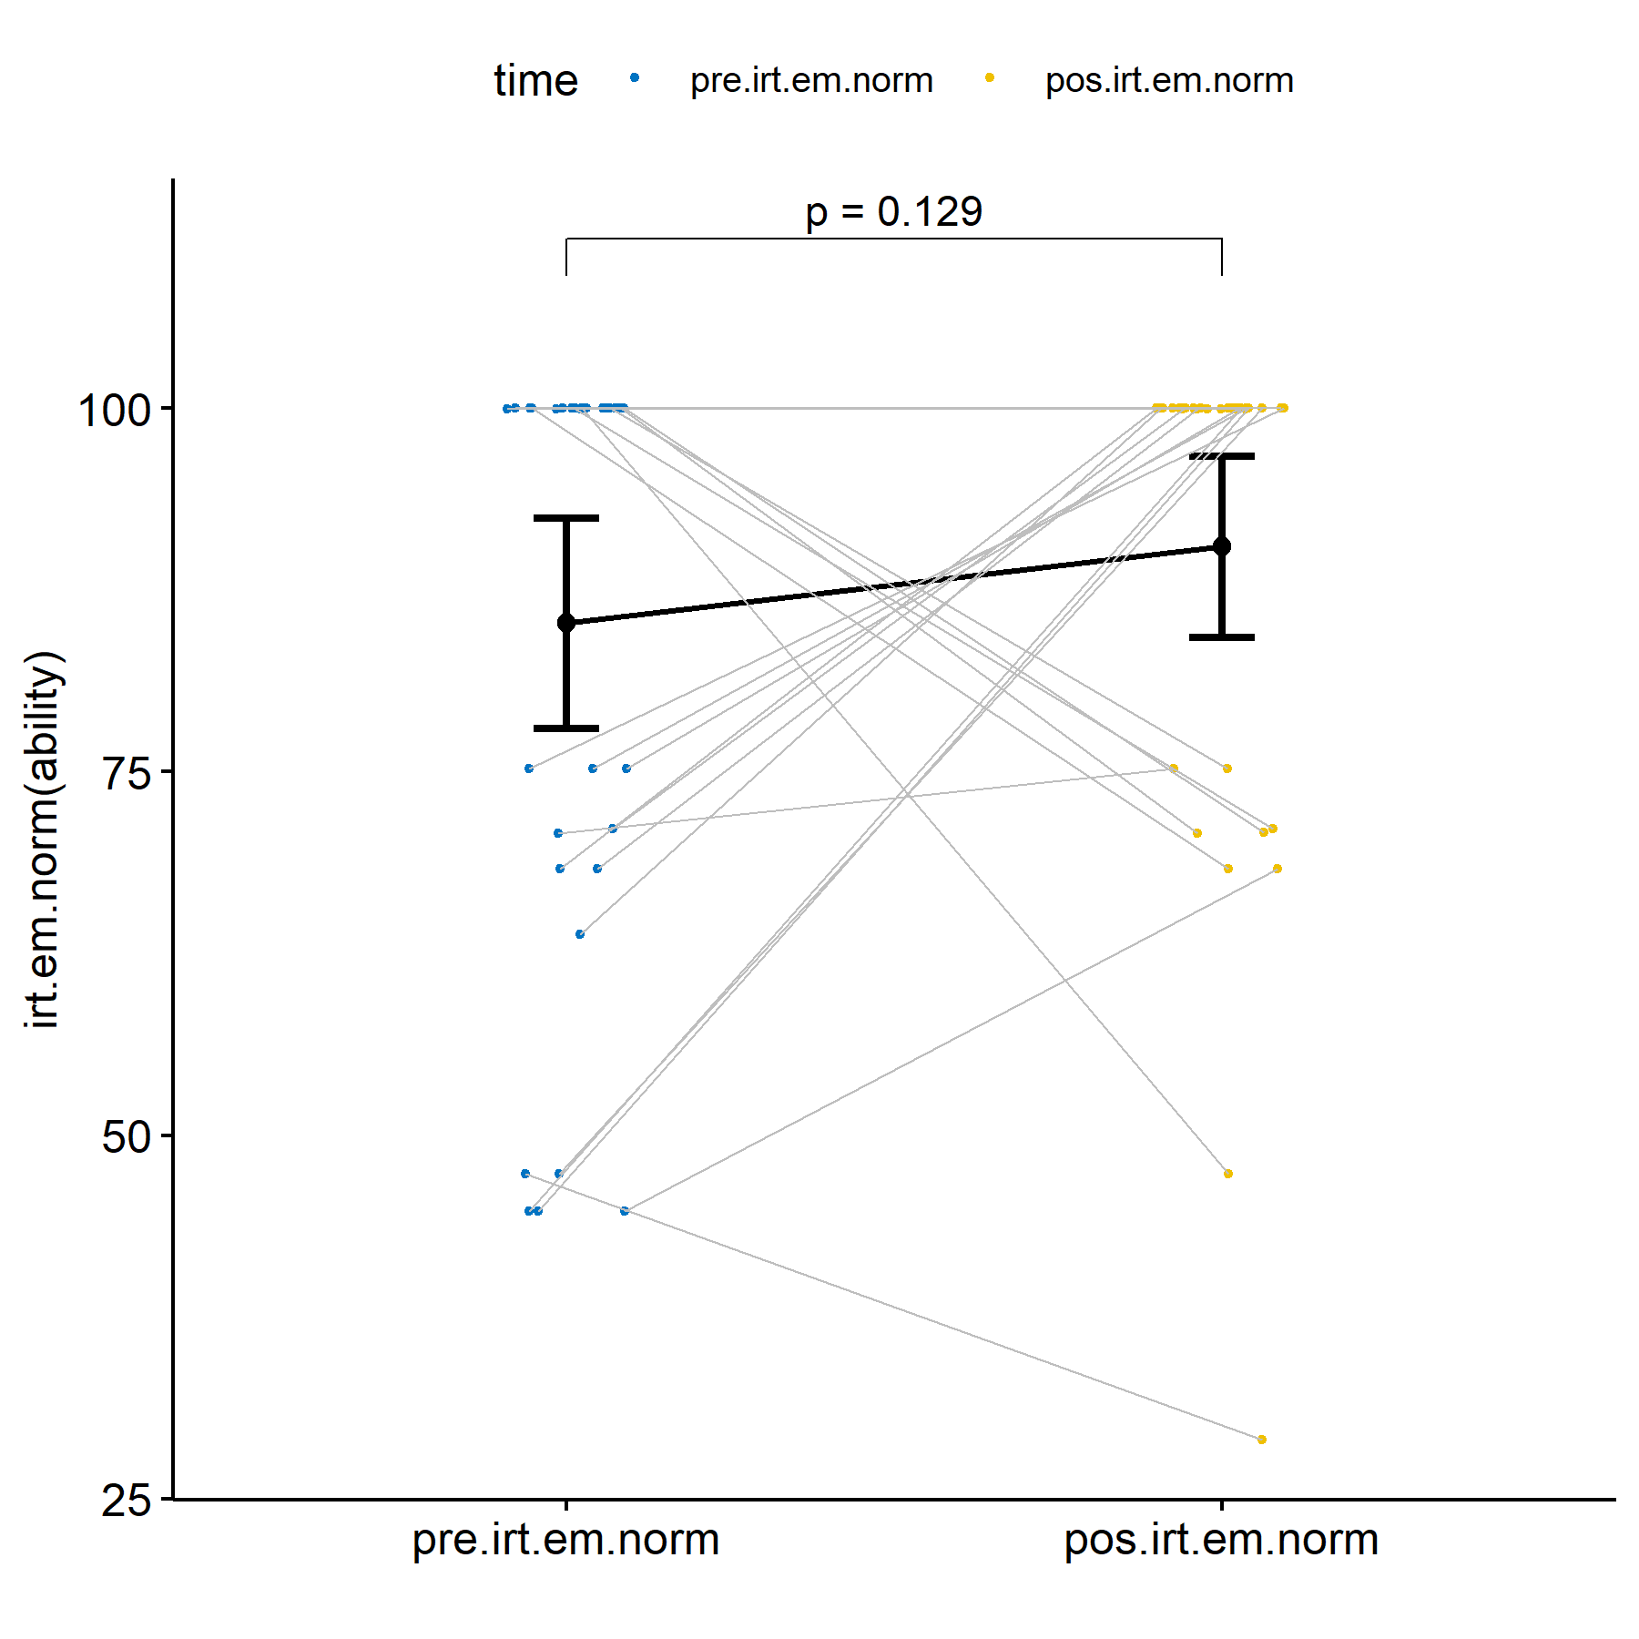

### Limoeiro - PE :: Evaluating H2 (null)

knitr::kable(df)

| group1 | group2 | n1 | n2 | estimate | statistic | p | p.signif |
| --- | --- | --- | --- | --- | --- | --- | --- |
| pos.score | pre.score | 53 | 53 | -0.0000564 | 175.5 | 0.748 | ns |
| pos.irt.em.norm | pre.irt.em.norm | 53 | 53 | -2.8389065 | 345.0 | 0.811 | ns |

knitr::kable(do.call(rbind, df.sum))

| time | variable | n | min | max | median | q1 | q3 | iqr | mad | mean | sd | se | ci |
| --- | --- | --- | --- | --- | --- | --- | --- | --- | --- | --- | --- | --- | --- |
| pre.score | value | 53 | 0.000 | 4 | 3.000 | 2.000 | 4 | 2.000 | 1.483 | 2.868 | 1.241 | 0.170 | 0.342 |
| pos.score | value | 53 | 0.000 | 4 | 3.000 | 2.000 | 4 | 2.000 | 1.483 | 2.774 | 1.250 | 0.172 | 0.345 |
| pre.irt.em.norm | value | 53 | 11.805 | 100 | 75.243 | 33.776 | 100 | 66.224 | 36.705 | 70.040 | 33.418 | 4.590 | 9.211 |
| pos.irt.em.norm | value | 53 | 0.000 | 100 | 70.801 | 47.360 | 100 | 52.640 | 43.290 | 68.041 | 30.994 | 4.257 | 8.543 |

plots$score

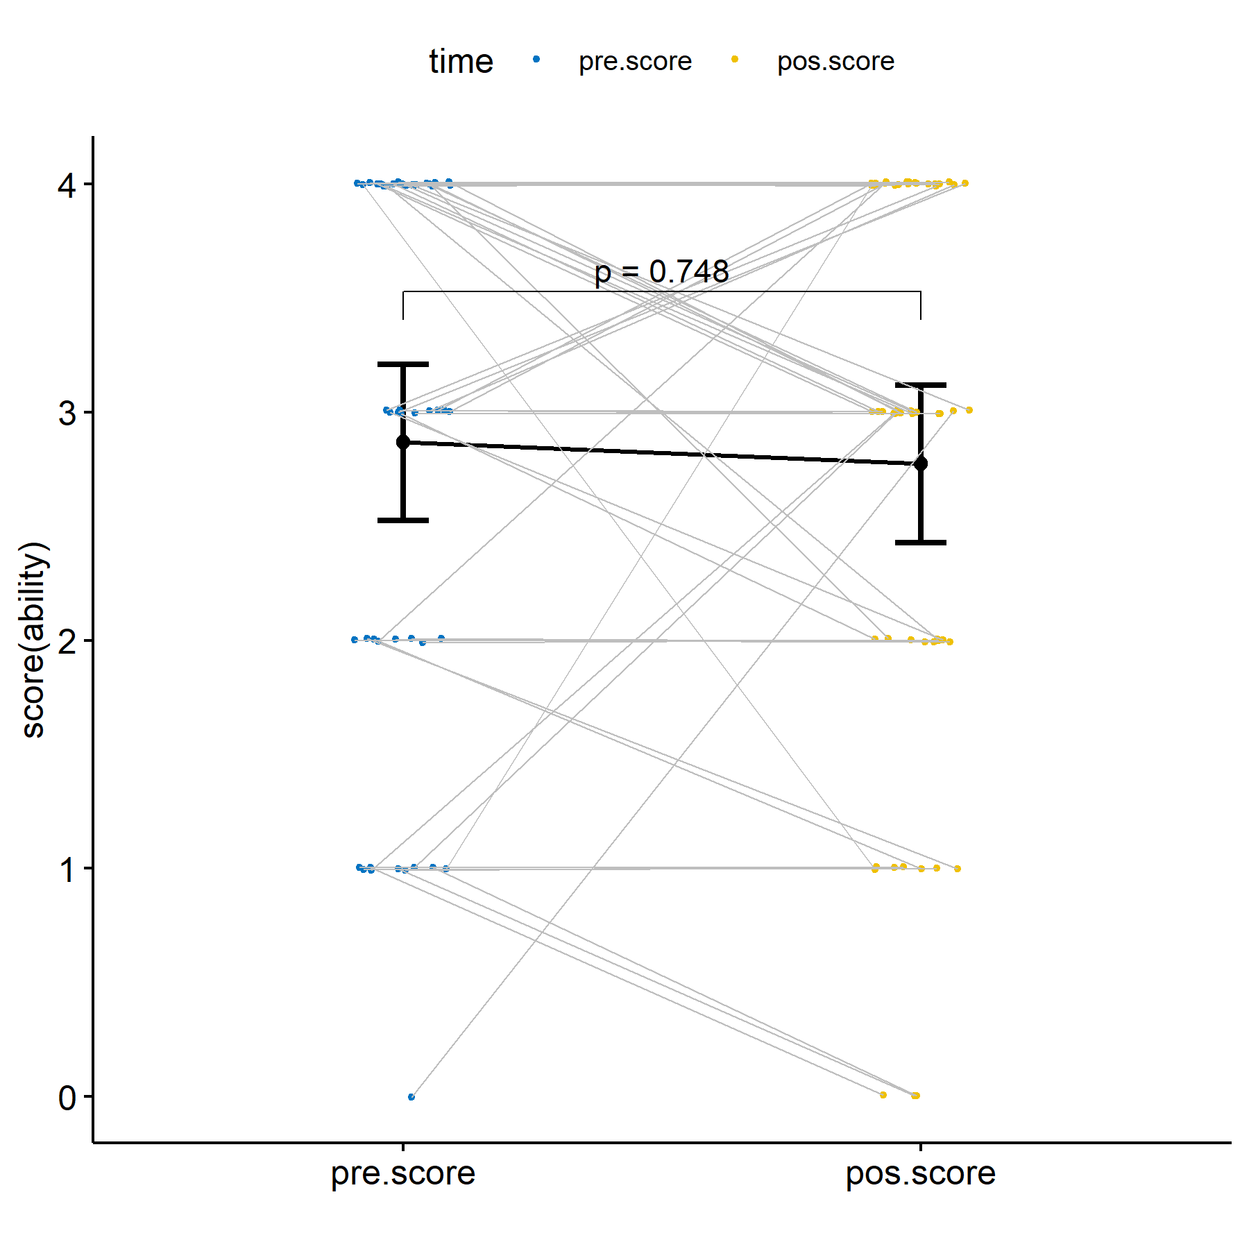

plots$irt.em.norm

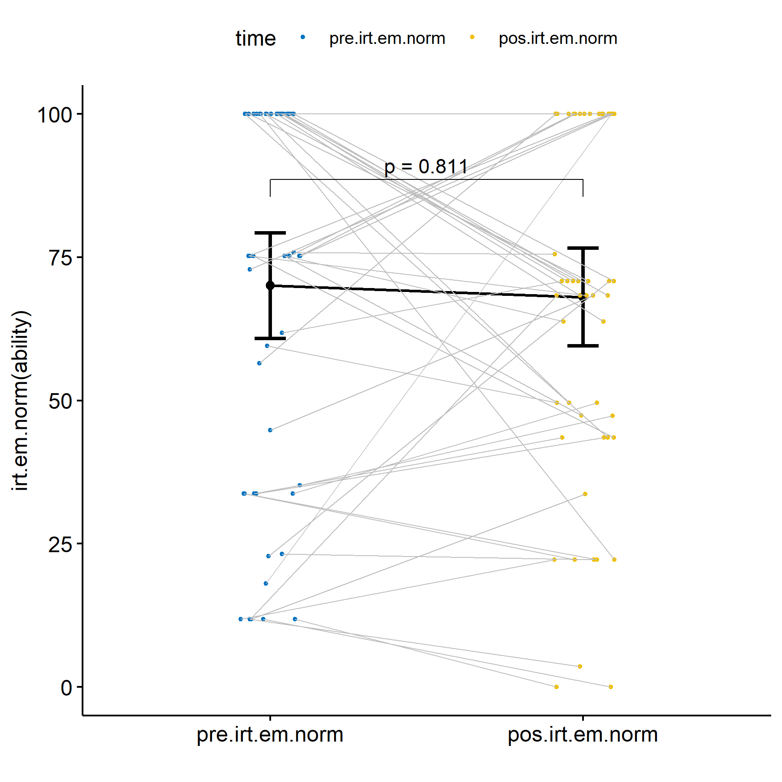

## Evaluating H3 (null)

H3 (null): Students who participated in scenarios with our proposed ITS and with training (experimental group) have the same learning gain that students who participated in control groups.

knitr::kable(df)

|  | var | n | df | statistic | p | p.signif |
| --- | --- | --- | --- | --- | --- | --- |
| score | dif.score | 221 | 2 | 6.637077 | 0.0362 | * |
| irt.em.norm | dif.irt.em.norm | 221 | 2 | 7.819429 | 0.0200 | * |

knitr::kable(df)

|  | var | group1 | group2 | n1 | n2 | estimate | statistic | p.adj | p.adj.signif |
| --- | --- | --- | --- | --- | --- | --- | --- | --- | --- |
| score.1 | dif.score | Ctr.A | Ctr.B | 27 | 107 | -0.9999745 | 1021.5 | 0.043 | * |
| score.2 | dif.score | Ctr.A | Exp | 27 | 87 | -0.0000402 | 905.5 | 0.168 | ns |
| score.3 | dif.score | Ctr.B | Exp | 107 | 87 | 0.0000000 | 5057.5 | 0.819 | ns |
| irt.em.norm.1 | dif.irt.em.norm | Ctr.A | Ctr.B | 27 | 107 | -17.3681209 | 955.5 | 0.019 | * |
| irt.em.norm.2 | dif.irt.em.norm | Ctr.A | Exp | 27 | 87 | -11.4516516 | 842.0 | 0.074 | ns |
| irt.em.norm.3 | dif.irt.em.norm | Ctr.B | Exp | 107 | 87 | 0.0000414 | 4988.0 | 1.000 | ns |

plots$score

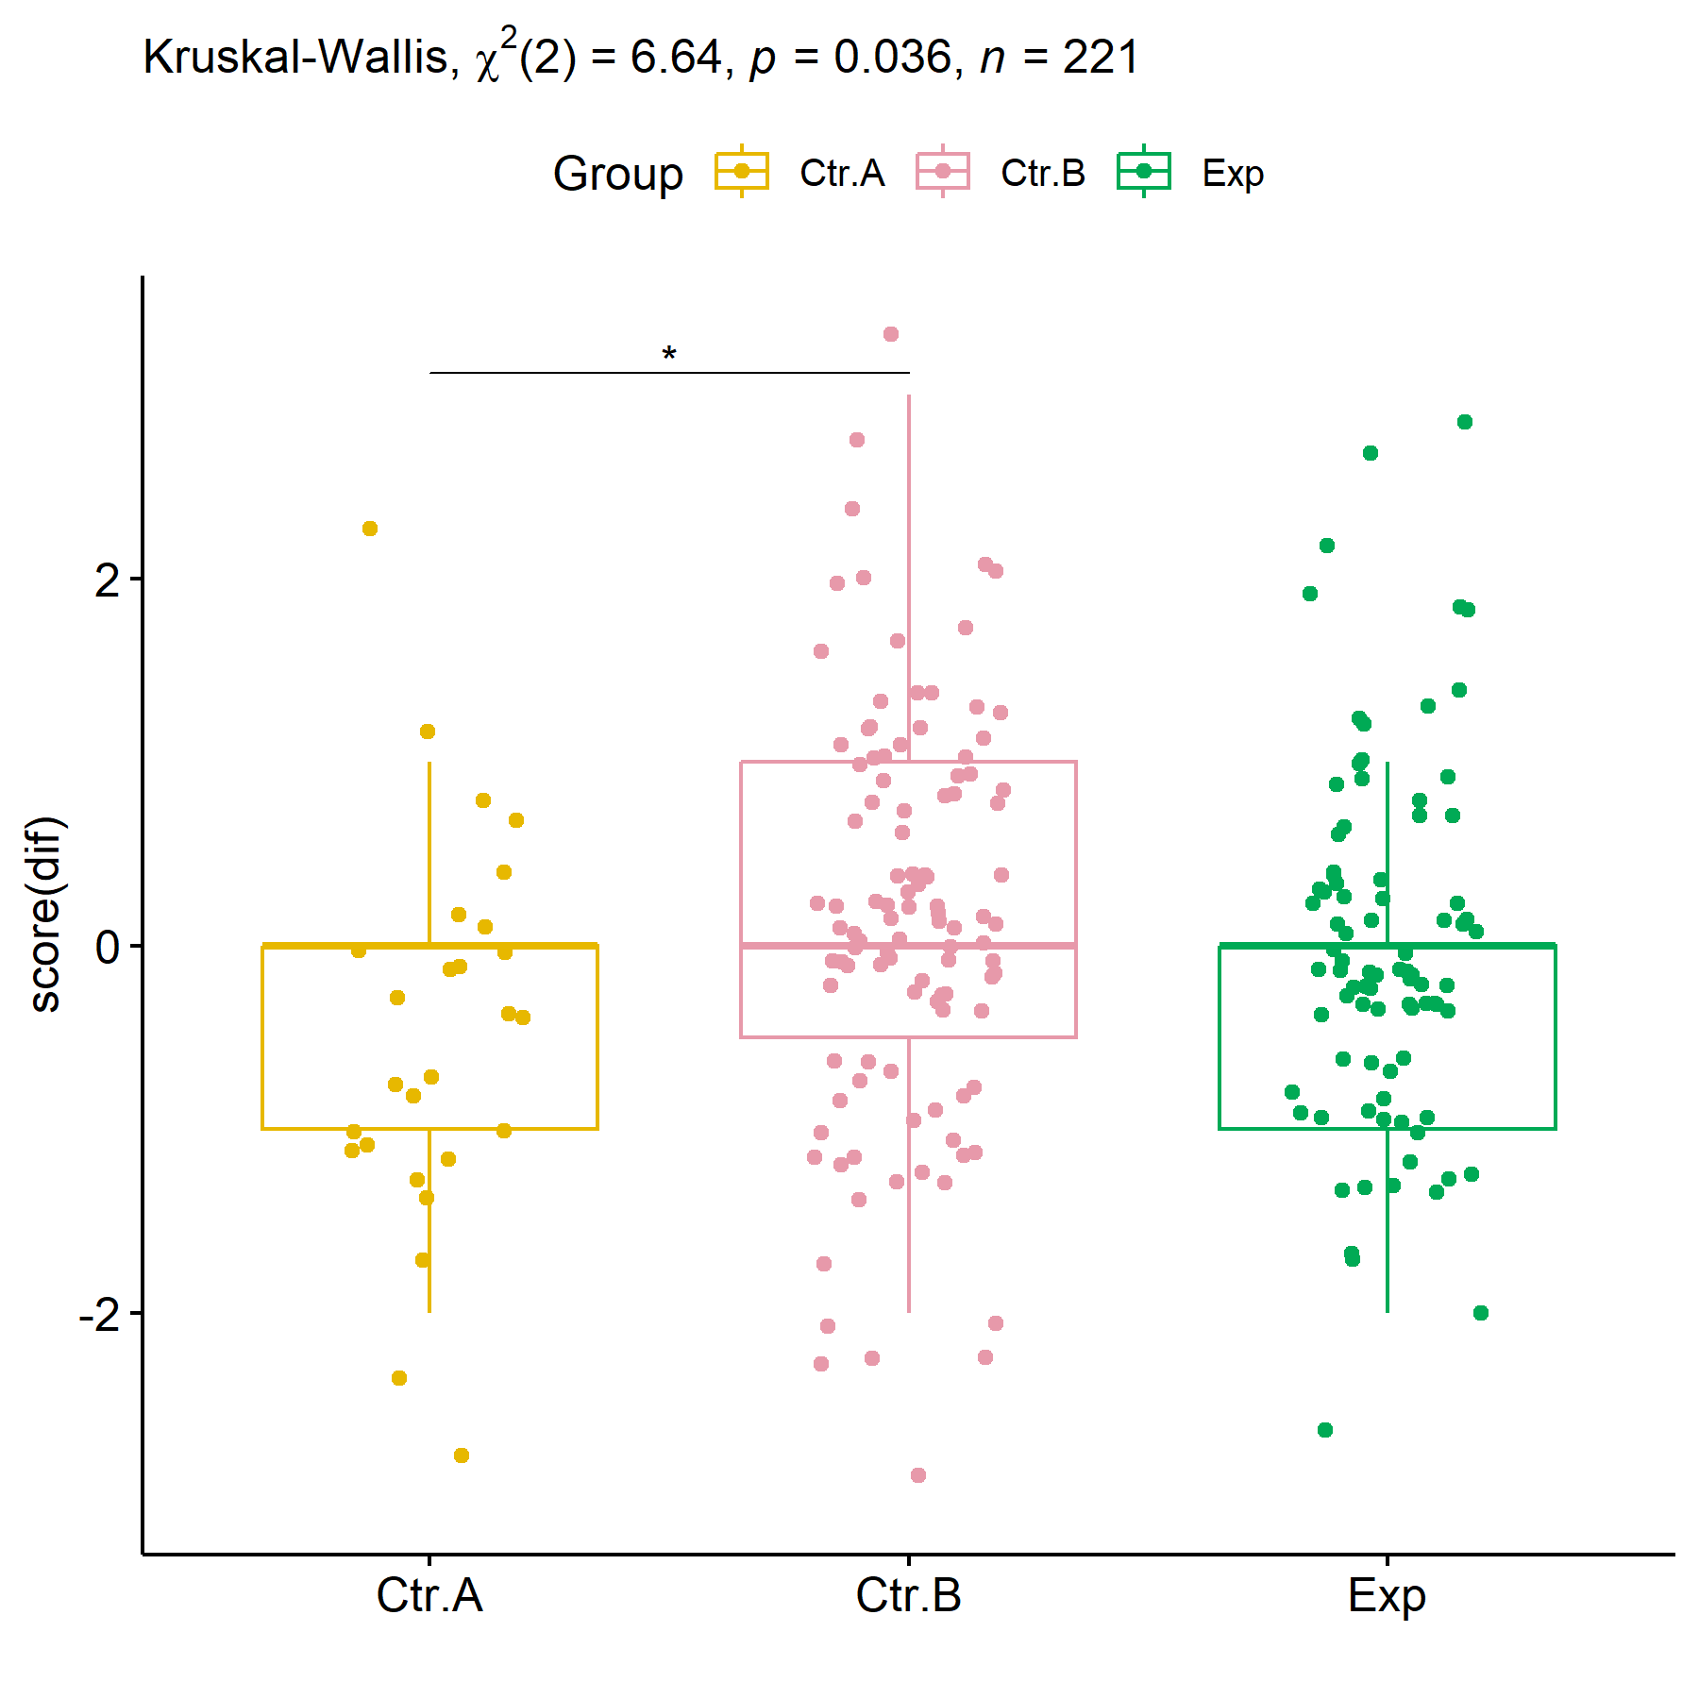

plots$irt.em.norm

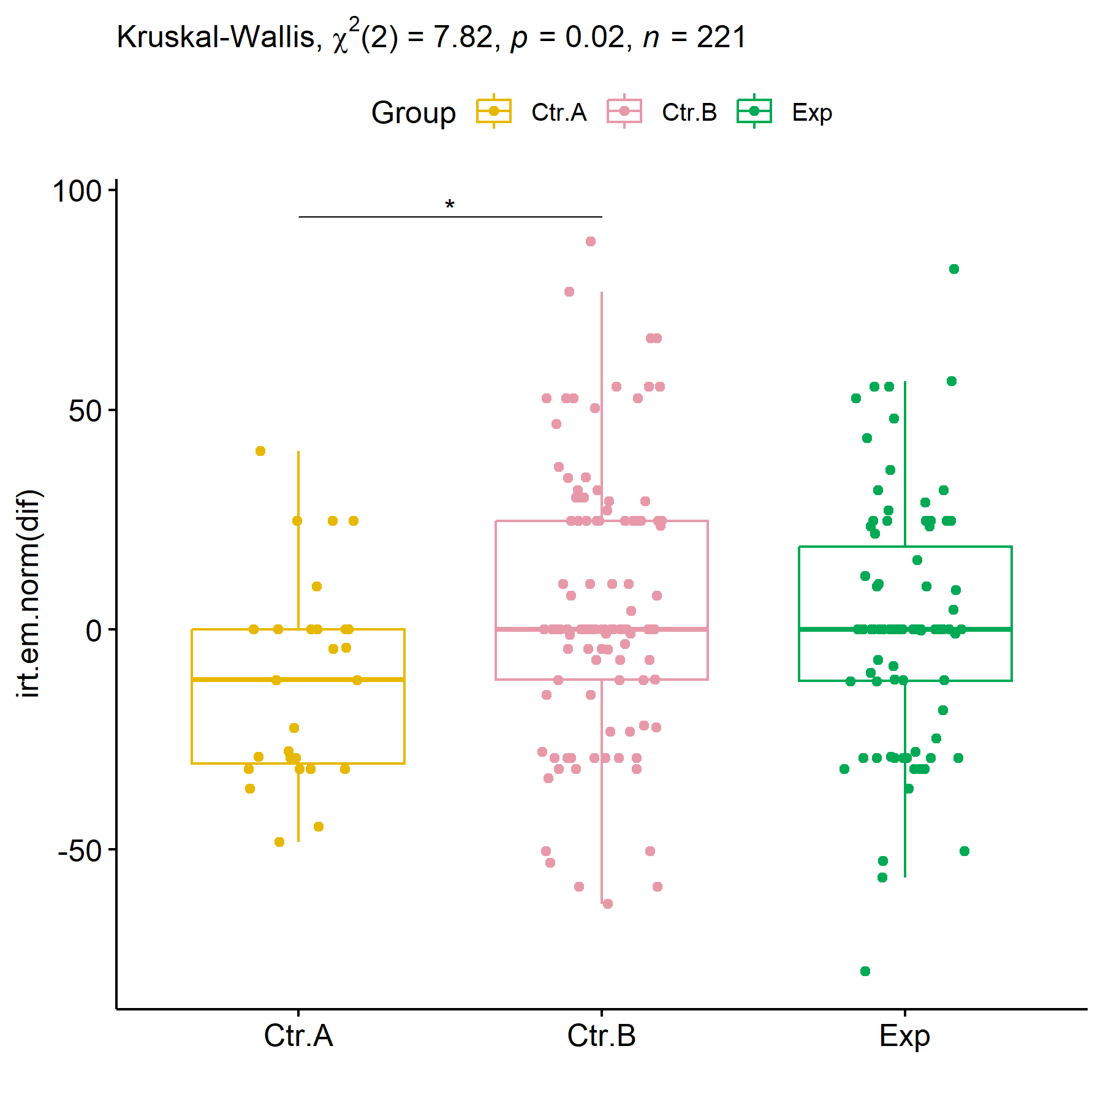

### Subgroup analysis for Group:Town

knitr::kable(df)

|  | var | Effect | Df | Sum Sq | H | p.value | p.value.signif |
| --- | --- | --- | --- | --- | --- | --- | --- |
| score.1 | dif.score | Group | 2 | 12307.9797 | 3.3591293 | 0.1864551 | ns |
| score.2 | dif.score | Town | 1 | 20219.5371 | 5.5183744 | 0.0188177 | * |
| score.3 | dif.score | Group:Town | 1 | 237.0239 | 0.0646892 | 0.7992323 | ns |
| score.4 | dif.score | Residuals | 216 | 761313.4333 | NA | NA |  |
| irt.em.norm.1 | dif.irt.em.norm | Group | 2 | 18318.9229 | 4.5739275 | 0.1015744 | ns |
| irt.em.norm.2 | dif.irt.em.norm | Town | 1 | 14622.4372 | 3.6509771 | 0.0560363 | ns |
| irt.em.norm.3 | dif.irt.em.norm | Group:Town | 1 | 396.5237 | 0.0990053 | 0.7530266 | ns |
| irt.em.norm.4 | dif.irt.em.norm | Residuals | 216 | 834780.1412 | NA | NA |  |

knitr::kable(df)

|  | var | Town | group1 | group2 | n1 | n2 | estimate | statistic | p.adj | p.adj.signif |
| --- | --- | --- | --- | --- | --- | --- | --- | --- | --- | --- |
| score.1 | dif.score | Limoeiro - PE | Ctr.A | Ctr.B | 27 | 60 | -0.0000348 | 633.0 | 0.259 | ns |
| score.2 | dif.score | Limoeiro - PE | Ctr.A | Exp | 27 | 53 | -0.0000382 | 600.5 | 0.645 | ns |
| score.3 | dif.score | Limoeiro - PE | Ctr.B | Exp | 60 | 53 | 0.0000000 | 1692.5 | 1.000 | ns |
| score.4 | dif.score | Sorocaba - SP | Ctr.B | Exp | 47 | 34 | 0.0000070 | 904.5 | 0.290 | ns |
| irt.em.norm.1 | dif.irt.em.norm | Limoeiro - PE | Ctr.A | Ctr.B | 27 | 60 | -11.4516169 | 569.5 | 0.080 | ns |
| irt.em.norm.2 | dif.irt.em.norm | Limoeiro - PE | Ctr.A | Exp | 27 | 53 | -9.7571382 | 566.5 | 0.384 | ns |
| irt.em.norm.3 | dif.irt.em.norm | Limoeiro - PE | Ctr.B | Exp | 60 | 53 | 0.2998719 | 1716.0 | 1.000 | ns |
| irt.em.norm.4 | dif.irt.em.norm | Sorocaba - SP | Ctr.B | Exp | 47 | 34 | 0.0000348 | 833.5 | 0.740 | ns |

plots$score

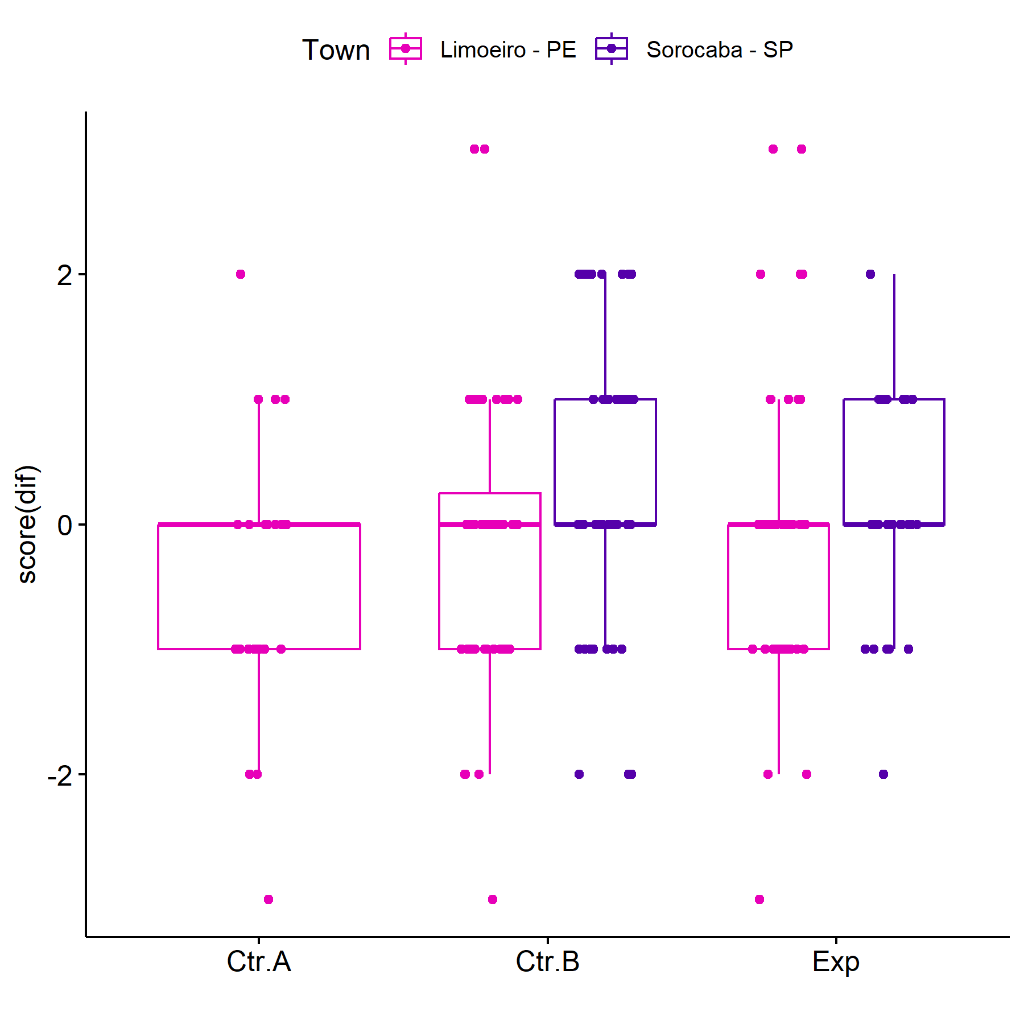

plots$irt.em.norm

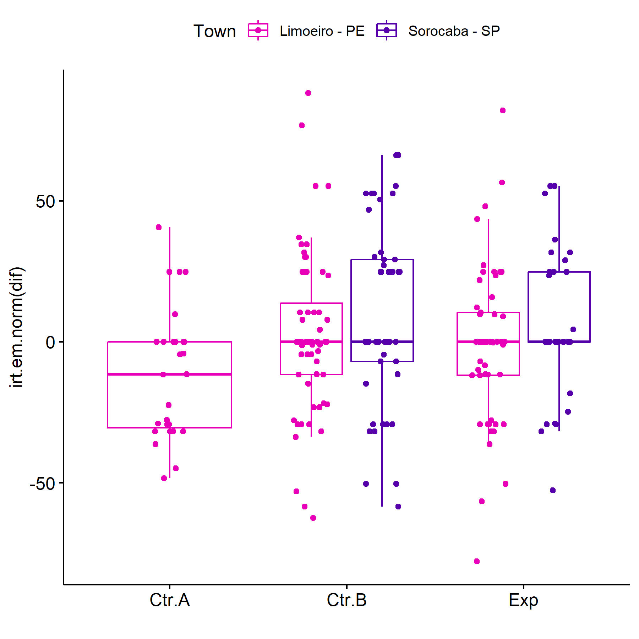

### Subgroup analysis for Group:Quintiles

knitr::kable(df)

|  | var | Effect | Df | Sum Sq | H | p.value | p.value.signif |
| --- | --- | --- | --- | --- | --- | --- | --- |
| score.1 | dif.score | Group | 2 | 15454.66 | 4.217929 | 0.1213636 | ns |
| score.2 | dif.score | qtl.score | 2 | 36053.96 | 9.839952 | 0.0072993 | ** |
| score.3 | dif.score | Group:qtl.score | 4 | 18720.27 | 5.109191 | 0.2762762 | ns |
| score.4 | dif.score | Residuals | 212 | 726995.76 | NA | NA |  |
| irt.em.norm.1 | dif.irt.em.norm | Group | 2 | 15506.48 | 3.871709 | 0.1443009 | ns |
| irt.em.norm.2 | dif.irt.em.norm | qtl.irt.em.norm | 2 | 147496.62 | 36.827430 | 0.0000000 | **** |
| irt.em.norm.3 | dif.irt.em.norm | Group:qtl.irt.em.norm | 4 | 35934.84 | 8.972326 | 0.0617949 | ns |
| irt.em.norm.4 | dif.irt.em.norm | Residuals | 212 | 666367.65 | NA | NA |  |

knitr::kable(df)

| .y. | Group | group1 | group2 | n1 | n2 | estimate | statistic | p.adj | p.adj.signif |
| --- | --- | --- | --- | --- | --- | --- | --- | --- | --- |
| dif.score | NA | Ctr.A | Ctr.B | 1 | 14 | 1.9999479 | 11.5 | 9.42e-01 | ns |
| dif.score | NA | Ctr.A | Exp | 1 | 11 | 1.9999828 | 8.0 | 1.00e+00 | ns |
| dif.score | NA | Ctr.B | Exp | 14 | 11 | 0.0000199 | 78.0 | 1.00e+00 | ns |
| dif.score | NA | Ctr.A | Ctr.B | 2 | 21 | -1.4696804 | 9.0 | 5.82e-01 | ns |
| dif.score | NA | Ctr.A | Exp | 2 | 10 | -0.4856178 | 6.0 | 1.00e+00 | ns |
| dif.score | NA | Ctr.B | Exp | 21 | 10 | 0.9999954 | 133.0 | 6.93e-01 | ns |
| dif.score | NA | Ctr.A | Ctr.B | 24 | 72 | -0.0000240 | 646.5 | 1.53e-01 | ns |
| dif.score | NA | Ctr.A | Exp | 24 | 66 | -0.0000418 | 605.5 | 2.08e-01 | ns |
| dif.score | NA | Ctr.B | Exp | 72 | 66 | 0.0000180 | 2443.0 | 1.00e+00 | ns |
| dif.score | Ctr.A | 1st | 2nd | 1 | 2 | 2.5000000 | 2.0 | 1.00e+00 | ns |
| dif.score | Ctr.A | 1st | 3rd | 1 | 24 | 2.9101519 | 24.0 | 2.81e-01 | ns |
| dif.score | Ctr.A | 2nd | 3rd | 2 | 24 | -0.0000808 | 24.0 | 1.00e+00 | ns |
| dif.score | Ctr.B | 1st | 2nd | 14 | 21 | -0.9999992 | 124.0 | 1.00e+00 | ns |
| dif.score | Ctr.B | 1st | 3rd | 14 | 72 | 0.0000513 | 601.0 | 6.75e-01 | ns |
| dif.score | Ctr.B | 2nd | 3rd | 21 | 72 | 0.9999843 | 1074.5 | 7.00e-03 | ** |
| dif.score | Exp | 1st | 2nd | 11 | 10 | 0.0000157 | 61.0 | 1.00e+00 | ns |
| dif.score | Exp | 1st | 3rd | 11 | 66 | 0.0000185 | 440.5 | 6.90e-01 | ns |
| dif.score | Exp | 2nd | 3rd | 10 | 66 | 0.0000197 | 368.0 | 1.00e+00 | ns |
| dif.irt.em.norm | NA | Ctr.A | Ctr.B | 1 | 14 | 30.1881737 | 11.0 | 1.00e+00 | ns |
| dif.irt.em.norm | NA | Ctr.A | Exp | 1 | 9 | 30.1880735 | 6.0 | 1.00e+00 | ns |
| dif.irt.em.norm | NA | Ctr.B | Exp | 14 | 9 | -0.0000879 | 62.0 | 1.00e+00 | ns |
| dif.irt.em.norm | NA | Ctr.A | Ctr.B | 5 | 33 | -46.1085985 | 18.0 | 1.70e-02 | * |
| dif.irt.em.norm | NA | Ctr.A | Exp | 5 | 21 | -43.2480719 | 9.0 | 1.50e-02 | * |
| dif.irt.em.norm | NA | Ctr.B | Exp | 33 | 21 | 5.3432960 | 383.5 | 1.00e+00 | ns |
| dif.irt.em.norm | NA | Ctr.A | Ctr.B | 21 | 60 | -0.0000612 | 550.5 | 1.00e+00 | ns |
| dif.irt.em.norm | NA | Ctr.A | Exp | 21 | 57 | -0.0000405 | 530.0 | 1.00e+00 | ns |
| dif.irt.em.norm | NA | Ctr.B | Exp | 60 | 57 | 0.0000322 | 1738.5 | 1.00e+00 | ns |
| dif.irt.em.norm | Ctr.A | 1st | 2nd | 1 | 5 | 62.9585469 | 5.0 | 9.99e-01 | ns |
| dif.irt.em.norm | Ctr.A | 1st | 3rd | 1 | 21 | 45.0349633 | 21.0 | 3.30e-01 | ns |
| dif.irt.em.norm | Ctr.A | 2nd | 3rd | 5 | 21 | -14.9999737 | 36.0 | 8.82e-01 | ns |
| dif.irt.em.norm | Ctr.B | 1st | 2nd | 14 | 33 | -13.1162754 | 195.0 | 1.00e+00 | ns |
| dif.irt.em.norm | Ctr.B | 1st | 3rd | 14 | 60 | 11.4515520 | 597.0 | 3.80e-02 | * |
| dif.irt.em.norm | Ctr.B | 2nd | 3rd | 33 | 60 | 30.4457494 | 1567.0 | 9.00e-06 | **** |
| dif.irt.em.norm | Exp | 1st | 2nd | 9 | 21 | -1.8025354 | 88.0 | 1.00e+00 | ns |
| dif.irt.em.norm | Exp | 1st | 3rd | 9 | 57 | 21.8545948 | 350.0 | 2.11e-01 | ns |
| dif.irt.em.norm | Exp | 2nd | 3rd | 21 | 57 | 28.9344429 | 990.0 | 1.91e-05 | **** |

plots$score

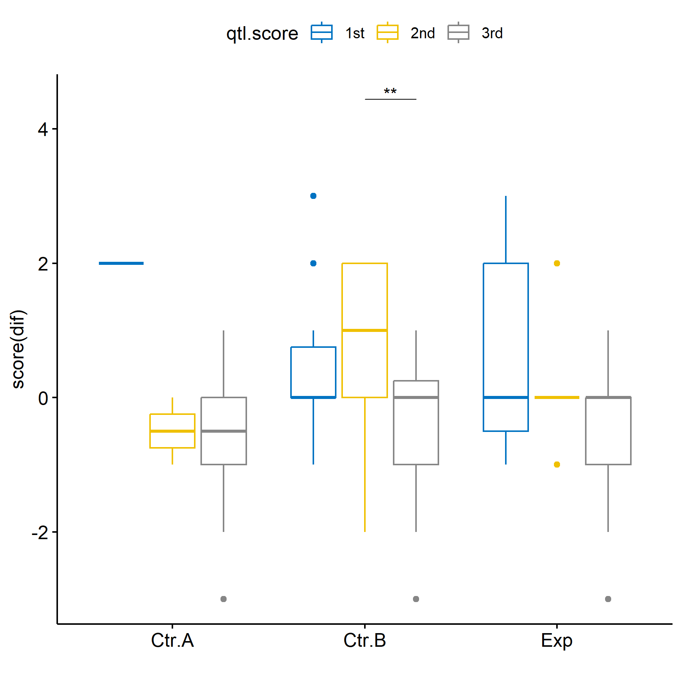

plots$irt.em.norm

