R Notebook for parametric analysis

Geiser C. Challco [geiser@alumni.usp.br](mailto:geiser@alumni.usp.br)

Table of Contents

Install and Load Packages 1

Evaluating H1 (null) 1

Removing outliers and non-normal data 1

Performing paired t-test 2

Plotting results 3

Evaluating H2 (null) 5

Removing outliers and non-normal data 5

Performing paired t-test 6

Plotting results 7

Evaluating H3 (null) 9

Removing outliers and non-normal data 9

Performing ANCOVA test (removing outliers) 10

Evaluating H4 (null) 14

Removing outliers and non-normal data 14

Performing ANCOVA test (removing outliers) 15

Performing ANCOVA test (removing outliers and non.normal data) 19

## Install and Load Packages

## Evaluating H1 (null)

H1 (null): Students who participated in scenarios without our proposed ITS and with training (control group) have the same mean score/ability in both the pre-test and post-test.

### Removing outliers and non-normal data

(non.normals)

## $score  
## [1] "P58" "P70" "P68" "P100" "P61" "P51" "P103" "P106" "P37" "P104"  
## [11] "P73" "P66" "P64" "P43" "P105" "P107" "P63" "P36" "P101" "P60"   
## [21] "P56" "P59" "P49" "P62" "P47" "P65" "P108" "P99" "P46" "P44"   
## [31] "P50" "P52"   
##   
## $irt.cc  
## [1] "P104" "P108" "P105" "P61" "P103" "P51" "P100" "P70" "P58" "P73"   
## [11] "P41" "P76" "P75" "P37" "P66" "P64" "P72" "P63" "P50" "P52"   
##   
## $irt.em.norm  
## character(0)

knitr::kable(df)

| variable | n | skewness | kurtosis | statistic | p | p.signif | normality |
| --- | --- | --- | --- | --- | --- | --- | --- |
| dif.score | 15 | -0.0563554 | -0.8494444 | 0.8825289 | 0.0517603 | ns | YES |
| dif.irt.cc | 27 | -0.2941603 | -0.6753903 | 0.9268838 | 0.0579842 | ns | YES |
| dif.irt.em.norm | 47 | -0.1101428 | -0.8257612 | 0.9524102 | 0.0538484 | ns | YES |

### Performing paired t-test

knitr::kable(df)

| group1 | group2 | n1 | n2 | estimate | statistic | p | p.signif |
| --- | --- | --- | --- | --- | --- | --- | --- |
| pos.score | pre.score | 15 | 15 | 0.4000000 | 1.870829 | 0.04120 | * |
| pos.irt.cc | pre.irt.cc | 27 | 27 | 0.5037488 | 3.390221 | 0.00112 | ** |
| pos.irt.em.norm | pre.irt.em.norm | 47 | 47 | 7.7854371 | 1.633170 | 0.05460 | ns |

knitr::kable(do.call(rbind, df.sum))

| time | n | median | iqr | mad | mean | sd | se | ci |
| --- | --- | --- | --- | --- | --- | --- | --- | --- |
| pre.score | 15 | 3.000 | 0.500 | 0.000 | 3.067 | 0.799 | 0.206 | 0.442 |
| pos.score | 15 | 3.000 | 1.000 | 0.000 | 3.467 | 0.516 | 0.133 | 0.286 |
| pre.irt.cc | 27 | 1.015 | 1.358 | 0.532 | 0.696 | 0.746 | 0.144 | 0.295 |
| pos.irt.cc | 27 | 1.373 | 0.295 | 0.252 | 1.200 | 0.534 | 0.103 | 0.211 |
| pre.irt.em.norm | 47 | 81.630 | 43.179 | 27.235 | 79.371 | 22.997 | 3.354 | 6.752 |
| pos.irt.em.norm | 47 | 100.000 | 31.722 | 0.000 | 87.156 | 19.961 | 2.912 | 5.861 |

### Plotting results

plots$score

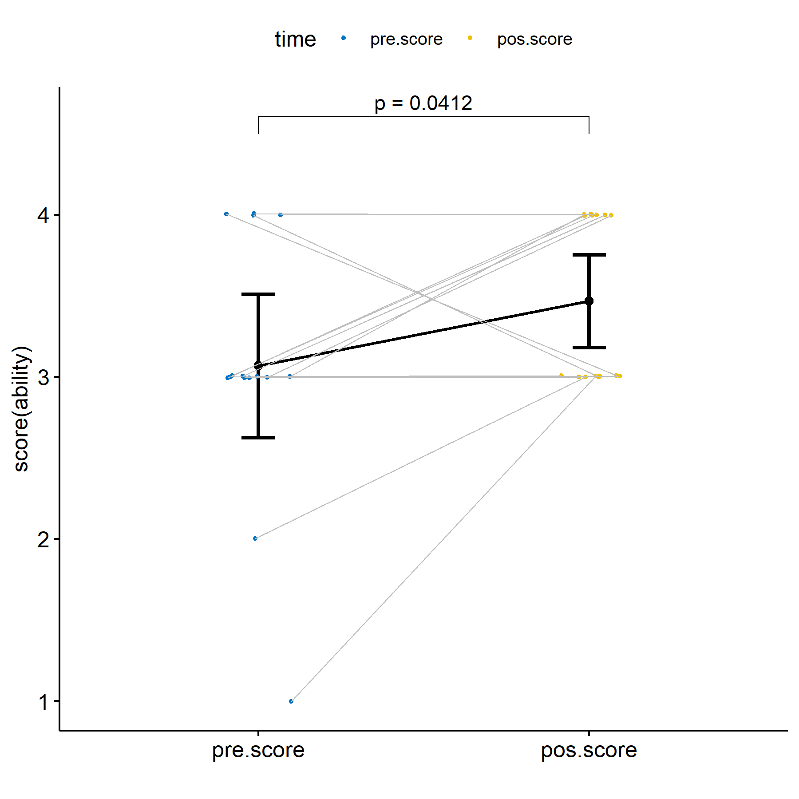

plots$irt.cc

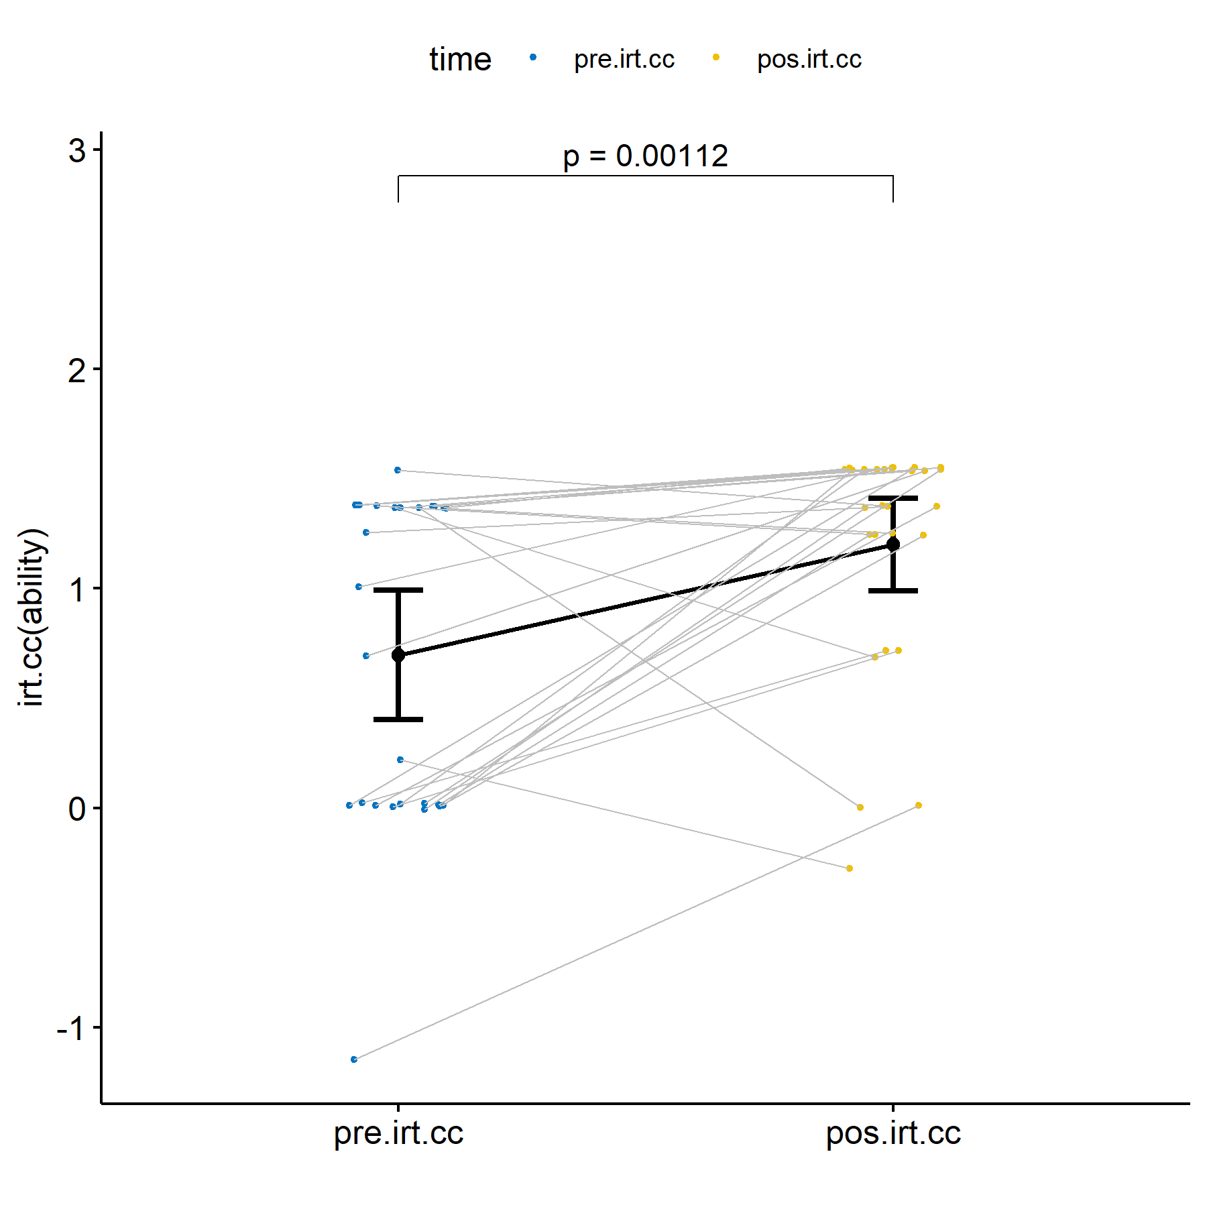

plots$irt.em.norm

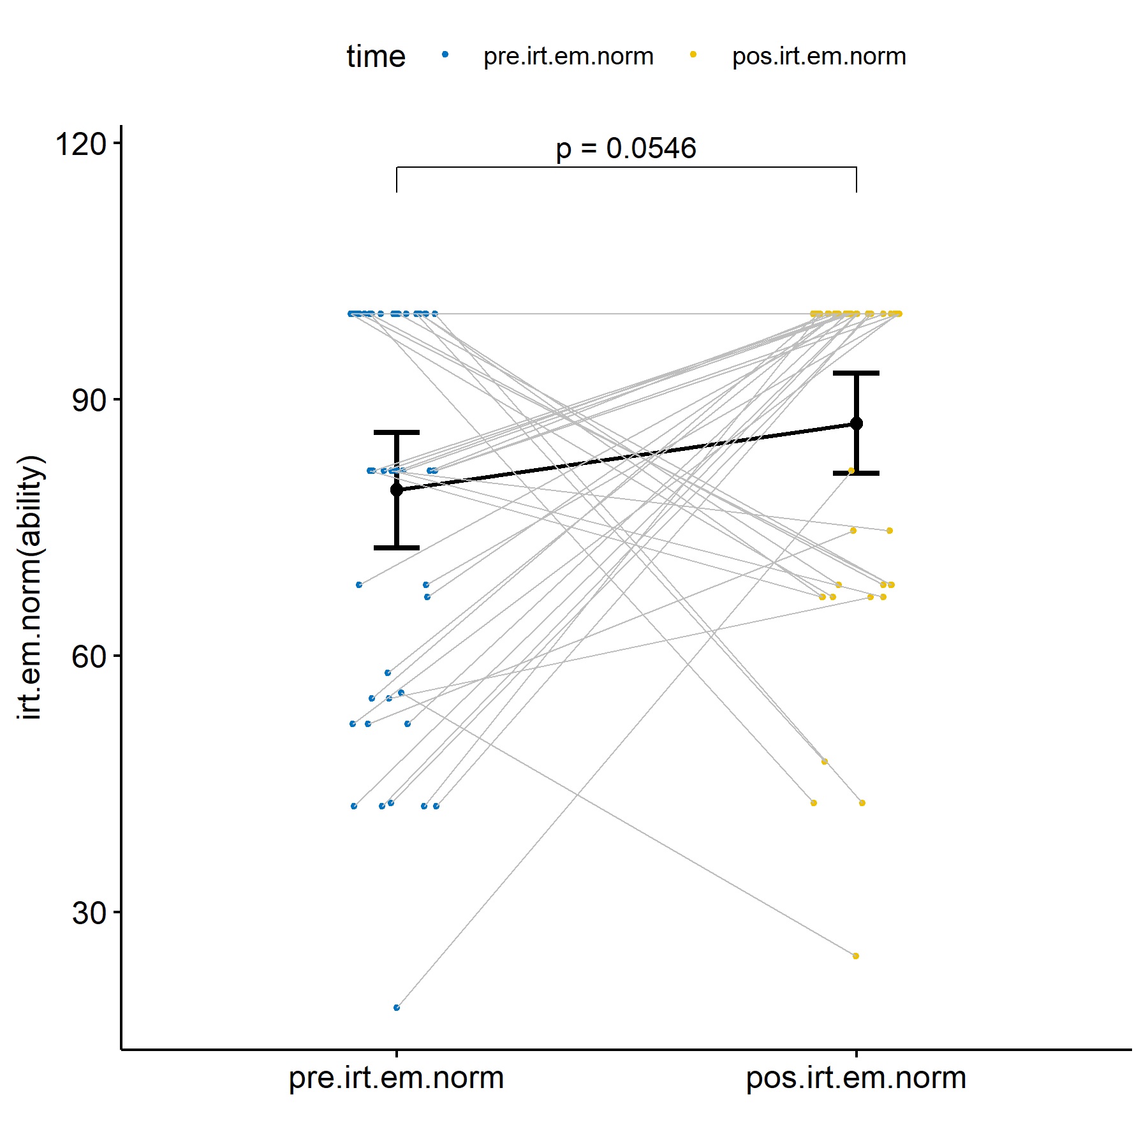

## Evaluating H2 (null)

H2 (null): Students who participated in scenarios with our proposed ITS and with training (experimental group) have the same mean score/ability in both the pre-test and post-test.

### Removing outliers and non-normal data

(non.normals)

## $score  
## [1] "P152" "P148" "P146" "P145" "P141" "P147" "P140" "P144" "P154" "P139"  
## [11] "P130" "P129" "P115" "P149" "P126" "P125" "P143" "P120" "P82"   
##   
## $irt.cc  
## [1] "P88" "P154" "P126" "P117" "P81" "P130" "P83" "P122" "P129" "P152"  
## [11] "P84" "P123" "P85" "P91" "P118" "P139" "P148" "P140" "P82" "P87"   
## [21] "P89" "P92" "P115" "P119" "P143" "P149"  
##   
## $irt.em.norm  
## [1] "P152" "P148" "P88" "P146" "P145" "P141" "P140" "P82" "P87" "P89"   
## [11] "P119" "P144" "P147"

knitr::kable(df)

| variable | n | skewness | kurtosis | statistic | p | p.signif | normality |
| --- | --- | --- | --- | --- | --- | --- | --- |
| dif.score | 15 | -0.0563554 | -0.8494444 | 0.8825289 | 0.0517603 | ns | YES |
| dif.irt.cc | 8 | 0.0429848 | -1.9566035 | 0.8521299 | 0.1001137 | ns | YES |
| dif.irt.em.norm | 21 | 0.1760047 | -0.8934259 | 0.9173522 | 0.0768314 | ns | YES |

### Performing paired t-test

knitr::kable(df)

| group1 | group2 | n1 | n2 | estimate | statistic | p | p.signif |
| --- | --- | --- | --- | --- | --- | --- | --- |
| pos.score | pre.score | 15 | 15 | 0.400000 | 1.8708287 | 0.04120 | * |
| pos.irt.cc | pre.irt.cc | 8 | 8 | -0.025716 | -0.4056732 | 0.65100 | ns |
| pos.irt.em.norm | pre.irt.em.norm | 21 | 21 | 9.735447 | 2.6357826 | 0.00792 | ** |

knitr::kable(do.call(rbind, df.sum))

| time | n | median | iqr | mean | sd | se | ci |
| --- | --- | --- | --- | --- | --- | --- | --- |
| pre.score | 15 | 3.000 | 1.000 | 3.333 | 0.617 | 0.159 | 0.342 |
| pos.score | 15 | 4.000 | 0.500 | 3.733 | 0.458 | 0.118 | 0.253 |
| pre.irt.cc | 8 | 1.373 | 0.043 | 1.244 | 0.508 | 0.180 | 0.425 |
| pos.irt.cc | 8 | 1.373 | 0.330 | 1.219 | 0.511 | 0.181 | 0.427 |
| pre.irt.em.norm | 21 | 81.630 | 32.682 | 83.197 | 18.511 | 4.039 | 8.426 |
| pos.irt.em.norm | 21 | 100.000 | 0.000 | 92.933 | 18.564 | 4.051 | 8.450 |

### Plotting results

plots$score

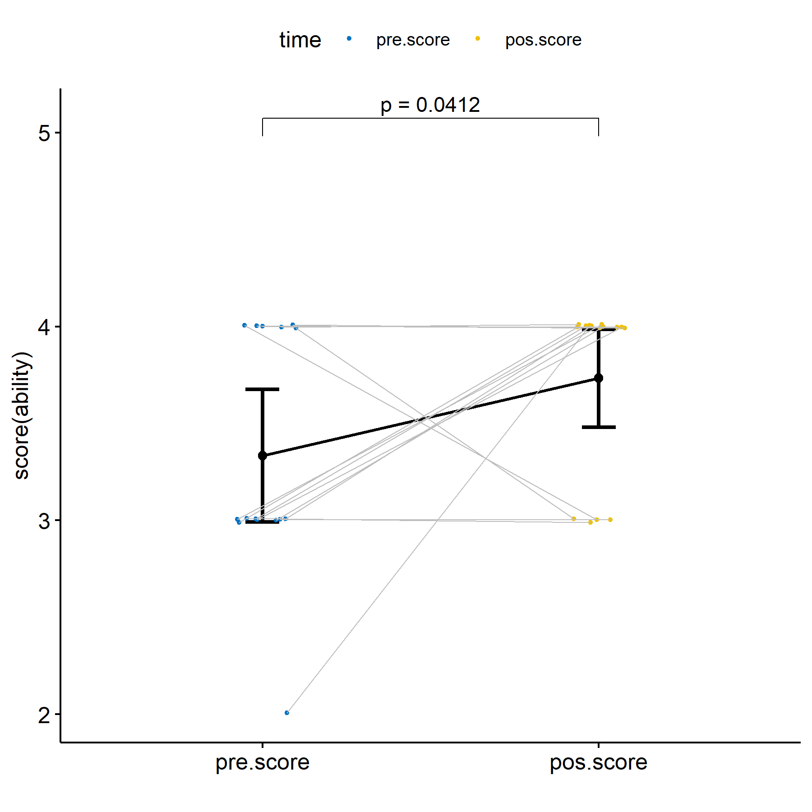

plots$irt.cc

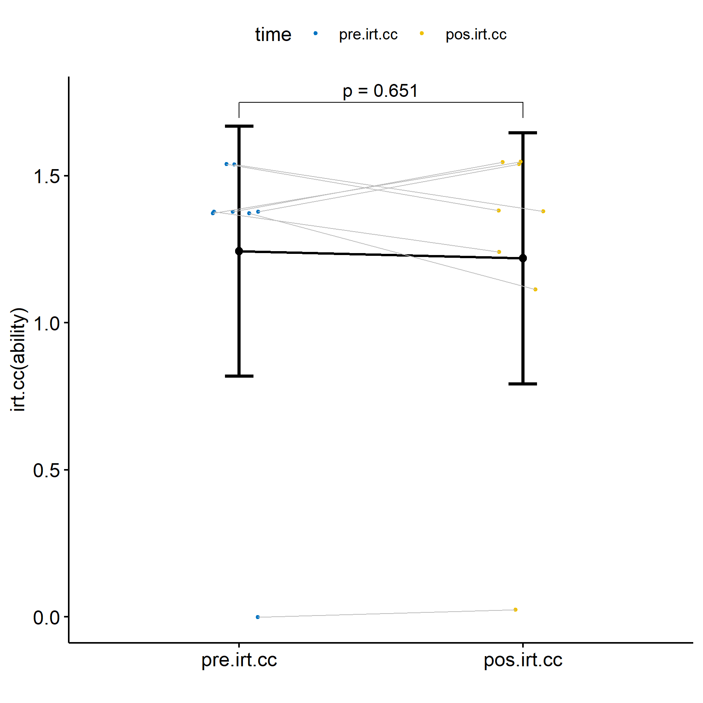

plots$irt.em.norm

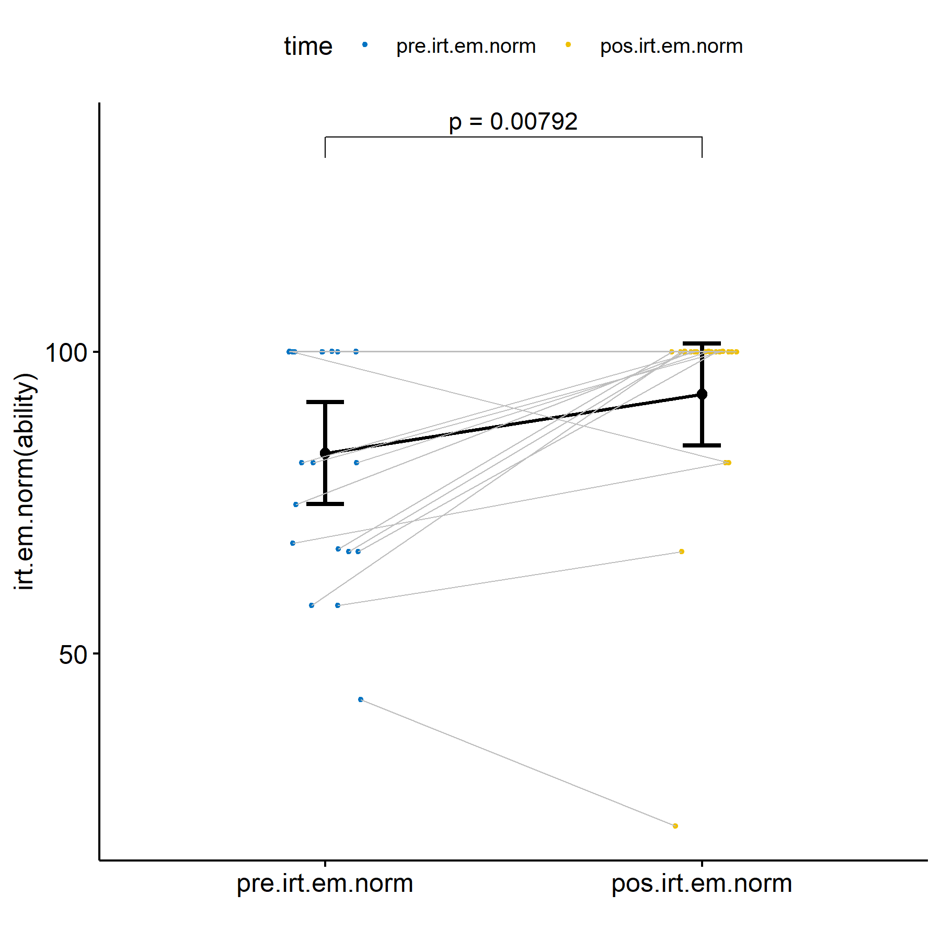

## Evaluating H3 (null)

H3 (null): Students who participated in scenarios with our proposed ITS and with training (experimental group) have the same learning outcomes that students who participated in scenarios without our proposed ITS and with training (control group), controlling the pre-level of knowledge before to participate in the scenarios.

### Removing outliers and non-normal data

(outliers)

## $score  
## [1] "P36"  
##   
## $irt.cc  
## character(0)  
##   
## $irt.em.norm  
## [1] "P36" "P126"

(non.normals)

## $score  
## [1] "P106" "P73" "P66" "P64" "P119" "P88" "P92" "P63" "P60" "P56"   
## [11] "P49" "P117" "P118" "P122" "P47" "P46" "P33" "P32" "P123" "P107"  
## [21] "P143" "P101" "P99" "P76" "P75" "P72" "P149" "P154" "P71" "P69"   
## [31] "P65" "P52" "P83" "P62" "P84" "P59" "P43" "P108" "P50" "P85"   
## [41] "P68" "P105" "P104" "P103" "P100" "P61" "P81" "P51" "P91" "P70"   
## [51] "P58" "P152" "P37" "P31" "P148" "P116" "P146" "P145" "P30" "P45"   
## [61] "P44" "P141" "P41" "P140" "P39" "P139" "P82" "P35" "P67" "P109"  
##   
## $irt.cc  
## [1] "P52" "P50" "P36" "P82" "P116" "P109" "P115" "P61" "P89" "P51"   
## [11] "P37" "P31" "P87" "P126" "P35" "P67" "P44" "P73" "P66" "P83"   
## [21] "P84" "P64" "P85" "P91" "P63" "P60" "P139" "P140" "P141" "P145"  
## [31] "P56" "P49" "P130" "P146" "P129" "P76"   
##   
## $irt.em.norm  
## [1] "P32" "P106" "P73" "P119" "P66" "P64" "P63" "P88" "P60" "P56"   
## [11] "P49" "P154" "P47" "P46" "P33" "P122" "P76" "P75" "P72" "P123"  
## [21] "P71" "P69" "P62" "P43" "P107" "P101" "P99" "P118" "P59" "P65"   
## [31] "P70" "P58" "P104" "P108" "P105" "P103" "P100" "P152" "P148" "P146"  
## [41] "P145" "P141" "P140" "P139" "P130" "P129" "P125" "P120" "P91" "P61"   
## [51] "P52" "P51" "P85" "P37" "P117" "P31" "P92" "P143" "P50" "P149"

**Note**: because there is a high number of data which cause non.normality, then we decided to remove only ouliers.

### Performing ANCOVA test (removing outliers)

knitr::kable(df)

| n | skewness | kurtosis | statistic | p | p.signif | normality |
| --- | --- | --- | --- | --- | --- | --- |
| 80 | -1.393206 | 0.9297886 | 0.7119827 | 0 | **** | NO |
| 81 | -1.524602 | 0.8422450 | 0.7004634 | 0 | **** | NO |
| 79 | -1.175596 | 0.2608410 | 0.8009559 | 0 | **** | NO |

knitr::kable(df)

| Effect | DFn | DFd | F | p | p<.05 | ges | p.signif |
| --- | --- | --- | --- | --- | --- | --- | --- |
| pre.score | 1 | 77 | 0.807 | 0.372 |  | 0.010 | ns |
| Group | 1 | 77 | 0.455 | 0.502 |  | 0.006 | ns |
| pre.irt.cc | 1 | 78 | 0.519 | 0.474 |  | 0.007 | ns |
| Group | 1 | 78 | 0.507 | 0.479 |  | 0.006 | ns |
| pre.irt.em.norm | 1 | 76 | 3.748 | 0.057 |  | 0.047 | ns |
| Group | 1 | 76 | 1.793 | 0.185 |  | 0.023 | ns |

knitr::kable(df)

| .y. | group1 | group2 | estimate | statistic | p | p.adj | p.adj.signif |
| --- | --- | --- | --- | --- | --- | --- | --- |
| pos.score | with.ITS | without | 0.0943108 | 0.6746587 | 0.5019133 | 0.5019133 | ns |
| pos.irt.cc | with.ITS | without | 0.1023266 | 0.7120295 | 0.4785708 | 0.4785708 | ns |
| pos.irt.em.norm | with.ITS | without | 5.1261329 | 1.3390652 | 0.1845408 | 0.1845408 | ns |

knitr::kable(df)

| Group | emmean | se | df | pre.score | pre.irt.cc | pre.irt.em.norm |
| --- | --- | --- | --- | --- | --- | --- |
| with.ITS | 3.691729 | 0.1049908 | 77 | 3.375 | NA | NA |
| without | 3.597418 | 0.0899548 | 77 | 3.375 | NA | NA |
| with.ITS | 1.222869 | 0.1077074 | 78 | NA | 0.8163246 | NA |
| without | 1.120542 | 0.0910287 | 78 | NA | 0.8163246 | NA |
| with.ITS | 93.044933 | 2.8987338 | 76 | NA | NA | 83.28914 |
| without | 87.918800 | 2.4476782 | 76 | NA | NA | 83.28914 |

#### Plotting results

plots$score

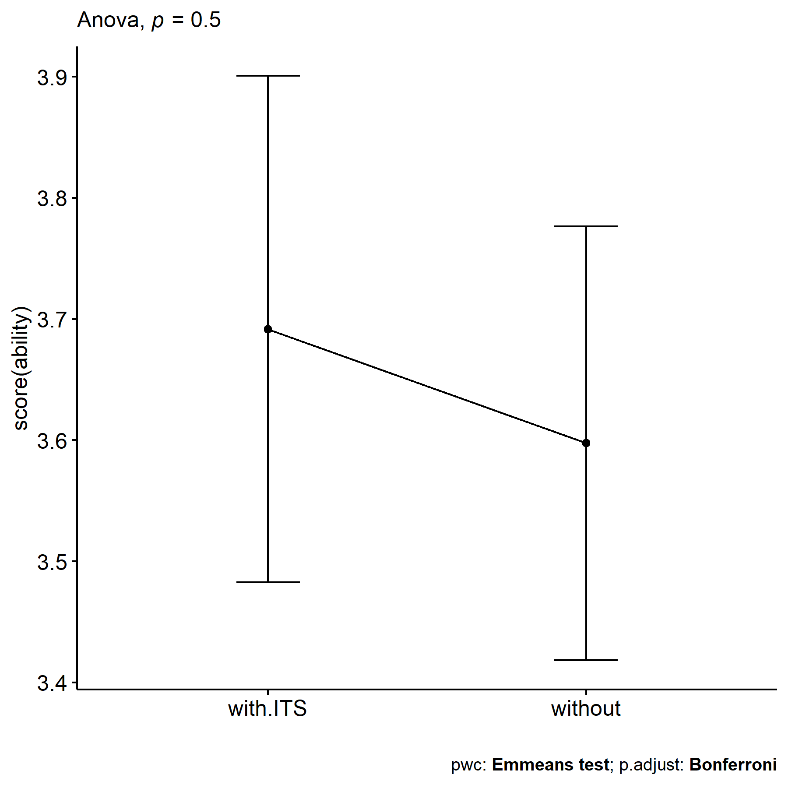

plots$irt.cc

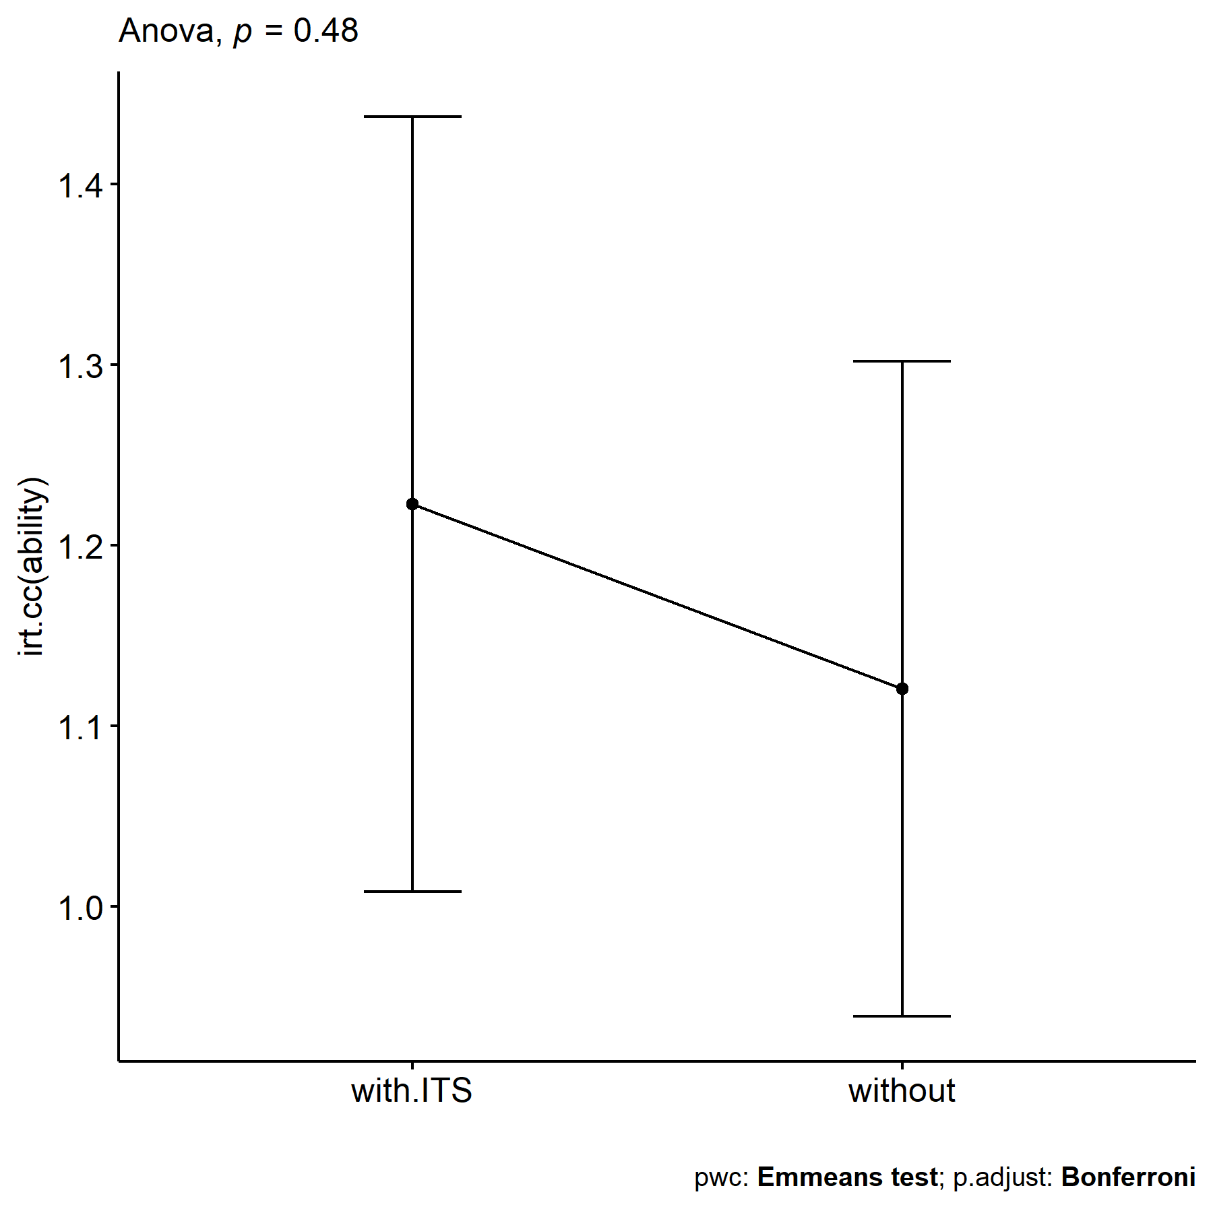

plots$irt.em.norm

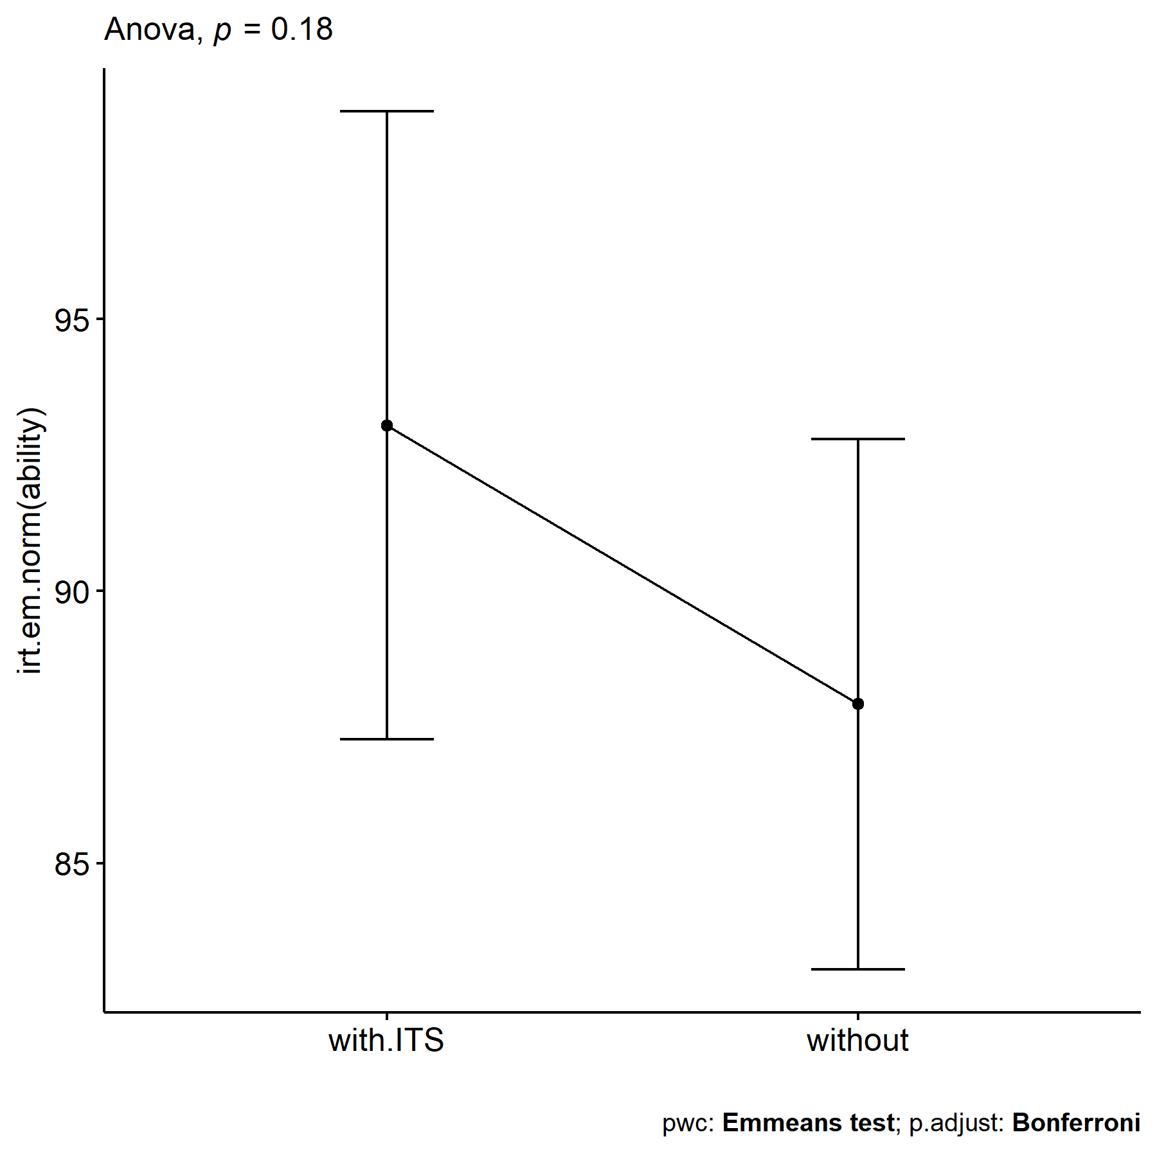

## Evaluating H4 (null)

H4 (null): Students who are not in the 10-th percentile during pre-test and who participated in scenarios with our proposed ITS and with training (experimental group) have the same learning outcomes that students who participated in scenarios without our proposed ITS and with training (control group), controlling their previous knowledge in the subject.

### Removing outliers and non-normal data

(outliers)

## $score  
## [1] "P36"  
##   
## $irt.cc  
## [1] "P36"  
##   
## $irt.em.norm  
## [1] "P36" "P126"

(non.normals)

## $score  
## [1] "P126" "P35" "P45" "P41" "P39" "P116" "P81" "P67" "P109" "P43"   
## [11] "P119" "P154"  
##   
## $irt.cc  
## [1] "P116" "P109" "P149" "P67" "P126" "P143" "P35" "P119" "P70" "P92"   
## [11] "P58" "P76" "P75" "P72" "P71"   
##   
## $irt.em.norm  
## [1] "P45" "P39" "P81" "P41" "P35" "P67" "P116"

**Note**: because there is a lower number of data which cause non.normality, then we decided to remove only ouliers.

### Performing ANCOVA test (removing outliers)

knitr::kable(df)

|  | n | skewness | kurtosis | statistic | p | p.signif | normality |
| --- | --- | --- | --- | --- | --- | --- | --- |
| score | 80 | -1.393206 | 0.9297886 | 0.7119827 | 0 | **** | NO |
| irt.cc | 80 | -1.592823 | 1.1237969 | 0.6992905 | 0 | **** | NO |
| irt.em.norm | 79 | -1.175596 | 0.2608410 | 0.8009559 | 0 | **** | NO |

knitr::kable(df)

|  | Effect | DFn | DFd | F | p | p<.05 | ges | p.signif |
| --- | --- | --- | --- | --- | --- | --- | --- | --- |
| score.1 | pre.score | 1 | 77 | 0.807 | 0.372 |  | 0.010 | ns |
| score.2 | Group | 1 | 77 | 0.455 | 0.502 |  | 0.006 | ns |
| irt.cc.1 | pre.irt.cc | 1 | 77 | 0.837 | 0.363 |  | 0.011 | ns |
| irt.cc.2 | Group | 1 | 77 | 0.308 | 0.581 |  | 0.004 | ns |
| irt.em.norm.1 | pre.irt.em.norm | 1 | 76 | 3.748 | 0.057 |  | 0.047 | ns |
| irt.em.norm.2 | Group | 1 | 76 | 1.793 | 0.185 |  | 0.023 | ns |

knitr::kable(df)

| .y. | group1 | group2 | estimate | statistic | p | p.adj | p.adj.signif |
| --- | --- | --- | --- | --- | --- | --- | --- |
| pos.score | with.ITS | without | 0.0943108 | 0.6746587 | 0.5019133 | 0.5019133 | ns |
| pos.irt.cc | with.ITS | without | 0.0774779 | 0.5548559 | 0.5806015 | 0.5806015 | ns |
| pos.irt.em.norm | with.ITS | without | 5.1261329 | 1.3390652 | 0.1845408 | 0.1845408 | ns |

knitr::kable(df)

| Group | emmean | se | df | pre.score | pre.irt.cc | pre.irt.em.norm |
| --- | --- | --- | --- | --- | --- | --- |
| with.ITS | 3.691729 | 0.1049908 | 77 | 3.375 | NA | NA |
| without | 3.597418 | 0.0899548 | 77 | 3.375 | NA | NA |
| with.ITS | 1.226091 | 0.1042388 | 77 | NA | 0.8237693 | NA |
| without | 1.148613 | 0.0891122 | 77 | NA | 0.8237693 | NA |
| with.ITS | 93.044933 | 2.8987338 | 76 | NA | NA | 83.28914 |
| without | 87.918800 | 2.4476782 | 76 | NA | NA | 83.28914 |

#### Plotting results

plots$score



plots$irt.cc

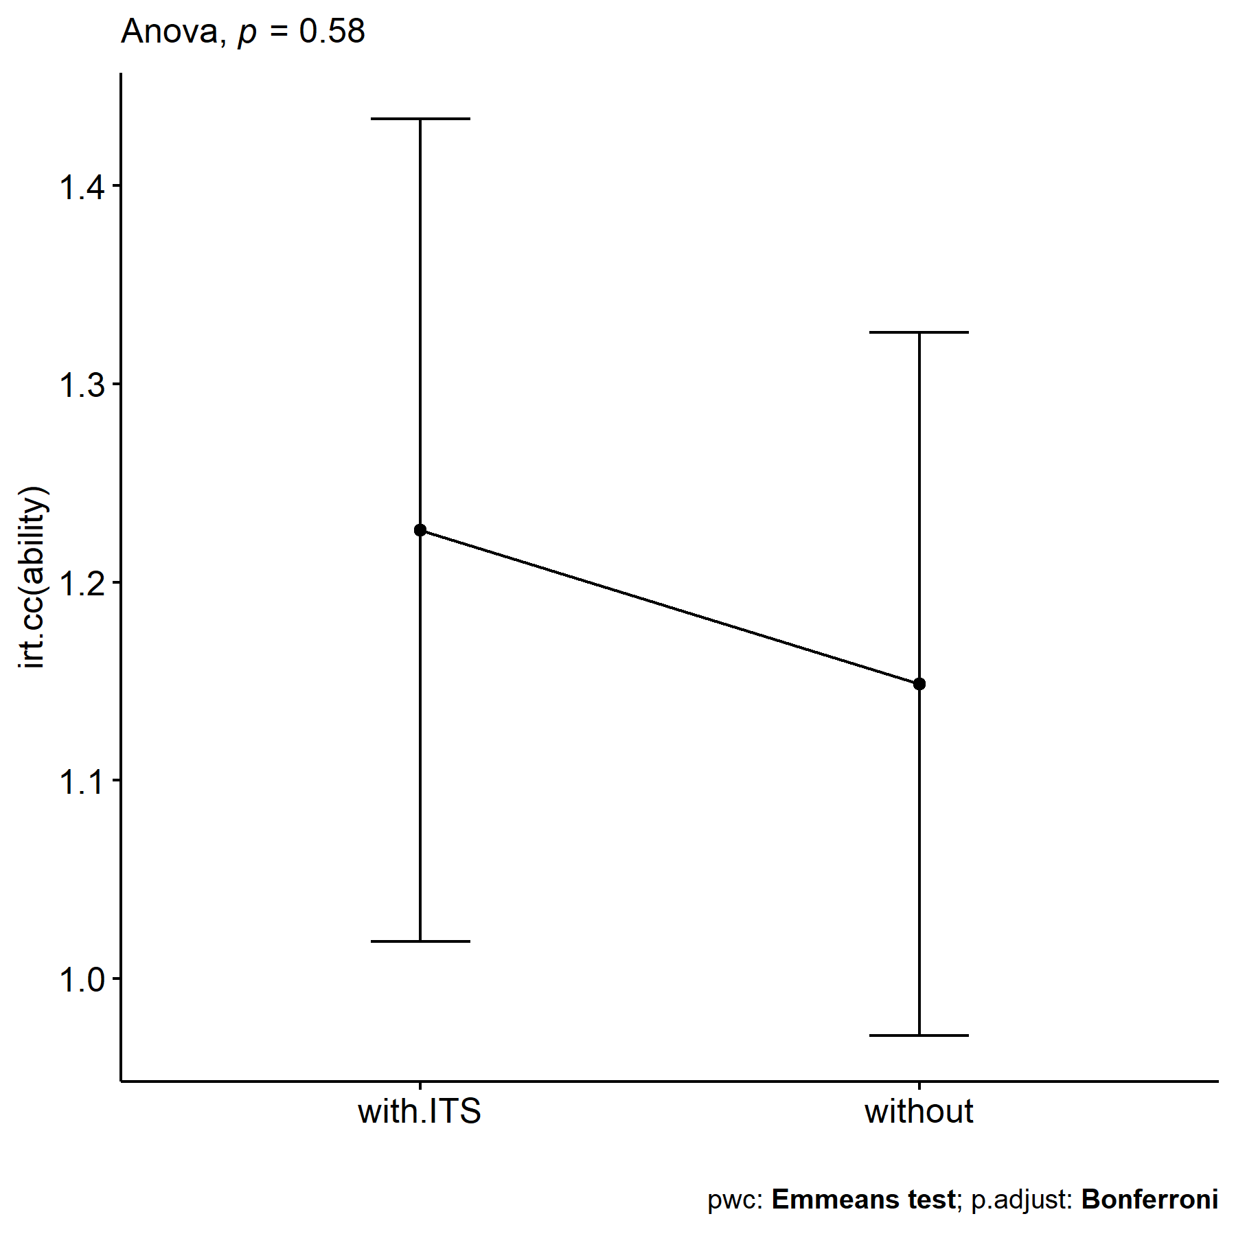

plots$irt.em.norm



### Performing ANCOVA test (removing outliers and non.normal data)

knitr::kable(df)

|  | n | skewness | kurtosis | symmetry | statistic | p | p.signif | normality |
| --- | --- | --- | --- | --- | --- | --- | --- | --- |
| score | 26 | 3.7092151 | 14.742674 | NO | 0.4147273 | 0.0000000 | **** | NO |
| irt.cc | 23 | 0.1209206 | -1.208835 | YES | 0.8374302 | 0.0016235 | ** | NO |
| irt.em.norm | 30 | -3.3633350 | 13.597191 | NO | 0.5908383 | 0.0000001 | **** | NO |

**Note**: Not posible to remove non.normal data