Non-Parametric ANCOVA tests for for assess H4(null) hypothesis

Geiser C. Challco [geiser@alumni.usp.br](mailto:geiser@alumni.usp.br)

Table of Contents

# Setting Initial Variables

dv = "irt.em.norm"  
dv.pos = "pos.irt.em.norm"  
dv.pre = "pre.irt.em.norm"  
dv.dif = "dif.irt.em.norm"  
  
fatores2 <- c("Gender","Town","Degree","qtl.irt.em.norm")  
lfatores2 <- as.list(fatores2)  
names(lfatores2) <- fatores2  
  
fatores1 <- c("Group", fatores2)  
lfatores1 <- as.list(fatores1)  
names(lfatores1) <- fatores1  
  
lfatores <- c(lfatores1)  
  
color <- list()  
color[["prepost"]] = c("#ffee65","#f28e2B")  
color[["Group"]] = c("#bcbd22","#fd7f6f","#008000")  
color[["Gender"]] = c("#FF007F","#4D4DFF")  
color[["Town"]] = c("#AA00CC","#00AA99")  
color[["Degree"]] = c("#d21820","#f36dff","#aa8882")  
  
  
level <- list()  
level[["Group"]] = c("Ctr.A","Ctr.B","Exp")  
level[["Gender"]] = c("Female","Male")  
level[["Town"]] = c("Sorocaba - SP","Limoeiro - PE")  
level[["Degree"]] = c("3a","4a","5a")  
level[["qtl.irt.em.norm"]] = c("1st","2nd","3rd")  
level[["qtl.score"]] = c("1st","2nd","3rd")  
  
# ..  
  
color[["Group:Gender"]] = c(  
 "Ctr.A:Female"="#ffccbb", "Ctr.B:Female"="#ff99cc", "Exp:Female"="#FF007F",  
 "Ctr.A:Male"="#aabbff", "Ctr.B:Male"="#bbaaff", "Exp:Male"="#4D4DFF",  
 "Ctr.A.Female"="#ffccbb", "Ctr.B.Female"="#ff99cc", "Exp.Female"="#FF007F",  
 "Ctr.A.Male"="#aabbff", "Ctr.B.Male"="#bbaaff", "Exp.Male"="#4D4DFF"  
)  
color[["Group:Town"]] = c(  
 "Ctr.A:Sorocaba - SP"="#AA00FF", "Ctr.B:Sorocaba - SP"="#FF00FF", "Exp:Sorocaba - SP"="#AA00FF",  
 "Ctr.A:Limoeiro - PE"="#00EEFF", "Ctr.B:Limoeiro - PE"="#00EECC", "Exp:Limoeiro - PE"="#00CFCF",  
 "Ctr.A.Sorocaba - SP"="#AA00FF", "Ctr.B.Sorocaba - SP"="#FF00FF", "Exp.Sorocaba - SP"="#AA00FF",  
 "Ctr.A.Limoeiro - PE"="#00EEFF", "Ctr.B.Limoeiro - PE"="#00EECC", "Exp.Limoeiro - PE"="#00CFCF"  
)  
  
  
for (coln in c("vocab")) {  
 color[[paste0(coln,".quintile")]] = c("#BF0040","#FF0000","#800080","#0000FF","#4000BF")  
 level[[paste0(coln,".quintile")]] = c("1st quintile","2nd quintile","3rd quintile","4th quintile","5th quintile")  
 color[[paste0("grupo:",coln,".quintile")]] = c(  
 "Experimental.1st quintile"="#BF0040", "Controle.1st quintile"="#d8668c",  
 "Experimental.2nd quintile"="#FF0000", "Controle.2nd quintile"="#ff7f7f",  
 "Experimental.3rd quintile"="#8fce00", "Controle.3rd quintile"="#ddf0b2",  
 "Experimental.4th quintile"="#0000FF", "Controle.4th quintile"="#b2b2ff",  
 "Experimental.5th quintile"="#4000BF", "Controle.5th quintile"="#b299e5",  
   
 "Experimental:1st quintile"="#BF0040", "Controle:1st quintile"="#d8668c",  
 "Experimental:2nd quintile"="#FF0000", "Controle:2nd quintile"="#ff7f7f",  
 "Experimental:3rd quintile"="#8fce00", "Controle:3rd quintile"="#ddf0b2",  
 "Experimental:4th quintile"="#0000FF", "Controle:4th quintile"="#b2b2ff",  
 "Experimental:5th quintile"="#4000BF", "Controle:5th quintile"="#b299e5")  
}  
  
  
gdat <- read_excel("../data/data.xlsx", sheet = "data")  
gdat <- gdat[!is.na(gdat[[dv.pre]]) & !is.na(gdat[[dv.pos]]),]  
  
  
  
dat <- gdat  
dat$Group <- factor(dat[["Group"]], level[["Group"]])  
for (coln in c(names(lfatores))) {  
 if (length(level[[coln]]) > 0)  
 plevel = level[[coln]][level[[coln]] %in% unique(dat[[coln]])]  
 else  
 plevel = unique(dat[[coln]])[!is.na(unique(dat[[coln]]))]  
   
 dat[[coln]] <- factor(dat[[coln]], plevel)  
}  
  
dat <- dat[,c("ID", names(lfatores), dv.pre, dv.pos, dv.dif)]  
  
dat.long <- rbind(dat, dat)  
dat.long$time <- c(rep("pre", nrow(dat)), rep("pos", nrow(dat)))  
dat.long$time <- factor(dat.long$time, c("pre","pos"))  
dat.long[[dv]] <- c(dat[[dv.pre]], dat[[dv.pos]])  
  
  
for (f in c("Group", names(lfatores))) {  
 if (is.null(color[[f]]) && length(unique(dat[[f]])) > 0)   
 color[[f]] <- distinctColorPalette(length(unique(dat[[f]])))  
}  
  
for (f in c(fatores2)) {  
 if (is.null(color[[paste0("Group:",f)]]) && length(unique(dat[[f]])) > 0)  
 color[[paste0("Group:",f)]] <- distinctColorPalette(  
 length(unique(dat[["Group"]]))*length(unique(dat[[f]])))  
}  
  
ldat <- list()  
laov <- list()  
lpwc <- list()  
lemms <- list()

# Descriptive Statistics of Initial Data

df <- get.descriptives(dat, c(dv.pre, dv.pos, dv.dif), c("Group"),  
 symmetry.test = T, normality.test = F)  
df <- plyr::rbind.fill(  
 df, do.call(plyr::rbind.fill, lapply(lfatores2, FUN = function(f) {  
 if (nrow(dat) > 0 && sum(!is.na(unique(dat[[f]]))) > 1)  
 get.descriptives(dat, c(dv.pre,dv.pos), c("Group", f), include.global = F,  
 symmetry.test = T, normality.test = F)  
 }))  
)

## Warning: There was 1 warning in `mutate()`.  
## ℹ In argument: `ci = abs(stats::qt(alpha/2, .data$n - 1) * .data$se)`.  
## Caused by warning:  
## ! There was 1 warning in `mutate()`.  
## ℹ In argument: `ci = abs(stats::qt(alpha/2, .data$n - 1) * .data$se)`.  
## Caused by warning in `stats::qt()`:  
## ! NaNs produced  
## There was 1 warning in `mutate()`.  
## ℹ In argument: `ci = abs(stats::qt(alpha/2, .data$n - 1) * .data$se)`.  
## Caused by warning:  
## ! There was 1 warning in `mutate()`.  
## ℹ In argument: `ci = abs(stats::qt(alpha/2, .data$n - 1) * .data$se)`.  
## Caused by warning in `stats::qt()`:  
## ! NaNs produced

df <- df[,c("variable",fatores1[fatores1 %in% colnames(df)],  
 colnames(df)[!colnames(df) %in% c(fatores1,"variable")])]

| variable | Group | Gender | Town | Degree | qtl.irt.em.norm | n | mean | median | min | max | sd | se | ci | iqr | symmetry | skewness | kurtosis |
| --- | --- | --- | --- | --- | --- | --- | --- | --- | --- | --- | --- | --- | --- | --- | --- | --- | --- |
| pre.irt.em.norm | Ctr.A |  |  |  |  | 27 | 79.820 | 75.243 | 23.198 | 100.000 | 24.345 | 4.685 | 9.630 | 24.757 | NO | -0.9163297 | -0.4230660 |
| pre.irt.em.norm | Ctr.B |  |  |  |  | 107 | 67.001 | 75.243 | 0.000 | 100.000 | 31.006 | 2.997 | 5.943 | 64.576 | YES | -0.4264144 | -1.1733724 |
| pre.irt.em.norm | Exp |  |  |  |  | 87 | 75.968 | 100.000 | 11.805 | 100.000 | 29.909 | 3.207 | 6.375 | 41.985 | NO | -0.8941781 | -0.5904994 |
| pos.irt.em.norm | Ctr.A |  |  |  |  | 27 | 68.692 | 70.801 | 0.000 | 100.000 | 28.823 | 5.547 | 11.402 | 44.318 | NO | -0.5800729 | -0.5871072 |
| pos.irt.em.norm | Ctr.B |  |  |  |  | 107 | 72.305 | 70.801 | 0.000 | 100.000 | 31.462 | 3.042 | 6.030 | 50.390 | NO | -0.8021967 | -0.5672608 |
| pos.irt.em.norm | Exp |  |  |  |  | 87 | 76.809 | 100.000 | 0.000 | 100.000 | 28.708 | 3.078 | 6.118 | 33.945 | NO | -0.9894760 | -0.0644938 |
| dif.irt.em.norm | Ctr.A |  |  |  |  | 27 | -11.129 | -11.452 | -48.335 | 40.593 | 23.220 | 4.469 | 9.186 | 30.440 | YES | 0.3887749 | -0.8171220 |
| dif.irt.em.norm | Ctr.B |  |  |  |  | 107 | 5.304 | 0.000 | -62.411 | 88.195 | 30.086 | 2.909 | 5.766 | 36.209 | YES | 0.2028154 | -0.0227014 |
| dif.irt.em.norm | Exp |  |  |  |  | 87 | 0.841 | 0.000 | -77.790 | 81.972 | 27.233 | 2.920 | 5.804 | 30.530 | YES | 0.1153149 | 0.5893188 |
| pre.irt.em.norm | Ctr.A | Female |  |  |  | 16 | 78.327 | 75.243 | 23.198 | 100.000 | 25.157 | 6.289 | 13.405 | 24.757 | NO | -0.8737072 | -0.5057954 |
| pre.irt.em.norm | Ctr.A | Male |  |  |  | 11 | 81.993 | 100.000 | 33.776 | 100.000 | 24.142 | 7.279 | 16.219 | 25.947 | NO | -0.8392723 | -0.8694852 |
| pre.irt.em.norm | Ctr.B | Female |  |  |  | 61 | 68.435 | 75.243 | 0.000 | 100.000 | 31.873 | 4.081 | 8.163 | 62.927 | YES | -0.4937090 | -1.2058790 |
| pre.irt.em.norm | Ctr.B | Male |  |  |  | 44 | 65.258 | 75.243 | 0.000 | 100.000 | 29.604 | 4.463 | 9.000 | 66.224 | YES | -0.3521042 | -1.1009559 |
| pre.irt.em.norm | Ctr.B |  |  |  |  | 2 | 61.599 | 61.599 | 23.198 | 100.000 | 54.307 | 38.401 | 487.930 | 38.401 | few data | 0.0000000 | 0.0000000 |
| pre.irt.em.norm | Exp | Female |  |  |  | 48 | 81.634 | 100.000 | 11.805 | 100.000 | 27.760 | 4.007 | 8.061 | 25.801 | NO | -1.1966678 | -0.0306234 |
| pre.irt.em.norm | Exp | Male |  |  |  | 35 | 72.462 | 75.243 | 11.805 | 100.000 | 30.226 | 5.109 | 10.383 | 41.985 | NO | -0.7598312 | -0.6708181 |
| pre.irt.em.norm | Exp |  |  |  |  | 4 | 38.650 | 33.776 | 11.805 | 75.243 | 26.503 | 13.251 | 42.172 | 15.860 | few data | 0.0000000 | 0.0000000 |
| pos.irt.em.norm | Ctr.A | Female |  |  |  | 16 | 69.404 | 69.560 | 0.000 | 100.000 | 28.641 | 7.160 | 15.262 | 36.209 | NO | -0.8170235 | 0.0439962 |
| pos.irt.em.norm | Ctr.A | Male |  |  |  | 11 | 67.656 | 70.801 | 22.432 | 100.000 | 30.456 | 9.183 | 20.460 | 56.467 | YES | -0.2103297 | -1.6583238 |
| pos.irt.em.norm | Ctr.B | Female |  |  |  | 61 | 68.719 | 70.801 | 0.000 | 100.000 | 33.205 | 4.252 | 8.504 | 58.460 | NO | -0.6074327 | -1.0280483 |
| pos.irt.em.norm | Ctr.B | Male |  |  |  | 44 | 78.290 | 100.000 | 0.000 | 100.000 | 26.595 | 4.009 | 8.086 | 36.209 | NO | -0.9675592 | 0.1300550 |
| pos.irt.em.norm | Ctr.B |  |  |  |  | 2 | 50.000 | 50.000 | 0.000 | 100.000 | 70.711 | 50.000 | 635.310 | 50.000 | few data | 0.0000000 | 0.0000000 |
| pos.irt.em.norm | Exp | Female |  |  |  | 48 | 77.994 | 73.154 | 22.210 | 100.000 | 23.388 | 3.376 | 6.791 | 31.682 | NO | -0.5868276 | -0.8253412 |
| pos.irt.em.norm | Exp | Male |  |  |  | 35 | 79.735 | 100.000 | 0.000 | 100.000 | 31.121 | 5.260 | 10.691 | 30.440 | NO | -1.2808741 | 0.3794228 |
| pos.irt.em.norm | Exp |  |  |  |  | 4 | 36.989 | 22.210 | 3.538 | 100.000 | 42.919 | 21.460 | 68.294 | 24.115 | few data | 0.0000000 | 0.0000000 |
| pre.irt.em.norm | Ctr.A |  | Limoeiro - PE |  |  | 27 | 79.820 | 75.243 | 23.198 | 100.000 | 24.345 | 4.685 | 9.630 | 24.757 | NO | -0.9163297 | -0.4230660 |
| pre.irt.em.norm | Ctr.B |  | Sorocaba - SP |  |  | 47 | 77.846 | 75.243 | 28.443 | 100.000 | 23.843 | 3.478 | 7.001 | 30.440 | NO | -0.6133257 | -0.9990874 |
| pre.irt.em.norm | Ctr.B |  | Limoeiro - PE |  |  | 60 | 58.505 | 64.368 | 0.000 | 100.000 | 33.420 | 4.314 | 8.633 | 66.224 | YES | -0.0731669 | -1.4811890 |
| pre.irt.em.norm | Exp |  | Sorocaba - SP |  |  | 34 | 85.210 | 100.000 | 44.797 | 100.000 | 20.666 | 3.544 | 7.211 | 29.133 | NO | -0.8889809 | -0.8073689 |
| pre.irt.em.norm | Exp |  | Limoeiro - PE |  |  | 53 | 70.040 | 75.243 | 11.805 | 100.000 | 33.418 | 4.590 | 9.211 | 66.224 | NO | -0.6007832 | -1.2442855 |
| pos.irt.em.norm | Ctr.A |  | Limoeiro - PE |  |  | 27 | 68.692 | 70.801 | 0.000 | 100.000 | 28.823 | 5.547 | 11.402 | 44.318 | NO | -0.5800729 | -0.5871072 |
| pos.irt.em.norm | Ctr.B |  | Sorocaba - SP |  |  | 47 | 87.034 | 100.000 | 22.210 | 100.000 | 19.951 | 2.910 | 5.858 | 29.199 | NO | -1.2872746 | 0.7918853 |
| pos.irt.em.norm | Ctr.B |  | Limoeiro - PE |  |  | 60 | 60.767 | 68.318 | 0.000 | 100.000 | 34.057 | 4.397 | 8.798 | 77.790 | YES | -0.2916065 | -1.2474711 |
| pos.irt.em.norm | Exp |  | Sorocaba - SP |  |  | 34 | 90.477 | 100.000 | 29.058 | 100.000 | 17.834 | 3.059 | 6.223 | 18.568 | NO | -1.7714176 | 2.5018433 |
| pos.irt.em.norm | Exp |  | Limoeiro - PE |  |  | 53 | 68.041 | 70.801 | 0.000 | 100.000 | 30.994 | 4.257 | 8.543 | 52.640 | NO | -0.5465605 | -0.8193517 |
| pre.irt.em.norm | Ctr.A |  |  | 3a |  | 8 | 93.811 | 100.000 | 75.243 | 100.000 | 11.460 | 4.052 | 9.581 | 6.189 | few data | 0.0000000 | 0.0000000 |
| pre.irt.em.norm | Ctr.A |  |  | 4a |  | 6 | 58.710 | 60.020 | 23.198 | 100.000 | 29.421 | 12.011 | 30.875 | 38.712 | YES | 0.1077257 | -1.8720932 |
| pre.irt.em.norm | Ctr.A |  |  | 5a |  | 13 | 80.955 | 75.243 | 33.776 | 100.000 | 22.184 | 6.153 | 13.406 | 24.757 | NO | -0.7898945 | -0.6301285 |
| pre.irt.em.norm | Ctr.B |  |  | 3a |  | 31 | 43.905 | 33.776 | 0.000 | 100.000 | 30.045 | 5.396 | 11.021 | 57.741 | YES | 0.2218743 | -1.4465895 |
| pre.irt.em.norm | Ctr.B |  |  | 4a |  | 39 | 75.369 | 75.243 | 23.198 | 100.000 | 27.153 | 4.348 | 8.802 | 55.203 | NO | -0.5417854 | -1.3233269 |
| pre.irt.em.norm | Ctr.B |  |  | 5a |  | 37 | 77.531 | 75.243 | 23.198 | 100.000 | 25.516 | 4.195 | 8.507 | 50.390 | NO | -0.6103511 | -1.1159734 |
| pre.irt.em.norm | Exp |  |  | 3a |  | 26 | 60.812 | 68.523 | 11.805 | 100.000 | 32.371 | 6.348 | 13.075 | 60.169 | YES | -0.1887932 | -1.4573425 |
| pre.irt.em.norm | Exp |  |  | 4a |  | 36 | 81.315 | 100.000 | 18.028 | 100.000 | 25.589 | 4.265 | 8.658 | 31.682 | NO | -1.0088869 | -0.3108235 |
| pre.irt.em.norm | Exp |  |  | 5a |  | 25 | 84.031 | 100.000 | 11.805 | 100.000 | 28.277 | 5.655 | 11.672 | 24.757 | NO | -1.5481709 | 1.0239133 |
| pos.irt.em.norm | Ctr.A |  |  | 3a |  | 8 | 92.390 | 100.000 | 68.318 | 100.000 | 14.107 | 4.987 | 11.794 | 7.300 | few data | 0.0000000 | 0.0000000 |
| pos.irt.em.norm | Ctr.A |  |  | 4a |  | 6 | 53.381 | 53.662 | 22.210 | 100.000 | 30.104 | 12.290 | 31.592 | 39.479 | YES | 0.2742672 | -1.6493269 |
| pos.irt.em.norm | Ctr.A |  |  | 5a |  | 13 | 61.174 | 68.318 | 0.000 | 100.000 | 27.450 | 7.613 | 16.588 | 23.494 | NO | -0.6135628 | -0.2194748 |
| pos.irt.em.norm | Ctr.B |  |  | 3a |  | 31 | 44.695 | 43.533 | 0.000 | 100.000 | 32.472 | 5.832 | 11.911 | 48.591 | YES | 0.2250872 | -1.1649190 |
| pos.irt.em.norm | Ctr.B |  |  | 4a |  | 39 | 88.162 | 100.000 | 22.210 | 100.000 | 19.642 | 3.145 | 6.367 | 30.440 | NO | -1.4765532 | 1.5116893 |
| pos.irt.em.norm | Ctr.B |  |  | 5a |  | 37 | 78.723 | 100.000 | 22.210 | 100.000 | 25.642 | 4.216 | 8.549 | 31.682 | NO | -0.8361870 | -0.5069593 |
| pos.irt.em.norm | Exp |  |  | 3a |  | 26 | 62.436 | 66.055 | 0.000 | 100.000 | 34.130 | 6.693 | 13.785 | 63.872 | YES | -0.2961140 | -1.3058029 |
| pos.irt.em.norm | Exp |  |  | 4a |  | 36 | 81.799 | 100.000 | 22.210 | 100.000 | 23.510 | 3.918 | 7.955 | 29.820 | NO | -0.9374265 | -0.3189419 |
| pos.irt.em.norm | Exp |  |  | 5a |  | 25 | 84.572 | 100.000 | 3.538 | 100.000 | 24.695 | 4.939 | 10.193 | 29.199 | NO | -1.6090705 | 2.2351419 |
| pre.irt.em.norm | Ctr.A |  |  |  | 1st | 1 | 23.198 | 23.198 | 23.198 | 23.198 |  |  |  | 0.000 | few data | 0.0000000 | 0.0000000 |
| pre.irt.em.norm | Ctr.A |  |  |  | 2nd | 5 | 46.002 | 44.797 | 33.776 | 72.864 | 15.995 | 7.153 | 19.861 | 11.021 | few data | 0.0000000 | 0.0000000 |
| pre.irt.em.norm | Ctr.A |  |  |  | 3rd | 21 | 90.569 | 100.000 | 75.243 | 100.000 | 12.319 | 2.688 | 5.608 | 24.757 | few data | 0.0000000 | 0.0000000 |
| pre.irt.em.norm | Ctr.B |  |  |  | 1st | 14 | 15.376 | 11.805 | 0.000 | 28.443 | 8.884 | 2.374 | 5.130 | 11.393 | YES | -0.2973692 | -1.1580640 |
| pre.irt.em.norm | Ctr.B |  |  |  | 2nd | 33 | 45.620 | 44.797 | 33.776 | 72.864 | 13.715 | 2.387 | 4.863 | 13.583 | NO | 0.9057667 | -0.6149984 |
| pre.irt.em.norm | Ctr.B |  |  |  | 3rd | 60 | 90.806 | 100.000 | 75.243 | 100.000 | 11.975 | 1.546 | 3.094 | 24.757 | few data | 0.0000000 | 0.0000000 |
| pre.irt.em.norm | Exp |  |  |  | 1st | 9 | 14.983 | 11.805 | 11.805 | 23.198 | 4.979 | 1.660 | 3.827 | 6.223 | NO | 0.7796101 | -1.3784196 |
| pre.irt.em.norm | Exp |  |  |  | 2nd | 21 | 50.997 | 47.360 | 33.776 | 72.864 | 14.441 | 3.151 | 6.573 | 28.639 | YES | 0.1626342 | -1.5980329 |
| pre.irt.em.norm | Exp |  |  |  | 3rd | 57 | 94.797 | 100.000 | 75.243 | 100.000 | 10.165 | 1.346 | 2.697 | 0.000 | few data | 0.0000000 | 0.0000000 |
| pos.irt.em.norm | Ctr.A |  |  |  | 1st | 1 | 63.791 | 63.791 | 63.791 | 63.791 |  |  |  | 0.000 | few data | 0.0000000 | 0.0000000 |
| pos.irt.em.norm | Ctr.A |  |  |  | 2nd | 5 | 22.541 | 22.432 | 0.000 | 43.533 | 15.434 | 6.902 | 19.164 | 2.319 | YES | -0.1193175 | -1.4055909 |
| pos.irt.em.norm | Ctr.A |  |  |  | 3rd | 21 | 79.913 | 71.066 | 43.533 | 100.000 | 19.144 | 4.177 | 8.714 | 31.682 | YES | -0.1747550 | -1.3927684 |
| pos.irt.em.norm | Ctr.B |  |  |  | 1st | 14 | 32.288 | 22.210 | 0.000 | 100.000 | 34.995 | 9.353 | 20.206 | 32.650 | NO | 0.9346271 | -0.6248980 |
| pos.irt.em.norm | Ctr.B |  |  |  | 2nd | 33 | 69.806 | 68.318 | 0.000 | 100.000 | 30.844 | 5.369 | 10.937 | 56.467 | YES | -0.4999557 | -1.0393866 |
| pos.irt.em.norm | Ctr.B |  |  |  | 3rd | 60 | 83.017 | 100.000 | 12.832 | 100.000 | 22.190 | 2.865 | 5.732 | 29.820 | NO | -1.0981852 | 0.5464010 |
| pos.irt.em.norm | Exp |  |  |  | 1st | 9 | 35.637 | 22.210 | 0.000 | 100.000 | 36.024 | 12.008 | 27.691 | 64.780 | NO | 0.5147071 | -1.4045460 |
| pos.irt.em.norm | Exp |  |  |  | 2nd | 21 | 70.943 | 70.801 | 22.210 | 100.000 | 29.244 | 6.382 | 13.312 | 52.640 | YES | -0.3005251 | -1.5268078 |
| pos.irt.em.norm | Exp |  |  |  | 3rd | 57 | 85.471 | 100.000 | 22.210 | 100.000 | 20.325 | 2.692 | 5.393 | 29.199 | NO | -1.0821459 | 0.1675164 |

# One-way factor analysis for: *irt.em.norm ~ Group*

pdat = remove_group_data(dat[!is.na(dat[["Group"]]),], "dif.irt.em.norm", "Group")  
  
pdat.long <- rbind(pdat[,c("ID","Group")], pdat[,c("ID","Group")])  
pdat.long[["time"]] <- c(rep("pre", nrow(pdat)), rep("pos", nrow(pdat)))  
pdat.long[["time"]] <- factor(pdat.long[["time"]], c("pre","pos"))  
pdat.long[["irt.em.norm"]] <- c(pdat[["pre.irt.em.norm"]], pdat[["pos.irt.em.norm"]])  
  
y.position.min <- abs(  
 max(pdat.long[["irt.em.norm"]])  
 - min(pdat.long[["irt.em.norm"]]))/20  
  
lvars = as.list(c("dif.irt.em.norm","pos.irt.em.norm","pre.irt.em.norm"))  
names(lvars) = unlist(lvars)

## Pre-test and Post-test PairWise comparisons for: *irt.em.norm ~ Group*

pwc.long <- group_by(pdat.long, Group) %>%  
 pairwise_wilcox_test(irt.em.norm ~ time, detailed = T)  
  
df <- pwc.long[,c(".y.","Group","group1","group2","n1","n2","estimate",  
 "statistic","p.adj","p.adj.signif")]

| .y. | Group | group1 | group2 | n1 | n2 | estimate | statistic | p.adj | p.adj.signif |
| --- | --- | --- | --- | --- | --- | --- | --- | --- | --- |
| irt.em.norm | Ctr.A | pre | pos | 27 | 27 | 6.9244853 | 477.5 | 0.043 | * |
| irt.em.norm | Ctr.B | pre | pos | 107 | 107 | -0.0000540 | 5320.0 | 0.355 | ns |
| irt.em.norm | Exp | pre | pos | 87 | 87 | 0.0000881 | 3811.5 | 0.931 | ns |

stat.test <- pwc.long %>% add_xy_position(x = "Group", fun = "max")  
stat.test$y.position <- stat.test$y.position + y.position.min  
  
ggboxplot(pdat.long, x = "Group", y = "irt.em.norm",  
 palette = color$prepost, fill = "time") +  
 stat_pvalue_manual(stat.test, tip.length = 0, hide.ns = T,  
 label = "{ p.adj } ({ p.adj.signif })") + xlab("")

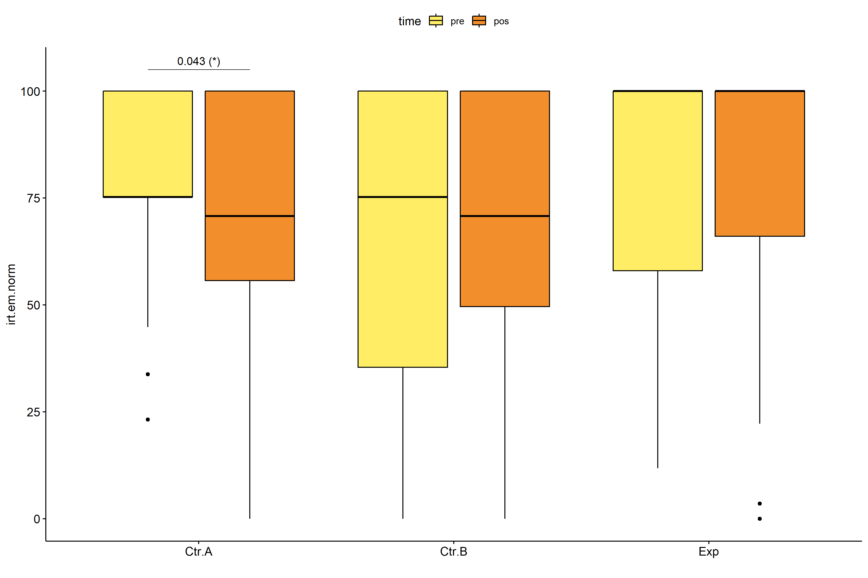

stat.test <- pwc.long %>% add_xy_position(x = "time", fun = "max")  
stat.test$y.position <- stat.test$y.position + y.position.min  
  
gg <- ggline(  
 pdat.long, x = "time", y = "irt.em.norm", size = 1.5,  
 facet.by = "Group", add = c("mean_se"), color = "Group",  
 position = position_dodge(width = 0.3), palette = color[["Group"]])  
  
pdat.long$xj = jitter(as.numeric(pdat.long[["time"]]), amount=.1)  
pdat.long$yj = jitter(pdat.long[["irt.em.norm"]], amount = .01)  
  
gg + geom_point(  
 data = pdat.long, aes_string(x="xj",y="yj", color = "Group"), size=0.5) +  
 stat_pvalue_manual(  
 stat.test, tip.length = 0, hide.ns = T, label.size = 5,  
 position = position_dodge(width = 0.3),  
 label = "{ p.adj } ({ p.adj.signif })") + xlab("") +  
 theme(strip.text = element_text(size = 16),  
 axis.text = element_text(size = 18))

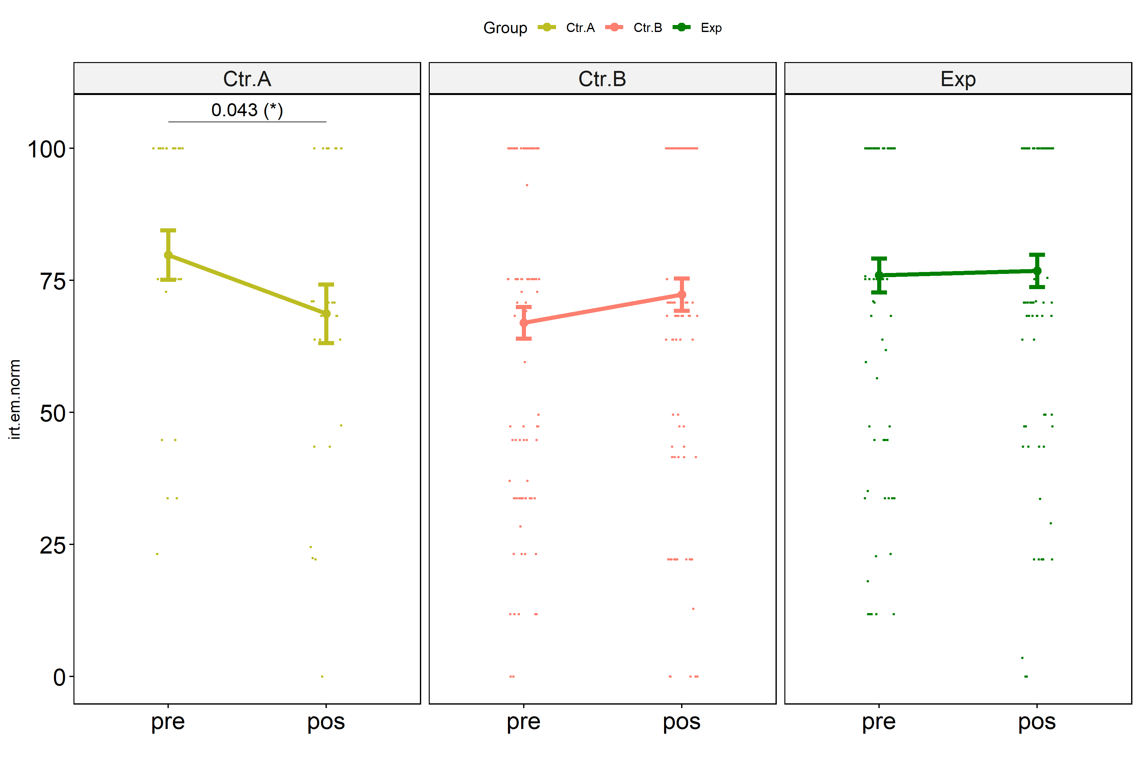

## Kruskal and Wilcoxon PairWise comparisons for: *irt.em.norm ~ Group*

kt <- lapply(lvars, FUN = function(x) {  
 kruskal_test(pdat, as.formula(paste0(x," ~ Group")))   
})  
  
df <- do.call(rbind.fill, lapply(lvars, function(x) {  
 add_significance(merge(  
 kt[[x]], kruskal_effsize(pdat, as.formula(paste0(x," ~ Group"))),  
 by = c(".y.","n"), suffixes = c("",".ez")))  
}))  
  
df <- df[,c(".y.","n","df","statistic","p","p.signif","effsize","magnitude")]

| .y. | n | df | statistic | p | p.signif | effsize | magnitude |
| --- | --- | --- | --- | --- | --- | --- | --- |
| dif.irt.em.norm | 221 | 2 | 7.819429 | 0.0200 | * | 0.0266946 | small |
| pos.irt.em.norm | 221 | 2 | 2.463545 | 0.2920 | ns | 0.0021264 | small |
| pre.irt.em.norm | 221 | 2 | 6.397292 | 0.0408 | * | 0.0201711 | small |

pwc <- lapply(lvars, FUN = function(x) {  
 pairwise_wilcox_test(pdat, as.formula(paste0(x," ~ Group")))   
})  
  
df <- do.call(rbind.fill, pwc)

| .y. | group1 | group2 | n1 | n2 | statistic | p | p.adj | p.adj.signif |
| --- | --- | --- | --- | --- | --- | --- | --- | --- |
| dif.irt.em.norm | Ctr.A | Ctr.B | 27 | 107 | 955.5 | 0.006 | 0.019 | * |
| dif.irt.em.norm | Ctr.A | Exp | 27 | 87 | 842.0 | 0.025 | 0.050 | * |
| dif.irt.em.norm | Ctr.B | Exp | 107 | 87 | 4988.0 | 0.387 | 0.387 | ns |
| pos.irt.em.norm | Ctr.A | Ctr.B | 27 | 107 | 1330.0 | 0.508 | 0.556 | ns |
| pos.irt.em.norm | Ctr.A | Exp | 27 | 87 | 961.0 | 0.133 | 0.399 | ns |
| pos.irt.em.norm | Ctr.B | Exp | 107 | 87 | 4258.5 | 0.278 | 0.556 | ns |
| pre.irt.em.norm | Ctr.A | Ctr.B | 27 | 107 | 1776.0 | 0.058 | 0.115 | ns |
| pre.irt.em.norm | Ctr.A | Exp | 27 | 87 | 1217.5 | 0.760 | 0.760 | ns |
| pre.irt.em.norm | Ctr.B | Exp | 107 | 87 | 3851.0 | 0.031 | 0.094 | ns |

plots <- lapply(lvars, FUN = function(y) {  
 stat.test <- pwc[[y]] %>% add_xy_position(x = "Group")  
 stat.test$y.position <- stat.test$y.position + y.position.min  
 ggboxplot(pdat, x = "Group", y = y, fill = "Group",  
 palette = color[["Group"]]) +  
 stat_pvalue_manual(stat.test, tip.length = 0, hide.ns = T, label.size = 5,  
 label="{ p.adj } ({ p.adj.signif })") + xlab("")  
})

egg::ggarrange(plots[["pre.irt.em.norm"]], plots[["pos.irt.em.norm"]], nrow = 1)

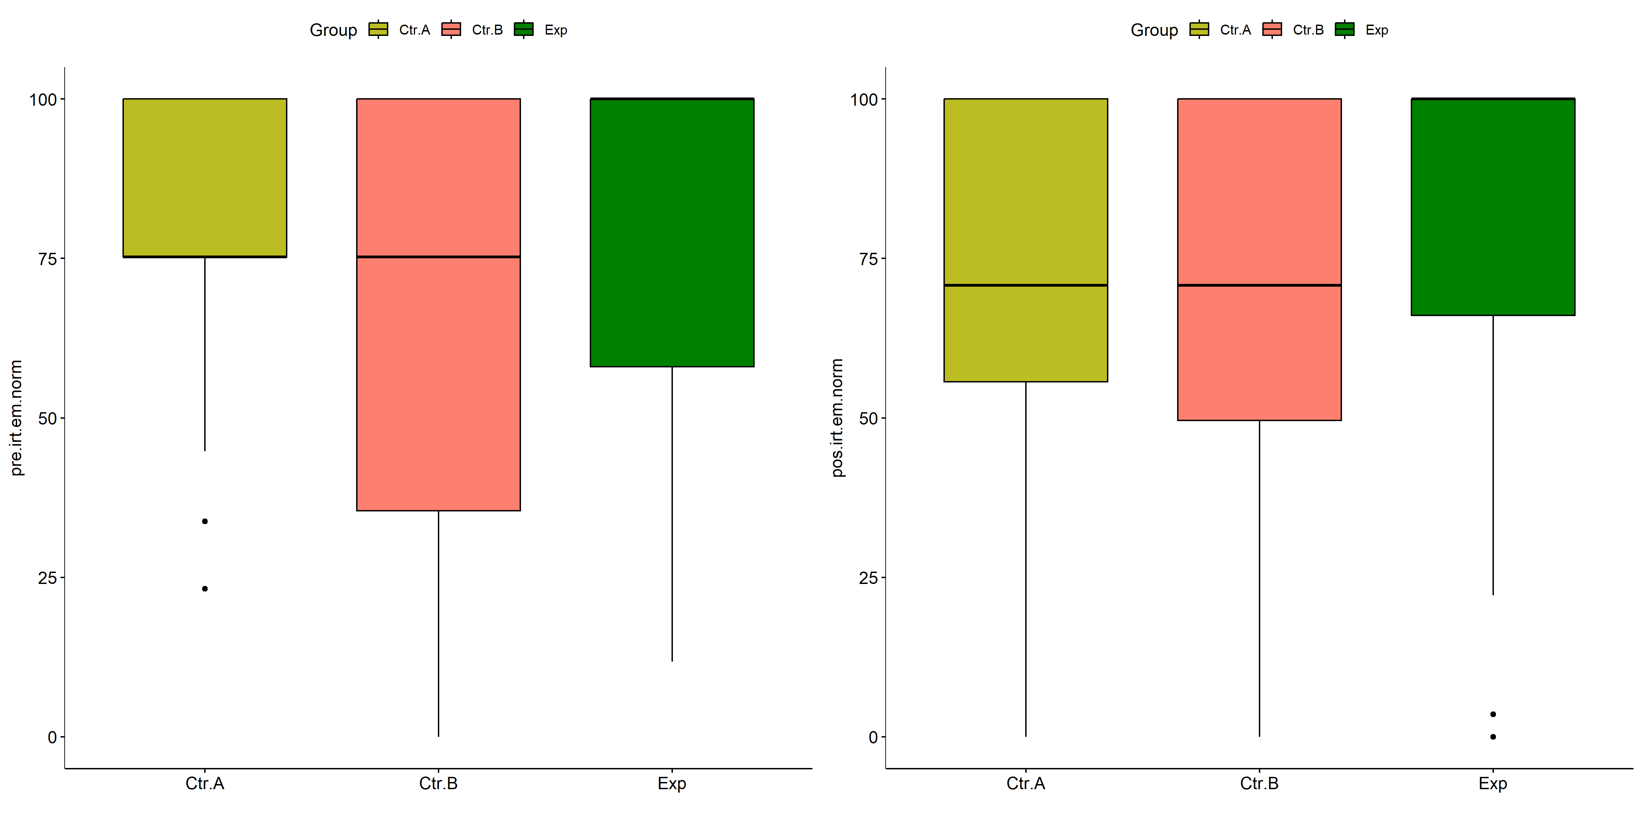

plots[["dif.irt.em.norm"]] +  
 labs(subtitle = get_test_label(kt[["dif.irt.em.norm"]], detailed = T),  
 caption = get_pwc_label(pwc[["dif.irt.em.norm"]])) +  
 ylab("irt.em.norm (dif)") +  
 theme(strip.text = element_text(size = 16),  
 axis.text = element_text(size = 18))

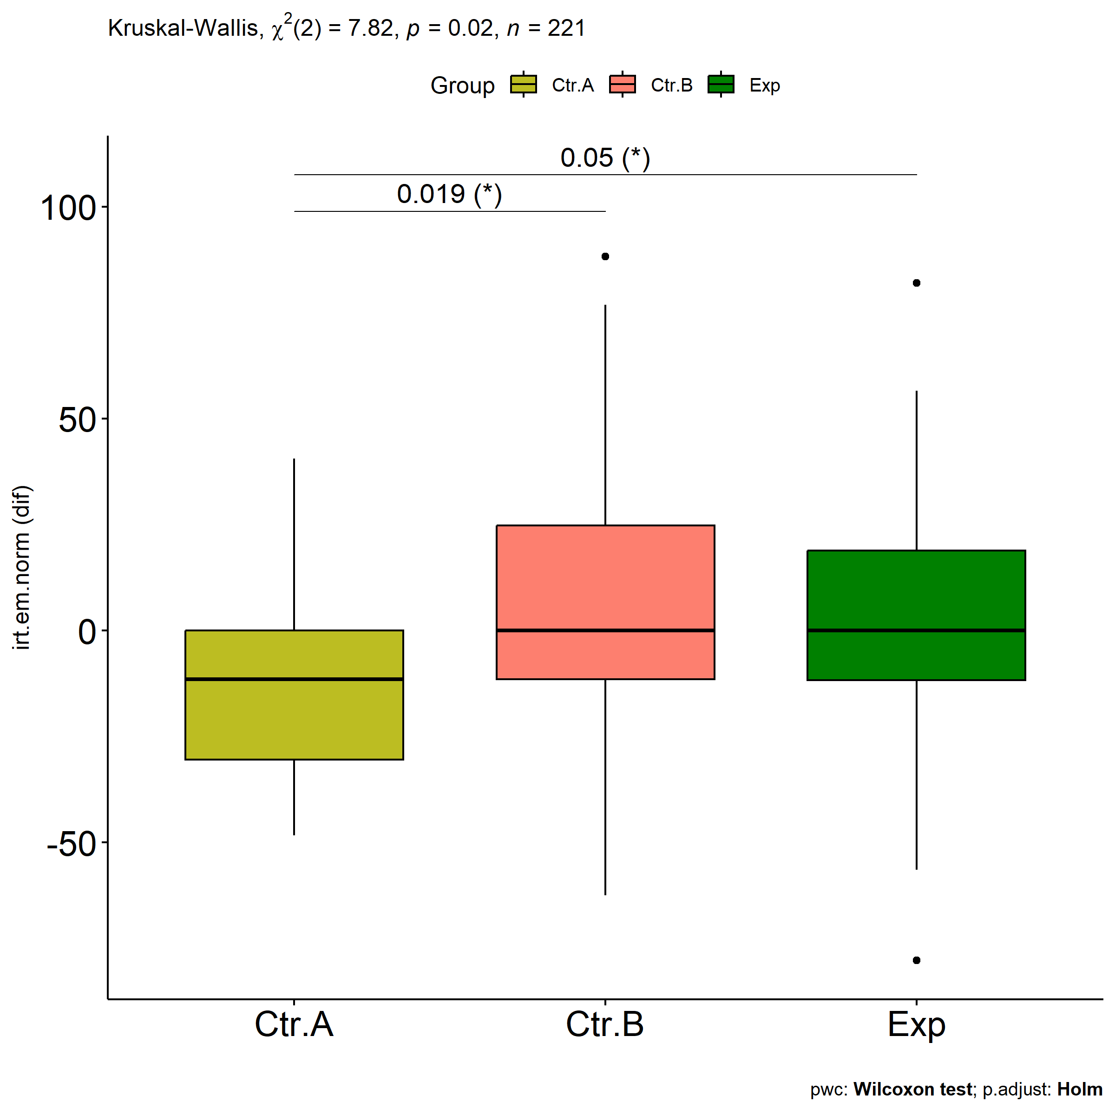

# Two-way factor analysis for: *irt.em.norm ~ Group:Gender*

pdat = remove_group_data(  
 dat[!is.na(dat[["Group"]]) & !is.na(dat[["Gender"]]),],  
 "dif.irt.em.norm", c("Group","Gender"))  
  
pdat.long <- rbind(pdat[,c("ID","Group","Gender")],  
 pdat[,c("ID","Group","Gender")])  
pdat.long[["time"]] <- c(rep("pre", nrow(pdat)), rep("pos", nrow(pdat)))  
pdat.long[["time"]] <- factor(pdat.long[["time"]], c("pre","pos"))  
pdat.long[["irt.em.norm"]] <- c(pdat[["pre.irt.em.norm"]], pdat[["pos.irt.em.norm"]])  
  
y.position.min <- abs(  
 max(pdat.long[["irt.em.norm"]])  
 - min(pdat.long[["irt.em.norm"]]))/20  
  
lvars = as.list(c("dif.irt.em.norm","pos.irt.em.norm","pre.irt.em.norm"))  
names(lvars) = unlist(lvars)

## Pre-test and Post-test PairWise comparisons for: *irt.em.norm ~ Group:Gender*

pwc.long <- group_by(pdat.long, Group:Gender) %>%  
 pairwise_wilcox_test(irt.em.norm ~ time, detailed = T)  
  
df <- pwc.long[,c(".y.","Group:Gender","group1","group2","n1","n2","estimate",  
 "statistic","p.adj","p.adj.signif")]

| .y. | Group:Gender | group1 | group2 | n1 | n2 | estimate | statistic | p.adj | p.adj.signif |
| --- | --- | --- | --- | --- | --- | --- | --- | --- | --- |
| irt.em.norm | Ctr.A:Female | pre | pos | 16 | 16 | 6.9245003 | 166.5 | 0.140 | ns |
| irt.em.norm | Ctr.A:Male | pre | pos | 11 | 11 | 4.5455250 | 81.0 | 0.168 | ns |
| irt.em.norm | Ctr.B:Female | pre | pos | 61 | 61 | 0.0000128 | 1916.5 | 0.768 | ns |
| irt.em.norm | Ctr.B:Male | pre | pos | 44 | 44 | -13.5835445 | 747.5 | 0.058 | ns |
| irt.em.norm | Exp:Female | pre | pos | 48 | 48 | 0.0000362 | 1336.5 | 0.141 | ns |
| irt.em.norm | Exp:Male | pre | pos | 35 | 35 | -0.0000506 | 508.5 | 0.188 | ns |

stat.test <- pwc.long %>% add_xy_position(x = "Group:Gender", fun = "max")  
sidx = which(stat.test$p.adj.signif != "ns")  
stat.test$y.position[sidx] <- stat.test$y.position[sidx] + y.position.min * (1:length(sidx))  
  
pdat.long[[paste0(c("Group","Gender"), collapse = ":")]] = apply(  
 pdat.long[, c("Group","Gender")], 1, paste0, collapse = ":")  
  
ggboxplot(pdat.long, x = "Group:Gender", y = "irt.em.norm",  
 palette = color$prepost, fill = "time") +  
 stat_pvalue_manual(stat.test, tip.length = 0, hide.ns = T,  
 label = "{ p.adj } ({ p.adj.signif })") + xlab("")

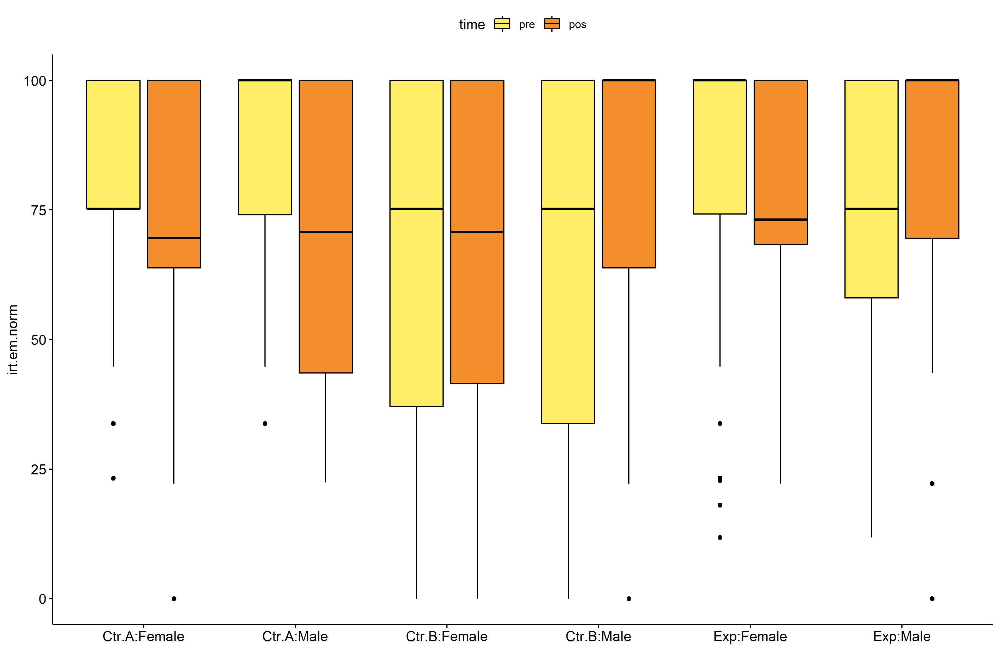

pwc.long <- group_by(pdat.long, Group, Gender) %>%  
 pairwise_wilcox_test(irt.em.norm ~ time, detailed = T)  
  
stat.test <- pwc.long %>% add_xy_position(x = "time", fun = "mean_se")  
sidx = which(stat.test$p.adj.signif != "ns")  
stat.test$y.position[sidx] <- stat.test$y.position[sidx] + y.position.min * (1:length(sidx))  
  
gg <- ggline(  
 pdat.long, x = "time", y = "irt.em.norm",  
 color = "Gender", linetype = "Gender", shape = "Gender", size = 1.5,  
 facet.by = "Group", add = c("mean_se"),  
 position = position_dodge(width = 0.3), palette = color[["Gender"]])  
  
pdat.long$xj = jitter(as.numeric(pdat.long[["time"]]), amount=.1)  
pdat.long$yj = jitter(pdat.long[["irt.em.norm"]], amount = .01)  
  
gg + geom_point(  
 data = pdat.long, aes_string(x="xj",y="yj",colour="Gender"), size=0.5) +  
 stat_pvalue_manual(  
 stat.test, tip.length = 0, hide.ns = T, label.size = 5,  
 position = position_dodge(width = 0.3), color = "Gender",  
 label = "{ p.adj } ({ p.adj.signif })") + xlab("") +  
 theme(strip.text = element_text(size = 16),  
 axis.text = element_text(size = 18))

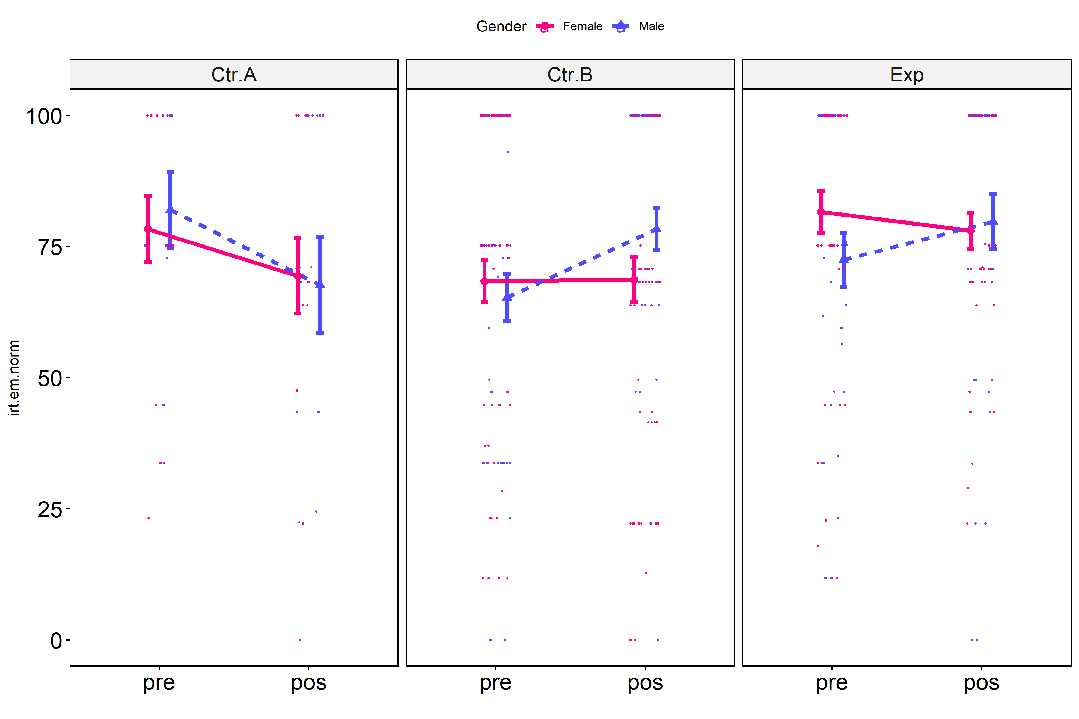

## Scheirer and Wilcoxon PairWise comparisons for: *irt.em.norm ~ Group:Gender*

sch <- lapply(lvars, FUN = function(x) {  
 scheirer.test(pdat, x, c("Group","Gender"), as.table = T)   
})  
df <- do.call(rbind.fill, sch)

| var | Effect | Df | Sum Sq | H | p.value | p.value.signif |
| --- | --- | --- | --- | --- | --- | --- |
| dif.irt.em.norm | Group | 2 | 29676.2951 | 7.8327114 | 0.0199135 | * |
| dif.irt.em.norm | Gender | 1 | 26343.2643 | 6.9529968 | 0.0083679 | ** |
| dif.irt.em.norm | Group:Gender | 2 | 5776.8536 | 1.5247330 | 0.4665610 | ns |
| dif.irt.em.norm | Residuals | 209 | 748573.9483 |  |  |  |
| pos.irt.em.norm | Group | 2 | 12135.1092 | 3.5214987 | 0.1719160 | ns |
| pos.irt.em.norm | Gender | 1 | 6427.6126 | 1.8652349 | 0.1720218 | ns |
| pos.irt.em.norm | Group:Gender | 2 | 677.2006 | 0.1965175 | 0.9064143 | ns |
| pos.irt.em.norm | Residuals | 209 | 718070.5111 |  |  |  |
| pre.irt.em.norm | Group | 2 | 27892.8805 | 7.9285397 | 0.0189819 | * |
| pre.irt.em.norm | Gender | 1 | 7276.9053 | 2.0684573 | 0.1503736 | ns |
| pre.irt.em.norm | Group:Gender | 2 | 4178.0462 | 1.1876079 | 0.5522227 | ns |
| pre.irt.em.norm | Residuals | 209 | 713477.7659 |  |  |  |

pwc <- lapply(lvars, FUN = function(x) {  
 list(  
 Group = tryCatch(pairwise_wilcox_test(group_by(pdat, Gender),  
 as.formula(paste0(x," ~ Group")))  
 , error = function(e) NULL),  
 Gender = tryCatch(pairwise_wilcox_test(group_by(pdat, Group),  
 as.formula(paste0(x," ~ Gender")))  
 , error = function(e) NULL)  
 )  
})  
  
df <- do.call(rbind.fill, lapply(pwc, FUN = function(x) {  
 do.call(rbind.fill, x)  
}))  
  
ivs = c()  
if ("Group" %in% colnames(df)) ivs = c(ivs, "Group")  
if ("Gender" %in% colnames(df)) ivs = c(ivs, "Gender")  
df <- df[,c(".y.",ivs,"group1","group2","n1","n2",  
 "statistic","p.adj","p.adj.signif")]

| .y. | Group | Gender | group1 | group2 | n1 | n2 | statistic | p.adj | p.adj.signif |
| --- | --- | --- | --- | --- | --- | --- | --- | --- | --- |
| dif.irt.em.norm |  | Female | Ctr.A | Ctr.B | 16 | 61 | 375.0 | 0.465 | ns |
| dif.irt.em.norm |  | Female | Ctr.A | Exp | 16 | 48 | 320.5 | 0.644 | ns |
| dif.irt.em.norm |  | Female | Ctr.B | Exp | 61 | 48 | 1565.0 | 0.644 | ns |
| dif.irt.em.norm |  | Male | Ctr.A | Ctr.B | 11 | 44 | 117.5 | 0.026 | * |
| dif.irt.em.norm |  | Male | Ctr.A | Exp | 11 | 35 | 104.0 | 0.042 | * |
| dif.irt.em.norm |  | Male | Ctr.B | Exp | 44 | 35 | 826.5 | 0.577 | ns |
| dif.irt.em.norm | Ctr.A |  | Female | Male | 16 | 11 | 94.0 | 0.785 | ns |
| dif.irt.em.norm | Ctr.B |  | Female | Male | 61 | 44 | 1030.5 | 0.042 | * |
| dif.irt.em.norm | Exp |  | Female | Male | 48 | 35 | 624.0 | 0.043 | * |
| pos.irt.em.norm |  | Female | Ctr.A | Ctr.B | 16 | 61 | 464.5 | 0.764 | ns |
| pos.irt.em.norm |  | Female | Ctr.A | Exp | 16 | 48 | 315.0 | 0.705 | ns |
| pos.irt.em.norm |  | Female | Ctr.B | Exp | 61 | 48 | 1278.0 | 0.705 | ns |
| pos.irt.em.norm |  | Male | Ctr.A | Ctr.B | 11 | 44 | 202.0 | 0.750 | ns |
| pos.irt.em.norm |  | Male | Ctr.A | Exp | 11 | 35 | 144.0 | 0.516 | ns |
| pos.irt.em.norm |  | Male | Ctr.B | Exp | 44 | 35 | 699.0 | 0.750 | ns |
| pos.irt.em.norm | Ctr.A |  | Female | Male | 16 | 11 | 87.5 | 1.000 | ns |
| pos.irt.em.norm | Ctr.B |  | Female | Male | 61 | 44 | 1179.5 | 0.266 | ns |
| pos.irt.em.norm | Exp |  | Female | Male | 48 | 35 | 736.5 | 0.303 | ns |
| pre.irt.em.norm |  | Female | Ctr.A | Ctr.B | 16 | 61 | 565.5 | 0.628 | ns |
| pre.irt.em.norm |  | Female | Ctr.A | Exp | 16 | 48 | 337.0 | 0.628 | ns |
| pre.irt.em.norm |  | Female | Ctr.B | Exp | 61 | 48 | 1105.0 | 0.058 | ns |
| pre.irt.em.norm |  | Male | Ctr.A | Ctr.B | 11 | 44 | 321.0 | 0.271 | ns |
| pre.irt.em.norm |  | Male | Ctr.A | Exp | 11 | 35 | 224.5 | 0.478 | ns |
| pre.irt.em.norm |  | Male | Ctr.B | Exp | 44 | 35 | 653.0 | 0.478 | ns |
| pre.irt.em.norm | Ctr.A |  | Female | Male | 16 | 11 | 82.0 | 0.770 | ns |
| pre.irt.em.norm | Ctr.B |  | Female | Male | 61 | 44 | 1446.0 | 0.490 | ns |
| pre.irt.em.norm | Exp |  | Female | Male | 48 | 35 | 1005.0 | 0.098 | ns |

plots <- lapply(lvars, FUN = function(y) {  
 livs = list("Group", "Gender")  
 names(livs) = unlist(livs)  
 lapply(livs, FUN = function(x) {  
 iv2 = setdiff(names(livs), x)  
 if (!is.null(pwc[[y]][[iv2]])) {  
 stat.test <- pwc[[y]][[iv2]] %>% add_xy_position(x = x, fun = "max")  
 sidx = which(stat.test$p.adj.signif != "ns")  
 stat.test$y.position[sidx] <- stat.test$y.position[sidx] + y.position.min * (1:length(sidx))  
   
 ggboxplot(pdat, x = x, y = y, fill = iv2, palette = color[[iv2]]) +  
 stat_pvalue_manual(stat.test, tip.length = 0, hide.ns = T, label.size = 5,  
 label="{ p.adj } ({ p.adj.signif })") + xlab("")  
 }  
 })  
})

if (!is.null(plots[["pre.irt.em.norm"]][["Group"]]) &&  
 !is.null(plots[["pos.irt.em.norm"]][["Group"]])) {  
 egg::ggarrange(plots[["pre.irt.em.norm"]][["Group"]],  
 plots[["pos.irt.em.norm"]][["Group"]], nrow = 1)   
}

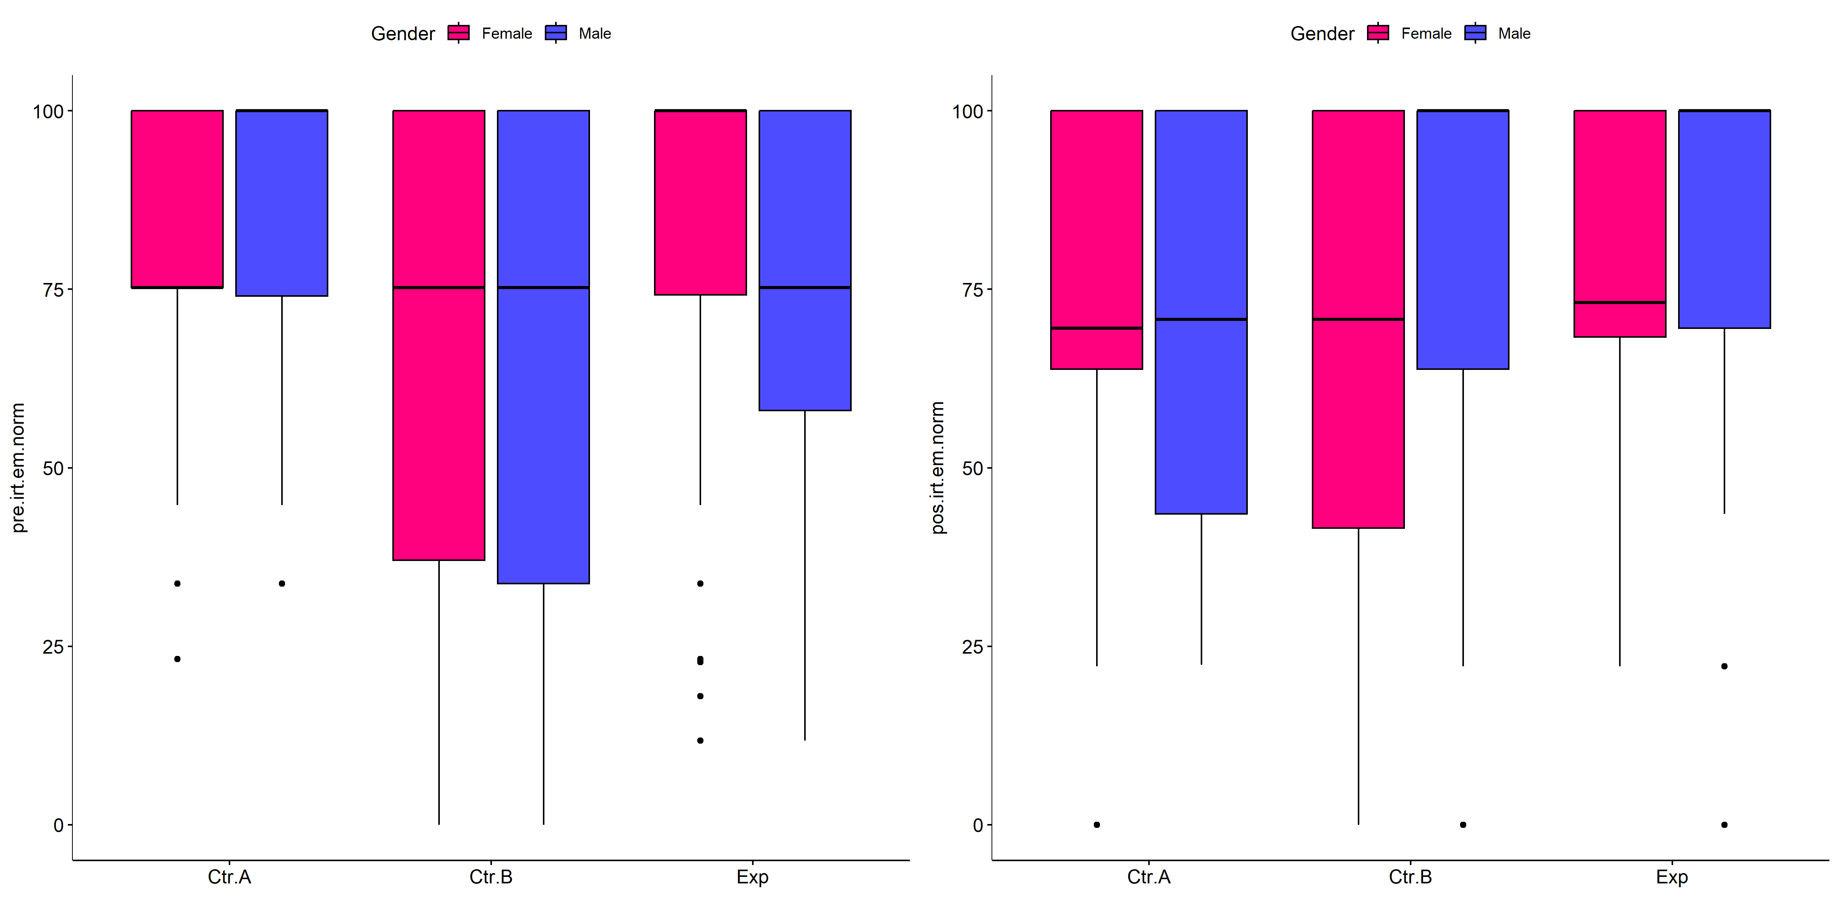

if (!is.null(plots[["pre.irt.em.norm"]][["Gender"]]) &&  
 !is.null(plots[["pos.irt.em.norm"]][["Gender"]])) {  
 egg::ggarrange(plots[["pre.irt.em.norm"]][["Gender"]],  
 plots[["pos.irt.em.norm"]][["Gender"]], nrow = 1)  
}

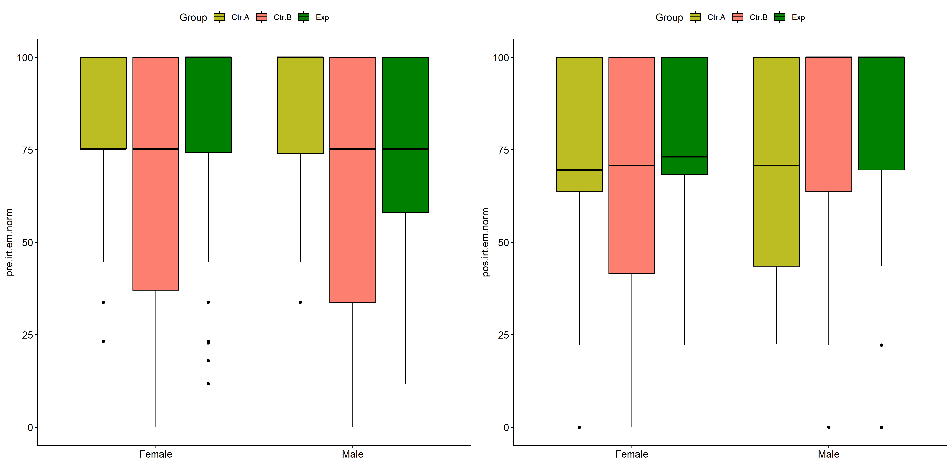

psch = sch[["dif.irt.em.norm"]]  
idx = which(psch$Effect == "Group:Gender")   
  
dof = floor(as.double(psch$Df[idx]))  
dof.res = floor(as.double(psch$Df[which(psch$Effect == "Residuals")]))  
statistic = round(as.double(psch$H[idx]), 3)  
p = round(as.double(psch[["p.value"]][idx]), 3)  
pval = ifelse(p < 0.001,paste0(" , p<0.001"),paste0(" , p=",p))  
  
if (!is.null(plots[["dif.irt.em.norm"]][["Group"]]))  
 plots[["dif.irt.em.norm"]][["Group"]] +  
 labs(subtitle = paste0("Scheirer-Ray-Hare H(", dof, ",",   
 dof.res, ")=", statistic, pval),  
 caption = get_pwc_label(pwc[["dif.irt.em.norm"]][["Gender"]])) +  
 ylab("irt.em.norm (dif)") +  
 theme(strip.text = element_text(size = 16),  
 axis.text = element_text(size = 18))

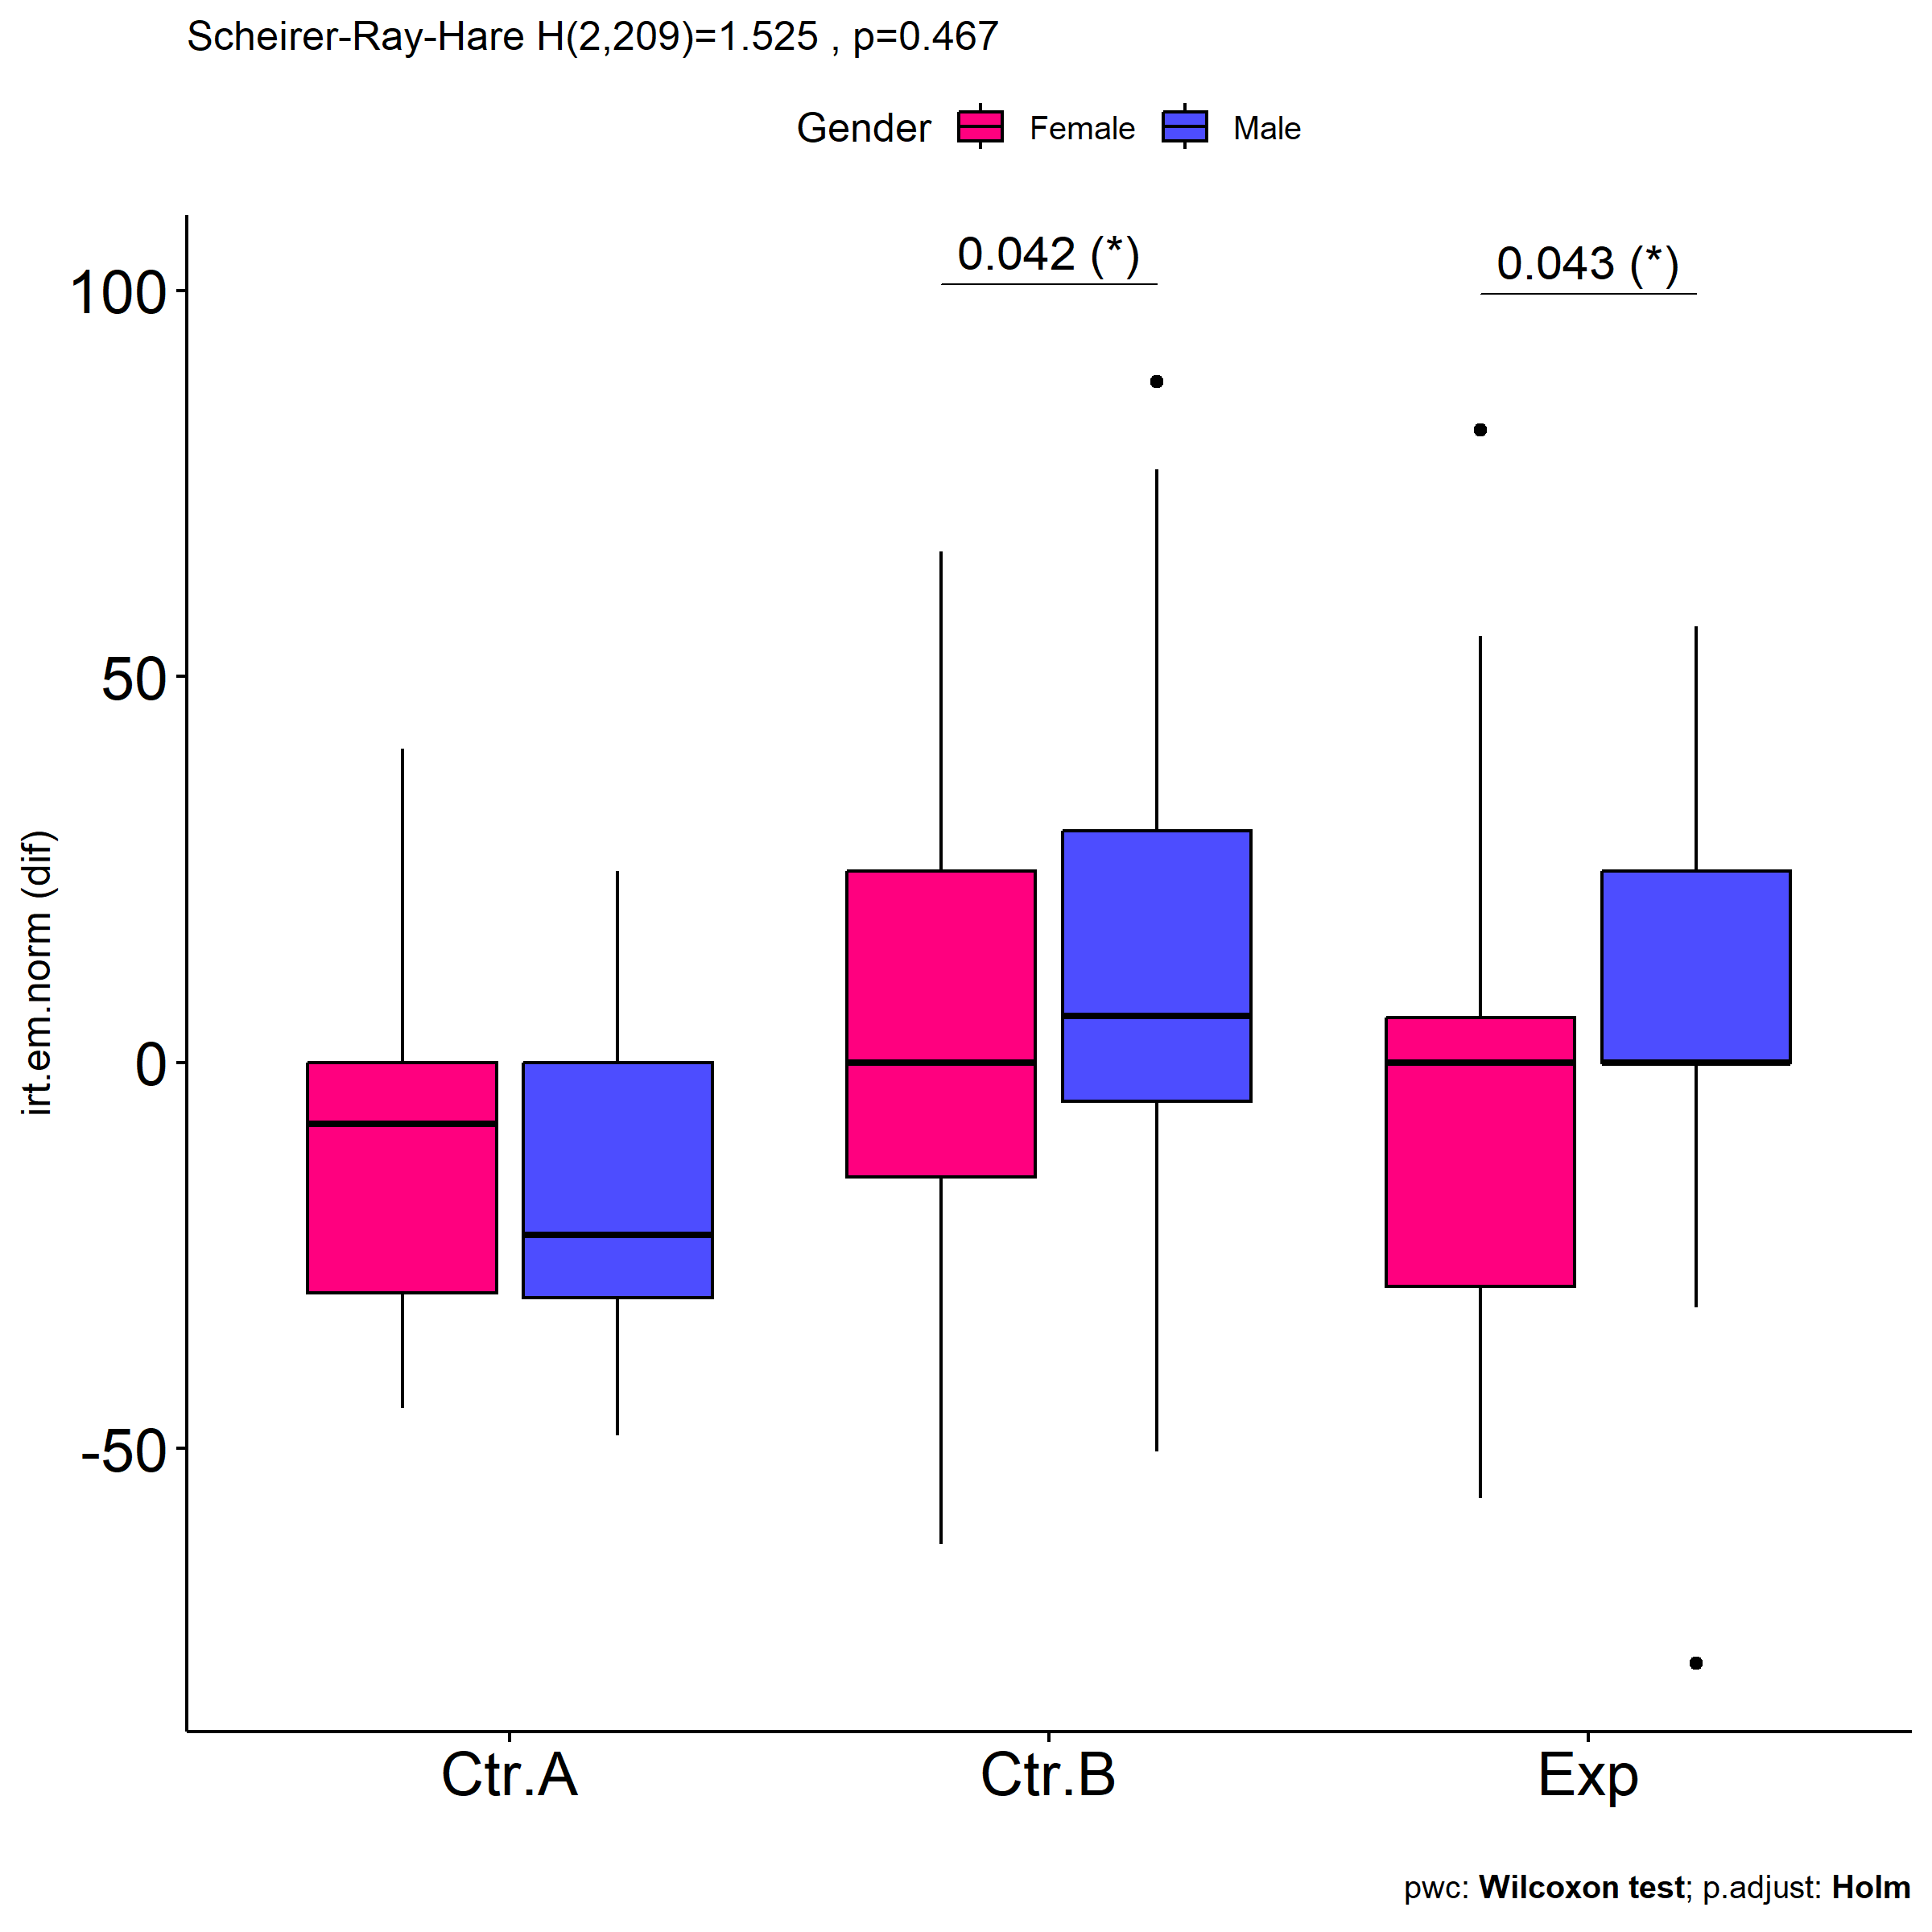

psch = sch[["dif.irt.em.norm"]]  
idx = which(psch$Effect == "Group:Gender")   
  
dof = floor(as.double(psch$Df[idx]))  
dof.res = floor(as.double(psch$Df[which(psch$Effect == "Residuals")]))  
statistic = round(as.double(psch$H[idx]), 3)  
p = round(as.double(psch[["p.value"]][idx]), 3)  
pval = ifelse(p < 0.001,paste0(" , p<0.001"),paste0(" , p=",p))  
  
if (!is.null(plots[["dif.irt.em.norm"]][["Gender"]]))  
 plots[["dif.irt.em.norm"]][["Gender"]] +  
 labs(subtitle = paste0("Scheirer-Ray-Hare H(", dof, ",",   
 dof.res, ")=", statistic, pval),  
 caption = get_pwc_label(pwc[["dif.irt.em.norm"]][["Group"]])) +  
 ylab("irt.em.norm (dif)") +  
 theme(strip.text = element_text(size = 16),  
 axis.text = element_text(size = 18))

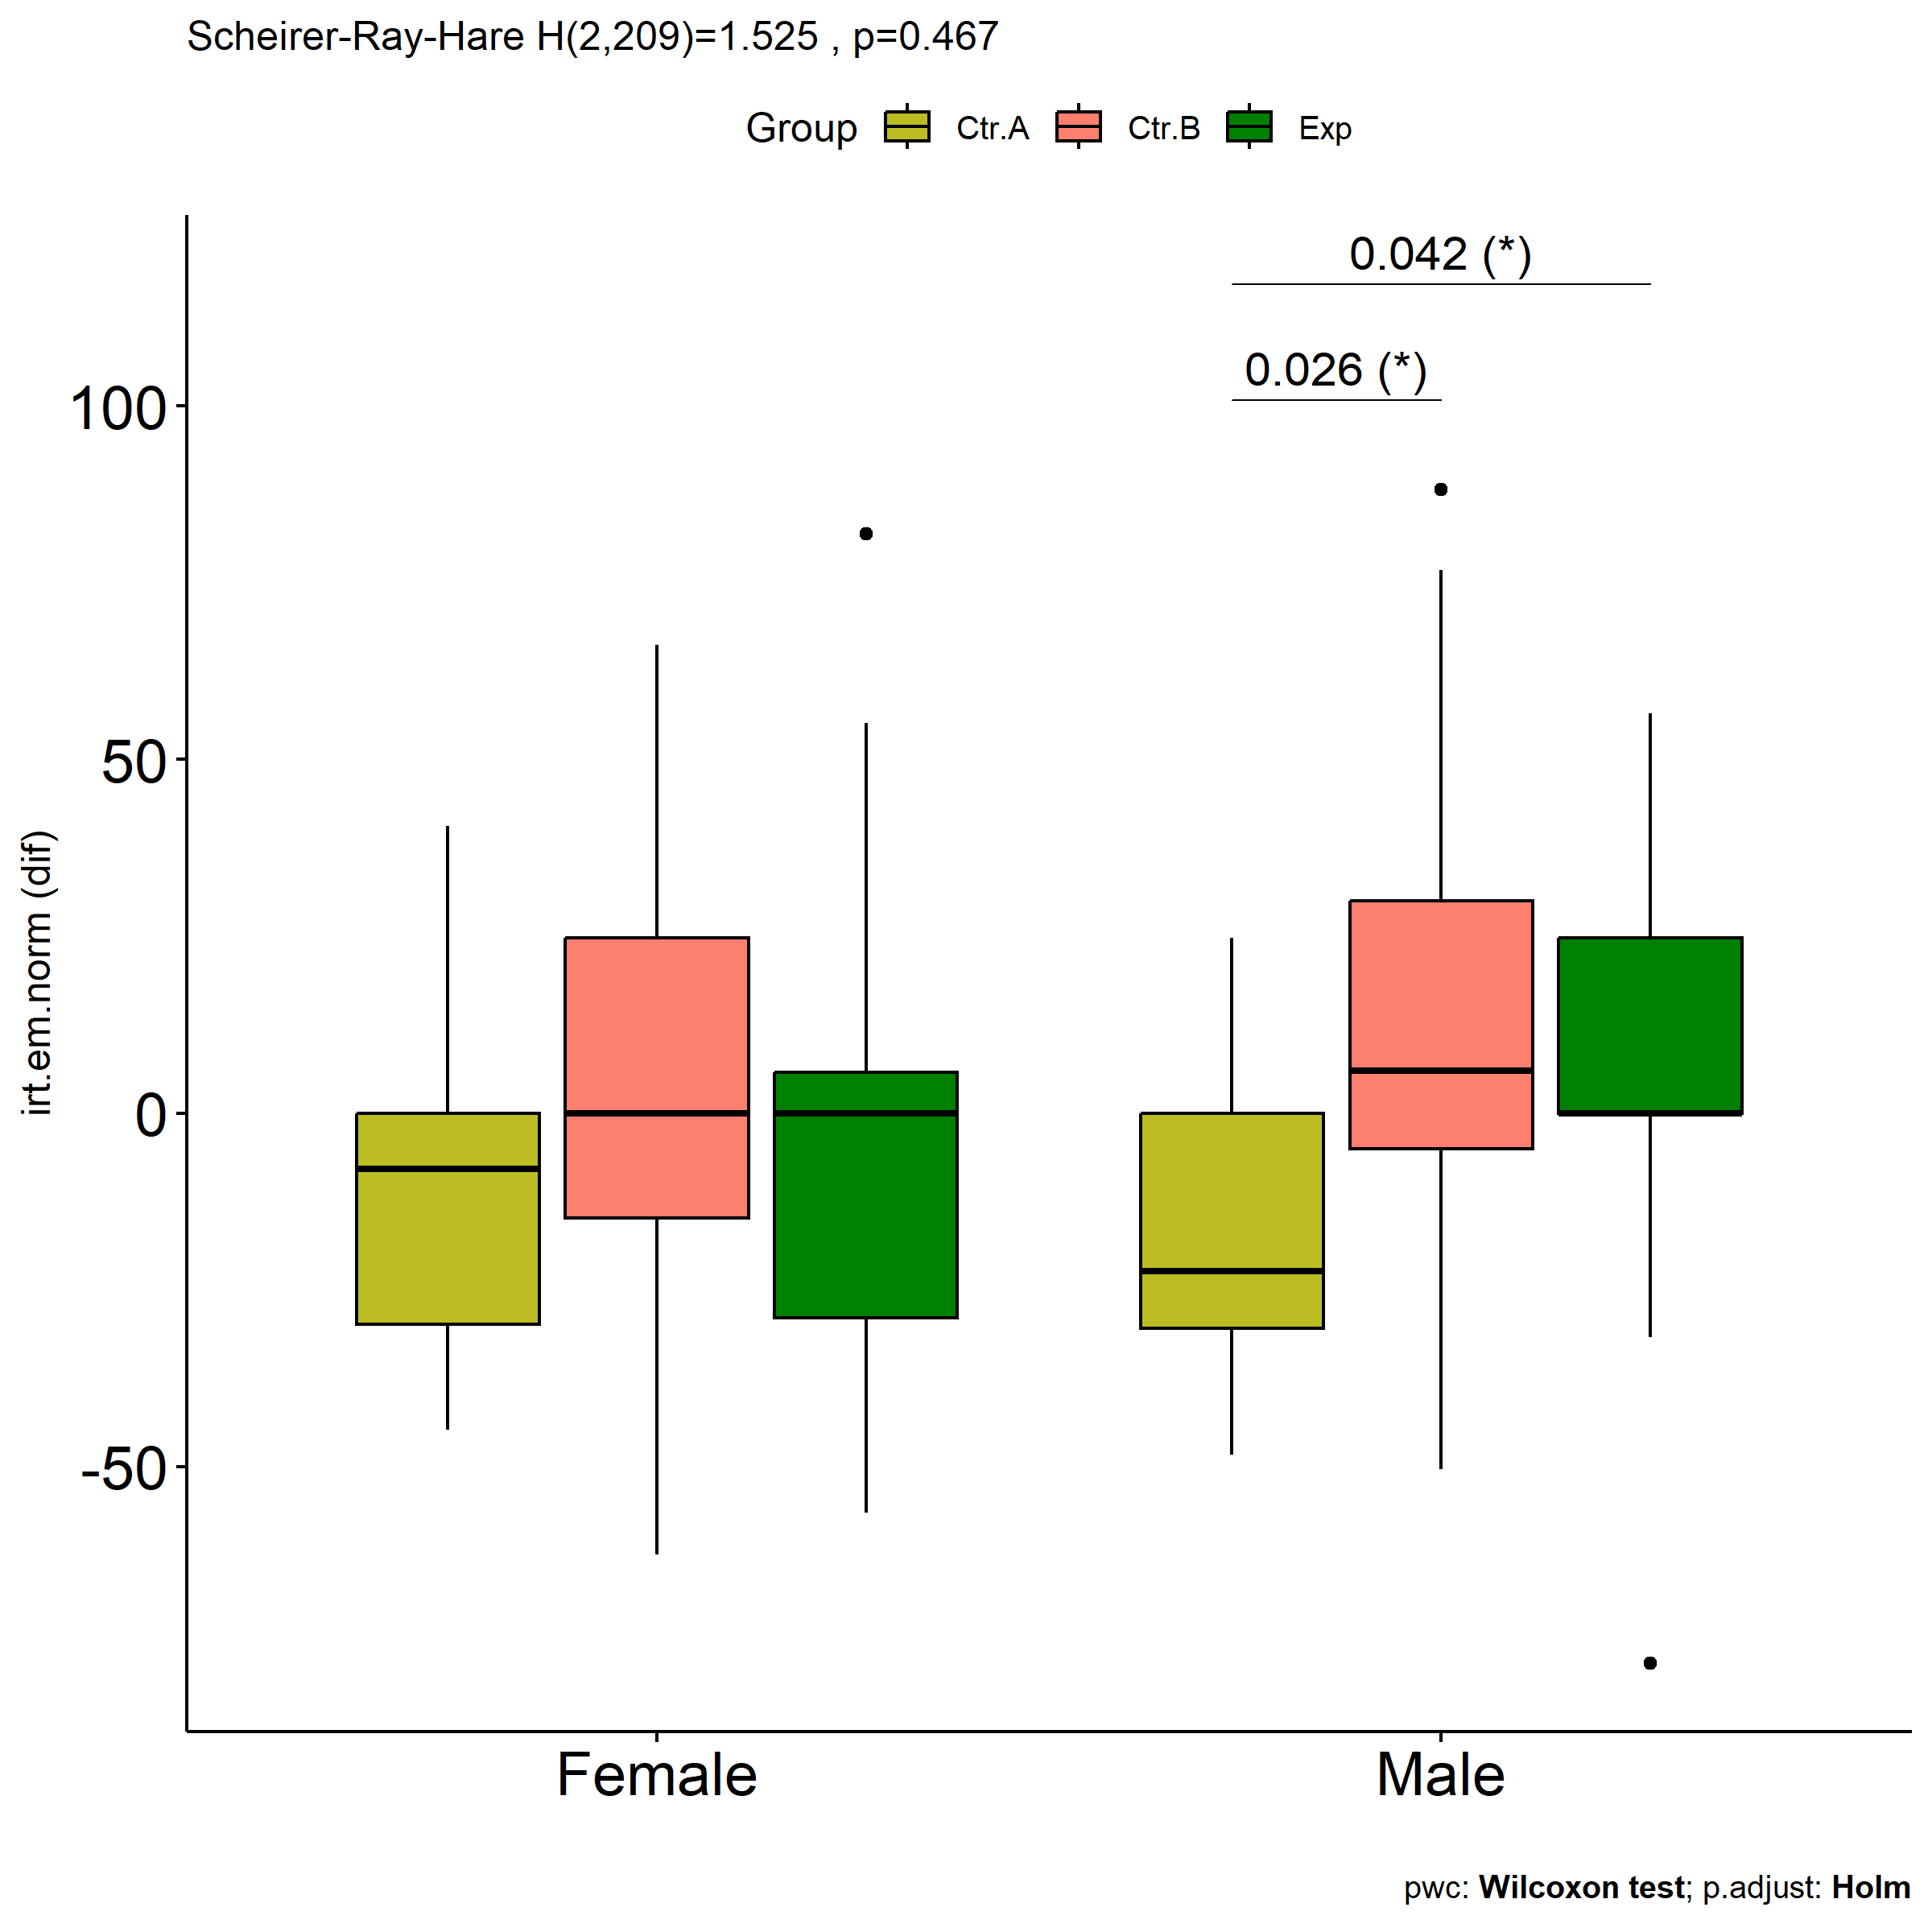

# Two-way factor analysis for: *irt.em.norm ~ Group:Town*

pdat = remove_group_data(  
 dat[!is.na(dat[["Group"]]) & !is.na(dat[["Town"]]),],  
 "dif.irt.em.norm", c("Group","Town"))  
  
pdat.long <- rbind(pdat[,c("ID","Group","Town")],  
 pdat[,c("ID","Group","Town")])  
pdat.long[["time"]] <- c(rep("pre", nrow(pdat)), rep("pos", nrow(pdat)))  
pdat.long[["time"]] <- factor(pdat.long[["time"]], c("pre","pos"))  
pdat.long[["irt.em.norm"]] <- c(pdat[["pre.irt.em.norm"]], pdat[["pos.irt.em.norm"]])  
  
y.position.min <- abs(  
 max(pdat.long[["irt.em.norm"]])  
 - min(pdat.long[["irt.em.norm"]]))/20  
  
lvars = as.list(c("dif.irt.em.norm","pos.irt.em.norm","pre.irt.em.norm"))  
names(lvars) = unlist(lvars)

## Pre-test and Post-test PairWise comparisons for: *irt.em.norm ~ Group:Town*

pwc.long <- group_by(pdat.long, Group:Town) %>%  
 pairwise_wilcox_test(irt.em.norm ~ time, detailed = T)  
  
df <- pwc.long[,c(".y.","Group:Town","group1","group2","n1","n2","estimate",  
 "statistic","p.adj","p.adj.signif")]

| .y. | Group:Town | group1 | group2 | n1 | n2 | estimate | statistic | p.adj | p.adj.signif |
| --- | --- | --- | --- | --- | --- | --- | --- | --- | --- |
| irt.em.norm | Ctr.A:Limoeiro - PE | pre | pos | 27 | 27 | 6.9244853 | 477.5 | 0.043 | * |
| irt.em.norm | Ctr.B:Sorocaba - SP | pre | pos | 47 | 47 | -0.0000243 | 899.0 | 0.089 | ns |
| irt.em.norm | Ctr.B:Limoeiro - PE | pre | pos | 60 | 60 | -0.0000112 | 1799.0 | 0.998 | ns |
| irt.em.norm | Exp:Sorocaba - SP | pre | pos | 34 | 34 | -0.0000361 | 501.0 | 0.259 | ns |
| irt.em.norm | Exp:Limoeiro - PE | pre | pos | 53 | 53 | 0.0000279 | 1511.0 | 0.487 | ns |

stat.test <- pwc.long %>% add_xy_position(x = "Group:Town", fun = "max")  
sidx = which(stat.test$p.adj.signif != "ns")  
stat.test$y.position[sidx] <- stat.test$y.position[sidx] + y.position.min * (1:length(sidx))  
  
pdat.long[[paste0(c("Group","Town"), collapse = ":")]] = apply(  
 pdat.long[, c("Group","Town")], 1, paste0, collapse = ":")  
  
ggboxplot(pdat.long, x = "Group:Town", y = "irt.em.norm",  
 palette = color$prepost, fill = "time") +  
 stat_pvalue_manual(stat.test, tip.length = 0, hide.ns = T,  
 label = "{ p.adj } ({ p.adj.signif })") + xlab("")

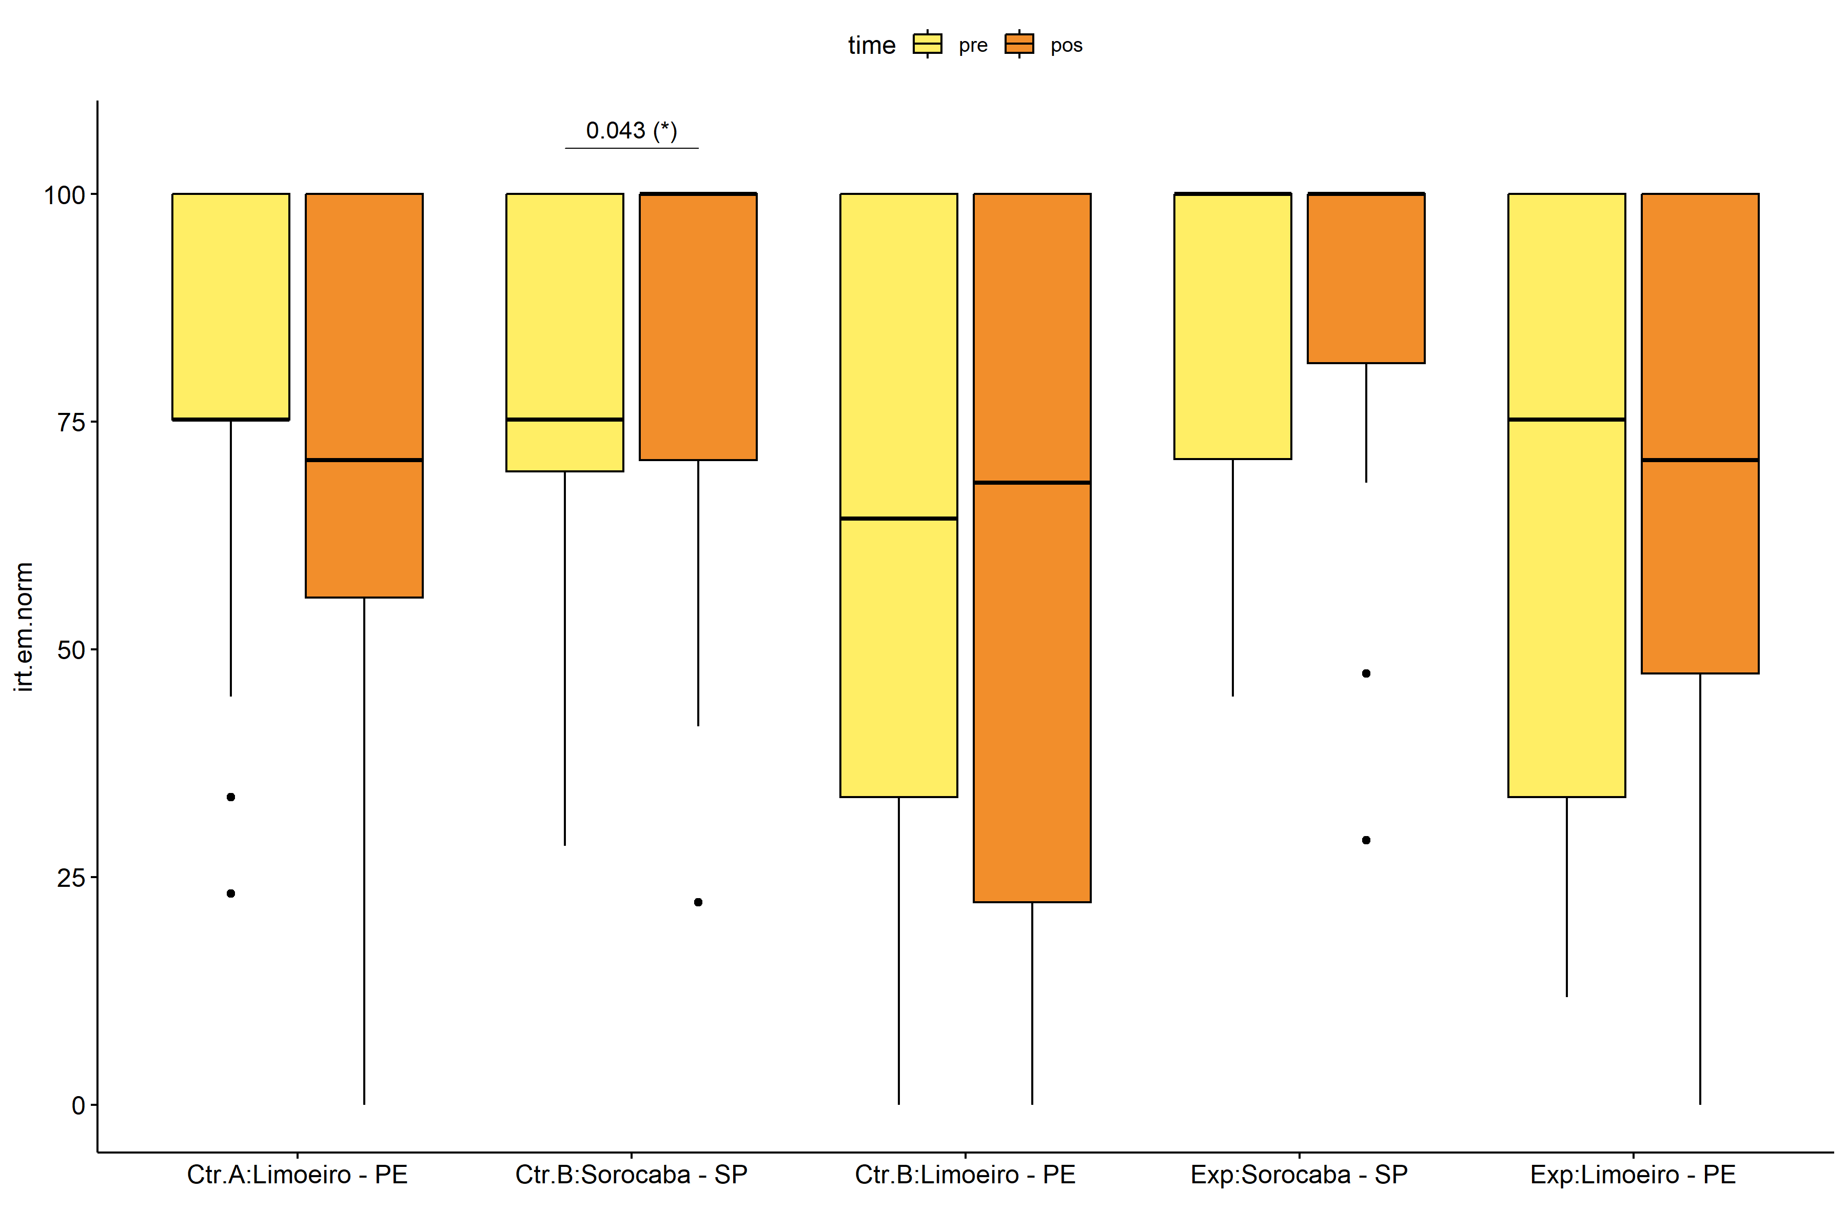

pwc.long <- group_by(pdat.long, Group, Town) %>%  
 pairwise_wilcox_test(irt.em.norm ~ time, detailed = T)  
  
stat.test <- pwc.long %>% add_xy_position(x = "time", fun = "mean_se")  
sidx = which(stat.test$p.adj.signif != "ns")  
stat.test$y.position[sidx] <- stat.test$y.position[sidx] + y.position.min * (1:length(sidx))  
  
gg <- ggline(  
 pdat.long, x = "time", y = "irt.em.norm",  
 color = "Town", linetype = "Town", shape = "Town", size = 1.5,  
 facet.by = "Group", add = c("mean_se"),  
 position = position_dodge(width = 0.3), palette = color[["Town"]])  
  
pdat.long$xj = jitter(as.numeric(pdat.long[["time"]]), amount=.1)  
pdat.long$yj = jitter(pdat.long[["irt.em.norm"]], amount = .01)  
  
gg + geom_point(  
 data = pdat.long, aes_string(x="xj",y="yj",colour="Town"), size=0.5) +  
 stat_pvalue_manual(  
 stat.test, tip.length = 0, hide.ns = T, label.size = 5,  
 position = position_dodge(width = 0.3), color = "Town",  
 label = "{ p.adj } ({ p.adj.signif })") + xlab("") +  
 theme(strip.text = element_text(size = 16),  
 axis.text = element_text(size = 18))

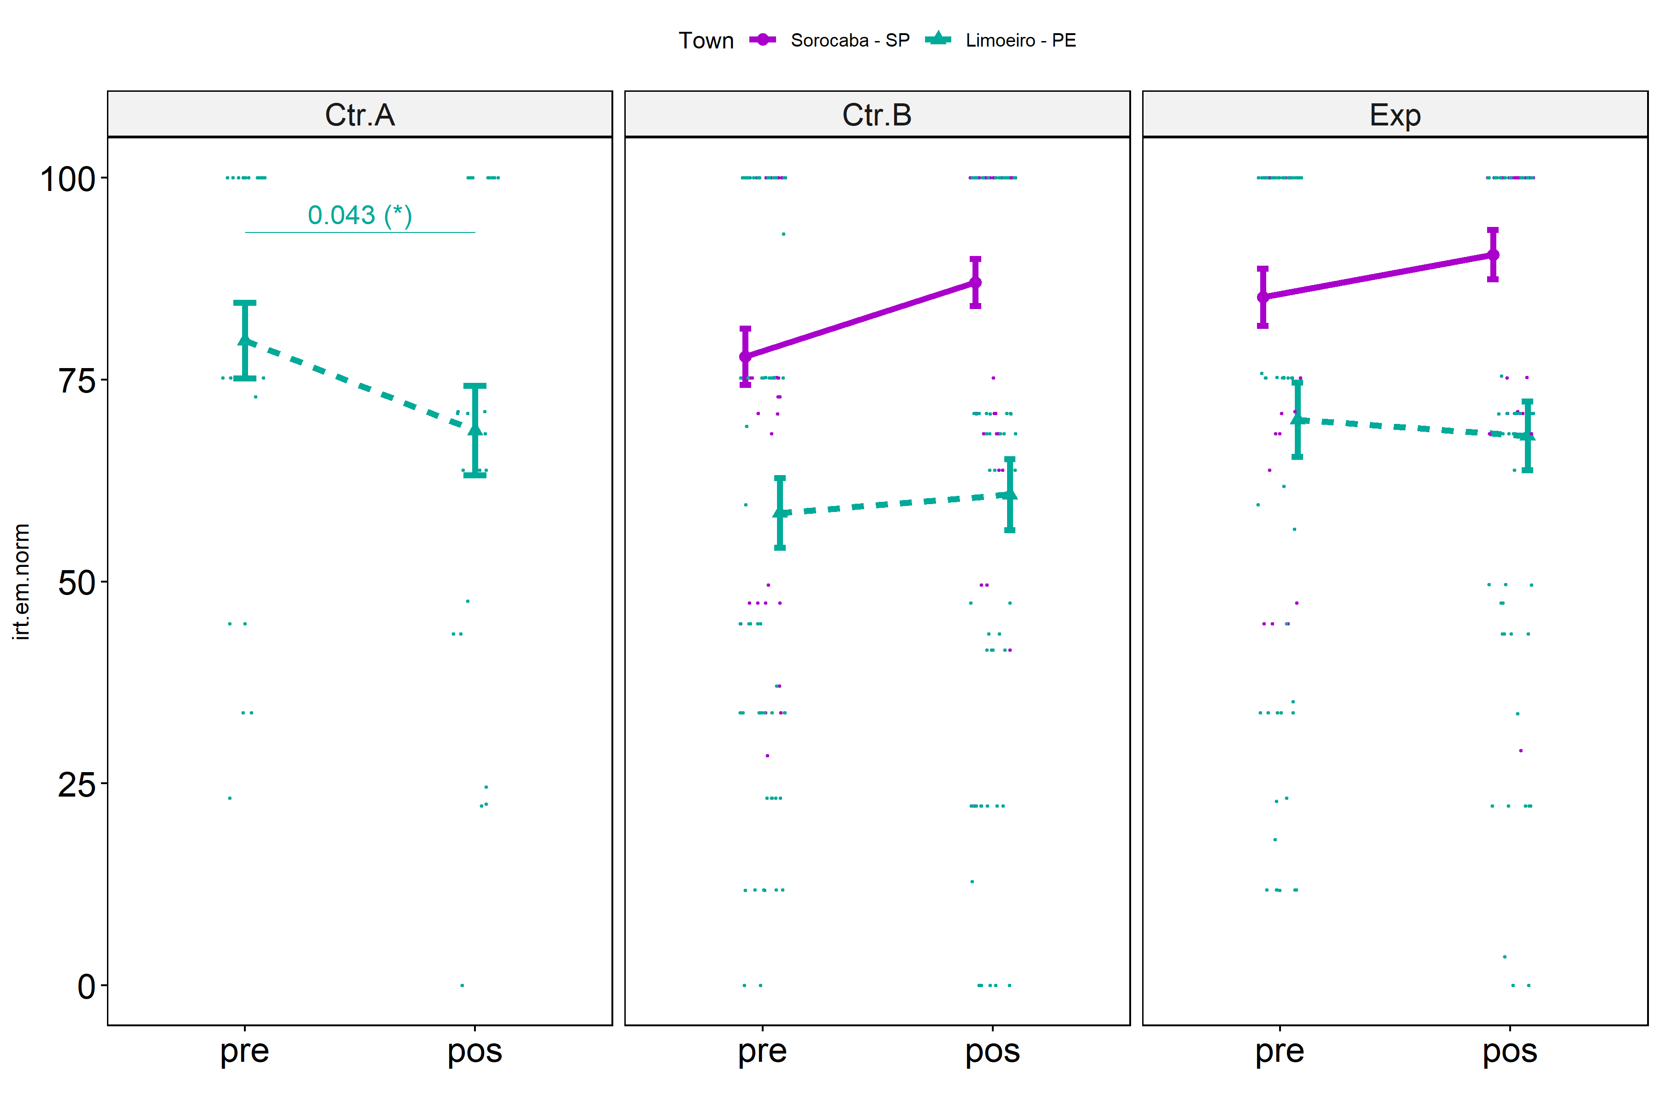

## Scheirer and Wilcoxon PairWise comparisons for: *irt.em.norm ~ Group:Town*

sch <- lapply(lvars, FUN = function(x) {  
 scheirer.test(pdat, x, c("Group","Town"), as.table = T)   
})  
df <- do.call(rbind.fill, sch)

| var | Effect | Df | Sum Sq | H | p.value | p.value.signif |
| --- | --- | --- | --- | --- | --- | --- |
| dif.irt.em.norm | Group | 2 | 18318.92288 | 4.5739275 | 0.1015744 | ns |
| dif.irt.em.norm | Town | 1 | 14622.43720 | 3.6509771 | 0.0560363 | ns |
| dif.irt.em.norm | Group:Town | 1 | 396.52369 | 0.0990053 | 0.7530266 | ns |
| dif.irt.em.norm | Residuals | 216 | 834780.14115 |  |  |  |
| pos.irt.em.norm | Group | 2 | 7870.04473 | 2.1554009 | 0.3403773 | ns |
| pos.irt.em.norm | Town | 1 | 115139.69829 | 31.5337738 | 0.0000000 | **** |
| pos.irt.em.norm | Group:Town | 1 | 78.29874 | 0.0214440 | 0.8835759 | ns |
| pos.irt.em.norm | Residuals | 216 | 679075.82573 |  |  |  |
| pre.irt.em.norm | Group | 2 | 38326.07056 | 10.2665409 | 0.0058972 | ** |
| pre.irt.em.norm | Town | 1 | 45433.44251 | 12.1704179 | 0.0004855 | *** |
| pre.irt.em.norm | Group:Town | 1 | 701.91872 | 0.1880255 | 0.6645651 | ns |
| pre.irt.em.norm | Residuals | 216 | 751265.88012 |  |  |  |

pwc <- lapply(lvars, FUN = function(x) {  
 list(  
 Group = tryCatch(pairwise_wilcox_test(group_by(pdat, Town),  
 as.formula(paste0(x," ~ Group")))  
 , error = function(e) NULL),  
 Town = tryCatch(pairwise_wilcox_test(group_by(pdat, Group),  
 as.formula(paste0(x," ~ Town")))  
 , error = function(e) NULL)  
 )  
})  
  
df <- do.call(rbind.fill, lapply(pwc, FUN = function(x) {  
 do.call(rbind.fill, x)  
}))  
  
ivs = c()  
if ("Group" %in% colnames(df)) ivs = c(ivs, "Group")  
if ("Town" %in% colnames(df)) ivs = c(ivs, "Town")  
df <- df[,c(".y.",ivs,"group1","group2","n1","n2",  
 "statistic","p.adj","p.adj.signif")]

| .y. | Town | group1 | group2 | n1 | n2 | statistic | p.adj | p.adj.signif |
| --- | --- | --- | --- | --- | --- | --- | --- | --- |
| dif.irt.em.norm | Sorocaba - SP | Ctr.B | Exp | 47 | 34 | 833.5 | 0.740 | ns |
| dif.irt.em.norm | Limoeiro - PE | Ctr.A | Ctr.B | 27 | 60 | 569.5 | 0.080 | ns |
| dif.irt.em.norm | Limoeiro - PE | Ctr.A | Exp | 27 | 53 | 566.5 | 0.256 | ns |
| dif.irt.em.norm | Limoeiro - PE | Ctr.B | Exp | 60 | 53 | 1716.0 | 0.467 | ns |
| pos.irt.em.norm | Sorocaba - SP | Ctr.B | Exp | 47 | 34 | 718.5 | 0.349 | ns |
| pos.irt.em.norm | Limoeiro - PE | Ctr.A | Ctr.B | 27 | 60 | 928.5 | 0.666 | ns |
| pos.irt.em.norm | Limoeiro - PE | Ctr.A | Exp | 27 | 53 | 720.5 | 0.962 | ns |
| pos.irt.em.norm | Limoeiro - PE | Ctr.B | Exp | 60 | 53 | 1382.5 | 0.666 | ns |
| pre.irt.em.norm | Sorocaba - SP | Ctr.B | Exp | 47 | 34 | 675.0 | 0.201 | ns |
| pre.irt.em.norm | Limoeiro - PE | Ctr.A | Ctr.B | 27 | 60 | 1102.5 | 0.018 | * |
| pre.irt.em.norm | Limoeiro - PE | Ctr.A | Exp | 27 | 53 | 807.0 | 0.327 | ns |
| pre.irt.em.norm | Limoeiro - PE | Ctr.B | Exp | 60 | 53 | 1277.5 | 0.130 | ns |

plots <- lapply(lvars, FUN = function(y) {  
 livs = list("Group", "Town")  
 names(livs) = unlist(livs)  
 lapply(livs, FUN = function(x) {  
 iv2 = setdiff(names(livs), x)  
 if (!is.null(pwc[[y]][[iv2]])) {  
 stat.test <- pwc[[y]][[iv2]] %>% add_xy_position(x = x, fun = "max")  
 sidx = which(stat.test$p.adj.signif != "ns")  
 stat.test$y.position[sidx] <- stat.test$y.position[sidx] + y.position.min * (1:length(sidx))  
   
 ggboxplot(pdat, x = x, y = y, fill = iv2, palette = color[[iv2]]) +  
 stat_pvalue_manual(stat.test, tip.length = 0, hide.ns = T, label.size = 5,  
 label="{ p.adj } ({ p.adj.signif })") + xlab("")  
 }  
 })  
})

if (!is.null(plots[["pre.irt.em.norm"]][["Group"]]) &&  
 !is.null(plots[["pos.irt.em.norm"]][["Group"]])) {  
 egg::ggarrange(plots[["pre.irt.em.norm"]][["Group"]],  
 plots[["pos.irt.em.norm"]][["Group"]], nrow = 1)   
}

if (!is.null(plots[["pre.irt.em.norm"]][["Town"]]) &&  
 !is.null(plots[["pos.irt.em.norm"]][["Town"]])) {  
 egg::ggarrange(plots[["pre.irt.em.norm"]][["Town"]],  
 plots[["pos.irt.em.norm"]][["Town"]], nrow = 1)  
}

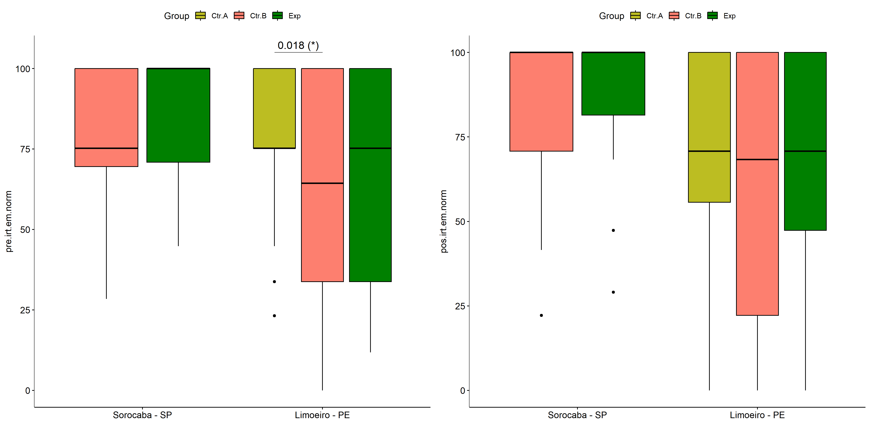

psch = sch[["dif.irt.em.norm"]]  
idx = which(psch$Effect == "Group:Town")   
  
dof = floor(as.double(psch$Df[idx]))  
dof.res = floor(as.double(psch$Df[which(psch$Effect == "Residuals")]))  
statistic = round(as.double(psch$H[idx]), 3)  
p = round(as.double(psch[["p.value"]][idx]), 3)  
pval = ifelse(p < 0.001,paste0(" , p<0.001"),paste0(" , p=",p))  
  
if (!is.null(plots[["dif.irt.em.norm"]][["Group"]]))  
 plots[["dif.irt.em.norm"]][["Group"]] +  
 labs(subtitle = paste0("Scheirer-Ray-Hare H(", dof, ",",   
 dof.res, ")=", statistic, pval),  
 caption = get_pwc_label(pwc[["dif.irt.em.norm"]][["Town"]])) +  
 ylab("irt.em.norm (dif)") +  
 theme(strip.text = element_text(size = 16),  
 axis.text = element_text(size = 18))

psch = sch[["dif.irt.em.norm"]]  
idx = which(psch$Effect == "Group:Town")   
  
dof = floor(as.double(psch$Df[idx]))  
dof.res = floor(as.double(psch$Df[which(psch$Effect == "Residuals")]))  
statistic = round(as.double(psch$H[idx]), 3)  
p = round(as.double(psch[["p.value"]][idx]), 3)  
pval = ifelse(p < 0.001,paste0(" , p<0.001"),paste0(" , p=",p))  
  
if (!is.null(plots[["dif.irt.em.norm"]][["Town"]]))  
 plots[["dif.irt.em.norm"]][["Town"]] +  
 labs(subtitle = paste0("Scheirer-Ray-Hare H(", dof, ",",   
 dof.res, ")=", statistic, pval),  
 caption = get_pwc_label(pwc[["dif.irt.em.norm"]][["Group"]])) +  
 ylab("irt.em.norm (dif)") +  
 theme(strip.text = element_text(size = 16),  
 axis.text = element_text(size = 18))

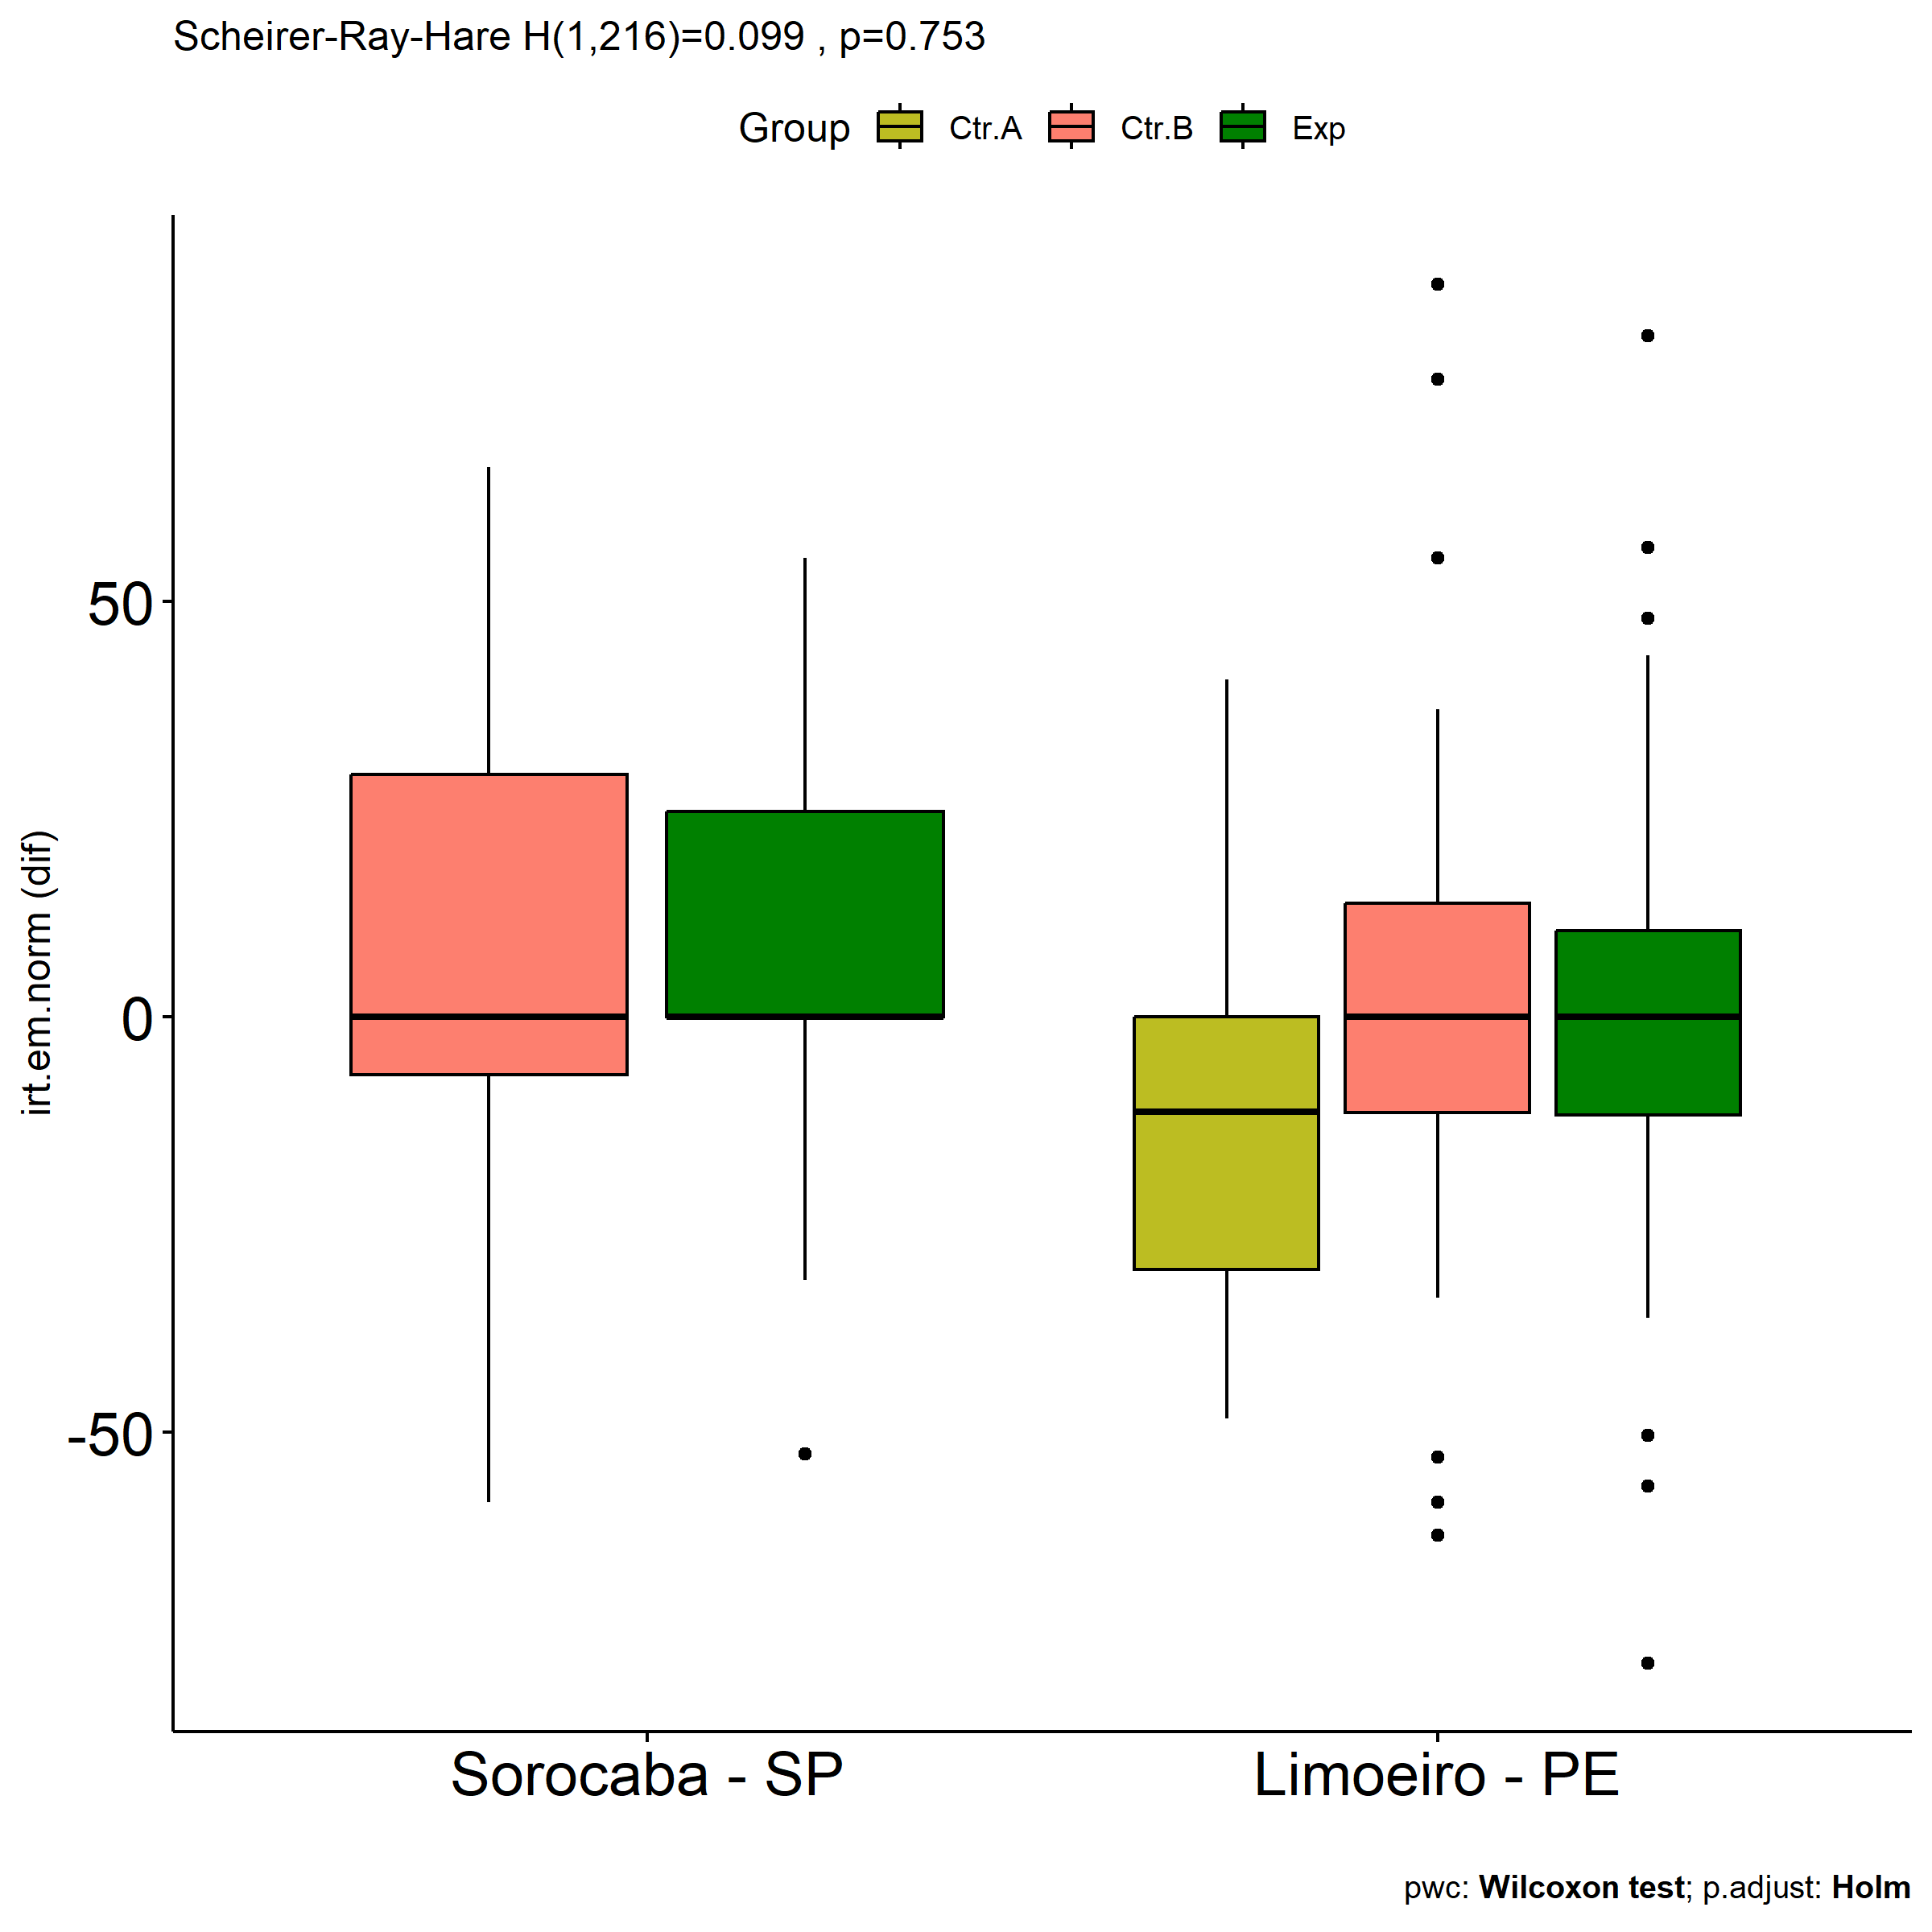

# Two-way factor analysis for: *irt.em.norm ~ Group:Degree*

pdat = remove_group_data(  
 dat[!is.na(dat[["Group"]]) & !is.na(dat[["Degree"]]),],  
 "dif.irt.em.norm", c("Group","Degree"))  
  
pdat.long <- rbind(pdat[,c("ID","Group","Degree")],  
 pdat[,c("ID","Group","Degree")])  
pdat.long[["time"]] <- c(rep("pre", nrow(pdat)), rep("pos", nrow(pdat)))  
pdat.long[["time"]] <- factor(pdat.long[["time"]], c("pre","pos"))  
pdat.long[["irt.em.norm"]] <- c(pdat[["pre.irt.em.norm"]], pdat[["pos.irt.em.norm"]])  
  
y.position.min <- abs(  
 max(pdat.long[["irt.em.norm"]])  
 - min(pdat.long[["irt.em.norm"]]))/20  
  
lvars = as.list(c("dif.irt.em.norm","pos.irt.em.norm","pre.irt.em.norm"))  
names(lvars) = unlist(lvars)

## Pre-test and Post-test PairWise comparisons for: *irt.em.norm ~ Group:Degree*

pwc.long <- group_by(pdat.long, Group:Degree) %>%  
 pairwise_wilcox_test(irt.em.norm ~ time, detailed = T)  
  
df <- pwc.long[,c(".y.","Group:Degree","group1","group2","n1","n2","estimate",  
 "statistic","p.adj","p.adj.signif")]

| .y. | Group:Degree | group1 | group2 | n1 | n2 | estimate | statistic | p.adj | p.adj.signif |
| --- | --- | --- | --- | --- | --- | --- | --- | --- | --- |
| irt.em.norm | Ctr.A:3a | pre | pos | 8 | 8 | 0.0000596 | 34.0 | 0.836 | ns |
| irt.em.norm | Ctr.A:4a | pre | pos | 6 | 6 | 6.9245501 | 22.5 | 0.520 | ns |
| irt.em.norm | Ctr.A:5a | pre | pos | 13 | 13 | 27.6709691 | 132.0 | 0.014 | * |
| irt.em.norm | Ctr.B:3a | pre | pos | 31 | 31 | 0.9884702 | 502.0 | 0.766 | ns |
| irt.em.norm | Ctr.B:4a | pre | pos | 39 | 39 | -0.0000131 | 584.0 | 0.050 | ns |
| irt.em.norm | Ctr.B:5a | pre | pos | 37 | 37 | -0.0000365 | 683.0 | 0.991 | ns |
| irt.em.norm | Exp:3a | pre | pos | 26 | 26 | -0.0000245 | 330.5 | 0.896 | ns |
| irt.em.norm | Exp:4a | pre | pos | 36 | 36 | 0.0000211 | 657.5 | 0.911 | ns |
| irt.em.norm | Exp:5a | pre | pos | 25 | 25 | 0.0000347 | 330.0 | 0.696 | ns |

stat.test <- pwc.long %>% add_xy_position(x = "Group:Degree", fun = "max")  
sidx = which(stat.test$p.adj.signif != "ns")  
stat.test$y.position[sidx] <- stat.test$y.position[sidx] + y.position.min * (1:length(sidx))  
  
pdat.long[[paste0(c("Group","Degree"), collapse = ":")]] = apply(  
 pdat.long[, c("Group","Degree")], 1, paste0, collapse = ":")  
  
ggboxplot(pdat.long, x = "Group:Degree", y = "irt.em.norm",  
 palette = color$prepost, fill = "time") +  
 stat_pvalue_manual(stat.test, tip.length = 0, hide.ns = T,  
 label = "{ p.adj } ({ p.adj.signif })") + xlab("")

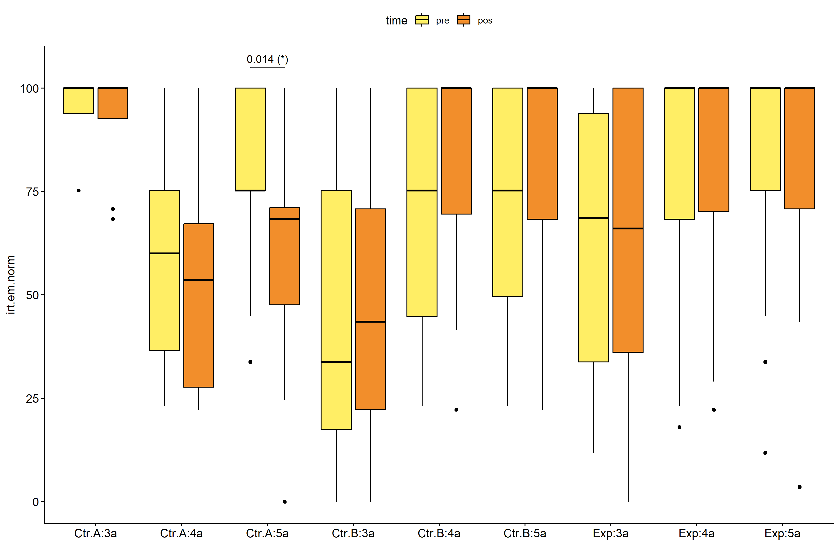

pwc.long <- group_by(pdat.long, Group, Degree) %>%  
 pairwise_wilcox_test(irt.em.norm ~ time, detailed = T)  
  
stat.test <- pwc.long %>% add_xy_position(x = "time", fun = "mean_se")  
sidx = which(stat.test$p.adj.signif != "ns")  
stat.test$y.position[sidx] <- stat.test$y.position[sidx] + y.position.min * (1:length(sidx))  
  
gg <- ggline(  
 pdat.long, x = "time", y = "irt.em.norm",  
 color = "Degree", linetype = "Degree", shape = "Degree", size = 1.5,  
 facet.by = "Group", add = c("mean_se"),  
 position = position_dodge(width = 0.3), palette = color[["Degree"]])  
  
pdat.long$xj = jitter(as.numeric(pdat.long[["time"]]), amount=.1)  
pdat.long$yj = jitter(pdat.long[["irt.em.norm"]], amount = .01)  
  
gg + geom_point(  
 data = pdat.long, aes_string(x="xj",y="yj",colour="Degree"), size=0.5) +  
 stat_pvalue_manual(  
 stat.test, tip.length = 0, hide.ns = T, label.size = 5,  
 position = position_dodge(width = 0.3), color = "Degree",  
 label = "{ p.adj } ({ p.adj.signif })") + xlab("") +  
 theme(strip.text = element_text(size = 16),  
 axis.text = element_text(size = 18))

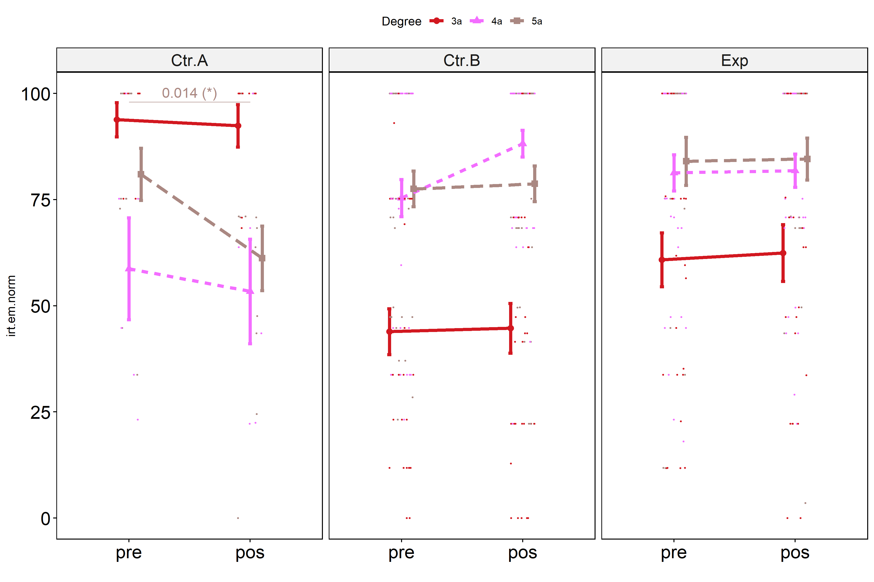

## Scheirer and Wilcoxon PairWise comparisons for: *irt.em.norm ~ Group:Degree*

sch <- lapply(lvars, FUN = function(x) {  
 scheirer.test(pdat, x, c("Group","Degree"), as.table = T)   
})  
df <- do.call(rbind.fill, sch)

| var | Effect | Df | Sum Sq | H | p.value | p.value.signif |
| --- | --- | --- | --- | --- | --- | --- |
| dif.irt.em.norm | Group | 2 | 26911.768 | 6.719417 | 0.0347454 | * |
| dif.irt.em.norm | Degree | 2 | 14484.422 | 3.616517 | 0.1639394 | ns |
| dif.irt.em.norm | Group:Degree | 4 | 21322.371 | 5.323838 | 0.2556536 | ns |
| dif.irt.em.norm | Residuals | 212 | 813992.309 |  |  |  |
| pos.irt.em.norm | Group | 2 | 7907.896 | 2.165767 | 0.3386176 | ns |
| pos.irt.em.norm | Degree | 2 | 80020.441 | 21.915521 | 0.0000174 | **** |
| pos.irt.em.norm | Group:Degree | 4 | 97078.809 | 26.587365 | 0.0000241 | **** |
| pos.irt.em.norm | Residuals | 212 | 617194.572 |  |  |  |
| pre.irt.em.norm | Group | 2 | 24566.021 | 6.580587 | 0.0372429 | * |
| pre.irt.em.norm | Degree | 2 | 83607.044 | 22.396117 | 0.0000137 | **** |
| pre.irt.em.norm | Group:Degree | 4 | 59682.678 | 15.987411 | 0.0030361 | ** |
| pre.irt.em.norm | Residuals | 212 | 654111.519 |  |  |  |

pwc <- lapply(lvars, FUN = function(x) {  
 list(  
 Group = tryCatch(pairwise_wilcox_test(group_by(pdat, Degree),  
 as.formula(paste0(x," ~ Group")))  
 , error = function(e) NULL),  
 Degree = tryCatch(pairwise_wilcox_test(group_by(pdat, Group),  
 as.formula(paste0(x," ~ Degree")))  
 , error = function(e) NULL)  
 )  
})  
  
df <- do.call(rbind.fill, lapply(pwc, FUN = function(x) {  
 do.call(rbind.fill, x)  
}))  
  
ivs = c()  
if ("Group" %in% colnames(df)) ivs = c(ivs, "Group")  
if ("Degree" %in% colnames(df)) ivs = c(ivs, "Degree")  
df <- df[,c(".y.",ivs,"group1","group2","n1","n2",  
 "statistic","p.adj","p.adj.signif")]

| .y. | Group | Degree | group1 | group2 | n1 | n2 | statistic | p.adj | p.adj.signif |
| --- | --- | --- | --- | --- | --- | --- | --- | --- | --- |
| dif.irt.em.norm |  | 3a | Ctr.A | Ctr.B | 8 | 31 | 124.5 | 1.00e+00 | ns |
| dif.irt.em.norm |  | 3a | Ctr.A | Exp | 8 | 26 | 99.0 | 1.00e+00 | ns |
| dif.irt.em.norm |  | 3a | Ctr.B | Exp | 31 | 26 | 370.0 | 1.00e+00 | ns |
| dif.irt.em.norm |  | 4a | Ctr.A | Ctr.B | 6 | 39 | 68.0 | 2.15e-01 | ns |
| dif.irt.em.norm |  | 4a | Ctr.A | Exp | 6 | 36 | 88.5 | 4.90e-01 | ns |
| dif.irt.em.norm |  | 4a | Ctr.B | Exp | 39 | 36 | 868.5 | 2.15e-01 | ns |
| dif.irt.em.norm |  | 5a | Ctr.A | Ctr.B | 13 | 37 | 156.5 | 1.27e-01 | ns |
| dif.irt.em.norm |  | 5a | Ctr.A | Exp | 13 | 25 | 82.5 | 3.60e-02 | * |
| dif.irt.em.norm |  | 5a | Ctr.B | Exp | 37 | 25 | 442.5 | 7.76e-01 | ns |
| dif.irt.em.norm | Ctr.A |  | 3a | 4a | 8 | 6 | 28.5 | 1.00e+00 | ns |
| dif.irt.em.norm | Ctr.A |  | 3a | 5a | 8 | 13 | 78.0 | 1.84e-01 | ns |
| dif.irt.em.norm | Ctr.A |  | 4a | 5a | 6 | 13 | 46.5 | 1.00e+00 | ns |
| dif.irt.em.norm | Ctr.B |  | 3a | 4a | 31 | 39 | 433.0 | 1.24e-01 | ns |
| dif.irt.em.norm | Ctr.B |  | 3a | 5a | 31 | 37 | 571.5 | 9.85e-01 | ns |
| dif.irt.em.norm | Ctr.B |  | 4a | 5a | 39 | 37 | 906.5 | 1.24e-01 | ns |
| dif.irt.em.norm | Exp |  | 3a | 4a | 26 | 36 | 488.5 | 1.00e+00 | ns |
| dif.irt.em.norm | Exp |  | 3a | 5a | 26 | 25 | 339.0 | 1.00e+00 | ns |
| dif.irt.em.norm | Exp |  | 4a | 5a | 36 | 25 | 454.5 | 1.00e+00 | ns |
| pos.irt.em.norm |  | 3a | Ctr.A | Ctr.B | 8 | 31 | 219.0 | 3.00e-03 | ** |
| pos.irt.em.norm |  | 3a | Ctr.A | Exp | 8 | 26 | 157.5 | 4.80e-02 | * |
| pos.irt.em.norm |  | 3a | Ctr.B | Exp | 31 | 26 | 282.0 | 5.10e-02 | ns |
| pos.irt.em.norm |  | 4a | Ctr.A | Ctr.B | 6 | 39 | 40.0 | 1.00e-02 | ** |
| pos.irt.em.norm |  | 4a | Ctr.A | Exp | 6 | 36 | 44.0 | 2.90e-02 | * |
| pos.irt.em.norm |  | 4a | Ctr.B | Exp | 39 | 36 | 783.0 | 3.25e-01 | ns |
| pos.irt.em.norm |  | 5a | Ctr.A | Ctr.B | 13 | 37 | 157.5 | 1.15e-01 | ns |
| pos.irt.em.norm |  | 5a | Ctr.A | Exp | 13 | 25 | 80.0 | 2.30e-02 | * |
| pos.irt.em.norm |  | 5a | Ctr.B | Exp | 37 | 25 | 395.5 | 2.91e-01 | ns |
| pos.irt.em.norm | Ctr.A |  | 3a | 4a | 8 | 6 | 42.5 | 3.30e-02 | * |
| pos.irt.em.norm | Ctr.A |  | 3a | 5a | 8 | 13 | 86.5 | 3.30e-02 | * |
| pos.irt.em.norm | Ctr.A |  | 4a | 5a | 6 | 13 | 28.0 | 3.55e-01 | ns |
| pos.irt.em.norm | Ctr.B |  | 3a | 4a | 31 | 39 | 189.5 | 8.00e-07 | **** |
| pos.irt.em.norm | Ctr.B |  | 3a | 5a | 31 | 37 | 253.5 | 1.13e-04 | *** |
| pos.irt.em.norm | Ctr.B |  | 4a | 5a | 39 | 37 | 853.0 | 1.22e-01 | ns |
| pos.irt.em.norm | Exp |  | 3a | 4a | 26 | 36 | 314.0 | 4.10e-02 | * |
| pos.irt.em.norm | Exp |  | 3a | 5a | 26 | 25 | 199.5 | 3.60e-02 | * |
| pos.irt.em.norm | Exp |  | 4a | 5a | 36 | 25 | 416.0 | 5.81e-01 | ns |
| pre.irt.em.norm |  | 3a | Ctr.A | Ctr.B | 8 | 31 | 232.0 | 4.14e-04 | *** |
| pre.irt.em.norm |  | 3a | Ctr.A | Exp | 8 | 26 | 166.0 | 2.00e-02 | * |
| pre.irt.em.norm |  | 3a | Ctr.B | Exp | 31 | 26 | 276.0 | 4.00e-02 | * |
| pre.irt.em.norm |  | 4a | Ctr.A | Ctr.B | 6 | 39 | 77.5 | 3.44e-01 | ns |
| pre.irt.em.norm |  | 4a | Ctr.A | Exp | 6 | 36 | 60.5 | 2.03e-01 | ns |
| pre.irt.em.norm |  | 4a | Ctr.B | Exp | 39 | 36 | 618.5 | 3.44e-01 | ns |
| pre.irt.em.norm |  | 5a | Ctr.A | Ctr.B | 13 | 37 | 254.0 | 7.60e-01 | ns |
| pre.irt.em.norm |  | 5a | Ctr.A | Exp | 13 | 25 | 135.5 | 7.06e-01 | ns |
| pre.irt.em.norm |  | 5a | Ctr.B | Exp | 37 | 25 | 379.5 | 5.70e-01 | ns |
| pre.irt.em.norm | Ctr.A |  | 3a | 4a | 8 | 6 | 41.0 | 6.40e-02 | ns |
| pre.irt.em.norm | Ctr.A |  | 3a | 5a | 8 | 13 | 70.0 | 2.62e-01 | ns |
| pre.irt.em.norm | Ctr.A |  | 4a | 5a | 6 | 13 | 22.0 | 2.62e-01 | ns |
| pre.irt.em.norm | Ctr.B |  | 3a | 4a | 31 | 39 | 254.5 | 4.86e-05 | **** |
| pre.irt.em.norm | Ctr.B |  | 3a | 5a | 31 | 37 | 226.5 | 4.32e-05 | **** |
| pre.irt.em.norm | Ctr.B |  | 4a | 5a | 39 | 37 | 690.0 | 7.32e-01 | ns |
| pre.irt.em.norm | Exp |  | 3a | 4a | 26 | 36 | 297.5 | 2.20e-02 | * |
| pre.irt.em.norm | Exp |  | 3a | 5a | 26 | 25 | 188.0 | 1.90e-02 | * |
| pre.irt.em.norm | Exp |  | 4a | 5a | 36 | 25 | 407.5 | 4.79e-01 | ns |

plots <- lapply(lvars, FUN = function(y) {  
 livs = list("Group", "Degree")  
 names(livs) = unlist(livs)  
 lapply(livs, FUN = function(x) {  
 iv2 = setdiff(names(livs), x)  
 if (!is.null(pwc[[y]][[iv2]])) {  
 stat.test <- pwc[[y]][[iv2]] %>% add_xy_position(x = x, fun = "max")  
 sidx = which(stat.test$p.adj.signif != "ns")  
 stat.test$y.position[sidx] <- stat.test$y.position[sidx] + y.position.min * (1:length(sidx))  
   
 ggboxplot(pdat, x = x, y = y, fill = iv2, palette = color[[iv2]]) +  
 stat_pvalue_manual(stat.test, tip.length = 0, hide.ns = T, label.size = 5,  
 label="{ p.adj } ({ p.adj.signif })") + xlab("")  
 }  
 })  
})

if (!is.null(plots[["pre.irt.em.norm"]][["Group"]]) &&  
 !is.null(plots[["pos.irt.em.norm"]][["Group"]])) {  
 egg::ggarrange(plots[["pre.irt.em.norm"]][["Group"]],  
 plots[["pos.irt.em.norm"]][["Group"]], nrow = 1)   
}

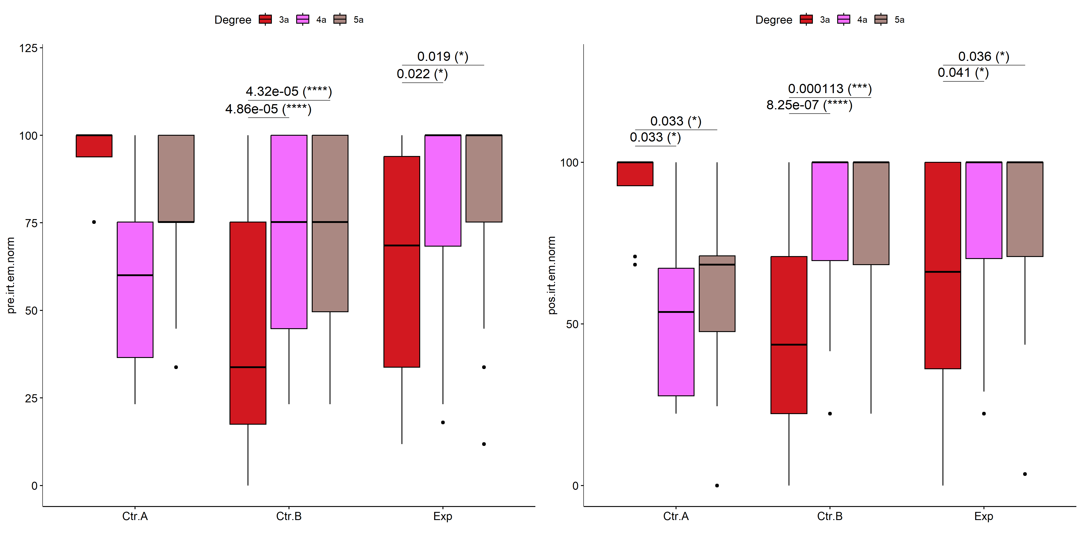

if (!is.null(plots[["pre.irt.em.norm"]][["Degree"]]) &&  
 !is.null(plots[["pos.irt.em.norm"]][["Degree"]])) {  
 egg::ggarrange(plots[["pre.irt.em.norm"]][["Degree"]],  
 plots[["pos.irt.em.norm"]][["Degree"]], nrow = 1)  
}

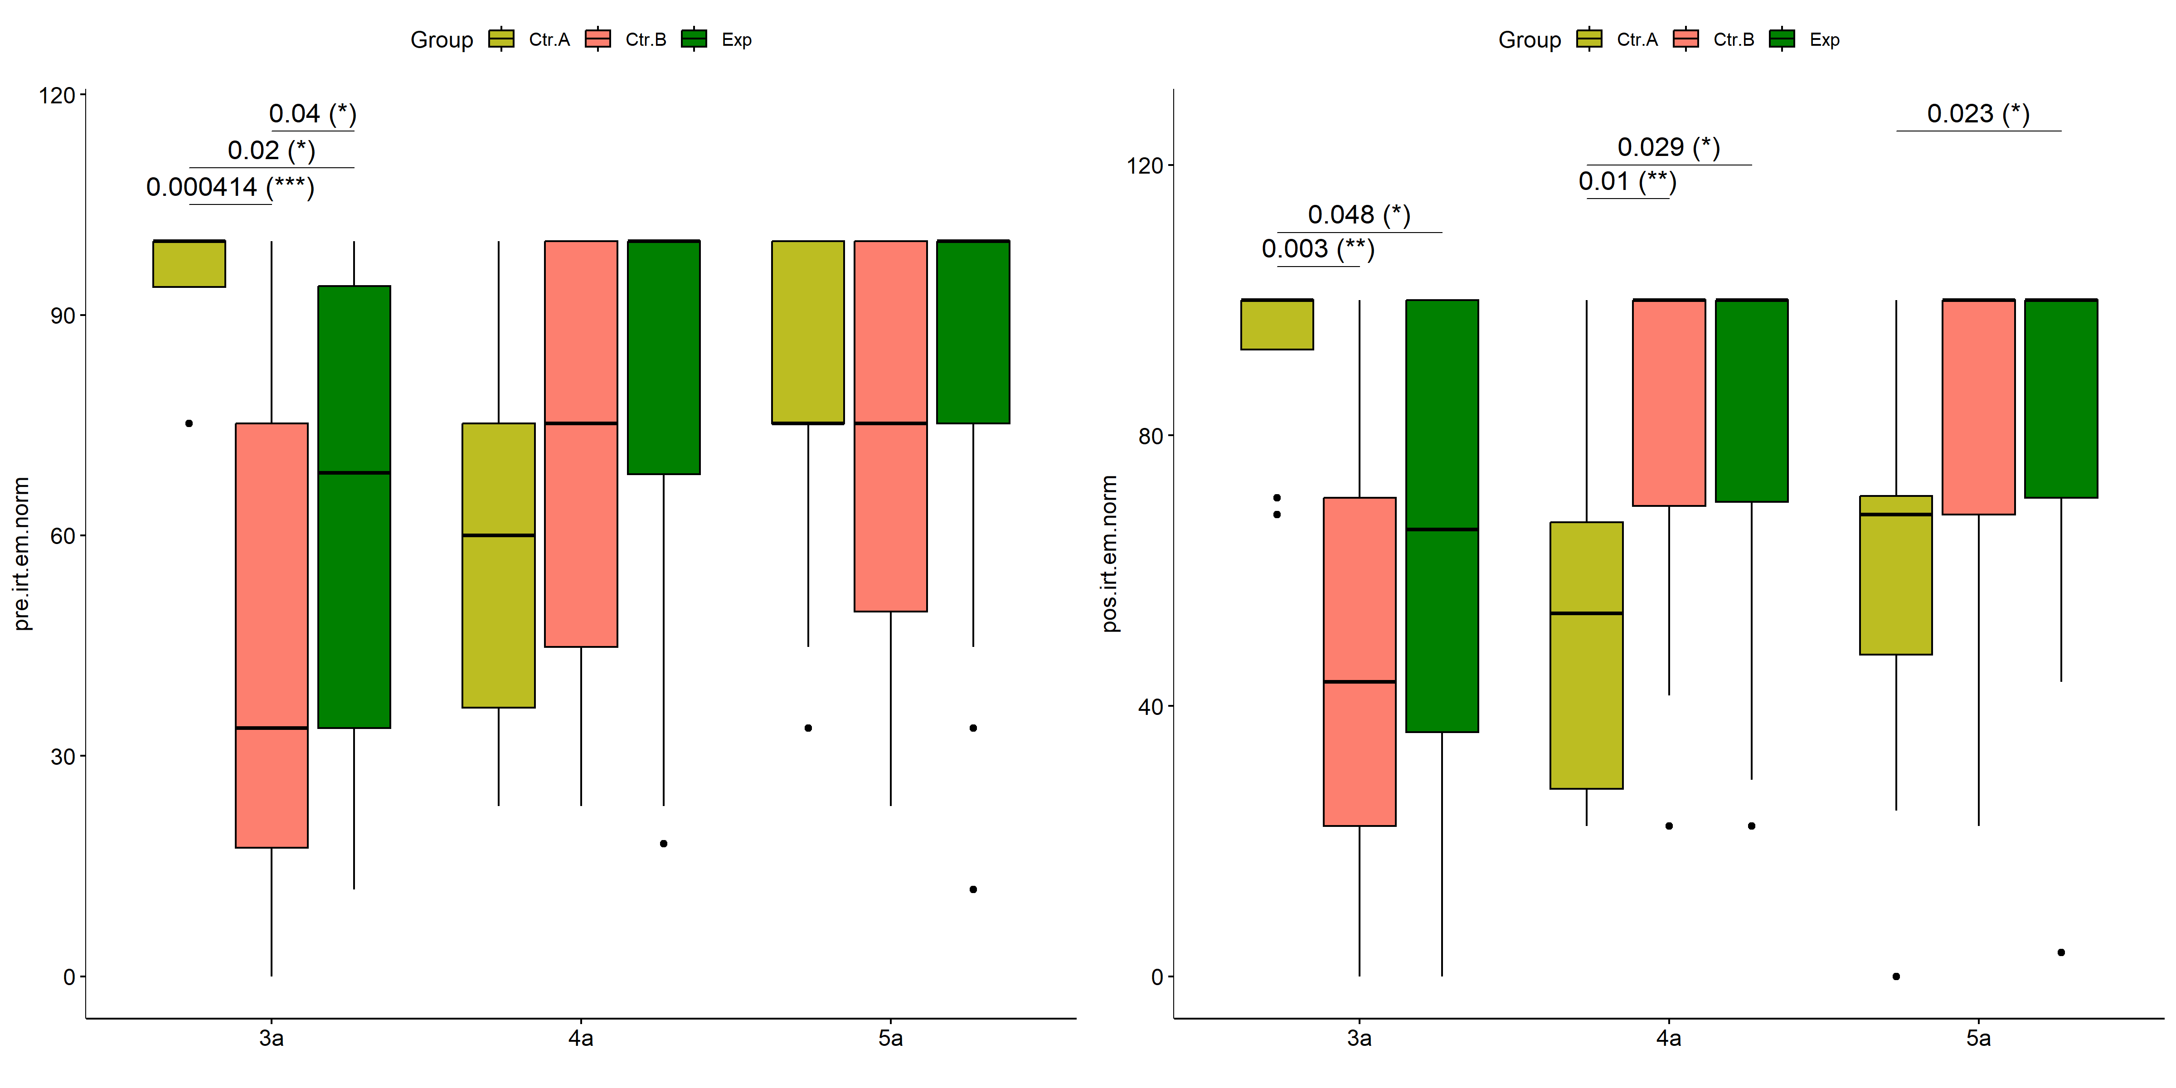

psch = sch[["dif.irt.em.norm"]]  
idx = which(psch$Effect == "Group:Degree")   
  
dof = floor(as.double(psch$Df[idx]))  
dof.res = floor(as.double(psch$Df[which(psch$Effect == "Residuals")]))  
statistic = round(as.double(psch$H[idx]), 3)  
p = round(as.double(psch[["p.value"]][idx]), 3)  
pval = ifelse(p < 0.001,paste0(" , p<0.001"),paste0(" , p=",p))  
  
if (!is.null(plots[["dif.irt.em.norm"]][["Group"]]))  
 plots[["dif.irt.em.norm"]][["Group"]] +  
 labs(subtitle = paste0("Scheirer-Ray-Hare H(", dof, ",",   
 dof.res, ")=", statistic, pval),  
 caption = get_pwc_label(pwc[["dif.irt.em.norm"]][["Degree"]])) +  
 ylab("irt.em.norm (dif)") +  
 theme(strip.text = element_text(size = 16),  
 axis.text = element_text(size = 18))

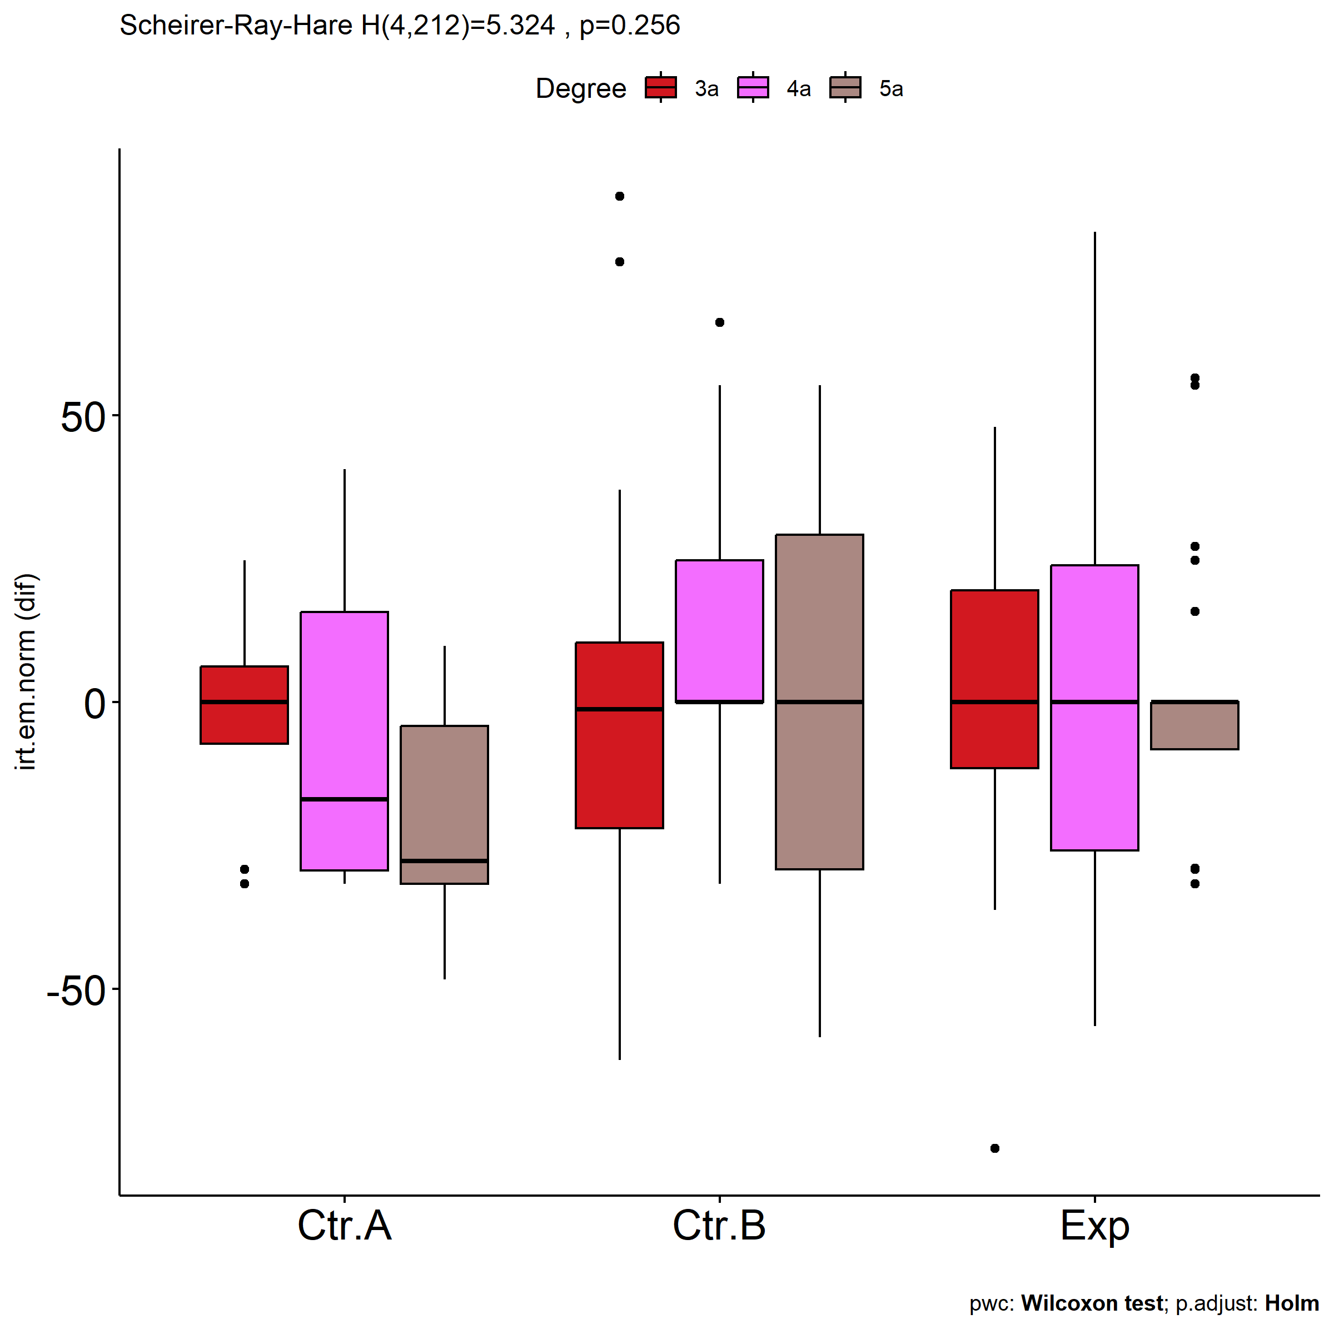

psch = sch[["dif.irt.em.norm"]]  
idx = which(psch$Effect == "Group:Degree")   
  
dof = floor(as.double(psch$Df[idx]))  
dof.res = floor(as.double(psch$Df[which(psch$Effect == "Residuals")]))  
statistic = round(as.double(psch$H[idx]), 3)  
p = round(as.double(psch[["p.value"]][idx]), 3)  
pval = ifelse(p < 0.001,paste0(" , p<0.001"),paste0(" , p=",p))  
  
if (!is.null(plots[["dif.irt.em.norm"]][["Degree"]]))  
 plots[["dif.irt.em.norm"]][["Degree"]] +  
 labs(subtitle = paste0("Scheirer-Ray-Hare H(", dof, ",",   
 dof.res, ")=", statistic, pval),  
 caption = get_pwc_label(pwc[["dif.irt.em.norm"]][["Group"]])) +  
 ylab("irt.em.norm (dif)") +  
 theme(strip.text = element_text(size = 16),  
 axis.text = element_text(size = 18))

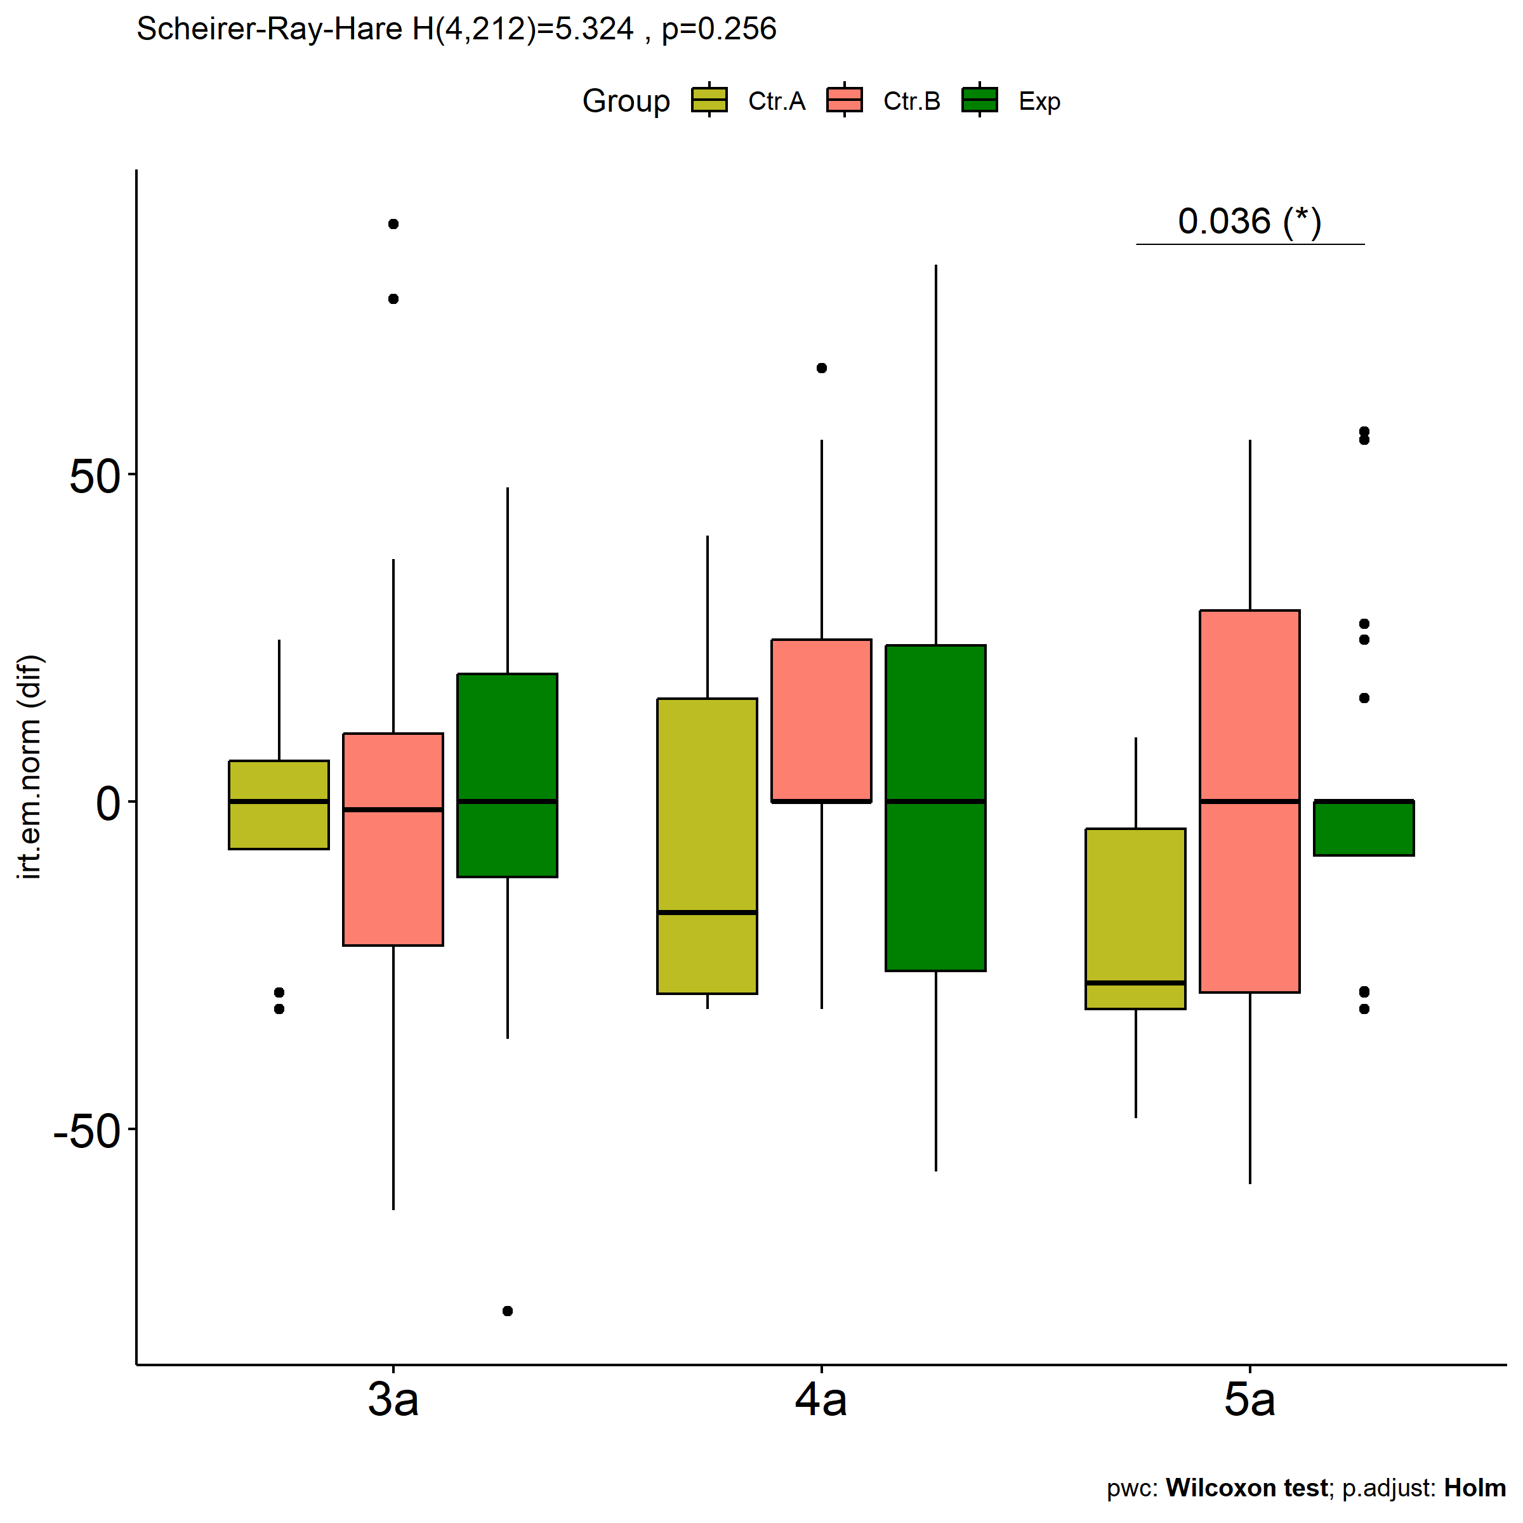

# Two-way factor analysis for: *irt.em.norm ~ Group:qtl.irt.em.norm*

pdat = remove_group_data(  
 dat[!is.na(dat[["Group"]]) & !is.na(dat[["qtl.irt.em.norm"]]),],  
 "dif.irt.em.norm", c("Group","qtl.irt.em.norm"))

## Warning: There was 1 warning in `mutate()`.  
## ℹ In argument: `ci = abs(stats::qt(alpha/2, .data$n - 1) * .data$se)`.  
## Caused by warning:  
## ! There was 1 warning in `mutate()`.  
## ℹ In argument: `ci = abs(stats::qt(alpha/2, .data$n - 1) * .data$se)`.  
## Caused by warning in `stats::qt()`:  
## ! NaNs produced

pdat.long <- rbind(pdat[,c("ID","Group","qtl.irt.em.norm")],  
 pdat[,c("ID","Group","qtl.irt.em.norm")])  
pdat.long[["time"]] <- c(rep("pre", nrow(pdat)), rep("pos", nrow(pdat)))  
pdat.long[["time"]] <- factor(pdat.long[["time"]], c("pre","pos"))  
pdat.long[["irt.em.norm"]] <- c(pdat[["pre.irt.em.norm"]], pdat[["pos.irt.em.norm"]])  
  
y.position.min <- abs(  
 max(pdat.long[["irt.em.norm"]])  
 - min(pdat.long[["irt.em.norm"]]))/20  
  
lvars = as.list(c("dif.irt.em.norm","pos.irt.em.norm","pre.irt.em.norm"))  
names(lvars) = unlist(lvars)

## Pre-test and Post-test PairWise comparisons for: *irt.em.norm ~ Group:qtl.irt.em.norm*

pwc.long <- group_by(pdat.long, Group:qtl.irt.em.norm) %>%  
 pairwise_wilcox_test(irt.em.norm ~ time, detailed = T)  
  
df <- pwc.long[,c(".y.","Group:qtl.irt.em.norm","group1","group2","n1","n2","estimate",  
 "statistic","p.adj","p.adj.signif")]

| .y. | Group:qtl.irt.em.norm | group1 | group2 | n1 | n2 | estimate | statistic | p.adj | p.adj.signif |
| --- | --- | --- | --- | --- | --- | --- | --- | --- | --- |
| irt.em.norm | Ctr.A:2nd | pre | pos | 5 | 5 | 22.3654128 | 23.0 | 0.036 | * |
| irt.em.norm | Ctr.A:3rd | pre | pos | 21 | 21 | 4.4419216 | 310.5 | 0.015 | * |
| irt.em.norm | Ctr.B:1st | pre | pos | 14 | 14 | -10.4049554 | 88.0 | 0.657 | ns |
| irt.em.norm | Ctr.B:2nd | pre | pos | 33 | 33 | -29.1990557 | 296.0 | 0.001 | ** |
| irt.em.norm | Ctr.B:3rd | pre | pos | 60 | 60 | 0.0000190 | 2189.0 | 0.021 | * |
| irt.em.norm | Exp:1st | pre | pos | 9 | 9 | -10.4049905 | 31.0 | 0.418 | ns |
| irt.em.norm | Exp:2nd | pre | pos | 21 | 21 | -26.0038865 | 131.5 | 0.025 | * |
| irt.em.norm | Exp:3rd | pre | pos | 57 | 57 | 0.0000246 | 2025.0 | 0.005 | ** |

stat.test <- pwc.long %>% add_xy_position(x = "Group:qtl.irt.em.norm", fun = "max")  
sidx = which(stat.test$p.adj.signif != "ns")  
stat.test$y.position[sidx] <- stat.test$y.position[sidx] + y.position.min * (1:length(sidx))  
  
pdat.long[[paste0(c("Group","qtl.irt.em.norm"), collapse = ":")]] = apply(  
 pdat.long[, c("Group","qtl.irt.em.norm")], 1, paste0, collapse = ":")  
  
ggboxplot(pdat.long, x = "Group:qtl.irt.em.norm", y = "irt.em.norm",  
 palette = color$prepost, fill = "time") +  
 stat_pvalue_manual(stat.test, tip.length = 0, hide.ns = T,  
 label = "{ p.adj } ({ p.adj.signif })") + xlab("")

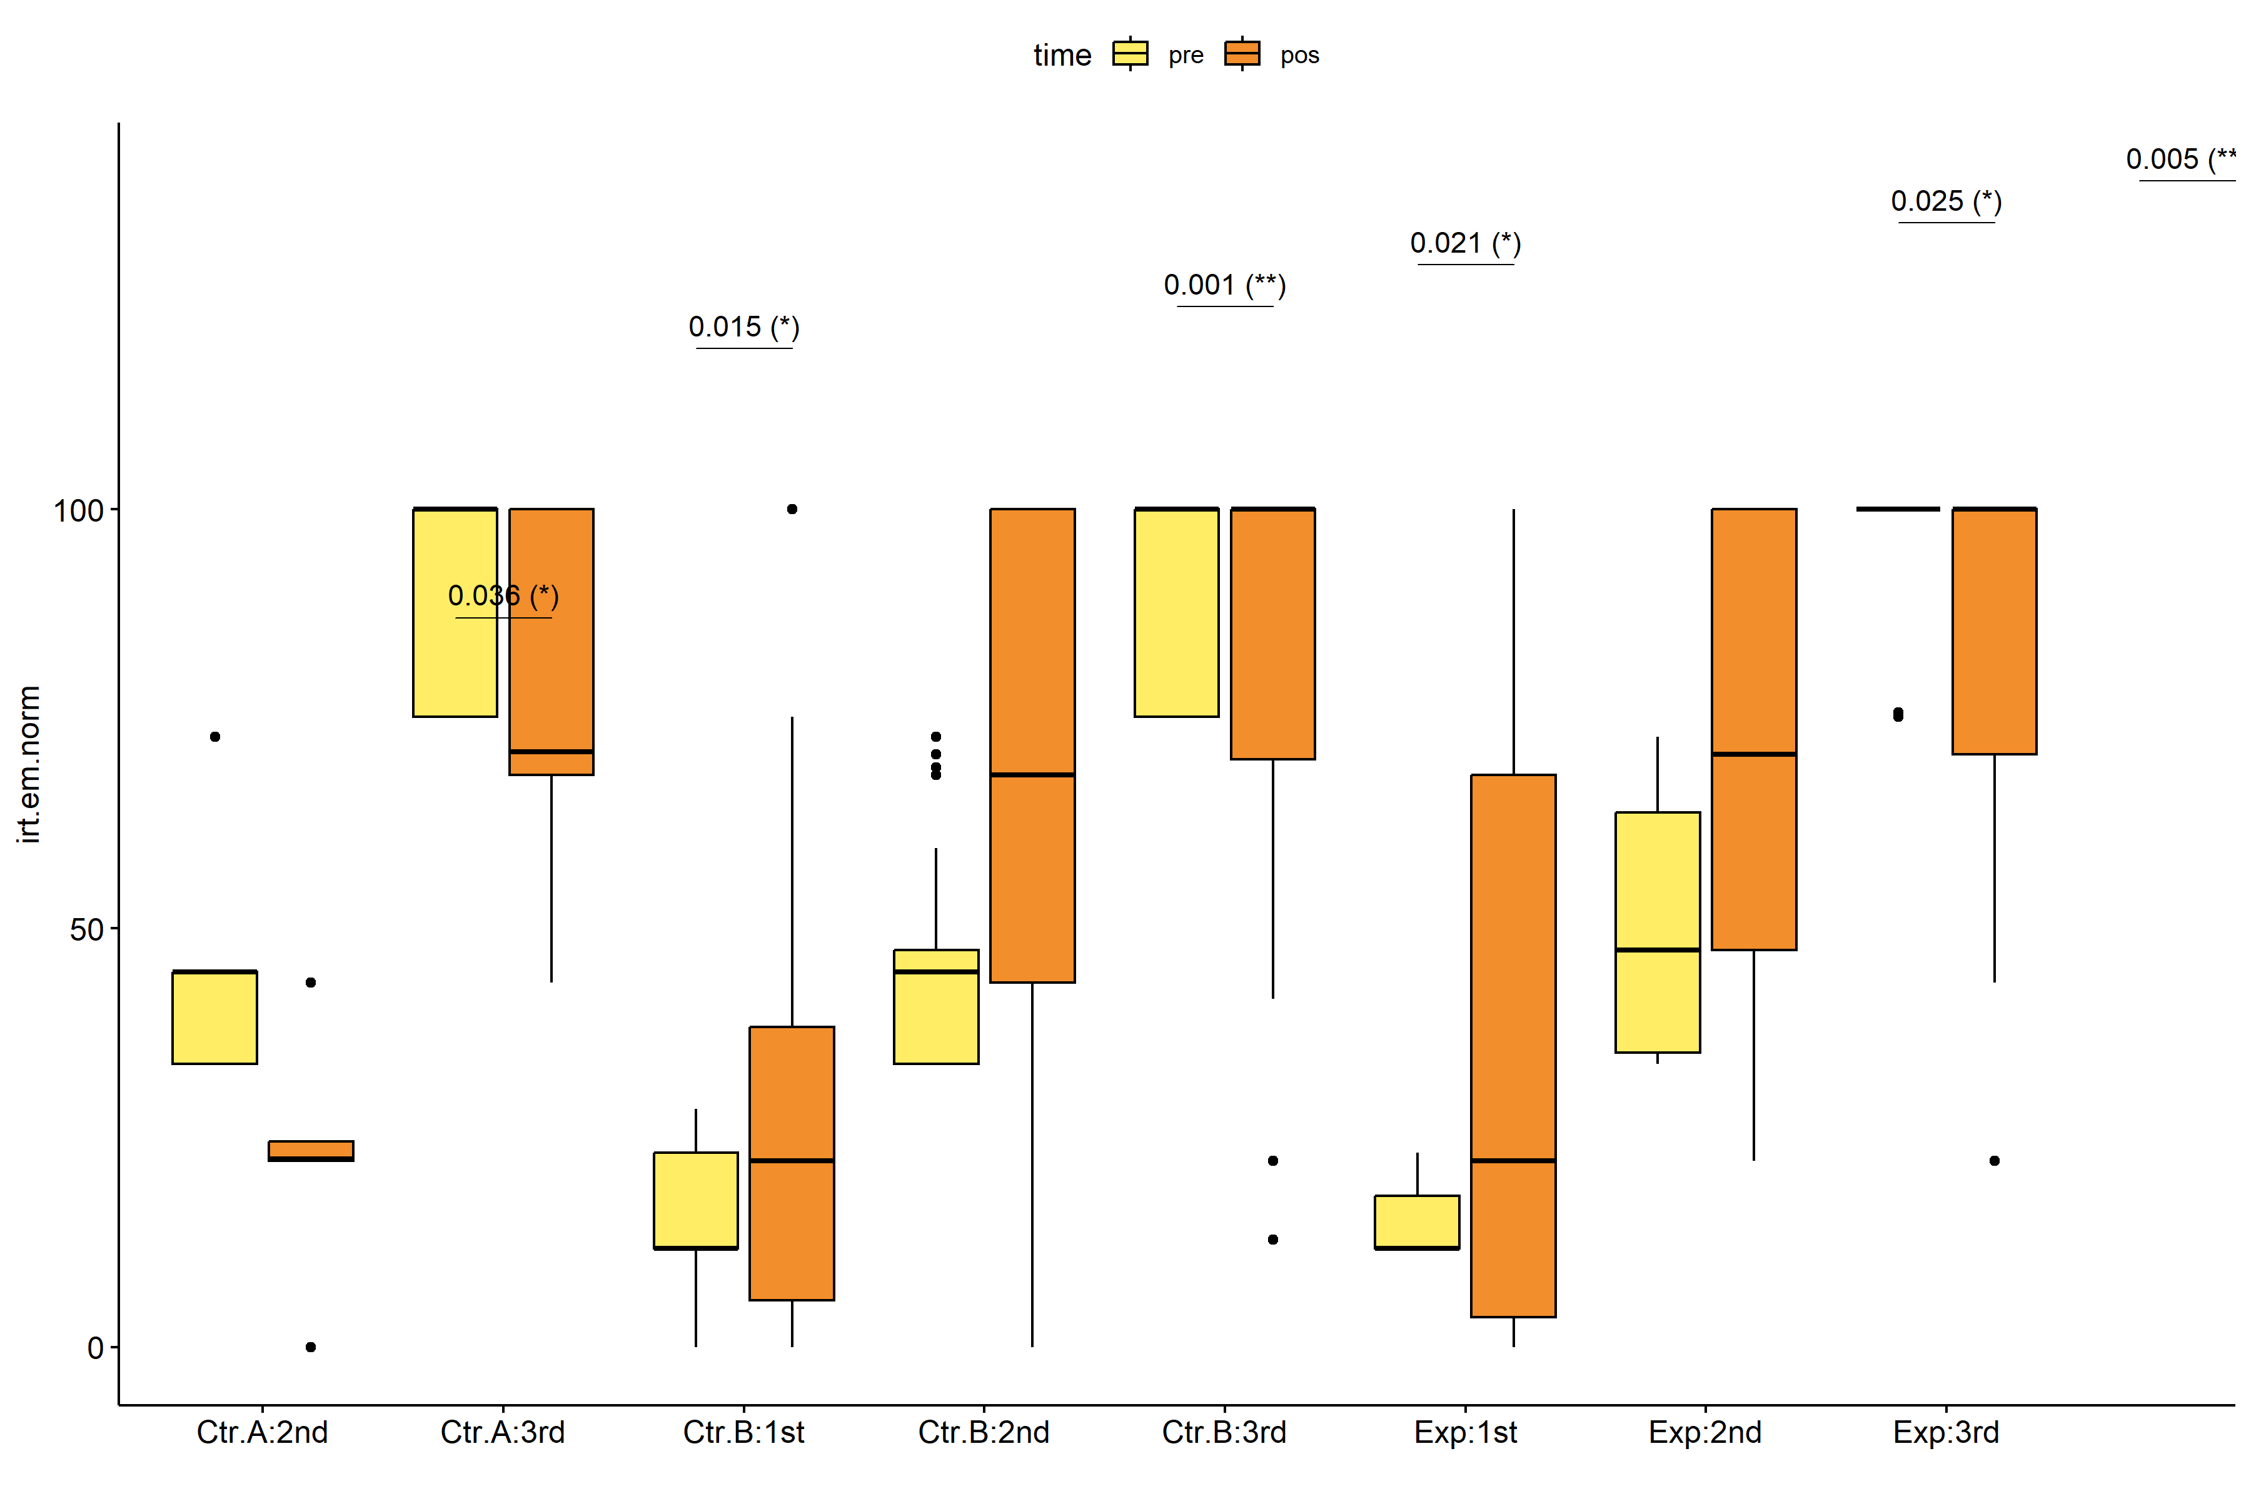

pwc.long <- group_by(pdat.long, Group, qtl.irt.em.norm) %>%  
 pairwise_wilcox_test(irt.em.norm ~ time, detailed = T)  
  
stat.test <- pwc.long %>% add_xy_position(x = "time", fun = "mean_se")  
sidx = which(stat.test$p.adj.signif != "ns")  
stat.test$y.position[sidx] <- stat.test$y.position[sidx] + y.position.min * (1:length(sidx))  
  
gg <- ggline(  
 pdat.long, x = "time", y = "irt.em.norm",  
 color = "qtl.irt.em.norm", linetype = "qtl.irt.em.norm", shape = "qtl.irt.em.norm", size = 1.5,  
 facet.by = "Group", add = c("mean_se"),  
 position = position_dodge(width = 0.3), palette = color[["qtl.irt.em.norm"]])  
  
pdat.long$xj = jitter(as.numeric(pdat.long[["time"]]), amount=.1)  
pdat.long$yj = jitter(pdat.long[["irt.em.norm"]], amount = .01)  
  
gg + geom_point(  
 data = pdat.long, aes_string(x="xj",y="yj",colour="qtl.irt.em.norm"), size=0.5) +  
 stat_pvalue_manual(  
 stat.test, tip.length = 0, hide.ns = T, label.size = 5,  
 position = position_dodge(width = 0.3), color = "qtl.irt.em.norm",  
 label = "{ p.adj } ({ p.adj.signif })") + xlab("") +  
 theme(strip.text = element_text(size = 16),  
 axis.text = element_text(size = 18))

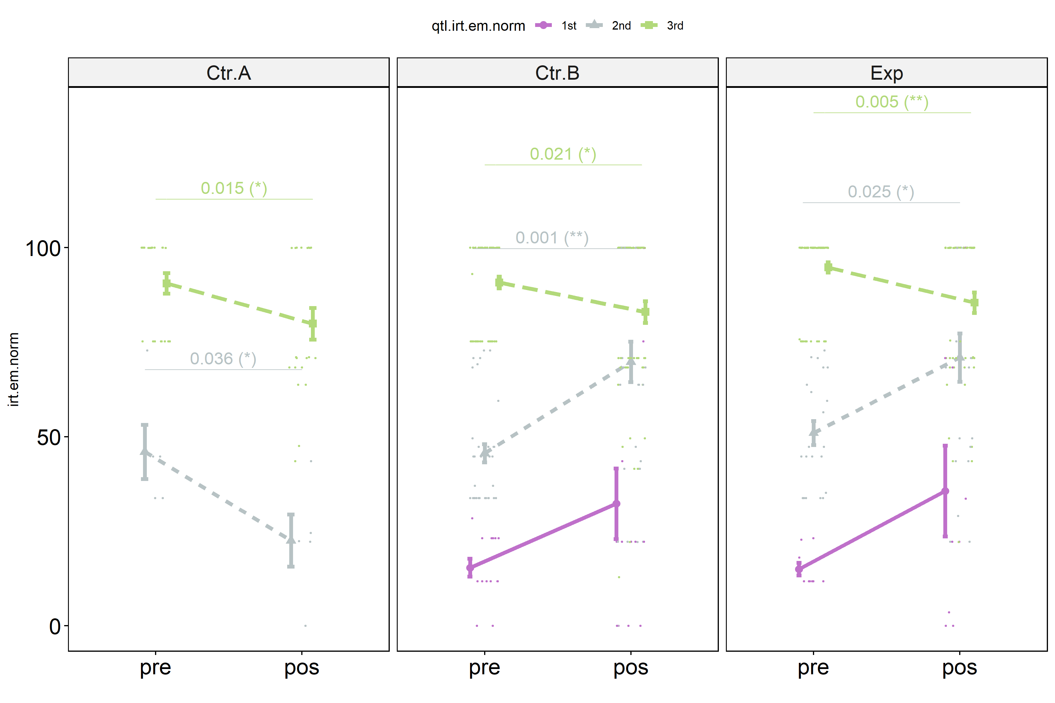

## Scheirer and Wilcoxon PairWise comparisons for: *irt.em.norm ~ Group:qtl.irt.em.norm*

sch <- lapply(lvars, FUN = function(x) {  
 scheirer.test(pdat, x, c("Group","qtl.irt.em.norm"), as.table = T)   
})  
df <- do.call(rbind.fill, sch)

| var | Effect | Df | Sum Sq | H | p.value | p.value.signif |
| --- | --- | --- | --- | --- | --- | --- |
| dif.irt.em.norm | Group | 2 | 19485.8792 | 4.9109282 | 0.0858234 | ns |
| dif.irt.em.norm | qtl.irt.em.norm | 2 | 139047.9828 | 35.0435643 | 0.0000000 | **** |
| dif.irt.em.norm | Group:qtl.irt.em.norm | 3 | 27930.1558 | 7.0390968 | 0.0706620 | ns |
| dif.irt.em.norm | Residuals | 212 | 663958.3313 |  |  |  |
| pos.irt.em.norm | Group | 2 | 15834.4428 | 4.3831038 | 0.1117432 | ns |
| pos.irt.em.norm | qtl.irt.em.norm | 2 | 162609.6499 | 45.0116864 | 0.0000000 | **** |
| pos.irt.em.norm | Group:qtl.irt.em.norm | 3 | 15323.2343 | 4.2415971 | 0.2365301 | ns |
| pos.irt.em.norm | Residuals | 212 | 605324.0056 |  |  |  |
| pre.irt.em.norm | Group | 2 | 4468.2013 | 1.2093555 | 0.5462504 | ns |
| pre.irt.em.norm | qtl.irt.em.norm | 2 | 627772.4486 | 169.9117843 | 0.0000000 | **** |
| pre.irt.em.norm | Group:qtl.irt.em.norm | 3 | 982.9899 | 0.2660543 | 0.9662810 | ns |
| pre.irt.em.norm | Residuals | 212 | 153488.8089 |  |  |  |

pwc <- lapply(lvars, FUN = function(x) {  
 list(  
 Group = tryCatch(pairwise_wilcox_test(group_by(pdat, qtl.irt.em.norm),  
 as.formula(paste0(x," ~ Group")))  
 , error = function(e) NULL),  
 qtl.irt.em.norm = tryCatch(pairwise_wilcox_test(group_by(pdat, Group),  
 as.formula(paste0(x," ~ qtl.irt.em.norm")))  
 , error = function(e) NULL)  
 )  
})  
  
df <- do.call(rbind.fill, lapply(pwc, FUN = function(x) {  
 do.call(rbind.fill, x)  
}))  
  
ivs = c()  
if ("Group" %in% colnames(df)) ivs = c(ivs, "Group")  
if ("qtl.irt.em.norm" %in% colnames(df)) ivs = c(ivs, "qtl.irt.em.norm")  
df <- df[,c(".y.",ivs,"group1","group2","n1","n2",  
 "statistic","p.adj","p.adj.signif")]

| .y. | Group | qtl.irt.em.norm | group1 | group2 | n1 | n2 | statistic | p.adj | p.adj.signif |
| --- | --- | --- | --- | --- | --- | --- | --- | --- | --- |
| dif.irt.em.norm |  | 1st | Ctr.B | Exp | 14 | 9 | 62.0 | 9.75e-01 | ns |
| dif.irt.em.norm |  | 2nd | Ctr.A | Ctr.B | 5 | 33 | 18.0 | 1.50e-02 | * |
| dif.irt.em.norm |  | 2nd | Ctr.A | Exp | 5 | 21 | 9.0 | 1.50e-02 | * |
| dif.irt.em.norm |  | 2nd | Ctr.B | Exp | 33 | 21 | 383.5 | 5.17e-01 | ns |
| dif.irt.em.norm |  | 3rd | Ctr.A | Ctr.B | 21 | 60 | 550.5 | 1.00e+00 | ns |
| dif.irt.em.norm |  | 3rd | Ctr.A | Exp | 21 | 57 | 530.0 | 1.00e+00 | ns |
| dif.irt.em.norm |  | 3rd | Ctr.B | Exp | 60 | 57 | 1738.5 | 1.00e+00 | ns |
| dif.irt.em.norm | Ctr.A |  | 2nd | 3rd | 5 | 21 | 36.0 | 2.94e-01 | ns |
| dif.irt.em.norm | Ctr.B |  | 1st | 2nd | 14 | 33 | 195.0 | 4.08e-01 | ns |
| dif.irt.em.norm | Ctr.B |  | 1st | 3rd | 14 | 60 | 597.0 | 2.60e-02 | * |
| dif.irt.em.norm | Ctr.B |  | 2nd | 3rd | 33 | 60 | 1567.0 | 9.00e-06 | **** |
| dif.irt.em.norm | Exp |  | 1st | 2nd | 9 | 21 | 88.0 | 7.86e-01 | ns |
| dif.irt.em.norm | Exp |  | 1st | 3rd | 9 | 57 | 350.0 | 1.40e-01 | ns |
| dif.irt.em.norm | Exp |  | 2nd | 3rd | 21 | 57 | 990.0 | 1.91e-05 | **** |
| pos.irt.em.norm |  | 1st | Ctr.B | Exp | 14 | 9 | 59.0 | 8.20e-01 | ns |
| pos.irt.em.norm |  | 2nd | Ctr.A | Ctr.B | 5 | 33 | 22.0 | 1.50e-02 | * |
| pos.irt.em.norm |  | 2nd | Ctr.A | Exp | 5 | 21 | 9.0 | 1.30e-02 | * |
| pos.irt.em.norm |  | 2nd | Ctr.B | Exp | 33 | 21 | 332.0 | 7.96e-01 | ns |
| pos.irt.em.norm |  | 3rd | Ctr.A | Ctr.B | 21 | 60 | 561.5 | 8.50e-01 | ns |
| pos.irt.em.norm |  | 3rd | Ctr.A | Exp | 21 | 57 | 492.0 | 5.61e-01 | ns |
| pos.irt.em.norm |  | 3rd | Ctr.B | Exp | 60 | 57 | 1605.0 | 8.50e-01 | ns |
| pos.irt.em.norm | Ctr.A |  | 2nd | 3rd | 5 | 21 | 0.5 | 6.08e-04 | *** |
| pos.irt.em.norm | Ctr.B |  | 1st | 2nd | 14 | 33 | 99.5 | 4.00e-03 | ** |
| pos.irt.em.norm | Ctr.B |  | 1st | 3rd | 14 | 60 | 125.0 | 4.41e-05 | **** |
| pos.irt.em.norm | Ctr.B |  | 2nd | 3rd | 33 | 60 | 726.0 | 2.20e-02 | * |
| pos.irt.em.norm | Exp |  | 1st | 2nd | 9 | 21 | 41.0 | 2.90e-02 | * |
| pos.irt.em.norm | Exp |  | 1st | 3rd | 9 | 57 | 67.0 | 3.36e-04 | *** |
| pos.irt.em.norm | Exp |  | 2nd | 3rd | 21 | 57 | 432.5 | 3.90e-02 | * |
| pre.irt.em.norm |  | 1st | Ctr.B | Exp | 14 | 9 | 69.5 | 6.80e-01 | ns |
| pre.irt.em.norm |  | 2nd | Ctr.A | Ctr.B | 5 | 33 | 81.0 | 9.74e-01 | ns |
| pre.irt.em.norm |  | 2nd | Ctr.A | Exp | 5 | 21 | 41.5 | 9.74e-01 | ns |
| pre.irt.em.norm |  | 2nd | Ctr.B | Exp | 33 | 21 | 275.0 | 5.91e-01 | ns |
| pre.irt.em.norm |  | 3rd | Ctr.A | Ctr.B | 21 | 60 | 627.5 | 9.80e-01 | ns |
| pre.irt.em.norm |  | 3rd | Ctr.A | Exp | 21 | 57 | 492.5 | 2.34e-01 | ns |
| pre.irt.em.norm |  | 3rd | Ctr.B | Exp | 60 | 57 | 1409.5 | 1.19e-01 | ns |
| pre.irt.em.norm | Ctr.A |  | 2nd | 3rd | 5 | 21 | 0.0 | 2.35e-04 | *** |
| pre.irt.em.norm | Ctr.B |  | 1st | 2nd | 14 | 33 | 0.0 | 1.00e-07 | **** |
| pre.irt.em.norm | Ctr.B |  | 1st | 3rd | 14 | 60 | 0.0 | 0.00e+00 | **** |
| pre.irt.em.norm | Ctr.B |  | 2nd | 3rd | 33 | 60 | 0.0 | 0.00e+00 | **** |
| pre.irt.em.norm | Exp |  | 1st | 2nd | 9 | 21 | 0.0 | 1.82e-05 | **** |
| pre.irt.em.norm | Exp |  | 1st | 3rd | 9 | 57 | 0.0 | 0.00e+00 | **** |
| pre.irt.em.norm | Exp |  | 2nd | 3rd | 21 | 57 | 0.0 | 0.00e+00 | **** |

plots <- lapply(lvars, FUN = function(y) {  
 livs = list("Group", "qtl.irt.em.norm")  
 names(livs) = unlist(livs)  
 lapply(livs, FUN = function(x) {  
 iv2 = setdiff(names(livs), x)  
 if (!is.null(pwc[[y]][[iv2]])) {  
 stat.test <- pwc[[y]][[iv2]] %>% add_xy_position(x = x, fun = "max")  
 sidx = which(stat.test$p.adj.signif != "ns")  
 stat.test$y.position[sidx] <- stat.test$y.position[sidx] + y.position.min * (1:length(sidx))  
   
 ggboxplot(pdat, x = x, y = y, fill = iv2, palette = color[[iv2]]) +  
 stat_pvalue_manual(stat.test, tip.length = 0, hide.ns = T, label.size = 5,  
 label="{ p.adj } ({ p.adj.signif })") + xlab("")  
 }  
 })  
})

if (!is.null(plots[["pre.irt.em.norm"]][["Group"]]) &&  
 !is.null(plots[["pos.irt.em.norm"]][["Group"]])) {  
 egg::ggarrange(plots[["pre.irt.em.norm"]][["Group"]],  
 plots[["pos.irt.em.norm"]][["Group"]], nrow = 1)   
}

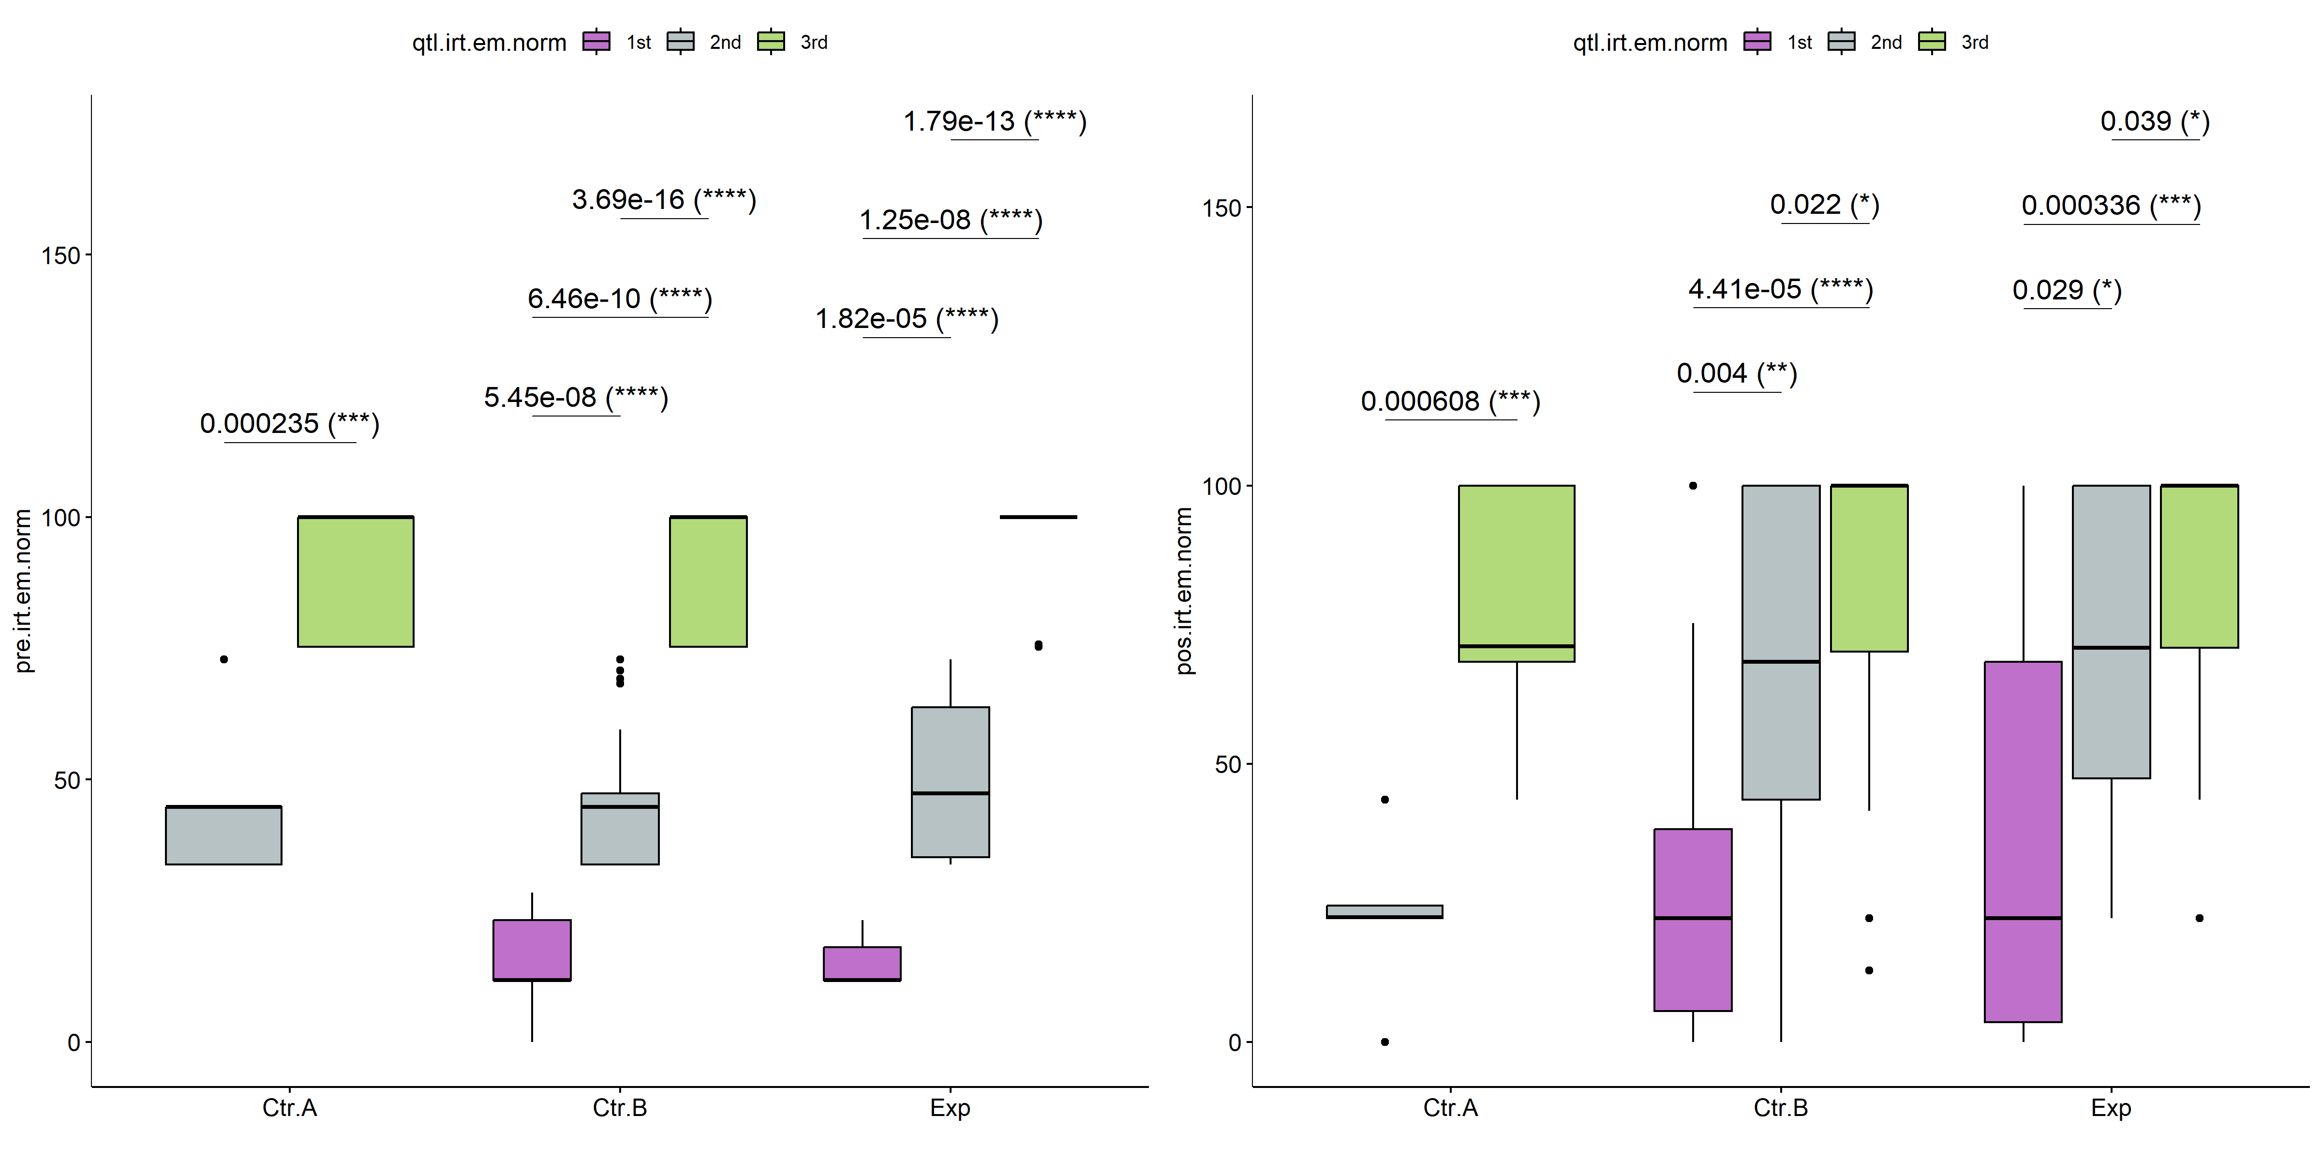

if (!is.null(plots[["pre.irt.em.norm"]][["qtl.irt.em.norm"]]) &&  
 !is.null(plots[["pos.irt.em.norm"]][["qtl.irt.em.norm"]])) {  
 egg::ggarrange(plots[["pre.irt.em.norm"]][["qtl.irt.em.norm"]],  
 plots[["pos.irt.em.norm"]][["qtl.irt.em.norm"]], nrow = 1)  
}

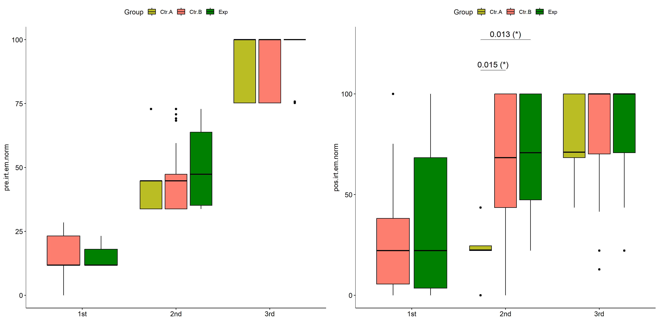

psch = sch[["dif.irt.em.norm"]]  
idx = which(psch$Effect == "Group:qtl.irt.em.norm")   
  
dof = floor(as.double(psch$Df[idx]))  
dof.res = floor(as.double(psch$Df[which(psch$Effect == "Residuals")]))  
statistic = round(as.double(psch$H[idx]), 3)  
p = round(as.double(psch[["p.value"]][idx]), 3)  
pval = ifelse(p < 0.001,paste0(" , p<0.001"),paste0(" , p=",p))  
  
if (!is.null(plots[["dif.irt.em.norm"]][["Group"]]))  
 plots[["dif.irt.em.norm"]][["Group"]] +  
 labs(subtitle = paste0("Scheirer-Ray-Hare H(", dof, ",",   
 dof.res, ")=", statistic, pval),  
 caption = get_pwc_label(pwc[["dif.irt.em.norm"]][["qtl.irt.em.norm"]])) +  
 ylab("irt.em.norm (dif)") +  
 theme(strip.text = element_text(size = 16),  
 axis.text = element_text(size = 18))

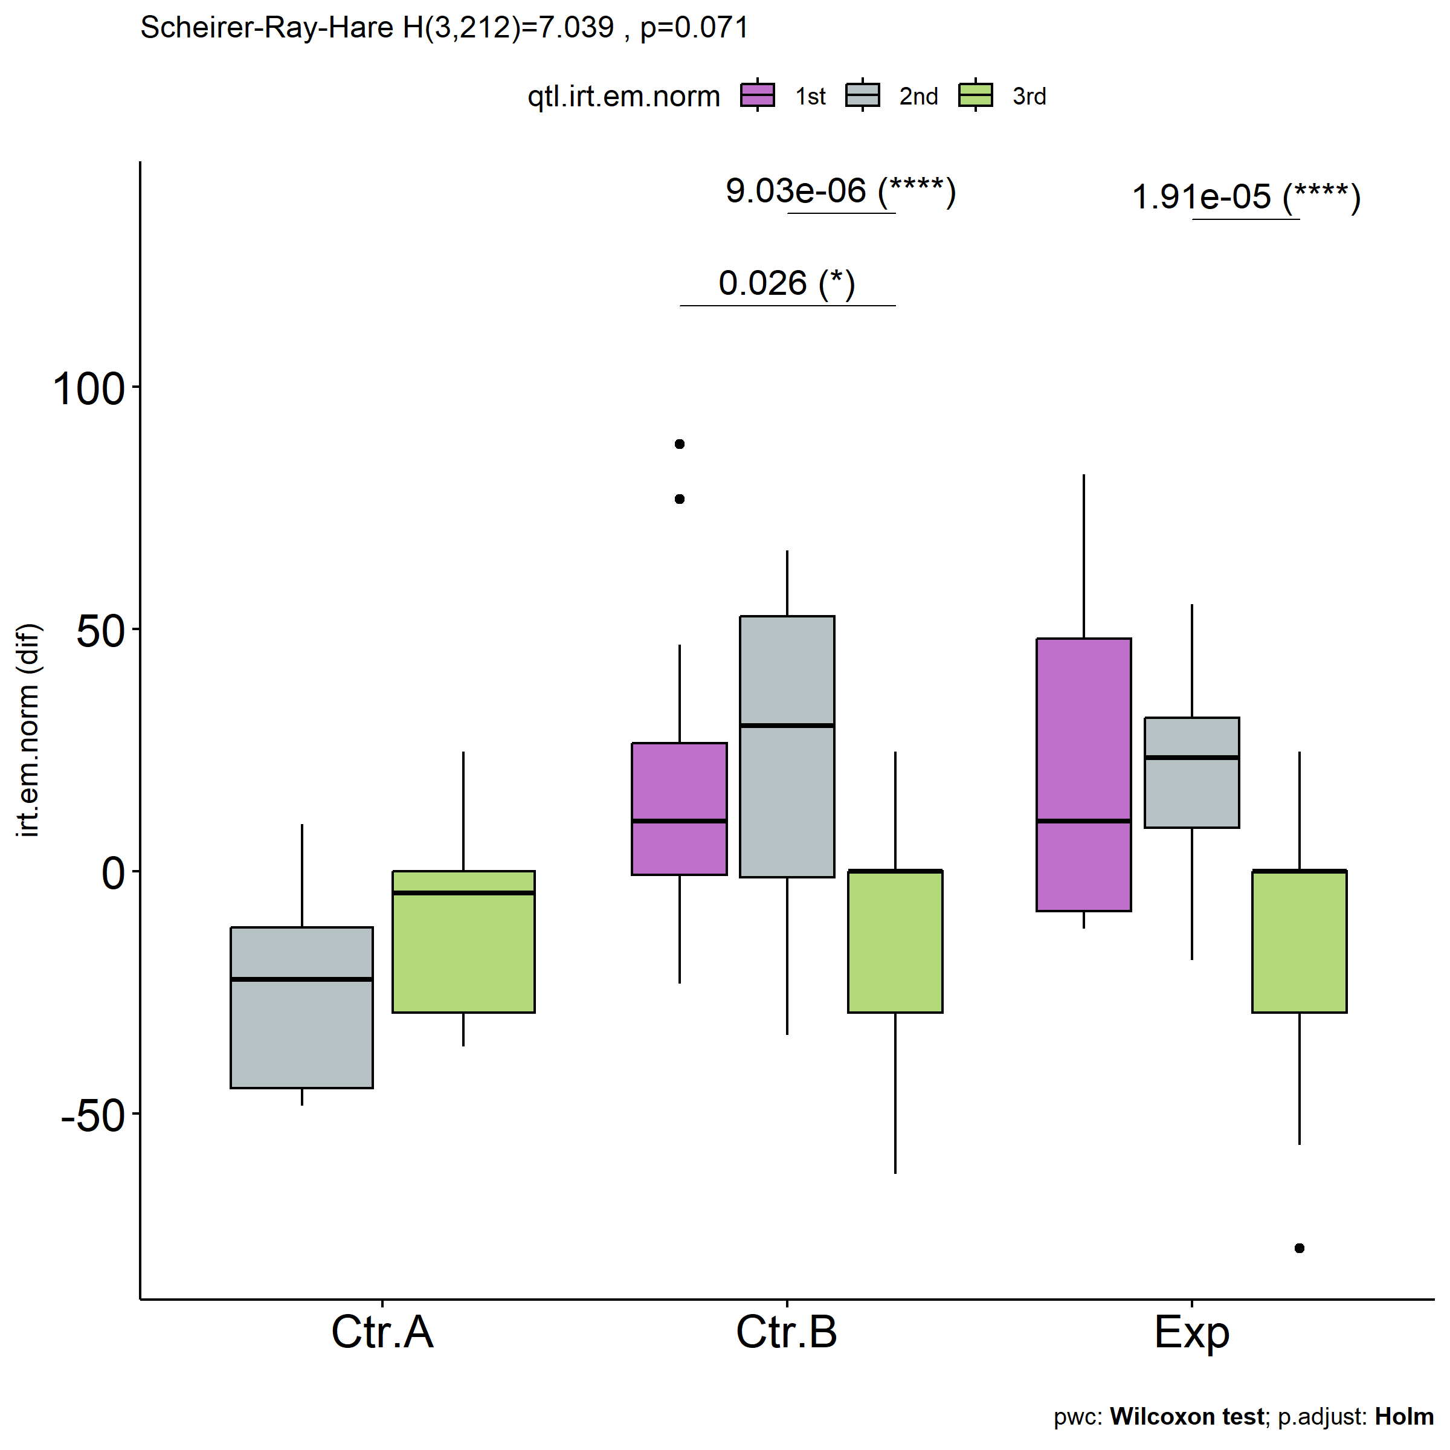

psch = sch[["dif.irt.em.norm"]]  
idx = which(psch$Effect == "Group:qtl.irt.em.norm")   
  
dof = floor(as.double(psch$Df[idx]))  
dof.res = floor(as.double(psch$Df[which(psch$Effect == "Residuals")]))  
statistic = round(as.double(psch$H[idx]), 3)  
p = round(as.double(psch[["p.value"]][idx]), 3)  
pval = ifelse(p < 0.001,paste0(" , p<0.001"),paste0(" , p=",p))  
  
if (!is.null(plots[["dif.irt.em.norm"]][["qtl.irt.em.norm"]]))  
 plots[["dif.irt.em.norm"]][["qtl.irt.em.norm"]] +  
 labs(subtitle = paste0("Scheirer-Ray-Hare H(", dof, ",",   
 dof.res, ")=", statistic, pval),  
 caption = get_pwc_label(pwc[["dif.irt.em.norm"]][["Group"]])) +  
 ylab("irt.em.norm (dif)") +  
 theme(strip.text = element_text(size = 16),  
 axis.text = element_text(size = 18))

