Non-Parametric ANCOVA tests for for assess H4(null) hypothesis

Geiser C. Challco [geiser@alumni.usp.br](mailto:geiser@alumni.usp.br)

Table of Contents

# Setting Initial Variables

dv = "irt.em.norm"  
dv.pos = "pos.irt.em.norm"  
dv.pre = "pre.irt.em.norm"  
dv.dif = "dif.irt.em.norm"  
  
fatores2 <- c("Gender","Town","Degree","qtl.irt.em.norm")  
lfatores2 <- as.list(fatores2)  
names(lfatores2) <- fatores2  
  
fatores1 <- c("Group", fatores2)  
lfatores1 <- as.list(fatores1)  
names(lfatores1) <- fatores1  
  
lfatores <- c(lfatores1)  
  
color <- list()  
color[["prepost"]] = c("#ffee65","#f28e2B")  
color[["Group"]] = c("#bcbd22","#fd7f6f","#008000")  
color[["Gender"]] = c("#FF007F","#4D4DFF")  
color[["Town"]] = c("#AA00CC","#00AA99")  
color[["Degree"]] = c("#d21820","#f36dff","#aa8882")  
  
  
level <- list()  
level[["Group"]] = c("Ctr.A","Ctr.B","Exp")  
level[["Gender"]] = c("Female","Male")  
level[["Town"]] = c("Sorocaba - SP","Limoeiro - PE")  
level[["Degree"]] = c("3a","4a","5a")  
level[["qtl.irt.em.norm"]] = c("1st","2nd","3rd")  
level[["qtl.score"]] = c("1st","2nd","3rd")  
  
# ..  
  
color[["Group:Gender"]] = c(  
 "Ctr.A:Female"="#ffccbb", "Ctr.B:Female"="#ff99cc", "Exp:Female"="#FF007F",  
 "Ctr.A:Male"="#aabbff", "Ctr.B:Male"="#bbaaff", "Exp:Male"="#4D4DFF",  
 "Ctr.A.Female"="#ffccbb", "Ctr.B.Female"="#ff99cc", "Exp.Female"="#FF007F",  
 "Ctr.A.Male"="#aabbff", "Ctr.B.Male"="#bbaaff", "Exp.Male"="#4D4DFF"  
)  
color[["Group:Town"]] = c(  
 "Ctr.A:Sorocaba - SP"="#AA00FF", "Ctr.B:Sorocaba - SP"="#FF00FF", "Exp:Sorocaba - SP"="#AA00FF",  
 "Ctr.A:Limoeiro - PE"="#00EEFF", "Ctr.B:Limoeiro - PE"="#00EECC", "Exp:Limoeiro - PE"="#00CFCF",  
 "Ctr.A.Sorocaba - SP"="#AA00FF", "Ctr.B.Sorocaba - SP"="#FF00FF", "Exp.Sorocaba - SP"="#AA00FF",  
 "Ctr.A.Limoeiro - PE"="#00EEFF", "Ctr.B.Limoeiro - PE"="#00EECC", "Exp.Limoeiro - PE"="#00CFCF"  
)  
  
  
for (coln in c("vocab")) {  
 color[[paste0(coln,".quintile")]] = c("#BF0040","#FF0000","#800080","#0000FF","#4000BF")  
 level[[paste0(coln,".quintile")]] = c("1st quintile","2nd quintile","3rd quintile","4th quintile","5th quintile")  
 color[[paste0("grupo:",coln,".quintile")]] = c(  
 "Experimental.1st quintile"="#BF0040", "Controle.1st quintile"="#d8668c",  
 "Experimental.2nd quintile"="#FF0000", "Controle.2nd quintile"="#ff7f7f",  
 "Experimental.3rd quintile"="#8fce00", "Controle.3rd quintile"="#ddf0b2",  
 "Experimental.4th quintile"="#0000FF", "Controle.4th quintile"="#b2b2ff",  
 "Experimental.5th quintile"="#4000BF", "Controle.5th quintile"="#b299e5",  
   
 "Experimental:1st quintile"="#BF0040", "Controle:1st quintile"="#d8668c",  
 "Experimental:2nd quintile"="#FF0000", "Controle:2nd quintile"="#ff7f7f",  
 "Experimental:3rd quintile"="#8fce00", "Controle:3rd quintile"="#ddf0b2",  
 "Experimental:4th quintile"="#0000FF", "Controle:4th quintile"="#b2b2ff",  
 "Experimental:5th quintile"="#4000BF", "Controle:5th quintile"="#b299e5")  
}  
  
  
gdat <- read_excel("../data/data.xlsx", sheet = "data")  
gdat <- gdat[!is.na(gdat[[dv.pre]]) & !is.na(gdat[[dv.pos]]),]  
  
gdat <- gdat[which(gdat$dif.irt.em.norm != 0 & gdat$pre.irt.em.norm != 100),]  
  
dat <- gdat  
dat$Group <- factor(dat[["Group"]], level[["Group"]])  
for (coln in c(names(lfatores))) {  
 if (length(level[[coln]]) > 0)  
 plevel = level[[coln]][level[[coln]] %in% unique(dat[[coln]])]  
 else  
 plevel = unique(dat[[coln]])[!is.na(unique(dat[[coln]]))]  
   
 dat[[coln]] <- factor(dat[[coln]], plevel)  
}  
  
dat <- dat[,c("ID", names(lfatores), dv.pre, dv.pos, dv.dif)]  
  
dat.long <- rbind(dat, dat)  
dat.long$time <- c(rep("pre", nrow(dat)), rep("pos", nrow(dat)))  
dat.long$time <- factor(dat.long$time, c("pre","pos"))  
dat.long[[dv]] <- c(dat[[dv.pre]], dat[[dv.pos]])  
  
  
for (f in c("Group", names(lfatores))) {  
 if (is.null(color[[f]]) && length(unique(dat[[f]])) > 0)   
 color[[f]] <- distinctColorPalette(length(unique(dat[[f]])))  
}  
  
for (f in c(fatores2)) {  
 if (is.null(color[[paste0("Group:",f)]]) && length(unique(dat[[f]])) > 0)  
 color[[paste0("Group:",f)]] <- distinctColorPalette(  
 length(unique(dat[["Group"]]))*length(unique(dat[[f]])))  
}  
  
ldat <- list()  
laov <- list()  
lpwc <- list()  
lemms <- list()

# Descriptive Statistics of Initial Data

df <- get.descriptives(dat, c(dv.pre, dv.pos, dv.dif), c("Group"),  
 symmetry.test = T, normality.test = F)  
df <- plyr::rbind.fill(  
 df, do.call(plyr::rbind.fill, lapply(lfatores2, FUN = function(f) {  
 if (nrow(dat) > 0 && sum(!is.na(unique(dat[[f]]))) > 1)  
 get.descriptives(dat, c(dv.pre,dv.pos), c("Group", f), include.global = F,  
 symmetry.test = T, normality.test = F)  
 }))  
)

## Warning: There was 1 warning in `mutate()`.  
## ℹ In argument: `ci = abs(stats::qt(alpha/2, .data$n - 1) * .data$se)`.  
## Caused by warning:  
## ! There was 1 warning in `mutate()`.  
## ℹ In argument: `ci = abs(stats::qt(alpha/2, .data$n - 1) * .data$se)`.  
## Caused by warning in `stats::qt()`:  
## ! NaNs produced  
## There was 1 warning in `mutate()`.  
## ℹ In argument: `ci = abs(stats::qt(alpha/2, .data$n - 1) * .data$se)`.  
## Caused by warning:  
## ! There was 1 warning in `mutate()`.  
## ℹ In argument: `ci = abs(stats::qt(alpha/2, .data$n - 1) * .data$se)`.  
## Caused by warning in `stats::qt()`:  
## ! NaNs produced  
## There was 1 warning in `mutate()`.  
## ℹ In argument: `ci = abs(stats::qt(alpha/2, .data$n - 1) * .data$se)`.  
## Caused by warning:  
## ! There was 1 warning in `mutate()`.  
## ℹ In argument: `ci = abs(stats::qt(alpha/2, .data$n - 1) * .data$se)`.  
## Caused by warning in `stats::qt()`:  
## ! NaNs produced  
## There was 1 warning in `mutate()`.  
## ℹ In argument: `ci = abs(stats::qt(alpha/2, .data$n - 1) * .data$se)`.  
## Caused by warning:  
## ! There was 1 warning in `mutate()`.  
## ℹ In argument: `ci = abs(stats::qt(alpha/2, .data$n - 1) * .data$se)`.  
## Caused by warning in `stats::qt()`:  
## ! NaNs produced

df <- df[,c("variable",fatores1[fatores1 %in% colnames(df)],  
 colnames(df)[!colnames(df) %in% c(fatores1,"variable")])]

| variable | Group | Gender | Town | Degree | qtl.irt.em.norm | n | mean | median | min | max | sd | se | ci | iqr | symmetry | skewness | kurtosis |
| --- | --- | --- | --- | --- | --- | --- | --- | --- | --- | --- | --- | --- | --- | --- | --- | --- | --- |
| pre.irt.em.norm | Ctr.A |  |  |  |  | 14 | 61.082 | 75.243 | 23.198 | 75.243 | 20.000 | 5.345 | 11.547 | 30.446 | NO | -0.7087597 | -1.3689578 |
| pre.irt.em.norm | Ctr.B |  |  |  |  | 68 | 51.016 | 47.360 | 11.805 | 93.027 | 22.941 | 2.782 | 5.553 | 41.467 | YES | -0.1454210 | -1.3896233 |
| pre.irt.em.norm | Exp |  |  |  |  | 42 | 50.220 | 51.925 | 11.805 | 75.781 | 23.735 | 3.662 | 7.396 | 41.467 | YES | -0.3646594 | -1.4015677 |
| pos.irt.em.norm | Ctr.A |  |  |  |  | 14 | 55.233 | 55.682 | 0.000 | 100.000 | 31.798 | 8.498 | 18.359 | 41.720 | YES | 0.0127877 | -1.2696808 |
| pos.irt.em.norm | Ctr.B |  |  |  |  | 68 | 66.967 | 68.318 | 0.000 | 100.000 | 32.760 | 3.973 | 7.930 | 58.460 | YES | -0.4861066 | -1.1182797 |
| pos.irt.em.norm | Exp |  |  |  |  | 42 | 66.882 | 69.560 | 0.000 | 100.000 | 33.243 | 5.129 | 10.359 | 56.467 | YES | -0.4824511 | -1.1061834 |
| dif.irt.em.norm | Ctr.A |  |  |  |  | 14 | -5.850 | -7.947 | -48.335 | 40.593 | 27.762 | 7.420 | 16.029 | 47.352 | YES | 0.0723598 | -1.3581213 |
| dif.irt.em.norm | Ctr.B |  |  |  |  | 68 | 15.951 | 24.757 | -62.411 | 88.195 | 30.115 | 3.652 | 7.289 | 36.834 | YES | -0.0672311 | -0.2059701 |
| dif.irt.em.norm | Exp |  |  |  |  | 42 | 16.662 | 22.688 | -31.710 | 81.972 | 25.131 | 3.878 | 7.831 | 33.925 | YES | 0.2342158 | -0.3658467 |
| pre.irt.em.norm | Ctr.A | Female |  |  |  | 9 | 61.470 | 75.243 | 23.198 | 75.243 | 21.354 | 7.118 | 16.414 | 30.446 | NO | -0.7560725 | -1.3824688 |
| pre.irt.em.norm | Ctr.A | Male |  |  |  | 5 | 60.385 | 72.864 | 33.776 | 75.243 | 19.674 | 8.798 | 24.428 | 30.446 | YES | -0.3709082 | -2.0895003 |
| pre.irt.em.norm | Ctr.B | Female |  |  |  | 36 | 49.292 | 44.797 | 11.805 | 75.243 | 23.402 | 3.900 | 7.918 | 41.467 | YES | -0.1219004 | -1.5262112 |
| pre.irt.em.norm | Ctr.B | Male |  |  |  | 31 | 53.915 | 49.610 | 11.805 | 93.027 | 22.326 | 4.010 | 8.189 | 41.467 | YES | -0.2119987 | -1.2883002 |
| pre.irt.em.norm | Ctr.B |  |  |  |  | 1 | 23.198 | 23.198 | 23.198 | 23.198 |  |  |  | 0.000 | few data | 0.0000000 | 0.0000000 |
| pre.irt.em.norm | Exp | Female |  |  |  | 18 | 51.025 | 46.078 | 11.805 | 75.243 | 23.308 | 5.494 | 11.591 | 41.467 | YES | -0.2208823 | -1.6169865 |
| pre.irt.em.norm | Exp | Male |  |  |  | 20 | 51.809 | 60.672 | 11.805 | 75.781 | 24.233 | 5.419 | 11.342 | 38.651 | NO | -0.6328965 | -1.2099954 |
| pre.irt.em.norm | Exp |  |  |  |  | 4 | 38.650 | 33.776 | 11.805 | 75.243 | 26.503 | 13.251 | 42.172 | 15.860 | few data | 0.0000000 | 0.0000000 |
| pos.irt.em.norm | Ctr.A | Female |  |  |  | 9 | 59.915 | 63.791 | 0.000 | 100.000 | 32.883 | 10.961 | 25.276 | 23.494 | YES | -0.4341981 | -1.0875306 |
| pos.irt.em.norm | Ctr.A | Male |  |  |  | 5 | 46.805 | 43.533 | 22.432 | 100.000 | 31.390 | 14.038 | 38.976 | 19.005 | NO | 0.8077339 | -1.2271576 |
| pos.irt.em.norm | Ctr.B | Female |  |  |  | 36 | 60.168 | 68.318 | 0.000 | 100.000 | 35.146 | 5.858 | 11.892 | 77.790 | YES | -0.1804006 | -1.5343996 |
| pos.irt.em.norm | Ctr.B | Male |  |  |  | 31 | 77.024 | 70.801 | 22.210 | 100.000 | 25.421 | 4.566 | 9.324 | 36.209 | NO | -0.5950995 | -0.9043817 |
| pos.irt.em.norm | Ctr.B |  |  |  |  | 1 | 0.000 | 0.000 | 0.000 | 0.000 |  |  |  | 0.000 | few data | 0.0000000 | 0.0000000 |
| pos.irt.em.norm | Exp | Female |  |  |  | 18 | 68.564 | 68.318 | 22.210 | 100.000 | 27.260 | 6.425 | 13.556 | 55.510 | YES | -0.1592713 | -1.4519300 |
| pos.irt.em.norm | Exp | Male |  |  |  | 20 | 71.346 | 87.741 | 0.000 | 100.000 | 34.888 | 7.801 | 16.328 | 50.953 | NO | -0.7836514 | -0.7802592 |
| pos.irt.em.norm | Exp |  |  |  |  | 4 | 36.989 | 22.210 | 3.538 | 100.000 | 42.919 | 21.460 | 68.294 | 24.115 | few data | 0.0000000 | 0.0000000 |
| pre.irt.em.norm | Ctr.A |  | Limoeiro - PE |  |  | 14 | 61.082 | 75.243 | 23.198 | 75.243 | 20.000 | 5.345 | 11.547 | 30.446 | NO | -0.7087597 | -1.3689578 |
| pre.irt.em.norm | Ctr.B |  | Sorocaba - SP |  |  | 26 | 59.953 | 70.801 | 28.443 | 75.243 | 17.343 | 3.401 | 7.005 | 27.883 | YES | -0.4899631 | -1.5257343 |
| pre.irt.em.norm | Ctr.B |  | Limoeiro - PE |  |  | 42 | 45.484 | 35.424 | 11.805 | 93.027 | 24.385 | 3.763 | 7.599 | 49.400 | YES | 0.2276511 | -1.3824847 |
| pre.irt.em.norm | Exp |  | Sorocaba - SP |  |  | 13 | 61.318 | 68.318 | 44.797 | 75.243 | 13.163 | 3.651 | 7.954 | 23.706 | YES | -0.2828356 | -1.8876353 |
| pre.irt.em.norm | Exp |  | Limoeiro - PE |  |  | 29 | 45.245 | 35.152 | 11.805 | 75.781 | 25.843 | 4.799 | 9.830 | 52.453 | YES | -0.0014812 | -1.7087455 |
| pos.irt.em.norm | Ctr.A |  | Limoeiro - PE |  |  | 14 | 55.233 | 55.682 | 0.000 | 100.000 | 31.798 | 8.498 | 18.359 | 41.720 | YES | 0.0127877 | -1.2696808 |
| pos.irt.em.norm | Ctr.B |  | Sorocaba - SP |  |  | 26 | 89.615 | 100.000 | 22.210 | 100.000 | 19.487 | 3.822 | 7.871 | 18.568 | NO | -1.8262078 | 2.9780354 |
| pos.irt.em.norm | Ctr.B |  | Limoeiro - PE |  |  | 42 | 52.947 | 55.575 | 0.000 | 100.000 | 31.553 | 4.869 | 9.833 | 48.591 | YES | 0.0566616 | -1.1944851 |
| pos.irt.em.norm | Exp |  | Sorocaba - SP |  |  | 13 | 90.201 | 100.000 | 29.058 | 100.000 | 21.216 | 5.884 | 12.820 | 0.000 | NO | -1.8769367 | 2.4478110 |
| pos.irt.em.norm | Exp |  | Limoeiro - PE |  |  | 29 | 56.428 | 49.610 | 0.000 | 100.000 | 32.551 | 6.045 | 12.382 | 41.822 | YES | -0.0905270 | -1.1735271 |
| pre.irt.em.norm | Ctr.A |  |  | 3a |  | 2 | 75.243 | 75.243 | 75.243 | 75.243 | 0.000 | 0.000 | 0.000 | 0.000 | few data | 0.0000000 | 0.0000000 |
| pre.irt.em.norm | Ctr.A |  |  | 4a |  | 5 | 50.451 | 44.797 | 23.198 | 75.243 | 23.885 | 10.682 | 29.657 | 41.467 | YES | 0.0794730 | -2.1486168 |
| pre.irt.em.norm | Ctr.A |  |  | 5a |  | 7 | 64.630 | 75.243 | 33.776 | 75.243 | 17.624 | 6.661 | 16.299 | 16.412 | NO | -0.8307167 | -1.3470817 |
| pre.irt.em.norm | Ctr.B |  |  | 3a |  | 28 | 45.038 | 33.776 | 11.805 | 93.027 | 27.246 | 5.149 | 10.565 | 52.045 | YES | 0.1962780 | -1.6228339 |
| pre.irt.em.norm | Ctr.B |  |  | 4a |  | 21 | 54.257 | 44.797 | 23.198 | 75.243 | 19.668 | 4.292 | 8.953 | 41.467 | YES | -0.0272718 | -1.8255975 |
| pre.irt.em.norm | Ctr.B |  |  | 5a |  | 19 | 56.244 | 49.610 | 23.198 | 75.243 | 17.860 | 4.097 | 8.608 | 27.975 | YES | -0.2720853 | -1.4775977 |
| pre.irt.em.norm | Exp |  |  | 3a |  | 19 | 46.374 | 44.797 | 11.805 | 75.781 | 25.261 | 5.795 | 12.176 | 46.960 | YES | -0.1079885 | -1.6518026 |
| pre.irt.em.norm | Exp |  |  | 4a |  | 15 | 55.156 | 63.791 | 18.028 | 75.243 | 19.498 | 5.034 | 10.798 | 26.136 | NO | -0.5340963 | -1.2192908 |
| pre.irt.em.norm | Exp |  |  | 5a |  | 8 | 50.097 | 58.831 | 11.805 | 75.243 | 28.391 | 10.038 | 23.735 | 46.960 | YES | -0.3129260 | -1.8764432 |
| pos.irt.em.norm | Ctr.A |  |  | 3a |  | 2 | 100.000 | 100.000 | 100.000 | 100.000 | 0.000 | 0.000 | 0.000 | 0.000 | few data | 0.0000000 | 0.0000000 |
| pos.irt.em.norm | Ctr.A |  |  | 4a |  | 5 | 50.393 | 43.533 | 22.210 | 100.000 | 32.648 | 14.601 | 40.538 | 41.360 | YES | 0.4592566 | -1.7092278 |
| pos.irt.em.norm | Ctr.A |  |  | 5a |  | 7 | 45.899 | 47.572 | 0.000 | 71.066 | 26.285 | 9.935 | 24.310 | 33.265 | NO | -0.5455584 | -1.3435247 |
| pos.irt.em.norm | Ctr.B |  |  | 3a |  | 28 | 46.955 | 43.533 | 0.000 | 100.000 | 31.513 | 5.955 | 12.219 | 48.591 | YES | 0.2482926 | -1.1163764 |
| pos.irt.em.norm | Ctr.B |  |  | 4a |  | 21 | 82.305 | 100.000 | 22.210 | 100.000 | 23.282 | 5.081 | 10.598 | 31.682 | NO | -0.9366991 | -0.1662967 |
| pos.irt.em.norm | Ctr.B |  |  | 5a |  | 19 | 79.506 | 100.000 | 22.210 | 100.000 | 28.972 | 6.647 | 13.964 | 31.682 | NO | -1.0339818 | -0.4318475 |
| pos.irt.em.norm | Exp |  |  | 3a |  | 19 | 54.597 | 49.610 | 0.000 | 100.000 | 32.727 | 7.508 | 15.774 | 45.207 | YES | -0.0652619 | -1.2265291 |
| pos.irt.em.norm | Exp |  |  | 4a |  | 15 | 80.445 | 100.000 | 22.210 | 100.000 | 28.230 | 7.289 | 15.633 | 31.682 | NO | -0.9479436 | -0.7231581 |
| pos.irt.em.norm | Exp |  |  | 5a |  | 8 | 70.625 | 84.159 | 3.538 | 100.000 | 36.121 | 12.771 | 30.198 | 51.909 | NO | -0.6092978 | -1.2400616 |
| pre.irt.em.norm | Ctr.A |  |  |  | 1st | 1 | 23.198 | 23.198 | 23.198 | 23.198 |  |  |  | 0.000 | few data | 0.0000000 | 0.0000000 |
| pre.irt.em.norm | Ctr.A |  |  |  | 2nd | 5 | 46.002 | 44.797 | 33.776 | 72.864 | 15.995 | 7.153 | 19.861 | 11.021 | few data | 0.0000000 | 0.0000000 |
| pre.irt.em.norm | Ctr.A |  |  |  | 3rd | 8 | 75.243 | 75.243 | 75.243 | 75.243 | 0.000 | 0.000 | 0.000 | 0.000 | few data | 0.0000000 | 0.0000000 |
| pre.irt.em.norm | Ctr.B |  |  |  | 1st | 12 | 17.939 | 17.501 | 11.805 | 28.443 | 6.567 | 1.896 | 4.173 | 11.393 | few data | 0.0000000 | 0.0000000 |
| pre.irt.em.norm | Ctr.B |  |  |  | 2nd | 33 | 45.620 | 44.797 | 33.776 | 72.864 | 13.715 | 2.387 | 4.863 | 13.583 | NO | 0.9057667 | -0.6149984 |
| pre.irt.em.norm | Ctr.B |  |  |  | 3rd | 23 | 76.016 | 75.243 | 75.243 | 93.027 | 3.708 | 0.773 | 1.604 | 0.000 | few data | 0.0000000 | 0.0000000 |
| pre.irt.em.norm | Exp |  |  |  | 1st | 9 | 14.983 | 11.805 | 11.805 | 23.198 | 4.979 | 1.660 | 3.827 | 6.223 | NO | 0.7796101 | -1.3784196 |
| pre.irt.em.norm | Exp |  |  |  | 2nd | 21 | 50.997 | 47.360 | 33.776 | 72.864 | 14.441 | 3.151 | 6.573 | 28.639 | YES | 0.1626342 | -1.5980329 |
| pre.irt.em.norm | Exp |  |  |  | 3rd | 12 | 75.288 | 75.243 | 75.243 | 75.781 | 0.155 | 0.045 | 0.099 | 0.000 | few data | 0.0000000 | 0.0000000 |
| pos.irt.em.norm | Ctr.A |  |  |  | 1st | 1 | 63.791 | 63.791 | 63.791 | 63.791 |  |  |  | 0.000 | few data | 0.0000000 | 0.0000000 |
| pos.irt.em.norm | Ctr.A |  |  |  | 2nd | 5 | 22.541 | 22.432 | 0.000 | 43.533 | 15.434 | 6.902 | 19.164 | 2.319 | YES | -0.1193175 | -1.4055909 |
| pos.irt.em.norm | Ctr.A |  |  |  | 3rd | 8 | 74.595 | 70.933 | 43.533 | 100.000 | 23.222 | 8.210 | 19.414 | 40.264 | YES | -0.0187306 | -1.8274973 |
| pos.irt.em.norm | Ctr.B |  |  |  | 1st | 12 | 37.670 | 22.210 | 0.000 | 100.000 | 35.017 | 10.109 | 22.249 | 29.251 | NO | 0.7927758 | -0.9741981 |
| pos.irt.em.norm | Ctr.B |  |  |  | 2nd | 33 | 69.806 | 68.318 | 0.000 | 100.000 | 30.844 | 5.369 | 10.937 | 56.467 | YES | -0.4999557 | -1.0393866 |
| pos.irt.em.norm | Ctr.B |  |  |  | 3rd | 23 | 78.180 | 70.801 | 12.832 | 100.000 | 25.685 | 5.356 | 11.107 | 31.682 | NO | -0.9746332 | 0.1539423 |
| pos.irt.em.norm | Exp |  |  |  | 1st | 9 | 35.637 | 22.210 | 0.000 | 100.000 | 36.024 | 12.008 | 27.691 | 64.780 | NO | 0.5147071 | -1.4045460 |
| pos.irt.em.norm | Exp |  |  |  | 2nd | 21 | 70.943 | 70.801 | 22.210 | 100.000 | 29.244 | 6.382 | 13.312 | 52.640 | YES | -0.3005251 | -1.5268078 |
| pos.irt.em.norm | Exp |  |  |  | 3rd | 12 | 83.207 | 100.000 | 43.533 | 100.000 | 22.343 | 6.450 | 14.196 | 32.813 | NO | -0.6458141 | -1.3681401 |

# One-way factor analysis for: *irt.em.norm ~ Group*

pdat = remove_group_data(dat[!is.na(dat[["Group"]]),], "dif.irt.em.norm", "Group")  
  
pdat.long <- rbind(pdat[,c("ID","Group")], pdat[,c("ID","Group")])  
pdat.long[["time"]] <- c(rep("pre", nrow(pdat)), rep("pos", nrow(pdat)))  
pdat.long[["time"]] <- factor(pdat.long[["time"]], c("pre","pos"))  
pdat.long[["irt.em.norm"]] <- c(pdat[["pre.irt.em.norm"]], pdat[["pos.irt.em.norm"]])  
  
y.position.min <- abs(  
 max(pdat.long[["irt.em.norm"]])  
 - min(pdat.long[["irt.em.norm"]]))/20  
  
lvars = as.list(c("dif.irt.em.norm","pos.irt.em.norm","pre.irt.em.norm"))  
names(lvars) = unlist(lvars)

## Pre-test and Post-test PairWise comparisons for: *irt.em.norm ~ Group*

pwc.long <- group_by(pdat.long, Group) %>%  
 pairwise_wilcox_test(irt.em.norm ~ time, detailed = T)  
  
df <- pwc.long[,c(".y.","Group","group1","group2","n1","n2","estimate",  
 "statistic","p.adj","p.adj.signif")]

| .y. | Group | group1 | group2 | n1 | n2 | estimate | statistic | p.adj | p.adj.signif |
| --- | --- | --- | --- | --- | --- | --- | --- | --- | --- |
| irt.em.norm | Ctr.A | pre | pos | 14 | 14 | 7.672307 | 122.0 | 0.274 | ns |
| irt.em.norm | Ctr.B | pre | pos | 68 | 68 | -24.757101 | 1734.5 | 0.011 | * |
| irt.em.norm | Exp | pre | pos | 42 | 42 | -24.757119 | 617.0 | 0.017 | * |

stat.test <- pwc.long %>% add_xy_position(x = "Group", fun = "max")  
stat.test$y.position <- stat.test$y.position + y.position.min  
  
ggboxplot(pdat.long, x = "Group", y = "irt.em.norm",  
 palette = color$prepost, fill = "time") +  
 stat_pvalue_manual(stat.test, tip.length = 0, hide.ns = T,  
 label = "{ p.adj } ({ p.adj.signif })") + xlab("")

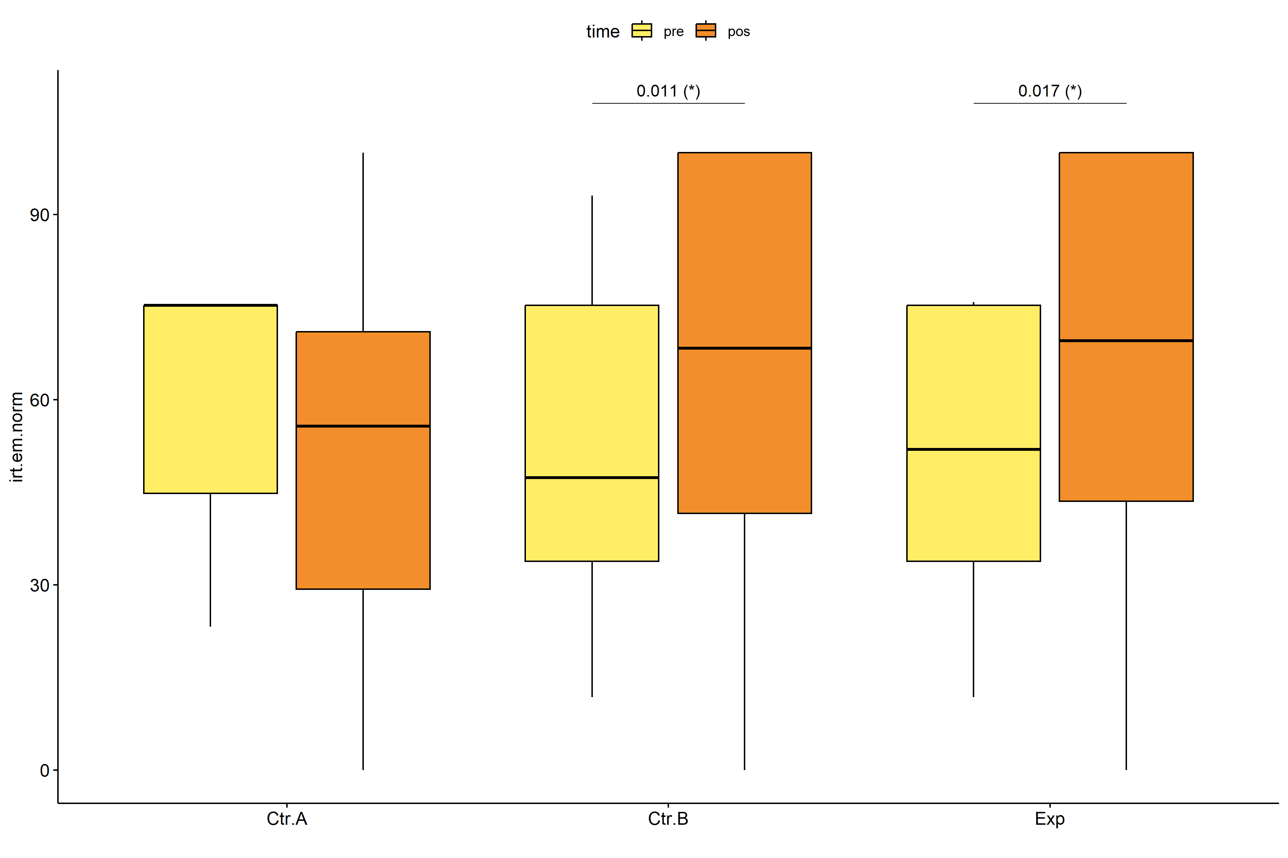

stat.test <- pwc.long %>% add_xy_position(x = "time", fun = "max")  
stat.test$y.position <- stat.test$y.position + y.position.min  
  
gg <- ggline(  
 pdat.long, x = "time", y = "irt.em.norm", size = 1.5,  
 facet.by = "Group", add = c("mean_se"), color = "Group",  
 position = position_dodge(width = 0.3), palette = color[["Group"]])  
  
pdat.long$xj = jitter(as.numeric(pdat.long[["time"]]), amount=.1)  
pdat.long$yj = jitter(pdat.long[["irt.em.norm"]], amount = .01)  
  
gg + geom_point(  
 data = pdat.long, aes_string(x="xj",y="yj", color = "Group"), size=0.5) +  
 stat_pvalue_manual(  
 stat.test, tip.length = 0, hide.ns = T, label.size = 5,  
 position = position_dodge(width = 0.3),  
 label = "{ p.adj } ({ p.adj.signif })") + xlab("") +  
 theme(strip.text = element_text(size = 16),  
 axis.text = element_text(size = 18))

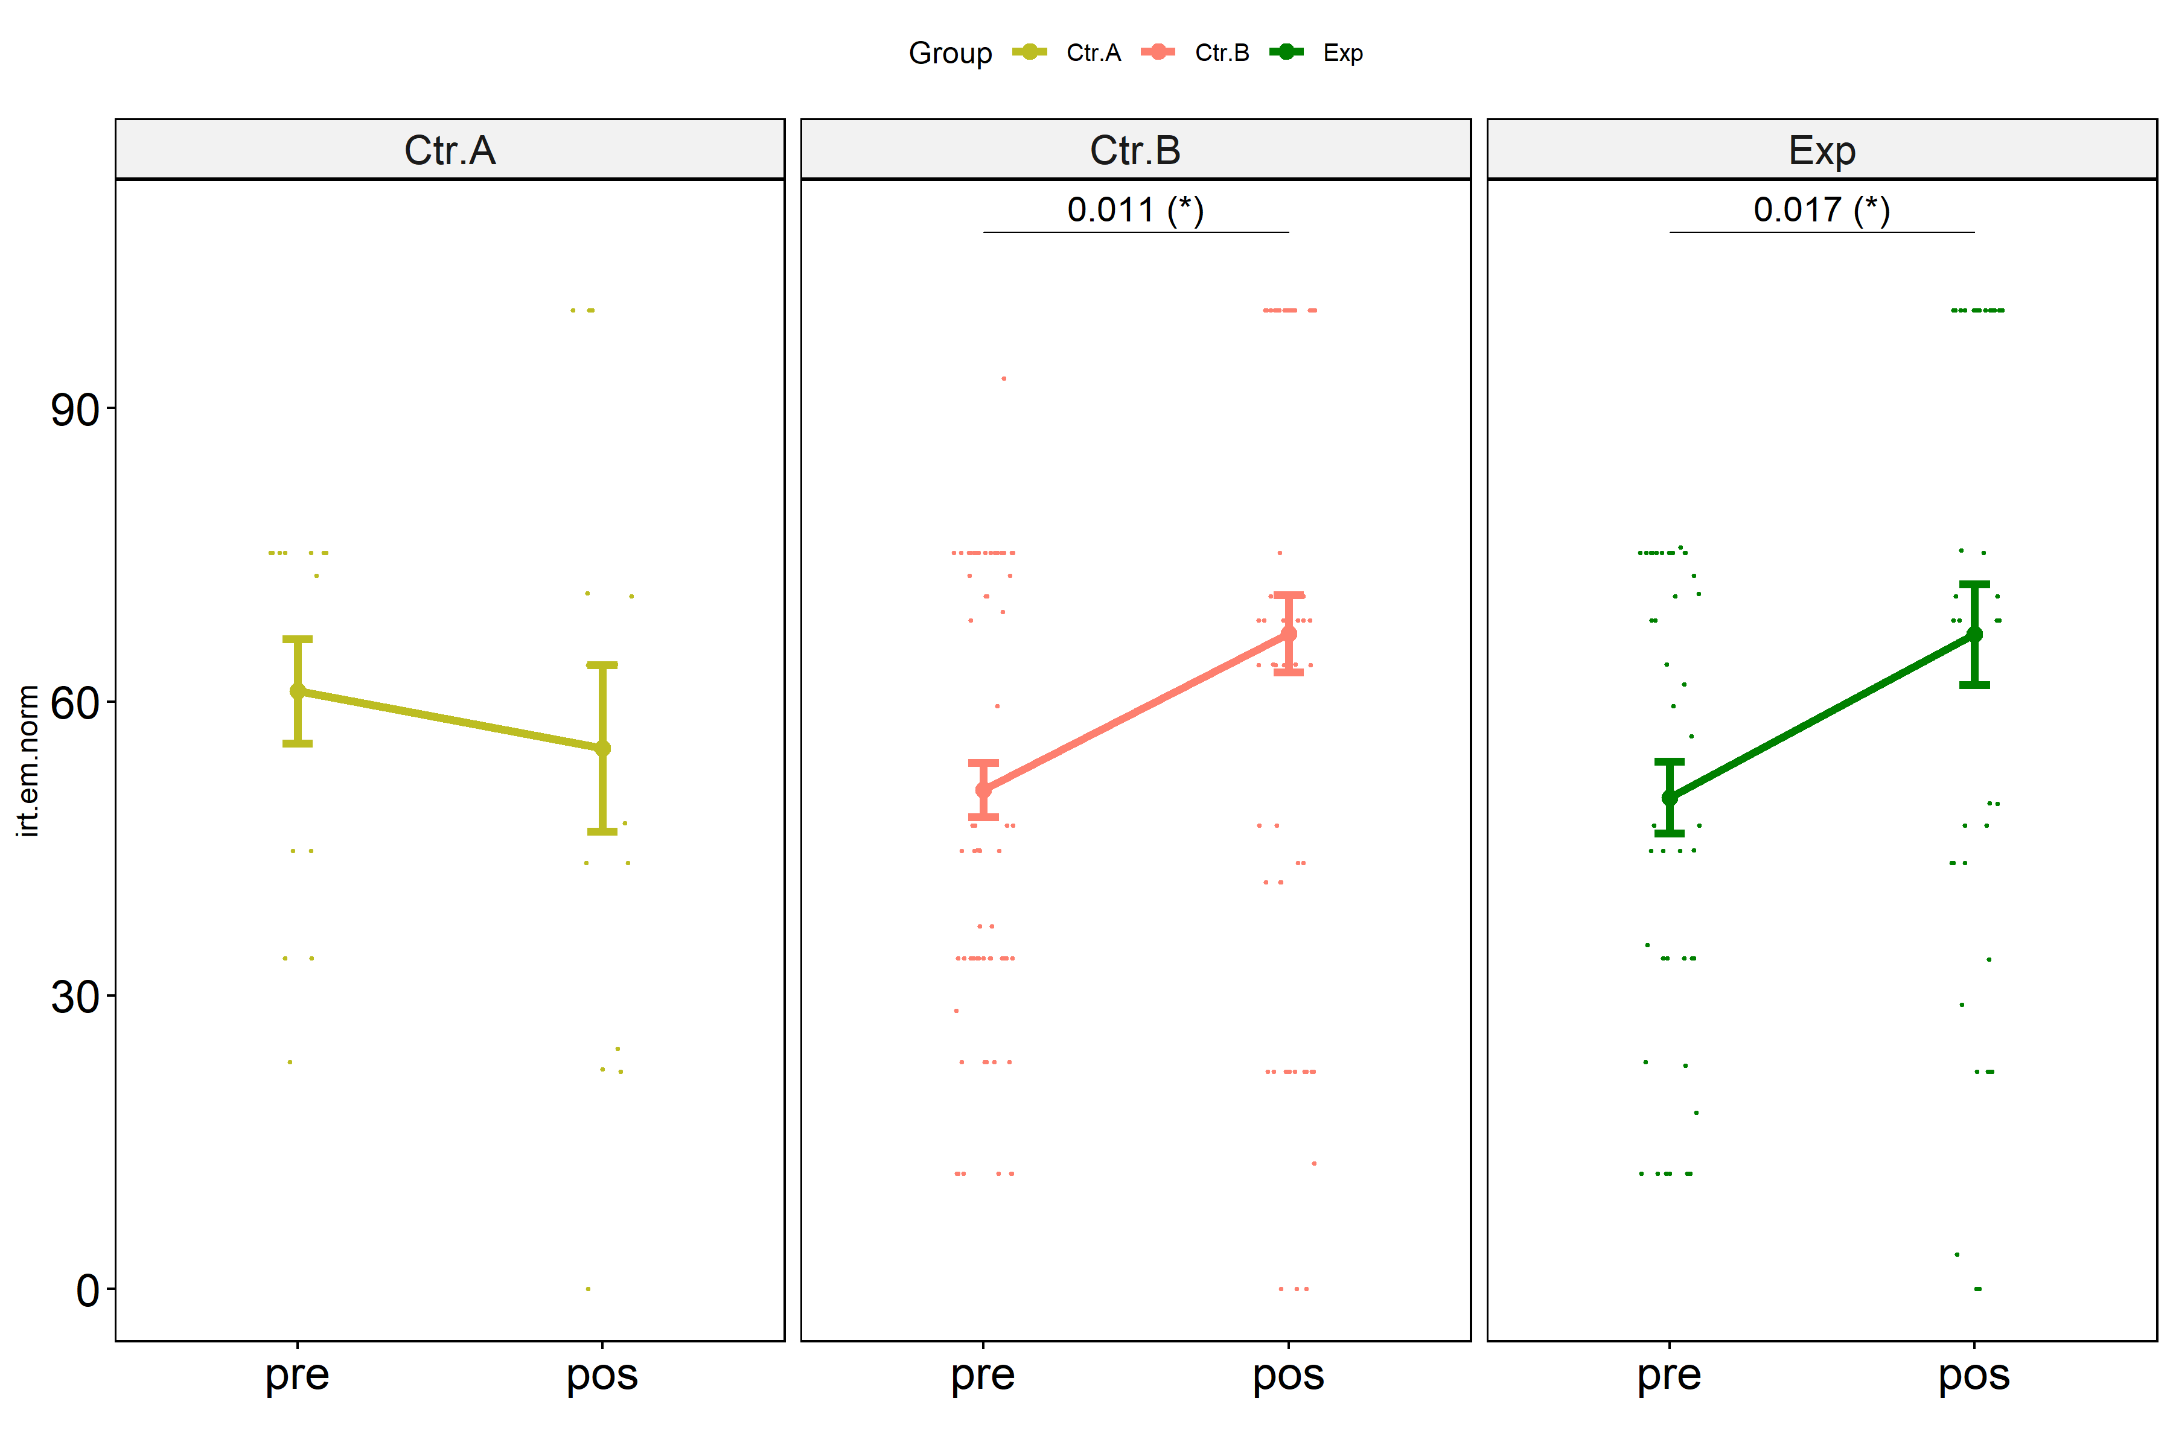

## Kruskal and Wilcoxon PairWise comparisons for: *irt.em.norm ~ Group*

kt <- lapply(lvars, FUN = function(x) {  
 kruskal_test(pdat, as.formula(paste0(x," ~ Group")))   
})  
  
df <- do.call(rbind.fill, lapply(lvars, function(x) {  
 add_significance(merge(  
 kt[[x]], kruskal_effsize(pdat, as.formula(paste0(x," ~ Group"))),  
 by = c(".y.","n"), suffixes = c("",".ez")))  
}))  
  
df <- df[,c(".y.","n","df","statistic","p","p.signif","effsize","magnitude")]

| .y. | n | df | statistic | p | p.signif | effsize | magnitude |
| --- | --- | --- | --- | --- | --- | --- | --- |
| dif.irt.em.norm | 124 | 2 | 6.413810 | 0.0405 | * | 0.0364778 | small |
| pos.irt.em.norm | 124 | 2 | 1.407533 | 0.4950 | ns | -0.0048964 | small |
| pre.irt.em.norm | 124 | 2 | 2.832761 | 0.2430 | ns | 0.0068823 | small |

pwc <- lapply(lvars, FUN = function(x) {  
 pairwise_wilcox_test(pdat, as.formula(paste0(x," ~ Group")))   
})  
  
df <- do.call(rbind.fill, pwc)

| .y. | group1 | group2 | n1 | n2 | statistic | p | p.adj | p.adj.signif |
| --- | --- | --- | --- | --- | --- | --- | --- | --- |
| dif.irt.em.norm | Ctr.A | Ctr.B | 14 | 68 | 280.0 | 0.016 | 0.047 | * |
| dif.irt.em.norm | Ctr.A | Exp | 14 | 42 | 170.5 | 0.020 | 0.047 | * |
| dif.irt.em.norm | Ctr.B | Exp | 68 | 42 | 1453.0 | 0.880 | 0.880 | ns |
| pos.irt.em.norm | Ctr.A | Ctr.B | 14 | 68 | 392.0 | 0.290 | 0.735 | ns |
| pos.irt.em.norm | Ctr.A | Exp | 14 | 42 | 233.5 | 0.245 | 0.735 | ns |
| pos.irt.em.norm | Ctr.B | Exp | 68 | 42 | 1405.0 | 0.886 | 0.886 | ns |
| pre.irt.em.norm | Ctr.A | Ctr.B | 14 | 68 | 597.5 | 0.125 | 0.306 | ns |
| pre.irt.em.norm | Ctr.A | Exp | 14 | 42 | 379.0 | 0.102 | 0.306 | ns |
| pre.irt.em.norm | Ctr.B | Exp | 68 | 42 | 1464.5 | 0.822 | 0.822 | ns |

plots <- lapply(lvars, FUN = function(y) {  
 stat.test <- pwc[[y]] %>% add_xy_position(x = "Group")  
 stat.test$y.position <- stat.test$y.position + y.position.min  
 ggboxplot(pdat, x = "Group", y = y, fill = "Group",  
 palette = color[["Group"]]) +  
 stat_pvalue_manual(stat.test, tip.length = 0, hide.ns = T, label.size = 5,  
 label="{ p.adj } ({ p.adj.signif })") + xlab("")  
})

egg::ggarrange(plots[["pre.irt.em.norm"]], plots[["pos.irt.em.norm"]], nrow = 1)

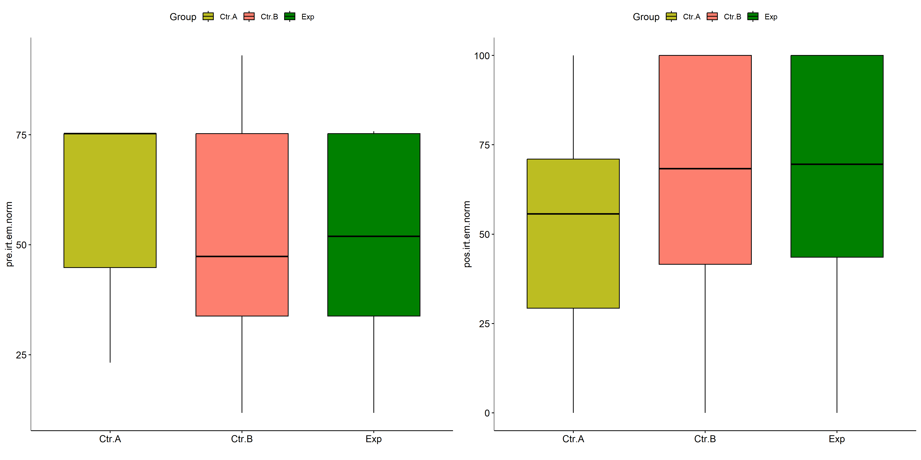

plots[["dif.irt.em.norm"]] +  
 labs(subtitle = get_test_label(kt[["dif.irt.em.norm"]], detailed = T),  
 caption = get_pwc_label(pwc[["dif.irt.em.norm"]])) +  
 ylab("irt.em.norm (dif)") +  
 theme(strip.text = element_text(size = 16),  
 axis.text = element_text(size = 18))

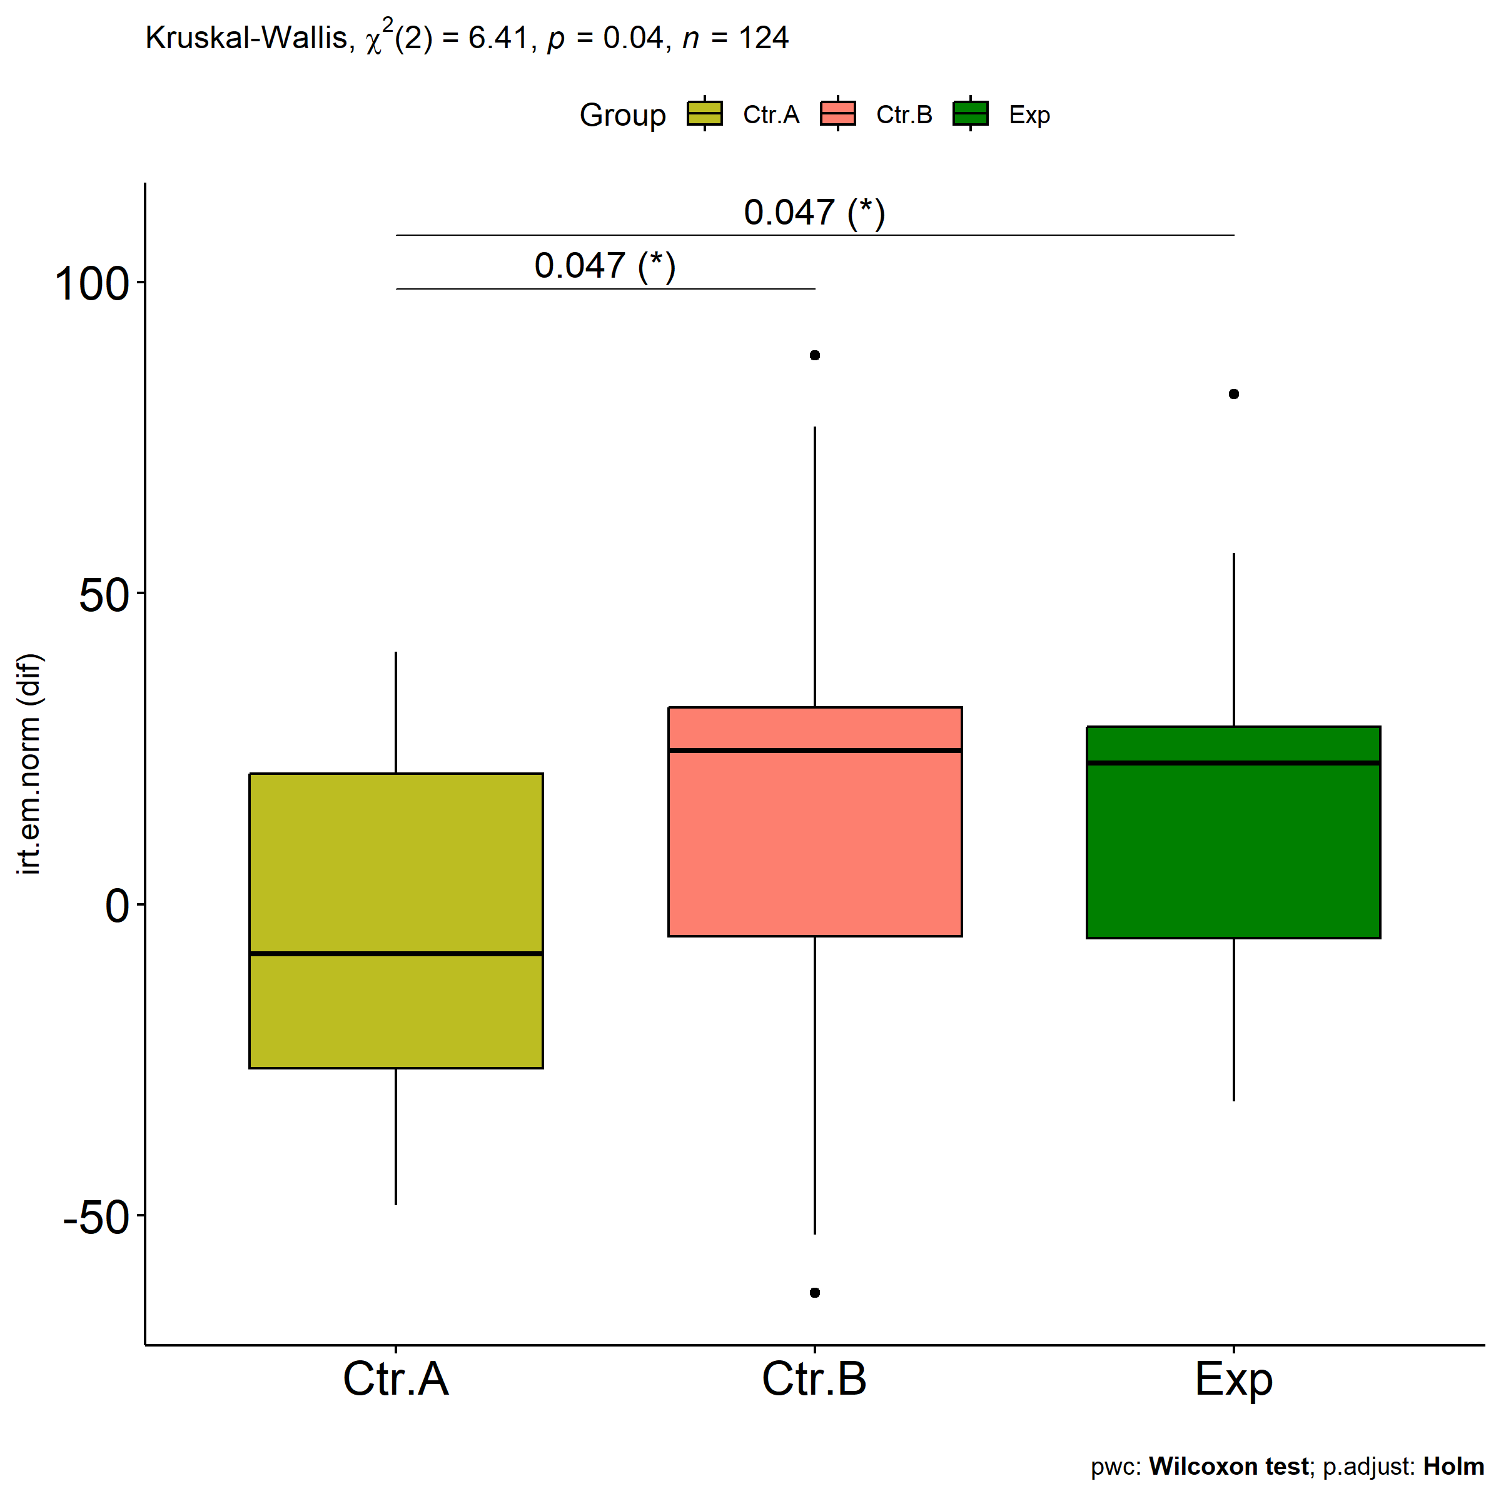

# Two-way factor analysis for: *irt.em.norm ~ Group:Gender*

pdat = remove_group_data(  
 dat[!is.na(dat[["Group"]]) & !is.na(dat[["Gender"]]),],  
 "dif.irt.em.norm", c("Group","Gender"))  
  
pdat.long <- rbind(pdat[,c("ID","Group","Gender")],  
 pdat[,c("ID","Group","Gender")])  
pdat.long[["time"]] <- c(rep("pre", nrow(pdat)), rep("pos", nrow(pdat)))  
pdat.long[["time"]] <- factor(pdat.long[["time"]], c("pre","pos"))  
pdat.long[["irt.em.norm"]] <- c(pdat[["pre.irt.em.norm"]], pdat[["pos.irt.em.norm"]])  
  
y.position.min <- abs(  
 max(pdat.long[["irt.em.norm"]])  
 - min(pdat.long[["irt.em.norm"]]))/20  
  
lvars = as.list(c("dif.irt.em.norm","pos.irt.em.norm","pre.irt.em.norm"))  
names(lvars) = unlist(lvars)

## Pre-test and Post-test PairWise comparisons for: *irt.em.norm ~ Group:Gender*

pwc.long <- group_by(pdat.long, Group:Gender) %>%  
 pairwise_wilcox_test(irt.em.norm ~ time, detailed = T)  
  
df <- pwc.long[,c(".y.","Group:Gender","group1","group2","n1","n2","estimate",  
 "statistic","p.adj","p.adj.signif")]

| .y. | Group:Gender | group1 | group2 | n1 | n2 | estimate | statistic | p.adj | p.adj.signif |
| --- | --- | --- | --- | --- | --- | --- | --- | --- | --- |
| irt.em.norm | Ctr.A:Female | pre | pos | 9 | 9 | 4.441848 | 48.0 | 0.529 | ns |
| irt.em.norm | Ctr.A:Male | pre | pos | 5 | 5 | 22.365539 | 18.0 | 0.293 | ns |
| irt.em.norm | Ctr.B:Female | pre | pos | 36 | 36 | -10.405021 | 574.5 | 0.408 | ns |
| irt.em.norm | Ctr.B:Male | pre | pos | 31 | 31 | -24.757179 | 270.0 | 0.003 | ** |
| irt.em.norm | Exp:Female | pre | pos | 18 | 18 | -23.521266 | 119.0 | 0.176 | ns |
| irt.em.norm | Exp:Male | pre | pos | 20 | 20 | -24.757198 | 120.5 | 0.031 | * |

stat.test <- pwc.long %>% add_xy_position(x = "Group:Gender", fun = "max")  
sidx = which(stat.test$p.adj.signif != "ns")  
stat.test$y.position[sidx] <- stat.test$y.position[sidx] + y.position.min * (1:length(sidx))  
  
pdat.long[[paste0(c("Group","Gender"), collapse = ":")]] = apply(  
 pdat.long[, c("Group","Gender")], 1, paste0, collapse = ":")  
  
ggboxplot(pdat.long, x = "Group:Gender", y = "irt.em.norm",  
 palette = color$prepost, fill = "time") +  
 stat_pvalue_manual(stat.test, tip.length = 0, hide.ns = T,  
 label = "{ p.adj } ({ p.adj.signif })") + xlab("")

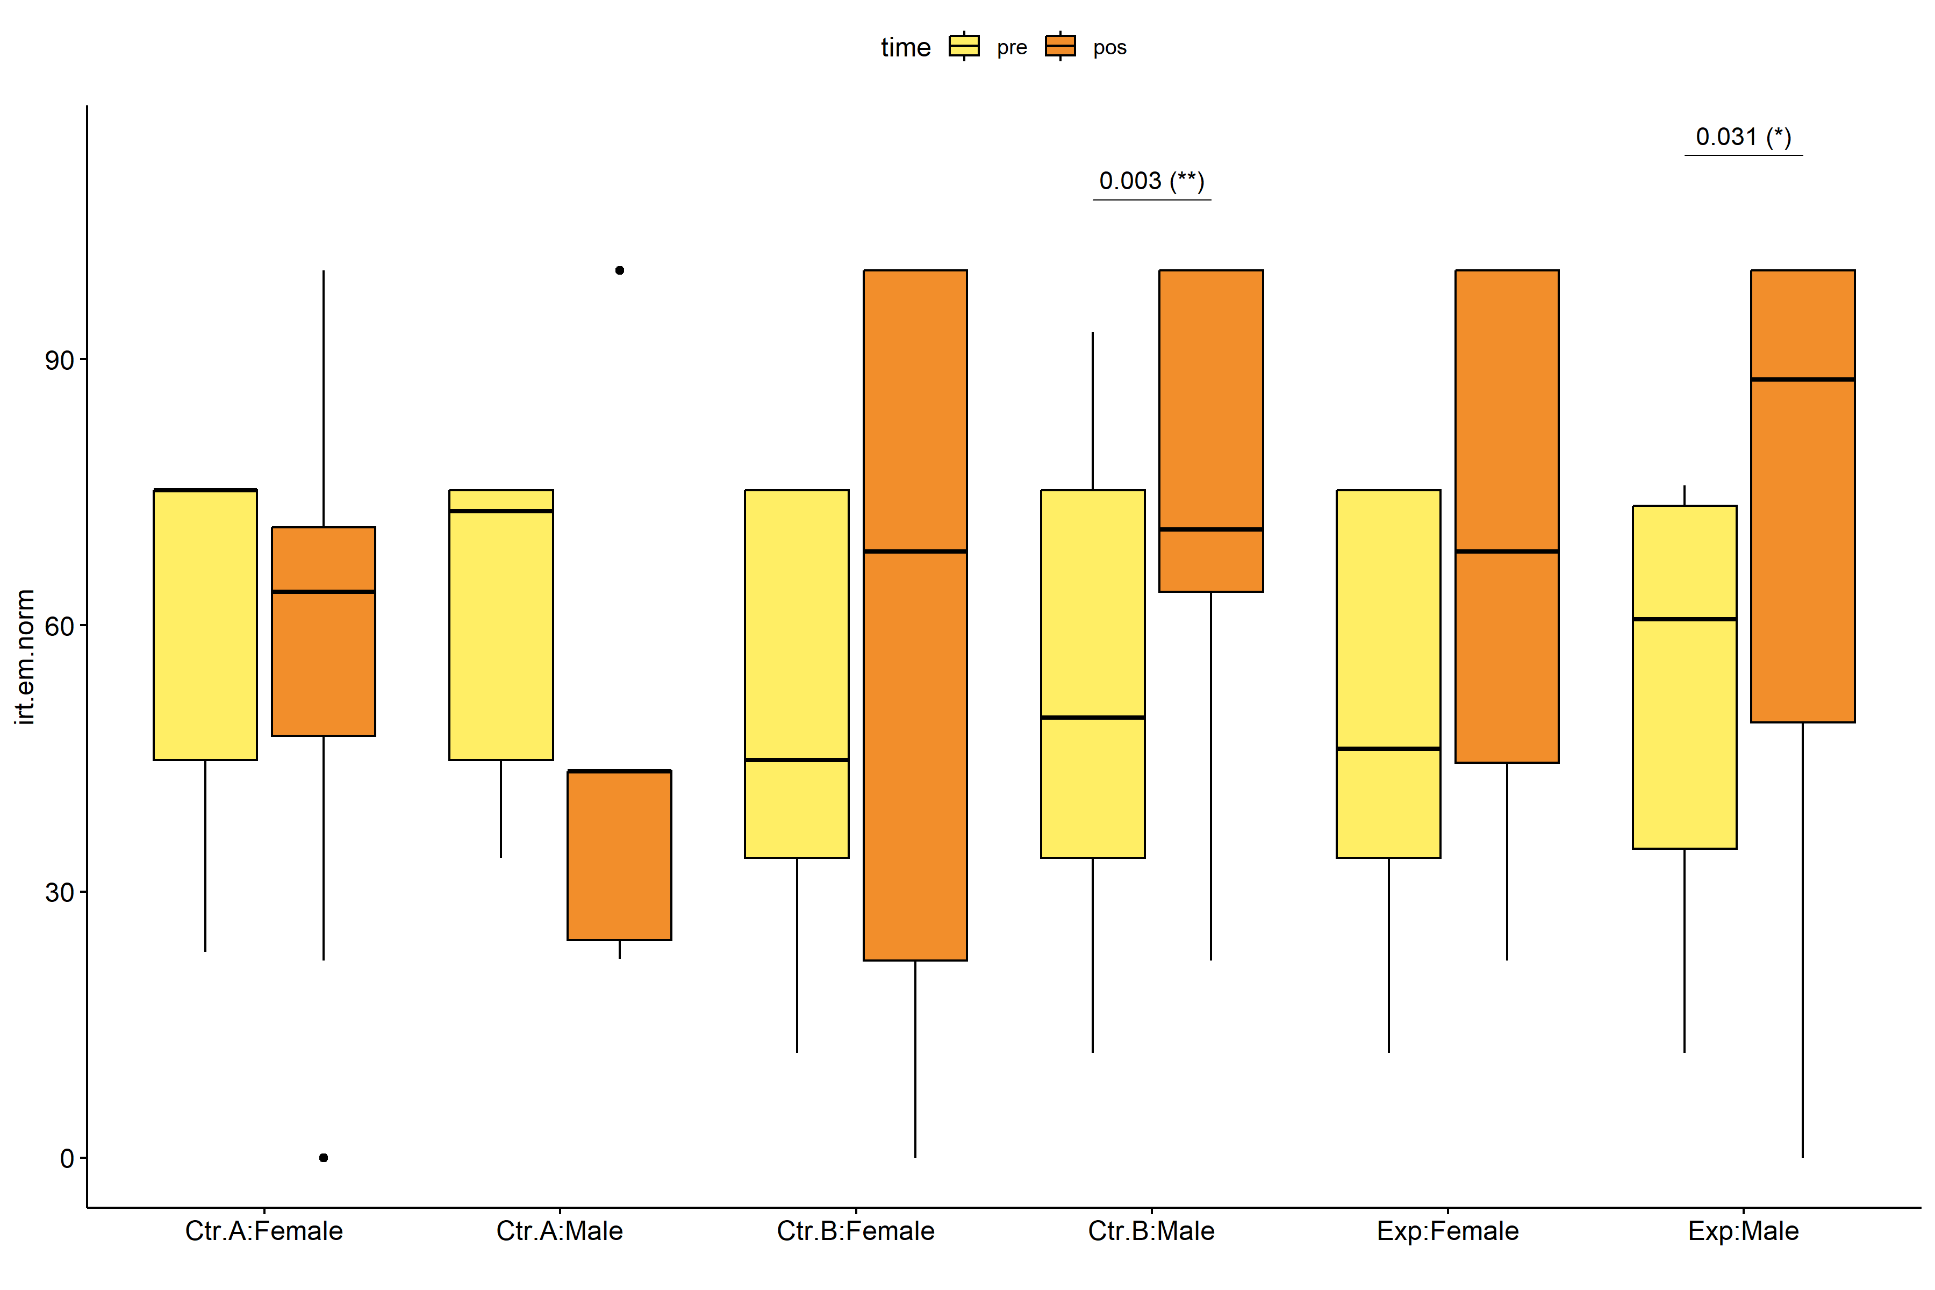

pwc.long <- group_by(pdat.long, Group, Gender) %>%  
 pairwise_wilcox_test(irt.em.norm ~ time, detailed = T)  
  
stat.test <- pwc.long %>% add_xy_position(x = "time", fun = "mean_se")  
sidx = which(stat.test$p.adj.signif != "ns")  
stat.test$y.position[sidx] <- stat.test$y.position[sidx] + y.position.min * (1:length(sidx))  
  
gg <- ggline(  
 pdat.long, x = "time", y = "irt.em.norm",  
 color = "Gender", linetype = "Gender", shape = "Gender", size = 1.5,  
 facet.by = "Group", add = c("mean_se"),  
 position = position_dodge(width = 0.3), palette = color[["Gender"]])  
  
pdat.long$xj = jitter(as.numeric(pdat.long[["time"]]), amount=.1)  
pdat.long$yj = jitter(pdat.long[["irt.em.norm"]], amount = .01)  
  
gg + geom_point(  
 data = pdat.long, aes_string(x="xj",y="yj",colour="Gender"), size=0.5) +  
 stat_pvalue_manual(  
 stat.test, tip.length = 0, hide.ns = T, label.size = 5,  
 position = position_dodge(width = 0.3), color = "Gender",  
 label = "{ p.adj } ({ p.adj.signif })") + xlab("") +  
 theme(strip.text = element_text(size = 16),  
 axis.text = element_text(size = 18))

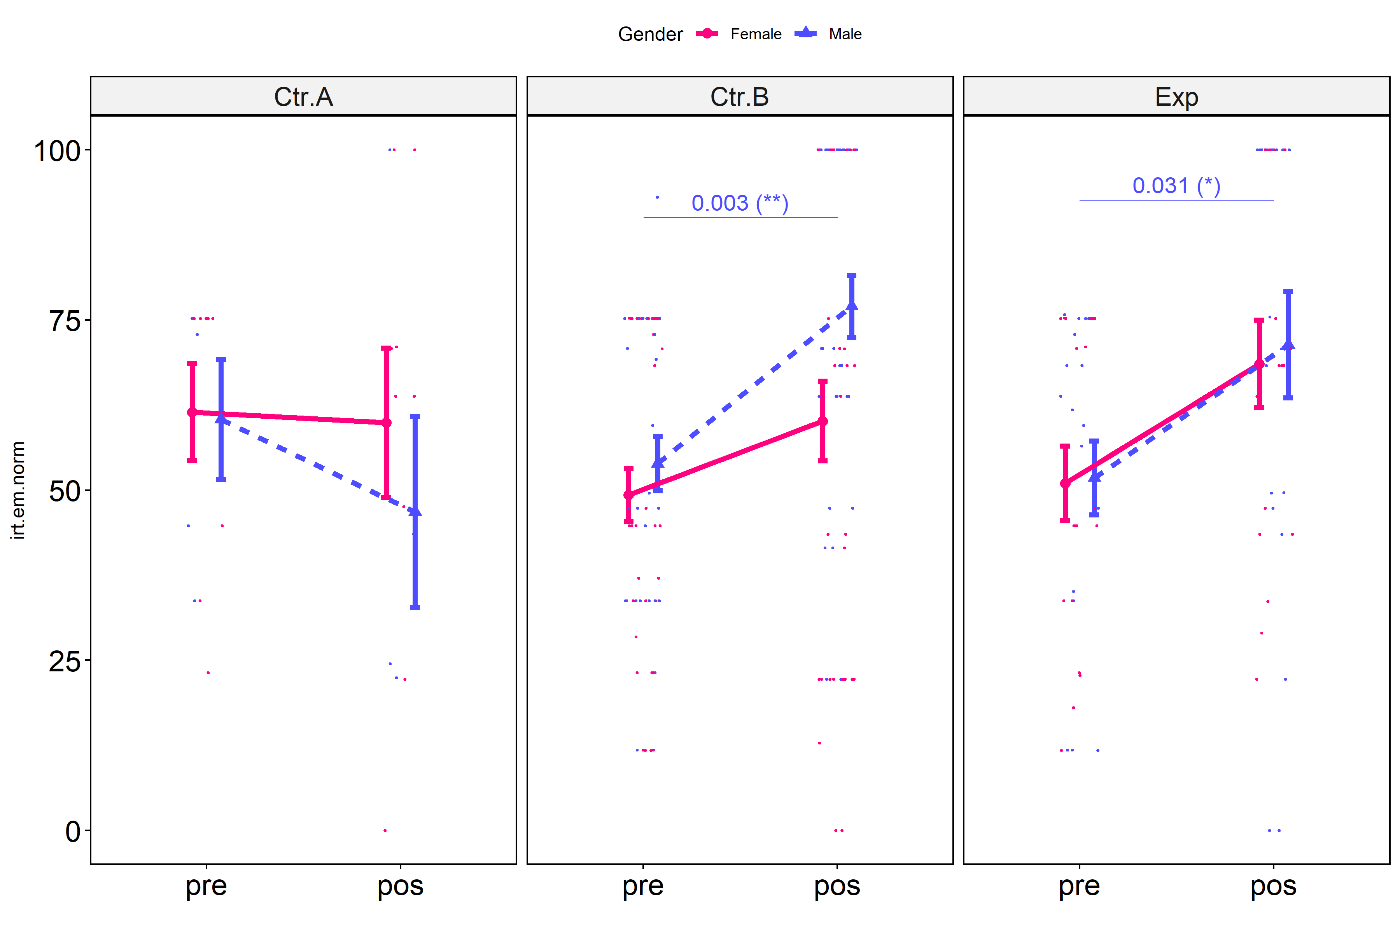

## Scheirer and Wilcoxon PairWise comparisons for: *irt.em.norm ~ Group:Gender*

sch <- lapply(lvars, FUN = function(x) {  
 scheirer.test(pdat, x, c("Group","Gender"), as.table = T)   
})  
df <- do.call(rbind.fill, sch)

| var | Effect | Df | Sum Sq | H | p.value | p.value.signif |
| --- | --- | --- | --- | --- | --- | --- |
| dif.irt.em.norm | Group | 2 | 7658.5419 | 6.4692197 | 0.0393756 | * |
| dif.irt.em.norm | Gender | 1 | 1804.5449 | 1.5243107 | 0.2169683 | ns |
| dif.irt.em.norm | Group:Gender | 2 | 1691.0919 | 1.4284762 | 0.4895650 | ns |
| dif.irt.em.norm | Residuals | 113 | 127829.9913 |  |  |  |
| pos.irt.em.norm | Group | 2 | 1916.2193 | 1.7152319 | 0.4241721 | ns |
| pos.irt.em.norm | Gender | 1 | 2514.9765 | 2.2511870 | 0.1335120 | ns |
| pos.irt.em.norm | Group:Gender | 2 | 2270.3878 | 2.0322526 | 0.3619945 | ns |
| pos.irt.em.norm | Residuals | 113 | 124655.0630 |  |  |  |
| pre.irt.em.norm | Group | 2 | 2942.0016 | 2.5847863 | 0.2746128 | ns |
| pre.irt.em.norm | Gender | 1 | 289.4244 | 0.2542827 | 0.6140755 | ns |
| pre.irt.em.norm | Group:Gender | 2 | 465.9460 | 0.4093712 | 0.8149035 | ns |
| pre.irt.em.norm | Residuals | 113 | 130745.8694 |  |  |  |

pwc <- lapply(lvars, FUN = function(x) {  
 list(  
 Group = tryCatch(pairwise_wilcox_test(group_by(pdat, Gender),  
 as.formula(paste0(x," ~ Group")))  
 , error = function(e) NULL),  
 Gender = tryCatch(pairwise_wilcox_test(group_by(pdat, Group),  
 as.formula(paste0(x," ~ Gender")))  
 , error = function(e) NULL)  
 )  
})  
  
df <- do.call(rbind.fill, lapply(pwc, FUN = function(x) {  
 do.call(rbind.fill, x)  
}))  
  
ivs = c()  
if ("Group" %in% colnames(df)) ivs = c(ivs, "Group")  
if ("Gender" %in% colnames(df)) ivs = c(ivs, "Gender")  
df <- df[,c(".y.",ivs,"group1","group2","n1","n2",  
 "statistic","p.adj","p.adj.signif")]

| .y. | Group | Gender | group1 | group2 | n1 | n2 | statistic | p.adj | p.adj.signif |
| --- | --- | --- | --- | --- | --- | --- | --- | --- | --- |
| dif.irt.em.norm |  | Female | Ctr.A | Ctr.B | 9 | 36 | 118.5 | 0.489 | ns |
| dif.irt.em.norm |  | Female | Ctr.A | Exp | 9 | 18 | 53.5 | 0.489 | ns |
| dif.irt.em.norm |  | Female | Ctr.B | Exp | 36 | 18 | 308.0 | 0.775 | ns |
| dif.irt.em.norm |  | Male | Ctr.A | Ctr.B | 5 | 31 | 26.5 | 0.062 | ns |
| dif.irt.em.norm |  | Male | Ctr.A | Exp | 5 | 20 | 18.0 | 0.064 | ns |
| dif.irt.em.norm |  | Male | Ctr.B | Exp | 31 | 20 | 323.5 | 0.802 | ns |
| dif.irt.em.norm | Ctr.A |  | Female | Male | 9 | 5 | 29.0 | 0.422 | ns |
| dif.irt.em.norm | Ctr.B |  | Female | Male | 36 | 31 | 446.5 | 0.162 | ns |
| dif.irt.em.norm | Exp |  | Female | Male | 18 | 20 | 157.0 | 0.510 | ns |
| pos.irt.em.norm |  | Female | Ctr.A | Ctr.B | 9 | 36 | 159.0 | 1.000 | ns |
| pos.irt.em.norm |  | Female | Ctr.A | Exp | 9 | 18 | 71.0 | 1.000 | ns |
| pos.irt.em.norm |  | Female | Ctr.B | Exp | 36 | 18 | 279.0 | 1.000 | ns |
| pos.irt.em.norm |  | Male | Ctr.A | Ctr.B | 5 | 31 | 35.5 | 0.139 | ns |
| pos.irt.em.norm |  | Male | Ctr.A | Exp | 5 | 20 | 28.0 | 0.252 | ns |
| pos.irt.em.norm |  | Male | Ctr.B | Exp | 31 | 20 | 319.5 | 0.853 | ns |
| pos.irt.em.norm | Ctr.A |  | Female | Male | 9 | 5 | 29.0 | 0.421 | ns |
| pos.irt.em.norm | Ctr.B |  | Female | Male | 36 | 31 | 421.5 | 0.076 | ns |
| pos.irt.em.norm | Exp |  | Female | Male | 18 | 20 | 157.0 | 0.494 | ns |
| pre.irt.em.norm |  | Female | Ctr.A | Ctr.B | 9 | 36 | 213.5 | 0.399 | ns |
| pre.irt.em.norm |  | Female | Ctr.A | Exp | 9 | 18 | 106.0 | 0.399 | ns |
| pre.irt.em.norm |  | Female | Ctr.B | Exp | 36 | 18 | 313.0 | 0.844 | ns |
| pre.irt.em.norm |  | Male | Ctr.A | Ctr.B | 5 | 31 | 88.0 | 1.000 | ns |
| pre.irt.em.norm |  | Male | Ctr.A | Exp | 5 | 20 | 59.5 | 1.000 | ns |
| pre.irt.em.norm |  | Male | Ctr.B | Exp | 31 | 20 | 323.0 | 1.000 | ns |
| pre.irt.em.norm | Ctr.A |  | Female | Male | 9 | 5 | 26.0 | 0.657 | ns |
| pre.irt.em.norm | Ctr.B |  | Female | Male | 36 | 31 | 497.5 | 0.440 | ns |
| pre.irt.em.norm | Exp |  | Female | Male | 18 | 20 | 180.0 | 1.000 | ns |

plots <- lapply(lvars, FUN = function(y) {  
 livs = list("Group", "Gender")  
 names(livs) = unlist(livs)  
 lapply(livs, FUN = function(x) {  
 iv2 = setdiff(names(livs), x)  
 if (!is.null(pwc[[y]][[iv2]])) {  
 stat.test <- pwc[[y]][[iv2]] %>% add_xy_position(x = x, fun = "max")  
 sidx = which(stat.test$p.adj.signif != "ns")  
 stat.test$y.position[sidx] <- stat.test$y.position[sidx] + y.position.min * (1:length(sidx))  
   
 ggboxplot(pdat, x = x, y = y, fill = iv2, palette = color[[iv2]]) +  
 stat_pvalue_manual(stat.test, tip.length = 0, hide.ns = T, label.size = 5,  
 label="{ p.adj } ({ p.adj.signif })") + xlab("")  
 }  
 })  
})

if (!is.null(plots[["pre.irt.em.norm"]][["Group"]]) &&  
 !is.null(plots[["pos.irt.em.norm"]][["Group"]])) {  
 egg::ggarrange(plots[["pre.irt.em.norm"]][["Group"]],  
 plots[["pos.irt.em.norm"]][["Group"]], nrow = 1)   
}

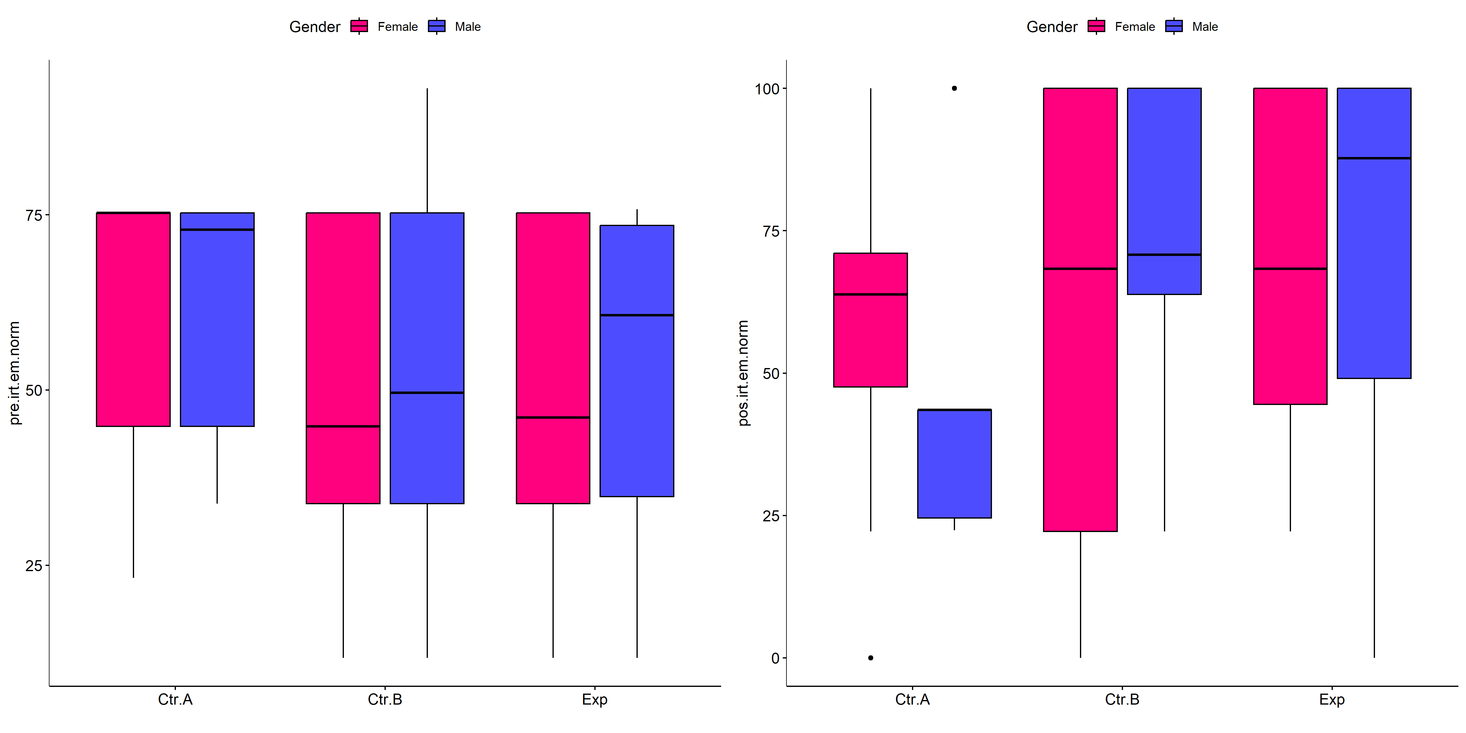

if (!is.null(plots[["pre.irt.em.norm"]][["Gender"]]) &&  
 !is.null(plots[["pos.irt.em.norm"]][["Gender"]])) {  
 egg::ggarrange(plots[["pre.irt.em.norm"]][["Gender"]],  
 plots[["pos.irt.em.norm"]][["Gender"]], nrow = 1)  
}

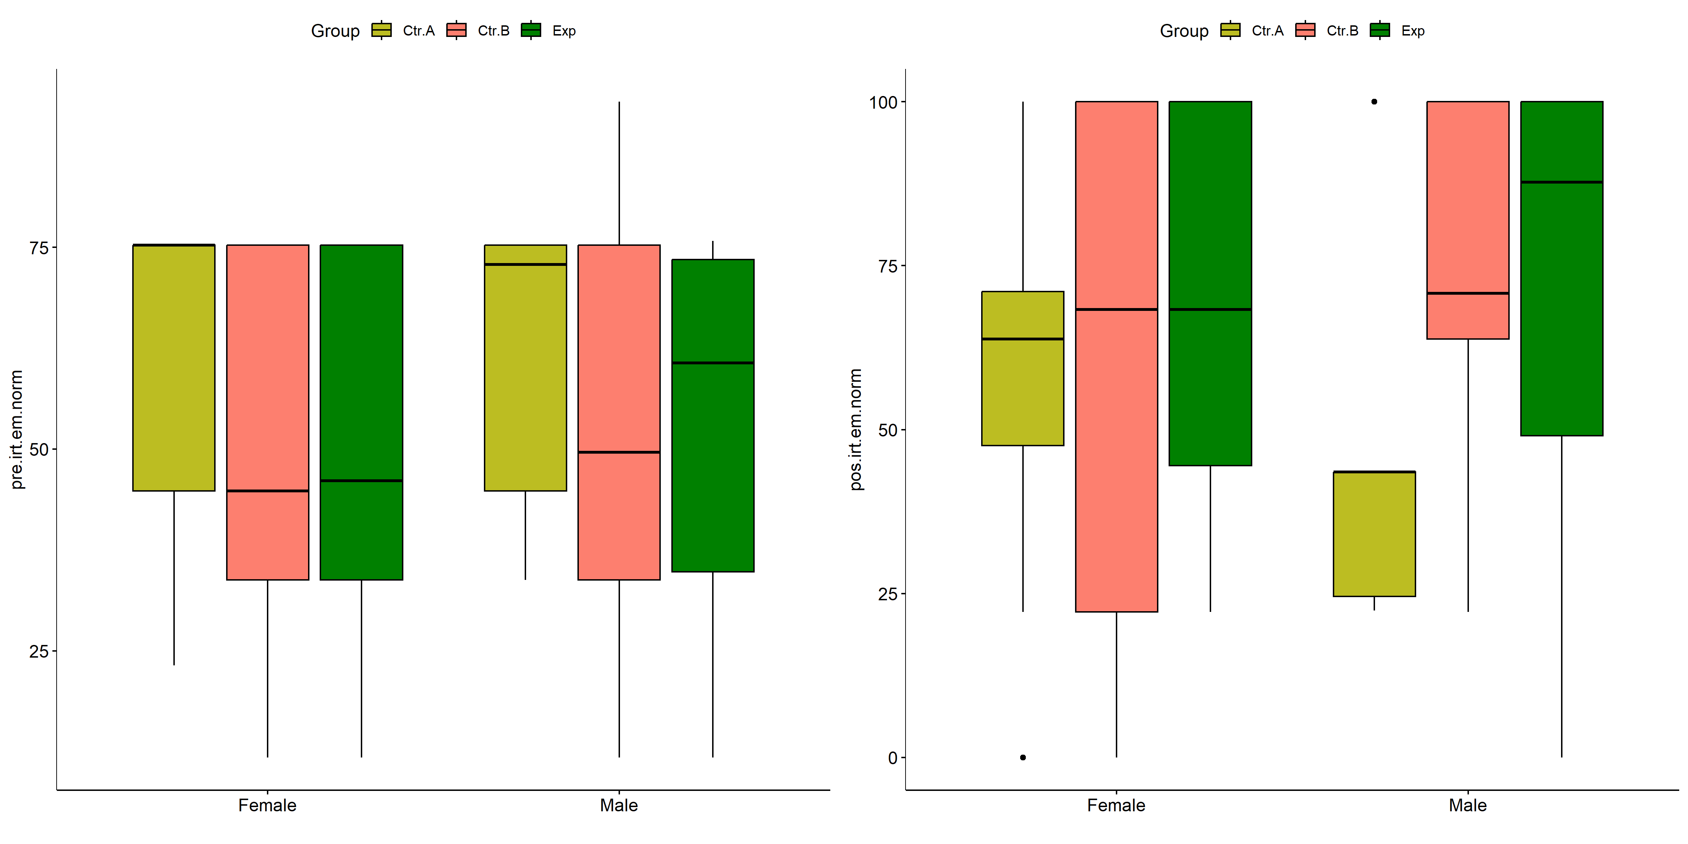

psch = sch[["dif.irt.em.norm"]]  
idx = which(psch$Effect == "Group:Gender")   
  
dof = floor(as.double(psch$Df[idx]))  
dof.res = floor(as.double(psch$Df[which(psch$Effect == "Residuals")]))  
statistic = round(as.double(psch$H[idx]), 3)  
p = round(as.double(psch[["p.value"]][idx]), 3)  
pval = ifelse(p < 0.001,paste0(" , p<0.001"),paste0(" , p=",p))  
  
if (!is.null(plots[["dif.irt.em.norm"]][["Group"]]))  
 plots[["dif.irt.em.norm"]][["Group"]] +  
 labs(subtitle = paste0("Scheirer-Ray-Hare H(", dof, ",",   
 dof.res, ")=", statistic, pval),  
 caption = get_pwc_label(pwc[["dif.irt.em.norm"]][["Gender"]])) +  
 ylab("irt.em.norm (dif)") +  
 theme(strip.text = element_text(size = 16),  
 axis.text = element_text(size = 18))

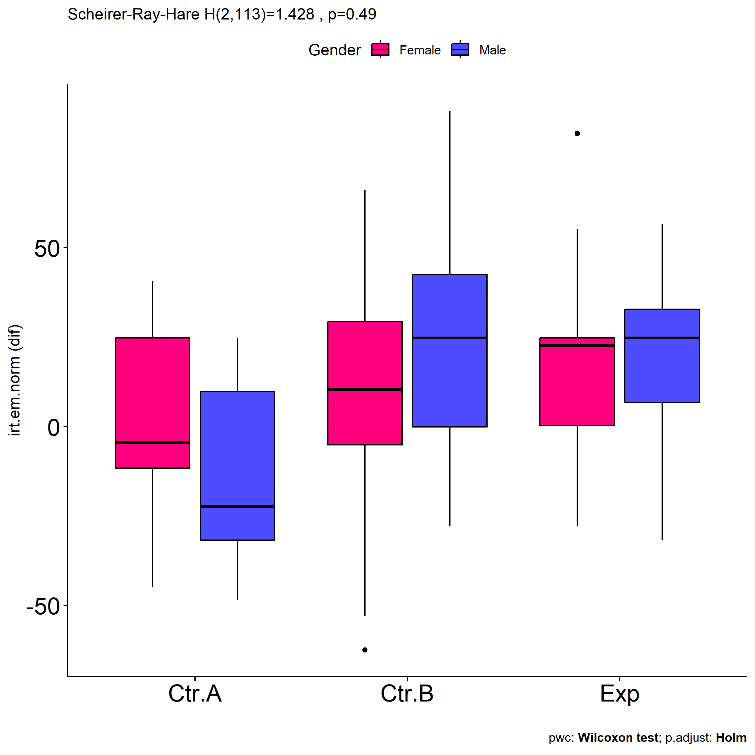

psch = sch[["dif.irt.em.norm"]]  
idx = which(psch$Effect == "Group:Gender")   
  
dof = floor(as.double(psch$Df[idx]))  
dof.res = floor(as.double(psch$Df[which(psch$Effect == "Residuals")]))  
statistic = round(as.double(psch$H[idx]), 3)  
p = round(as.double(psch[["p.value"]][idx]), 3)  
pval = ifelse(p < 0.001,paste0(" , p<0.001"),paste0(" , p=",p))  
  
if (!is.null(plots[["dif.irt.em.norm"]][["Gender"]]))  
 plots[["dif.irt.em.norm"]][["Gender"]] +  
 labs(subtitle = paste0("Scheirer-Ray-Hare H(", dof, ",",   
 dof.res, ")=", statistic, pval),  
 caption = get_pwc_label(pwc[["dif.irt.em.norm"]][["Group"]])) +  
 ylab("irt.em.norm (dif)") +  
 theme(strip.text = element_text(size = 16),  
 axis.text = element_text(size = 18))

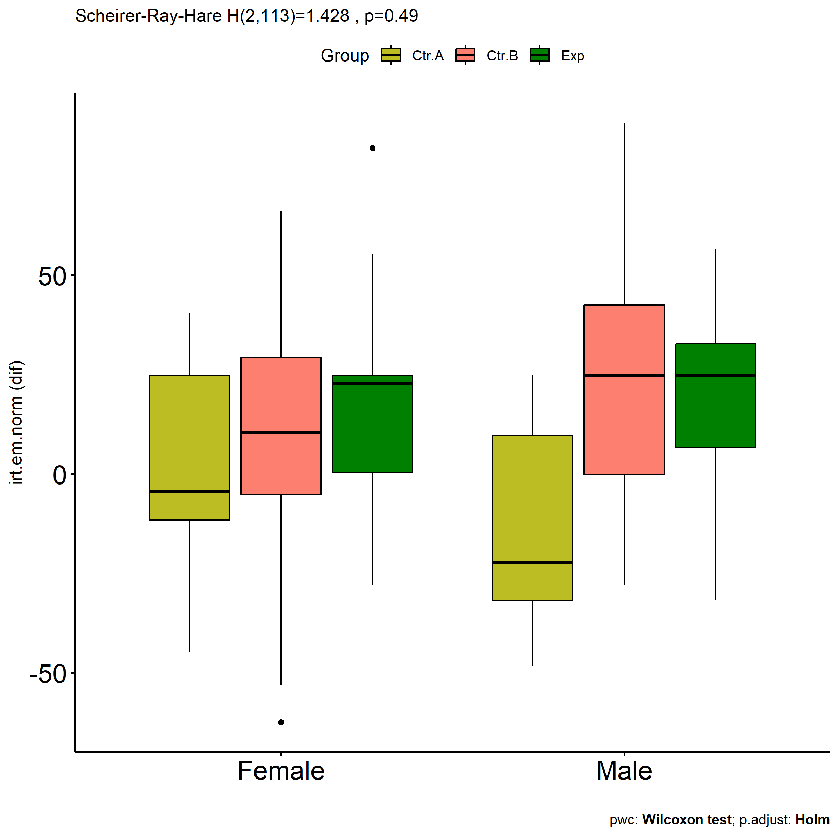

# Two-way factor analysis for: *irt.em.norm ~ Group:Town*

pdat = remove_group_data(  
 dat[!is.na(dat[["Group"]]) & !is.na(dat[["Town"]]),],  
 "dif.irt.em.norm", c("Group","Town"))  
  
pdat.long <- rbind(pdat[,c("ID","Group","Town")],  
 pdat[,c("ID","Group","Town")])  
pdat.long[["time"]] <- c(rep("pre", nrow(pdat)), rep("pos", nrow(pdat)))  
pdat.long[["time"]] <- factor(pdat.long[["time"]], c("pre","pos"))  
pdat.long[["irt.em.norm"]] <- c(pdat[["pre.irt.em.norm"]], pdat[["pos.irt.em.norm"]])  
  
y.position.min <- abs(  
 max(pdat.long[["irt.em.norm"]])  
 - min(pdat.long[["irt.em.norm"]]))/20  
  
lvars = as.list(c("dif.irt.em.norm","pos.irt.em.norm","pre.irt.em.norm"))  
names(lvars) = unlist(lvars)

## Pre-test and Post-test PairWise comparisons for: *irt.em.norm ~ Group:Town*

pwc.long <- group_by(pdat.long, Group:Town) %>%  
 pairwise_wilcox_test(irt.em.norm ~ time, detailed = T)  
  
df <- pwc.long[,c(".y.","Group:Town","group1","group2","n1","n2","estimate",  
 "statistic","p.adj","p.adj.signif")]

| .y. | Group:Town | group1 | group2 | n1 | n2 | estimate | statistic | p.adj | p.adj.signif |
| --- | --- | --- | --- | --- | --- | --- | --- | --- | --- |
| irt.em.norm | Ctr.A:Limoeiro - PE | pre | pos | 14 | 14 | 7.672307 | 122.0 | 0.274000 | ns |
| irt.em.norm | Ctr.B:Sorocaba - SP | pre | pos | 26 | 26 | -26.718532 | 104.5 | 0.000011 | **** |
| irt.em.norm | Ctr.B:Limoeiro - PE | pre | pos | 42 | 42 | -7.763449 | 829.0 | 0.637000 | ns |
| irt.em.norm | Exp:Sorocaba - SP | pre | pos | 13 | 13 | -29.199082 | 20.5 | 0.000768 | *** |
| irt.em.norm | Exp:Limoeiro - PE | pre | pos | 29 | 29 | -10.461074 | 350.0 | 0.275000 | ns |

stat.test <- pwc.long %>% add_xy_position(x = "Group:Town", fun = "max")  
sidx = which(stat.test$p.adj.signif != "ns")  
stat.test$y.position[sidx] <- stat.test$y.position[sidx] + y.position.min * (1:length(sidx))  
  
pdat.long[[paste0(c("Group","Town"), collapse = ":")]] = apply(  
 pdat.long[, c("Group","Town")], 1, paste0, collapse = ":")  
  
ggboxplot(pdat.long, x = "Group:Town", y = "irt.em.norm",  
 palette = color$prepost, fill = "time") +  
 stat_pvalue_manual(stat.test, tip.length = 0, hide.ns = T,  
 label = "{ p.adj } ({ p.adj.signif })") + xlab("")

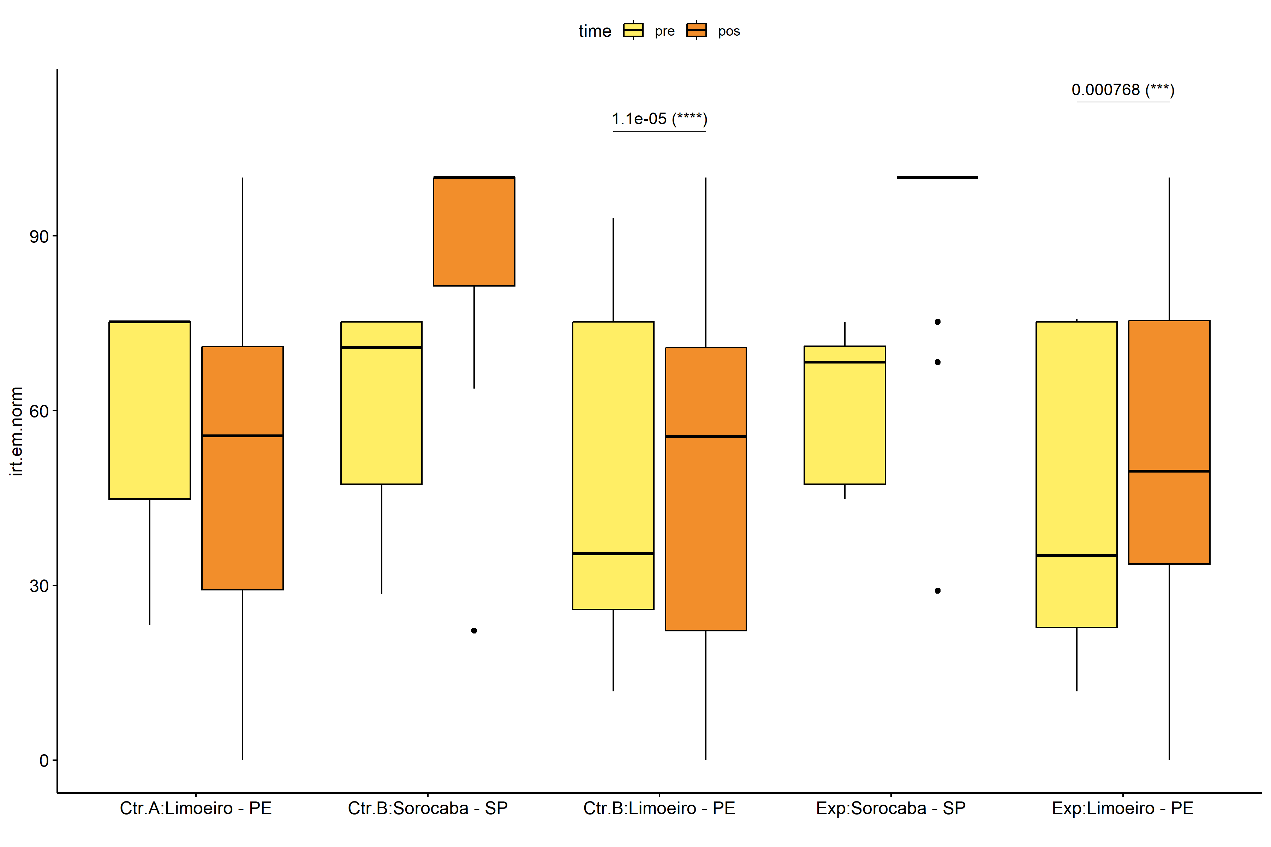

pwc.long <- group_by(pdat.long, Group, Town) %>%  
 pairwise_wilcox_test(irt.em.norm ~ time, detailed = T)  
  
stat.test <- pwc.long %>% add_xy_position(x = "time", fun = "mean_se")  
sidx = which(stat.test$p.adj.signif != "ns")  
stat.test$y.position[sidx] <- stat.test$y.position[sidx] + y.position.min * (1:length(sidx))  
  
gg <- ggline(  
 pdat.long, x = "time", y = "irt.em.norm",  
 color = "Town", linetype = "Town", shape = "Town", size = 1.5,  
 facet.by = "Group", add = c("mean_se"),  
 position = position_dodge(width = 0.3), palette = color[["Town"]])  
  
pdat.long$xj = jitter(as.numeric(pdat.long[["time"]]), amount=.1)  
pdat.long$yj = jitter(pdat.long[["irt.em.norm"]], amount = .01)  
  
gg + geom_point(  
 data = pdat.long, aes_string(x="xj",y="yj",colour="Town"), size=0.5) +  
 stat_pvalue_manual(  
 stat.test, tip.length = 0, hide.ns = T, label.size = 5,  
 position = position_dodge(width = 0.3), color = "Town",  
 label = "{ p.adj } ({ p.adj.signif })") + xlab("") +  
 theme(strip.text = element_text(size = 16),  
 axis.text = element_text(size = 18))

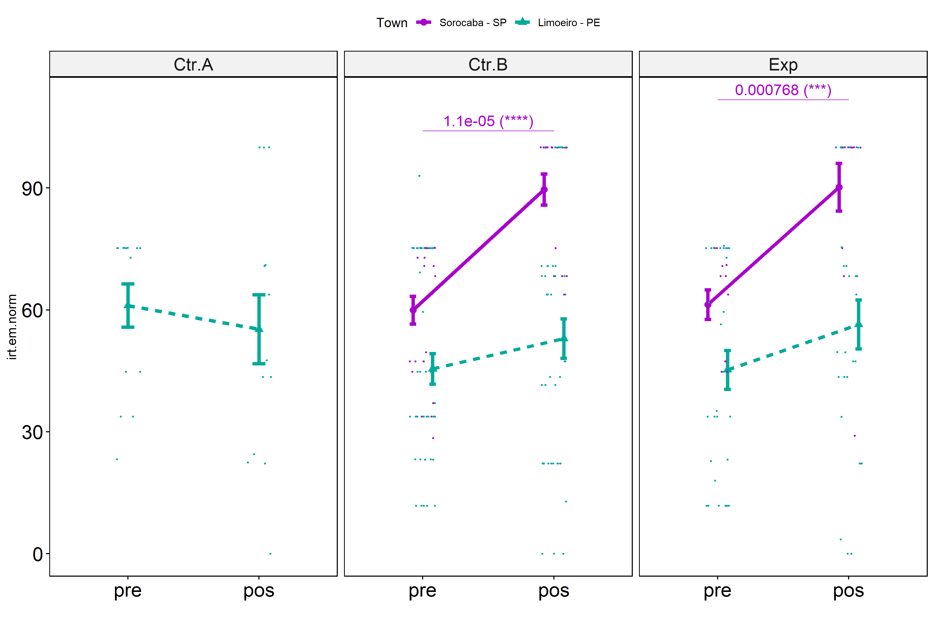

## Scheirer and Wilcoxon PairWise comparisons for: *irt.em.norm ~ Group:Town*

sch <- lapply(lvars, FUN = function(x) {  
 scheirer.test(pdat, x, c("Group","Town"), as.table = T)   
})  
df <- do.call(rbind.fill, sch)

| var | Effect | Df | Sum Sq | H | p.value | p.value.signif |
| --- | --- | --- | --- | --- | --- | --- |
| dif.irt.em.norm | Group | 2 | 2.958046e+03 | 2.3022728 | 0.3162771 | ns |
| dif.irt.em.norm | Town | 1 | 1.968526e+04 | 15.3212058 | 0.0000907 | **** |
| dif.irt.em.norm | Group:Town | 1 | 3.822288e+00 | 0.0029749 | 0.9565027 | ns |
| dif.irt.em.norm | Residuals | 119 | 1.301052e+05 |  |  |  |
| pos.irt.em.norm | Group | 2 | 4.506456e+02 | 0.3704642 | 0.8309114 | ns |
| pos.irt.em.norm | Town | 1 | 3.811459e+04 | 31.3330262 | 0.0000000 | **** |
| pos.irt.em.norm | Group:Town | 1 | 4.492732e+01 | 0.0369336 | 0.8476003 | ns |
| pos.irt.em.norm | Residuals | 119 | 1.097498e+05 |  |  |  |
| pre.irt.em.norm | Group | 2 | 6.565912e+03 | 5.3087169 | 0.0703440 | ns |
| pre.irt.em.norm | Town | 1 | 9.930455e+03 | 8.0290411 | 0.0046033 | ** |
| pre.irt.em.norm | Group:Town | 1 | 1.459214e+01 | 0.0117981 | 0.9135045 | ns |
| pre.irt.em.norm | Residuals | 119 | 1.386798e+05 |  |  |  |

pwc <- lapply(lvars, FUN = function(x) {  
 list(  
 Group = tryCatch(pairwise_wilcox_test(group_by(pdat, Town),  
 as.formula(paste0(x," ~ Group")))  
 , error = function(e) NULL),  
 Town = tryCatch(pairwise_wilcox_test(group_by(pdat, Group),  
 as.formula(paste0(x," ~ Town")))  
 , error = function(e) NULL)  
 )  
})  
  
df <- do.call(rbind.fill, lapply(pwc, FUN = function(x) {  
 do.call(rbind.fill, x)  
}))  
  
ivs = c()  
if ("Group" %in% colnames(df)) ivs = c(ivs, "Group")  
if ("Town" %in% colnames(df)) ivs = c(ivs, "Town")  
df <- df[,c(".y.",ivs,"group1","group2","n1","n2",  
 "statistic","p.adj","p.adj.signif")]

| .y. | Town | group1 | group2 | n1 | n2 | statistic | p.adj | p.adj.signif |
| --- | --- | --- | --- | --- | --- | --- | --- | --- |
| dif.irt.em.norm | Sorocaba - SP | Ctr.B | Exp | 26 | 13 | 171.5 | 0.952 | ns |
| dif.irt.em.norm | Limoeiro - PE | Ctr.A | Ctr.B | 14 | 42 | 220.0 | 0.330 | ns |
| dif.irt.em.norm | Limoeiro - PE | Ctr.A | Exp | 14 | 29 | 141.0 | 0.330 | ns |
| dif.irt.em.norm | Limoeiro - PE | Ctr.B | Exp | 42 | 29 | 575.0 | 0.695 | ns |
| pos.irt.em.norm | Sorocaba - SP | Ctr.B | Exp | 26 | 13 | 161.0 | 0.771 | ns |
| pos.irt.em.norm | Limoeiro - PE | Ctr.A | Ctr.B | 14 | 42 | 321.0 | 1.000 | ns |
| pos.irt.em.norm | Limoeiro - PE | Ctr.A | Exp | 14 | 29 | 200.5 | 1.000 | ns |
| pos.irt.em.norm | Limoeiro - PE | Ctr.B | Exp | 42 | 29 | 559.0 | 1.000 | ns |
| pre.irt.em.norm | Sorocaba - SP | Ctr.B | Exp | 26 | 13 | 181.5 | 0.715 | ns |
| pre.irt.em.norm | Limoeiro - PE | Ctr.A | Ctr.B | 14 | 42 | 398.5 | 0.127 | ns |
| pre.irt.em.norm | Limoeiro - PE | Ctr.A | Exp | 14 | 29 | 274.0 | 0.127 | ns |
| pre.irt.em.norm | Limoeiro - PE | Ctr.B | Exp | 42 | 29 | 621.5 | 0.886 | ns |

plots <- lapply(lvars, FUN = function(y) {  
 livs = list("Group", "Town")  
 names(livs) = unlist(livs)  
 lapply(livs, FUN = function(x) {  
 iv2 = setdiff(names(livs), x)  
 if (!is.null(pwc[[y]][[iv2]])) {  
 stat.test <- pwc[[y]][[iv2]] %>% add_xy_position(x = x, fun = "max")  
 sidx = which(stat.test$p.adj.signif != "ns")  
 stat.test$y.position[sidx] <- stat.test$y.position[sidx] + y.position.min * (1:length(sidx))  
   
 ggboxplot(pdat, x = x, y = y, fill = iv2, palette = color[[iv2]]) +  
 stat_pvalue_manual(stat.test, tip.length = 0, hide.ns = T, label.size = 5,  
 label="{ p.adj } ({ p.adj.signif })") + xlab("")  
 }  
 })  
})

if (!is.null(plots[["pre.irt.em.norm"]][["Group"]]) &&  
 !is.null(plots[["pos.irt.em.norm"]][["Group"]])) {  
 egg::ggarrange(plots[["pre.irt.em.norm"]][["Group"]],  
 plots[["pos.irt.em.norm"]][["Group"]], nrow = 1)   
}

if (!is.null(plots[["pre.irt.em.norm"]][["Town"]]) &&  
 !is.null(plots[["pos.irt.em.norm"]][["Town"]])) {  
 egg::ggarrange(plots[["pre.irt.em.norm"]][["Town"]],  
 plots[["pos.irt.em.norm"]][["Town"]], nrow = 1)  
}

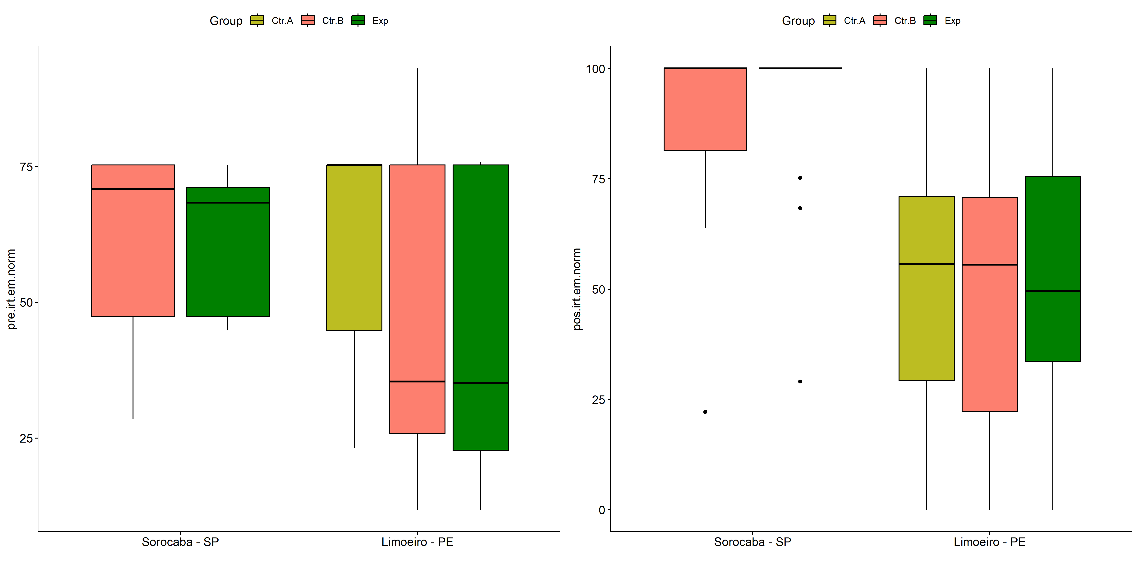

psch = sch[["dif.irt.em.norm"]]  
idx = which(psch$Effect == "Group:Town")   
  
dof = floor(as.double(psch$Df[idx]))  
dof.res = floor(as.double(psch$Df[which(psch$Effect == "Residuals")]))  
statistic = round(as.double(psch$H[idx]), 3)  
p = round(as.double(psch[["p.value"]][idx]), 3)  
pval = ifelse(p < 0.001,paste0(" , p<0.001"),paste0(" , p=",p))  
  
if (!is.null(plots[["dif.irt.em.norm"]][["Group"]]))  
 plots[["dif.irt.em.norm"]][["Group"]] +  
 labs(subtitle = paste0("Scheirer-Ray-Hare H(", dof, ",",   
 dof.res, ")=", statistic, pval),  
 caption = get_pwc_label(pwc[["dif.irt.em.norm"]][["Town"]])) +  
 ylab("irt.em.norm (dif)") +  
 theme(strip.text = element_text(size = 16),  
 axis.text = element_text(size = 18))

psch = sch[["dif.irt.em.norm"]]  
idx = which(psch$Effect == "Group:Town")   
  
dof = floor(as.double(psch$Df[idx]))  
dof.res = floor(as.double(psch$Df[which(psch$Effect == "Residuals")]))  
statistic = round(as.double(psch$H[idx]), 3)  
p = round(as.double(psch[["p.value"]][idx]), 3)  
pval = ifelse(p < 0.001,paste0(" , p<0.001"),paste0(" , p=",p))  
  
if (!is.null(plots[["dif.irt.em.norm"]][["Town"]]))  
 plots[["dif.irt.em.norm"]][["Town"]] +  
 labs(subtitle = paste0("Scheirer-Ray-Hare H(", dof, ",",   
 dof.res, ")=", statistic, pval),  
 caption = get_pwc_label(pwc[["dif.irt.em.norm"]][["Group"]])) +  
 ylab("irt.em.norm (dif)") +  
 theme(strip.text = element_text(size = 16),  
 axis.text = element_text(size = 18))

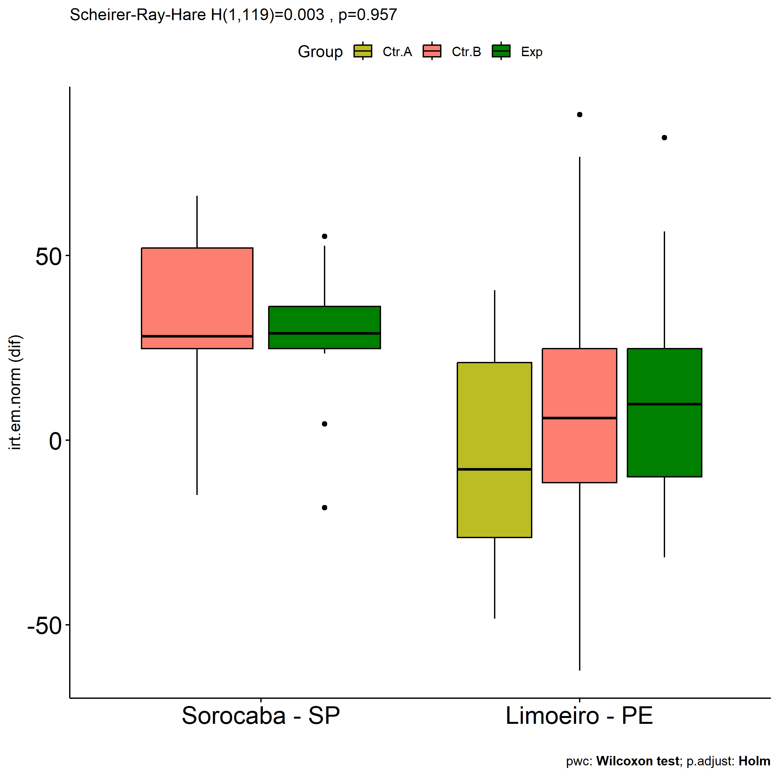

# Two-way factor analysis for: *irt.em.norm ~ Group:Degree*

pdat = remove_group_data(  
 dat[!is.na(dat[["Group"]]) & !is.na(dat[["Degree"]]),],  
 "dif.irt.em.norm", c("Group","Degree"))  
  
pdat.long <- rbind(pdat[,c("ID","Group","Degree")],  
 pdat[,c("ID","Group","Degree")])  
pdat.long[["time"]] <- c(rep("pre", nrow(pdat)), rep("pos", nrow(pdat)))  
pdat.long[["time"]] <- factor(pdat.long[["time"]], c("pre","pos"))  
pdat.long[["irt.em.norm"]] <- c(pdat[["pre.irt.em.norm"]], pdat[["pos.irt.em.norm"]])  
  
y.position.min <- abs(  
 max(pdat.long[["irt.em.norm"]])  
 - min(pdat.long[["irt.em.norm"]]))/20  
  
lvars = as.list(c("dif.irt.em.norm","pos.irt.em.norm","pre.irt.em.norm"))  
names(lvars) = unlist(lvars)

## Pre-test and Post-test PairWise comparisons for: *irt.em.norm ~ Group:Degree*

pwc.long <- group_by(pdat.long, Group:Degree) %>%  
 pairwise_wilcox_test(irt.em.norm ~ time, detailed = T)  
  
df <- pwc.long[,c(".y.","Group:Degree","group1","group2","n1","n2","estimate",  
 "statistic","p.adj","p.adj.signif")]

| .y. | Group:Degree | group1 | group2 | n1 | n2 | estimate | statistic | p.adj | p.adj.signif |
| --- | --- | --- | --- | --- | --- | --- | --- | --- | --- |
| irt.em.norm | Ctr.A:4a | pre | pos | 5 | 5 | 1.2639448 | 15.0 | 0.675 | ns |
| irt.em.norm | Ctr.A:5a | pre | pos | 7 | 7 | 11.4515997 | 40.0 | 0.053 | ns |
| irt.em.norm | Ctr.B:3a | pre | pos | 28 | 28 | 0.9883975 | 402.0 | 0.876 | ns |
| irt.em.norm | Ctr.B:4a | pre | pos | 21 | 21 | -24.7571802 | 98.0 | 0.002 | ** |
| irt.em.norm | Ctr.B:5a | pre | pos | 19 | 19 | -24.7571682 | 94.0 | 0.011 | * |
| irt.em.norm | Exp:3a | pre | pos | 19 | 19 | -10.4049400 | 159.0 | 0.539 | ns |
| irt.em.norm | Exp:4a | pre | pos | 15 | 15 | -28.9344905 | 52.5 | 0.012 | * |
| irt.em.norm | Exp:5a | pre | pos | 8 | 8 | -24.7571766 | 21.0 | 0.265 | ns |

stat.test <- pwc.long %>% add_xy_position(x = "Group:Degree", fun = "max")  
sidx = which(stat.test$p.adj.signif != "ns")  
stat.test$y.position[sidx] <- stat.test$y.position[sidx] + y.position.min * (1:length(sidx))  
  
pdat.long[[paste0(c("Group","Degree"), collapse = ":")]] = apply(  
 pdat.long[, c("Group","Degree")], 1, paste0, collapse = ":")  
  
ggboxplot(pdat.long, x = "Group:Degree", y = "irt.em.norm",  
 palette = color$prepost, fill = "time") +  
 stat_pvalue_manual(stat.test, tip.length = 0, hide.ns = T,  
 label = "{ p.adj } ({ p.adj.signif })") + xlab("")

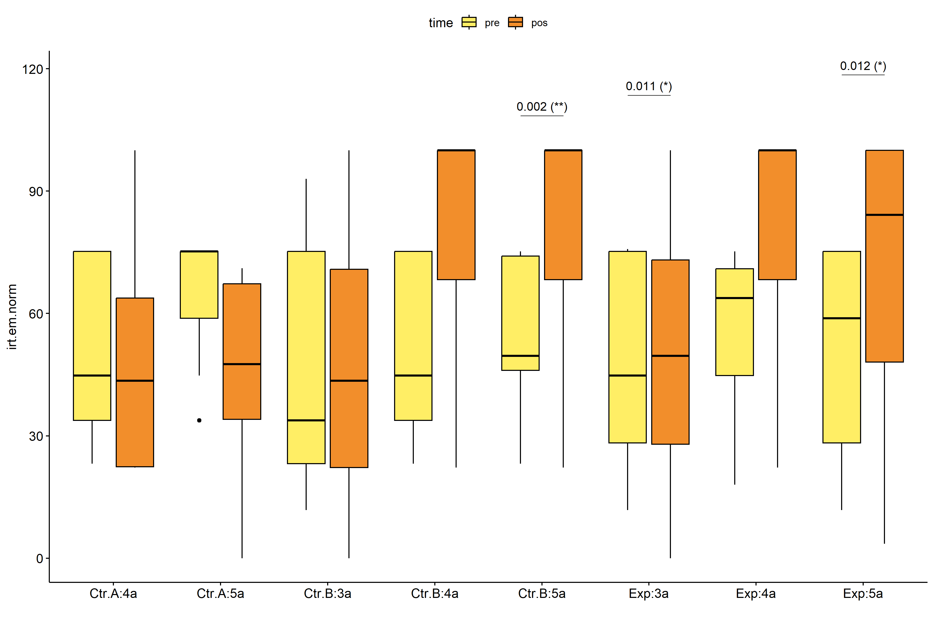

pwc.long <- group_by(pdat.long, Group, Degree) %>%  
 pairwise_wilcox_test(irt.em.norm ~ time, detailed = T)  
  
stat.test <- pwc.long %>% add_xy_position(x = "time", fun = "mean_se")  
sidx = which(stat.test$p.adj.signif != "ns")  
stat.test$y.position[sidx] <- stat.test$y.position[sidx] + y.position.min * (1:length(sidx))  
  
gg <- ggline(  
 pdat.long, x = "time", y = "irt.em.norm",  
 color = "Degree", linetype = "Degree", shape = "Degree", size = 1.5,  
 facet.by = "Group", add = c("mean_se"),  
 position = position_dodge(width = 0.3), palette = color[["Degree"]])  
  
pdat.long$xj = jitter(as.numeric(pdat.long[["time"]]), amount=.1)  
pdat.long$yj = jitter(pdat.long[["irt.em.norm"]], amount = .01)  
  
gg + geom_point(  
 data = pdat.long, aes_string(x="xj",y="yj",colour="Degree"), size=0.5) +  
 stat_pvalue_manual(  
 stat.test, tip.length = 0, hide.ns = T, label.size = 5,  
 position = position_dodge(width = 0.3), color = "Degree",  
 label = "{ p.adj } ({ p.adj.signif })") + xlab("") +  
 theme(strip.text = element_text(size = 16),  
 axis.text = element_text(size = 18))

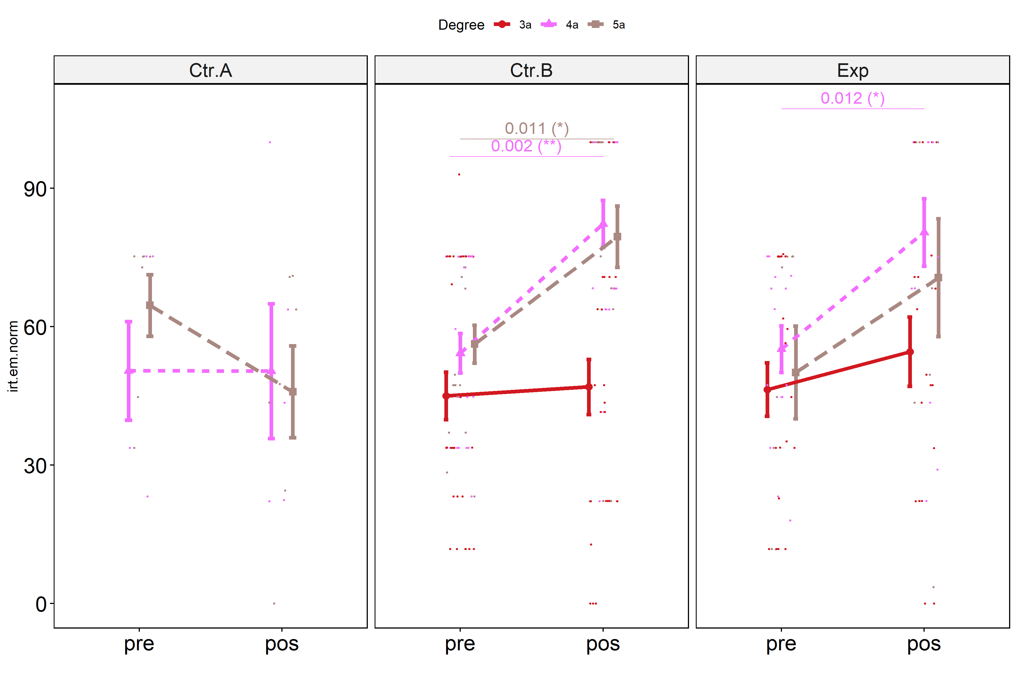

## Scheirer and Wilcoxon PairWise comparisons for: *irt.em.norm ~ Group:Degree*

sch <- lapply(lvars, FUN = function(x) {  
 scheirer.test(pdat, x, c("Group","Degree"), as.table = T)   
})  
df <- do.call(rbind.fill, sch)

| var | Effect | Df | Sum Sq | H | p.value | p.value.signif |
| --- | --- | --- | --- | --- | --- | --- |
| dif.irt.em.norm | Group | 2 | 17343.0632 | 13.9278137 | 0.0009454 | *** |
| dif.irt.em.norm | Degree | 2 | 21003.9892 | 16.8678188 | 0.0002174 | *** |
| dif.irt.em.norm | Group:Degree | 3 | 925.6556 | 0.7433726 | 0.8629579 | ns |
| dif.irt.em.norm | Residuals | 114 | 118072.4111 |  |  |  |
| pos.irt.em.norm | Group | 2 | 10204.9967 | 8.6280586 | 0.0133795 | * |
| pos.irt.em.norm | Degree | 2 | 25121.6060 | 21.2396627 | 0.0000244 | **** |
| pos.irt.em.norm | Group:Degree | 3 | 1102.7887 | 0.9323791 | 0.8176078 | ns |
| pos.irt.em.norm | Residuals | 114 | 112764.7928 |  |  |  |
| pre.irt.em.norm | Group | 2 | 499.8375 | 0.4160614 | 0.8121821 | ns |
| pre.irt.em.norm | Degree | 2 | 3596.6117 | 2.9937950 | 0.2238235 | ns |
| pre.irt.em.norm | Group:Degree | 3 | 1385.9006 | 1.1536142 | 0.7641497 | ns |
| pre.irt.em.norm | Residuals | 114 | 138667.8594 |  |  |  |

pwc <- lapply(lvars, FUN = function(x) {  
 list(  
 Group = tryCatch(pairwise_wilcox_test(group_by(pdat, Degree),  
 as.formula(paste0(x," ~ Group")))  
 , error = function(e) NULL),  
 Degree = tryCatch(pairwise_wilcox_test(group_by(pdat, Group),  
 as.formula(paste0(x," ~ Degree")))  
 , error = function(e) NULL)  
 )  
})  
  
df <- do.call(rbind.fill, lapply(pwc, FUN = function(x) {  
 do.call(rbind.fill, x)  
}))  
  
ivs = c()  
if ("Group" %in% colnames(df)) ivs = c(ivs, "Group")  
if ("Degree" %in% colnames(df)) ivs = c(ivs, "Degree")  
df <- df[,c(".y.",ivs,"group1","group2","n1","n2",  
 "statistic","p.adj","p.adj.signif")]

| .y. | Group | Degree | group1 | group2 | n1 | n2 | statistic | p.adj | p.adj.signif |
| --- | --- | --- | --- | --- | --- | --- | --- | --- | --- |
| dif.irt.em.norm |  | 3a | Ctr.B | Exp | 28 | 19 | 224.0 | 0.368 | ns |
| dif.irt.em.norm |  | 4a | Ctr.A | Ctr.B | 5 | 21 | 25.5 | 0.240 | ns |
| dif.irt.em.norm |  | 4a | Ctr.A | Exp | 5 | 15 | 20.0 | 0.274 | ns |
| dif.irt.em.norm |  | 4a | Ctr.B | Exp | 21 | 15 | 166.5 | 0.783 | ns |
| dif.irt.em.norm |  | 5a | Ctr.A | Ctr.B | 7 | 19 | 21.5 | 0.030 | * |
| dif.irt.em.norm |  | 5a | Ctr.A | Exp | 7 | 8 | 8.0 | 0.048 | * |
| dif.irt.em.norm |  | 5a | Ctr.B | Exp | 19 | 8 | 79.5 | 0.873 | ns |
| dif.irt.em.norm | Ctr.A |  | 4a | 5a | 5 | 7 | 22.0 | 0.530 | ns |
| dif.irt.em.norm | Ctr.B |  | 3a | 4a | 28 | 21 | 134.0 | 0.004 | ** |
| dif.irt.em.norm | Ctr.B |  | 3a | 5a | 28 | 19 | 161.5 | 0.048 | * |
| dif.irt.em.norm | Ctr.B |  | 4a | 5a | 21 | 19 | 216.5 | 0.653 | ns |
| dif.irt.em.norm | Exp |  | 3a | 4a | 19 | 15 | 83.0 | 0.121 | ns |
| dif.irt.em.norm | Exp |  | 3a | 5a | 19 | 8 | 47.0 | 0.258 | ns |
| dif.irt.em.norm | Exp |  | 4a | 5a | 15 | 8 | 64.5 | 0.796 | ns |
| pos.irt.em.norm |  | 3a | Ctr.B | Exp | 28 | 19 | 224.5 | 0.369 | ns |
| pos.irt.em.norm |  | 4a | Ctr.A | Ctr.B | 5 | 21 | 22.0 | 0.109 | ns |
| pos.irt.em.norm |  | 4a | Ctr.A | Exp | 5 | 15 | 17.5 | 0.137 | ns |
| pos.irt.em.norm |  | 4a | Ctr.B | Exp | 21 | 15 | 153.5 | 0.900 | ns |
| pos.irt.em.norm |  | 5a | Ctr.A | Ctr.B | 7 | 19 | 26.5 | 0.052 | ns |
| pos.irt.em.norm |  | 5a | Ctr.A | Exp | 7 | 8 | 15.5 | 0.322 | ns |
| pos.irt.em.norm |  | 5a | Ctr.B | Exp | 19 | 8 | 86.5 | 0.559 | ns |
| pos.irt.em.norm | Ctr.A |  | 4a | 5a | 5 | 7 | 16.0 | 0.871 | ns |
| pos.irt.em.norm | Ctr.B |  | 3a | 4a | 28 | 21 | 126.5 | 0.002 | ** |
| pos.irt.em.norm | Ctr.B |  | 3a | 5a | 28 | 19 | 124.5 | 0.004 | ** |
| pos.irt.em.norm | Ctr.B |  | 4a | 5a | 21 | 19 | 199.0 | 1.000 | ns |
| pos.irt.em.norm | Exp |  | 3a | 4a | 19 | 15 | 80.0 | 0.080 | ns |
| pos.irt.em.norm | Exp |  | 3a | 5a | 19 | 8 | 54.5 | 0.516 | ns |
| pos.irt.em.norm | Exp |  | 4a | 5a | 15 | 8 | 68.5 | 0.568 | ns |
| pre.irt.em.norm |  | 3a | Ctr.B | Exp | 28 | 19 | 253.5 | 0.790 | ns |
| pre.irt.em.norm |  | 4a | Ctr.A | Ctr.B | 5 | 21 | 47.5 | 1.000 | ns |
| pre.irt.em.norm |  | 4a | Ctr.A | Exp | 5 | 15 | 35.0 | 1.000 | ns |
| pre.irt.em.norm |  | 4a | Ctr.B | Exp | 21 | 15 | 159.5 | 1.000 | ns |
| pre.irt.em.norm |  | 5a | Ctr.A | Ctr.B | 7 | 19 | 86.0 | 0.783 | ns |
| pre.irt.em.norm |  | 5a | Ctr.A | Exp | 7 | 8 | 36.5 | 0.783 | ns |
| pre.irt.em.norm |  | 5a | Ctr.B | Exp | 19 | 8 | 82.5 | 0.783 | ns |
| pre.irt.em.norm | Ctr.A |  | 4a | 5a | 5 | 7 | 12.0 | 0.384 | ns |
| pre.irt.em.norm | Ctr.B |  | 3a | 4a | 28 | 21 | 224.5 | 0.420 | ns |
| pre.irt.em.norm | Ctr.B |  | 3a | 5a | 28 | 19 | 198.5 | 0.420 | ns |
| pre.irt.em.norm | Ctr.B |  | 4a | 5a | 21 | 19 | 186.0 | 0.719 | ns |
| pre.irt.em.norm | Exp |  | 3a | 4a | 19 | 15 | 119.0 | 1.000 | ns |
| pre.irt.em.norm | Exp |  | 3a | 5a | 19 | 8 | 72.5 | 1.000 | ns |
| pre.irt.em.norm | Exp |  | 4a | 5a | 15 | 8 | 61.0 | 1.000 | ns |

plots <- lapply(lvars, FUN = function(y) {  
 livs = list("Group", "Degree")  
 names(livs) = unlist(livs)  
 lapply(livs, FUN = function(x) {  
 iv2 = setdiff(names(livs), x)  
 if (!is.null(pwc[[y]][[iv2]])) {  
 stat.test <- pwc[[y]][[iv2]] %>% add_xy_position(x = x, fun = "max")  
 sidx = which(stat.test$p.adj.signif != "ns")  
 stat.test$y.position[sidx] <- stat.test$y.position[sidx] + y.position.min * (1:length(sidx))  
   
 ggboxplot(pdat, x = x, y = y, fill = iv2, palette = color[[iv2]]) +  
 stat_pvalue_manual(stat.test, tip.length = 0, hide.ns = T, label.size = 5,  
 label="{ p.adj } ({ p.adj.signif })") + xlab("")  
 }  
 })  
})

if (!is.null(plots[["pre.irt.em.norm"]][["Group"]]) &&  
 !is.null(plots[["pos.irt.em.norm"]][["Group"]])) {  
 egg::ggarrange(plots[["pre.irt.em.norm"]][["Group"]],  
 plots[["pos.irt.em.norm"]][["Group"]], nrow = 1)   
}

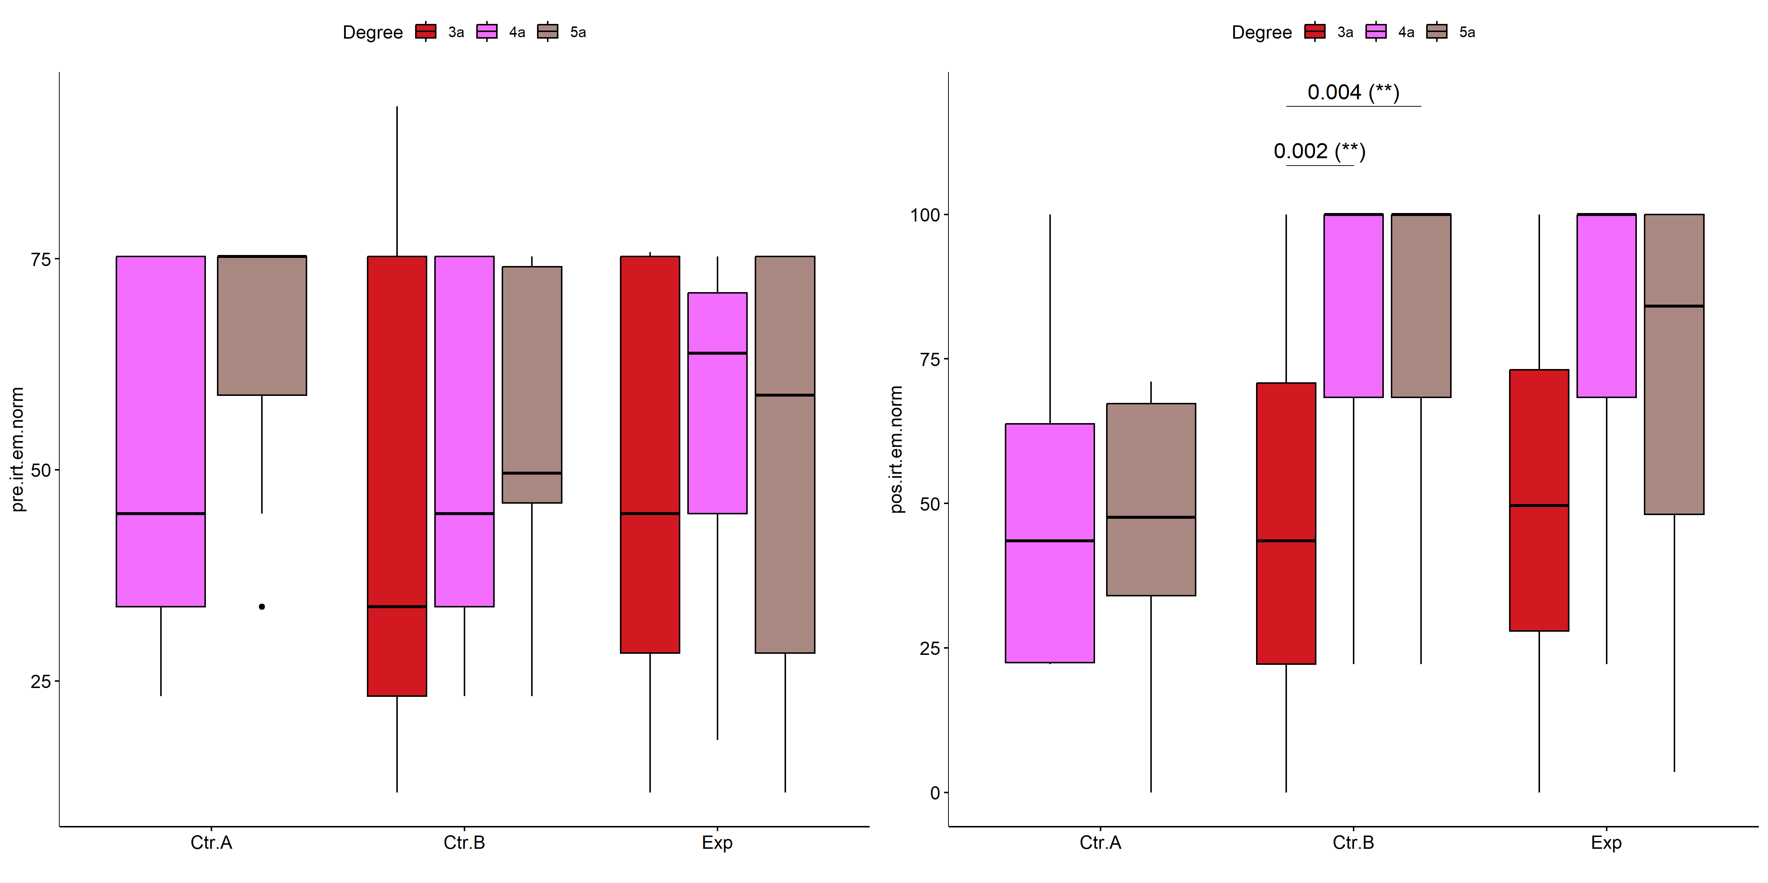

if (!is.null(plots[["pre.irt.em.norm"]][["Degree"]]) &&  
 !is.null(plots[["pos.irt.em.norm"]][["Degree"]])) {  
 egg::ggarrange(plots[["pre.irt.em.norm"]][["Degree"]],  
 plots[["pos.irt.em.norm"]][["Degree"]], nrow = 1)  
}

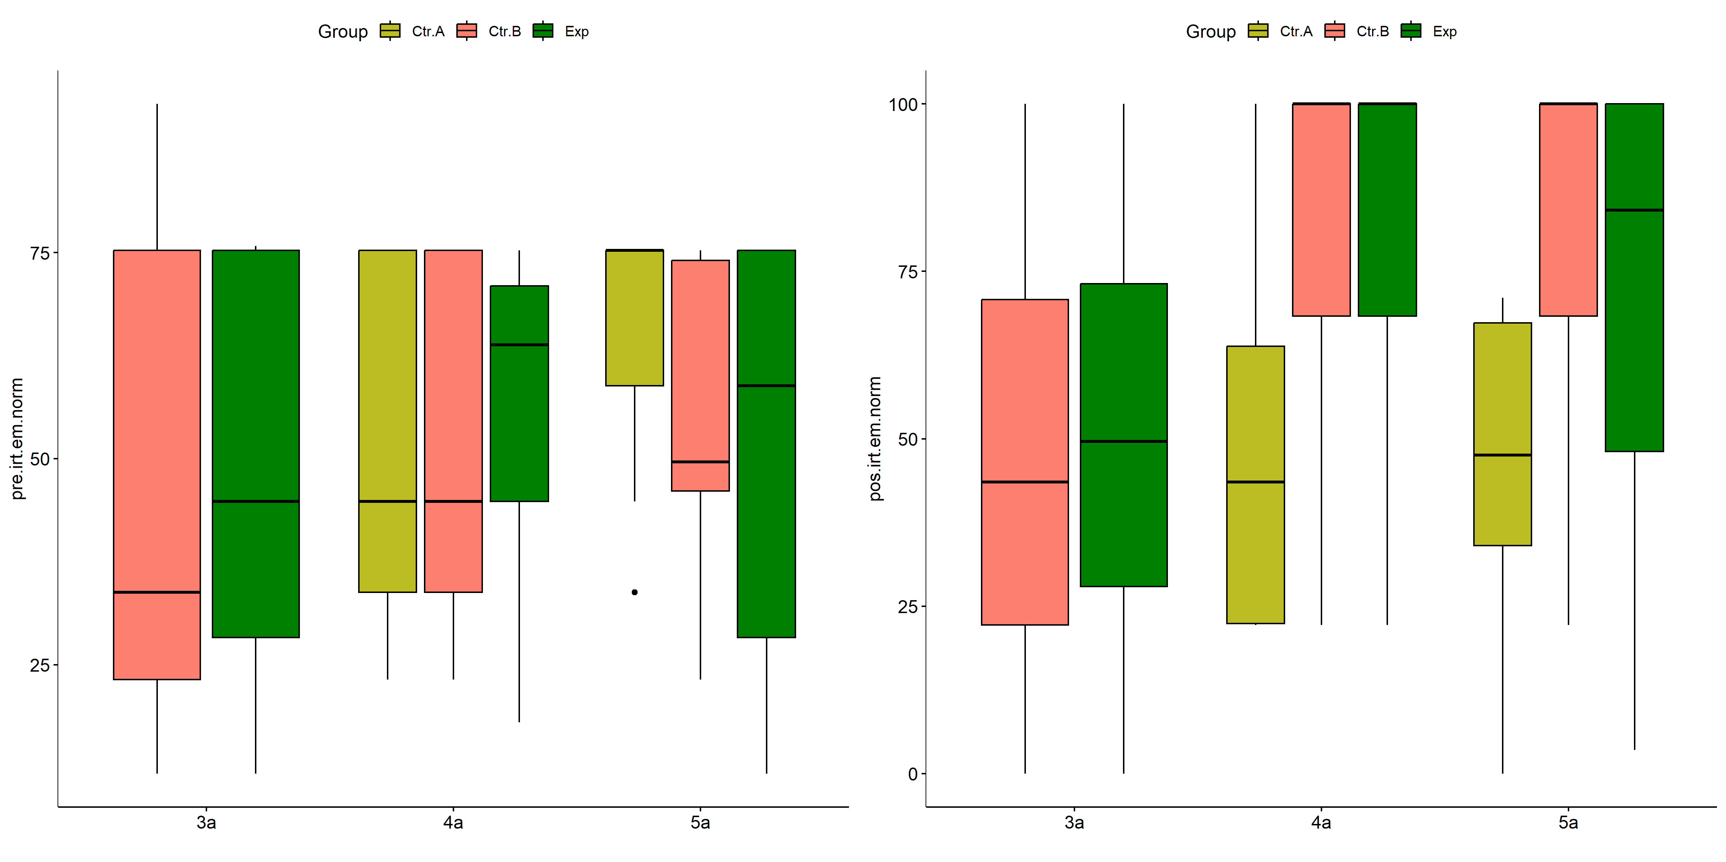

psch = sch[["dif.irt.em.norm"]]  
idx = which(psch$Effect == "Group:Degree")   
  
dof = floor(as.double(psch$Df[idx]))  
dof.res = floor(as.double(psch$Df[which(psch$Effect == "Residuals")]))  
statistic = round(as.double(psch$H[idx]), 3)  
p = round(as.double(psch[["p.value"]][idx]), 3)  
pval = ifelse(p < 0.001,paste0(" , p<0.001"),paste0(" , p=",p))  
  
if (!is.null(plots[["dif.irt.em.norm"]][["Group"]]))  
 plots[["dif.irt.em.norm"]][["Group"]] +  
 labs(subtitle = paste0("Scheirer-Ray-Hare H(", dof, ",",   
 dof.res, ")=", statistic, pval),  
 caption = get_pwc_label(pwc[["dif.irt.em.norm"]][["Degree"]])) +  
 ylab("irt.em.norm (dif)") +  
 theme(strip.text = element_text(size = 16),  
 axis.text = element_text(size = 18))

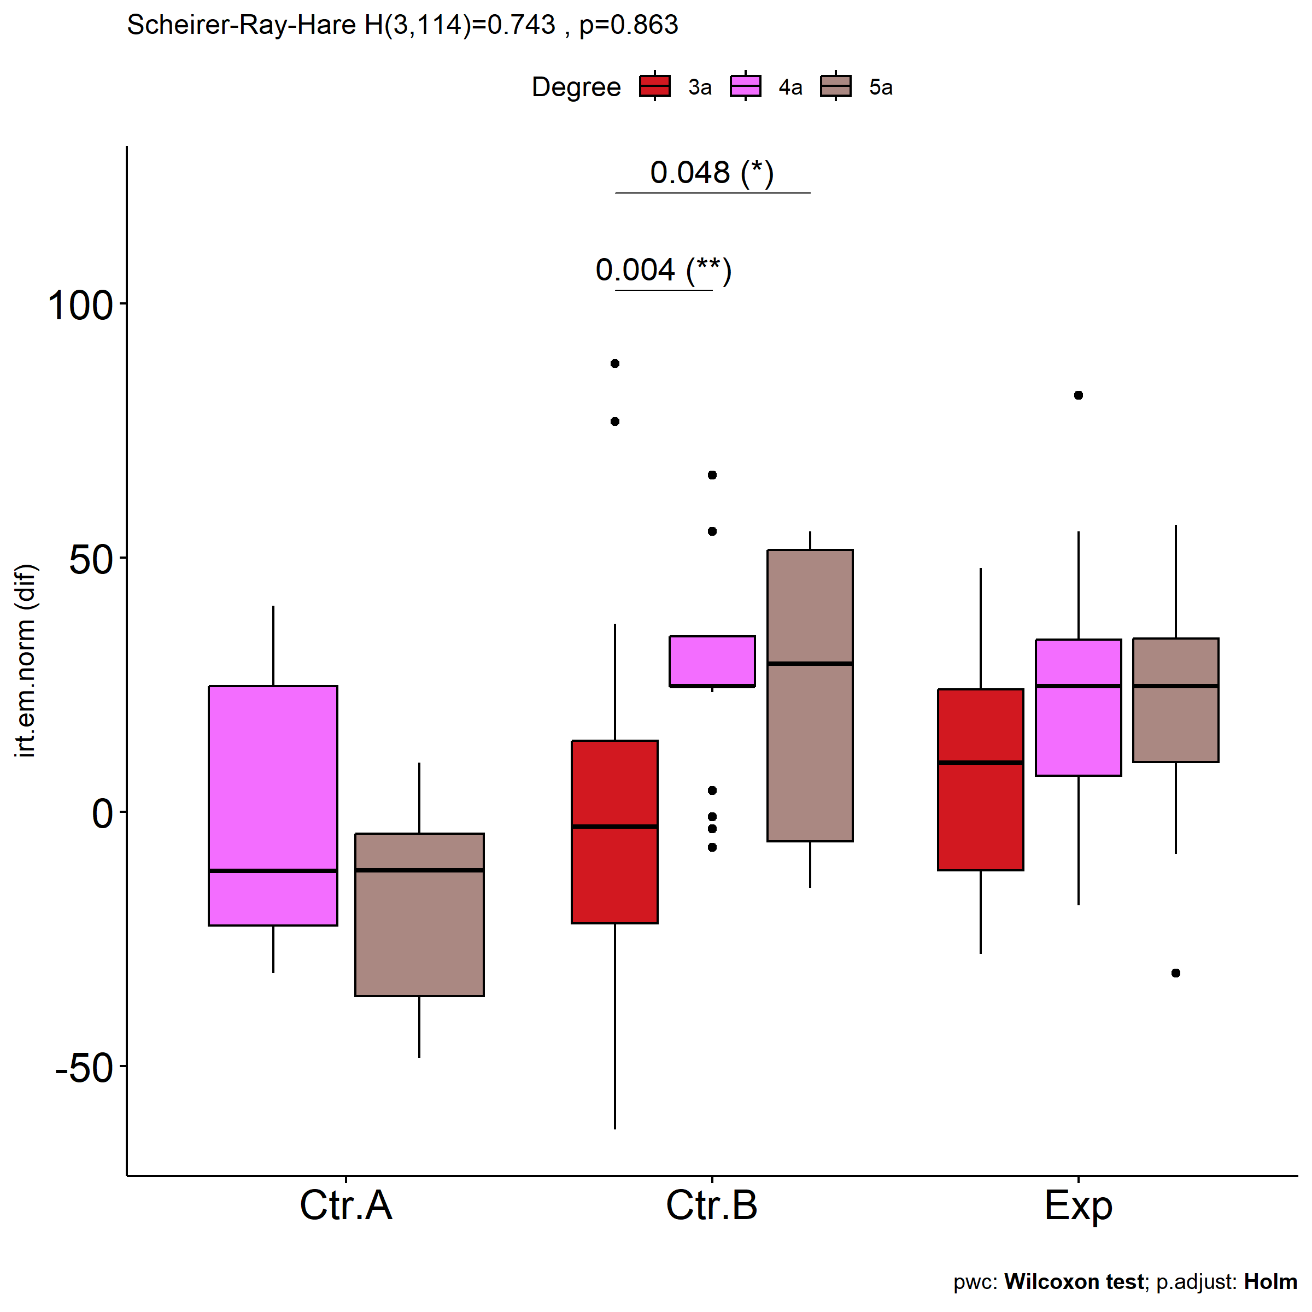

psch = sch[["dif.irt.em.norm"]]  
idx = which(psch$Effect == "Group:Degree")   
  
dof = floor(as.double(psch$Df[idx]))  
dof.res = floor(as.double(psch$Df[which(psch$Effect == "Residuals")]))  
statistic = round(as.double(psch$H[idx]), 3)  
p = round(as.double(psch[["p.value"]][idx]), 3)  
pval = ifelse(p < 0.001,paste0(" , p<0.001"),paste0(" , p=",p))  
  
if (!is.null(plots[["dif.irt.em.norm"]][["Degree"]]))  
 plots[["dif.irt.em.norm"]][["Degree"]] +  
 labs(subtitle = paste0("Scheirer-Ray-Hare H(", dof, ",",   
 dof.res, ")=", statistic, pval),  
 caption = get_pwc_label(pwc[["dif.irt.em.norm"]][["Group"]])) +  
 ylab("irt.em.norm (dif)") +  
 theme(strip.text = element_text(size = 16),  
 axis.text = element_text(size = 18))

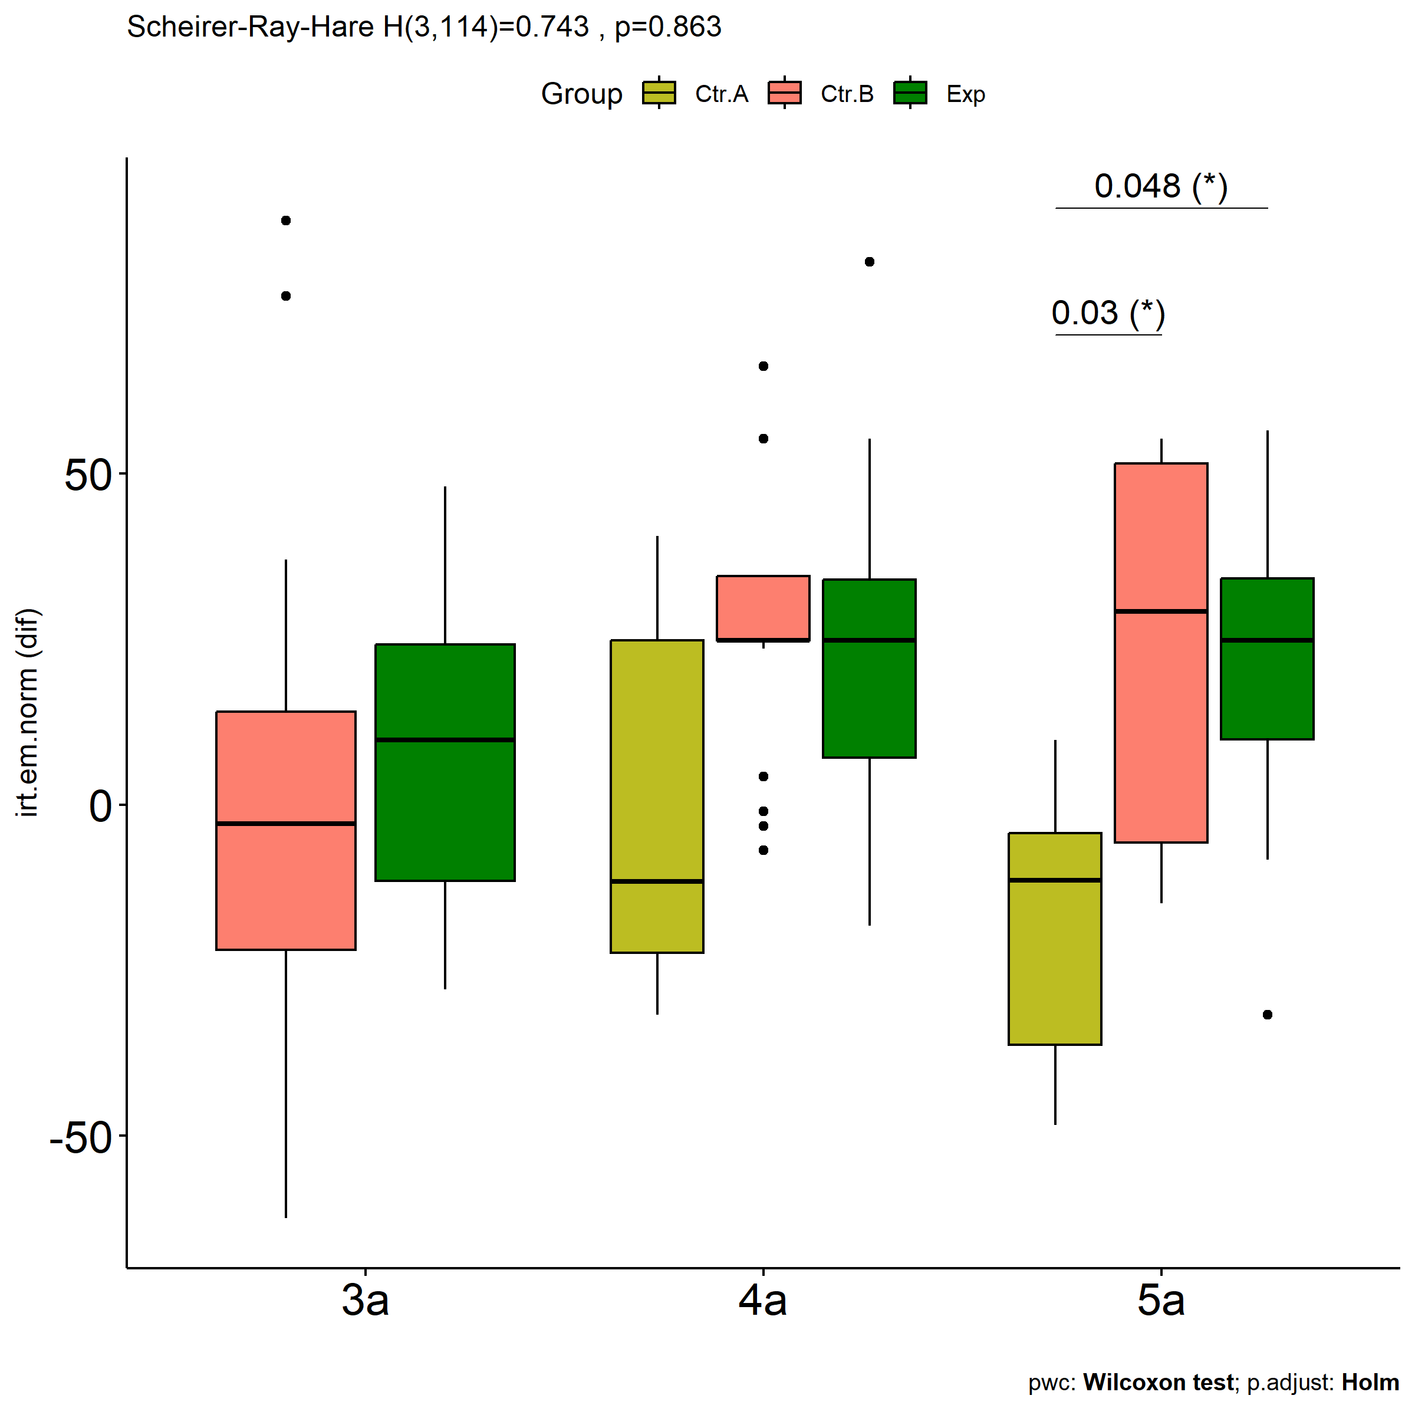

# Two-way factor analysis for: *irt.em.norm ~ Group:qtl.irt.em.norm*

pdat = remove_group_data(  
 dat[!is.na(dat[["Group"]]) & !is.na(dat[["qtl.irt.em.norm"]]),],  
 "dif.irt.em.norm", c("Group","qtl.irt.em.norm"))

## Warning: There was 1 warning in `mutate()`.  
## ℹ In argument: `ci = abs(stats::qt(alpha/2, .data$n - 1) * .data$se)`.  
## Caused by warning:  
## ! There was 1 warning in `mutate()`.  
## ℹ In argument: `ci = abs(stats::qt(alpha/2, .data$n - 1) * .data$se)`.  
## Caused by warning in `stats::qt()`:  
## ! NaNs produced

pdat.long <- rbind(pdat[,c("ID","Group","qtl.irt.em.norm")],  
 pdat[,c("ID","Group","qtl.irt.em.norm")])  
pdat.long[["time"]] <- c(rep("pre", nrow(pdat)), rep("pos", nrow(pdat)))  
pdat.long[["time"]] <- factor(pdat.long[["time"]], c("pre","pos"))  
pdat.long[["irt.em.norm"]] <- c(pdat[["pre.irt.em.norm"]], pdat[["pos.irt.em.norm"]])  
  
y.position.min <- abs(  
 max(pdat.long[["irt.em.norm"]])  
 - min(pdat.long[["irt.em.norm"]]))/20  
  
lvars = as.list(c("dif.irt.em.norm","pos.irt.em.norm","pre.irt.em.norm"))  
names(lvars) = unlist(lvars)

## Pre-test and Post-test PairWise comparisons for: *irt.em.norm ~ Group:qtl.irt.em.norm*

pwc.long <- group_by(pdat.long, Group:qtl.irt.em.norm) %>%  
 pairwise_wilcox_test(irt.em.norm ~ time, detailed = T)  
  
df <- pwc.long[,c(".y.","Group:qtl.irt.em.norm","group1","group2","n1","n2","estimate",  
 "statistic","p.adj","p.adj.signif")]

| .y. | Group:qtl.irt.em.norm | group1 | group2 | n1 | n2 | estimate | statistic | p.adj | p.adj.signif |
| --- | --- | --- | --- | --- | --- | --- | --- | --- | --- |
| irt.em.norm | Ctr.A:2nd | pre | pos | 5 | 5 | 22.365413 | 23.0 | 0.036 | * |
| irt.em.norm | Ctr.A:3rd | pre | pos | 8 | 8 | 4.384584 | 40.0 | 0.399 | ns |
| irt.em.norm | Ctr.B:1st | pre | pos | 12 | 12 | -10.404944 | 60.0 | 0.498 | ns |
| irt.em.norm | Ctr.B:2nd | pre | pos | 33 | 33 | -29.199056 | 296.0 | 0.001 | ** |
| irt.em.norm | Ctr.B:3rd | pre | pos | 23 | 23 | 4.441855 | 276.0 | 0.796 | ns |
| irt.em.norm | Exp:1st | pre | pos | 9 | 9 | -10.404991 | 31.0 | 0.418 | ns |
| irt.em.norm | Exp:2nd | pre | pos | 21 | 21 | -26.003887 | 131.5 | 0.025 | * |
| irt.em.norm | Exp:3rd | pre | pos | 12 | 12 | -24.757073 | 49.0 | 0.166 | ns |

stat.test <- pwc.long %>% add_xy_position(x = "Group:qtl.irt.em.norm", fun = "max")  
sidx = which(stat.test$p.adj.signif != "ns")  
stat.test$y.position[sidx] <- stat.test$y.position[sidx] + y.position.min * (1:length(sidx))  
  
pdat.long[[paste0(c("Group","qtl.irt.em.norm"), collapse = ":")]] = apply(  
 pdat.long[, c("Group","qtl.irt.em.norm")], 1, paste0, collapse = ":")  
  
ggboxplot(pdat.long, x = "Group:qtl.irt.em.norm", y = "irt.em.norm",  
 palette = color$prepost, fill = "time") +  
 stat_pvalue_manual(stat.test, tip.length = 0, hide.ns = T,  
 label = "{ p.adj } ({ p.adj.signif })") + xlab("")

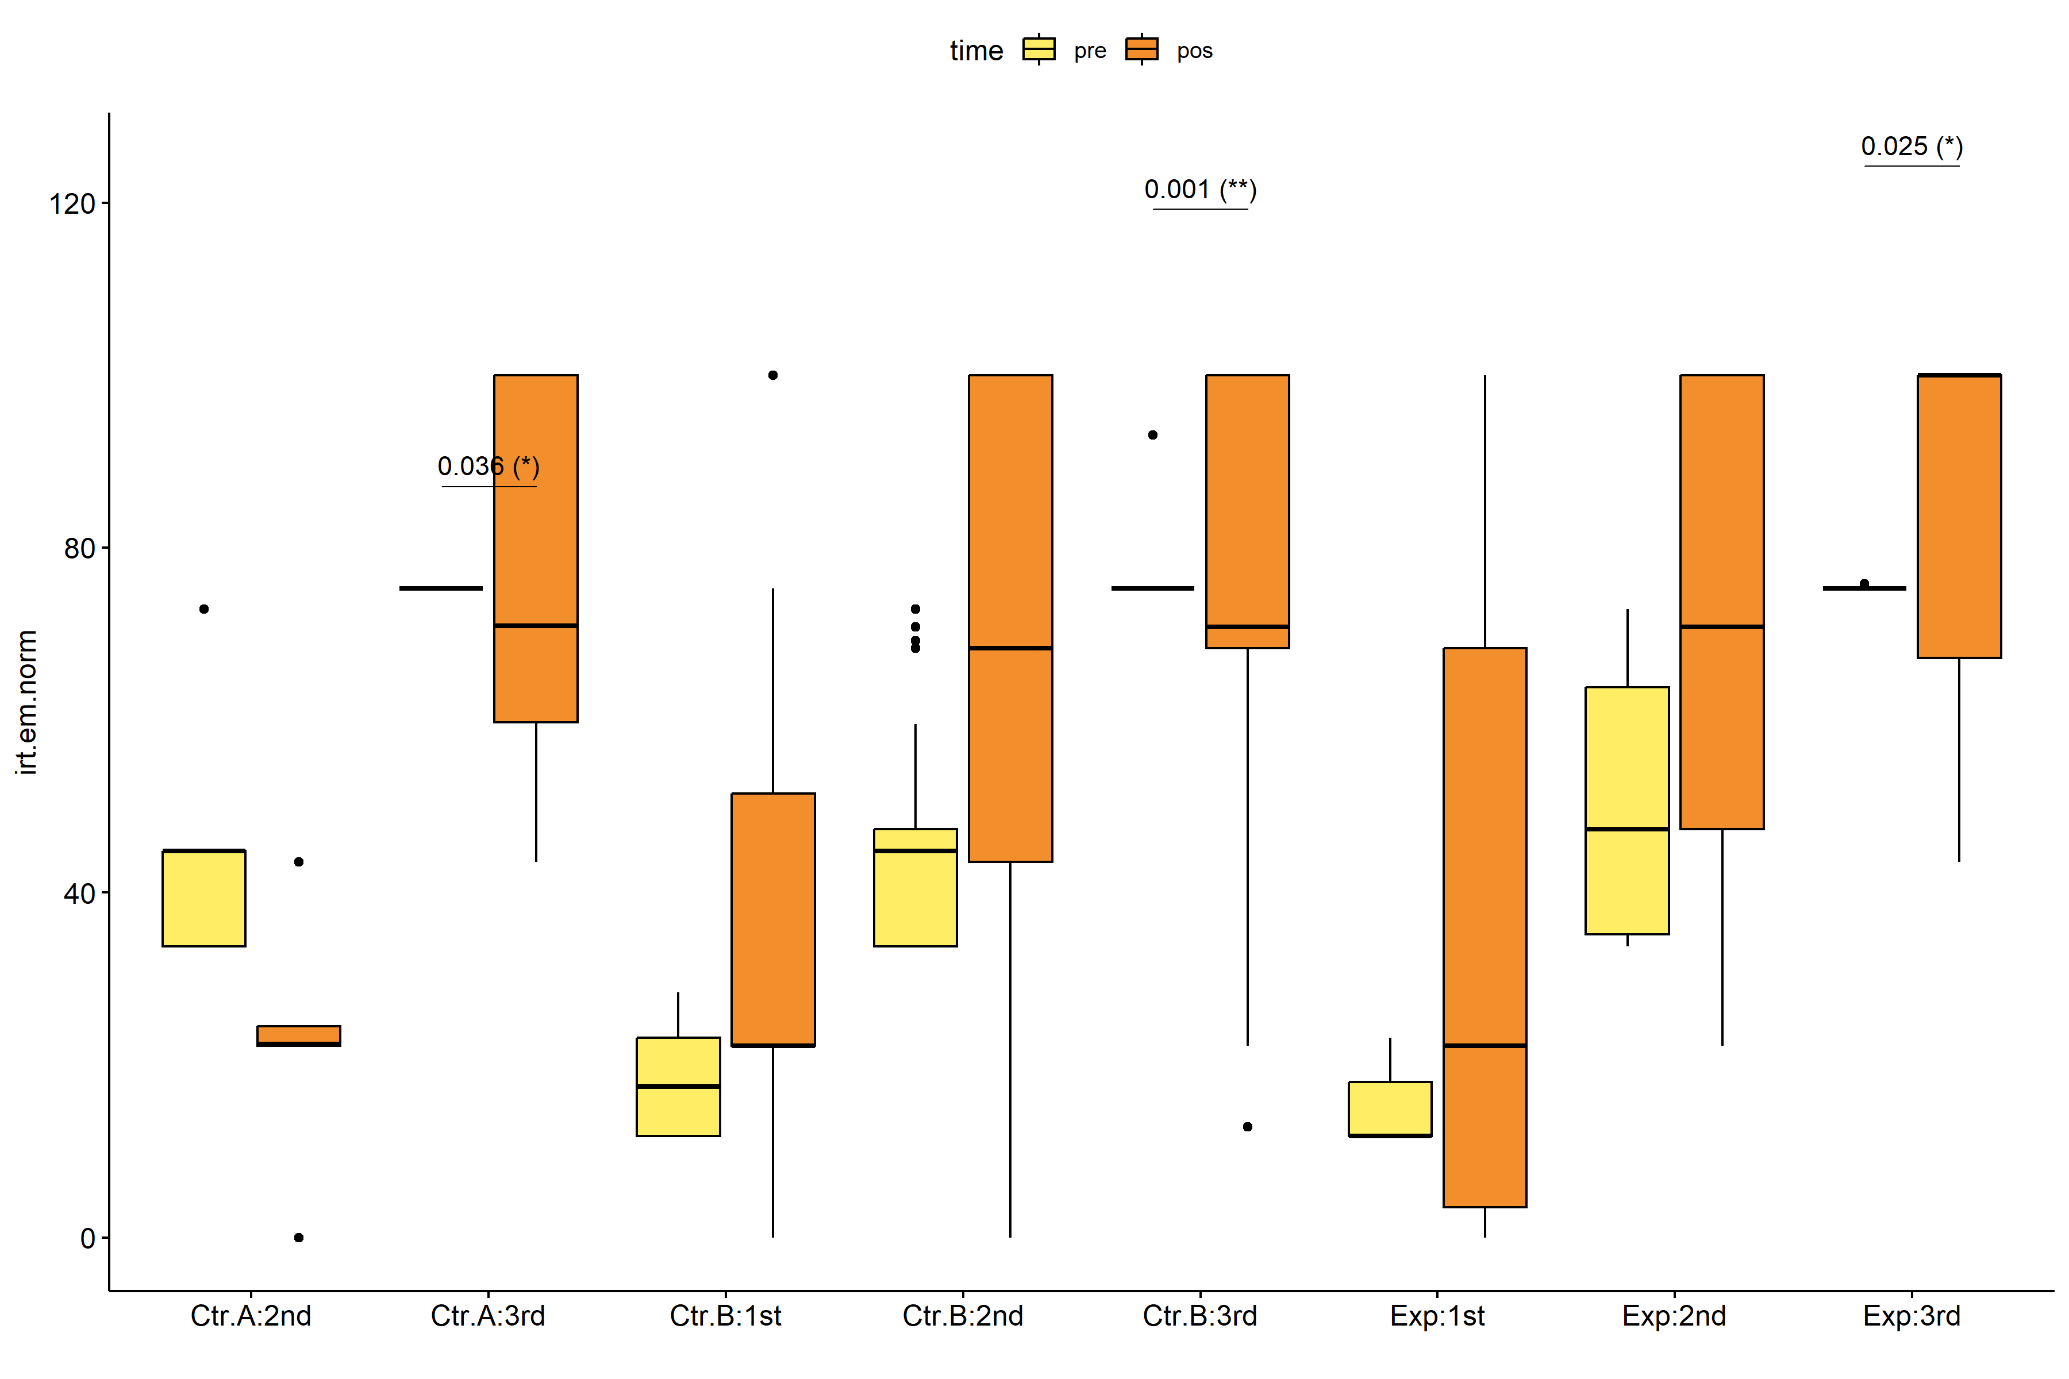

pwc.long <- group_by(pdat.long, Group, qtl.irt.em.norm) %>%  
 pairwise_wilcox_test(irt.em.norm ~ time, detailed = T)  
  
stat.test <- pwc.long %>% add_xy_position(x = "time", fun = "mean_se")  
sidx = which(stat.test$p.adj.signif != "ns")  
stat.test$y.position[sidx] <- stat.test$y.position[sidx] + y.position.min * (1:length(sidx))  
  
gg <- ggline(  
 pdat.long, x = "time", y = "irt.em.norm",  
 color = "qtl.irt.em.norm", linetype = "qtl.irt.em.norm", shape = "qtl.irt.em.norm", size = 1.5,  
 facet.by = "Group", add = c("mean_se"),  
 position = position_dodge(width = 0.3), palette = color[["qtl.irt.em.norm"]])  
  
pdat.long$xj = jitter(as.numeric(pdat.long[["time"]]), amount=.1)  
pdat.long$yj = jitter(pdat.long[["irt.em.norm"]], amount = .01)  
  
gg + geom_point(  
 data = pdat.long, aes_string(x="xj",y="yj",colour="qtl.irt.em.norm"), size=0.5) +  
 stat_pvalue_manual(  
 stat.test, tip.length = 0, hide.ns = T, label.size = 5,  
 position = position_dodge(width = 0.3), color = "qtl.irt.em.norm",  
 label = "{ p.adj } ({ p.adj.signif })") + xlab("") +  
 theme(strip.text = element_text(size = 16),  
 axis.text = element_text(size = 18))

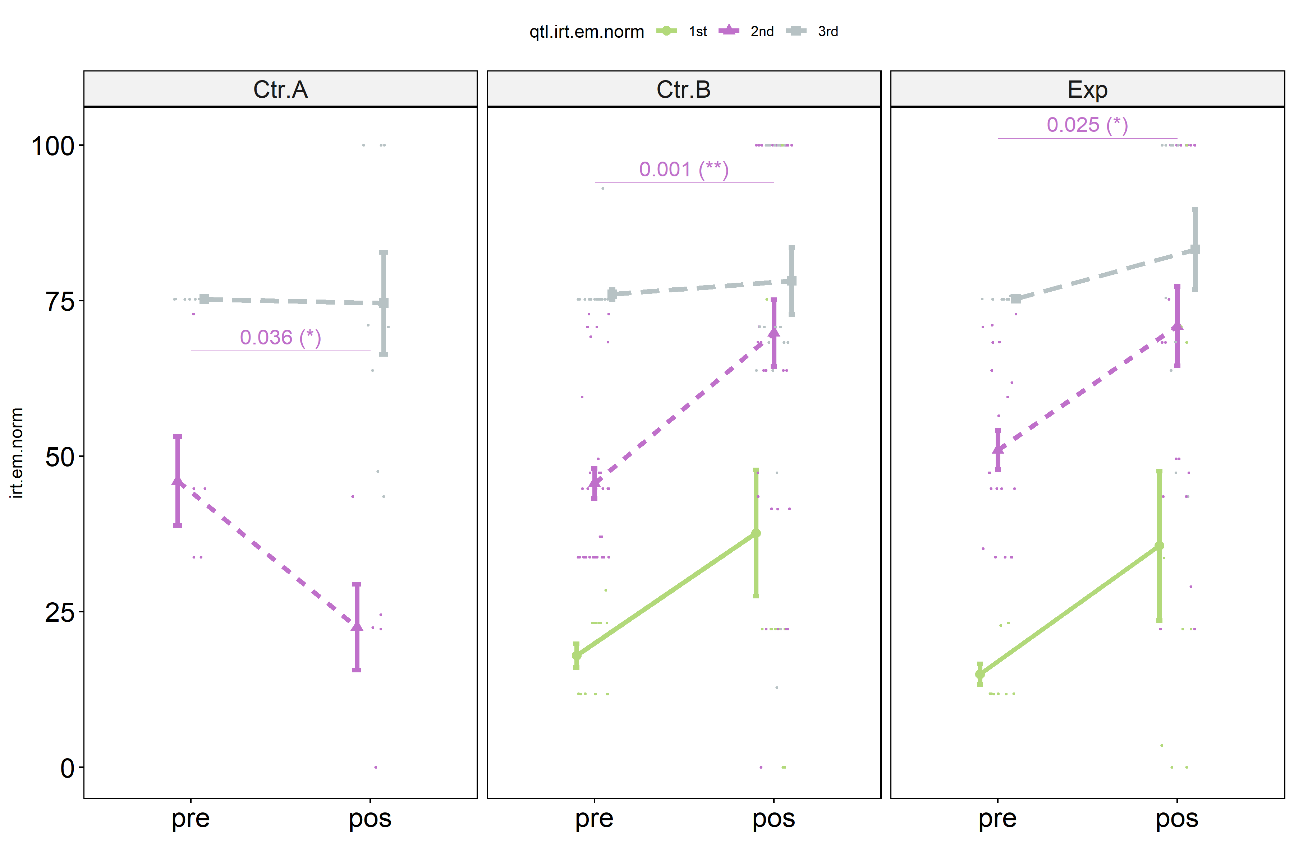

## Scheirer and Wilcoxon PairWise comparisons for: *irt.em.norm ~ Group:qtl.irt.em.norm*

sch <- lapply(lvars, FUN = function(x) {  
 scheirer.test(pdat, x, c("Group","qtl.irt.em.norm"), as.table = T)   
})  
df <- do.call(rbind.fill, sch)

| var | Effect | Df | Sum Sq | H | p.value | p.value.signif |
| --- | --- | --- | --- | --- | --- | --- |
| dif.irt.em.norm | Group | 2 | 8017.7590 | 6.3425879 | 0.0419493 | * |
| dif.irt.em.norm | qtl.irt.em.norm | 2 | 6574.1092 | 5.2005636 | 0.0742526 | ns |
| dif.irt.em.norm | Group:qtl.irt.em.norm | 3 | 6703.0291 | 5.3025480 | 0.1509371 | ns |
| dif.irt.em.norm | Residuals | 115 | 130115.3448 |  |  |  |
| pos.irt.em.norm | Group | 2 | 5396.9226 | 4.5151228 | 0.1046053 | ns |
| pos.irt.em.norm | qtl.irt.em.norm | 2 | 27899.2532 | 23.3408118 | 0.0000085 | **** |
| pos.irt.em.norm | Group:qtl.irt.em.norm | 3 | 4269.4145 | 3.5718376 | 0.3115639 | ns |
| pos.irt.em.norm | Residuals | 115 | 112149.3954 |  |  |  |
| pre.irt.em.norm | Group | 2 | 219.7309 | 0.1807314 | 0.9135970 | ns |
| pre.irt.em.norm | qtl.irt.em.norm | 2 | 125574.1638 | 103.2863287 | 0.0000000 | **** |
| pre.irt.em.norm | Group:qtl.irt.em.norm | 3 | 345.6199 | 0.2842767 | 0.9629580 | ns |
| pre.irt.em.norm | Residuals | 115 | 17200.6493 |  |  |  |

pwc <- lapply(lvars, FUN = function(x) {  
 list(  
 Group = tryCatch(pairwise_wilcox_test(group_by(pdat, qtl.irt.em.norm),  
 as.formula(paste0(x," ~ Group")))  
 , error = function(e) NULL),  
 qtl.irt.em.norm = tryCatch(pairwise_wilcox_test(group_by(pdat, Group),  
 as.formula(paste0(x," ~ qtl.irt.em.norm")))  
 , error = function(e) NULL)  
 )  
})  
  
df <- do.call(rbind.fill, lapply(pwc, FUN = function(x) {  
 do.call(rbind.fill, x)  
}))  
  
ivs = c()  
if ("Group" %in% colnames(df)) ivs = c(ivs, "Group")  
if ("qtl.irt.em.norm" %in% colnames(df)) ivs = c(ivs, "qtl.irt.em.norm")  
df <- df[,c(".y.",ivs,"group1","group2","n1","n2",  
 "statistic","p.adj","p.adj.signif")]

| .y. | Group | qtl.irt.em.norm | group1 | group2 | n1 | n2 | statistic | p.adj | p.adj.signif |
| --- | --- | --- | --- | --- | --- | --- | --- | --- | --- |
| dif.irt.em.norm |  | 1st | Ctr.B | Exp | 12 | 9 | 54.0 | 1.00e+00 | ns |
| dif.irt.em.norm |  | 2nd | Ctr.A | Ctr.B | 5 | 33 | 18.0 | 1.50e-02 | * |
| dif.irt.em.norm |  | 2nd | Ctr.A | Exp | 5 | 21 | 9.0 | 1.50e-02 | * |
| dif.irt.em.norm |  | 2nd | Ctr.B | Exp | 33 | 21 | 383.5 | 5.17e-01 | ns |
| dif.irt.em.norm |  | 3rd | Ctr.A | Ctr.B | 8 | 23 | 85.0 | 1.00e+00 | ns |
| dif.irt.em.norm |  | 3rd | Ctr.A | Exp | 8 | 12 | 38.5 | 1.00e+00 | ns |
| dif.irt.em.norm |  | 3rd | Ctr.B | Exp | 23 | 12 | 124.5 | 1.00e+00 | ns |
| dif.irt.em.norm | Ctr.A |  | 2nd | 3rd | 5 | 8 | 9.0 | 1.22e-01 | ns |
| dif.irt.em.norm | Ctr.B |  | 1st | 2nd | 12 | 33 | 177.0 | 5.98e-01 | ns |
| dif.irt.em.norm | Ctr.B |  | 1st | 3rd | 12 | 23 | 170.0 | 5.30e-01 | ns |
| dif.irt.em.norm | Ctr.B |  | 2nd | 3rd | 33 | 23 | 563.0 | 7.00e-03 | ** |
| dif.irt.em.norm | Exp |  | 1st | 2nd | 9 | 21 | 88.0 | 1.00e+00 | ns |
| dif.irt.em.norm | Exp |  | 1st | 3rd | 9 | 12 | 57.0 | 1.00e+00 | ns |
| dif.irt.em.norm | Exp |  | 2nd | 3rd | 21 | 12 | 157.0 | 7.53e-01 | ns |
| pos.irt.em.norm |  | 1st | Ctr.B | Exp | 12 | 9 | 57.0 | 8.54e-01 | ns |
| pos.irt.em.norm |  | 2nd | Ctr.A | Ctr.B | 5 | 33 | 22.0 | 1.50e-02 | * |
| pos.irt.em.norm |  | 2nd | Ctr.A | Exp | 5 | 21 | 9.0 | 1.30e-02 | * |
| pos.irt.em.norm |  | 2nd | Ctr.B | Exp | 33 | 21 | 332.0 | 7.96e-01 | ns |
| pos.irt.em.norm |  | 3rd | Ctr.A | Ctr.B | 8 | 23 | 83.5 | 1.00e+00 | ns |
| pos.irt.em.norm |  | 3rd | Ctr.A | Exp | 8 | 12 | 38.5 | 1.00e+00 | ns |
| pos.irt.em.norm |  | 3rd | Ctr.B | Exp | 23 | 12 | 126.5 | 1.00e+00 | ns |
| pos.irt.em.norm | Ctr.A |  | 2nd | 3rd | 5 | 8 | 0.5 | 5.00e-03 | ** |
| pos.irt.em.norm | Ctr.B |  | 1st | 2nd | 12 | 33 | 98.5 | 1.80e-02 | * |
| pos.irt.em.norm | Ctr.B |  | 1st | 3rd | 12 | 23 | 58.0 | 1.30e-02 | * |
| pos.irt.em.norm | Ctr.B |  | 2nd | 3rd | 33 | 23 | 313.5 | 2.52e-01 | ns |
| pos.irt.em.norm | Exp |  | 1st | 2nd | 9 | 21 | 41.0 | 2.90e-02 | * |
| pos.irt.em.norm | Exp |  | 1st | 3rd | 9 | 12 | 16.0 | 1.80e-02 | * |
| pos.irt.em.norm | Exp |  | 2nd | 3rd | 21 | 12 | 98.0 | 2.74e-01 | ns |
| pre.irt.em.norm |  | 1st | Ctr.B | Exp | 12 | 9 | 69.5 | 2.31e-01 | ns |
| pre.irt.em.norm |  | 2nd | Ctr.A | Ctr.B | 5 | 33 | 81.0 | 9.74e-01 | ns |
| pre.irt.em.norm |  | 2nd | Ctr.A | Exp | 5 | 21 | 41.5 | 9.74e-01 | ns |
| pre.irt.em.norm |  | 2nd | Ctr.B | Exp | 33 | 21 | 275.0 | 5.91e-01 | ns |
| pre.irt.em.norm |  | 3rd | Ctr.A | Ctr.B | 8 | 23 | 88.0 | 1.00e+00 | ns |
| pre.irt.em.norm |  | 3rd | Ctr.A | Exp | 8 | 12 | 44.0 | 1.00e+00 | ns |
| pre.irt.em.norm |  | 3rd | Ctr.B | Exp | 23 | 12 | 133.0 | 1.00e+00 | ns |
| pre.irt.em.norm | Ctr.A |  | 2nd | 3rd | 5 | 8 | 0.0 | 1.00e-03 | ** |
| pre.irt.em.norm | Ctr.B |  | 1st | 2nd | 12 | 33 | 0.0 | 3.00e-07 | **** |
| pre.irt.em.norm | Ctr.B |  | 1st | 3rd | 12 | 23 | 0.0 | 1.00e-07 | **** |
| pre.irt.em.norm | Ctr.B |  | 2nd | 3rd | 33 | 23 | 0.0 | 0.00e+00 | **** |
| pre.irt.em.norm | Exp |  | 1st | 2nd | 9 | 21 | 0.0 | 3.64e-05 | **** |
| pre.irt.em.norm | Exp |  | 1st | 3rd | 9 | 12 | 0.0 | 3.64e-05 | **** |
| pre.irt.em.norm | Exp |  | 2nd | 3rd | 21 | 12 | 0.0 | 4.80e-06 | **** |

plots <- lapply(lvars, FUN = function(y) {  
 livs = list("Group", "qtl.irt.em.norm")  
 names(livs) = unlist(livs)  
 lapply(livs, FUN = function(x) {  
 iv2 = setdiff(names(livs), x)  
 if (!is.null(pwc[[y]][[iv2]])) {  
 stat.test <- pwc[[y]][[iv2]] %>% add_xy_position(x = x, fun = "max")  
 sidx = which(stat.test$p.adj.signif != "ns")  
 stat.test$y.position[sidx] <- stat.test$y.position[sidx] + y.position.min * (1:length(sidx))  
   
 ggboxplot(pdat, x = x, y = y, fill = iv2, palette = color[[iv2]]) +  
 stat_pvalue_manual(stat.test, tip.length = 0, hide.ns = T, label.size = 5,  
 label="{ p.adj } ({ p.adj.signif })") + xlab("")  
 }  
 })  
})

if (!is.null(plots[["pre.irt.em.norm"]][["Group"]]) &&  
 !is.null(plots[["pos.irt.em.norm"]][["Group"]])) {  
 egg::ggarrange(plots[["pre.irt.em.norm"]][["Group"]],  
 plots[["pos.irt.em.norm"]][["Group"]], nrow = 1)   
}

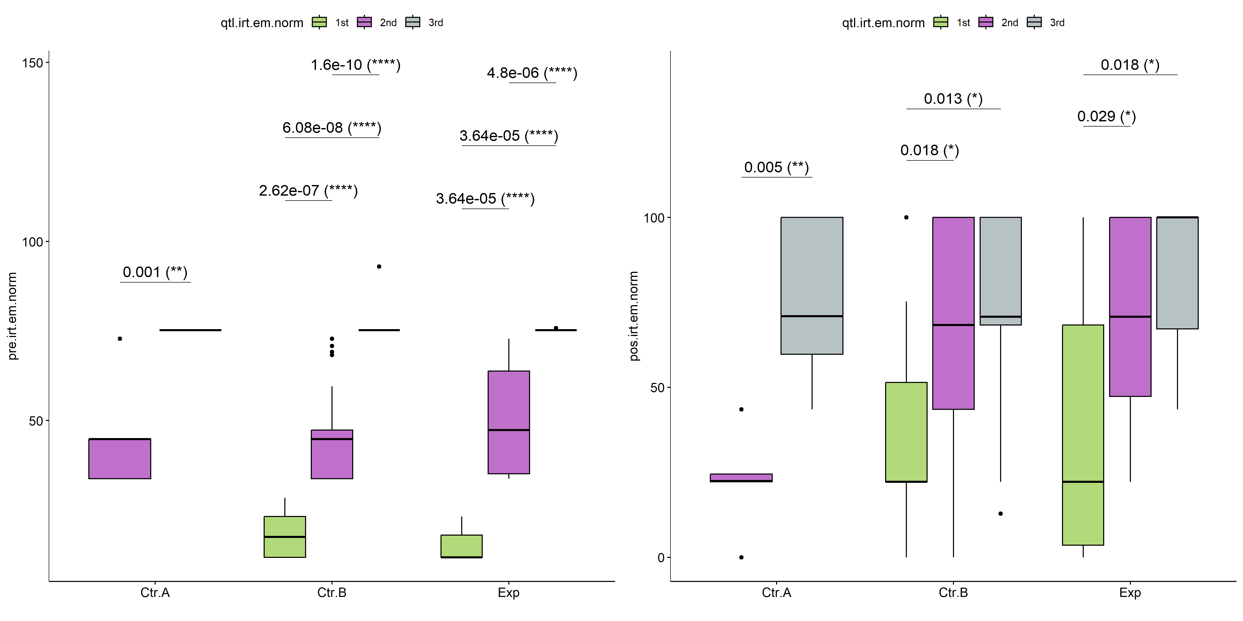

if (!is.null(plots[["pre.irt.em.norm"]][["qtl.irt.em.norm"]]) &&  
 !is.null(plots[["pos.irt.em.norm"]][["qtl.irt.em.norm"]])) {  
 egg::ggarrange(plots[["pre.irt.em.norm"]][["qtl.irt.em.norm"]],  
 plots[["pos.irt.em.norm"]][["qtl.irt.em.norm"]], nrow = 1)  
}

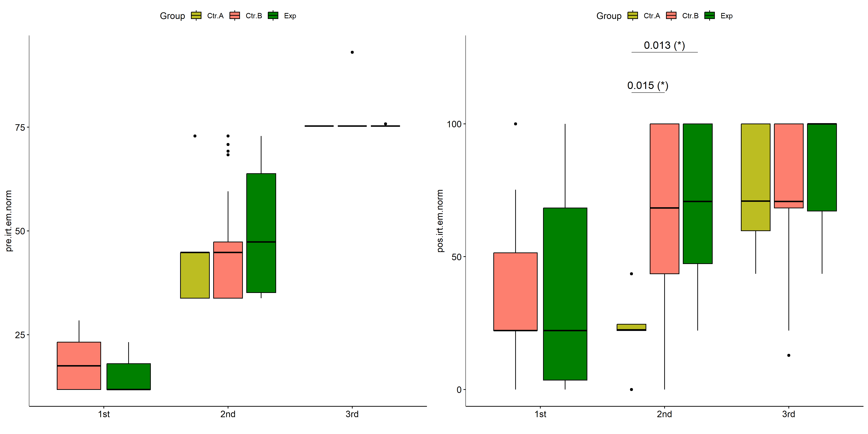

psch = sch[["dif.irt.em.norm"]]  
idx = which(psch$Effect == "Group:qtl.irt.em.norm")   
  
dof = floor(as.double(psch$Df[idx]))  
dof.res = floor(as.double(psch$Df[which(psch$Effect == "Residuals")]))  
statistic = round(as.double(psch$H[idx]), 3)  
p = round(as.double(psch[["p.value"]][idx]), 3)  
pval = ifelse(p < 0.001,paste0(" , p<0.001"),paste0(" , p=",p))  
  
if (!is.null(plots[["dif.irt.em.norm"]][["Group"]]))  
 plots[["dif.irt.em.norm"]][["Group"]] +  
 labs(subtitle = paste0("Scheirer-Ray-Hare H(", dof, ",",   
 dof.res, ")=", statistic, pval),  
 caption = get_pwc_label(pwc[["dif.irt.em.norm"]][["qtl.irt.em.norm"]])) +  
 ylab("irt.em.norm (dif)") +  
 theme(strip.text = element_text(size = 16),  
 axis.text = element_text(size = 18))

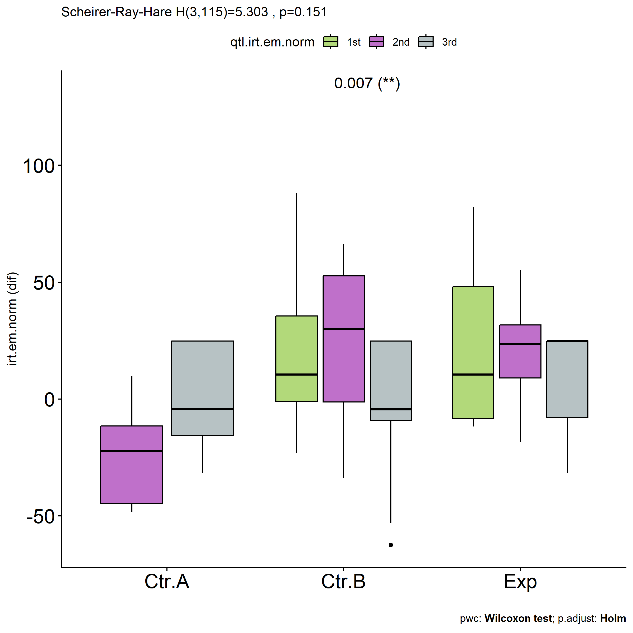

psch = sch[["dif.irt.em.norm"]]  
idx = which(psch$Effect == "Group:qtl.irt.em.norm")   
  
dof = floor(as.double(psch$Df[idx]))  
dof.res = floor(as.double(psch$Df[which(psch$Effect == "Residuals")]))  
statistic = round(as.double(psch$H[idx]), 3)  
p = round(as.double(psch[["p.value"]][idx]), 3)  
pval = ifelse(p < 0.001,paste0(" , p<0.001"),paste0(" , p=",p))  
  
if (!is.null(plots[["dif.irt.em.norm"]][["qtl.irt.em.norm"]]))  
 plots[["dif.irt.em.norm"]][["qtl.irt.em.norm"]] +  
 labs(subtitle = paste0("Scheirer-Ray-Hare H(", dof, ",",   
 dof.res, ")=", statistic, pval),  
 caption = get_pwc_label(pwc[["dif.irt.em.norm"]][["Group"]])) +  
 ylab("irt.em.norm (dif)") +  
 theme(strip.text = element_text(size = 16),  
 axis.text = element_text(size = 18))

