Metanalysis of flow state in condition of Stereotype Boost (stBoost)

Geiser C. Challco [geiser@alumni.usp.br](mailto:geiser@alumni.usp.br)

Table of Contents

## Initial Variables and Loading Data

cond <- "stBoost"  
to_remove <- c('S11')  
sub.groups <- c("age","ed.level","intervention","age:intervention",  
 "ed.level:intervention","age:ed.level:intervention")

dat <- read_excel("../data/data-without-outliers.xlsx", sheet = "fss-cond-descriptive")  
dat <- dat[!dat$study %in% to_remove, ]  
  
leg <- read_excel("../data/data-without-outliers.xlsx", sheet = "legend")

## New names:  
## • `` -> `...10`

leg <- leg[!leg$study %in% to_remove, ]  
  
idx.e <- which(dat$condition==cond)  
idx.c <- which(dat$condition=="control")  
  
data <- data.frame(  
 study = dat$study[idx.c],  
 n.e = dat$N[idx.e], mean.e = dat$M.emms[idx.e], sd.e = dat$SD.emms[idx.e],  
 n.c = dat$N[idx.c], mean.c = dat$M.emms[idx.c], sd.c = dat$SD.emms[idx.c]  
)  
for (cgroups in strsplit(sub.groups,":")) {  
 data[[paste0(cgroups, collapse = ":")]] <- sapply(data$study, FUN = function(x) {  
 paste0(sapply(cgroups, FUN = function(namecol) leg[[namecol]][which(x == leg$study)]), collapse = ":")  
 })  
}  
data[["lbl"]] <- sapply(data$study, FUN = function(x) leg$Note[which(x == leg$study)])

## Perform meta-analyses

m.cont <- metacont(  
 n.e = n.e, mean.e = mean.e, sd.e = sd.e, n.c = n.c, mean.c = mean.c, sd.c = sd.c,  
 studlab = lbl, data = data, sm = "SMD", method.smd = "Hedges",  
 fixed = F, random = T, method.tau = "REML", hakn = T, title = paste("Performance in",cond)  
)  
summary(m.cont)

## Review: Performance in stBoost  
##   
## SMD 95%-CI %W(random)  
## S1 0.6017 [ 0.0897; 1.1136] 10.1  
## S2 0.0200 [-0.4562; 0.4962] 11.6  
## S3 -0.1774 [-0.7134; 0.3587] 9.2  
## S4 0.5120 [-0.0442; 1.0682] 8.5  
## S5 0.0845 [-0.3315; 0.5005] 15.3  
## S6 0.3476 [-0.1021; 0.7973] 13.1  
## S7 0.1612 [-0.2355; 0.5580] 16.8  
## S10: Only use prompt msgs -0.0106 [-0.4241; 0.4028] 15.4  
##   
## Number of studies combined: k = 8  
## Number of observations: o = 597  
##   
## SMD 95%-CI t p-value  
## Random effects model 0.1741 [-0.0312; 0.3793] 2.01 0.0849  
##   
## Quantifying heterogeneity:  
## tau^2 < 0.0001 [0.0000; 0.2358]; tau = 0.0006 [0.0000; 0.4856]  
## I^2 = 8.8% [0.0%; 70.4%]; H = 1.05 [1.00; 1.84]  
##   
## Test of heterogeneity:  
## Q d.f. p-value  
## 7.67 7 0.3625  
##   
## Details on meta-analytical method:  
## - Inverse variance method  
## - Restricted maximum-likelihood estimator for tau^2  
## - Q-profile method for confidence interval of tau^2 and tau  
## - Hartung-Knapp adjustment for random effects model  
## - Hedges' g (bias corrected standardised mean difference; using exact formulae)

forest(m.cont, digits=2, digits.sd = 2, test.overall = T, label.e = cond)

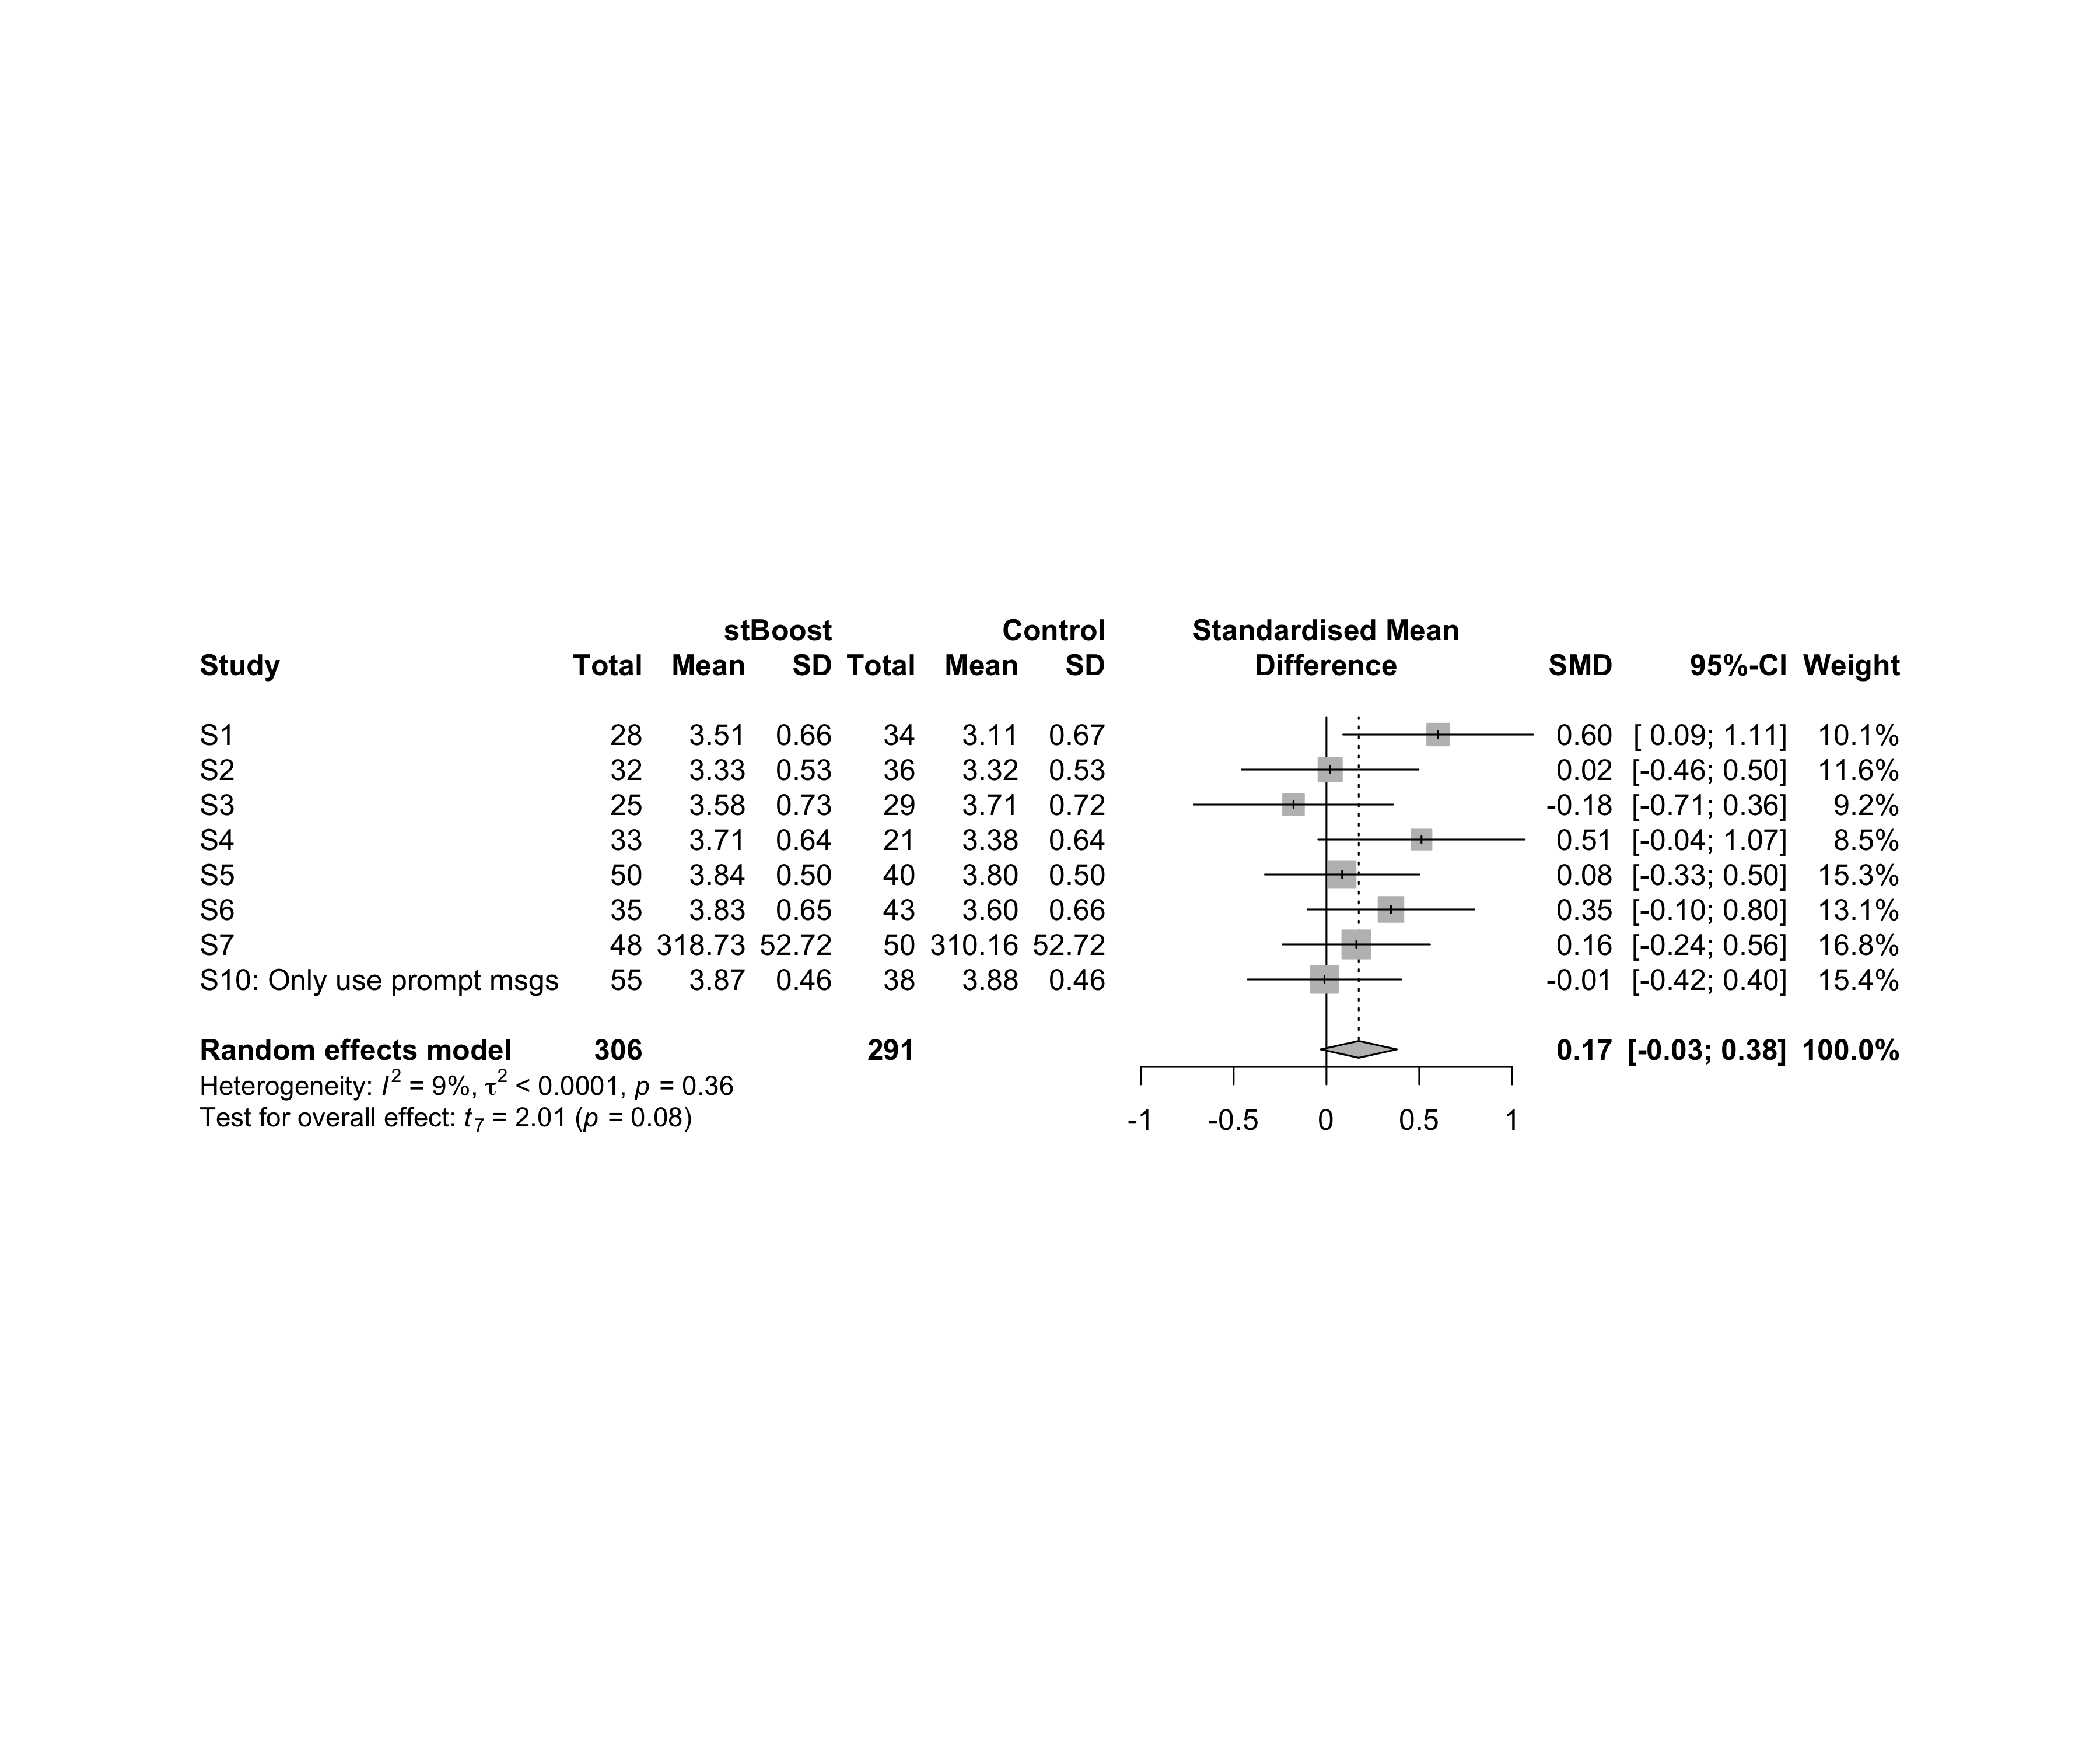

### Subgroup analysis by “age”

m.sg4sub <- update.meta(m.cont, subgroup = age, random = T, fixed = F)  
summary(m.sg4sub)

## Review: Performance in stBoost  
##   
## SMD 95%-CI %W(random) age  
## S1 0.6017 [ 0.0897; 1.1136] 10.1 adolescent  
## S2 0.0200 [-0.4562; 0.4962] 11.6 adolescent  
## S3 -0.1774 [-0.7134; 0.3587] 9.2 adolescent  
## S4 0.5120 [-0.0442; 1.0682] 8.5 adult  
## S5 0.0845 [-0.3315; 0.5005] 15.3 adult  
## S6 0.3476 [-0.1021; 0.7973] 13.1 adult  
## S7 0.1612 [-0.2355; 0.5580] 16.8 adult  
## S10: Only use prompt msgs -0.0106 [-0.4241; 0.4028] 15.4 adolescence  
##   
## Number of studies combined: k = 8  
## Number of observations: o = 597  
##   
## SMD 95%-CI t p-value  
## Random effects model 0.1741 [-0.0312; 0.3793] 2.01 0.0849  
##   
## Quantifying heterogeneity:  
## tau^2 < 0.0001 [0.0000; 0.2358]; tau = 0.0006 [0.0000; 0.4856]  
## I^2 = 8.8% [0.0%; 70.4%]; H = 1.05 [1.00; 1.84]  
##   
## Test of heterogeneity:  
## Q d.f. p-value  
## 7.67 7 0.3625  
##   
## Results for subgroups (random effects model):  
## k SMD 95%-CI tau^2 tau Q I^2  
## age = adolescent 3 0.1498 [-0.8478; 1.1473] 0.0917 0.3028 4.71 57.5%  
## age = adult 4 0.2406 [-0.0406; 0.5218] 0 0 1.83 0.0%  
## age = adolescence 1 -0.0106 [-0.4241; 0.4028] -- -- 0.00 --  
##   
## Test for subgroup differences (random effects model):  
## Q d.f. p-value  
## Between groups 1.25 2 0.5343  
##   
## Details on meta-analytical method:  
## - Inverse variance method  
## - Restricted maximum-likelihood estimator for tau^2  
## - Q-profile method for confidence interval of tau^2 and tau  
## - Hartung-Knapp adjustment for random effects model  
## - Hedges' g (bias corrected standardised mean difference; using exact formulae)

forest(m.sg4sub, digits=2, digits.sd = 2, test.overall = T, label.e = cond)

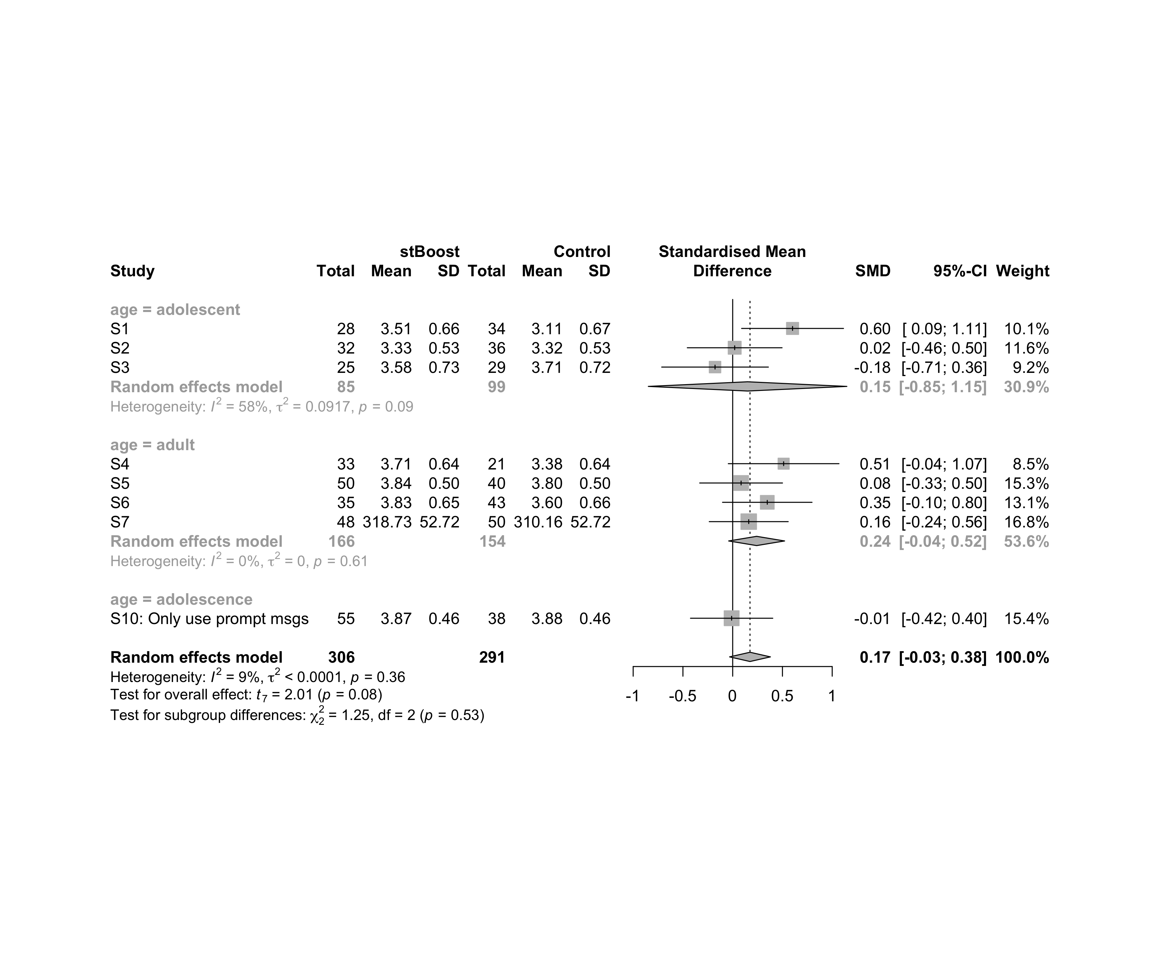

### Subgroup analysis by “ed.level”

m.sg4sub <- update.meta(m.cont, subgroup = ed.level, random = T, fixed = F)  
summary(m.sg4sub)

## Review: Performance in stBoost  
##   
## SMD 95%-CI %W(random) ed.level  
## S1 0.6017 [ 0.0897; 1.1136] 10.1 upper-secundary  
## S2 0.0200 [-0.4562; 0.4962] 11.6 upper-secundary  
## S3 -0.1774 [-0.7134; 0.3587] 9.2 upper-secundary  
## S4 0.5120 [-0.0442; 1.0682] 8.5 higher-education  
## S5 0.0845 [-0.3315; 0.5005] 15.3 higher-education  
## S6 0.3476 [-0.1021; 0.7973] 13.1 higher-education  
## S7 0.1612 [-0.2355; 0.5580] 16.8 unknown  
## S10: Only use prompt msgs -0.0106 [-0.4241; 0.4028] 15.4 upper-secundary  
##   
## Number of studies combined: k = 8  
## Number of observations: o = 597  
##   
## SMD 95%-CI t p-value  
## Random effects model 0.1741 [-0.0312; 0.3793] 2.01 0.0849  
##   
## Quantifying heterogeneity:  
## tau^2 < 0.0001 [0.0000; 0.2358]; tau = 0.0006 [0.0000; 0.4856]  
## I^2 = 8.8% [0.0%; 70.4%]; H = 1.05 [1.00; 1.84]  
##   
## Test of heterogeneity:  
## Q d.f. p-value  
## 7.67 7 0.3625  
##   
## Results for subgroups (random effects model):  
## k SMD 95%-CI tau^2 tau Q I^2  
## ed.level = upper-secundary 4 0.1025 [-0.4182; 0.6233] 0.0397 0.1993 5.10 41.2%  
## ed.level = higher-education 3 0.2767 [-0.2494; 0.8028] 0 0 1.60 0.0%  
## ed.level = unknown 1 0.1612 [-0.2355; 0.5580] -- -- 0.00 --  
##   
## Test for subgroup differences (random effects model):  
## Q d.f. p-value  
## Between groups 0.78 2 0.6761  
##   
## Details on meta-analytical method:  
## - Inverse variance method  
## - Restricted maximum-likelihood estimator for tau^2  
## - Q-profile method for confidence interval of tau^2 and tau  
## - Hartung-Knapp adjustment for random effects model  
## - Hedges' g (bias corrected standardised mean difference; using exact formulae)

forest(m.sg4sub, digits=2, digits.sd = 2, test.overall = T, label.e = cond)

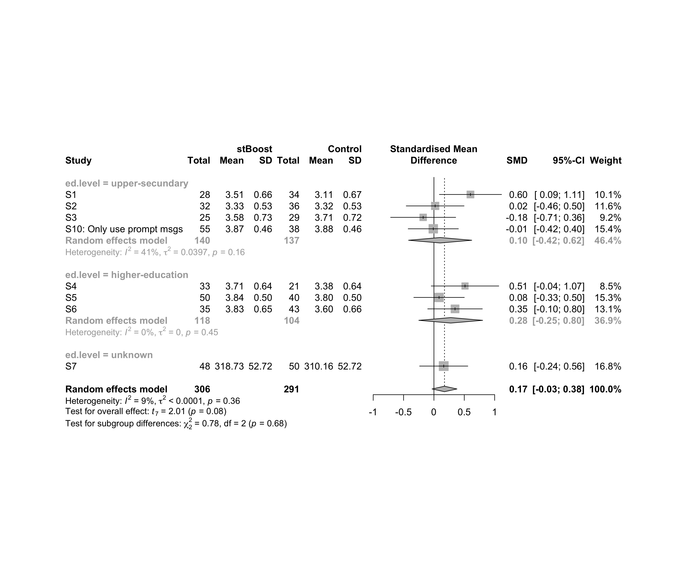

### Subgroup analysis by “intervention”

m.sg4sub <- update.meta(m.cont, subgroup = intervention, random = T, fixed = F)  
summary(m.sg4sub)

## Review: Performance in stBoost  
##   
## SMD 95%-CI %W(random)  
## S1 0.6017 [ 0.0897; 1.1136] 10.1  
## S2 0.0200 [-0.4562; 0.4962] 11.6  
## S3 -0.1774 [-0.7134; 0.3587] 9.2  
## S4 0.5120 [-0.0442; 1.0682] 8.5  
## S5 0.0845 [-0.3315; 0.5005] 15.3  
## S6 0.3476 [-0.1021; 0.7973] 13.1  
## S7 0.1612 [-0.2355; 0.5580] 16.8  
## S10: Only use prompt msgs -0.0106 [-0.4241; 0.4028] 15.4  
## intervention  
## S1 Gender-stereotype color, ranking, badges, and avatar  
## S2 Gender-stereotype color, ranking, badges, and avatar  
## S3 Gender-stereotype color, ranking, badges, and avatar  
## S4 Gender-stereotype color, ranking, badges, and avatar  
## S5 Gender-stereotype color, ranking, badges, and avatar  
## S6 Gender-stereotype color, ranking, badges, and avatar  
## S7 Gender-stereotype color, ranking, badges, and avatar  
## S10: Only use prompt msgs Gender-stereotyped motivational message prompts  
##   
## Number of studies combined: k = 8  
## Number of observations: o = 597  
##   
## SMD 95%-CI t p-value  
## Random effects model 0.1741 [-0.0312; 0.3793] 2.01 0.0849  
##   
## Quantifying heterogeneity:  
## tau^2 < 0.0001 [0.0000; 0.2358]; tau = 0.0006 [0.0000; 0.4856]  
## I^2 = 8.8% [0.0%; 70.4%]; H = 1.05 [1.00; 1.84]  
##   
## Test of heterogeneity:  
## Q d.f. p-value  
## 7.67 7 0.3625  
##   
## Results for subgroups (random effects model):  
## k SMD 95%-CI tau^2 tau Q I^2  
## intervention = Gender-stereotype color, rankin ... 7 0.2078 [-0.0265; 0.4421] <0.0001 0.0013 6.76 11.3%  
## intervention = Gender-stereotyped motivational ... 1 -0.0106 [-0.4241; 0.4028] -- -- 0.00 --  
##   
## Test for subgroup differences (random effects model):  
## Q d.f. p-value  
## Between groups 0.89 1 0.3457  
##   
## Details on meta-analytical method:  
## - Inverse variance method  
## - Restricted maximum-likelihood estimator for tau^2  
## - Q-profile method for confidence interval of tau^2 and tau  
## - Hartung-Knapp adjustment for random effects model  
## - Hedges' g (bias corrected standardised mean difference; using exact formulae)

forest(m.sg4sub, digits=2, digits.sd = 2, test.overall = T, label.e = cond)

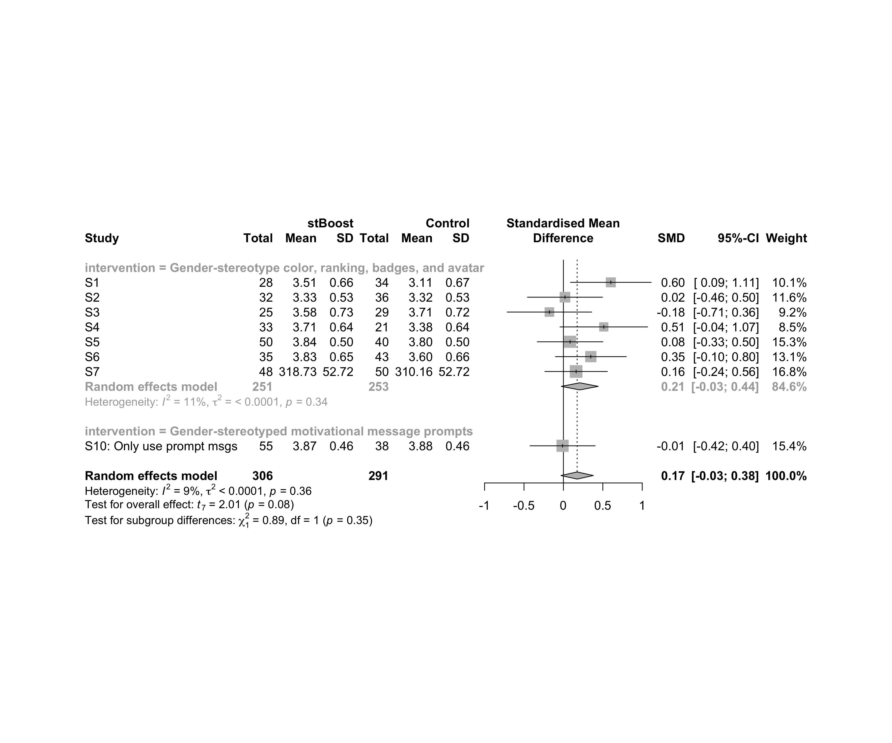

### Subgroup analysis by “age:intervention”

m.sg4sub <- update.meta(m.cont, subgroup = `age:intervention`, random = T, fixed = F)  
summary(m.sg4sub)

## Review: Performance in stBoost  
##   
## SMD 95%-CI %W(random)  
## S1 0.6017 [ 0.0897; 1.1136] 10.1  
## S2 0.0200 [-0.4562; 0.4962] 11.6  
## S3 -0.1774 [-0.7134; 0.3587] 9.2  
## S4 0.5120 [-0.0442; 1.0682] 8.5  
## S5 0.0845 [-0.3315; 0.5005] 15.3  
## S6 0.3476 [-0.1021; 0.7973] 13.1  
## S7 0.1612 [-0.2355; 0.5580] 16.8  
## S10: Only use prompt msgs -0.0106 [-0.4241; 0.4028] 15.4  
## age:intervention  
## S1 adolescent:Gender-stereotype color, ranking, badges, and avatar  
## S2 adolescent:Gender-stereotype color, ranking, badges, and avatar  
## S3 adolescent:Gender-stereotype color, ranking, badges, and avatar  
## S4 adult:Gender-stereotype color, ranking, badges, and avatar  
## S5 adult:Gender-stereotype color, ranking, badges, and avatar  
## S6 adult:Gender-stereotype color, ranking, badges, and avatar  
## S7 adult:Gender-stereotype color, ranking, badges, and avatar  
## S10: Only use prompt msgs adolescence:Gender-stereotyped motivational message prompts  
##   
## Number of studies combined: k = 8  
## Number of observations: o = 597  
##   
## SMD 95%-CI t p-value  
## Random effects model 0.1741 [-0.0312; 0.3793] 2.01 0.0849  
##   
## Quantifying heterogeneity:  
## tau^2 < 0.0001 [0.0000; 0.2358]; tau = 0.0006 [0.0000; 0.4856]  
## I^2 = 8.8% [0.0%; 70.4%]; H = 1.05 [1.00; 1.84]  
##   
## Test of heterogeneity:  
## Q d.f. p-value  
## 7.67 7 0.3625  
##   
## Results for subgroups (random effects model):  
## k SMD 95%-CI tau^2 tau Q  
## age:intervention = adolescent:Gender-stereotype co ... 3 0.1498 [-0.8478; 1.1473] 0.0917 0.3028 4.71  
## age:intervention = adult:Gender-stereotype color, ... 4 0.2406 [-0.0406; 0.5218] 0 0 1.83  
## age:intervention = adolescence:Gender-stereotyped ... 1 -0.0106 [-0.4241; 0.4028] -- -- 0.00  
## I^2  
## age:intervention = adolescent:Gender-stereotype co ... 57.5%  
## age:intervention = adult:Gender-stereotype color, ... 0.0%  
## age:intervention = adolescence:Gender-stereotyped ... --  
##   
## Test for subgroup differences (random effects model):  
## Q d.f. p-value  
## Between groups 1.25 2 0.5343  
##   
## Details on meta-analytical method:  
## - Inverse variance method  
## - Restricted maximum-likelihood estimator for tau^2  
## - Q-profile method for confidence interval of tau^2 and tau  
## - Hartung-Knapp adjustment for random effects model  
## - Hedges' g (bias corrected standardised mean difference; using exact formulae)

forest(m.sg4sub, digits=2, digits.sd = 2, test.overall = T, label.e = cond)

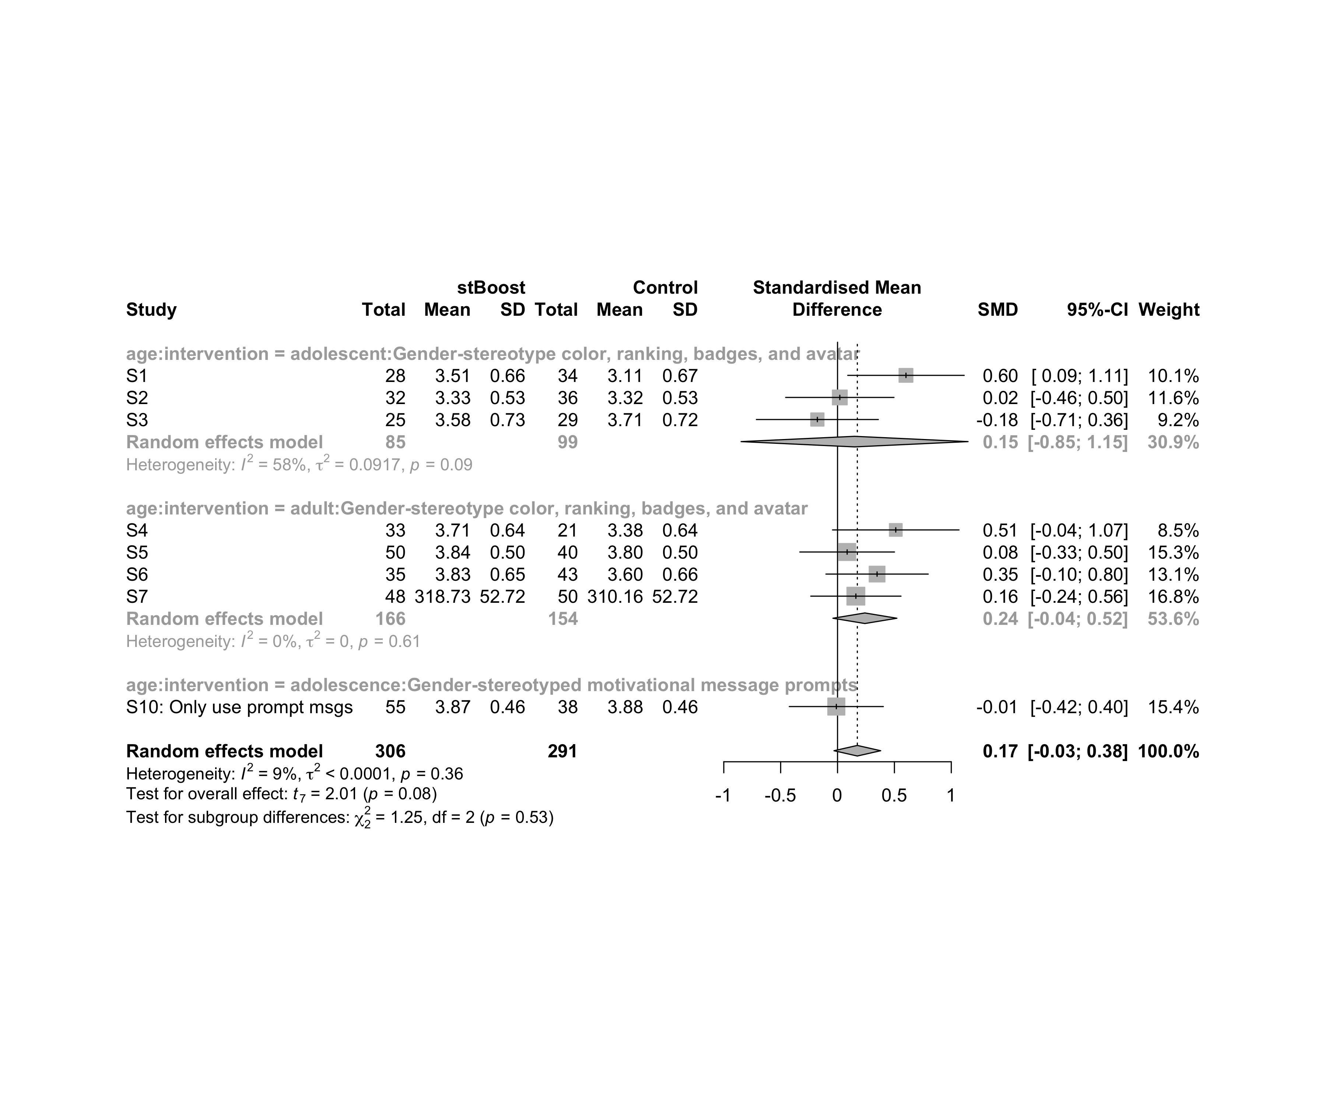

### Subgroup analysis by “ed.level:intervention”

m.sg4sub <- update.meta(m.cont, subgroup = `ed.level:intervention`, random = T, fixed = F)  
summary(m.sg4sub)

## Review: Performance in stBoost  
##   
## SMD 95%-CI %W(random)  
## S1 0.6017 [ 0.0897; 1.1136] 10.1  
## S2 0.0200 [-0.4562; 0.4962] 11.6  
## S3 -0.1774 [-0.7134; 0.3587] 9.2  
## S4 0.5120 [-0.0442; 1.0682] 8.5  
## S5 0.0845 [-0.3315; 0.5005] 15.3  
## S6 0.3476 [-0.1021; 0.7973] 13.1  
## S7 0.1612 [-0.2355; 0.5580] 16.8  
## S10: Only use prompt msgs -0.0106 [-0.4241; 0.4028] 15.4  
## ed.level:intervention  
## S1 upper-secundary:Gender-stereotype color, ranking, badges, and avatar  
## S2 upper-secundary:Gender-stereotype color, ranking, badges, and avatar  
## S3 upper-secundary:Gender-stereotype color, ranking, badges, and avatar  
## S4 higher-education:Gender-stereotype color, ranking, badges, and avatar  
## S5 higher-education:Gender-stereotype color, ranking, badges, and avatar  
## S6 higher-education:Gender-stereotype color, ranking, badges, and avatar  
## S7 unknown:Gender-stereotype color, ranking, badges, and avatar  
## S10: Only use prompt msgs upper-secundary:Gender-stereotyped motivational message prompts  
##   
## Number of studies combined: k = 8  
## Number of observations: o = 597  
##   
## SMD 95%-CI t p-value  
## Random effects model 0.1741 [-0.0312; 0.3793] 2.01 0.0849  
##   
## Quantifying heterogeneity:  
## tau^2 < 0.0001 [0.0000; 0.2358]; tau = 0.0006 [0.0000; 0.4856]  
## I^2 = 8.8% [0.0%; 70.4%]; H = 1.05 [1.00; 1.84]  
##   
## Test of heterogeneity:  
## Q d.f. p-value  
## 7.67 7 0.3625  
##   
## Results for subgroups (random effects model):  
## k SMD 95%-CI tau^2 tau Q  
## ed.level:intervention = upper-secundary:Gender-stereoty ... 3 0.1498 [-0.8478; 1.1473] 0.0917 0.3028 4.71  
## ed.level:intervention = higher-education:Gender-stereot ... 3 0.2767 [-0.2494; 0.8028] 0 0 1.60  
## ed.level:intervention = unknown:Gender-stereotype color ... 1 0.1612 [-0.2355; 0.5580] -- -- 0.00  
## ed.level:intervention = upper-secundary:Gender-stereoty ... 1 -0.0106 [-0.4241; 0.4028] -- -- 0.00  
## I^2  
## ed.level:intervention = upper-secundary:Gender-stereoty ... 57.5%  
## ed.level:intervention = higher-education:Gender-stereot ... 0.0%  
## ed.level:intervention = unknown:Gender-stereotype color ... --  
## ed.level:intervention = upper-secundary:Gender-stereoty ... --  
##   
## Test for subgroup differences (random effects model):  
## Q d.f. p-value  
## Between groups 1.46 3 0.6921  
##   
## Details on meta-analytical method:  
## - Inverse variance method  
## - Restricted maximum-likelihood estimator for tau^2  
## - Q-profile method for confidence interval of tau^2 and tau  
## - Hartung-Knapp adjustment for random effects model  
## - Hedges' g (bias corrected standardised mean difference; using exact formulae)

forest(m.sg4sub, digits=2, digits.sd = 2, test.overall = T, label.e = cond)

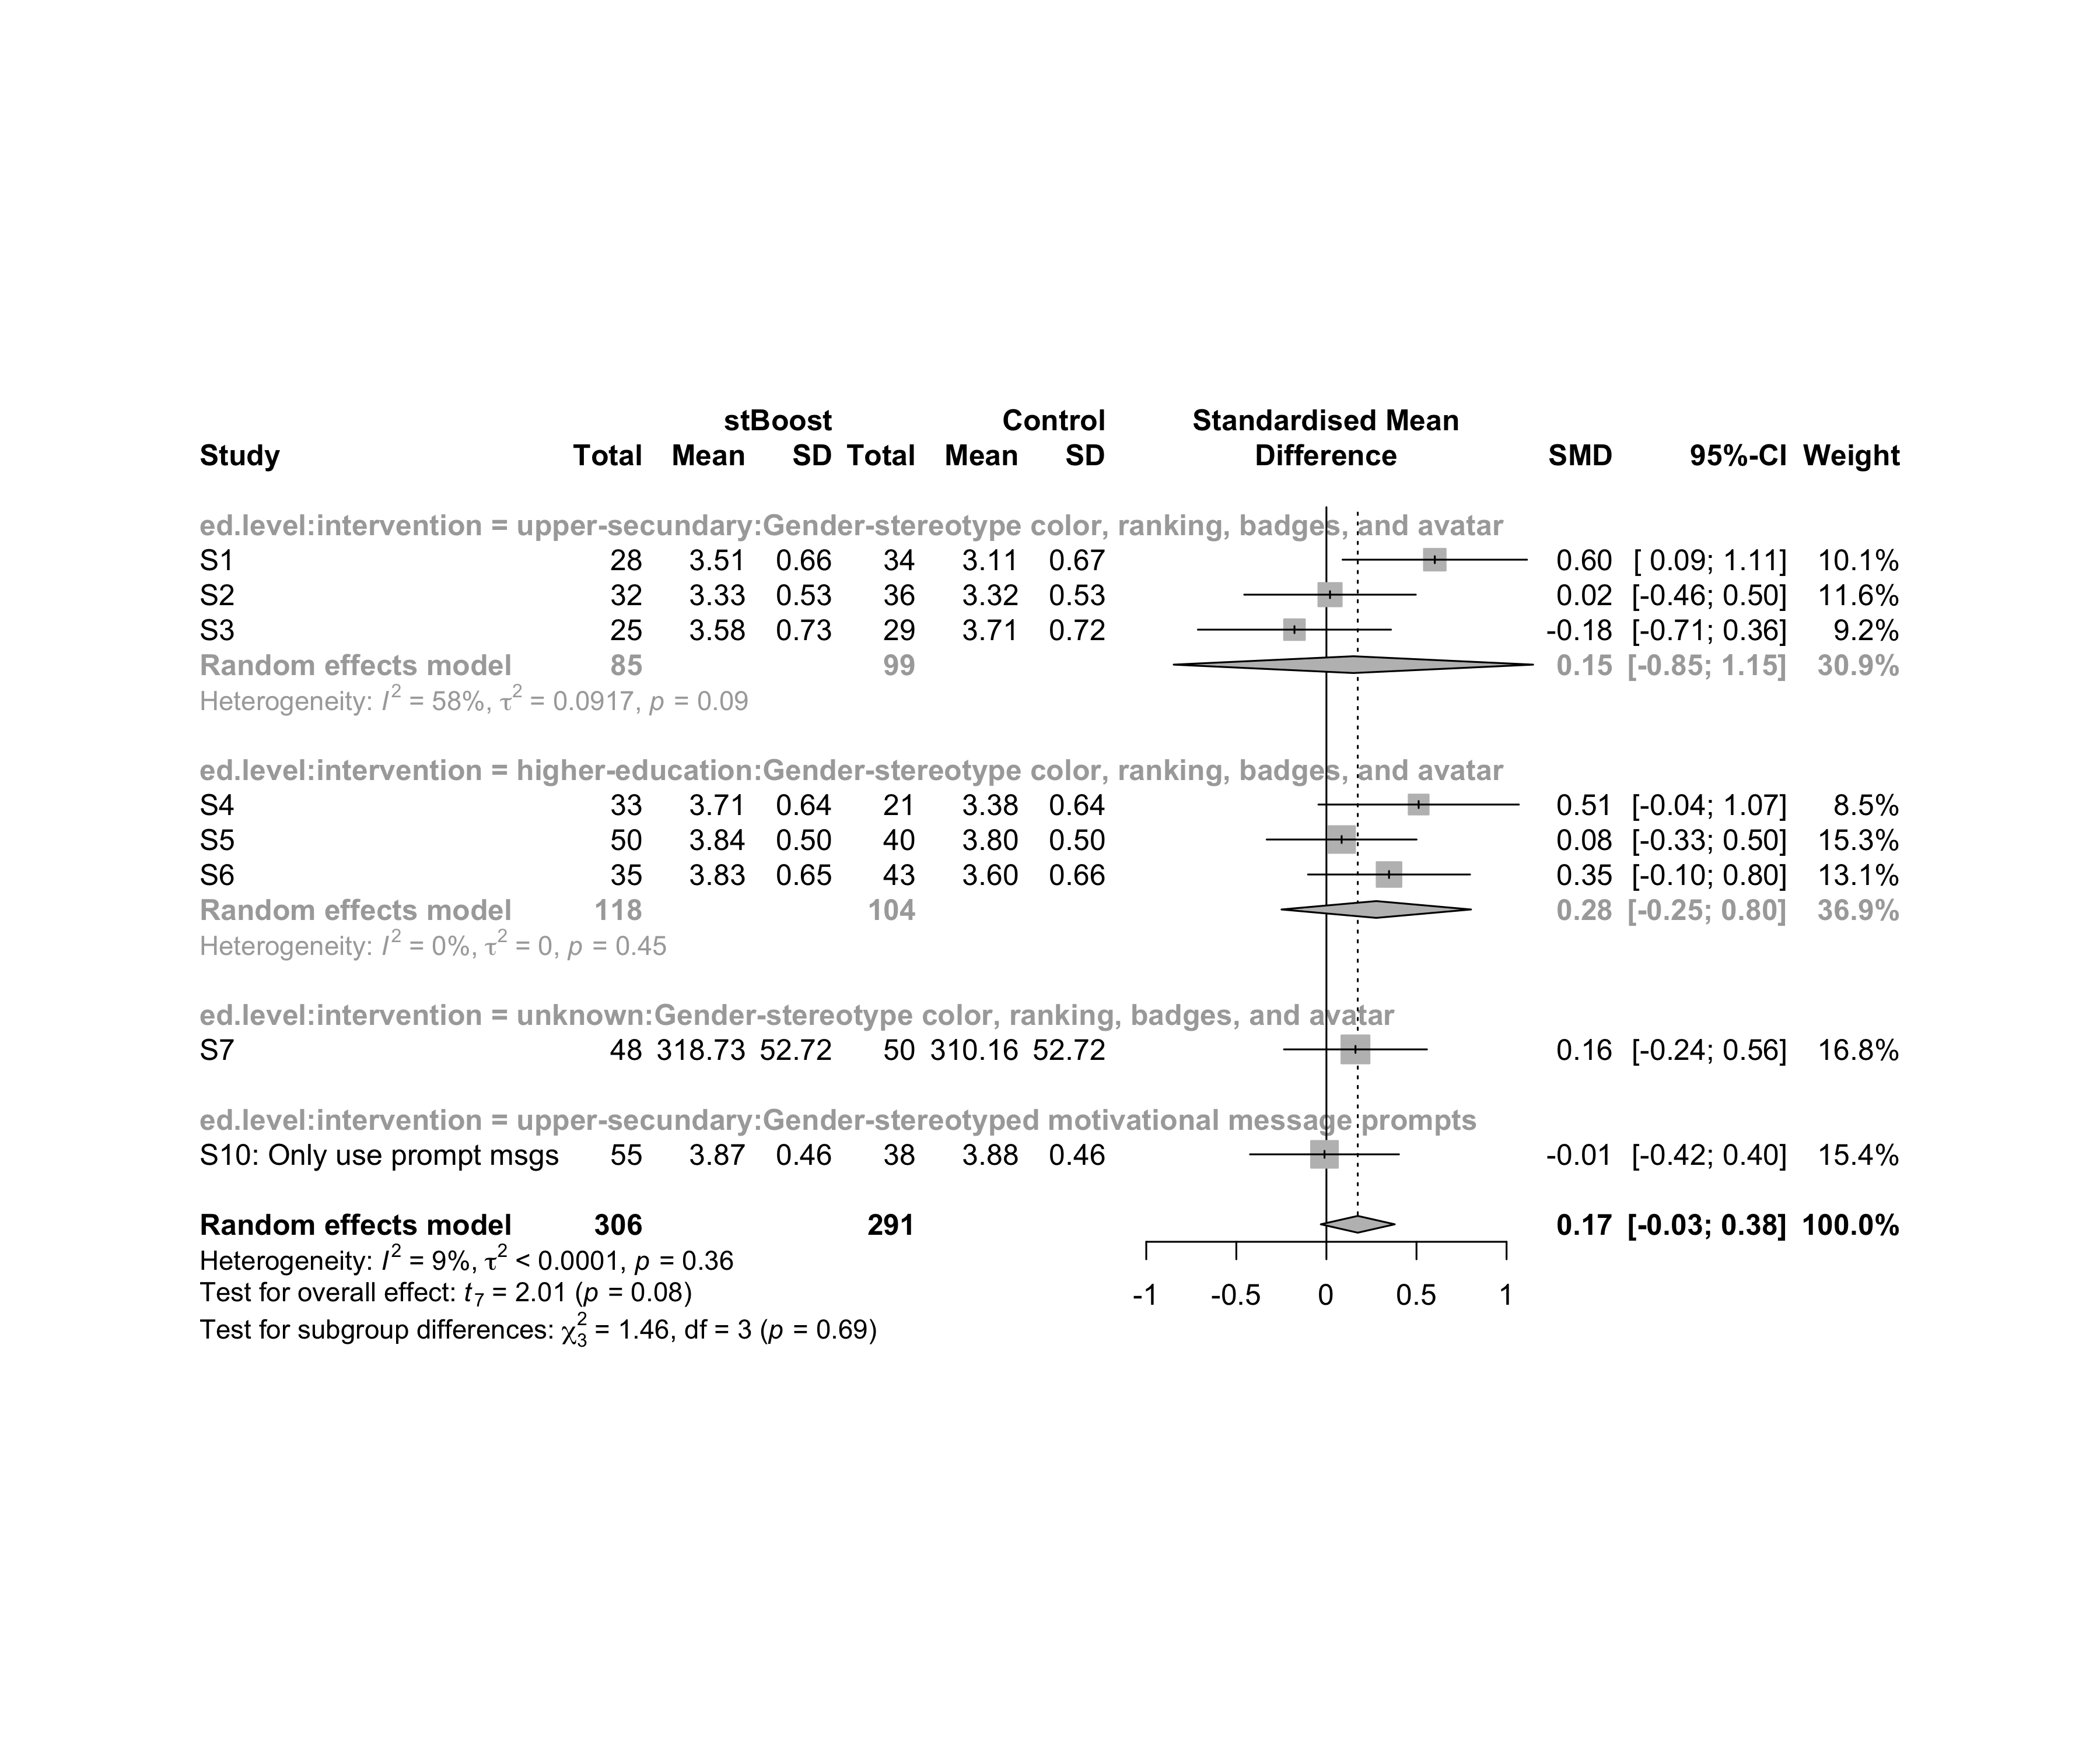

### Subgroup analysis by “age:ed.level:intervention”

m.sg4sub <- update.meta(m.cont, subgroup = `age:ed.level:intervention`, random = T, fixed = F)  
summary(m.sg4sub)

## Review: Performance in stBoost  
##   
## SMD 95%-CI %W(random)  
## S1 0.6017 [ 0.0897; 1.1136] 10.1  
## S2 0.0200 [-0.4562; 0.4962] 11.6  
## S3 -0.1774 [-0.7134; 0.3587] 9.2  
## S4 0.5120 [-0.0442; 1.0682] 8.5  
## S5 0.0845 [-0.3315; 0.5005] 15.3  
## S6 0.3476 [-0.1021; 0.7973] 13.1  
## S7 0.1612 [-0.2355; 0.5580] 16.8  
## S10: Only use prompt msgs -0.0106 [-0.4241; 0.4028] 15.4  
## age:ed.level:intervention  
## S1 adolescent:upper-secundary:Gender-stereotype color, ranking, badges, and avatar  
## S2 adolescent:upper-secundary:Gender-stereotype color, ranking, badges, and avatar  
## S3 adolescent:upper-secundary:Gender-stereotype color, ranking, badges, and avatar  
## S4 adult:higher-education:Gender-stereotype color, ranking, badges, and avatar  
## S5 adult:higher-education:Gender-stereotype color, ranking, badges, and avatar  
## S6 adult:higher-education:Gender-stereotype color, ranking, badges, and avatar  
## S7 adult:unknown:Gender-stereotype color, ranking, badges, and avatar  
## S10: Only use prompt msgs adolescence:upper-secundary:Gender-stereotyped motivational message prompts  
##   
## Number of studies combined: k = 8  
## Number of observations: o = 597  
##   
## SMD 95%-CI t p-value  
## Random effects model 0.1741 [-0.0312; 0.3793] 2.01 0.0849  
##   
## Quantifying heterogeneity:  
## tau^2 < 0.0001 [0.0000; 0.2358]; tau = 0.0006 [0.0000; 0.4856]  
## I^2 = 8.8% [0.0%; 70.4%]; H = 1.05 [1.00; 1.84]  
##   
## Test of heterogeneity:  
## Q d.f. p-value  
## 7.67 7 0.3625  
##   
## Results for subgroups (random effects model):  
## k SMD 95%-CI tau^2 tau  
## age:ed.level:intervention = adolescent:upper-secundary:Gend ... 3 0.1498 [-0.8478; 1.1473] 0.0917 0.3028  
## age:ed.level:intervention = adult:higher-education:Gender-s ... 3 0.2767 [-0.2494; 0.8028] 0 0  
## age:ed.level:intervention = adult:unknown:Gender-stereotype ... 1 0.1612 [-0.2355; 0.5580] -- --  
## age:ed.level:intervention = adolescence:upper-secundary:Gen ... 1 -0.0106 [-0.4241; 0.4028] -- --  
## Q I^2  
## age:ed.level:intervention = adolescent:upper-secundary:Gend ... 4.71 57.5%  
## age:ed.level:intervention = adult:higher-education:Gender-s ... 1.60 0.0%  
## age:ed.level:intervention = adult:unknown:Gender-stereotype ... 0.00 --  
## age:ed.level:intervention = adolescence:upper-secundary:Gen ... 0.00 --  
##   
## Test for subgroup differences (random effects model):  
## Q d.f. p-value  
## Between groups 1.46 3 0.6921  
##   
## Details on meta-analytical method:  
## - Inverse variance method  
## - Restricted maximum-likelihood estimator for tau^2  
## - Q-profile method for confidence interval of tau^2 and tau  
## - Hartung-Knapp adjustment for random effects model  
## - Hedges' g (bias corrected standardised mean difference; using exact formulae)

forest(m.sg4sub, digits=2, digits.sd = 2, test.overall = T, label.e = cond)

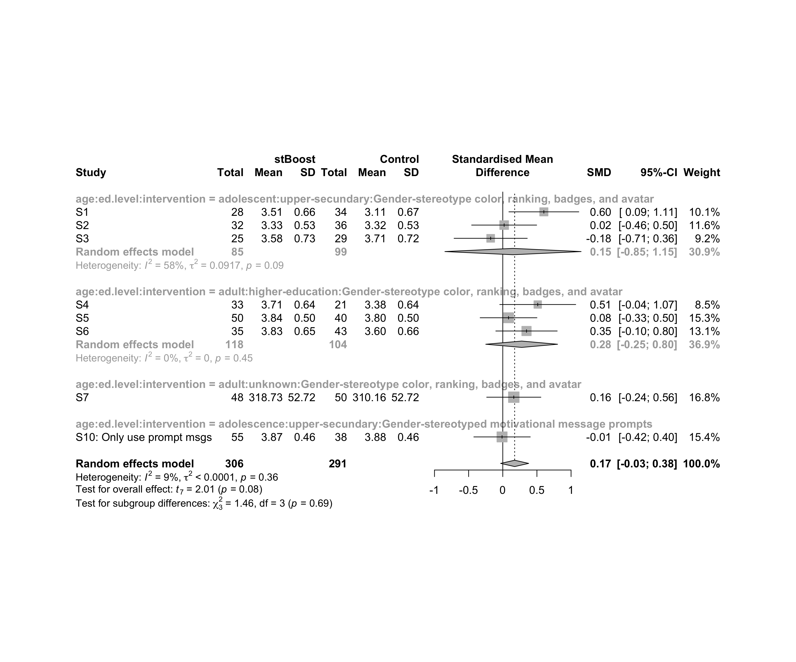

## Funnel Plot

m.cont <- update.meta(m.cont, studlab = data$study)  
summary(eggers.test(x = m.cont))

## Eggers' test of the intercept   
## =============================   
##   
## intercept 95% CI t p  
## 2.745 -3.54 - 9.03 0.856 0.42  
##   
## Eggers' test does not indicate the presence of funnel plot asymmetry.

funnel(m.cont, xlab = "Hedges' g", studlab = T, legend=T, addtau2 = T)

