Metanalysis of flow state on women caused by (stMale)

Geiser C. Challco [geiser@alumni.usp.br](mailto:geiser@alumni.usp.br)

Table of Contents

## Initial Variables and Loading Data

env <- "stMale"  
gender <- "women"  
to_remove <- c('S11')  
sub.groups <- c("age","ed.level","intervention","age:intervention",  
 "ed.level:intervention","age:ed.level:intervention")

dat <- read_excel("../data/data-without-outliers.xlsx", sheet = "fss-env.gender-descriptive")  
dat <- dat[!dat$study %in% to_remove, ]  
  
leg <- read_excel("../data/data-without-outliers.xlsx", sheet = "legend")

## New names:  
## • `` -> `...10`

leg <- leg[!leg$study %in% to_remove, ]  
  
idx.e <- which(dat$env == env & dat$gender == gender)  
idx.c <- which(dat$env == "control" & dat$gender == gender)  
  
data <- data.frame(  
 study = dat$study[idx.c],  
 n.e = dat$N[idx.e], mean.e = dat$M.emms[idx.e], sd.e = dat$SD.emms[idx.e],  
 n.c = dat$N[idx.c], mean.c = dat$M.emms[idx.c], sd.c = dat$SD.emms[idx.c]  
)  
for (cgroups in strsplit(sub.groups,":")) {  
 data[[paste0(cgroups, collapse = ":")]] <- sapply(data$study, FUN = function(x) {  
 paste0(sapply(cgroups, FUN = function(namecol) leg[[namecol]][which(x == leg$study)]), collapse = ":")  
 })  
}  
data[["lbl"]] <- sapply(data$study, FUN = function(x) leg$Note[which(x == leg$study)])

## Perform meta-analyses

m.cont <- metacont(  
 n.e = n.e, mean.e = mean.e, sd.e = sd.e, n.c = n.c, mean.c = mean.c, sd.c = sd.c,  
 studlab = lbl, data = data, sm = "SMD", method.smd = "Hedges",  
 fixed = F, random = T, method.tau = "REML", hakn = T, title = paste("Flow state for",gender,"in",env)  
)  
summary(m.cont)

## Review: Flow state for women in stMale  
##   
## SMD 95%-CI %W(random)  
## S1 0.5991 [-0.0366; 1.2348] 12.9  
## S2 -0.1546 [-0.6948; 0.3856] 14.4  
## S3 -0.3863 [-1.0761; 0.3035] 12.2  
## S4 0.7135 [-0.0246; 1.4516] 11.5  
## S5 0.1435 [-0.5478; 0.8348] 12.1  
## S6 0.6749 [-0.0769; 1.4266] 11.3  
## S7 -0.3427 [-0.9389; 0.2536] 13.5  
## S10: Only use prompt msgs -0.8127 [-1.5118; -0.1136] 12.0  
##   
## Number of studies combined: k = 8  
## Number of observations: o = 298  
##   
## SMD 95%-CI t p-value  
## Random effects model 0.0401 [-0.4281; 0.5083] 0.20 0.8453  
##   
## Quantifying heterogeneity:  
## tau^2 = 0.1887 [0.0169; 1.2175]; tau = 0.4344 [0.1300; 1.1034]  
## I^2 = 61.6% [16.9%; 82.2%]; H = 1.61 [1.10; 2.37]  
##   
## Test of heterogeneity:  
## Q d.f. p-value  
## 18.22 7 0.0110  
##   
## Details on meta-analytical method:  
## - Inverse variance method  
## - Restricted maximum-likelihood estimator for tau^2  
## - Q-profile method for confidence interval of tau^2 and tau  
## - Hartung-Knapp adjustment for random effects model  
## - Hedges' g (bias corrected standardised mean difference; using exact formulae)

forest(m.cont, digits=2, digits.sd = 2, test.overall = T, label.e = paste0(gender,':',env))

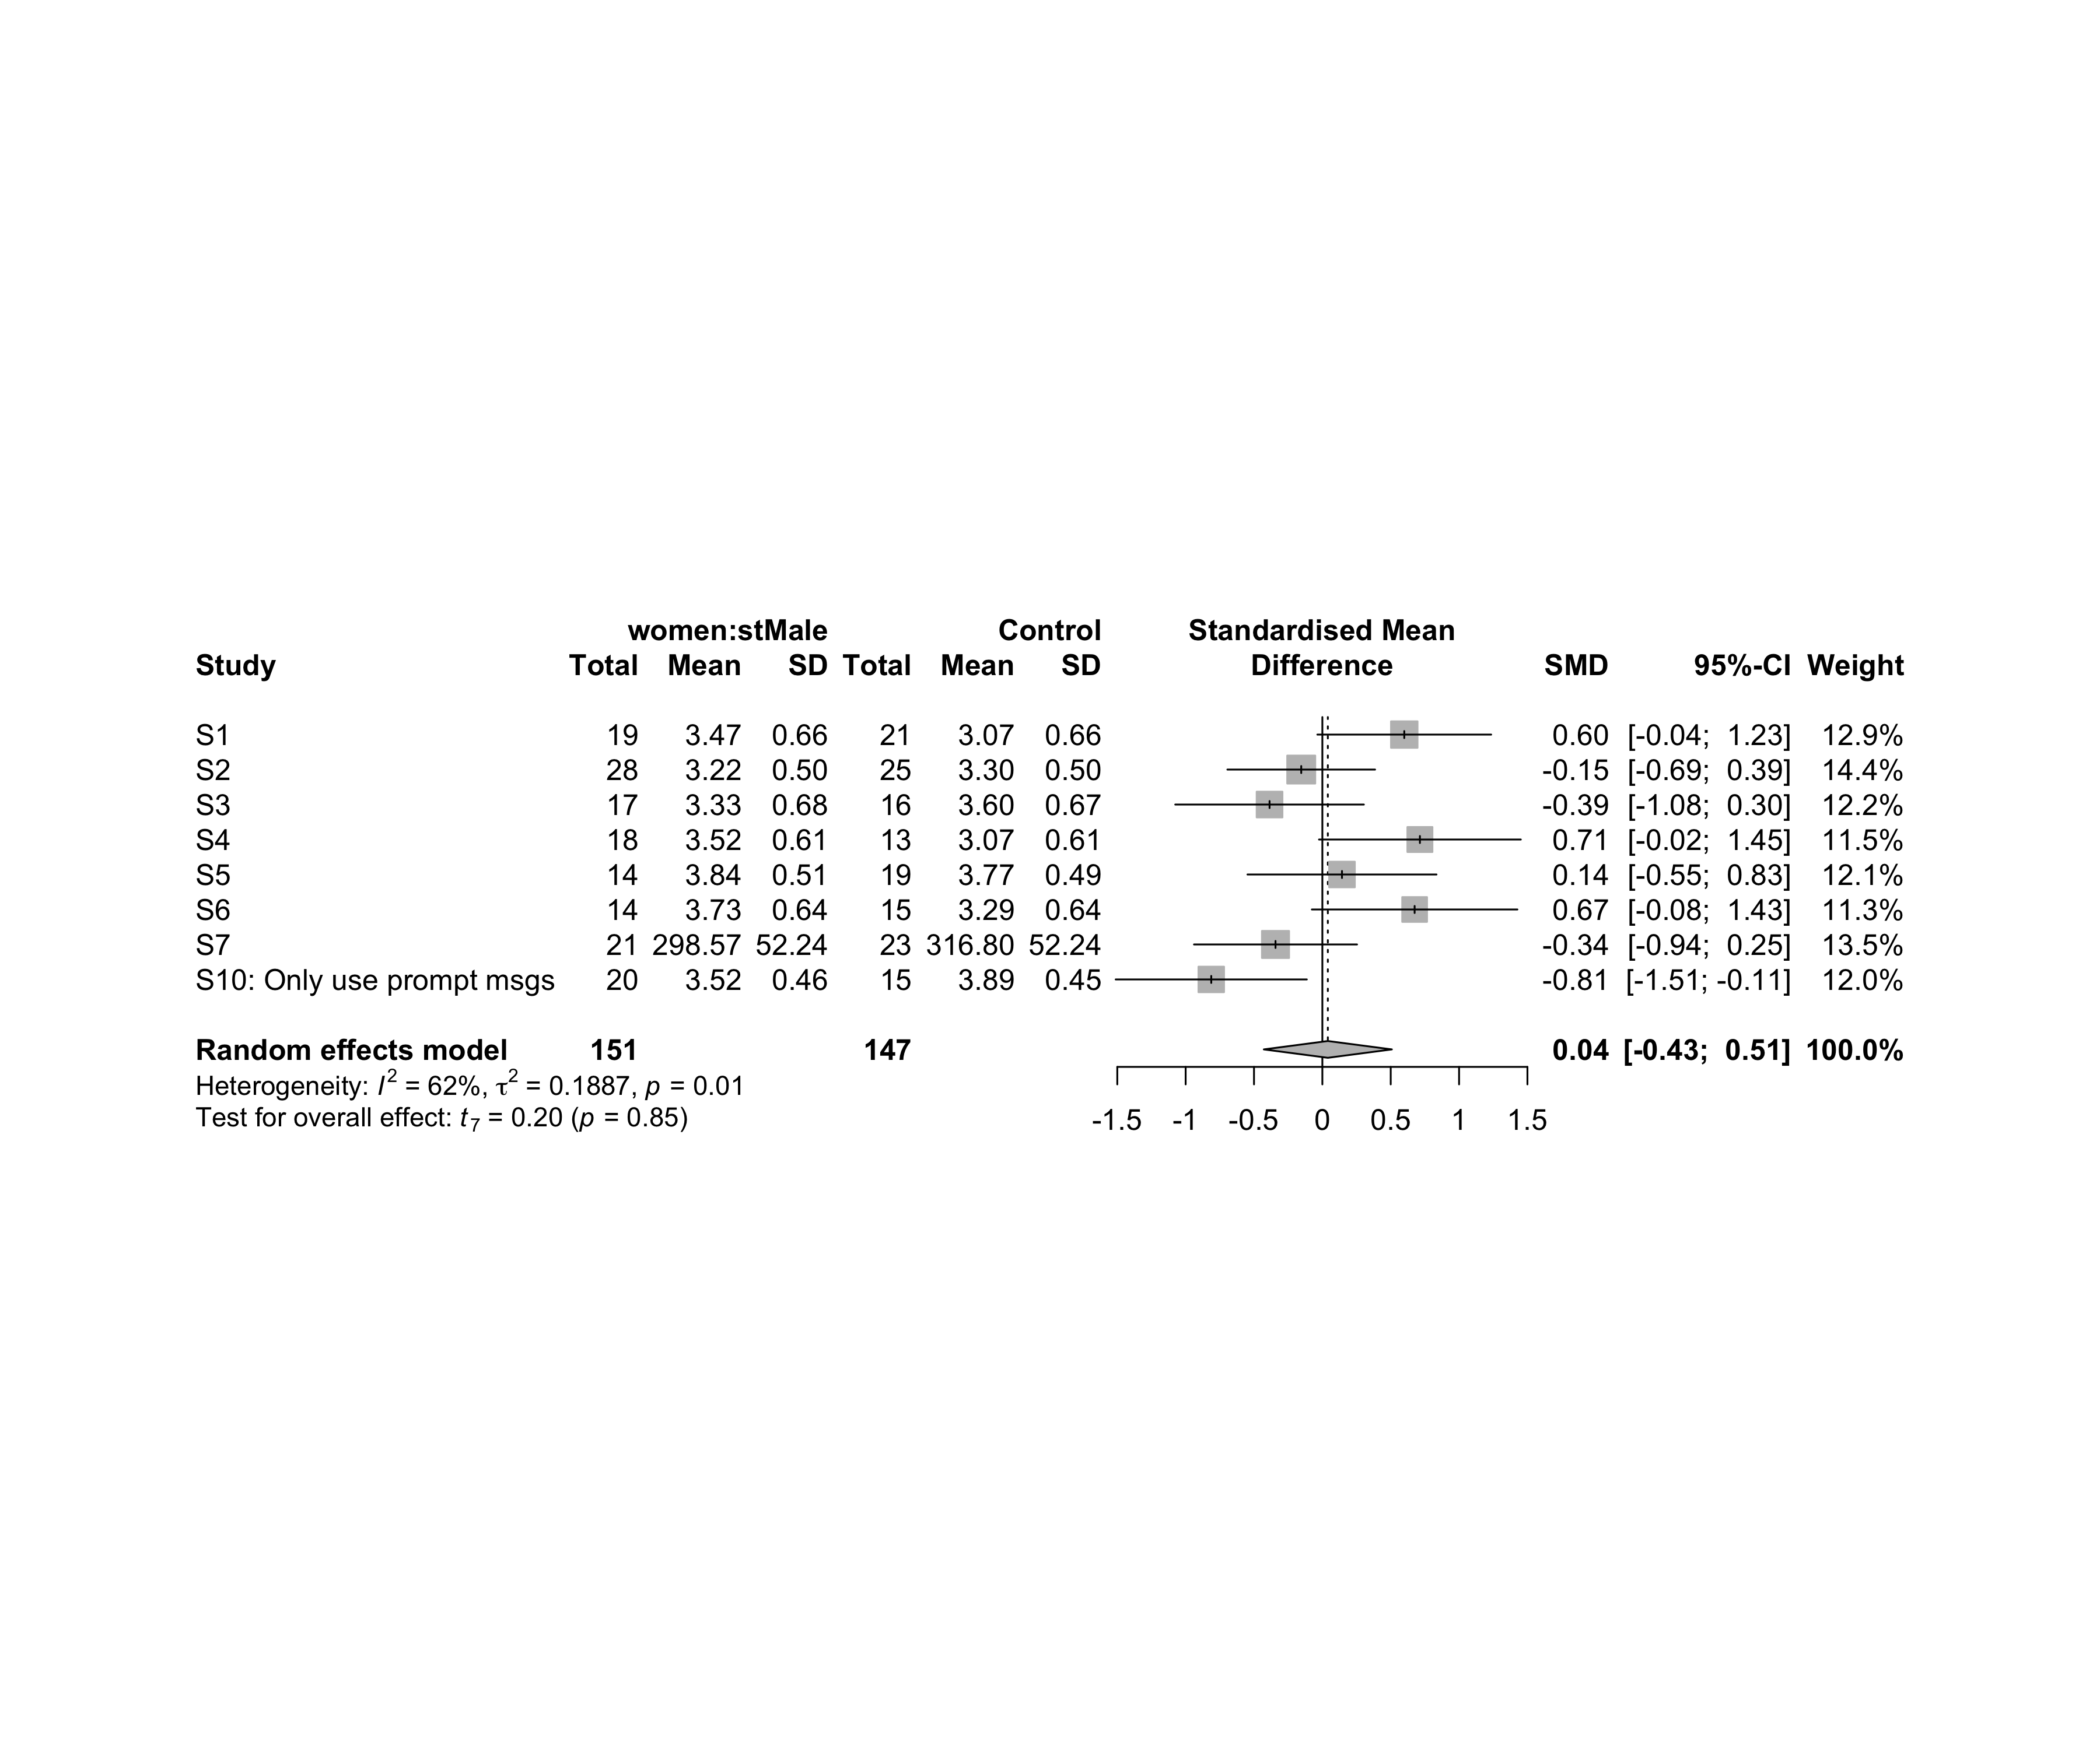

### Subgroup analysis by “age”

m.sg4sub <- update.meta(m.cont, subgroup = age, random = T, fixed = F)  
summary(m.sg4sub)

## Review: Flow state for women in stMale  
##   
## SMD 95%-CI %W(random) age  
## S1 0.5991 [-0.0366; 1.2348] 12.9 adolescent  
## S2 -0.1546 [-0.6948; 0.3856] 14.4 adolescent  
## S3 -0.3863 [-1.0761; 0.3035] 12.2 adolescent  
## S4 0.7135 [-0.0246; 1.4516] 11.5 adult  
## S5 0.1435 [-0.5478; 0.8348] 12.1 adult  
## S6 0.6749 [-0.0769; 1.4266] 11.3 adult  
## S7 -0.3427 [-0.9389; 0.2536] 13.5 adult  
## S10: Only use prompt msgs -0.8127 [-1.5118; -0.1136] 12.0 adolescent  
##   
## Number of studies combined: k = 8  
## Number of observations: o = 298  
##   
## SMD 95%-CI t p-value  
## Random effects model 0.0401 [-0.4281; 0.5083] 0.20 0.8453  
##   
## Quantifying heterogeneity:  
## tau^2 = 0.1887 [0.0169; 1.2175]; tau = 0.4344 [0.1300; 1.1034]  
## I^2 = 61.6% [16.9%; 82.2%]; H = 1.61 [1.10; 2.37]  
##   
## Test of heterogeneity:  
## Q d.f. p-value  
## 18.22 7 0.0110  
##   
## Results for subgroups (random effects model):  
## k SMD 95%-CI tau^2 tau Q I^2  
## age = adolescent 4 -0.1755 [-1.1071; 0.7561] 0.2294 0.4790 9.24 67.5%  
## age = adult 4 0.2623 [-0.5481; 1.0727] 0.1461 0.3823 6.59 54.5%  
##   
## Test for subgroup differences (random effects model):  
## Q d.f. p-value  
## Between groups 1.27 1 0.2591  
##   
## Details on meta-analytical method:  
## - Inverse variance method  
## - Restricted maximum-likelihood estimator for tau^2  
## - Q-profile method for confidence interval of tau^2 and tau  
## - Hartung-Knapp adjustment for random effects model  
## - Hedges' g (bias corrected standardised mean difference; using exact formulae)

forest(m.sg4sub, digits=2, digits.sd = 2, test.overall = T, label.e = paste0(gender,':',env))

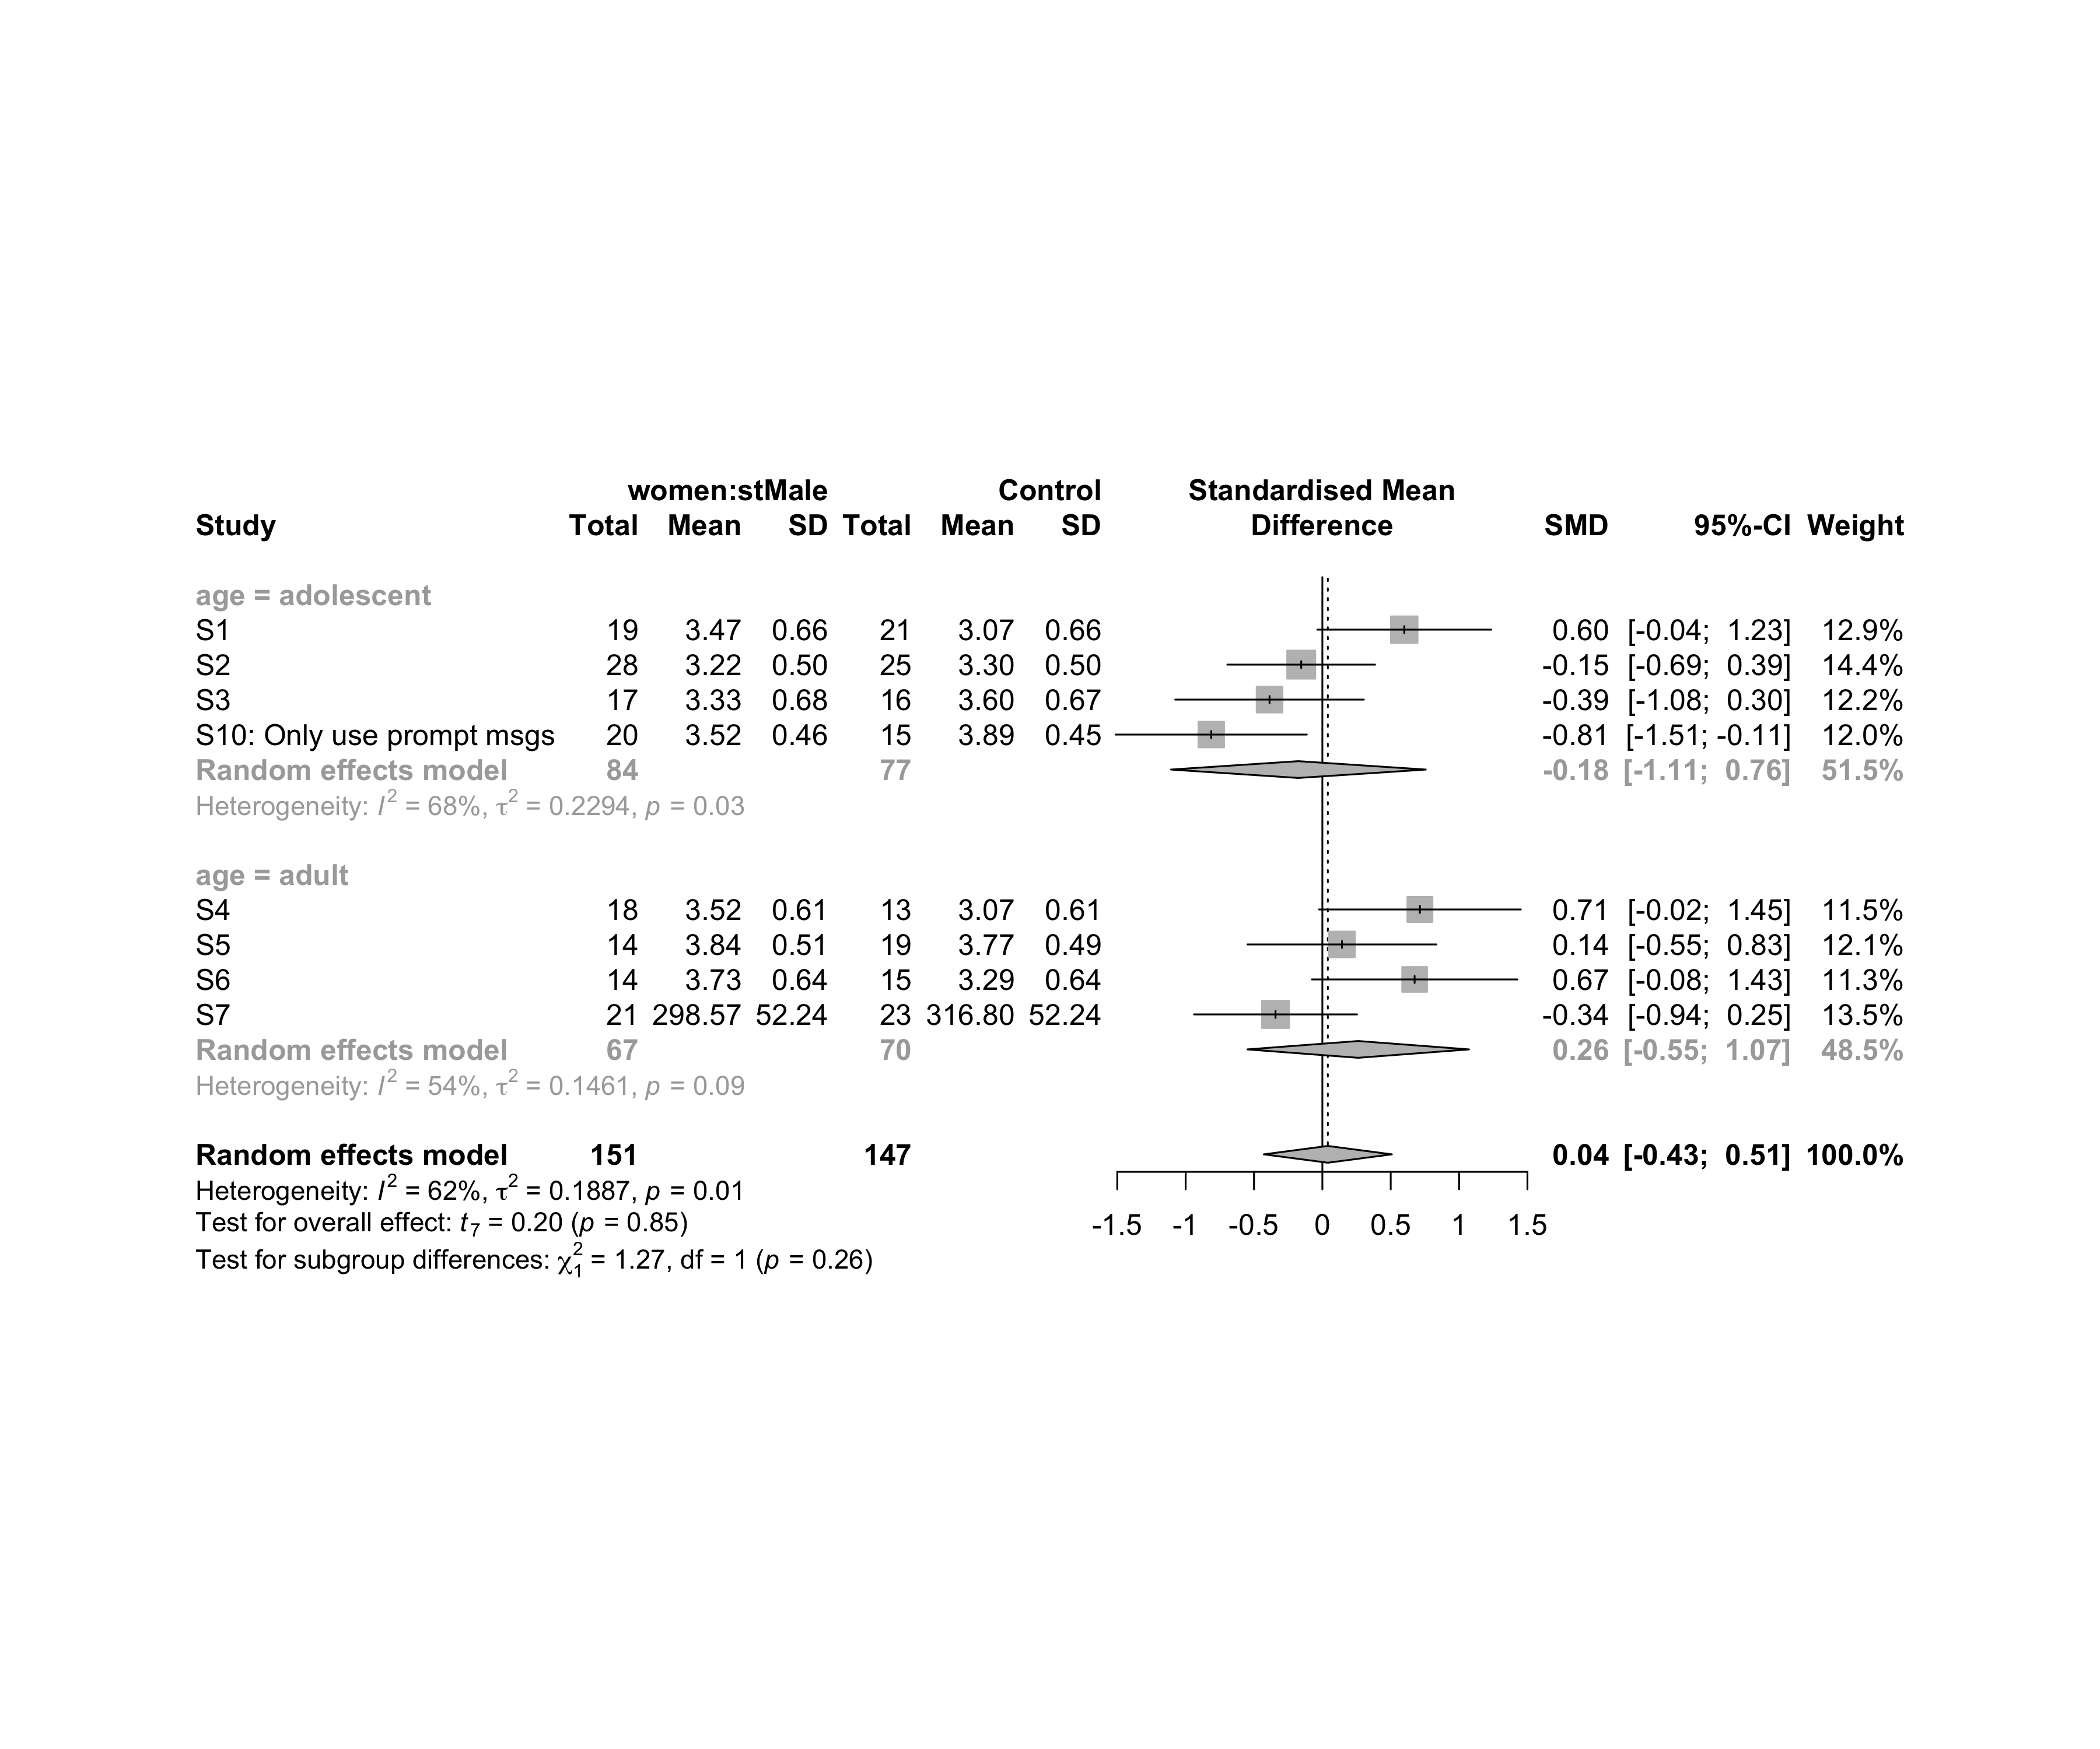

### Subgroup analysis by “ed.level”

m.sg4sub <- update.meta(m.cont, subgroup = ed.level, random = T, fixed = F)  
summary(m.sg4sub)

## Review: Flow state for women in stMale  
##   
## SMD 95%-CI %W(random) ed.level  
## S1 0.5991 [-0.0366; 1.2348] 12.9 upper-secundary  
## S2 -0.1546 [-0.6948; 0.3856] 14.4 upper-secundary  
## S3 -0.3863 [-1.0761; 0.3035] 12.2 upper-secundary  
## S4 0.7135 [-0.0246; 1.4516] 11.5 higher-education  
## S5 0.1435 [-0.5478; 0.8348] 12.1 higher-education  
## S6 0.6749 [-0.0769; 1.4266] 11.3 higher-education  
## S7 -0.3427 [-0.9389; 0.2536] 13.5 unknown  
## S10: Only use prompt msgs -0.8127 [-1.5118; -0.1136] 12.0 upper-secundary  
##   
## Number of studies combined: k = 8  
## Number of observations: o = 298  
##   
## SMD 95%-CI t p-value  
## Random effects model 0.0401 [-0.4281; 0.5083] 0.20 0.8453  
##   
## Quantifying heterogeneity:  
## tau^2 = 0.1887 [0.0169; 1.2175]; tau = 0.4344 [0.1300; 1.1034]  
## I^2 = 61.6% [16.9%; 82.2%]; H = 1.61 [1.10; 2.37]  
##   
## Test of heterogeneity:  
## Q d.f. p-value  
## 18.22 7 0.0110  
##   
## Results for subgroups (random effects model):  
## k SMD 95%-CI tau^2 tau Q I^2  
## ed.level = upper-secundary 4 -0.1755 [-1.1071; 0.7561] 0.2294 0.4790 9.24 67.5%  
## ed.level = higher-education 3 0.4922 [-0.3173; 1.3017] 0 0 1.55 0.0%  
## ed.level = unknown 1 -0.3427 [-0.9389; 0.2536] -- -- 0.00 --  
##   
## Test for subgroup differences (random effects model):  
## Q d.f. p-value  
## Between groups 7.16 2 0.0279  
##   
## Details on meta-analytical method:  
## - Inverse variance method  
## - Restricted maximum-likelihood estimator for tau^2  
## - Q-profile method for confidence interval of tau^2 and tau  
## - Hartung-Knapp adjustment for random effects model  
## - Hedges' g (bias corrected standardised mean difference; using exact formulae)

forest(m.sg4sub, digits=2, digits.sd = 2, test.overall = T, label.e = paste0(gender,':',env))

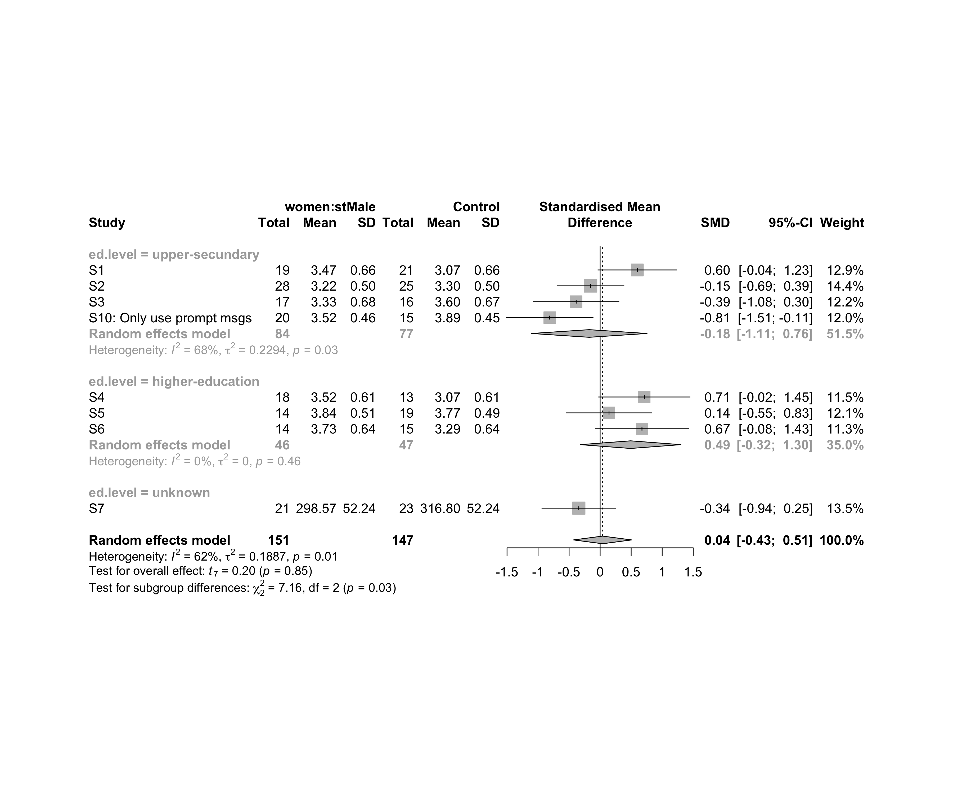

### Subgroup analysis by “intervention”

m.sg4sub <- update.meta(m.cont, subgroup = intervention, random = T, fixed = F)  
summary(m.sg4sub)

## Review: Flow state for women in stMale  
##   
## SMD 95%-CI %W(random)  
## S1 0.5991 [-0.0366; 1.2348] 12.9  
## S2 -0.1546 [-0.6948; 0.3856] 14.4  
## S3 -0.3863 [-1.0761; 0.3035] 12.2  
## S4 0.7135 [-0.0246; 1.4516] 11.5  
## S5 0.1435 [-0.5478; 0.8348] 12.1  
## S6 0.6749 [-0.0769; 1.4266] 11.3  
## S7 -0.3427 [-0.9389; 0.2536] 13.5  
## S10: Only use prompt msgs -0.8127 [-1.5118; -0.1136] 12.0  
## intervention  
## S1 Gender-stereotype color, ranking, badges, and avatar  
## S2 Gender-stereotype color, ranking, badges, and avatar  
## S3 Gender-stereotype color, ranking, badges, and avatar  
## S4 Gender-stereotype color, ranking, badges, and avatar  
## S5 Gender-stereotype color, ranking, badges, and avatar  
## S6 Gender-stereotype color, ranking, badges, and avatar  
## S7 Gender-stereotype color, ranking, badges, and avatar  
## S10: Only use prompt msgs Gender-stereotyped motivational message prompts  
##   
## Number of studies combined: k = 8  
## Number of observations: o = 298  
##   
## SMD 95%-CI t p-value  
## Random effects model 0.0401 [-0.4281; 0.5083] 0.20 0.8453  
##   
## Quantifying heterogeneity:  
## tau^2 = 0.1887 [0.0169; 1.2175]; tau = 0.4344 [0.1300; 1.1034]  
## I^2 = 61.6% [16.9%; 82.2%]; H = 1.61 [1.10; 2.37]  
##   
## Test of heterogeneity:  
## Q d.f. p-value  
## 18.22 7 0.0110  
##   
## Results for subgroups (random effects model):  
## k SMD 95%-CI tau^2 tau Q I^2  
## intervention = Gender-stereotype color, rankin ... 7 0.1498 [-0.2943; 0.5939] 0.1147 0.3387 12.14 50.6%  
## intervention = Gender-stereotyped motivational ... 1 -0.8127 [-1.5118; -0.1136] -- -- 0.00 --  
##   
## Test for subgroup differences (random effects model):  
## Q d.f. p-value  
## Between groups 5.78 1 0.0162  
##   
## Details on meta-analytical method:  
## - Inverse variance method  
## - Restricted maximum-likelihood estimator for tau^2  
## - Q-profile method for confidence interval of tau^2 and tau  
## - Hartung-Knapp adjustment for random effects model  
## - Hedges' g (bias corrected standardised mean difference; using exact formulae)

forest(m.sg4sub, digits=2, digits.sd = 2, test.overall = T, label.e = paste0(gender,':',env))

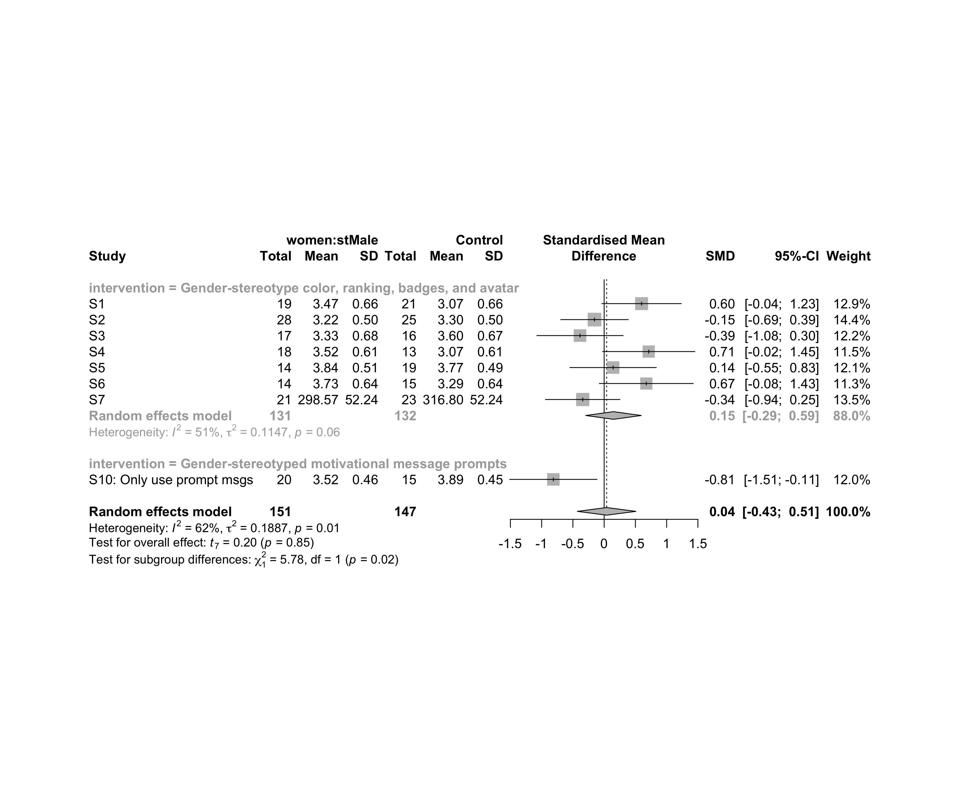

### Subgroup analysis by “age:intervention”

m.sg4sub <- update.meta(m.cont, subgroup = `age:intervention`, random = T, fixed = F)  
summary(m.sg4sub)

## Review: Flow state for women in stMale  
##   
## SMD 95%-CI %W(random)  
## S1 0.5991 [-0.0366; 1.2348] 12.9  
## S2 -0.1546 [-0.6948; 0.3856] 14.4  
## S3 -0.3863 [-1.0761; 0.3035] 12.2  
## S4 0.7135 [-0.0246; 1.4516] 11.5  
## S5 0.1435 [-0.5478; 0.8348] 12.1  
## S6 0.6749 [-0.0769; 1.4266] 11.3  
## S7 -0.3427 [-0.9389; 0.2536] 13.5  
## S10: Only use prompt msgs -0.8127 [-1.5118; -0.1136] 12.0  
## age:intervention  
## S1 adolescent:Gender-stereotype color, ranking, badges, and avatar  
## S2 adolescent:Gender-stereotype color, ranking, badges, and avatar  
## S3 adolescent:Gender-stereotype color, ranking, badges, and avatar  
## S4 adult:Gender-stereotype color, ranking, badges, and avatar  
## S5 adult:Gender-stereotype color, ranking, badges, and avatar  
## S6 adult:Gender-stereotype color, ranking, badges, and avatar  
## S7 adult:Gender-stereotype color, ranking, badges, and avatar  
## S10: Only use prompt msgs adolescent:Gender-stereotyped motivational message prompts  
##   
## Number of studies combined: k = 8  
## Number of observations: o = 298  
##   
## SMD 95%-CI t p-value  
## Random effects model 0.0401 [-0.4281; 0.5083] 0.20 0.8453  
##   
## Quantifying heterogeneity:  
## tau^2 = 0.1887 [0.0169; 1.2175]; tau = 0.4344 [0.1300; 1.1034]  
## I^2 = 61.6% [16.9%; 82.2%]; H = 1.61 [1.10; 2.37]  
##   
## Test of heterogeneity:  
## Q d.f. p-value  
## 18.22 7 0.0110  
##   
## Results for subgroups (random effects model):  
## k SMD 95%-CI tau^2 tau Q  
## age:intervention = adolescent:Gender-stereotype co ... 3 0.0211 [-1.2371; 1.2793] 0.1492 0.3863 4.92  
## age:intervention = adult:Gender-stereotype color, ... 4 0.2623 [-0.5481; 1.0727] 0.1461 0.3823 6.59  
## age:intervention = adolescent:Gender-stereotyped m ... 1 -0.8127 [-1.5118; -0.1136] -- -- 0.00  
## I^2  
## age:intervention = adolescent:Gender-stereotype co ... 59.4%  
## age:intervention = adult:Gender-stereotype color, ... 54.5%  
## age:intervention = adolescent:Gender-stereotyped m ... --  
##   
## Test for subgroup differences (random effects model):  
## Q d.f. p-value  
## Between groups 6.13 2 0.0466  
##   
## Details on meta-analytical method:  
## - Inverse variance method  
## - Restricted maximum-likelihood estimator for tau^2  
## - Q-profile method for confidence interval of tau^2 and tau  
## - Hartung-Knapp adjustment for random effects model  
## - Hedges' g (bias corrected standardised mean difference; using exact formulae)

forest(m.sg4sub, digits=2, digits.sd = 2, test.overall = T, label.e = paste0(gender,':',env))

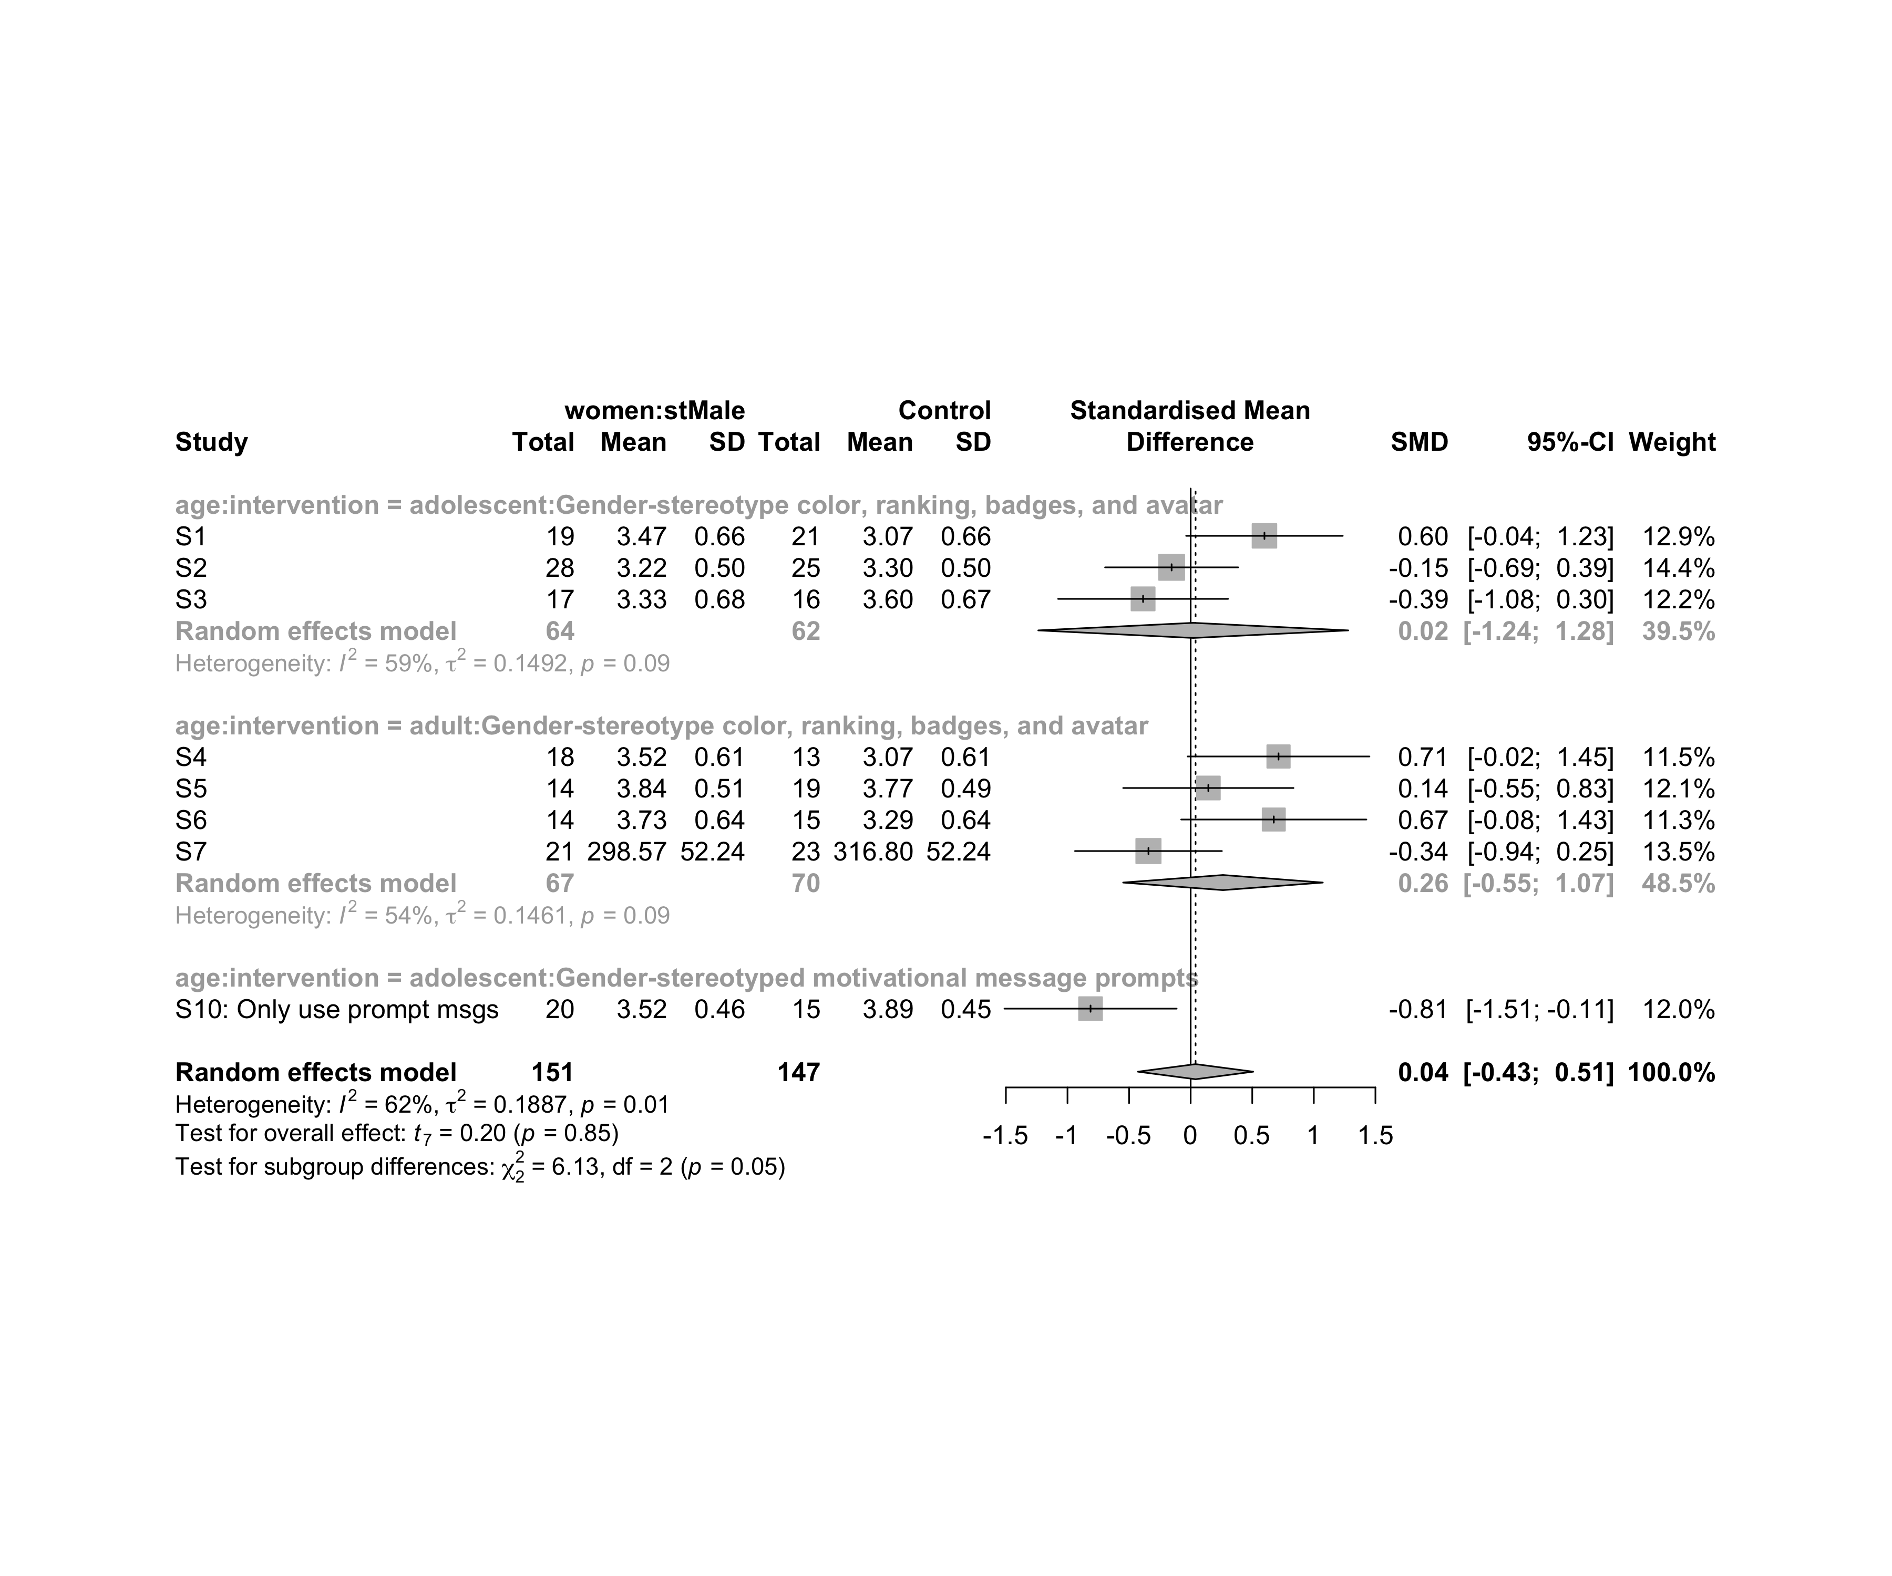

### Subgroup analysis by “ed.level:intervention”

m.sg4sub <- update.meta(m.cont, subgroup = `ed.level:intervention`, random = T, fixed = F)  
summary(m.sg4sub)

## Review: Flow state for women in stMale  
##   
## SMD 95%-CI %W(random)  
## S1 0.5991 [-0.0366; 1.2348] 12.9  
## S2 -0.1546 [-0.6948; 0.3856] 14.4  
## S3 -0.3863 [-1.0761; 0.3035] 12.2  
## S4 0.7135 [-0.0246; 1.4516] 11.5  
## S5 0.1435 [-0.5478; 0.8348] 12.1  
## S6 0.6749 [-0.0769; 1.4266] 11.3  
## S7 -0.3427 [-0.9389; 0.2536] 13.5  
## S10: Only use prompt msgs -0.8127 [-1.5118; -0.1136] 12.0  
## ed.level:intervention  
## S1 upper-secundary:Gender-stereotype color, ranking, badges, and avatar  
## S2 upper-secundary:Gender-stereotype color, ranking, badges, and avatar  
## S3 upper-secundary:Gender-stereotype color, ranking, badges, and avatar  
## S4 higher-education:Gender-stereotype color, ranking, badges, and avatar  
## S5 higher-education:Gender-stereotype color, ranking, badges, and avatar  
## S6 higher-education:Gender-stereotype color, ranking, badges, and avatar  
## S7 unknown:Gender-stereotype color, ranking, badges, and avatar  
## S10: Only use prompt msgs upper-secundary:Gender-stereotyped motivational message prompts  
##   
## Number of studies combined: k = 8  
## Number of observations: o = 298  
##   
## SMD 95%-CI t p-value  
## Random effects model 0.0401 [-0.4281; 0.5083] 0.20 0.8453  
##   
## Quantifying heterogeneity:  
## tau^2 = 0.1887 [0.0169; 1.2175]; tau = 0.4344 [0.1300; 1.1034]  
## I^2 = 61.6% [16.9%; 82.2%]; H = 1.61 [1.10; 2.37]  
##   
## Test of heterogeneity:  
## Q d.f. p-value  
## 18.22 7 0.0110  
##   
## Results for subgroups (random effects model):  
## k SMD 95%-CI tau^2 tau  
## ed.level:intervention = upper-secundary:Gender-stereoty ... 3 0.0211 [-1.2371; 1.2793] 0.1492 0.3863  
## ed.level:intervention = higher-education:Gender-stereot ... 3 0.4922 [-0.3173; 1.3017] 0 0  
## ed.level:intervention = unknown:Gender-stereotype color ... 1 -0.3427 [-0.9389; 0.2536] -- --  
## ed.level:intervention = upper-secundary:Gender-stereoty ... 1 -0.8127 [-1.5118; -0.1136] -- --  
## Q I^2  
## ed.level:intervention = upper-secundary:Gender-stereoty ... 4.92 59.4%  
## ed.level:intervention = higher-education:Gender-stereot ... 1.55 0.0%  
## ed.level:intervention = unknown:Gender-stereotype color ... 0.00 --  
## ed.level:intervention = upper-secundary:Gender-stereoty ... 0.00 --  
##   
## Test for subgroup differences (random effects model):  
## Q d.f. p-value  
## Between groups 13.03 3 0.0046  
##   
## Details on meta-analytical method:  
## - Inverse variance method  
## - Restricted maximum-likelihood estimator for tau^2  
## - Q-profile method for confidence interval of tau^2 and tau  
## - Hartung-Knapp adjustment for random effects model  
## - Hedges' g (bias corrected standardised mean difference; using exact formulae)

forest(m.sg4sub, digits=2, digits.sd = 2, test.overall = T, label.e = paste0(gender,':',env))

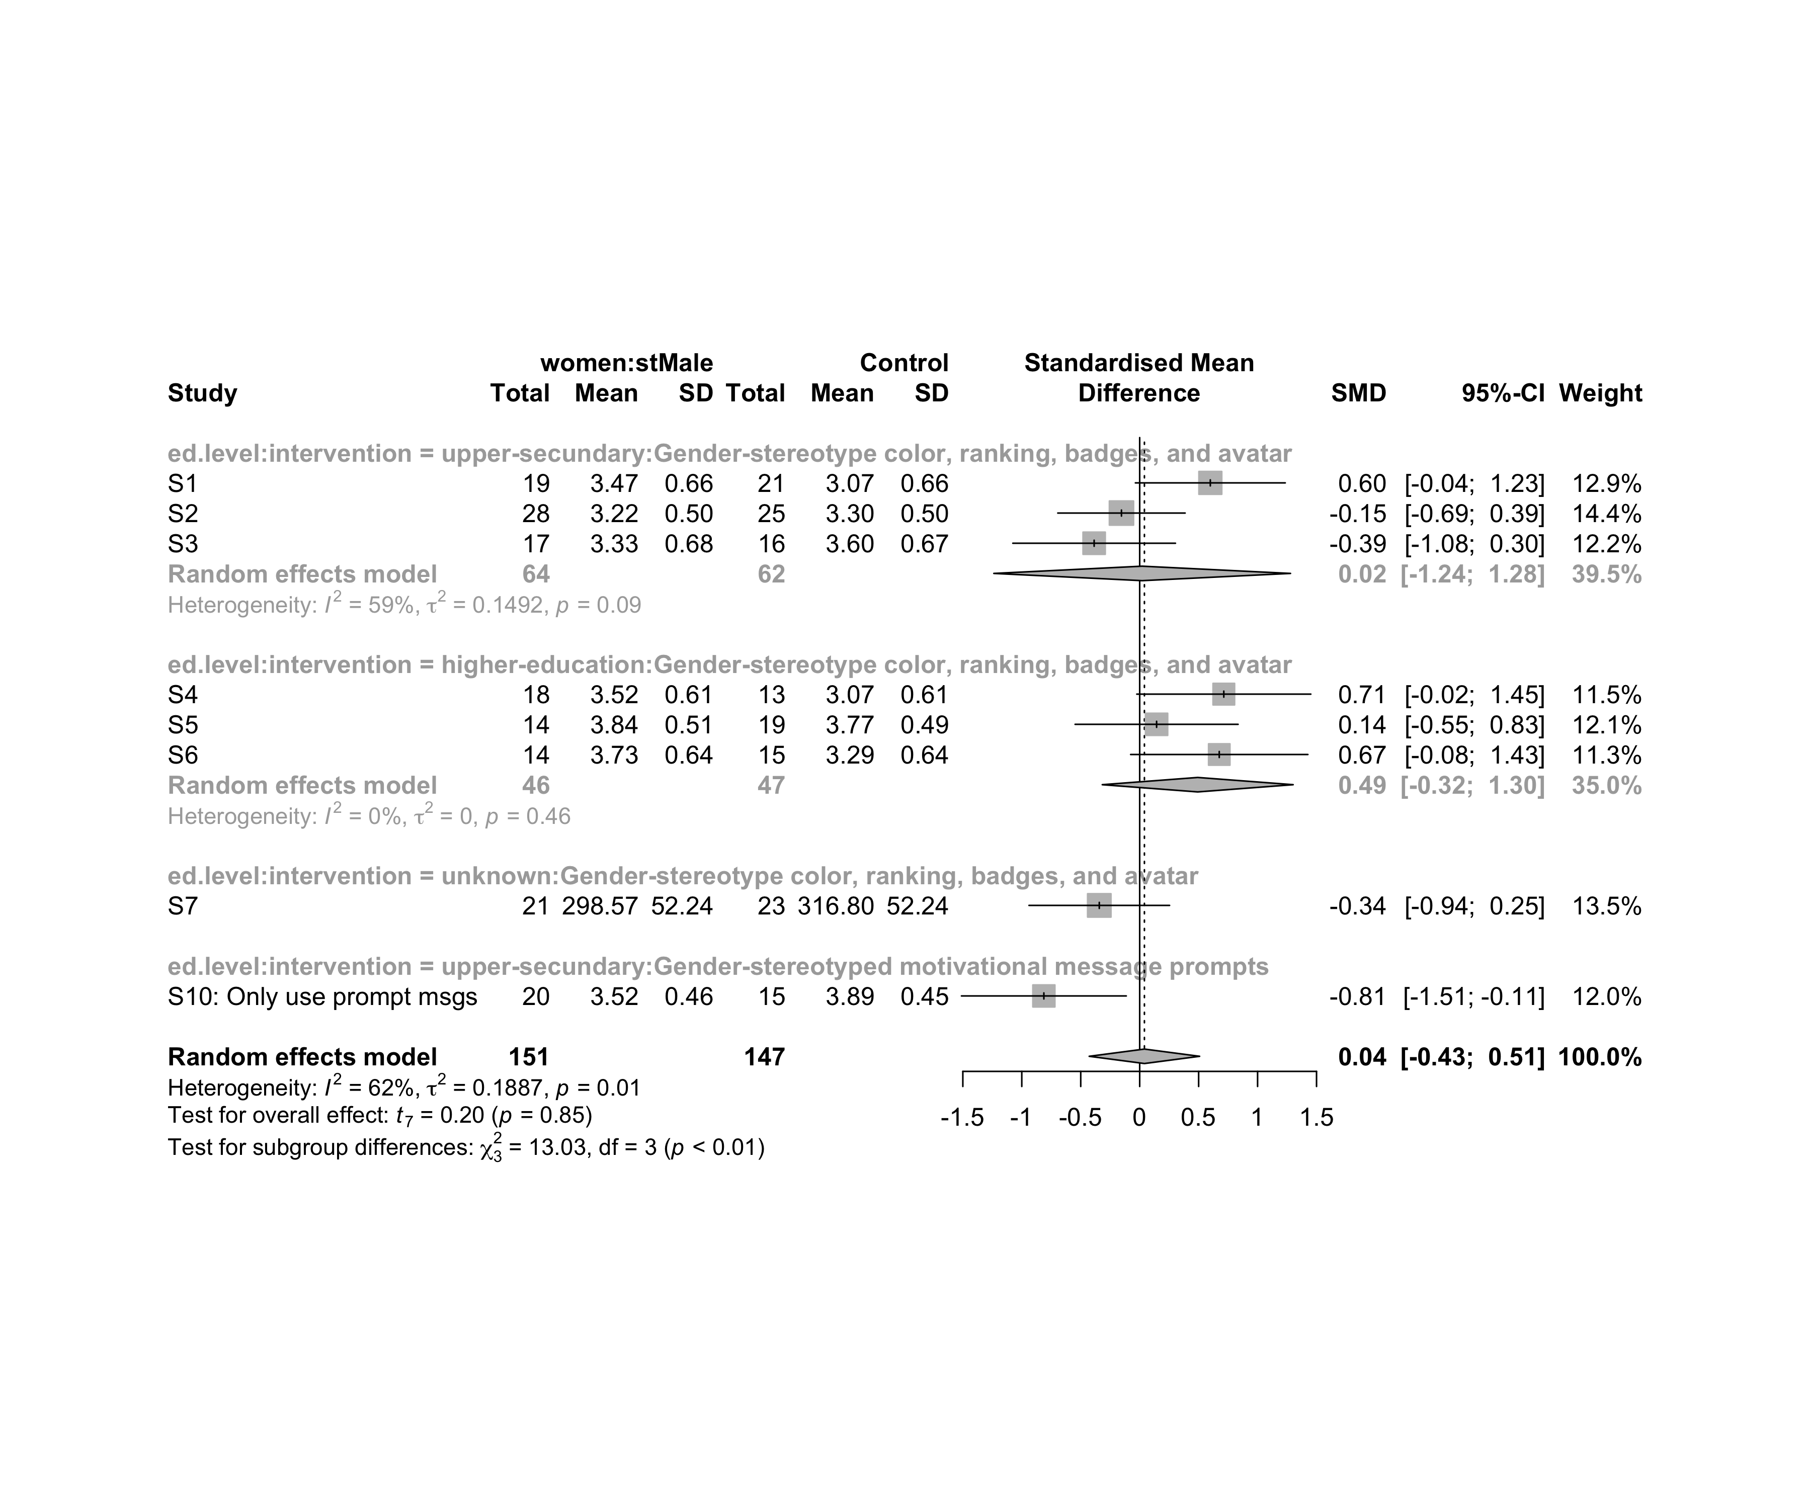

### Subgroup analysis by “age:ed.level:intervention”

m.sg4sub <- update.meta(m.cont, subgroup = `age:ed.level:intervention`, random = T, fixed = F)  
summary(m.sg4sub)

## Review: Flow state for women in stMale  
##   
## SMD 95%-CI %W(random)  
## S1 0.5991 [-0.0366; 1.2348] 12.9  
## S2 -0.1546 [-0.6948; 0.3856] 14.4  
## S3 -0.3863 [-1.0761; 0.3035] 12.2  
## S4 0.7135 [-0.0246; 1.4516] 11.5  
## S5 0.1435 [-0.5478; 0.8348] 12.1  
## S6 0.6749 [-0.0769; 1.4266] 11.3  
## S7 -0.3427 [-0.9389; 0.2536] 13.5  
## S10: Only use prompt msgs -0.8127 [-1.5118; -0.1136] 12.0  
## age:ed.level:intervention  
## S1 adolescent:upper-secundary:Gender-stereotype color, ranking, badges, and avatar  
## S2 adolescent:upper-secundary:Gender-stereotype color, ranking, badges, and avatar  
## S3 adolescent:upper-secundary:Gender-stereotype color, ranking, badges, and avatar  
## S4 adult:higher-education:Gender-stereotype color, ranking, badges, and avatar  
## S5 adult:higher-education:Gender-stereotype color, ranking, badges, and avatar  
## S6 adult:higher-education:Gender-stereotype color, ranking, badges, and avatar  
## S7 adult:unknown:Gender-stereotype color, ranking, badges, and avatar  
## S10: Only use prompt msgs adolescent:upper-secundary:Gender-stereotyped motivational message prompts  
##   
## Number of studies combined: k = 8  
## Number of observations: o = 298  
##   
## SMD 95%-CI t p-value  
## Random effects model 0.0401 [-0.4281; 0.5083] 0.20 0.8453  
##   
## Quantifying heterogeneity:  
## tau^2 = 0.1887 [0.0169; 1.2175]; tau = 0.4344 [0.1300; 1.1034]  
## I^2 = 61.6% [16.9%; 82.2%]; H = 1.61 [1.10; 2.37]  
##   
## Test of heterogeneity:  
## Q d.f. p-value  
## 18.22 7 0.0110  
##   
## Results for subgroups (random effects model):  
## k SMD 95%-CI tau^2  
## age:ed.level:intervention = adolescent:upper-secundary:Gend ... 3 0.0211 [-1.2371; 1.2793] 0.1492  
## age:ed.level:intervention = adult:higher-education:Gender-s ... 3 0.4922 [-0.3173; 1.3017] 0  
## age:ed.level:intervention = adult:unknown:Gender-stereotype ... 1 -0.3427 [-0.9389; 0.2536] --  
## age:ed.level:intervention = adolescent:upper-secundary:Gend ... 1 -0.8127 [-1.5118; -0.1136] --  
## tau Q I^2  
## age:ed.level:intervention = adolescent:upper-secundary:Gend ... 0.3863 4.92 59.4%  
## age:ed.level:intervention = adult:higher-education:Gender-s ... 0 1.55 0.0%  
## age:ed.level:intervention = adult:unknown:Gender-stereotype ... -- 0.00 --  
## age:ed.level:intervention = adolescent:upper-secundary:Gend ... -- 0.00 --  
##   
## Test for subgroup differences (random effects model):  
## Q d.f. p-value  
## Between groups 13.03 3 0.0046  
##   
## Details on meta-analytical method:  
## - Inverse variance method  
## - Restricted maximum-likelihood estimator for tau^2  
## - Q-profile method for confidence interval of tau^2 and tau  
## - Hartung-Knapp adjustment for random effects model  
## - Hedges' g (bias corrected standardised mean difference; using exact formulae)

forest(m.sg4sub, digits=2, digits.sd = 2, test.overall = T, label.e = paste0(gender,':',env))

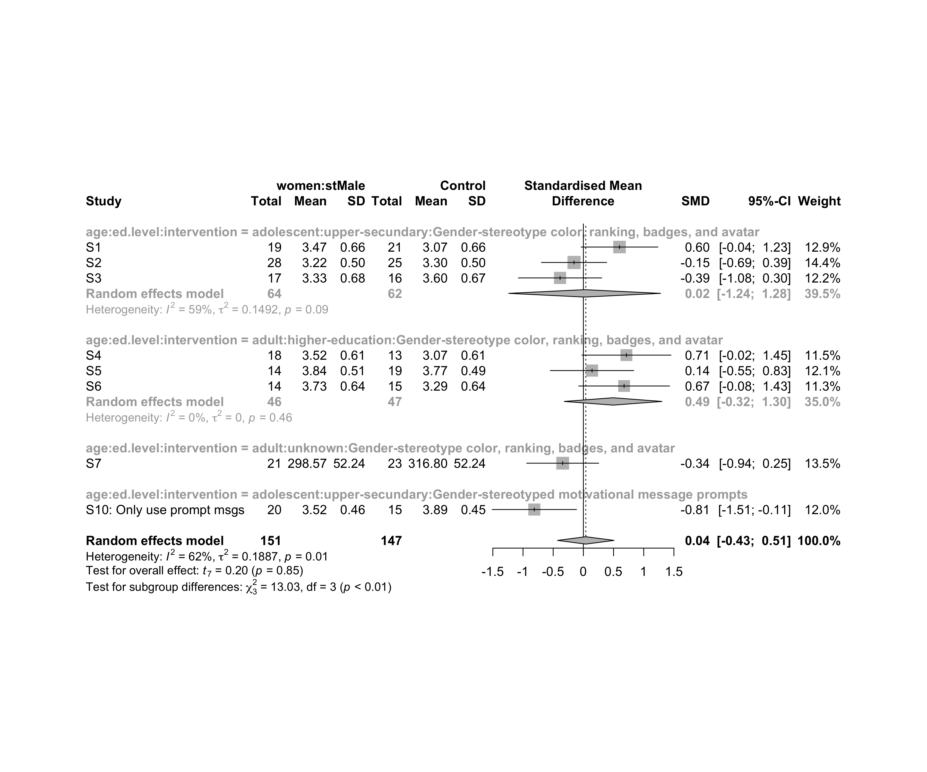

## Funnel Plot

m.cont <- update.meta(m.cont, studlab = data$study)  
summary(eggers.test(x = m.cont))

## Eggers' test of the intercept   
## =============================   
##   
## intercept 95% CI t p  
## 4.642 -5.85 - 15.13 0.868 0.42  
##   
## Eggers' test does not indicate the presence of funnel plot asymmetry.

funnel(m.cont, xlab = "Hedges' g", studlab = T, legend=T, addtau2 = T)

