Metanalysis of flow state on men caused by (stFemale)

Geiser C. Challco [geiser@alumni.usp.br](mailto:geiser@alumni.usp.br)

Table of Contents

## Initial Variables and Loading Data

env <- "stFemale"  
gender <- "men"  
to_remove <- c('S11')  
sub.groups <- c("age","ed.level","intervention","age:intervention",  
 "ed.level:intervention","age:ed.level:intervention")

dat <- read_excel("../data/data-without-outliers.xlsx", sheet = "fss-env.gender-descriptive")  
dat <- dat[!dat$study %in% to_remove, ]  
  
leg <- read_excel("../data/data-without-outliers.xlsx", sheet = "legend")

## New names:  
## • `` -> `...10`

leg <- leg[!leg$study %in% to_remove, ]  
  
idx.e <- which(dat$env == env & dat$gender == gender)  
idx.c <- which(dat$env == "control" & dat$gender == gender)  
  
data <- data.frame(  
 study = dat$study[idx.c],  
 n.e = dat$N[idx.e], mean.e = dat$M.emms[idx.e], sd.e = dat$SD.emms[idx.e],  
 n.c = dat$N[idx.c], mean.c = dat$M.emms[idx.c], sd.c = dat$SD.emms[idx.c]  
)  
for (cgroups in strsplit(sub.groups,":")) {  
 data[[paste0(cgroups, collapse = ":")]] <- sapply(data$study, FUN = function(x) {  
 paste0(sapply(cgroups, FUN = function(namecol) leg[[namecol]][which(x == leg$study)]), collapse = ":")  
 })  
}  
data[["lbl"]] <- sapply(data$study, FUN = function(x) leg$Note[which(x == leg$study)])

## Perform meta-analyses

m.cont <- metacont(  
 n.e = n.e, mean.e = mean.e, sd.e = sd.e, n.c = n.c, mean.c = mean.c, sd.c = sd.c,  
 studlab = lbl, data = data, sm = "SMD", method.smd = "Hedges",  
 fixed = F, random = T, method.tau = "REML", hakn = T, title = paste("Flow state for",gender,"in",env)  
)  
summary(m.cont)

## Review: Flow state for men in stFemale  
##   
## SMD 95%-CI %W(random)  
## S1 0.1557 [-0.7647; 1.0761] 7.8  
## S2 0.3383 [-0.4460; 1.1227] 10.2  
## S3 0.0012 [-0.8018; 0.8041] 9.8  
## S4 -0.4039 [-1.2316; 0.4239] 9.3  
## S5 0.4648 [-0.1740; 1.1036] 14.0  
## S6 -0.0146 [-0.6417; 0.6125] 14.4  
## S7 0.6989 [ 0.1373; 1.2605] 16.9  
## S10: Only use prompt msgs -0.1682 [-0.7164; 0.3801] 17.5  
##   
## Number of studies combined: k = 8  
## Number of observations: o = 284  
##   
## SMD 95%-CI t p-value  
## Random effects model 0.1610 [-0.1496; 0.4715] 1.23 0.2599  
##   
## Quantifying heterogeneity:  
## tau^2 = 0.0368 [0.0000; 0.4087]; tau = 0.1917 [0.0000; 0.6393]  
## I^2 = 14.8% [0.0%; 57.7%]; H = 1.08 [1.00; 1.54]  
##   
## Test of heterogeneity:  
## Q d.f. p-value  
## 8.21 7 0.3141  
##   
## Details on meta-analytical method:  
## - Inverse variance method  
## - Restricted maximum-likelihood estimator for tau^2  
## - Q-profile method for confidence interval of tau^2 and tau  
## - Hartung-Knapp adjustment for random effects model  
## - Hedges' g (bias corrected standardised mean difference; using exact formulae)

forest(m.cont, digits=2, digits.sd = 2, test.overall = T, label.e = paste0(gender,':',env))

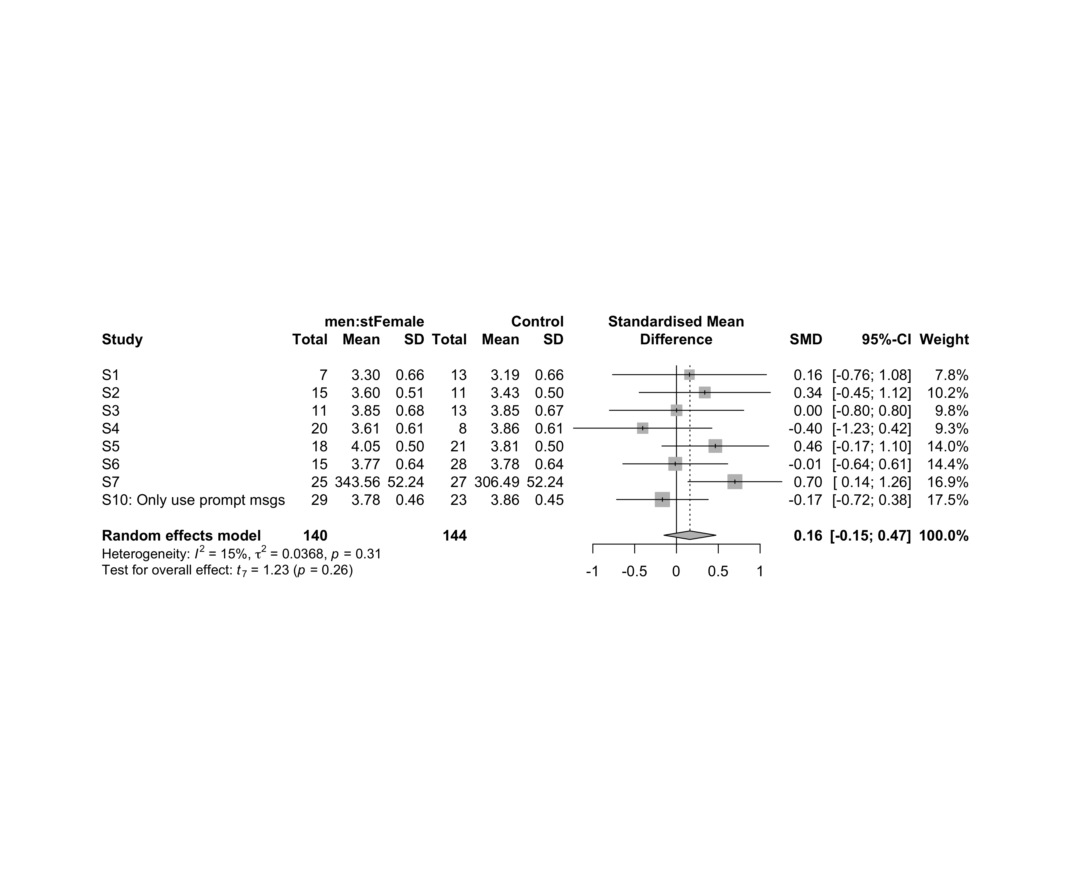

### Subgroup analysis by “age”

m.sg4sub <- update.meta(m.cont, subgroup = age, random = T, fixed = F)  
summary(m.sg4sub)

## Review: Flow state for men in stFemale  
##   
## SMD 95%-CI %W(random) age  
## S1 0.1557 [-0.7647; 1.0761] 7.8 adolescent  
## S2 0.3383 [-0.4460; 1.1227] 10.2 adolescent  
## S3 0.0012 [-0.8018; 0.8041] 9.8 adolescent  
## S4 -0.4039 [-1.2316; 0.4239] 9.3 adult  
## S5 0.4648 [-0.1740; 1.1036] 14.0 adult  
## S6 -0.0146 [-0.6417; 0.6125] 14.4 adult  
## S7 0.6989 [ 0.1373; 1.2605] 16.9 adult  
## S10: Only use prompt msgs -0.1682 [-0.7164; 0.3801] 17.5 adolescence  
##   
## Number of studies combined: k = 8  
## Number of observations: o = 284  
##   
## SMD 95%-CI t p-value  
## Random effects model 0.1610 [-0.1496; 0.4715] 1.23 0.2599  
##   
## Quantifying heterogeneity:  
## tau^2 = 0.0368 [0.0000; 0.4087]; tau = 0.1917 [0.0000; 0.6393]  
## I^2 = 14.8% [0.0%; 57.7%]; H = 1.08 [1.00; 1.54]  
##   
## Test of heterogeneity:  
## Q d.f. p-value  
## 8.21 7 0.3141  
##   
## Results for subgroups (random effects model):  
## k SMD 95%-CI tau^2 tau Q I^2  
## age = adolescent 3 0.1688 [-0.2697; 0.6073] 0 0 0.35 0.0%  
## age = adult 4 0.2406 [-0.5180; 0.9992] 0.1064 0.3262 5.93 49.4%  
## age = adolescence 1 -0.1682 [-0.7164; 0.3801] -- -- 0.00 --  
##   
## Test for subgroup differences (random effects model):  
## Q d.f. p-value  
## Between groups 1.47 2 0.4798  
##   
## Details on meta-analytical method:  
## - Inverse variance method  
## - Restricted maximum-likelihood estimator for tau^2  
## - Q-profile method for confidence interval of tau^2 and tau  
## - Hartung-Knapp adjustment for random effects model  
## - Hedges' g (bias corrected standardised mean difference; using exact formulae)

forest(m.sg4sub, digits=2, digits.sd = 2, test.overall = T, label.e = paste0(gender,':',env))

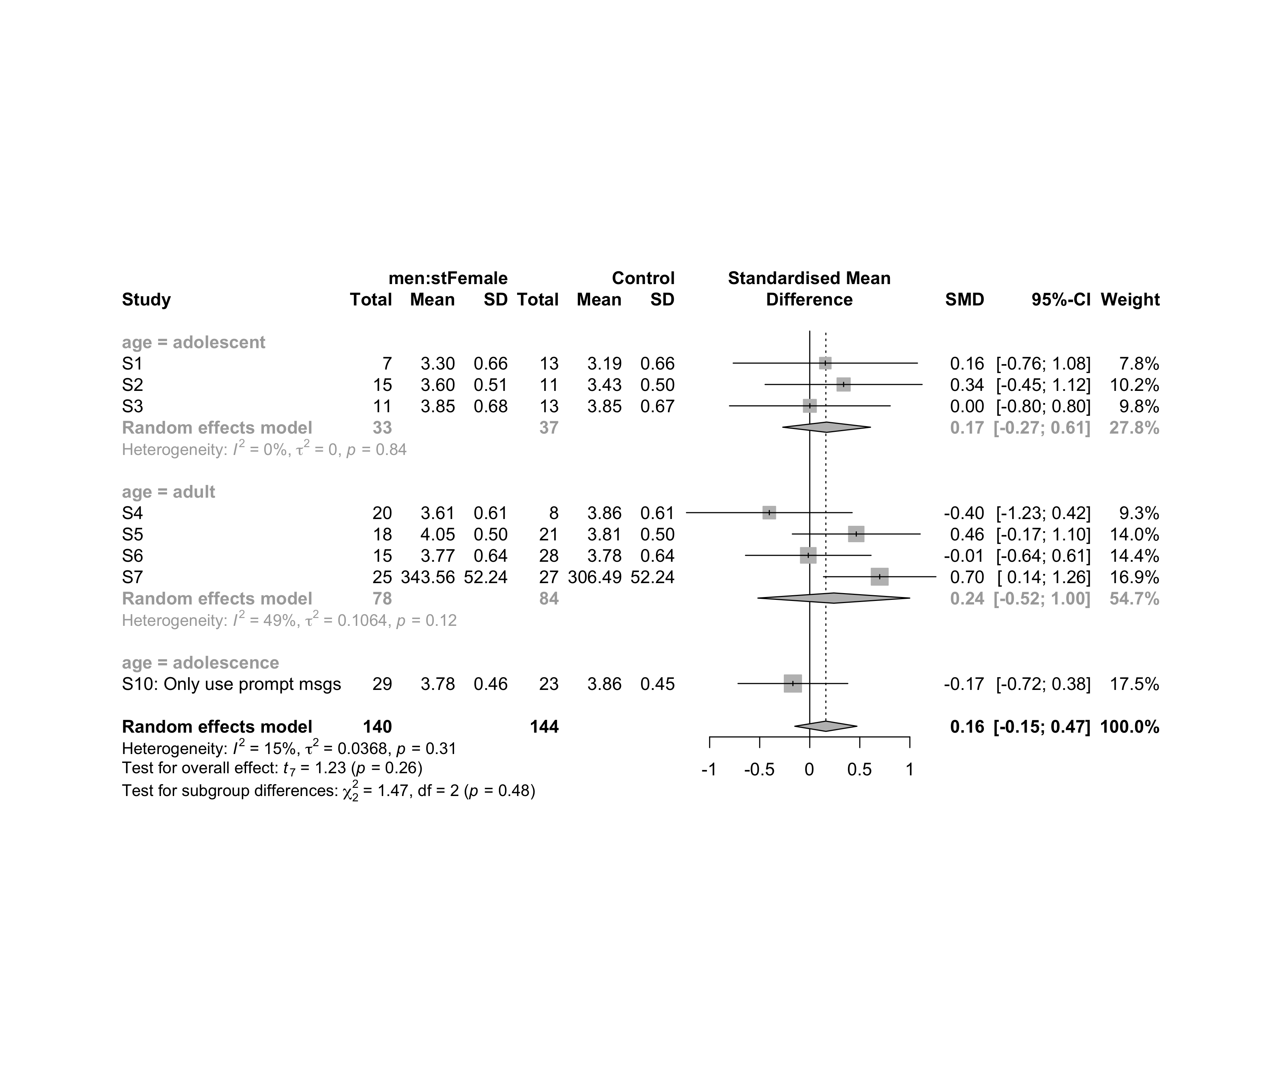

### Subgroup analysis by “ed.level”

m.sg4sub <- update.meta(m.cont, subgroup = ed.level, random = T, fixed = F)  
summary(m.sg4sub)

## Review: Flow state for men in stFemale  
##   
## SMD 95%-CI %W(random) ed.level  
## S1 0.1557 [-0.7647; 1.0761] 7.8 upper-secundary  
## S2 0.3383 [-0.4460; 1.1227] 10.2 upper-secundary  
## S3 0.0012 [-0.8018; 0.8041] 9.8 upper-secundary  
## S4 -0.4039 [-1.2316; 0.4239] 9.3 higher-education  
## S5 0.4648 [-0.1740; 1.1036] 14.0 higher-education  
## S6 -0.0146 [-0.6417; 0.6125] 14.4 higher-education  
## S7 0.6989 [ 0.1373; 1.2605] 16.9 unknown  
## S10: Only use prompt msgs -0.1682 [-0.7164; 0.3801] 17.5 upper-secundary  
##   
## Number of studies combined: k = 8  
## Number of observations: o = 284  
##   
## SMD 95%-CI t p-value  
## Random effects model 0.1610 [-0.1496; 0.4715] 1.23 0.2599  
##   
## Quantifying heterogeneity:  
## tau^2 = 0.0368 [0.0000; 0.4087]; tau = 0.1917 [0.0000; 0.6393]  
## I^2 = 14.8% [0.0%; 57.7%]; H = 1.08 [1.00; 1.54]  
##   
## Test of heterogeneity:  
## Q d.f. p-value  
## 8.21 7 0.3141  
##   
## Results for subgroups (random effects model):  
## k SMD 95%-CI tau^2 tau Q I^2  
## ed.level = upper-secundary 4 0.0229 [-0.3430; 0.3888] 0 0 1.17 0.0%  
## ed.level = higher-education 3 0.0654 [-0.9733; 1.1041] 0.0443 0.2104 2.79 28.4%  
## ed.level = unknown 1 0.6989 [ 0.1373; 1.2605] -- -- 0.00 --  
##   
## Test for subgroup differences (random effects model):  
## Q d.f. p-value  
## Between groups 4.83 2 0.0893  
##   
## Details on meta-analytical method:  
## - Inverse variance method  
## - Restricted maximum-likelihood estimator for tau^2  
## - Q-profile method for confidence interval of tau^2 and tau  
## - Hartung-Knapp adjustment for random effects model  
## - Hedges' g (bias corrected standardised mean difference; using exact formulae)

forest(m.sg4sub, digits=2, digits.sd = 2, test.overall = T, label.e = paste0(gender,':',env))

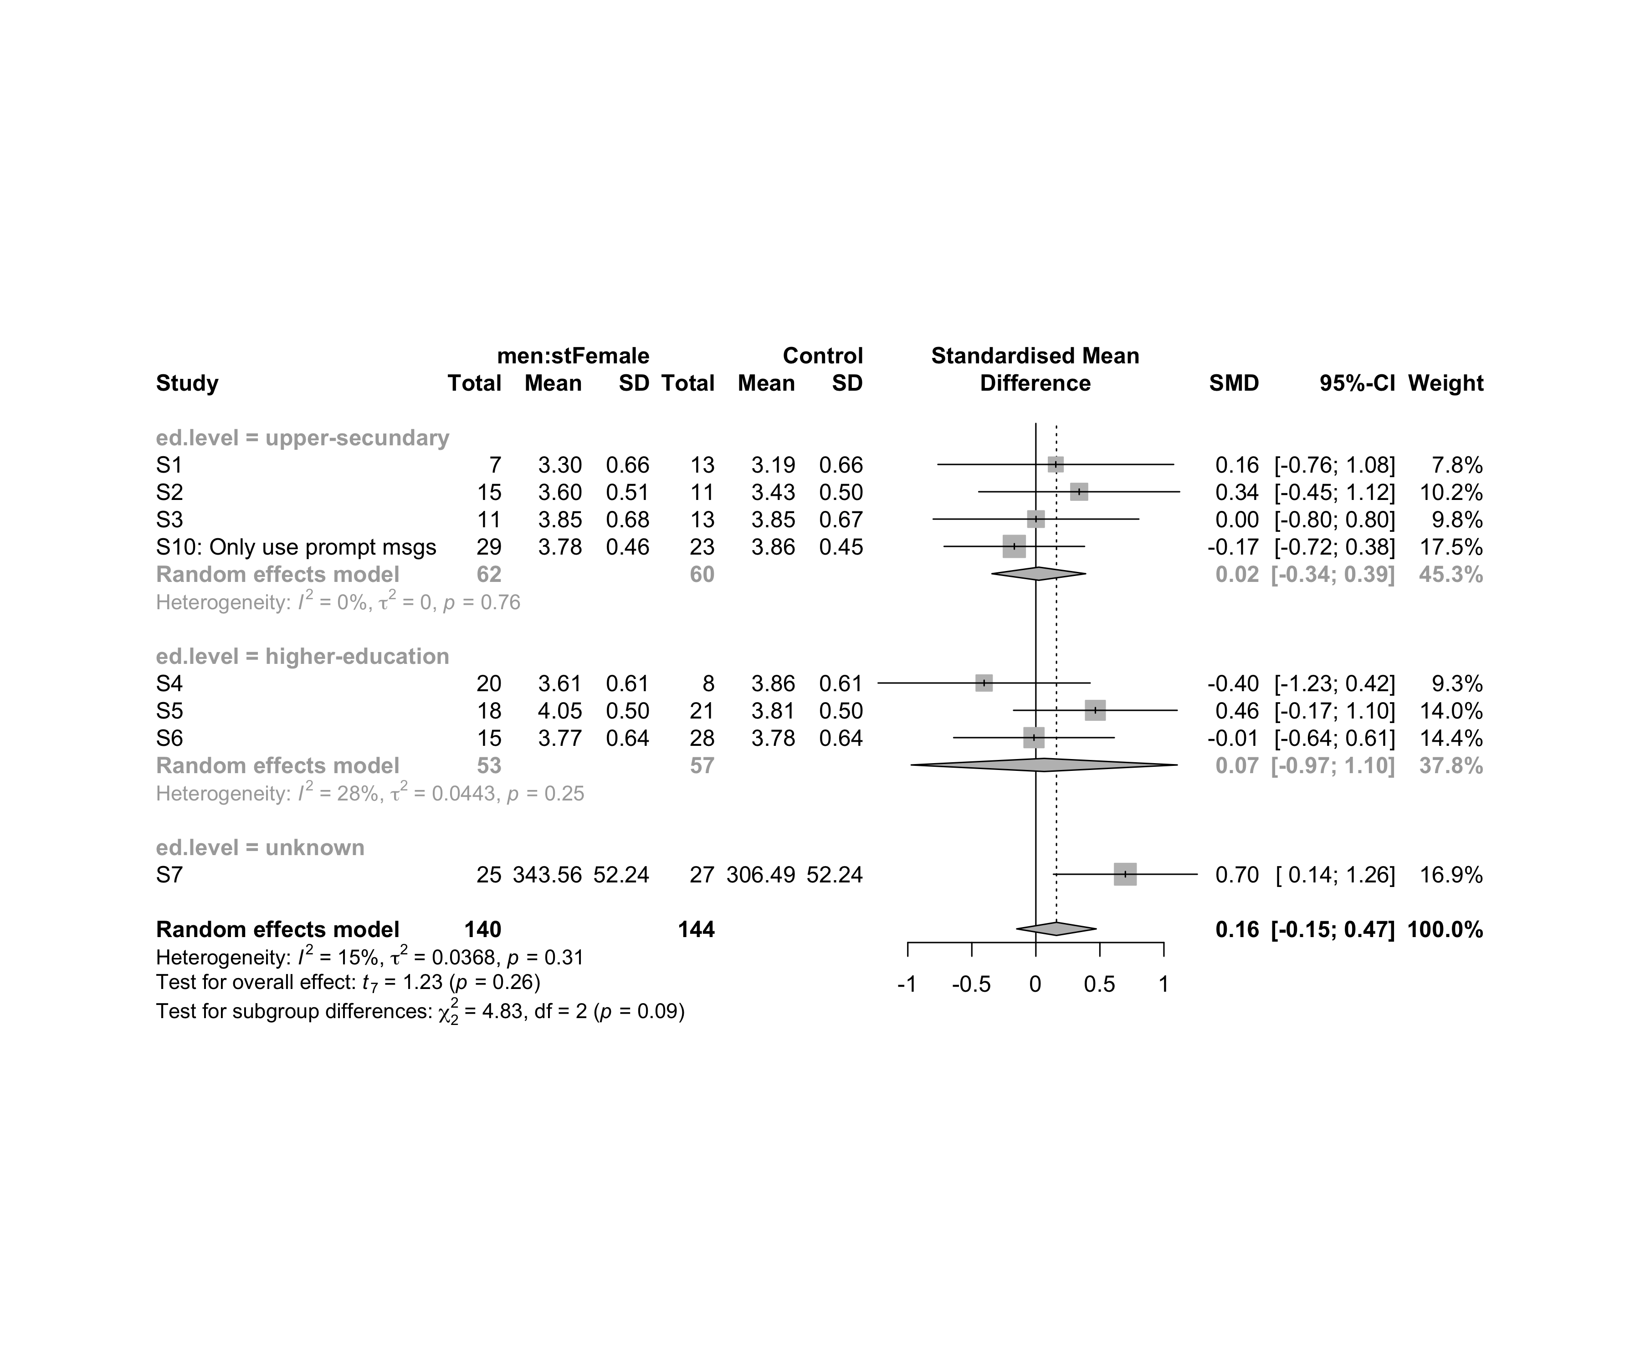

### Subgroup analysis by “intervention”

m.sg4sub <- update.meta(m.cont, subgroup = intervention, random = T, fixed = F)  
summary(m.sg4sub)

## Review: Flow state for men in stFemale  
##   
## SMD 95%-CI %W(random)  
## S1 0.1557 [-0.7647; 1.0761] 7.8  
## S2 0.3383 [-0.4460; 1.1227] 10.2  
## S3 0.0012 [-0.8018; 0.8041] 9.8  
## S4 -0.4039 [-1.2316; 0.4239] 9.3  
## S5 0.4648 [-0.1740; 1.1036] 14.0  
## S6 -0.0146 [-0.6417; 0.6125] 14.4  
## S7 0.6989 [ 0.1373; 1.2605] 16.9  
## S10: Only use prompt msgs -0.1682 [-0.7164; 0.3801] 17.5  
## intervention  
## S1 Gender-stereotype color, ranking, badges, and avatar  
## S2 Gender-stereotype color, ranking, badges, and avatar  
## S3 Gender-stereotype color, ranking, badges, and avatar  
## S4 Gender-stereotype color, ranking, badges, and avatar  
## S5 Gender-stereotype color, ranking, badges, and avatar  
## S6 Gender-stereotype color, ranking, badges, and avatar  
## S7 Gender-stereotype color, ranking, badges, and avatar  
## S10: Only use prompt msgs Gender-stereotyped motivational message prompts  
##   
## Number of studies combined: k = 8  
## Number of observations: o = 284  
##   
## SMD 95%-CI t p-value  
## Random effects model 0.1610 [-0.1496; 0.4715] 1.23 0.2599  
##   
## Quantifying heterogeneity:  
## tau^2 = 0.0368 [0.0000; 0.4087]; tau = 0.1917 [0.0000; 0.6393]  
## I^2 = 14.8% [0.0%; 57.7%]; H = 1.08 [1.00; 1.54]  
##   
## Test of heterogeneity:  
## Q d.f. p-value  
## 8.21 7 0.3141  
##   
## Results for subgroups (random effects model):  
## k SMD 95%-CI tau^2 tau Q I^2  
## intervention = Gender-stereotype color, rankin ... 7 0.2353 [-0.1091; 0.5797] 0.0246 0.1569 6.43 6.7%  
## intervention = Gender-stereotyped motivational ... 1 -0.1682 [-0.7164; 0.3801] -- -- 0.00 --  
##   
## Test for subgroup differences (random effects model):  
## Q d.f. p-value  
## Between groups 1.66 1 0.1977  
##   
## Details on meta-analytical method:  
## - Inverse variance method  
## - Restricted maximum-likelihood estimator for tau^2  
## - Q-profile method for confidence interval of tau^2 and tau  
## - Hartung-Knapp adjustment for random effects model  
## - Hedges' g (bias corrected standardised mean difference; using exact formulae)

forest(m.sg4sub, digits=2, digits.sd = 2, test.overall = T, label.e = paste0(gender,':',env))

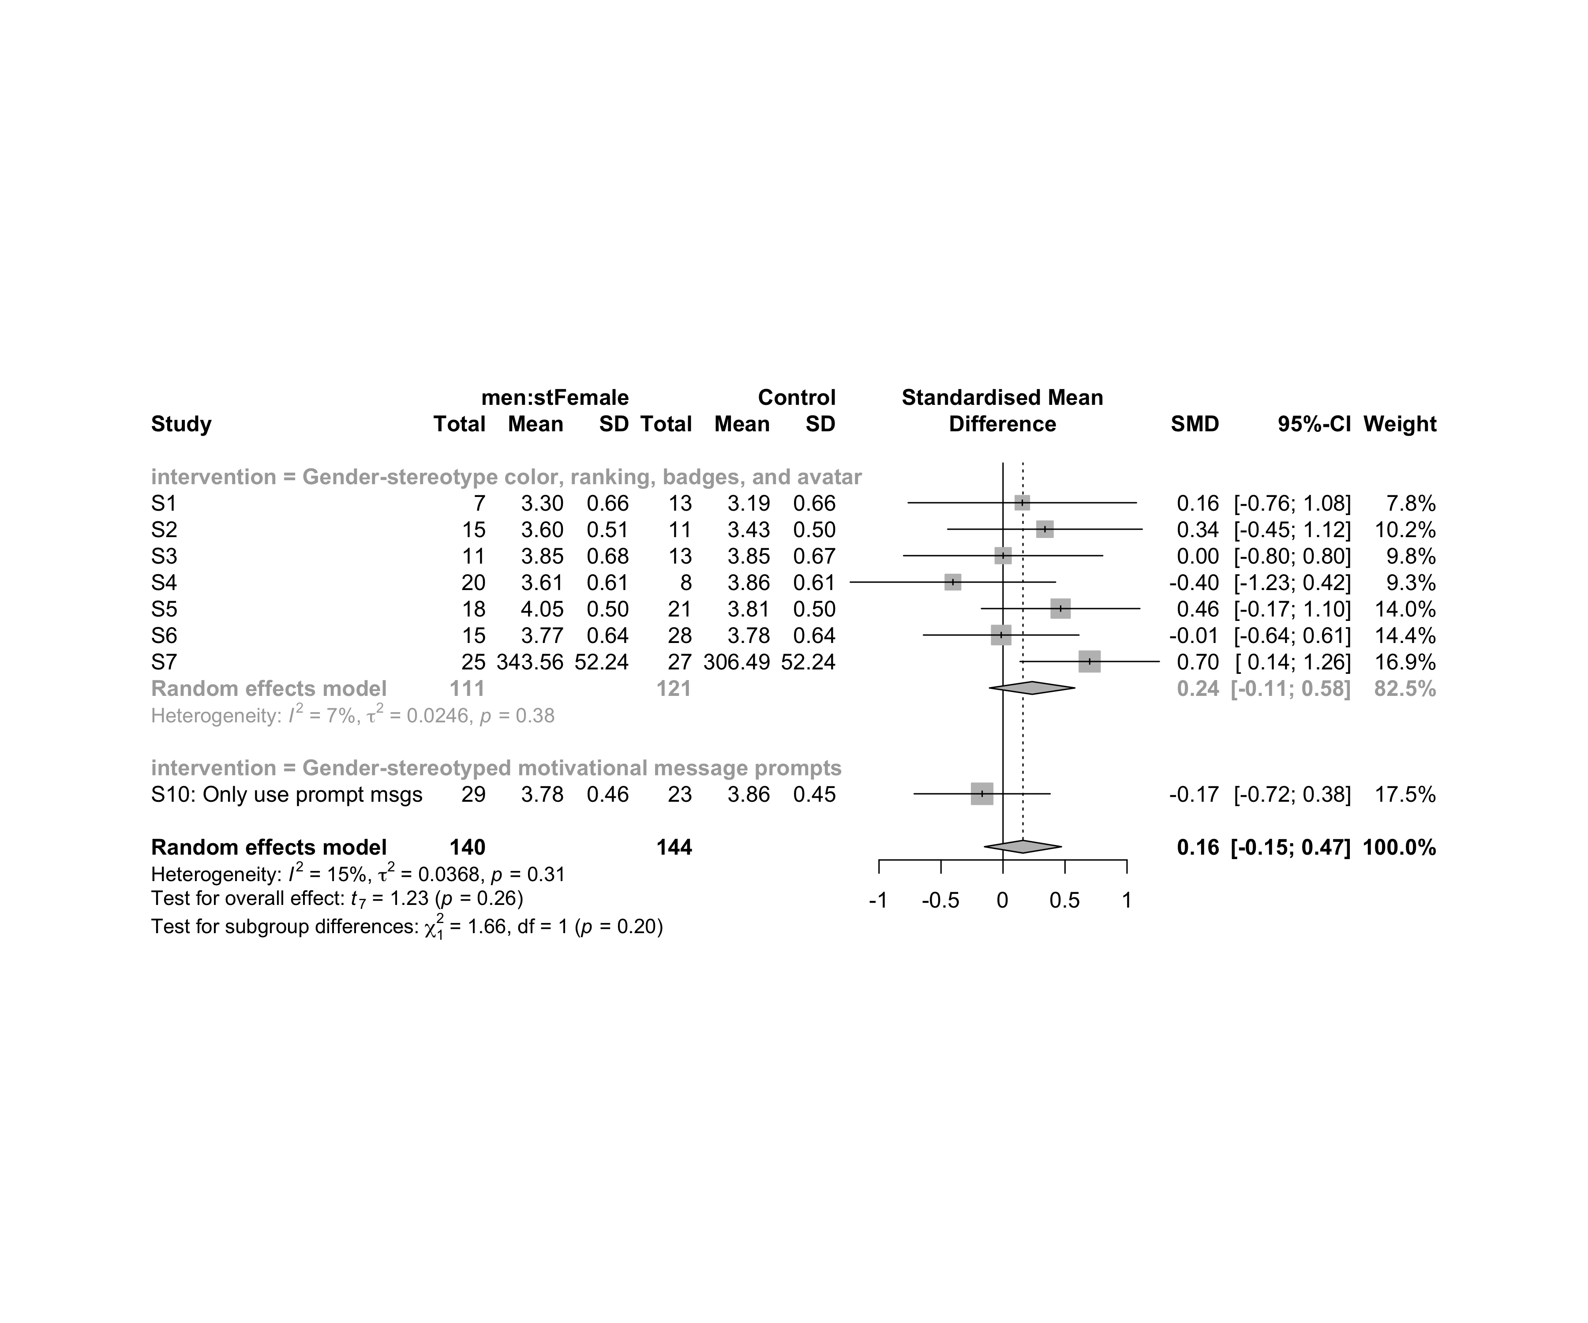

### Subgroup analysis by “age:intervention”

m.sg4sub <- update.meta(m.cont, subgroup = `age:intervention`, random = T, fixed = F)  
summary(m.sg4sub)

## Review: Flow state for men in stFemale  
##   
## SMD 95%-CI %W(random)  
## S1 0.1557 [-0.7647; 1.0761] 7.8  
## S2 0.3383 [-0.4460; 1.1227] 10.2  
## S3 0.0012 [-0.8018; 0.8041] 9.8  
## S4 -0.4039 [-1.2316; 0.4239] 9.3  
## S5 0.4648 [-0.1740; 1.1036] 14.0  
## S6 -0.0146 [-0.6417; 0.6125] 14.4  
## S7 0.6989 [ 0.1373; 1.2605] 16.9  
## S10: Only use prompt msgs -0.1682 [-0.7164; 0.3801] 17.5  
## age:intervention  
## S1 adolescent:Gender-stereotype color, ranking, badges, and avatar  
## S2 adolescent:Gender-stereotype color, ranking, badges, and avatar  
## S3 adolescent:Gender-stereotype color, ranking, badges, and avatar  
## S4 adult:Gender-stereotype color, ranking, badges, and avatar  
## S5 adult:Gender-stereotype color, ranking, badges, and avatar  
## S6 adult:Gender-stereotype color, ranking, badges, and avatar  
## S7 adult:Gender-stereotype color, ranking, badges, and avatar  
## S10: Only use prompt msgs adolescence:Gender-stereotyped motivational message prompts  
##   
## Number of studies combined: k = 8  
## Number of observations: o = 284  
##   
## SMD 95%-CI t p-value  
## Random effects model 0.1610 [-0.1496; 0.4715] 1.23 0.2599  
##   
## Quantifying heterogeneity:  
## tau^2 = 0.0368 [0.0000; 0.4087]; tau = 0.1917 [0.0000; 0.6393]  
## I^2 = 14.8% [0.0%; 57.7%]; H = 1.08 [1.00; 1.54]  
##   
## Test of heterogeneity:  
## Q d.f. p-value  
## 8.21 7 0.3141  
##   
## Results for subgroups (random effects model):  
## k SMD 95%-CI tau^2 tau Q  
## age:intervention = adolescent:Gender-stereotype co ... 3 0.1688 [-0.2697; 0.6073] 0 0 0.35  
## age:intervention = adult:Gender-stereotype color, ... 4 0.2406 [-0.5180; 0.9992] 0.1064 0.3262 5.93  
## age:intervention = adolescence:Gender-stereotyped ... 1 -0.1682 [-0.7164; 0.3801] -- -- 0.00  
## I^2  
## age:intervention = adolescent:Gender-stereotype co ... 0.0%  
## age:intervention = adult:Gender-stereotype color, ... 49.4%  
## age:intervention = adolescence:Gender-stereotyped ... --  
##   
## Test for subgroup differences (random effects model):  
## Q d.f. p-value  
## Between groups 1.47 2 0.4798  
##   
## Details on meta-analytical method:  
## - Inverse variance method  
## - Restricted maximum-likelihood estimator for tau^2  
## - Q-profile method for confidence interval of tau^2 and tau  
## - Hartung-Knapp adjustment for random effects model  
## - Hedges' g (bias corrected standardised mean difference; using exact formulae)

forest(m.sg4sub, digits=2, digits.sd = 2, test.overall = T, label.e = paste0(gender,':',env))

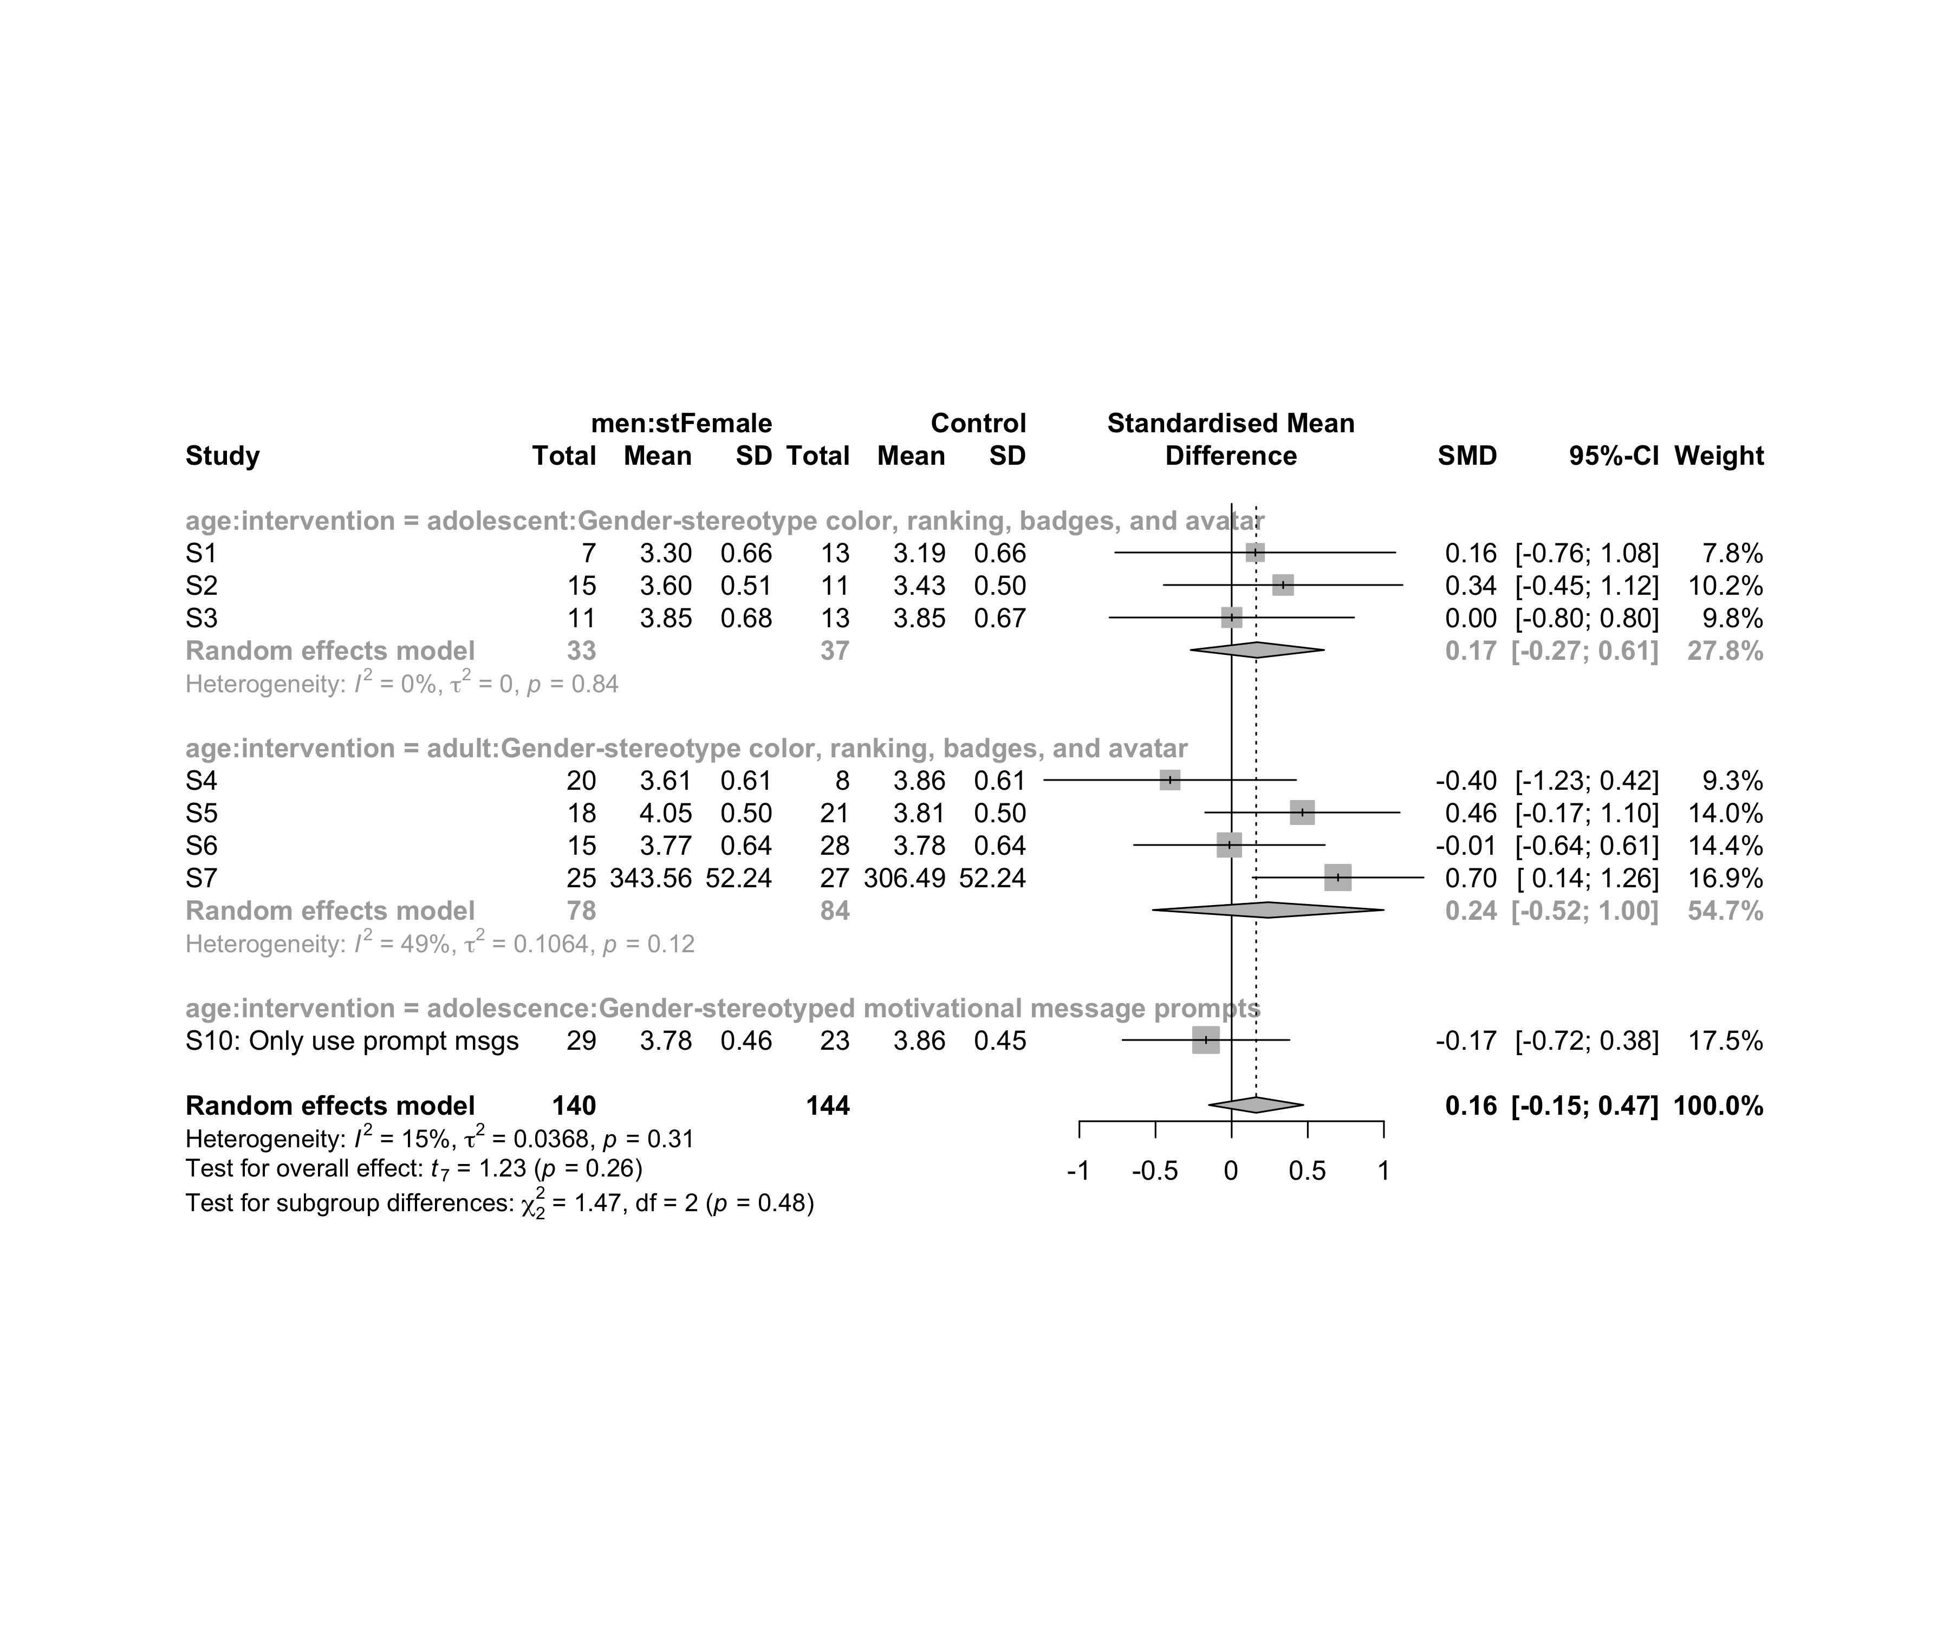

### Subgroup analysis by “ed.level:intervention”

m.sg4sub <- update.meta(m.cont, subgroup = `ed.level:intervention`, random = T, fixed = F)  
summary(m.sg4sub)

## Review: Flow state for men in stFemale  
##   
## SMD 95%-CI %W(random)  
## S1 0.1557 [-0.7647; 1.0761] 7.8  
## S2 0.3383 [-0.4460; 1.1227] 10.2  
## S3 0.0012 [-0.8018; 0.8041] 9.8  
## S4 -0.4039 [-1.2316; 0.4239] 9.3  
## S5 0.4648 [-0.1740; 1.1036] 14.0  
## S6 -0.0146 [-0.6417; 0.6125] 14.4  
## S7 0.6989 [ 0.1373; 1.2605] 16.9  
## S10: Only use prompt msgs -0.1682 [-0.7164; 0.3801] 17.5  
## ed.level:intervention  
## S1 upper-secundary:Gender-stereotype color, ranking, badges, and avatar  
## S2 upper-secundary:Gender-stereotype color, ranking, badges, and avatar  
## S3 upper-secundary:Gender-stereotype color, ranking, badges, and avatar  
## S4 higher-education:Gender-stereotype color, ranking, badges, and avatar  
## S5 higher-education:Gender-stereotype color, ranking, badges, and avatar  
## S6 higher-education:Gender-stereotype color, ranking, badges, and avatar  
## S7 unknown:Gender-stereotype color, ranking, badges, and avatar  
## S10: Only use prompt msgs upper-secundary:Gender-stereotyped motivational message prompts  
##   
## Number of studies combined: k = 8  
## Number of observations: o = 284  
##   
## SMD 95%-CI t p-value  
## Random effects model 0.1610 [-0.1496; 0.4715] 1.23 0.2599  
##   
## Quantifying heterogeneity:  
## tau^2 = 0.0368 [0.0000; 0.4087]; tau = 0.1917 [0.0000; 0.6393]  
## I^2 = 14.8% [0.0%; 57.7%]; H = 1.08 [1.00; 1.54]  
##   
## Test of heterogeneity:  
## Q d.f. p-value  
## 8.21 7 0.3141  
##   
## Results for subgroups (random effects model):  
## k SMD 95%-CI tau^2 tau  
## ed.level:intervention = upper-secundary:Gender-stereoty ... 3 0.1688 [-0.2697; 0.6073] 0 0  
## ed.level:intervention = higher-education:Gender-stereot ... 3 0.0654 [-0.9733; 1.1041] 0.0443 0.2104  
## ed.level:intervention = unknown:Gender-stereotype color ... 1 0.6989 [ 0.1373; 1.2605] -- --  
## ed.level:intervention = upper-secundary:Gender-stereoty ... 1 -0.1682 [-0.7164; 0.3801] -- --  
## Q I^2  
## ed.level:intervention = upper-secundary:Gender-stereoty ... 0.35 0.0%  
## ed.level:intervention = higher-education:Gender-stereot ... 2.79 28.4%  
## ed.level:intervention = unknown:Gender-stereotype color ... 0.00 --  
## ed.level:intervention = upper-secundary:Gender-stereoty ... 0.00 --  
##   
## Test for subgroup differences (random effects model):  
## Q d.f. p-value  
## Between groups 5.06 3 0.1677  
##   
## Details on meta-analytical method:  
## - Inverse variance method  
## - Restricted maximum-likelihood estimator for tau^2  
## - Q-profile method for confidence interval of tau^2 and tau  
## - Hartung-Knapp adjustment for random effects model  
## - Hedges' g (bias corrected standardised mean difference; using exact formulae)

forest(m.sg4sub, digits=2, digits.sd = 2, test.overall = T, label.e = paste0(gender,':',env))

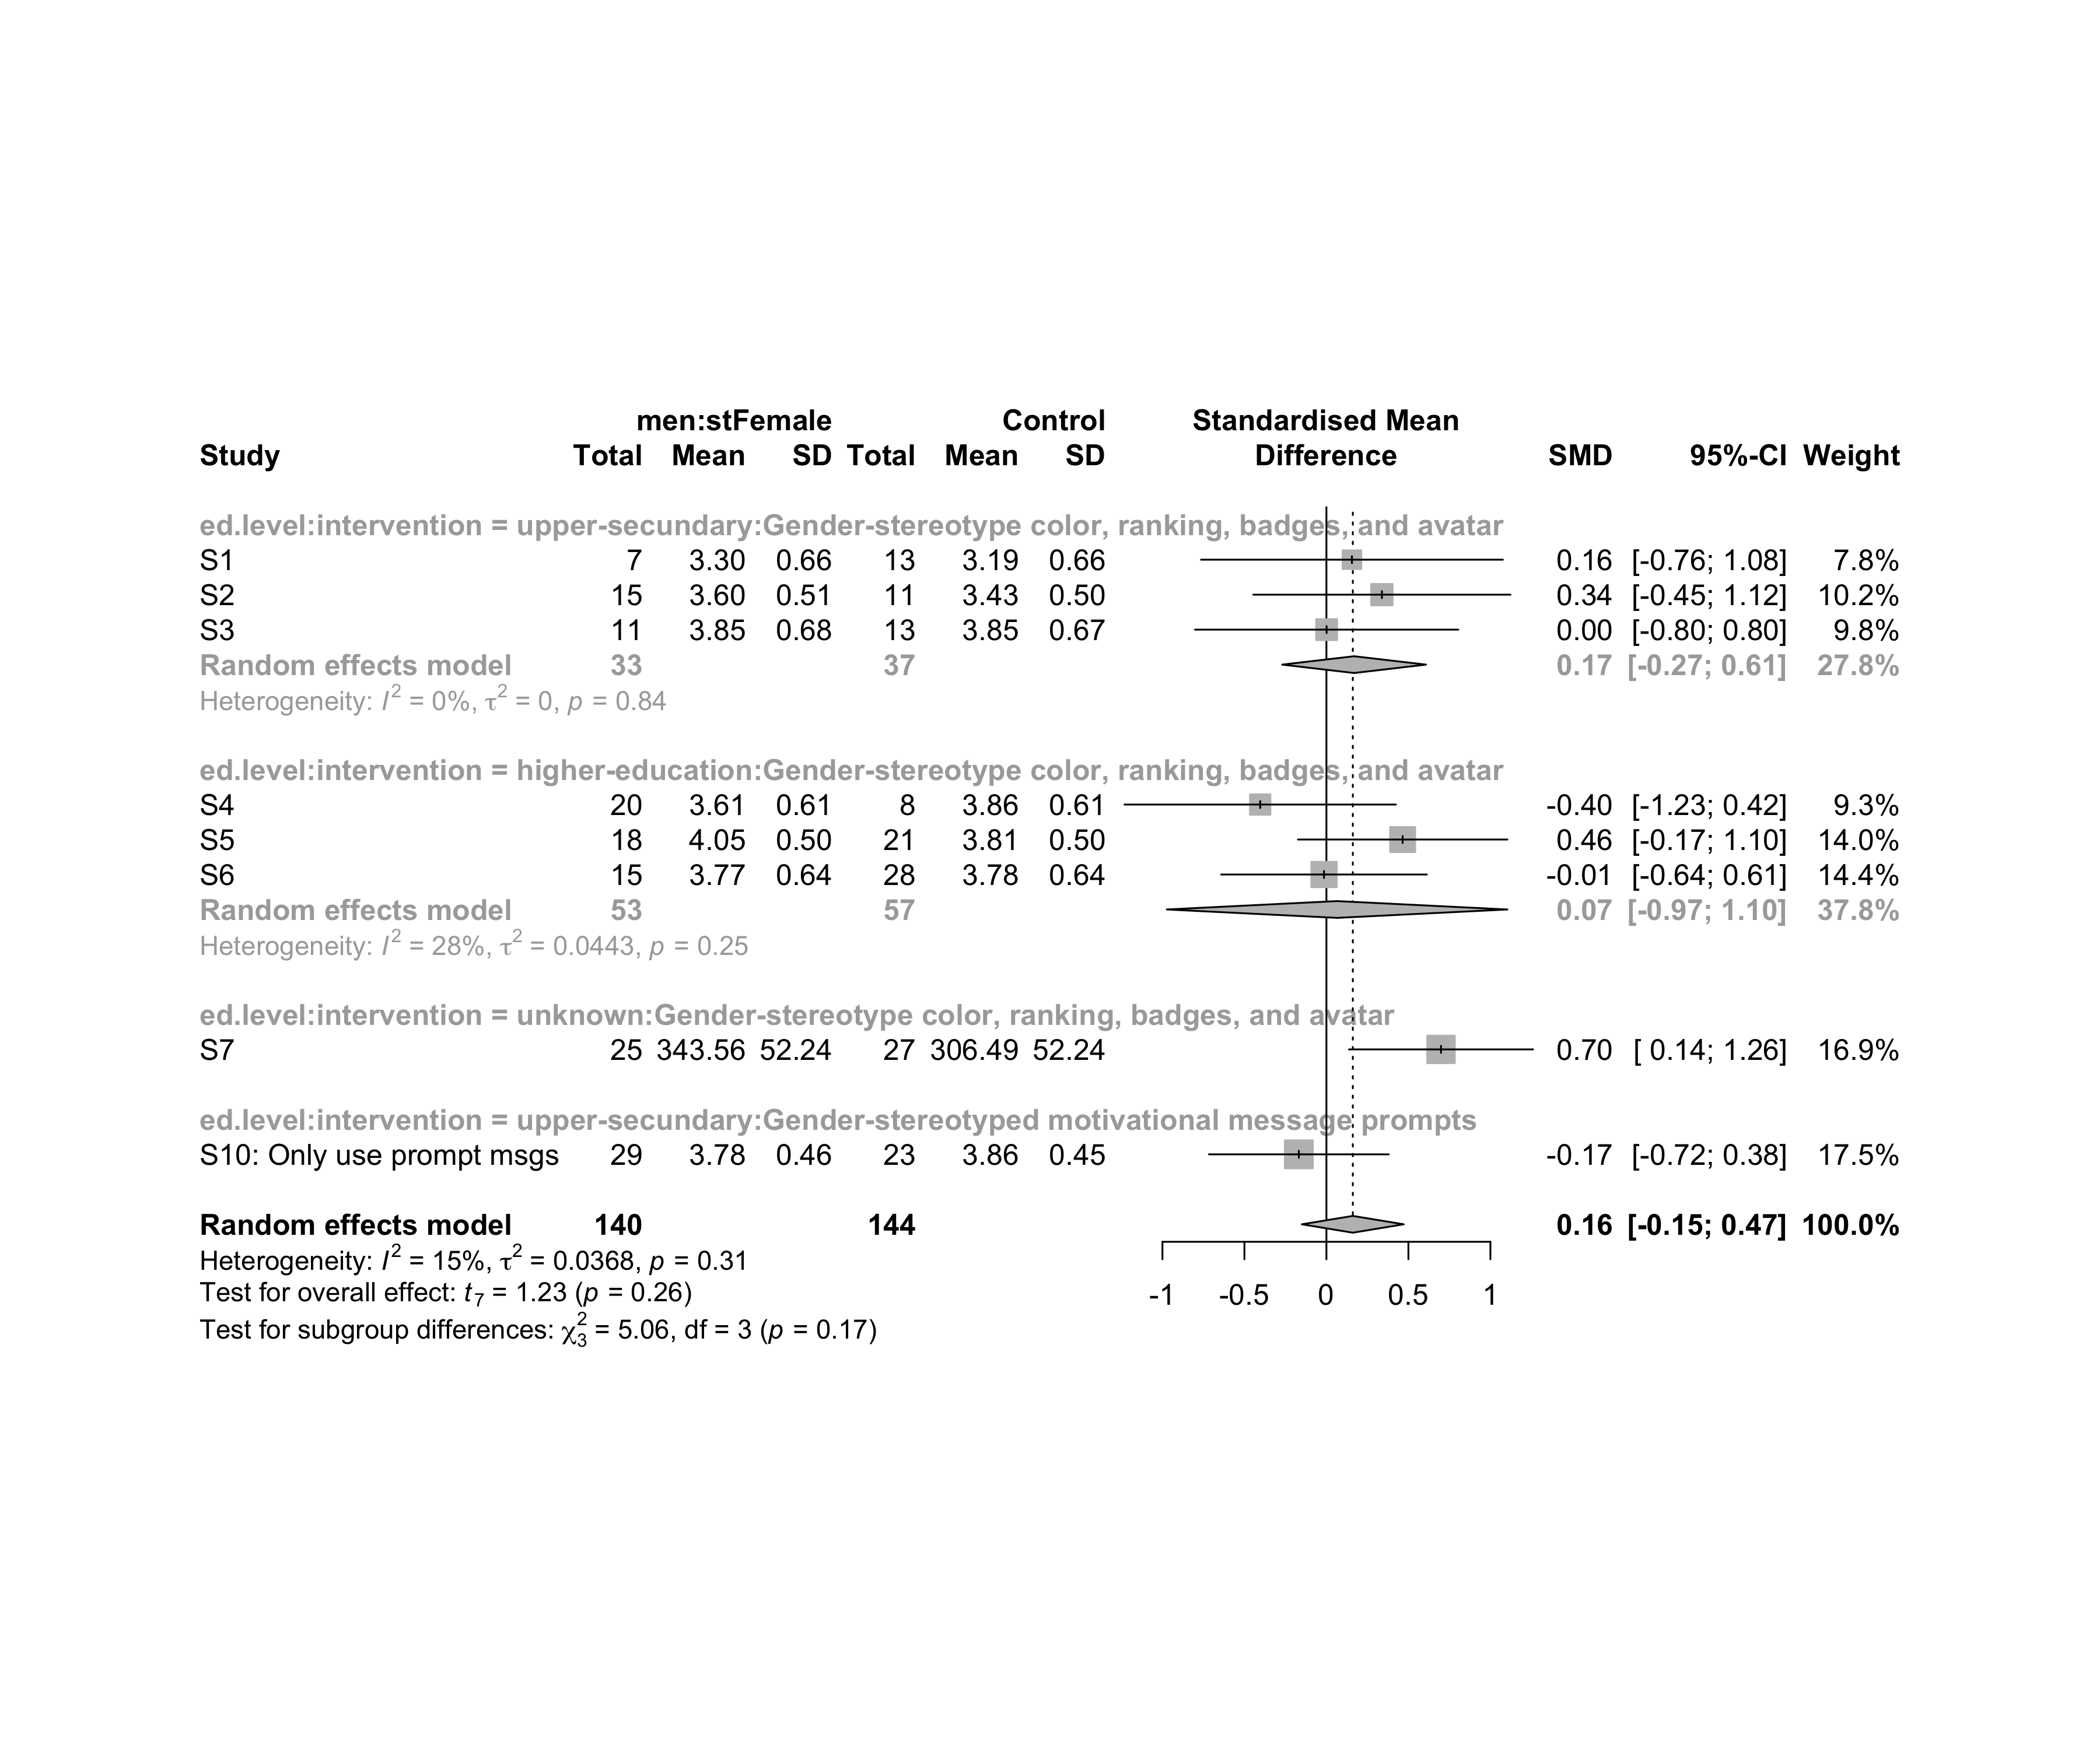

### Subgroup analysis by “age:ed.level:intervention”

m.sg4sub <- update.meta(m.cont, subgroup = `age:ed.level:intervention`, random = T, fixed = F)  
summary(m.sg4sub)

## Review: Flow state for men in stFemale  
##   
## SMD 95%-CI %W(random)  
## S1 0.1557 [-0.7647; 1.0761] 7.8  
## S2 0.3383 [-0.4460; 1.1227] 10.2  
## S3 0.0012 [-0.8018; 0.8041] 9.8  
## S4 -0.4039 [-1.2316; 0.4239] 9.3  
## S5 0.4648 [-0.1740; 1.1036] 14.0  
## S6 -0.0146 [-0.6417; 0.6125] 14.4  
## S7 0.6989 [ 0.1373; 1.2605] 16.9  
## S10: Only use prompt msgs -0.1682 [-0.7164; 0.3801] 17.5  
## age:ed.level:intervention  
## S1 adolescent:upper-secundary:Gender-stereotype color, ranking, badges, and avatar  
## S2 adolescent:upper-secundary:Gender-stereotype color, ranking, badges, and avatar  
## S3 adolescent:upper-secundary:Gender-stereotype color, ranking, badges, and avatar  
## S4 adult:higher-education:Gender-stereotype color, ranking, badges, and avatar  
## S5 adult:higher-education:Gender-stereotype color, ranking, badges, and avatar  
## S6 adult:higher-education:Gender-stereotype color, ranking, badges, and avatar  
## S7 adult:unknown:Gender-stereotype color, ranking, badges, and avatar  
## S10: Only use prompt msgs adolescence:upper-secundary:Gender-stereotyped motivational message prompts  
##   
## Number of studies combined: k = 8  
## Number of observations: o = 284  
##   
## SMD 95%-CI t p-value  
## Random effects model 0.1610 [-0.1496; 0.4715] 1.23 0.2599  
##   
## Quantifying heterogeneity:  
## tau^2 = 0.0368 [0.0000; 0.4087]; tau = 0.1917 [0.0000; 0.6393]  
## I^2 = 14.8% [0.0%; 57.7%]; H = 1.08 [1.00; 1.54]  
##   
## Test of heterogeneity:  
## Q d.f. p-value  
## 8.21 7 0.3141  
##   
## Results for subgroups (random effects model):  
## k SMD 95%-CI tau^2 tau  
## age:ed.level:intervention = adolescent:upper-secundary:Gend ... 3 0.1688 [-0.2697; 0.6073] 0 0  
## age:ed.level:intervention = adult:higher-education:Gender-s ... 3 0.0654 [-0.9733; 1.1041] 0.0443 0.2104  
## age:ed.level:intervention = adult:unknown:Gender-stereotype ... 1 0.6989 [ 0.1373; 1.2605] -- --  
## age:ed.level:intervention = adolescence:upper-secundary:Gen ... 1 -0.1682 [-0.7164; 0.3801] -- --  
## Q I^2  
## age:ed.level:intervention = adolescent:upper-secundary:Gend ... 0.35 0.0%  
## age:ed.level:intervention = adult:higher-education:Gender-s ... 2.79 28.4%  
## age:ed.level:intervention = adult:unknown:Gender-stereotype ... 0.00 --  
## age:ed.level:intervention = adolescence:upper-secundary:Gen ... 0.00 --  
##   
## Test for subgroup differences (random effects model):  
## Q d.f. p-value  
## Between groups 5.06 3 0.1677  
##   
## Details on meta-analytical method:  
## - Inverse variance method  
## - Restricted maximum-likelihood estimator for tau^2  
## - Q-profile method for confidence interval of tau^2 and tau  
## - Hartung-Knapp adjustment for random effects model  
## - Hedges' g (bias corrected standardised mean difference; using exact formulae)

forest(m.sg4sub, digits=2, digits.sd = 2, test.overall = T, label.e = paste0(gender,':',env))

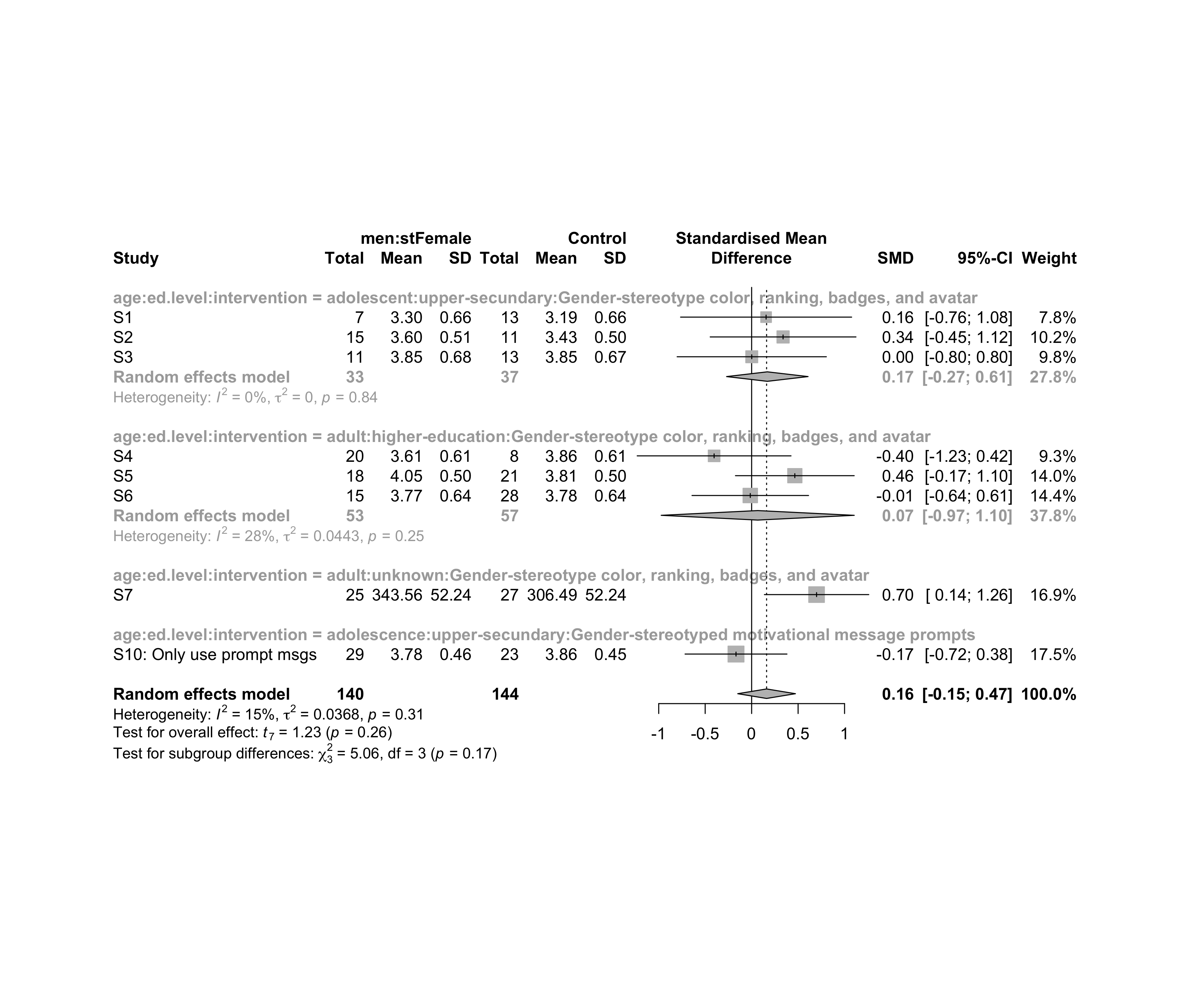

## Funnel Plot

m.cont <- update.meta(m.cont, studlab = data$study)  
summary(eggers.test(x = m.cont))

## Eggers' test of the intercept   
## =============================   
##   
## intercept 95% CI t p  
## -1.453 -5.86 - 2.96 -0.645 0.54  
##   
## Eggers' test does not indicate the presence of funnel plot asymmetry.

funnel(m.cont, xlab = "Hedges' g", studlab = T, legend=T, addtau2 = T)

