Metanalysis of flow state on women caused by (stFemale)

Geiser C. Challco [geiser@alumni.usp.br](mailto:geiser@alumni.usp.br)

Table of Contents

## Initial Variables and Loading Data

env <- "stFemale"  
gender <- "women"  
to_remove <- c('S11')  
sub.groups <- c("age","ed.level","intervention","age:intervention",  
 "ed.level:intervention","age:ed.level:intervention")

dat <- read_excel("../data/data-without-outliers.xlsx", sheet = "fss-env.gender-descriptive")  
dat <- dat[!dat$study %in% to_remove, ]  
  
leg <- read_excel("../data/data-without-outliers.xlsx", sheet = "legend")

## New names:  
## • `` -> `...10`

leg <- leg[!leg$study %in% to_remove, ]  
  
idx.e <- which(dat$env == env & dat$gender == gender)  
idx.c <- which(dat$env == "control" & dat$gender == gender)  
  
data <- data.frame(  
 study = dat$study[idx.c],  
 n.e = dat$N[idx.e], mean.e = dat$M.emms[idx.e], sd.e = dat$SD.emms[idx.e],  
 n.c = dat$N[idx.c], mean.c = dat$M.emms[idx.c], sd.c = dat$SD.emms[idx.c]  
)  
for (cgroups in strsplit(sub.groups,":")) {  
 data[[paste0(cgroups, collapse = ":")]] <- sapply(data$study, FUN = function(x) {  
 paste0(sapply(cgroups, FUN = function(namecol) leg[[namecol]][which(x == leg$study)]), collapse = ":")  
 })  
}  
data[["lbl"]] <- sapply(data$study, FUN = function(x) leg$Note[which(x == leg$study)])

## Perform meta-analyses

m.cont <- metacont(  
 n.e = n.e, mean.e = mean.e, sd.e = sd.e, n.c = n.c, mean.c = mean.c, sd.c = sd.c,  
 studlab = lbl, data = data, sm = "SMD", method.smd = "Hedges",  
 fixed = F, random = T, method.tau = "REML", hakn = T, title = paste("Flow state for",gender,"in",env)  
)  
summary(m.cont)

## Review: Flow state for women in stFemale  
##   
## SMD 95%-CI %W(random)  
## S1 0.6784 [ 0.0293; 1.3276] 12.8  
## S2 0.0758 [-0.4475; 0.5992] 19.7  
## S3 -0.3244 [-1.0470; 0.3982] 10.3  
## S4 0.7512 [-0.0340; 1.5363] 8.7  
## S5 0.3534 [-0.2481; 0.9549] 14.9  
## S6 0.6765 [-0.0622; 1.4152] 9.9  
## S7 0.2370 [-0.3729; 0.8470] 14.5  
## S10: Only use prompt msgs 0.3530 [-0.4128; 1.1189] 9.2  
##   
## Number of studies combined: k = 8  
## Number of observations: o = 296  
##   
## SMD 95%-CI t p-value  
## Random effects model 0.3202 [0.0360; 0.6044] 2.66 0.0323  
##   
## Quantifying heterogeneity:  
## tau^2 < 0.0001 [0.0000; 0.4122]; tau = 0.0003 [0.0000; 0.6420]  
## I^2 = 2.8% [0.0%; 68.5%]; H = 1.01 [1.00; 1.78]  
##   
## Test of heterogeneity:  
## Q d.f. p-value  
## 7.21 7 0.4078  
##   
## Details on meta-analytical method:  
## - Inverse variance method  
## - Restricted maximum-likelihood estimator for tau^2  
## - Q-profile method for confidence interval of tau^2 and tau  
## - Hartung-Knapp adjustment for random effects model  
## - Hedges' g (bias corrected standardised mean difference; using exact formulae)

forest(m.cont, digits=2, digits.sd = 2, test.overall = T, label.e = paste0(gender,':',env))

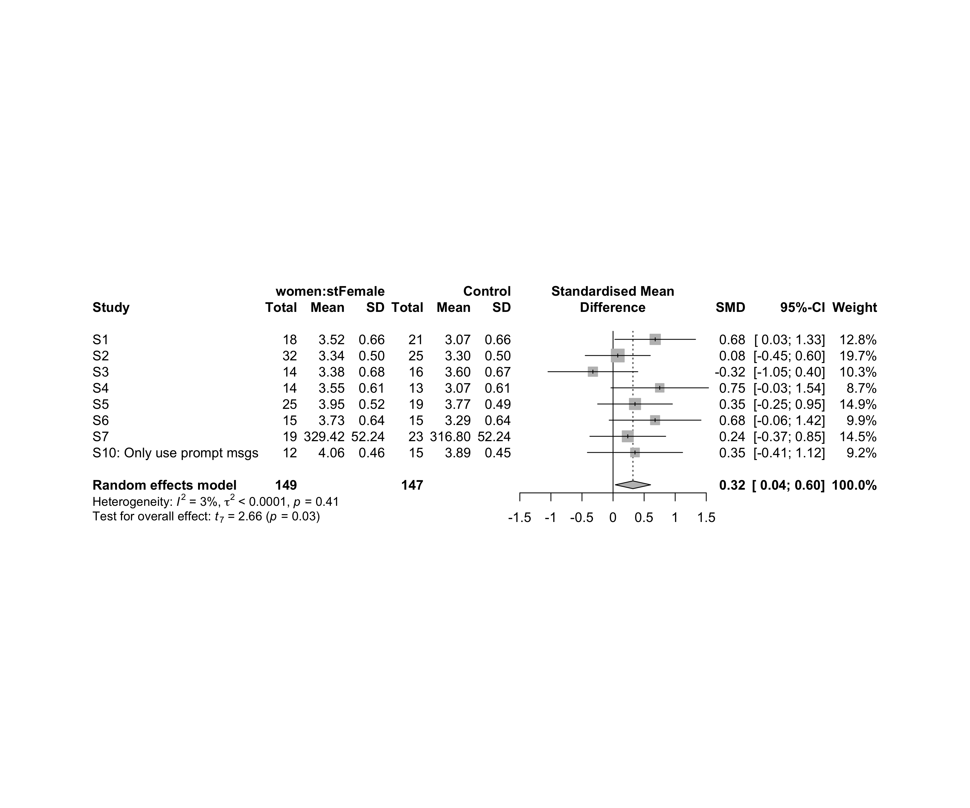

### Subgroup analysis by “age”

m.sg4sub <- update.meta(m.cont, subgroup = age, random = T, fixed = F)  
summary(m.sg4sub)

## Review: Flow state for women in stFemale  
##   
## SMD 95%-CI %W(random) age  
## S1 0.6784 [ 0.0293; 1.3276] 12.8 adolescent  
## S2 0.0758 [-0.4475; 0.5992] 19.7 adolescent  
## S3 -0.3244 [-1.0470; 0.3982] 10.3 adolescent  
## S4 0.7512 [-0.0340; 1.5363] 8.7 adult  
## S5 0.3534 [-0.2481; 0.9549] 14.9 adult  
## S6 0.6765 [-0.0622; 1.4152] 9.9 adult  
## S7 0.2370 [-0.3729; 0.8470] 14.5 adult  
## S10: Only use prompt msgs 0.3530 [-0.4128; 1.1189] 9.2 adolescence  
##   
## Number of studies combined: k = 8  
## Number of observations: o = 296  
##   
## SMD 95%-CI t p-value  
## Random effects model 0.3202 [0.0360; 0.6044] 2.66 0.0323  
##   
## Quantifying heterogeneity:  
## tau^2 < 0.0001 [0.0000; 0.4122]; tau = 0.0003 [0.0000; 0.6420]  
## I^2 = 2.8% [0.0%; 68.5%]; H = 1.01 [1.00; 1.78]  
##   
## Test of heterogeneity:  
## Q d.f. p-value  
## 7.21 7 0.4078  
##   
## Results for subgroups (random effects model):  
## k SMD 95%-CI tau^2 tau Q I^2  
## age = adolescent 3 0.1544 [-1.0524; 1.3613] 0.1185 0.3443 4.28 53.2%  
## age = adult 4 0.4572 [ 0.0735; 0.8409] 0 0 1.49 0.0%  
## age = adolescence 1 0.3530 [-0.4128; 1.1189] -- -- 0.00 --  
##   
## Test for subgroup differences (random effects model):  
## Q d.f. p-value  
## Between groups 1.00 2 0.6056  
##   
## Details on meta-analytical method:  
## - Inverse variance method  
## - Restricted maximum-likelihood estimator for tau^2  
## - Q-profile method for confidence interval of tau^2 and tau  
## - Hartung-Knapp adjustment for random effects model  
## - Hedges' g (bias corrected standardised mean difference; using exact formulae)

forest(m.sg4sub, digits=2, digits.sd = 2, test.overall = T, label.e = paste0(gender,':',env))

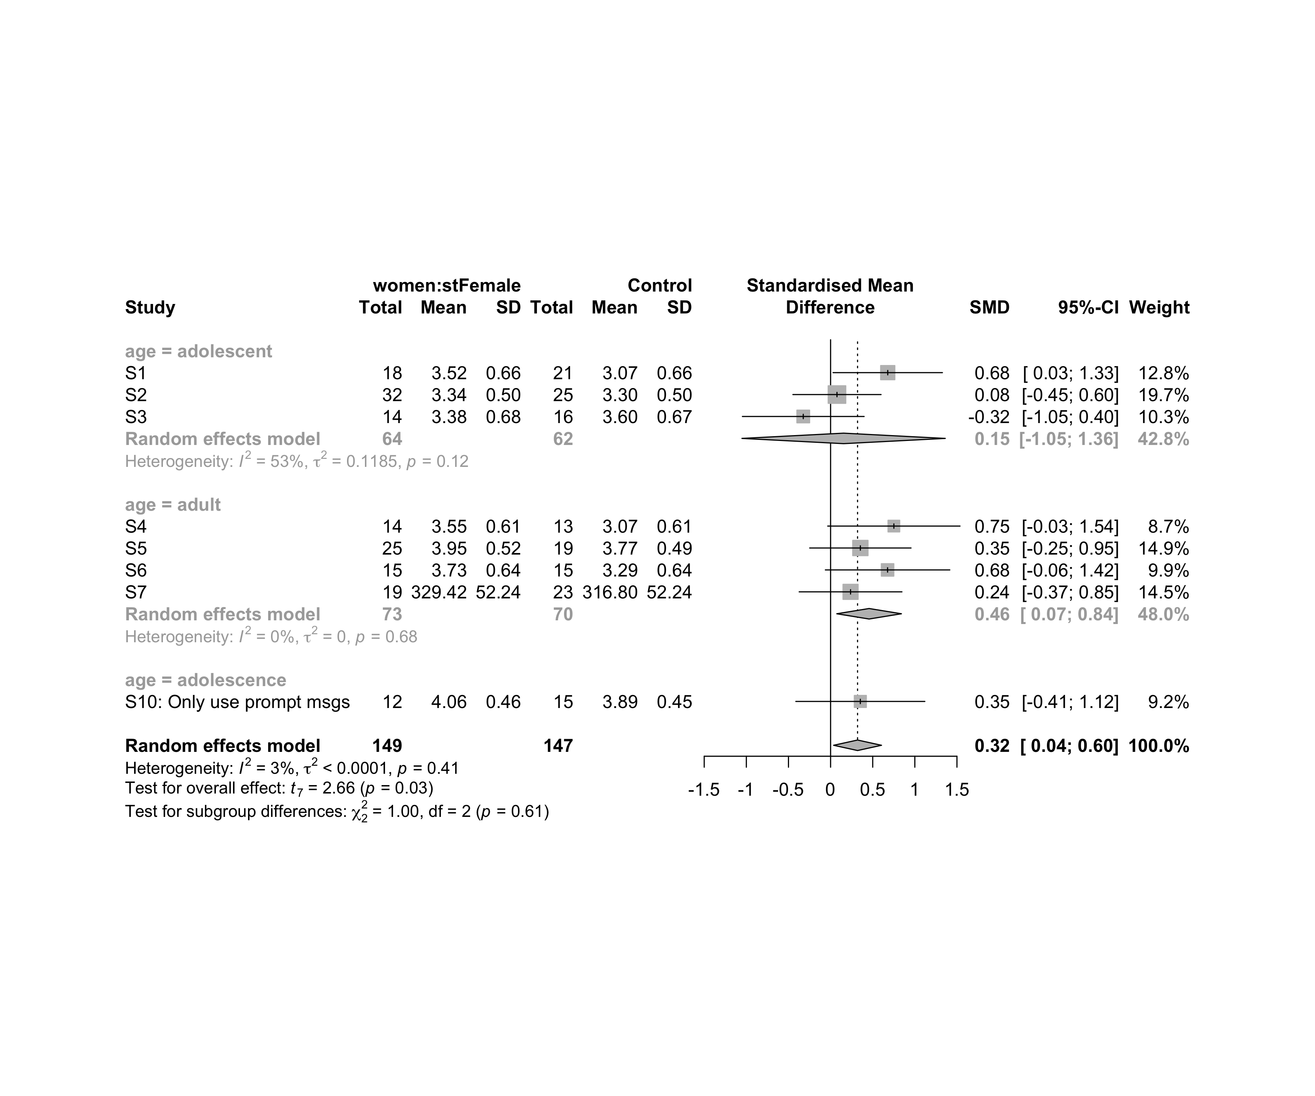

### Subgroup analysis by “ed.level”

m.sg4sub <- update.meta(m.cont, subgroup = ed.level, random = T, fixed = F)  
summary(m.sg4sub)

## Review: Flow state for women in stFemale  
##   
## SMD 95%-CI %W(random) ed.level  
## S1 0.6784 [ 0.0293; 1.3276] 12.8 upper-secundary  
## S2 0.0758 [-0.4475; 0.5992] 19.7 upper-secundary  
## S3 -0.3244 [-1.0470; 0.3982] 10.3 upper-secundary  
## S4 0.7512 [-0.0340; 1.5363] 8.7 higher-education  
## S5 0.3534 [-0.2481; 0.9549] 14.9 higher-education  
## S6 0.6765 [-0.0622; 1.4152] 9.9 higher-education  
## S7 0.2370 [-0.3729; 0.8470] 14.5 unknown  
## S10: Only use prompt msgs 0.3530 [-0.4128; 1.1189] 9.2 upper-secundary  
##   
## Number of studies combined: k = 8  
## Number of observations: o = 296  
##   
## SMD 95%-CI t p-value  
## Random effects model 0.3202 [0.0360; 0.6044] 2.66 0.0323  
##   
## Quantifying heterogeneity:  
## tau^2 < 0.0001 [0.0000; 0.4122]; tau = 0.0003 [0.0000; 0.6420]  
## I^2 = 2.8% [0.0%; 68.5%]; H = 1.01 [1.00; 1.78]  
##   
## Test of heterogeneity:  
## Q d.f. p-value  
## 7.21 7 0.4078  
##   
## Results for subgroups (random effects model):  
## k SMD 95%-CI tau^2 tau Q I^2  
## ed.level = upper-secundary 4 0.1963 [-0.4592; 0.8517] 0.0518 0.2277 4.48 33.0%  
## ed.level = higher-education 3 0.5524 [ 0.0044; 1.1004] 0 0 0.77 0.0%  
## ed.level = unknown 1 0.2370 [-0.3729; 0.8470] -- -- 0.00 --  
##   
## Test for subgroup differences (random effects model):  
## Q d.f. p-value  
## Between groups 2.60 2 0.2732  
##   
## Details on meta-analytical method:  
## - Inverse variance method  
## - Restricted maximum-likelihood estimator for tau^2  
## - Q-profile method for confidence interval of tau^2 and tau  
## - Hartung-Knapp adjustment for random effects model  
## - Hedges' g (bias corrected standardised mean difference; using exact formulae)

forest(m.sg4sub, digits=2, digits.sd = 2, test.overall = T, label.e = paste0(gender,':',env))

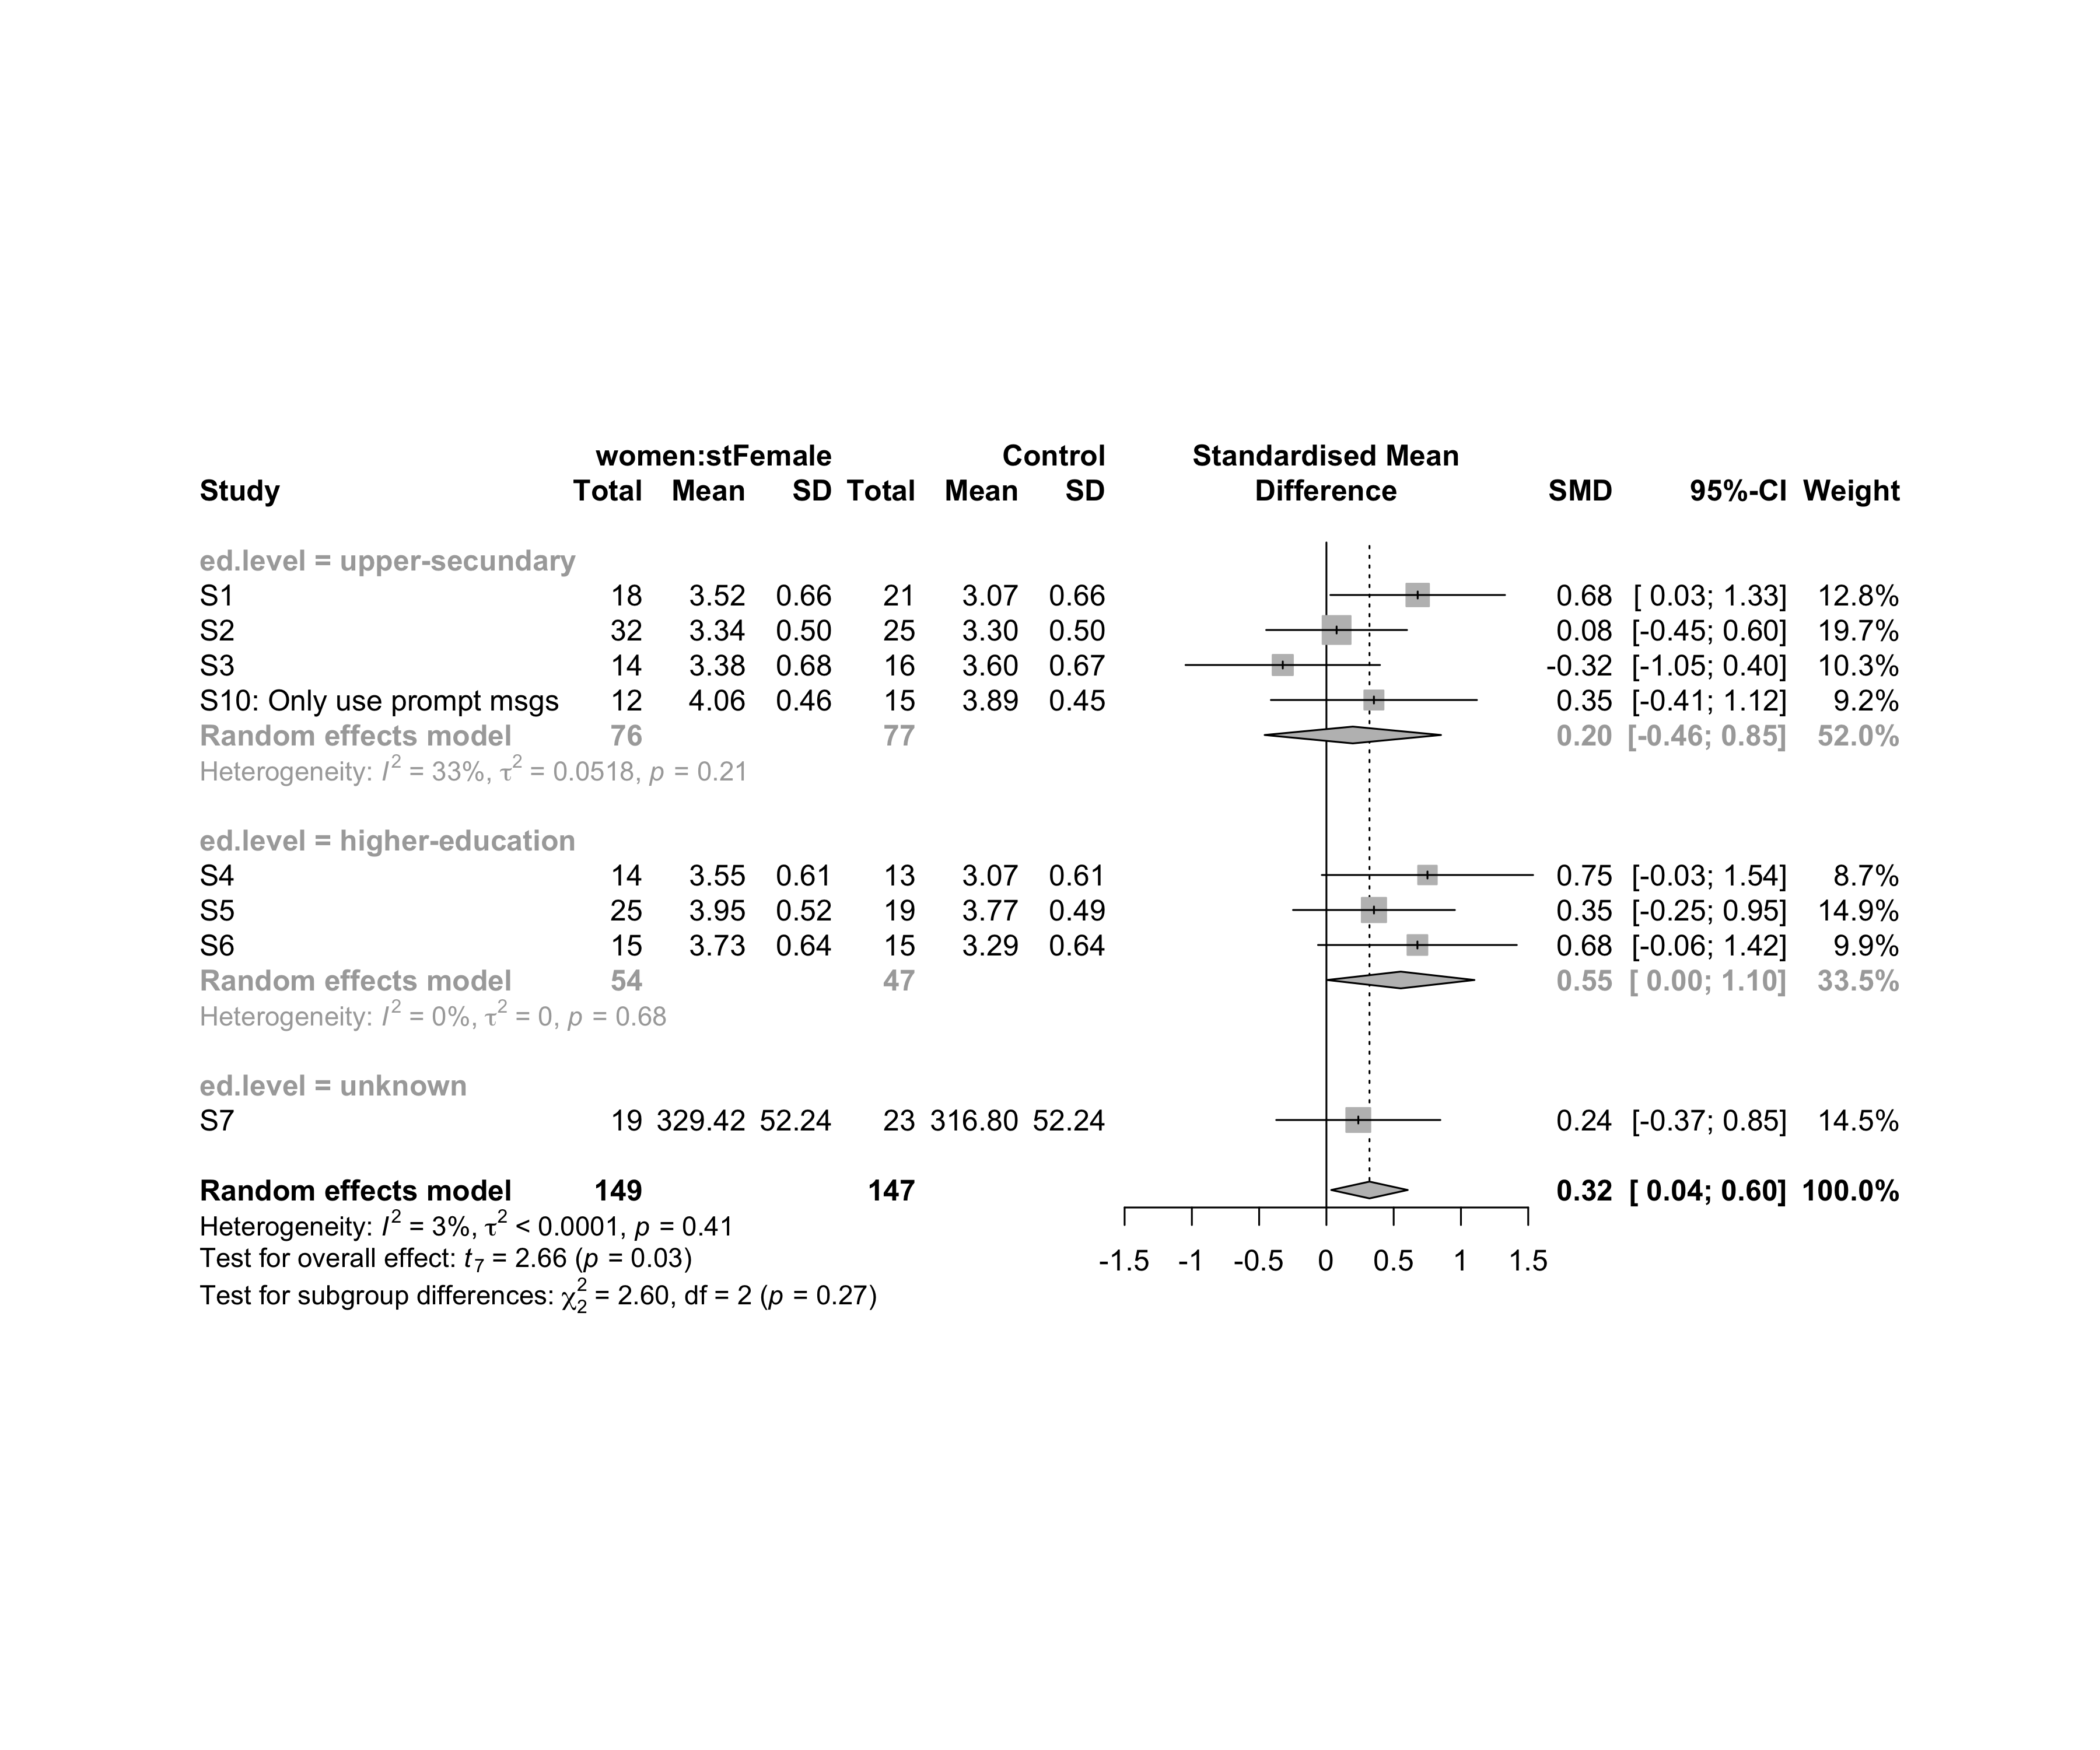

### Subgroup analysis by “intervention”

m.sg4sub <- update.meta(m.cont, subgroup = intervention, random = T, fixed = F)  
summary(m.sg4sub)

## Review: Flow state for women in stFemale  
##   
## SMD 95%-CI %W(random)  
## S1 0.6784 [ 0.0293; 1.3276] 12.8  
## S2 0.0758 [-0.4475; 0.5992] 19.7  
## S3 -0.3244 [-1.0470; 0.3982] 10.3  
## S4 0.7512 [-0.0340; 1.5363] 8.7  
## S5 0.3534 [-0.2481; 0.9549] 14.9  
## S6 0.6765 [-0.0622; 1.4152] 9.9  
## S7 0.2370 [-0.3729; 0.8470] 14.5  
## S10: Only use prompt msgs 0.3530 [-0.4128; 1.1189] 9.2  
## intervention  
## S1 Gender-stereotype color, ranking, badges, and avatar  
## S2 Gender-stereotype color, ranking, badges, and avatar  
## S3 Gender-stereotype color, ranking, badges, and avatar  
## S4 Gender-stereotype color, ranking, badges, and avatar  
## S5 Gender-stereotype color, ranking, badges, and avatar  
## S6 Gender-stereotype color, ranking, badges, and avatar  
## S7 Gender-stereotype color, ranking, badges, and avatar  
## S10: Only use prompt msgs Gender-stereotyped motivational message prompts  
##   
## Number of studies combined: k = 8  
## Number of observations: o = 296  
##   
## SMD 95%-CI t p-value  
## Random effects model 0.3202 [0.0360; 0.6044] 2.66 0.0323  
##   
## Quantifying heterogeneity:  
## tau^2 < 0.0001 [0.0000; 0.4122]; tau = 0.0003 [0.0000; 0.6420]  
## I^2 = 2.8% [0.0%; 68.5%]; H = 1.01 [1.00; 1.78]  
##   
## Test of heterogeneity:  
## Q d.f. p-value  
## 7.21 7 0.4078  
##   
## Results for subgroups (random effects model):  
## k SMD 95%-CI tau^2 tau Q I^2  
## intervention = Gender-stereotype color, rankin ... 7 0.3200 [-0.0158; 0.6557] 0.0103 0.1013 7.20 16.6%  
## intervention = Gender-stereotyped motivational ... 1 0.3530 [-0.4128; 1.1189] -- -- 0.00 --  
##   
## Test for subgroup differences (random effects model):  
## Q d.f. p-value  
## Between groups 0.01 1 0.9363  
##   
## Details on meta-analytical method:  
## - Inverse variance method  
## - Restricted maximum-likelihood estimator for tau^2  
## - Q-profile method for confidence interval of tau^2 and tau  
## - Hartung-Knapp adjustment for random effects model  
## - Hedges' g (bias corrected standardised mean difference; using exact formulae)

forest(m.sg4sub, digits=2, digits.sd = 2, test.overall = T, label.e = paste0(gender,':',env))

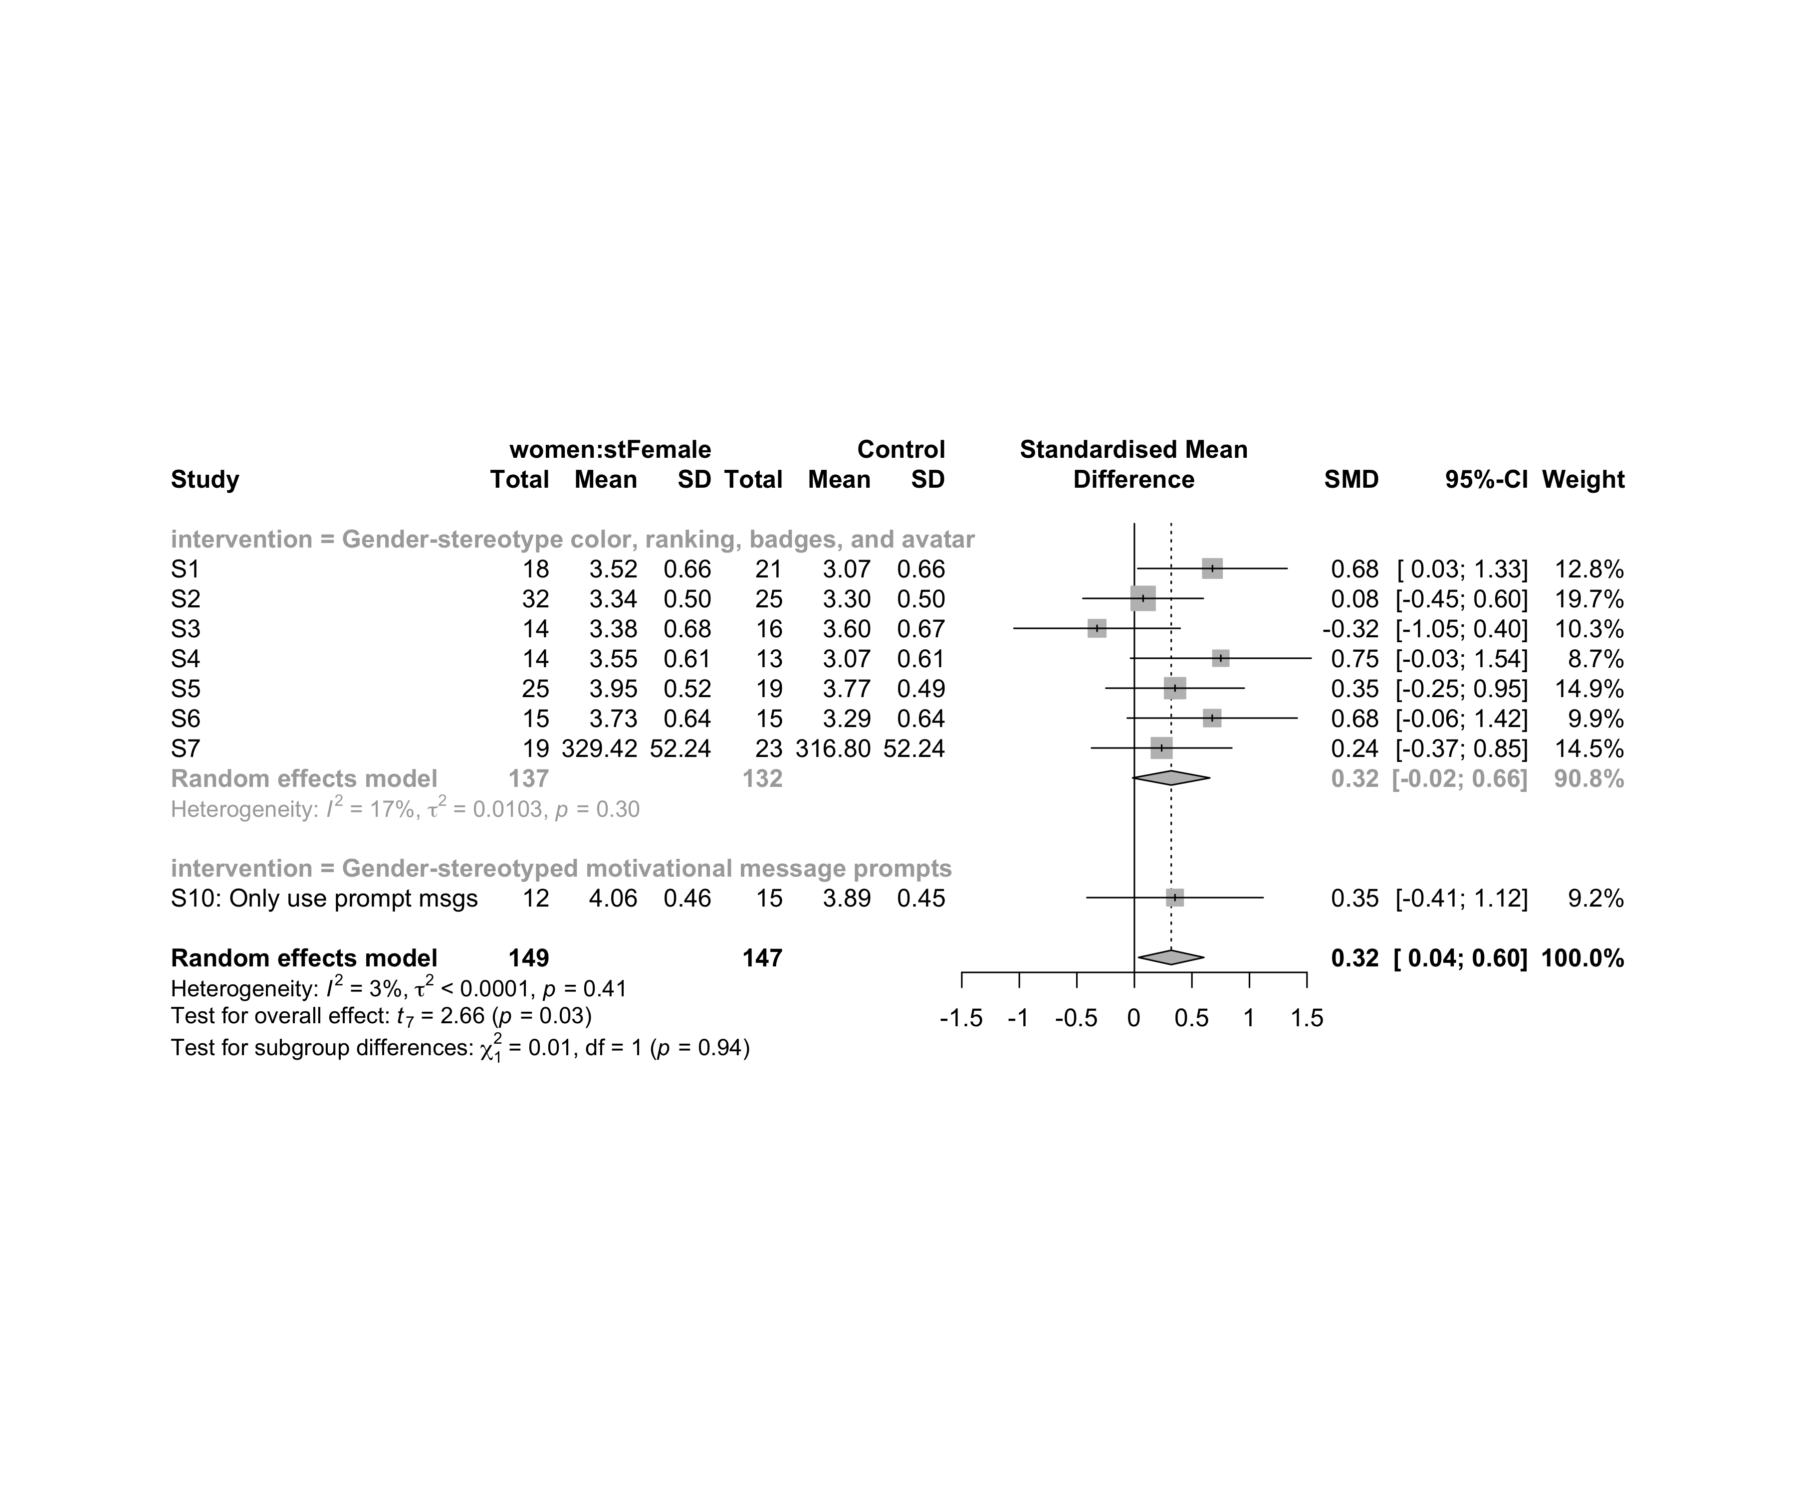

### Subgroup analysis by “age:intervention”

m.sg4sub <- update.meta(m.cont, subgroup = `age:intervention`, random = T, fixed = F)  
summary(m.sg4sub)

## Review: Flow state for women in stFemale  
##   
## SMD 95%-CI %W(random)  
## S1 0.6784 [ 0.0293; 1.3276] 12.8  
## S2 0.0758 [-0.4475; 0.5992] 19.7  
## S3 -0.3244 [-1.0470; 0.3982] 10.3  
## S4 0.7512 [-0.0340; 1.5363] 8.7  
## S5 0.3534 [-0.2481; 0.9549] 14.9  
## S6 0.6765 [-0.0622; 1.4152] 9.9  
## S7 0.2370 [-0.3729; 0.8470] 14.5  
## S10: Only use prompt msgs 0.3530 [-0.4128; 1.1189] 9.2  
## age:intervention  
## S1 adolescent:Gender-stereotype color, ranking, badges, and avatar  
## S2 adolescent:Gender-stereotype color, ranking, badges, and avatar  
## S3 adolescent:Gender-stereotype color, ranking, badges, and avatar  
## S4 adult:Gender-stereotype color, ranking, badges, and avatar  
## S5 adult:Gender-stereotype color, ranking, badges, and avatar  
## S6 adult:Gender-stereotype color, ranking, badges, and avatar  
## S7 adult:Gender-stereotype color, ranking, badges, and avatar  
## S10: Only use prompt msgs adolescence:Gender-stereotyped motivational message prompts  
##   
## Number of studies combined: k = 8  
## Number of observations: o = 296  
##   
## SMD 95%-CI t p-value  
## Random effects model 0.3202 [0.0360; 0.6044] 2.66 0.0323  
##   
## Quantifying heterogeneity:  
## tau^2 < 0.0001 [0.0000; 0.4122]; tau = 0.0003 [0.0000; 0.6420]  
## I^2 = 2.8% [0.0%; 68.5%]; H = 1.01 [1.00; 1.78]  
##   
## Test of heterogeneity:  
## Q d.f. p-value  
## 7.21 7 0.4078  
##   
## Results for subgroups (random effects model):  
## k SMD 95%-CI tau^2 tau Q  
## age:intervention = adolescent:Gender-stereotype co ... 3 0.1544 [-1.0524; 1.3613] 0.1185 0.3443 4.28  
## age:intervention = adult:Gender-stereotype color, ... 4 0.4572 [ 0.0735; 0.8409] 0 0 1.49  
## age:intervention = adolescence:Gender-stereotyped ... 1 0.3530 [-0.4128; 1.1189] -- -- 0.00  
## I^2  
## age:intervention = adolescent:Gender-stereotype co ... 53.2%  
## age:intervention = adult:Gender-stereotype color, ... 0.0%  
## age:intervention = adolescence:Gender-stereotyped ... --  
##   
## Test for subgroup differences (random effects model):  
## Q d.f. p-value  
## Between groups 1.00 2 0.6056  
##   
## Details on meta-analytical method:  
## - Inverse variance method  
## - Restricted maximum-likelihood estimator for tau^2  
## - Q-profile method for confidence interval of tau^2 and tau  
## - Hartung-Knapp adjustment for random effects model  
## - Hedges' g (bias corrected standardised mean difference; using exact formulae)

forest(m.sg4sub, digits=2, digits.sd = 2, test.overall = T, label.e = paste0(gender,':',env))

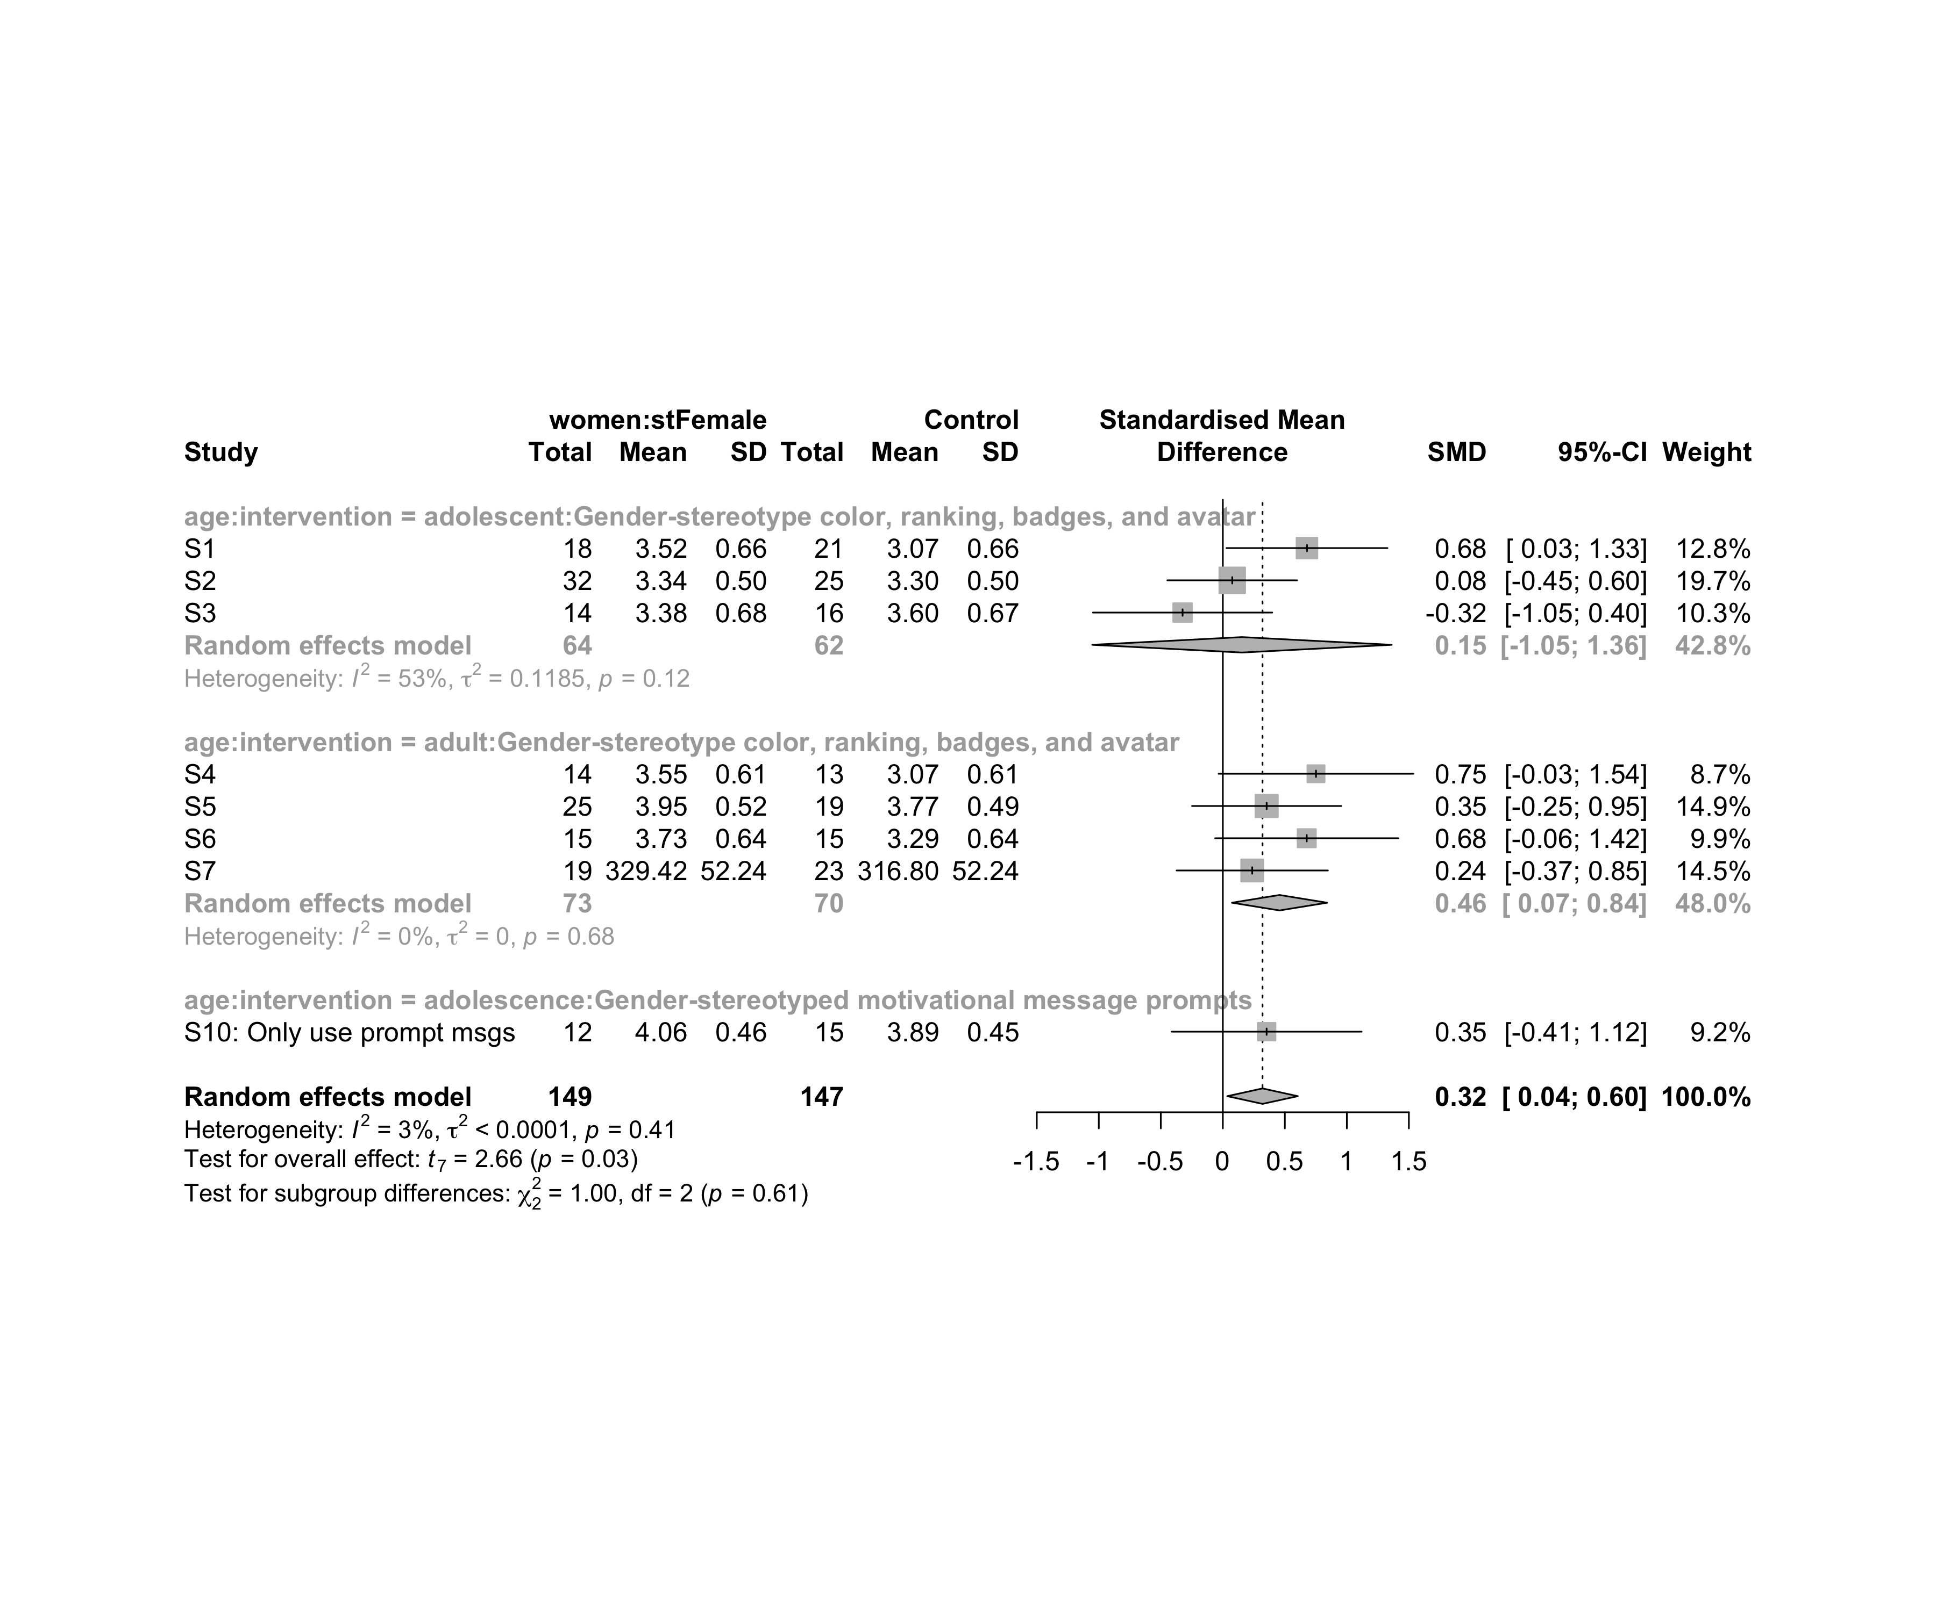

### Subgroup analysis by “ed.level:intervention”

m.sg4sub <- update.meta(m.cont, subgroup = `ed.level:intervention`, random = T, fixed = F)  
summary(m.sg4sub)

## Review: Flow state for women in stFemale  
##   
## SMD 95%-CI %W(random)  
## S1 0.6784 [ 0.0293; 1.3276] 12.8  
## S2 0.0758 [-0.4475; 0.5992] 19.7  
## S3 -0.3244 [-1.0470; 0.3982] 10.3  
## S4 0.7512 [-0.0340; 1.5363] 8.7  
## S5 0.3534 [-0.2481; 0.9549] 14.9  
## S6 0.6765 [-0.0622; 1.4152] 9.9  
## S7 0.2370 [-0.3729; 0.8470] 14.5  
## S10: Only use prompt msgs 0.3530 [-0.4128; 1.1189] 9.2  
## ed.level:intervention  
## S1 upper-secundary:Gender-stereotype color, ranking, badges, and avatar  
## S2 upper-secundary:Gender-stereotype color, ranking, badges, and avatar  
## S3 upper-secundary:Gender-stereotype color, ranking, badges, and avatar  
## S4 higher-education:Gender-stereotype color, ranking, badges, and avatar  
## S5 higher-education:Gender-stereotype color, ranking, badges, and avatar  
## S6 higher-education:Gender-stereotype color, ranking, badges, and avatar  
## S7 unknown:Gender-stereotype color, ranking, badges, and avatar  
## S10: Only use prompt msgs upper-secundary:Gender-stereotyped motivational message prompts  
##   
## Number of studies combined: k = 8  
## Number of observations: o = 296  
##   
## SMD 95%-CI t p-value  
## Random effects model 0.3202 [0.0360; 0.6044] 2.66 0.0323  
##   
## Quantifying heterogeneity:  
## tau^2 < 0.0001 [0.0000; 0.4122]; tau = 0.0003 [0.0000; 0.6420]  
## I^2 = 2.8% [0.0%; 68.5%]; H = 1.01 [1.00; 1.78]  
##   
## Test of heterogeneity:  
## Q d.f. p-value  
## 7.21 7 0.4078  
##   
## Results for subgroups (random effects model):  
## k SMD 95%-CI tau^2 tau Q  
## ed.level:intervention = upper-secundary:Gender-stereoty ... 3 0.1544 [-1.0524; 1.3613] 0.1185 0.3443 4.28  
## ed.level:intervention = higher-education:Gender-stereot ... 3 0.5524 [ 0.0044; 1.1004] 0 0 0.77  
## ed.level:intervention = unknown:Gender-stereotype color ... 1 0.2370 [-0.3729; 0.8470] -- -- 0.00  
## ed.level:intervention = upper-secundary:Gender-stereoty ... 1 0.3530 [-0.4128; 1.1189] -- -- 0.00  
## I^2  
## ed.level:intervention = upper-secundary:Gender-stereoty ... 53.2%  
## ed.level:intervention = higher-education:Gender-stereot ... 0.0%  
## ed.level:intervention = unknown:Gender-stereotype color ... --  
## ed.level:intervention = upper-secundary:Gender-stereoty ... --  
##   
## Test for subgroup differences (random effects model):  
## Q d.f. p-value  
## Between groups 2.29 3 0.5153  
##   
## Details on meta-analytical method:  
## - Inverse variance method  
## - Restricted maximum-likelihood estimator for tau^2  
## - Q-profile method for confidence interval of tau^2 and tau  
## - Hartung-Knapp adjustment for random effects model  
## - Hedges' g (bias corrected standardised mean difference; using exact formulae)

forest(m.sg4sub, digits=2, digits.sd = 2, test.overall = T, label.e = paste0(gender,':',env))

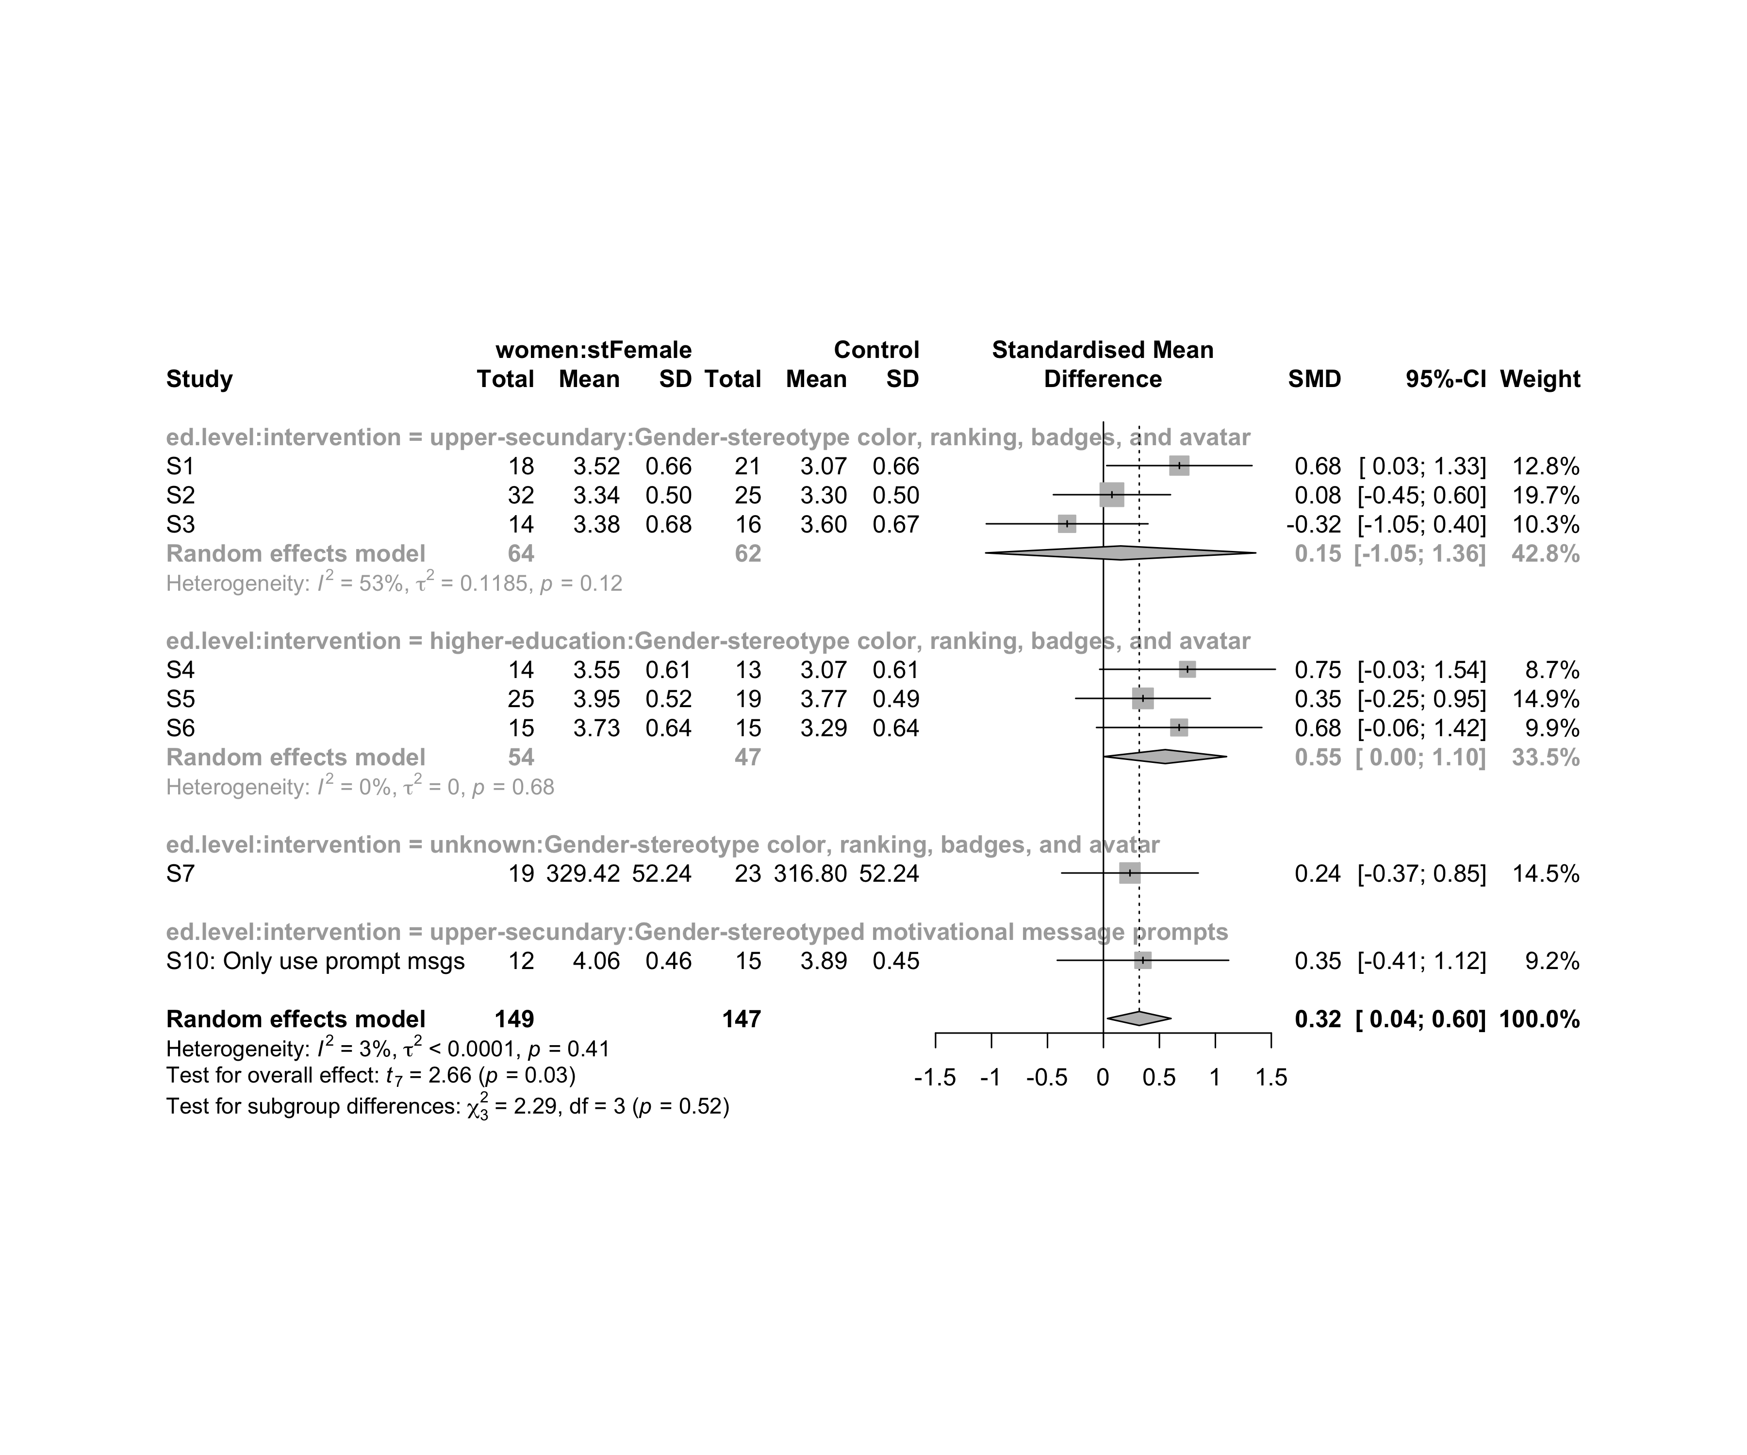

### Subgroup analysis by “age:ed.level:intervention”

m.sg4sub <- update.meta(m.cont, subgroup = `age:ed.level:intervention`, random = T, fixed = F)  
summary(m.sg4sub)

## Review: Flow state for women in stFemale  
##   
## SMD 95%-CI %W(random)  
## S1 0.6784 [ 0.0293; 1.3276] 12.8  
## S2 0.0758 [-0.4475; 0.5992] 19.7  
## S3 -0.3244 [-1.0470; 0.3982] 10.3  
## S4 0.7512 [-0.0340; 1.5363] 8.7  
## S5 0.3534 [-0.2481; 0.9549] 14.9  
## S6 0.6765 [-0.0622; 1.4152] 9.9  
## S7 0.2370 [-0.3729; 0.8470] 14.5  
## S10: Only use prompt msgs 0.3530 [-0.4128; 1.1189] 9.2  
## age:ed.level:intervention  
## S1 adolescent:upper-secundary:Gender-stereotype color, ranking, badges, and avatar  
## S2 adolescent:upper-secundary:Gender-stereotype color, ranking, badges, and avatar  
## S3 adolescent:upper-secundary:Gender-stereotype color, ranking, badges, and avatar  
## S4 adult:higher-education:Gender-stereotype color, ranking, badges, and avatar  
## S5 adult:higher-education:Gender-stereotype color, ranking, badges, and avatar  
## S6 adult:higher-education:Gender-stereotype color, ranking, badges, and avatar  
## S7 adult:unknown:Gender-stereotype color, ranking, badges, and avatar  
## S10: Only use prompt msgs adolescence:upper-secundary:Gender-stereotyped motivational message prompts  
##   
## Number of studies combined: k = 8  
## Number of observations: o = 296  
##   
## SMD 95%-CI t p-value  
## Random effects model 0.3202 [0.0360; 0.6044] 2.66 0.0323  
##   
## Quantifying heterogeneity:  
## tau^2 < 0.0001 [0.0000; 0.4122]; tau = 0.0003 [0.0000; 0.6420]  
## I^2 = 2.8% [0.0%; 68.5%]; H = 1.01 [1.00; 1.78]  
##   
## Test of heterogeneity:  
## Q d.f. p-value  
## 7.21 7 0.4078  
##   
## Results for subgroups (random effects model):  
## k SMD 95%-CI tau^2 tau  
## age:ed.level:intervention = adolescent:upper-secundary:Gend ... 3 0.1544 [-1.0524; 1.3613] 0.1185 0.3443  
## age:ed.level:intervention = adult:higher-education:Gender-s ... 3 0.5524 [ 0.0044; 1.1004] 0 0  
## age:ed.level:intervention = adult:unknown:Gender-stereotype ... 1 0.2370 [-0.3729; 0.8470] -- --  
## age:ed.level:intervention = adolescence:upper-secundary:Gen ... 1 0.3530 [-0.4128; 1.1189] -- --  
## Q I^2  
## age:ed.level:intervention = adolescent:upper-secundary:Gend ... 4.28 53.2%  
## age:ed.level:intervention = adult:higher-education:Gender-s ... 0.77 0.0%  
## age:ed.level:intervention = adult:unknown:Gender-stereotype ... 0.00 --  
## age:ed.level:intervention = adolescence:upper-secundary:Gen ... 0.00 --  
##   
## Test for subgroup differences (random effects model):  
## Q d.f. p-value  
## Between groups 2.29 3 0.5153  
##   
## Details on meta-analytical method:  
## - Inverse variance method  
## - Restricted maximum-likelihood estimator for tau^2  
## - Q-profile method for confidence interval of tau^2 and tau  
## - Hartung-Knapp adjustment for random effects model  
## - Hedges' g (bias corrected standardised mean difference; using exact formulae)

forest(m.sg4sub, digits=2, digits.sd = 2, test.overall = T, label.e = paste0(gender,':',env))

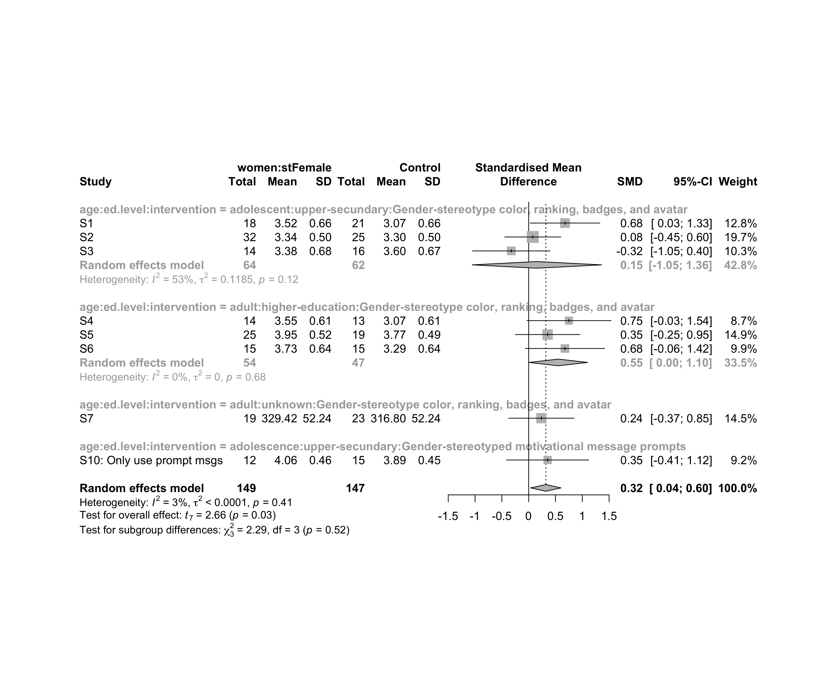

## Funnel Plot

m.cont <- update.meta(m.cont, studlab = data$study)  
summary(eggers.test(x = m.cont))

## Eggers' test of the intercept   
## =============================   
##   
## intercept 95% CI t p  
## 2.49 -2.76 - 7.74 0.93 0.39  
##   
## Eggers' test does not indicate the presence of funnel plot asymmetry.

funnel(m.cont, xlab = "Hedges' g", studlab = T, legend=T, addtau2 = T)

