TECHNOLOGICAL UNIVERSITY OF THE PHILIPPINES - MANILA

DOCUMENT TRACKING SYSTEM

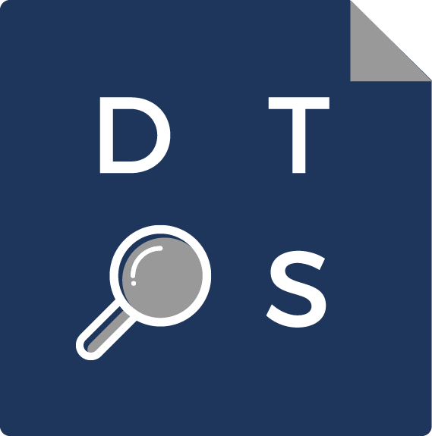

BSIT-3B, Web Development

Project Documentation

23 October 2017

PROJECT COMPOSITION

* TEAM LEADER, PROJECT MANAGER

Bernabe, Geisher G. (geisher09)

* DATABASE PROGRAMMER

Ancheta, Christian Daniel M. (AnchetaChristian)

* FRONT-END DEVELOPERS

Abendanio, Carlo C. (abendaniocarlo)

Aberilla, Angelo Jose A. (AngeloJose)

Waje, Audrey Noelle P. (audreynoelle)

PROJECT BRIEF

With the important need for proper document management, the Document Tracking System has been developed as an efficient way of monitoring and tracking document transfer between offices and departments.

**INTRODUCTION**

The Document Tracking System is innovative software designed to become an efficient way to track document location and status. We have been told that many companies have trouble transferring documents from one department or office to another because some of these documents get lost and employees find it hard to track whether it has reached the proper recipient, which department holds it back, or if it has been approved or rejected. Finally, we have come up to this Document Tracking System which could be a great solution to this problem.

**Project Objectives**

* Help in efficient tracking of documents
* Update the employees about the current status of the documents
* Provide fast transfer of documents from one department or office to another
* Send or retrieve documents in a modernized way using technology
* Secure document transfer
* Promote the advancement of technology through this Document Tracking System

**Target Audience**

* **The Panel.** We would like to present a good defense for our project proposal towards the panelists. We are open to any comments or any feedback from the panel but we are also hoping to impress them with the features of our system.
* **Companies.** Most companies still practice the traditional way of transporting documents from one department to another and we are looking forward to introduce our system to them so they could easily determine where their documents are without losing track of them.
* **Employees.** We would like to offer a hand to the employees who are dealing with document transfers. Through the Document Tracking System, it would be easy for them to keep track of the documents, see whether they are approved or rejected, and where it currently is.

**PROJECT SCOPE**

**[FILL OUT WHEN DONE]**

**NAVIGATION STRUCTURE**

**[FILL OUT WHEN DONE]**

TOOLS

* Project Management
  + - * Trello. We used Trello as a checklist of tasks to be done and properly assign task to each group member. Our Trello board is divided into four lists: (1) To Do—where tasks to be done are listed; (2) Ongoing—where the tasks currently being done are listed (such as ongoing modification of views, creation of functions, etc.); (3) Testing—parts of the system being tested for usability or functionality are listed here, and; (4) Done—finished tasks are transferred in this list.
* Repository
  + - * GitHub. We used GitHub to create a repository where we stored our Document Tracking System project. We also used the same application to properly incorporate our tasks with each other’s so we can continue to collaborate even we’re not physically together.
* Client-Side Scripts
  + - * HTML. We used HTML to organize, format and display the content of our web pages.
      * CSS. We used CSS to style our web pages.
      * Ajax. We used Ajax to make our web pages more interactive and dynamic.
* **Server-Side Scripts**
  + - * **PHP.**