Bernabe, Geisher G. August 29, 2017

BSIT-3B Prof. Mandi

1. 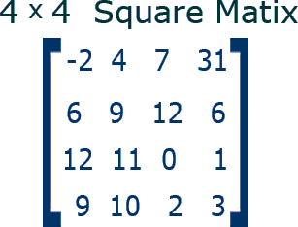**What is a square matrix?**

* A **square matrix** is a square array of numbers where the number of columns and rows are equal.  A square matrix can be any size as long as the numbers of rows and columns are equal. It can have entries of numbers, fractions, decimals, and even algebraic expressions.
* **Square matrix** is a matrix with the same number of rows and columns. An *n*-by-*n* matrix is known as a square matrix of order *n*. Any two square matrices of the same order can be added and multiplied.

Sources: <http://study.com/academy/lesson/square-matrix-definition-lesson-quiz.html>, <https://en.wikipedia.org/wiki/Square_matrix>, image: <http://www.mathwarehouse.com/algebra/matrix/images/square-matrix/square-matrix.gif>

**(2-4 TRUE OR FALSE)**

1. **All square echelon matrices are upper triangular matrices.**

* **True**
* In the mathematical discipline of linear algebra, a **triangular matrix** is a special kind of square matrix. A square matrix is called **upper triangular** if all the entries *below* the main diagonal are zero.
* While a matrix is in **echelon form** when it satisfies the following conditions.
* None-zero rows above any rows of all zeroes
* All entries in a column below a leading entry are zeros
* Each leading entry of a row is in a column to the right of the leading entry of the row above it.
* Both forms satisfy each other which make them equivalent so the answer is true.
* 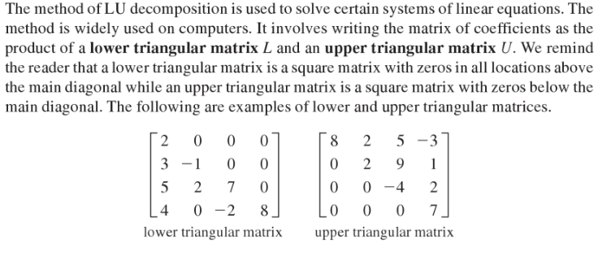Example:

Sources: <https://en.wikipedia.org/wiki/Triangular_matrix>, <https://math.stackexchange.com/questions/1720647/is-there-no-difference-between-upper-triangular-matrix-and-echelon-matrixrow-ec>

1. **All Upper triangular matrices are in echelon form.**

* **False**
* As said in the previous number, a matrix is in **echelon form** when it satisfies the following conditions:
* None-zero rows above any rows of all zeroes
* All entries in a column below a leading entry are zeros
* Each leading entry of a row is in a column to the right of the leading entry of the row above it.
* 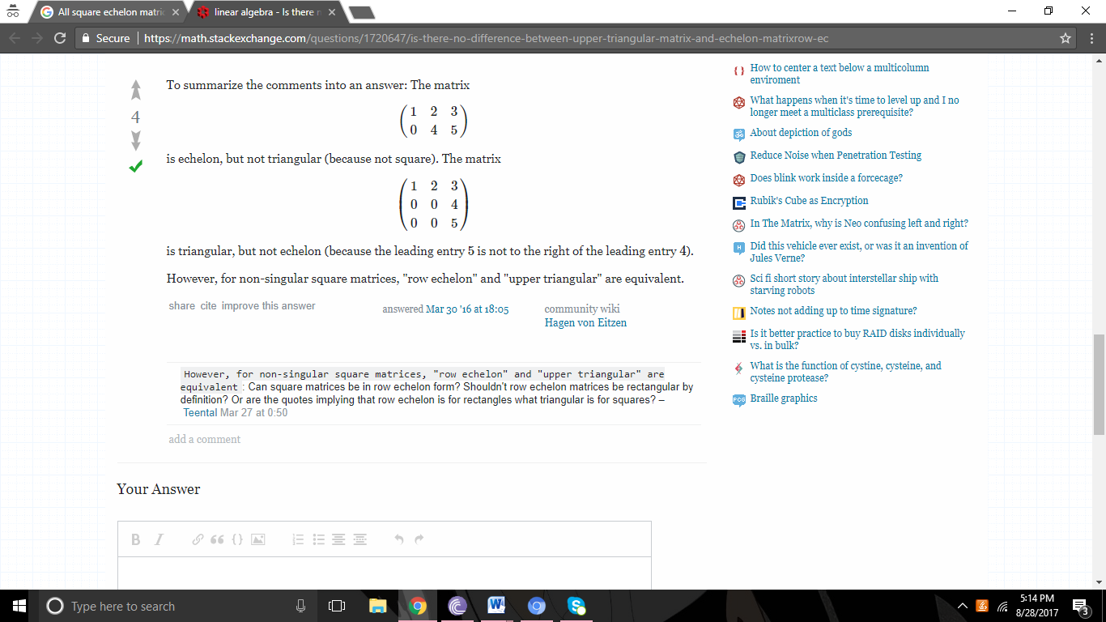In this scenario, there will be times that an upper triangle matrix can occur but it will not satisfy the conditions for an echelon form.

Example:

The matrix is triangular, but not echelon (because the leading entry 5 is not to the right of the leading entry 4).

Source: <https://math.stackexchange.com/questions/1720647/is-there-no-difference-between-upper-triangular-matrix-and-echelon-matrixrow-ec>

1. **If A² is an upper triangular matrix, then A is not an upper triangular matrix.**

* **False**
* These are some theorem about upper triangle matrices:
* The sum of two upper triangular matrices is upper triangular.
* The product of two upper triangular matrices is upper triangular.
* The inverse of an invertible upper triangular matrix is upper triangular.
* The product of an upper triangular matrix by a constant is an upper triangular matrix.
* This just means that if A2 is an upper triangular matrix then A is an upper triangular matrix also.

Source: <https://en.wikipedia.org/wiki/Triangular_matrix>

1. **When do matrices A and B commute?**

* In general, [matrix multiplication](http://mathworld.wolfram.com/MatrixMultiplication.html) is *not* [commutative](http://mathworld.wolfram.com/Commutative.html). Furthermore, in general there is no [matrix inverse](http://mathworld.wolfram.com/MatrixInverse.html) A^(-1) even when A!=0. Finally, AB can be zero even without A=0 or B=0. And when AB=0, we may still have BA!=0, a simple example of which is provided by

|  |  |  |  |  |  |
| --- | --- | --- | --- | --- | --- |
| A | = | [0 1; 0 0] B= [1 0; 0 0], | |  | |
|  |  |  | |  | |
| for which  AB=0,  but  BA=[0 1; 0 0]=A | | |  | |
|  | | |  | |

* In linear algebra, two matrices {\displaystyle A}A and {\displaystyle B}B are said to **commute** if {\displaystyle AB=BA} **AB = BA** and equivalently, their commutator {\displaystyle [A,B]=AB-BA}[A, B] = AB - BA is zero. A set of matrices {\displaystyle A_{1},\ldots ,A_{k}}**A1,…, Ak** is said to **commute** if they commute pairwise, meaning that every pair of matrices in the set commute with each other.

Sources: <http://mathworld.wolfram.com/CommutingMatrices.html>, <https://en.wikipedia.org/wiki/Commuting_matrices>

1. **Under what condition is B row equivalent to A?**

* In linear algebra, matrices B and A are **row equivalent** if one can be changed to the other by a sequence of elementary row operations. Alternatively, two *m* × *n* matrices are row equivalent if and only if they have the same row space. The concept is most commonly applied to matrices that represent systems of linear equations, in which case two matrices of the same size are row equivalent if and only if the corresponding homogeneous systems have the same set of solutions, or equivalently the matrices have the same null space.
* 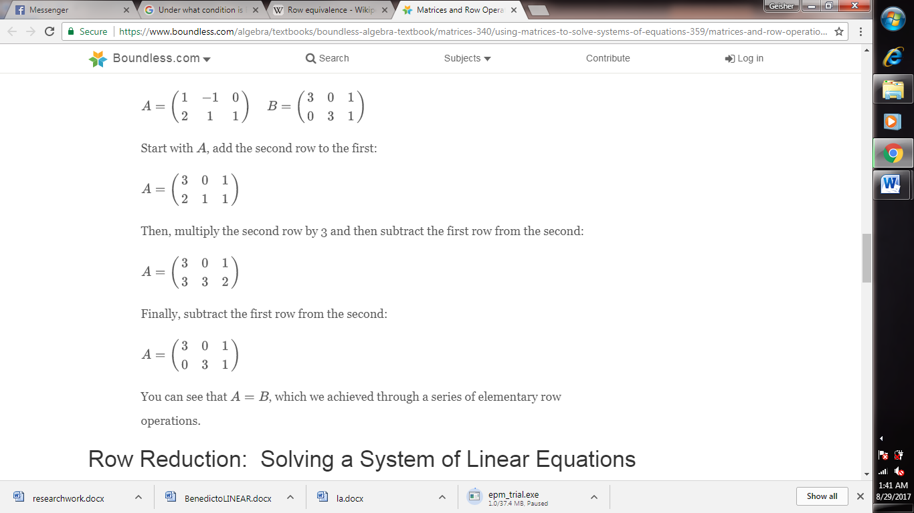Example: