Optimization of Non-Convex Cooperative Sensing With MCMC
Abstract-In cognitive radios (CRs), secondary users (SUs) transmit alongside primary users (PUs). Spectrum sensing is an essential functionality that enables cognitive radios to detect spectral holes and to opportunistically use under-utilized frequency bands without causing harmful interference to primary networks. The state of the art for efficient cooperative detection is statistic combination. Due to its non-convex nature, convex maximization is able to solve only an approximation of the optimization within a restricted solution domain. In this paper, we propose an alternative optimization technique based on Markov chain Monte Carlo method. Simulation results illustrate consistent cooperative gain achieved by the proposed strategies.
Index Terms-Cognitive radio, cooperative sensing, Markov chain Monte Carlo (MCMC), non-convex optimization, spectrum sensing.

I.INTRODUCTION
Traditional wireless networks are regulated by fixed spectrum allocation policies to operate in certain time frames, over certain frequency bands, and within certain geographical regions. The utilization rate of the wireless spectrum, nominally less than 10% under 3 GHz. This results in situations in which some radio bands are overcrowded while other bands remain moderately or rarely occupied. Cognitive radio (CR), defined by the Federal Communications Commission (FCC), which enables secondary users/networks to utilize the spectrum when primary users are not occupying it, has been proposed as a promising technology to improve spectrum utilization efficiency. In CR networks, secondary users are allowed to use some portions of licensed radio bands opportunistically provided that they do not cause harmful interference to the primary users in these frequency bands.
Spectrum sensing aims at reliably detecting weak primary radio signals of possibly-unknown formats. Energy detection has been shown to be optimal if the cognitive devices have no a priori information about the features if the primary signals except noise statistics. The CRs always use energy detection in spectrum sensing due to the limitation on the primary signals information. Single CR sensing is undermined by shadowing and multipath fading, and distant-dependent attenuation. Unreliable decisions cause the SU to collide with the primary transmissions. Multiple CR performs collaborative sensing by combing their sensing results in order to improve the detection reliability. A soft fusion technique is linear statistic combination (LSC) proposed by Quan et al. in [ ]. It combines the locally sense power levels, instead of binary hypothesis, and perform a unique test decision. LSCs demonstrated to enhance noticeably the performance of the individual sensors.
In this paper, we propose
II.COOPERATIV SENSING
In this section, we introduce a linear cooperative spectrum sensing strategy which is applied in [ ]. Since the transmitted signal of the primary user is unknown, we adopt energy detection as the local sensing rule.
- System Model
We consider a cognitive radio network with  secondary users. Denote  and as the hypotheses of the absence and the presence of the primary user. Then for CR , the binary hypothesis for spectrum sensing at the -th time instant is formulated as:
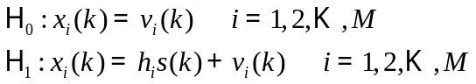
Where 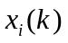 is the received signal by the -th CR and 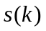 denotes the signal transmitted by the primary user. The sensing noise 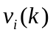 is a zero mean additive Gaussian noise (AWGN), i.e. 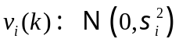, and denote 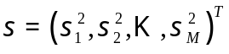. We also assume that the channel gain 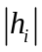 is Rayleigh distributed with variance . The received average local SNR at the CRs is given as

Each secondary user calculates a summary statistic 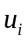 over a detection interval of  samples, i.e.,
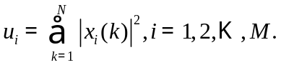
Next the summary statistic is transmitted to the fusion center with the i-th statistic received by the fusion center can be denote as 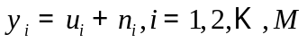, where 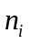 is the noise induced by the control channel which is a zero-mean Gaussian variance 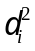. The fusion center calculates a global test statistic 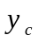 from the outputs  of the individual CR in a linear manner below:
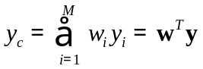
Where 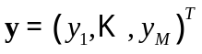 and 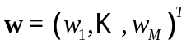 is the weight vector assigned on the summary statistic of each CR by the fusion center. For global detection, the fusion center makes decision by comparing the global test statistic with a threshold 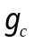, if 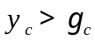, then fusion center tells the CRs that they can access the channel; otherwise, they can not. The detection performance can be evaluated by the probability of the false alarm and the probability of the detection.
Assuming that N is large enough, according to the central limit theorem, the summary test statistic are asymptotically normally distributed with the conditional means and covariances of the vector defines as
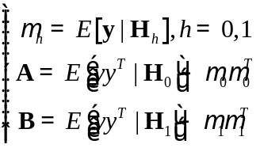
So that the probabilities of false-alarm and the detection can be calculated in closed form.
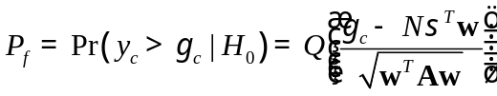
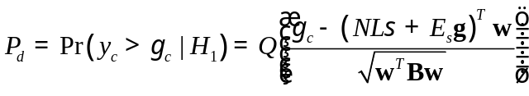
With these expressions, the threshold can be obtained by:
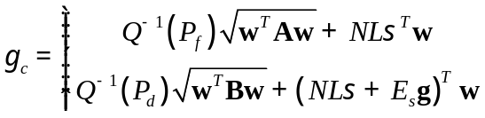
Given a targeted probability of false alarm 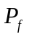, the probability of detection 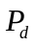 can be evaluated as:
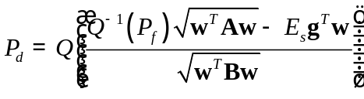
It can be discovered that we would like to maximize the probability of detection by optimizing the weight vector w. Therefore, the cooperative spectrum sensing optimization becomes finding the optimal w the maximize with a given . Since the Q-function is a non-decreasing function, maximizing is equal to minimizing the function 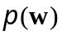 below:
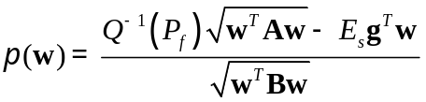
Then the optimization problem can be formulated as:
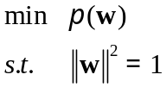
- Modified Deflection Coefficient(MDC) algorithm
The MDC algorithm is motivated by the effect of the weight vector on the probability distribution function(PDF) of the global test statistics 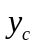under two different hypothesis. Since the weight vector w plays an important part in sharping the PDF of , a new approach to measure the variance-normalized distance between the centers of two conditional PDFs has been defined:
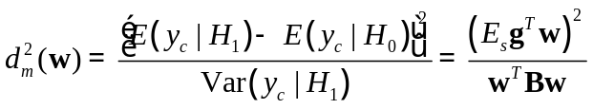
The suboptimal weight vector of ( ) can be obtained by solving the following problem:

Introducing 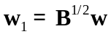, and according to the Rayleigh Ritz inequality, then
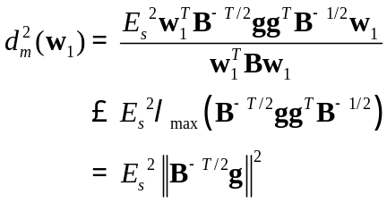
Then the equality is achieved in equality if 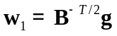is satisfied and the corresponding optimal solution of the MDC method is
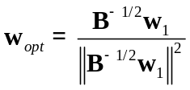
III.OPTIMIZATION WITH MCMC METHOD
The Markov Chain chain Monte Carlo (MCMC) algorithm originated from [ ], is a stochastic simulation technique designed to sample a probability distribution of interest. In general, it is computationally expensive to compare all the solutions to identify the optimal solution. So stochastic optimal methods have been developed with the idea that, instead of searching the whole solution space exhaustively, they just focus on exploring the ‘promising’ subspaces. MCMC is a powerful tool for stochastic optimization, given that one can appropriately represent the subspace of interest by a probability distribution. Then, the samples XXX from an MCMC algorithm can also be used to estimate the minimum of the objective function in ( ). Thus, maximizing is equivalent to minimizing , i.e.,
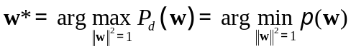
so  from the MCMC algorithm is also the estimate of the maximum of 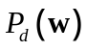.
The MCMC algorithm taking Metropolis sampler with simulated annealing for maximizing is described as follows:
Step1: Initialize 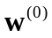 randomly or deterministically, .
Step2: Run Metropolis sampler , draw a sample 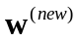 from the objective function .
Step3: Calculate the increment 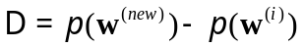. According to the accepting probability (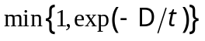), the new sample will be 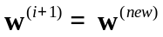 if the is accepted, and 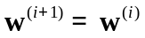 otherwise.
Step4: If 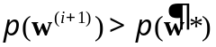,then .
Step5: If the stopping criterion is satisfied, them stop; otherwise set 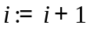 and go back to step 2. Here, the stopping criterion is the predefined number of iterations.
IV.SIMULATION RESULTS
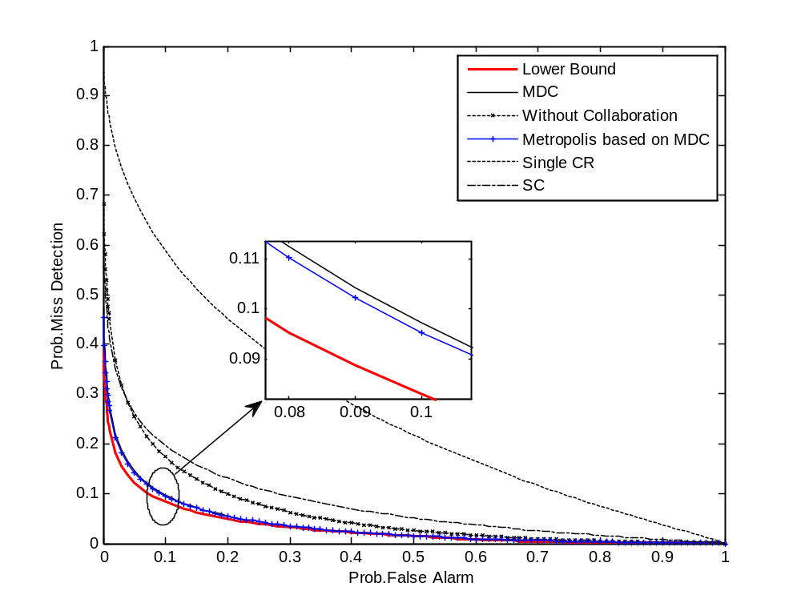
Fig.1.Probability of miss-detection (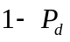) versus the probability of false alarm (), with , , 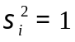 and 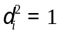, 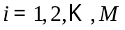.The local SNRs at individual CRs are 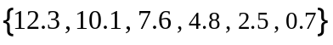 in dB.

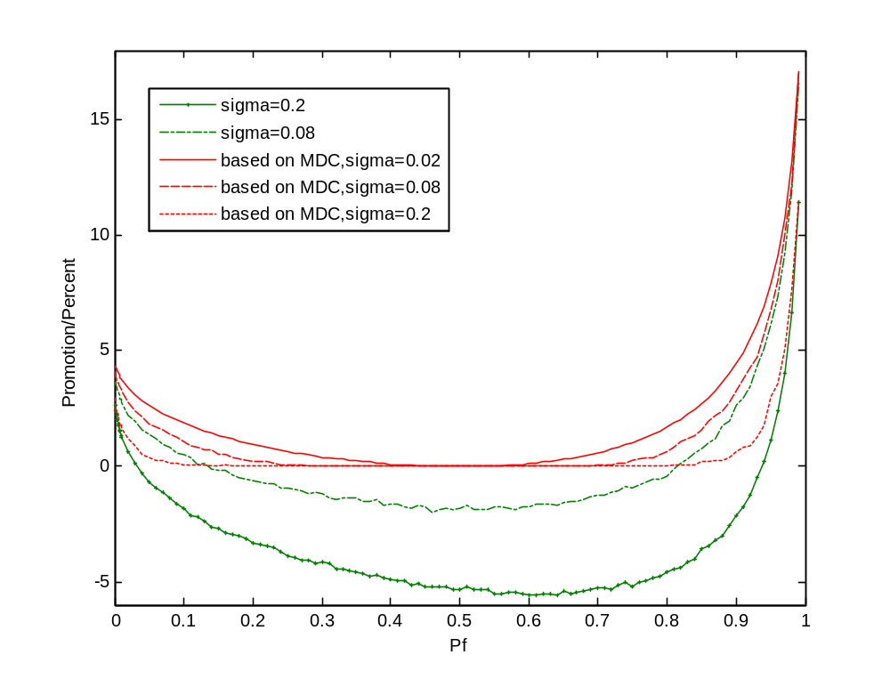
Fig.2. Percentile promotion of probability of detection () compared with MDC. The local SNRs at individual CRs are in dB.

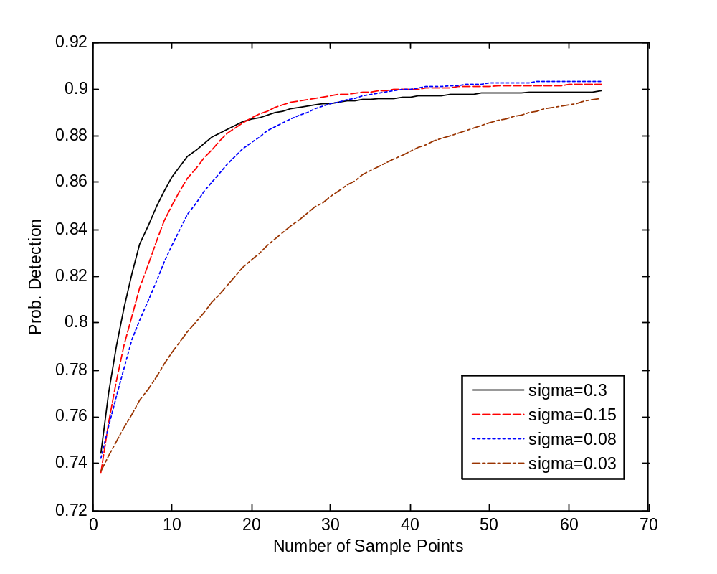
Fig.3. Probability of detection () versus number of sample points with Metropolis sampler with different sigma.

REFERENCES
[1]This is a test for 永中 office
[2]

