Simple Instruction Set Architecture 16

Programmer’s Manual and Teaching Resource
1st Edition

By David MHS Webster
Table of Contents
Table of Contents
Introduction 3
Compiling 4

Introduction
Sisa16 is a virtual machine instruction set architecture which mirrors many features and quirks of real-life ISAs while being useful and unique in its own right. Its portability is novel while still being powerful enough to create extremely dynamic and interesting programs.

Learning how to write code for SISA16 will give you an appreciation of low level programming, the fundamentals of systems engineering, as well as provide you with a new tool to use in your own projects. As an interpreted language, SISA16 is extremely competitive in speed, size, and footprint. The emulator can be made to interface with any C library by creating a “driver”, and the emulator can be embedded trivially into any C program as an extension language.

Whereas most assembly language courses are limited to blinking LEDs and printing characters to a tiny display, Sisa16 can be made to render color graphics, play sounds, use a network connection, interact with files, and interact with the host in a manner which is accessible to, and even extensible by students. A hypothetical driver could attempt to mirror real-life hardware interfaces, or just be something fun. This provides enormous flexibility to educators trying to teach low level systems engineering to students. See “Compiling”.

The assembler is designed for rapid prototyping and debugging. A shebang can be added to the top of an assembly file and it can be executed as a script on *nix-based systems. Helpful and specific error messages are displayed. Assembly-time syntax checking and validation is done to avoid errors. Special helper features are built into the assembler to provide the programmer with assistance in writing a working program.

Sisa16, including all resources, code, examples and documentation, lies fully in the public domain. It is my gift to you in the hopes that you find it useful. An example driver is provided which can load files into the segment and interact with the terminal. If Ncurses is available on the system, it can be used. It should be noted that the example driver has four lines under the permissive Ncurses license, which is a variant of the MiT License. This IP dependency can be avoided simply by not defining “USE_NCURSES” while compiling. See “Compiling” for more information.

“Let all that you do be done with love.”

Compiling
If you are using an ordinary Unix-like environment such as Linux, BSD, Msys2, or Cygwin, and your compiler is gcc, clang, or tinyc, then you should be able to just call ‘make’ and everything will build, including the test programs. If this does not work or you wish to understand the compilation process in detail...

On most platforms, this will compile the assembler, which has a built-in emulator:

cc assembler.c -DUSE_UNSIGNED_INT -o sisa16_asm

-DUSE_UNSIGNED_INT
Define the macro “USE_UNSIGNED_INT” which indicates that “unsigned int” in C is a compatible 4-byte unsigned binary integer type. If “unsigned long” is such a type but not unsigned int, then you should omit this define.

-DUSE_NCURSES -lncurses
For the default driver, use Ncurses to enable tighter control of the terminal. This allows for arbitrary graphical rendering and TUIs to be created from Sisa16, using the default driver. This also requires linking against ncurses, so -lncurses will need to be used while compiling.

-DFUZZTEST
For the default driver, disable file writing. File writing is potentially dangerous if doing fuzz testing or running random binaries. If you write your own driver it is recommended to use this flag to guard dangerous features which may harm a student’s computer if a random or malicious binary happens to come along.

-DUSE_COMPUTED_GOTO
Enable usage of the GNUC extension for computed goto, which speeds up the emulator tremendously and makes compilation much faster. If you are using a version of GCC released after 2015, you should enable this flag.

-DNO_FP
Disable the floating point unit. This is recommended if the host does not support the IEEE 754 32 bit binary floating point standard.

-DNO_SIGNED_DIV
Disable the signed integer division and modulo instructions (Needed for non twos complement architectures).

-DNO_SEGMENT
Disable the segment. It is a feature intended for sisa16’s viability as a scripting language. It is a “fantasy” feature, in that it does not mirror how real hardware works. This also disables the “emulate” feature, which while unique and interesting may be undesirable for educators aiming for a realistic microcontroller experience.

You can test if the assembler built successfully like this:

./sisa16_asm -C

-C tells it to Check the environment and exit. Read it carefully.
The exact same flags and semantics apply to building the emulator.

cc isa.c -DUSE_UNSIGNED_INT -o sisa16_emu

You can now test a simple program. Assuming that you are using the default textmode driver and you have a relatively ordinary terminal or terminal emulator, try the “wave” program...

./sisa16_asm -i wave.asm -o wave.bin
./sisa16_emu wave.bin

You should now see a “wave” printed out to the screen, forever. You can disassemble the program by doing this:

./sisa16_asm -dis wave.bin 0

this will show you the “machine code” in assembly again. It should look like this:
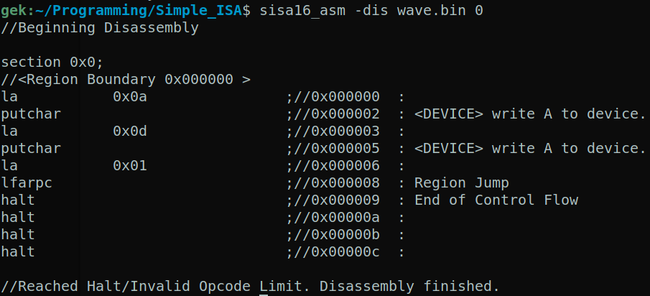

(if you know the language, you should be able to follow the control flow to 0x10000 and explore the rest of the binary.)

