

Ben-Gurion University of the Negev Faculty of Engineering Science

School of Electrical and Computer Engineering Dept. of Communication Systems Engineering

Fourth Year Engineering Project

Preliminary

# Simulator-for-LIDOR-with-ALExA

Simulator for Logical Infrastructure for Drone Optimization and Research with Adaptive Layered Exploration Architecture

|  |  |
| --- | --- |
| **Project number:** | **p-2025-124** |
| **Students  (name & ID):** | **Basa Shaked, 206310781 Gluhoy Yevgeniy, 336423629** |
| **Supervisors:** | **Prof. Gurewitz Omer** |
| **Submitting date:** | **20/12/2024** |

Table of Contents

1 Abstract 2

1.1 English Abstract 2

1.2 Hebrew Abstract 3

2 Project’s Goal 5

2.1 The Main Problem 5

2.2 The Goal 5

3 Spec Sheet 6

3.1 Project’s Name 6

3.2 Product Overview 6

3.3 Technologies Involved in the Project 6

3.4 Research, Development, and Work Stages 6

3.5 Potential Applications of the Product 7

3.6 Specification 7

4 Literature Review 8

5 Design Proposal 10

5.1 The Design 10

5.2 Project Constraints 15

5.3 Project Assumptions 15

5.4 Initial Risks 15

6 Project Scope 16

6.1 Objective 16

6.2 Deliverables 16

7 Proposal for a set of final tests 17

7.1 Functionality Tests 17

7.2 Usability Tests 17

7.3 Success Criteria 17

8 Gantt 18

9 Bibliography 19

10 Appendices 20

10.1 Copyright and Confidentiality Respect Form 20

10.2 Tasks 21

10.3 Recommendation for a grade for a preparatory report 22

# Abstract

## English Abstract

Simulator-for-LIDOR-with-ALExA

Students Names: Basa Shaked, Gluhoy Yevgeniy

*basashak@post.bgu.ac.il*Adviser: Prof. Gurewitz Omer

Our project focuses on developing a simulator for autonomous drones using the OMNeT++ framework. With the rapid development of autonomous drone technologies, efficient simulation environments have become indispensable for testing, analysis, and performance optimization. This project focuses on developing a versatile OMNeT++-based simulator that provides a robust platform for evaluating autonomous drone systems. The primary goal is to simulate energy consumption, communication protocols, and cooperative behaviors in dynamic and complex environments. Our innovative approach introduces a multi-layered architecture, which ensures realistic drone modeling, adaptive communication dynamics, and seamless integration of various operational parameters. By leveraging a modular design, the simulator will account for physical attributes such as weight, battery capacity, and rotor configurations, while also simulating realistic 3D environments. Advanced features include collision-avoidance algorithms, energy efficiency optimization, and support for user-defined drone behaviors. This simulation tool will enable researchers to assess the impact of variables like signal interference, energy limitations, and environmental constraints on drone performance. The expected outcome is a reliable, scalable, and flexible platform that advances autonomous drone research and enhances multi-drone system coordination.

**Keywords:** simulator, autonomous, drones, OMNeT++, optimization, signal interference, battery limitations, reliable and flexible simulation.

## Hebrew Abstract

**סימולטור רחפנים אוטונומיים מבוסס OMNeT++**

סטודנטים: בסה שקד, גלוחוי יבגני

[*basashak@post.bgu.ac.il*](mailto:basashak@post.bgu.ac.il)

מנחה: פרופ' גורביץ עומר

הפרויקט שלנו מתמקד בפיתוח סימולטור רחפנים אוטונומיים על בסיס OMNeT++. עם ההתפתחות המהירה של טכנולוגיות רחפנים אוטונומיות, סביבות סימולציה יעילות הפכו הכרחיות לבדיקות, ניתוח ואופטימיזציה. פרויקט זה מתמקד בפיתוח סימולטור רב-תכליתי מבוסס OMNeT++ המספק פלטפורמה חזקה להערכת מערכות רחפנים אוטונומיות. המטרה העיקרית היא לדמות צריכת אנרגיה, פרוטוקולי תקשורת והתנהגויות שיתופיות בסביבות דינמיות ומורכבות. הגישה החדשנית שלנו מציגה ארכיטקטורה רב-שכבתית, המבטיחה מודלים ריאליסטיים של רחפנים, דינמיקה תקשורתית אדפטיבית ושילוב חלק של פרמטרים תפעוליים שונים. על ידי מינוף עיצוב מודולרי, הסימולטור יתייחס לתכונות פיזיות כגון משקל, קיבולת סוללה ותצורות רוטור, תוך הדמיה של סביבות תלת מימד מציאותיות. תכונות מתקדמות כוללות אלגוריתמים למניעת התנגשות, אופטימיזציה של יעילות אנרגטית ותמיכה בהתנהגויות של רחפנים בהגדרת משתמש. כלי סימולציה זה יאפשר לחוקרים להעריך את ההשפעה של משתנים כמו הפרעות אותות, מגבלות אנרגיה ומגבלות סביבתיות על ביצועי הרחפנים. התוצאה הצפויה היא פלטפורמה אמינה, ניתנת להרחבה וגמישה, אשר מקדמת את חקר הרחפנים האוטונומי ומשפרת את התיאום של מערכות ריבוי רחפנים.

# Project’s Goal

## The Main Problem

The lack of a flexible and accurate simulation platform for autonomous drones limits the ability to test and optimize drone behaviours, especially in complex or large-scale environments. Existing tools often fall short in simulating interactions, communication, and safety measures critical for real-world applications. Our project aims to bridge this gap by developing an OMNeT++-based simulator that supports comprehensive testing of autonomous drone systems, enabling reliable performance analysis and safer deployment.

## The Goal

To create a flexible OMNeT++ based simulator that allows for the development and testing of autonomous drone technologies under various scenarios and environmental constraints.

# Spec Sheet

## Project’s Name

Simulator-for-LIDOR-with-ALExA - Simulator for Logical Infrastructure for Drone Optimization and Research with Adaptive Layered Exploration Architecture

## Product Overview

The primary deliverable of this project is an advanced simulator that models the behavior of autonomous drones in dynamic and complex scenarios. The simulator aims to provide a flexible and reliable platform for analyzing drone performance by integrating physical models, communication protocols, and cooperative behavior mechanisms. It allows the evaluation of variables such as energy consumption, signal interference, battery limitations, and environmental constraints to optimize drone operations.

## Technologies Involved in the Project

1. The project is based on OMNeT++, a discrete-event simulation platform that enables modular and flexible modeling.
2. Propagation Models: Free-Space Path Loss, Two-Ray Ground-Reflection, Knife-Edge Diffraction.
3. Communication Protocols: wifi and radio.

## Research, Development, and Work Stages

1. **Research Phase**:
   1. Analyze literature on trajectory planning [1] and Drone path optimization in complex environments [2].
   2. Review simulators like SwarmLab [4] and FANET [6] to identify missing capabilities in environmental modeling and energy optimization.
2. **Development Phase**:
   1. Develop modular components for the physical, communication, and user layers.
   2. Integrate energy models, realistic 3D obstacle interactions, and advanced collision-avoidance algorithms.
3. **Testing Phase**: Simulating various scenarios to evaluate the system's efficiency and reliability.
4. **Documentation Phase**: Writing technical documents, user manuals, and documenting the source code.

## Potential Applications of the Product

1. **Drone Behavior Analysis**: Testing algorithms for trajectory planning, collision avoidance, and energy efficiency in multi-drone operations.
2. **Communication System Design**: Optimizing drone-to-drone and drone-to-ground station communication under varying conditions, including signal interference and packet loss.
3. **Energy Optimization**: Analyzing the relationship between drone weight, battery capacity, and energy consumption to improve operational efficiency.
4. **Real-World Scenario Testing**: Simulating search-and-rescue missions, delivery logistics, and area monitoring to validate autonomous drone systems prior to deployment.

## Specification

1. **General Simulation Performance**
   1. Number of Supported Drones: The simulator will support up to **_____** drones in a single simulation while maintaining computational accuracy and reliable performance.
   2. Drone Models: Support for various drone types (e.g., quadcopters, hexacopters, and octocopters) with adjustable physical characteristics.
   3. Simulation Rate: A computational rate of at least **_____** events per second.
2. **Communication**
   1. **Propagation Models** (user-selectable):
      1. Free-Space Path Loss - Models signal attenuation in open space.
      2. Two-Ray Ground-Reflection - Considers direct and ground-reflected rays.
      3. Knife-Edge Diffraction - Accounts for signal bending around obstacles.
   2. **Communication Types** (user-selectable):
      1. WiFi - Higher frequencies with shorter range.
      2. Radio - Lower frequencies with longer range.
3. **Energy Model**:
   1. Accurate Energy Modeling:
      1. The simulator will compute energy consumption per drone based on weight, motion, and battery characteristics.
      2. Inclusion of the impact of antennas and sensors on energy consumption.
   2. Battery Life Prediction: Real-time display of remaining battery life for each drone based on active operations.
4. **3D Scenario Analysis:**
   1. Dynamic 3D Environments:
      1. Support for variable terrain modeling, including elevation, obstacles, and interactions with other moving objects.
      2. Collision-avoidance mechanisms based on sensors and trajectory planning algorithms.
   2. Map Size: The simulation world will support a map size of up to **5** km x **5** km in horizontal dimensions, with a maximum altitude (height) of **5** km, allowing for the modeling of large-scale scenarios and varied operational altitudes.
   3. Simulation Resolution: Accuracy of ± 20 cm in drone movement, and ± 100 cm in map resolution.
5. **User Interface and Data Visualization**
   1. Graphical Representation: Real-time data for energy consumption, signal strength, and battery status.
   2. Customization Capability: Users can define custom scenarios and select parameters such as drone type, communication characteristics.
   3. Data Export: Support for exporting simulation data in standard formats (e.g., CSV, JSON) for further analysis.

# Literature Review

Modern algorithms for drone trajectory planning, such as multi-drone 3D trajectory planning [1], path planning in complex 3D environments using the Improved Bat Algorithm [2] and optimizing spectral efficiency with NOMA in multi-user scenarios [3], require precise simulation frameworks. These algorithms depend heavily on realistic modelling of drone dynamics, complex 3D environments, and detailed communication channels.

Existing simulators like Adigar [5], FANET [6] and SwarmLab [4] fall short in several critical aspects:

Limited support for detailed and dynamic 3D obstacle interactions and realistic environmental modelling, Lack of sophisticated simulation models for communication channel models, such as using different signal propagation models: Free-space path loss, Two-ray ground-reflection model, Knife-edge diffraction model. Additionally, absence of comprehensive models for energy consumption and battery management under varying operational conditions.

The simulator should additionally calculate signal loss and packet loss during data transmission, support various types of drones (e.g., Quadcopters, Hexacopters and Octocopters) and communication methods (e.g., radio signal and Wi-Fi), and integrate their direct impact on both signal quality and battery consumption.

This diversity in drone configurations directly affects their communication capabilities, signal strength, and energy consumption, making it essential for the simulator to account for these variations.

To calculate the signal strength between drones or between a drone and its operator the calculation will depend on the propagation models, communication types, and environmental conditions.

Propagation Models:

1. Free-Space Path Loss – Models signal attenuation in open space. [7]
 $$P_{r}=P_{t}+G_{t}+G_{r}-20\log_{10}(d)-20\log_{10}(f)-20\log_{10}(\frac{4π}{c})$$  * P_r – received signal power.
   * P_t – Transmitted signal power
   * G_t, G_r ​- Gains of transmitter and receiver antennas
   * d – Distance between transmitter and receiver (in meters)
   * f – Frequency of operation (in Hz)
   * c – Speed of light $c=3*{10}^{8}\frac{m}{sec}$
2. Two-Ray Ground-Reflection - Considers direct and ground-reflected rays. [8]

$$P_{r}=P_{t}-40\log_{10}(d)+10\log_{10}{(G}_{t}G_{r}{h_{t}}^{2}{h_{r}}^{2})$$

* h_t, h_r – Heights of transmitter and receiver (the drone) antennas

1. Knife-Edge Diffraction - Accounts for signal bending around obstacles. [9]

$$P_{r}=P_{t}-6.9-20\log_{10}\sqrt{{\left(v-0.1\right)}^{2}+1}+v-0.1$$

$v=h_{eff}\sqrt{\frac{{2(d}_{1}+d_{2})}{{λd}_{1}d_{2}}}$

$h_{eff}=h_{obstacle}-(h_{t}+\frac{h_{r}-h_{t}}{d_{t}+d_{r}}d_{t})$

* d_1, d_2 - Distances from the obstacle to transmitter and receiver
* d_t, d_r - Distance from the transmitter and receiver to the obstacle
* h_eff - Effective height of the obstacle
* $λ$- Wavelength (c/f)
* v - is the Fresnel-Kirchhoff diffraction parameter - It quantifies the relative height of the obstacle in the path of the signal and determines the amount of diffraction loss.

Our simulator combines the above models for comprehensive analysis and optimization of drone operations.

# Design Proposal

## The Design

To develop a comprehensive drone coordination simulator with a multi-layered architecture, the system design is divided into three layers: Physical Layer, Basic Protocol Layer, and User Layer:

1. Physical Layer: Models drone-specific parameters (rotor count, weight, battery size) to simulate energy consumption and optimize energy efficiency. It calculates remaining battery charge and adjusts behaviours based on energy models.
2. Basic Protocol Layer: Provides core communication protocols for drone-to-drone and drone-to-operator interactions. Key features include navigation commands (move, hover, ascend), status updates (battery, position), and coordination commands (formation, obstacle avoidance).
3. User Layer: Enables users to script and test custom behavioural protocols using the Basic Protocol Layer. This allows for simulation of diverse scenarios like search-and-rescue or area coverage.

Each layer is designed to provide distinct functionalities while maintaining seamless integration with the other layers. The simulator is implemented in OMNeT++ to leverage its modular and discrete event simulation capabilities.

This proposal outlines the initial system design for the autonomous drone simulator, incorporating four key subsystems: the Drone State Machine, the Simulation Control Block, the Simulation Process Overview, and the Simulator Physical Layer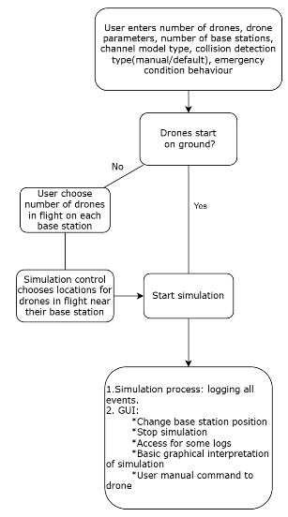:

1. **Simulation process scheme:**

This diagram describes the overall flow of the simulation, including initialization, execution, and monitoring. Key stages include:

* 1. Initialization:
     1. User inputs the number of drones, their parameters, base station count, channel model type, and collision detection mode.
     2. Simulation initializes with drones starting either on the ground or in flight, based on user specifications.
  2. Simulation Execution:
     1. Logs all simulation events, ensuring comprehensive tracking and analysis.
     2. Provides a graphical user interface (GUI) for monitoring and interaction. The GUI supports:
        + Changing base station positions.
        + Stopping the simulation.
        + Viewing logs and graphical interpretations of the simulation in real time.
        + Sending manual commands to specific drones.
  3. Dynamic Controls: During the simulation, the control system dynamically assigns initial locations and responds to changing environmental conditions or user commands.

1. **Simulation control block scheme:**

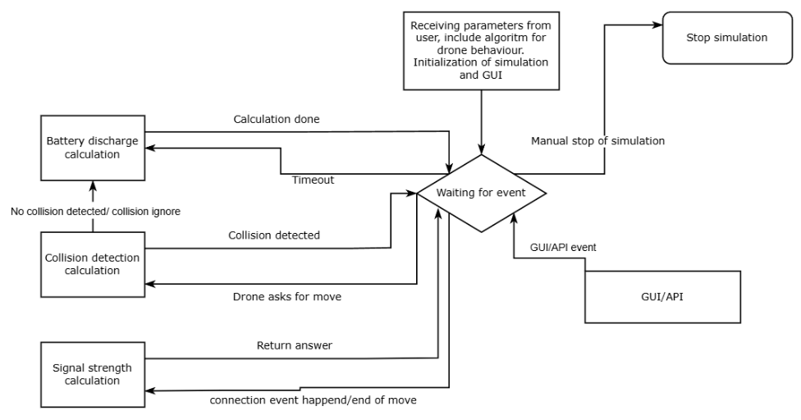

This block manages the overall simulation and serves as the control system. Its components include:

* 1. Initialization: Receives user input, including parameters such as drone behavior algorithms, GUI configurations, and simulation parameters.
  2. Event Management:
     + 1. Timeout Handling: Waits for simulation events like user inputs or automated triggers.
       2. Collision Detection: Processes potential collisions, categorizing them as "detected" or "ignored," depending on user-defined rules.
       3. Signal Strength Calculation: Evaluates connectivity strength between drones and base stations or other drones.
  3. Battery Discharge Calculation: Continuously monitors battery levels during flight, adjusting drone operations as necessary.
  4. Event Responses: Responds to API/GUI events, such as manually stopping the simulation or handling user-issued commands.
  5. Significance: This control block serves as the simulation’s decision-making core, balancing drone operations, events, and user interactions.

1. **Physical layer scheme:**

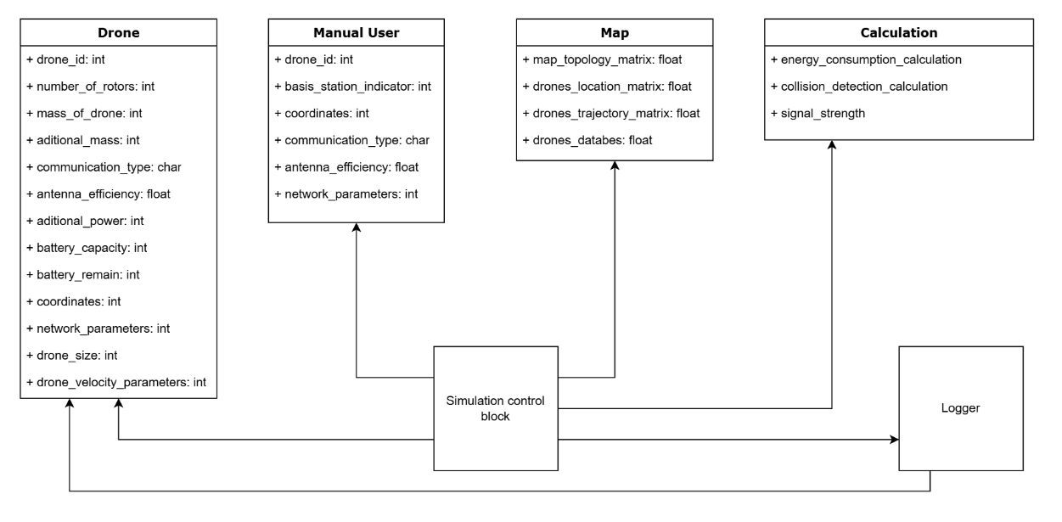

This diagram defines the physical attributes and key calculation modules of the simulator, including:

* 1. **Drone Attributes**:
     1. Unique identifiers (drone_id) and physical properties (e.g., mass_of_drone, number_of_rotors).
     2. Communication and power specifications (communication_type, antenna_efficiency, battery_capacity).
     3. Positioning and movement (coordinates, drone_velocity_parameters).
  2. **User Input**: Manual user inputs include commands for specific drones, base station indicators, and communication parameters.
  3. **Map Modeling**:
     1. Topology matrix for representing terrain.
     2. Matrices for drone locations, trajectories, and operational databases.
  4. **Core Calculations**: Modules for energy consumption, collision detection, and signal strength evaluation.

Significance: The physical layer integrates key drone and environment parameters, enabling realistic and accurate modeling of interactions and behaviors.

1. **Drone FSM**

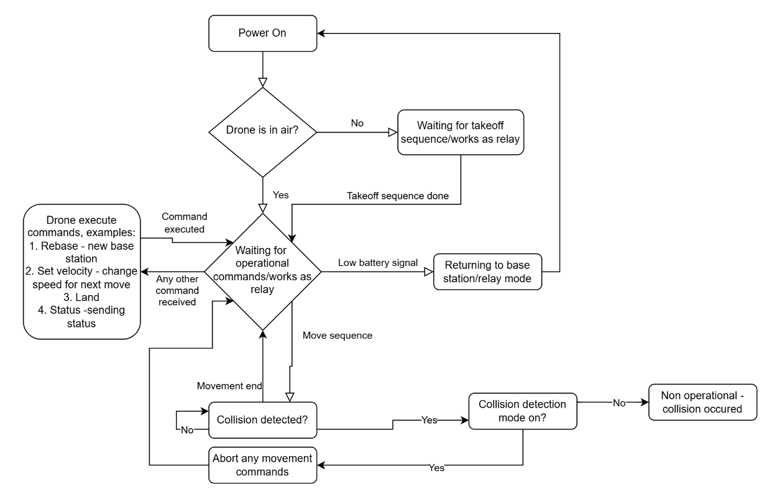

The Drone FSM illustrates the state-based behavior of a single drone within the simulation. Key aspects include:

* 1. Power On: The drone starts in the "powered on" state. If the drone is not airborne, it awaits the completion of the takeoff sequence.
  2. Takeoff Sequence: Once airborne, the drone transitions to operational states. If it fails to take off, it remains in relay mode.
  3. Operational States:
     1. Move Sequence: The drone executes movement commands such as rebasing to a new base station, setting velocity, or landing.
     2. Waiting State: The drone awaits further operational commands or acts as a communication relay.
  4. Collision Detection: If a collision is detected, the drone aborts all movement commands and set to waiting state.
  5. Low Battery: The drone enters relay mode or returns to the base station for recharge.

Significance: The FSM ensures systematic handling of drone behavior, enabling a realistic and robust response to operational scenarios.

Additional Features: The simulator includes terrain modeling with altitude variations for realistic movement and tools to analyze energy efficiency and communication stability across different protocols.

## Project Constraints

The project is subject to several constraints that could limit its progress:

1. **Computational Resources**: The complexity of simulating multiple drones with advanced communication models and realistic environments could require significant computational resources.
2. **Time Constraints**: Given the limited timeframe, there might be challenges in fully implementing and testing all desired features.
3. **Environmental Realism**: While OMNeT++ offers a flexible simulation platform, creating highly realistic environments and dynamic interactions may require additional custom tools and extensive testing.
4. **Scalability**: Ensuring that the simulator performs well with many drones and complex scenarios could be challenging without extensive optimization.

## Project Assumptions

Several assumptions have been made in the planning of the simulator, and their accuracy is crucial for successful implementation:

* + 1. Assumed Availability of OMNeT++ Tools: The simulator relies heavily on OMNeT++'s capabilities for event-driven simulation and modular architecture. If these tools are not as adaptable or powerful as expected, there may be delays or limitations in the system’s functionality.
    2. The drones are assumed to be ideal: operating without hardware or software malfunctions.
    3. Weather conditions: assumed to always be clear, without environmental disruptions such as rain, wind, or fog.

## Initial Risks

Several potential risks have been identified related to the project’s design and assumptions:

* + 1. Simulation Complexity: As the simulator needs to model a wide range of variables (e.g., communication protocols, battery consumption, 3D environments), the complexity could lead to performance issues or delays in achieving realistic behavior. To mitigate this, a phased approach will be used, starting with simpler models and progressively adding complexity.
    2. Integration of Communication Protocols: Integrating multiple communication protocols and channel models may introduce unforeseen technical challenges. A careful design and early-stage testing will be conducted to ensure smooth integration.

# Project Scope

## Objective

Develop an OMNeT++-based simulator for autonomous drones, focusing on energy consumption, communication efficiency, and collision avoidance in dynamic 3D environments.

## Deliverables

1. Simulation Framework:
   1. Multi-layered architecture: Physical, Protocol, and User Layers.
   2. Real-time calculations for energy consumption, signal strength, and collision detection.
2. Key Modules:
   1. Signal Strength Calculation:
      1. Supports Free-Space Path Loss, Two-Ray Ground Reflection, and Knife-Edge Diffraction models.
      2. User-configurable communication types (WiFi and Radio).
   2. Energy Consumption Modeling:
      1. Accounts for drone parameters (weight, movement, sensors, and antenna power).
      2. Displays remaining battery capacity dynamically
   3. 3D Simulation Environment:
      1. Models terrain, obstacles, and drone interactions
   4. User Interface / API:
      1. Supports implementation and testing of autonomous drone algorithms.
      2. Allows configuration of drones, base stations, and propagation models.
      3. Displays simulation data, signal strength, and energy usage.
3. Documentation:
   1. User manual that contains all needed information to use the simulator without external support.

# Proposal for a set of final tests

## Functionality Tests

1. Initialization: Verify simulation parameters (drones, base stations, propagation models) load correctly.
2. User Interface: Ensure GUI usability and responsiveness for parameter configuration, control, and data visualization.
3. Module Integration: Test seamless operation of signal strength, energy consumption, and collision detection modules.
4. Signal Strength: Compare results for propagation models (Free-Space, Two-Ray, Knife-Edge) with theoretical calculations.
5. Energy Consumption: Validate energy usage predictions for various operations against benchmarks.
6. Collision Detection: Ensure correct drone responses to obstacles in simulated environments.
7. Scalability: Run simulations with up to ___ drones.
8. Real-Time Processing: Ensure calculations for signal strength and energy are processed with ≤1 - second delay.
9. Stress Test: Evaluate stability under high collision frequency and simultaneous user commands.

## Usability Tests

Algorithm Implementation: implementation of user-defined drone algorithms (e.g., search-and-rescue) and compare it to real world test results.

## Success Criteria

All tests must pass with defined accuracy, performance, and usability thresholds to ensure system readiness.

# Gantt

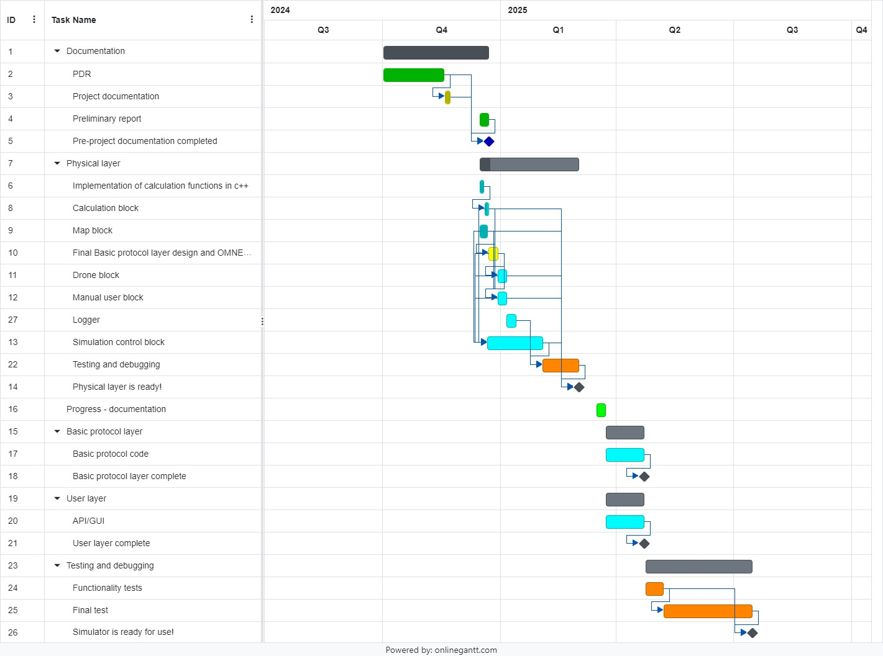

A list of tasks with dates appears in Appendix 10.2

# Bibliography

1. W. Shi, J. Li, N. Cheng, F. Lyu, S. Zhang, H. Zhou, and X. Shen, "Multi-Drone 3-D Trajectory Planning and Scheduling in Drone-Assisted Radio Access Networks," IEEE Transactions on Vehicular Technology, vol. 68, no. 8, pp. 8145–8158, Aug. 2019. DOI: [10.1109/TVT.2019.2925629]( https://doi.org/10.1109/TVT.2019.2925629 ).
2. X. Zhou, F. Gao, X. Fang, and Z. Lan, "Improved Bat Algorithm for UAV Path Planning in Three-Dimensional Space," IEEE Access, vol. 9, pp. 20100–20112, Jan. 2021. DOI: [10.1109/ACCESS.2021.3054179]( https://doi.org/10.1109/ACCESS.2021.3054179 ).
3. N. Rupasinghe, Y. Yapıcı, I. Güvenç, and Y. Kakishima, "Non-Orthogonal Multiple Access for mmWave Drone Networks With Limited Feedback," IEEE Transactions on Communications, vol. 67, no. 1, pp. 762–775, Jan. 2019. DOI: [10.1109/TCOMM.2018.2867465]( https://doi.org/10.1109/TCOMM.2018.2867465 ).
4. E. Soria, F. Schiano, and D. Floreano, "SwarmLab: A MATLAB Drone Swarm Simulator," arXiv preprint arXiv:2005.02769, Sep. 2020. Available: [https://github.com/lis-epfl/swarmlab]( https://github.com/lis-epfl/swarmlab ).
5. A. Amarasinghe, L. Jayaratne, and V. B. Wijesuriya, "Adigar: A drone simulator for agriculture," *Current Science*, vol. 122, no. 8, pp. 945–950, Apr. 2022. [Online]. Available:https://www.currentscience.ac.in.
6. M. Tropea, P. Fazio, F. De Rango, and N. Cordeschi, "A new FANET simulator for managing drone networks and providing dynamic connectivity," *Electronics*, vol. 9, no. 4, p. 543, Mar. 2020. DOI:10.3390/electronics9040543.
7. Wikipedia, "Free-space path loss," [Online]. Available: <https://en.wikipedia.org/wiki/Free-space_path_loss>. [Accessed: Dec. 18, 2024].
8. Wikipedia, "Two-ray ground-reflection model," [Online]. Available: <https://en.wikipedia.org/wiki/Two-ray_ground-reflection_model>. [Accessed: Dec. 18, 2024].
9. International Telecommunication Union, "Propagation by diffraction," ITU-R Recommendation P.526-14, 2018. [Online]. Available: <https://www.itu.int/dms_pubrec/itu-r/rec/p/R-REC-P.526-14-201801-I%21%21PDF-E.pdf>. [Accessed: Dec. 18, 2024].

# Appendices

## Copyright and Confidentiality Respect Form

אני מצהיר שלא אעשה שימוש בפרויקט ההנדסי שלי בכל חומר בעל זכויות יוצרים כגון:

טקסט.

תמונה,

אודיו,

וידיאו,

מוזיקה,

סרט,

אנימציה,

תוכנה

חומרה

תיכנון מעגל

ללא קבלת אישור מראש מבעל הזכויות

אני מצהיר שאשלב בפרויקט ההנדסי שלי בדוחות, סרטונים, והרצאות אינפורמציה שאינה נחלת הכלל

רק בתנאי שאושרה מראש ע״י בעל הזכויות.

הרישום לפרויקט ההנדסי משמש ההתחייבות שלי לקיים ולכבד זכויות יוצרים וסודיות

תאריך: 18/12/2024

חתימה: שקד בסה, יבגני גלוחוי

## Tasks

|  |  |  |  |  |  |  |  |
| --- | --- | --- | --- | --- | --- | --- | --- |
| **Outline Level** | **ID** | **Name** | **Start** | **Finish** | **Duration** | **% Complete** | **Resource Names** |
| 1 | 1 | Documentation | 01/10/2024 | 22/12/2024 | 83 days | 99 | Shaked Basa,Yevgeniy Gluhoy |
| 2 | 2 | PDR | 01/10/2024 | 17/11/2024 | 48 days | 100 | Shaked Basa,Yevgeniy Gluhoy |
| 2 | 3 | Project documentation | 18/11/2024 | 22/11/2024 | 5 days | 100 | Shaked Basa,Yevgeniy Gluhoy |
| 2 | 4 | Preliminary report | 15/12/2024 | 22/12/2024 | 8 days | 95 | Shaked Basa,Yevgeniy Gluhoy |
| 2 | 5 | Pre-project documentation completed | 22/12/2024 | 22/12/2024 | 1 day | 100 | Shaked Basa,Yevgeniy Gluhoy |
| 1 | 7 | Physical layer | 15/12/2024 | 02/03/2025 | 78 days | 10 | Shaked Basa,Yevgeniy Gluhoy |
| 2 | 6 | Implementation of calculation functions in c++ | 15/12/2024 | 18/12/2024 | 4 days | 100 | Shaked Basa |
| 2 | 8 | Calculation block | 19/12/2024 | 22/12/2024 | 4 days | 50 | Shaked Basa |
| 2 | 9 | Map block | 15/12/2024 | 21/12/2024 | 7 days | 90 | Yevgeniy Gluhoy |
| 2 | 10 | Final Basic protocol layer design and OMNET++ self-learning | 22/12/2024 | 29/12/2024 | 8 days | 0 | Shaked Basa,Yevgeniy Gluhoy |
| 2 | 11 | Drone block | 29/12/2024 | 05/01/2025 | 8 days | 0 | Shaked Basa |
| 2 | 12 | Manual user block | 29/12/2024 | 05/01/2025 | 8 days | 0 | Yevgeniy Gluhoy |
| 2 | 27 | Logger | 05/01/2025 | 12/01/2025 | 8 days | 0 | Yevgeniy Gluhoy |
| 2 | 13 | Simulation control block | 21/12/2024 | 02/02/2025 | 44 days | 0 | Shaked Basa,Yevgeniy Gluhoy |
| 2 | 22 | Testing and debugging | 02/02/2025 | 02/03/2025 | 29 days | 0 | Shaked Basa,Yevgeniy Gluhoy |
| 2 | 14 | Physical layer is ready! | 02/03/2025 | 02/03/2025 | 1 day | 0 | Shaked Basa,Yevgeniy Gluhoy |
| 1 | 16 | Progress - documentation | 16/03/2025 | 23/03/2025 | 8 days | 0 | Shaked Basa,Yevgeniy Gluhoy |
| 1 | 15 | Basic protocol layer | 23/03/2025 | 22/04/2025 | 31 days | 0 | Yevgeniy Gluhoy |
| 2 | 17 | Basic protocol code | 23/03/2025 | 22/04/2025 | 31 days | 0 | Yevgeniy Gluhoy |
| 2 | 18 | Basic protocol layer complete | 22/04/2025 | 22/04/2025 | 1 day | 0 | Yevgeniy Gluhoy |
| 1 | 19 | User layer | 23/03/2025 | 22/04/2025 | 31 days | 0 | Shaked Basa |
| 2 | 20 | API/GUI | 23/03/2025 | 22/04/2025 | 31 days | 0 | Shaked Basa |
| 2 | 21 | User layer complete | 22/04/2025 | 22/04/2025 | 1 day | 0 | Shaked Basa |
| 1 | 23 | Testing and debugging | 23/04/2025 | 15/07/2025 | 84 days | 0 | Shaked Basa,Yevgeniy Gluhoy |
| 2 | 24 | Functionality tests | 23/04/2025 | 07/05/2025 | 15 days | 0 | Shaked Basa,Yevgeniy Gluhoy |
| 2 | 25 | Final test | 07/05/2025 | 15/07/2025 | 70 days | 0 | Shaked Basa,Yevgeniy Gluhoy |
| 2 | 26 | Simulator is ready for use! | 15/07/2025 | 15/07/2025 | 1 day | 0 | Shaked Basa,Yevgeniy Gluhoy |

## Recommendation for a grade for a preparatory report

מספר הפרויקט: P-2025-124 , שם הפרויקט Simulator-for-LIDOR-with-ALExA :

שם המנחה: פרופ' גורביץ עומר

שם הסטודנט/ית: שקד בסה, יבגני גלוחוי ת.ז: 206310781, 336423629

|  |  |  |  |  |  |  |
| --- | --- | --- | --- | --- | --- | --- |
| % | קריטריון | 1- חלש | 2- בינוני | 3- טוב | 4- ט"מ | 5- מצוין |
| 12 | הגדרת המטרה - האם מטרת הפרויקט ברורה? המטרה צריכה לכלול גם את התרומה הצפויה מהשלמת הפרויקט. |  |  |  |  |  |
| 13 | הבנת הבעיה - האם ניכר שהסטודנט הבין את הבעיה ואת הפתרונות הקיימים? האם נערך סקר ספרות רלוונטי? (חיפוש מקורות והבנת עבודות דומות) |  |  |  |  |  |
| 12 | הארכיטקטורה המוצעת - האם הגישה הכללית ורכיבי הפתרון הוצגו והוסברו בצורה ברורה? האם ניכרת הבנה ? האם הובהר מדוע הארכיטקטורה המוצעת לפתרון ההנדסי מתאימה לפתרון ההנדסי? |  |  |  |  |  |
| 13 | הצגת הדו״ח המכין - האם יש מבנה הגיוני לדו״ח המכין? האם איכות ההצגה טובה? האם ישנה התייחסות לכל חלקי הדו״ח? האם יש קשר הגיוני בין החלקים? האם רמת התחבר טובה? |  |  |  |  |  |
| 12 | רמת קושי - כיצד הנך מעריך את רמת הקושי הצפויה בפרויקט בהשוואה לפרויקטים אחרים השנה או בשנים קודמות? |  |  |  |  |  |
| 13 | מדדים לבדיקת הצלחת הפרויקט - האם הוגדרו קריטריונים ברורים ומדידים כמותית לבחינת הצלחת הפרויקט? האם הקריטריונים שהוצגו תואמים להגדרת מטרות הפרויקט? |  |  |  |  |  |
| 12 | איכות הפרויקט המוצע - עבור פרויקטים מחקריים- מהי רמת הצעת מחקר? עבור פרויקטים טכניים - מהי רמת המפרט טכני? האם הדרישות עונות על הצורך? |  |  |  |  |  |
| 13 | המאפיינים העיקריים בפרויקט - יש לסמן את כל המאפיינים הרלוונטיים שהושגו (ולו באופן חלקי). מאפיין אחד בלבד יזכה במחצית הניקוד. שני מאפיינים ומעלה יזכו בניקוד מלא. |  |  |  |  |  |

הערכת רמת הקושי של הפרויקט: קל מאוד / קל / בינוני / קשה / קשה מאוד

הערות:_____________________________.