Ảnh chạy
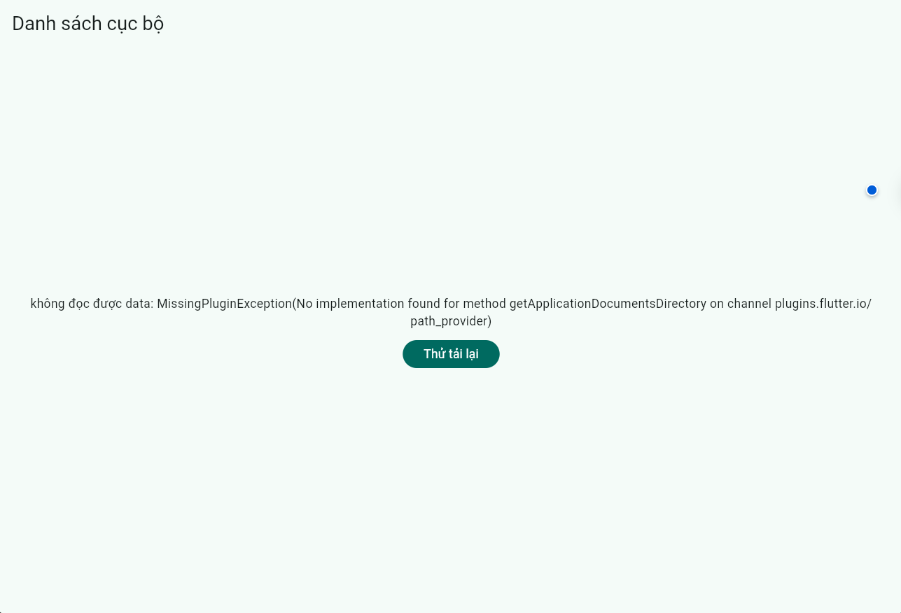

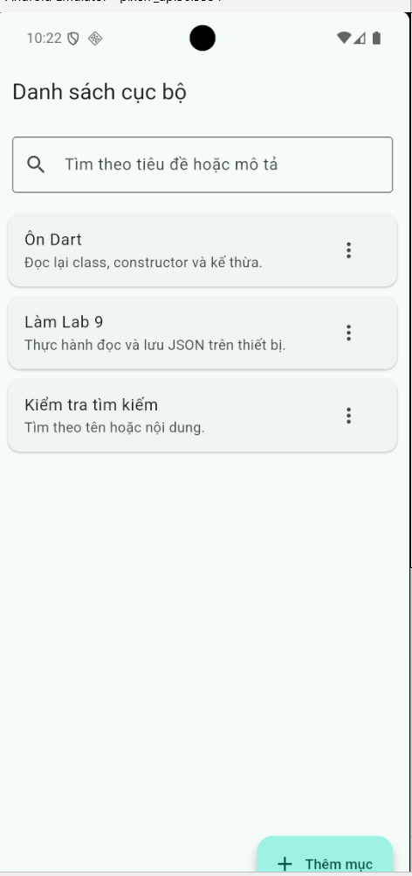
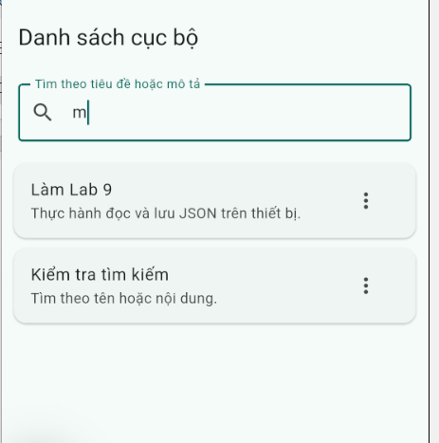
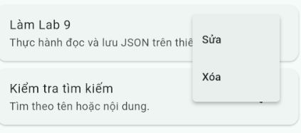

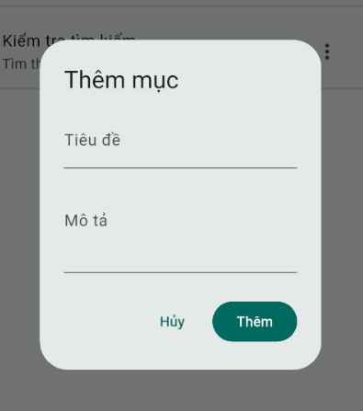
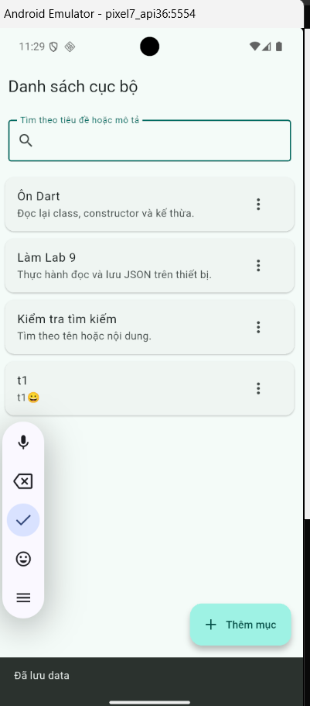

Code dự án

Code model
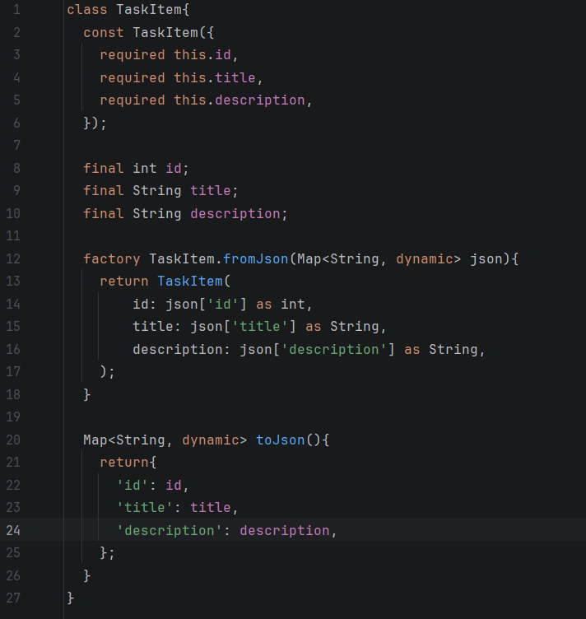

Data mẫu khi chưa có data cục bộ trong máy ảo
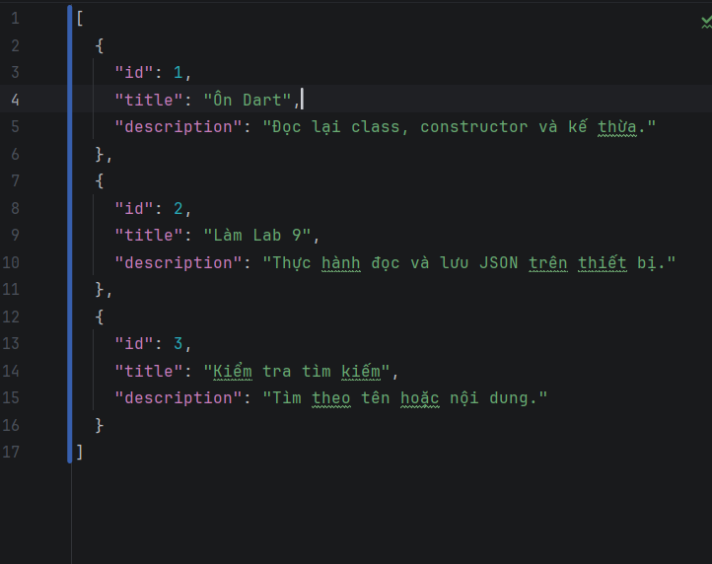

Code service
import 'dart:convert';
import 'dart:io';
import 'package:flutter/services.dart' show rootBundle;
import 'package:path_provider/path_provider.dart';
import '../models/task_item.dart';
class JsonStorageService {
static const String _assetPath= 'assets/data/seed_items.json';
static const String _fileName= 'tasks.json';
Future<File> _getLocalFile() async {
final directory = await getApplicationDocumentsDirectory();
return File('${directory.path}/$_fileName');
}
Future<List<TaskItem>> loadItems() async {
final file = await _getLocalFile();
if(await file.exists()){
final contents= await file.readAsString();
if(contents.trim().isNotEmpty){
return _decodeItems(contents);
}
}
//chưa có file cục bộ: đọc data ẫu trong assets final assetContents= await rootBundle.loadString(_assetPath);
final seedItems= _decodeItems(assetContents);
//tạo bản data đầu cho bộ nhớ của app await saveItems(seedItems);
return seedItems;
}
List<TaskItem> _decodeItems( String source){
final decoded= jsonDecode(source) as List<dynamic>;
return decoded
.map((item)=> TaskItem.fromJson(item as Map<String, dynamic>),
).toList();
}
Future<void> saveItems(List<TaskItem> items) async {
final file = await _getLocalFile();
final jsonText = jsonEncode(
items.map((item)=> item.toJson()).toList(),
);
await file.writeAsString(jsonText);
}
}

Code main
import 'package:flutter/material.dart';
import 'models/task_item.dart';
import 'services/json_storage_service.dart';
void main(){
runApp(const Lab9App());
}
class Lab9App extends StatelessWidget{
const Lab9App({super.key});
@override Widget build(BuildContext context) {
return MaterialApp(
debugShowCheckedModeBanner: false,
title: 'Lab9- Local JSON',
theme: ThemeData(
colorScheme: ColorScheme.fromSeed(seedColor: Colors.teal),
useMaterial3: true,
),
home: const TasksPage(),
);
}
}
class TasksPage extends StatefulWidget{
const TasksPage({
super.key,
});
@override State<TasksPage> createState() => _TaskPageState();
}
class _TaskPageState extends State<TasksPage>{
final JsonStorageService _storage= JsonStorageService();
List<TaskItem> _items= [];
String _query= '';
bool _isLoading= true;
String? _errorMessage;
@override void initState() {
super.initState();
_loadItems();
}
Future<void> _loadItems() async{
setState(() {
_isLoading=true;
_errorMessage=null;
});
try{
final loadedItems= await _storage.loadItems();
if(!mounted) return;
setState(() {
_items= loadedItems;
_isLoading=false;
});
} catch (e){
if(!mounted) return;
setState(() {
_errorMessage= 'không đọc được data: $e';
_isLoading= false;
});
}
}
List<TaskItem> get _filteredItems{
final query= _query.trim().toLowerCase();
if (query.isEmpty){
return _items;
}
return _items.where((item){
return item.title.toLowerCase().contains(query)||
item.description.toLowerCase().contains(query);
}).toList();
}
Future<void> _saveItems(List<TaskItem> updatedItems) async {
try{
//ghi file trước; chỉ cập nhật khi dao diện ghi thành công await _storage.saveItems(updatedItems);
if(!mounted) return;
setState(() {
_items= updatedItems;
});
ScaffoldMessenger.of(context).showSnackBar(
const SnackBar(content: Text('Đã lưu data')),
);
} catch (e){
if(!mounted) return;
ScaffoldMessenger.of(context).showSnackBar(
SnackBar(content: Text('Lưu thất bại: $e')),
);
}
}
Future<void> _showItemDialog({TaskItem? existing}) async{
final nextId= _items.fold<int>(
0,
(largestId, item)=> item.id>largestId ? item.id : largestId,
)+1;
TaskItem? dialogResult;
dialogResult= await showDialog<TaskItem>(
context: context,
builder:(_)=> TaskDialog(
existing: existing,
nextId:nextId,
),
);
final savedItem= dialogResult;
if(savedItem== null)return;
final updatedItems= existing==null ? <TaskItem>[..._items,savedItem]
: _items .map(
(item)=> item.id==savedItem.id?savedItem: item,
).toList();
await _saveItems(updatedItems);
}
Future<void> _deleteItem(TaskItem item) async{
final confirmed= await showDialog<bool>(
context: context,
builder: (dialogContext){
return AlertDialog(
title: const Text('Xóa mục này?'),
content: Text('Bạn muốn xóa "${item.title}" chứ?'),
actions: [
TextButton(
onPressed: ()=> Navigator.of(dialogContext).pop(false),
child: const Text('Hủy'),
),
FilledButton(
onPressed: ()=> Navigator.of(dialogContext).pop(true),
child: const Text('Xóa'),
),
],
);
},
);
if (confirmed!=true) return;
final updatedItems=_items .where((currentItem)=> currentItem.id !=item.id)
.toList();
await _saveItems(updatedItems);
}
Widget _buildBody(){
if (_isLoading){
return const Center(child: CircularProgressIndicator(),);
}
if(_errorMessage!=null){
return Center(
child: Padding(
padding: const EdgeInsets.all(24),
child: Column(
mainAxisSize: MainAxisSize.min,
children: [
Text(
_errorMessage!,
textAlign: TextAlign.center,
),
const SizedBox(height: 12,),
FilledButton(
onPressed: () async{
await _loadItems();
},
child: const Text('Thử tải lại'),
),
],
),
),
);
}
final visibleItems= _filteredItems;
if(visibleItems.isEmpty){
return Center(
child: Text(
_items.isEmpty ?'Danh sách đang trống' :'Không tìm thấy mục phù hợp',
),
);
}
return Column(
children: [
Padding(
padding: const EdgeInsets.all(16),
child: TextField(
onChanged: (value){
setState(() {
_query=value;
});
},
decoration: const InputDecoration(
labelText: 'Tìm theo tiêu đề hoặc mô tả',
prefixIcon: Icon(Icons.search),
border: OutlineInputBorder(),
),
),
),
Expanded(
child: ListView.builder(
padding: const EdgeInsets.only(bottom: 80),
itemCount: visibleItems.length,
itemBuilder: (context,index){
final item= visibleItems[index];
return Card(
margin: const EdgeInsets.symmetric(
horizontal: 12,
vertical: 5,
),
child: ListTile(
title: Text(item.title),
subtitle: Text(item.description),
trailing: PopupMenuButton<String>(
onSelected: (action)async{
if(action=='edit'){
await _showItemDialog(existing: item);
} else if(action=='delete'){
await _deleteItem(item);
}
},
itemBuilder: (context)=> const [
PopupMenuItem(
value: 'edit',
child: Text('Sửa'),
),
PopupMenuItem(
value: 'delete',
child: Text('Xóa'),
),
],
),
),
);
},
),
),
],
);
}
@override Widget build(BuildContext context) {
return Scaffold(
appBar: AppBar(
title: const Text('Danh sách cục bộ'),
),
body: _buildBody(),
floatingActionButton:
!_isLoading&&_errorMessage==null ? FloatingActionButton.extended(
onPressed: ()async{
await _showItemDialog();
},
icon: const Icon(Icons.add),
label: const Text('Thêm mục'),
)
:null,
);
}
}
class TaskDialog extends StatefulWidget{
const TaskDialog({
super.key,
this.existing,
required this.nextId,
});
final TaskItem? existing;
final int nextId;
@override State<TaskDialog> createState()=> _TaskDialogState();
}
class _TaskDialogState extends State<TaskDialog>{
final _formkey= GlobalKey<FormState>();
late final TextEditingController _titleController;
late final TextEditingController _descriptionController;
@override void initState(){
super.initState();
_titleController= TextEditingController(
text: widget.existing?.title??'',
);
_descriptionController= TextEditingController(
text: widget.existing?.title??'',
);
}
@override void dispose(){
super.dispose();
_titleController.dispose();
_descriptionController.dispose();
}
@override Widget build(BuildContext context) {
final isEditing= widget.existing!=null;
return AlertDialog(
title: Text(isEditing?'Sửa mục':'Thêm mục'),
content: Form(
key: _formkey,
child: Column(
mainAxisSize: MainAxisSize.min,
children: [
TextFormField(
controller: _titleController,
decoration: const InputDecoration(labelText: 'Tiêu đề'),
validator: (value){
if(value==null||value.trim().isEmpty){
return 'Hãy nhập tiêu đề';
}
return null;
},
),
TextFormField(
controller: _descriptionController,
decoration: const InputDecoration(labelText: 'Mô tả'),
maxLines: 3,
validator: (value){
if(value==null||value.trim().isEmpty){
return 'Hãy nhập mô tả';
}
return null;
},
)
],
),
),
actions: [
TextButton(
onPressed: ()=> Navigator.of(context).pop(),
child: const Text('Hủy'),
),
FilledButton(
onPressed: (){
final isValid=
_formkey.currentState?.validate()??false;
if(!isValid) return;
Navigator.of(context).pop(
TaskItem(
id: widget.existing?.id??widget.nextId,
title: _titleController.text.trim(),
description: _descriptionController.text.trim(),
),
);
},
child: Text(isEditing?'Lưu':'Thêm'),
),
],
);
}
}

