**Changyu Li**

**20513997**

**COMP1048 Databases and Interfaces**

**Lab 001**

**Software Installation and using Command Line Interfaces**

**19/9/2023**

2.3.1 exercise 1

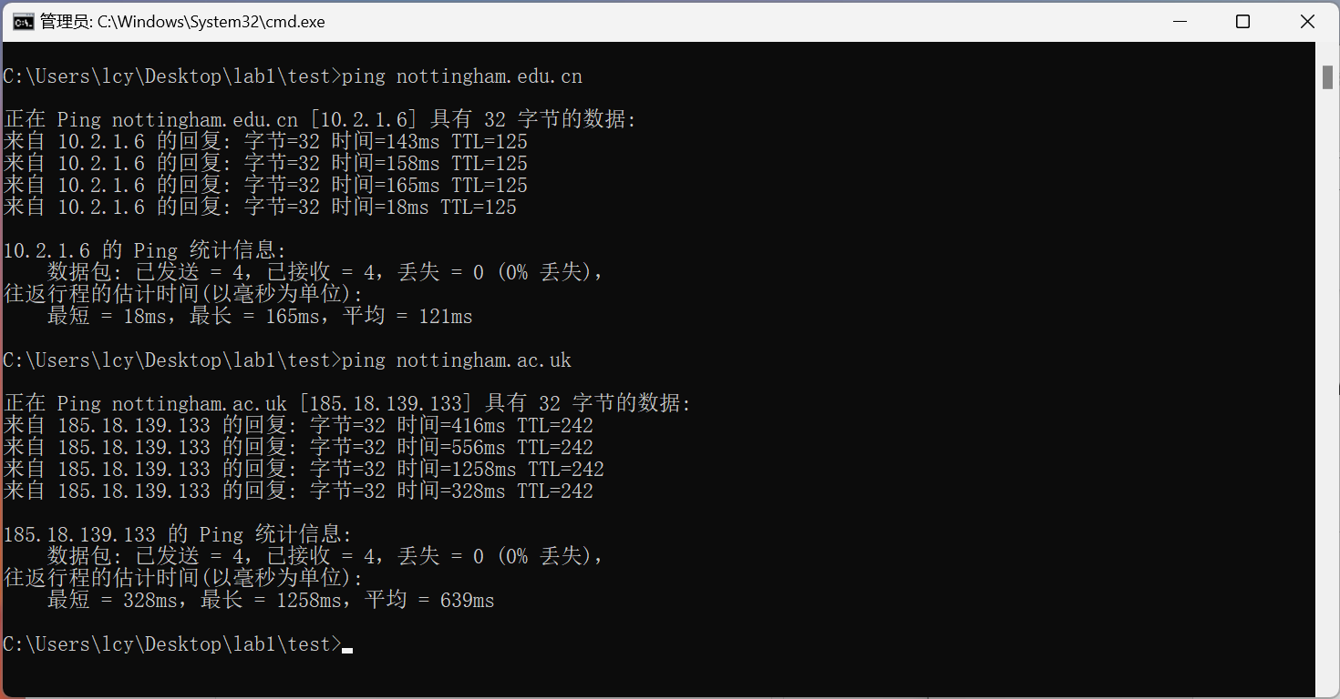

* The latency for the nottingham.edu.cn host is 121ms.
* The latency for the nottingham.ac.uk host is 639ms.
* Because the address of these two hosts are different.

2.3.2 exercise 2

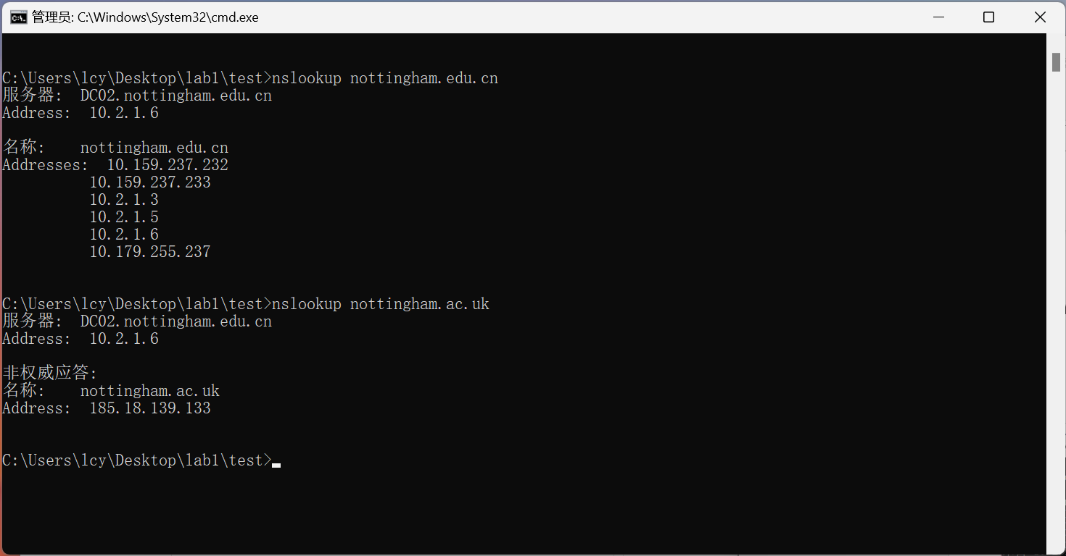

* The IP addresses of the Nottingham.edu.cn host are

10. 159. 237. 232

10. 159. 237. 233

10. 2. 1. 3

10. 2. 1. 5

10. 2. 1. 6

10. 179. 255. 237

* The IP address of the Nottingham.ac.uk host is

185.18.139.133

* Because the address of these two hosts are different.

2.3.3 exercise 3

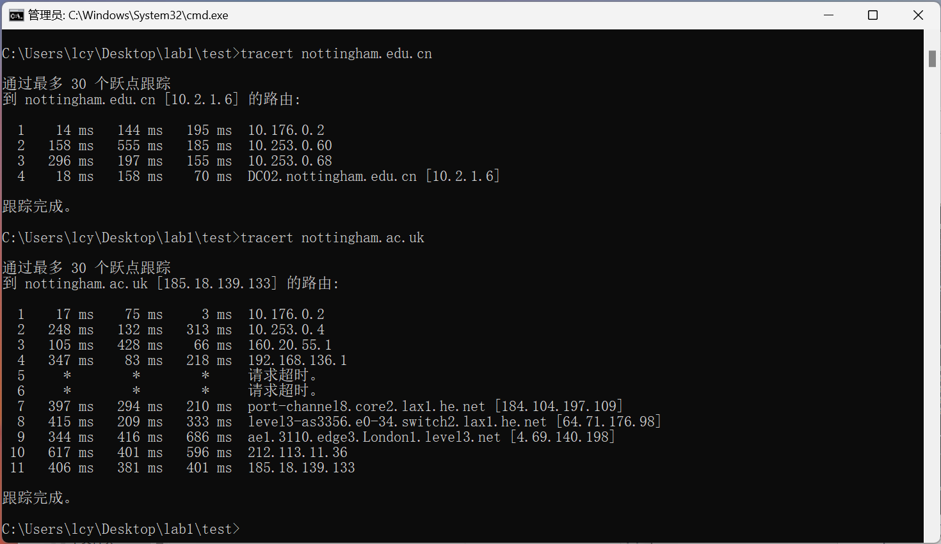

* 4 hops
* 11 hops
* Because the address of these two hosts are different.
* Yes. The more hops there are, the more latency will be caused.