Math Practice Web Application: Development Report
Gabriella Luciani · CSE 4095 Agentic Programming · October 21, 2026
GitHub: https://github.com/gel22008/Agentics_Class (app in the math-practice-app folder)
Live app: https://delightful-basbousa-bda4a2.netlify.app
AI agent used: Claude (Anthropic), working in my project folder and running commands on my computer

I did want to say that I did use the AI to help me with my report but I already gathered all the data, I’m just running low on time and energy. Please spare me.

1. Development Approach
I used Claude as my AI coding agent instead of Cursor. Before any code was written, I wrote out my own plan for the app (the header and nav bar, the flip cards, the statistics page, and how mistake review should work) and asked the agent to repeat back what it understood and tell me where my ideas were off, without writing code. It compared my plan to TODO.md and pointed out differences, such as the official difficulty names (Beginner, Easy, Intermediate, Advanced), the continuous-practice mode I had missed, and that the TODO has a separate Flip Card button.
After that, I followed TODO.md phase by phase. For each phase the agent wrote the code and tests and checked TypeScript and ESLint, and then I ran npm test myself, checked the app in the browser, and pushed to GitHub. The agent’s cloud workspace was not allowed to download npm packages, so we split the work: I ran installs, tests, builds and pushes on my own computer, and the agent wrote the code in my project folder. This actually made me verify every phase myself.
I did not follow the TODO exactly. I added my own features: a gentle red “recheck” nudge when a child says “I Got It Right” on a wrong answer (shake, red outline, ✗ and the text “Try to recheck if these two are the same,” but a second tap is accepted), a matching green nudge when a correct answer is reported as wrong, a short pause with encouraging feedback between cards, and short reasons on the disabled Practice Mistakes button (“Disabled because you haven’t started yet.”). Items I did not have time for, like cross-browser and screen-reader testing, are marked Deferred with a reason in TODO.md, and the README has a Known limitations section.
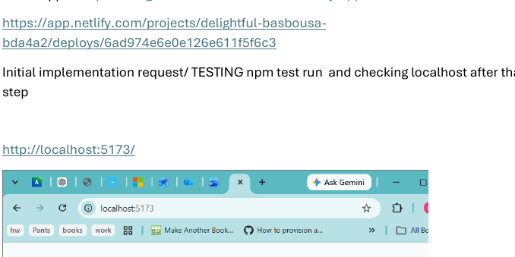
Figure 1. Verifying Phase 1 myself on localhost after the agent set up the React + TypeScript project.
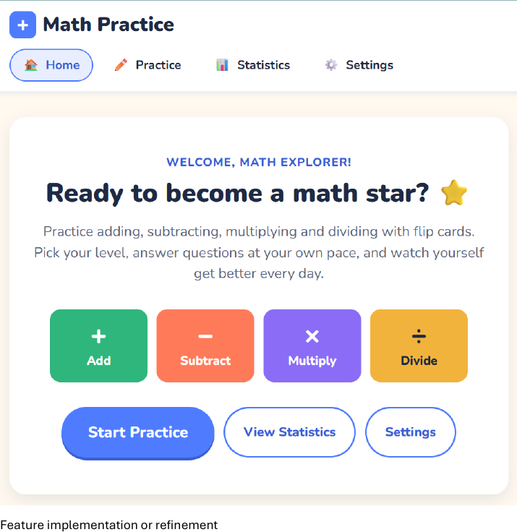
Figure 2. The finished home page with the always-visible nav bar (Home, Practice, Statistics, Settings).

2. Prompting Strategy
Prompt 1: Plan first, no code. My first real prompt gave the agent my whole design and limited what it could do:
“I want you only to repeat back to me what you understand, then reexplain it… I want you to tell me if my ideas are fully off base or not… Do not write any code yet.”
This worked because it caught mistakes in my plan before they became code, and the agent had a clear picture of what I wanted.
Prompt 2: Rules for how the agent works. Partway through, I set two rules that changed how the rest of the project went:
“I want you to keep a rule that first functionality, then aesthetics comes with telling me all the while what you’re doing.” / “For bugs specifically I want you to have me more part of the process of debugging… even if you know what is wrong.”
After this, when a bug appeared the agent stopped, showed me the evidence and asked me what I thought was wrong before offering fixes for me to choose from.
Prompt 3: Specific technical questions before accepting a feature. For session recovery (Phase 18) I asked:
“For the leave prompt, are you using React Router’s useBlocker? I think that only works with a data router… Does that need changing?” and “make sure the restored session can’t double-count the last answer.”
Specific questions forced the agent to explain its design (a custom navigation guard instead of useBlocker) and its limits (the browser Back button is not guarded), which I then documented in the README.

3. Debugging Experience
Bug 1: Sessions disappearing from Recent Sessions. While testing the Statistics page I noticed the numbers did not match: Overview said 13 questions attempted, but Recent Sessions only added up to 10 (Figure 3).
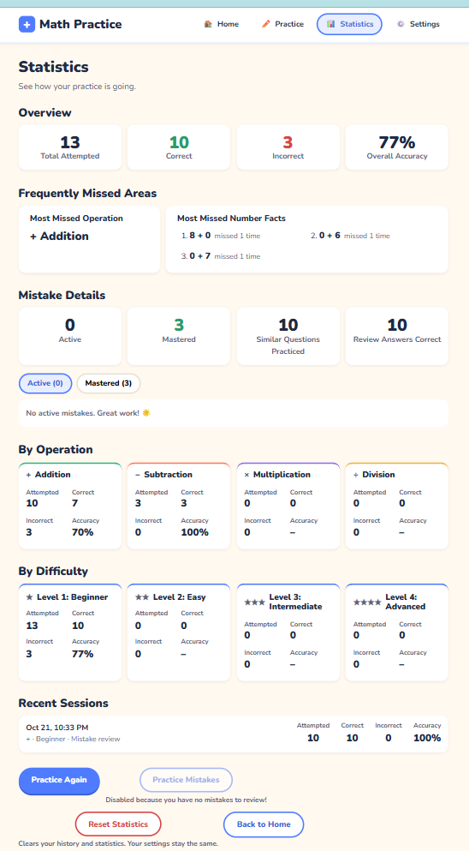
Figure 3. The bug I found: 13 total attempts in the Overview, but only 10 in Recent Sessions.
The agent gave me a hint instead of the answer: answers were saved the moment they were tapped, but a session was only saved when it reached the summary page. I worked out that the 3 missing answers came from a session I had left through the nav bar, so its answers were counted but the session itself was never saved. The agent offered two fixes and I chose to save the session’s running totals after every answer, so history always matches the saved answers even after a refresh or closing the tab. I also noticed a second, smaller bug in the same screenshot: a review session was labeled only “+” even though its fact-family questions included subtraction, so I asked for the label to show the operations actually practiced. I verified both fixes with new automated tests and by repeating the steps in the browser.
Bug 2: A test failing for the wrong reason. The test for a full 5-question session failed with “Unable to find an element with the text: Attempted” (Figure 4). Looking at the page snapshot in the error, I could see the app was still on the session page during the one-second pause between cards, so the app was working and the test was wrong: it waited for “any level-1 heading,” and the session page already has one. I chose the fix of waiting for “Attempted” itself and also asked for longer test timeouts, since 1 second was too close to the 0.9-second pause. The agent had actually tried to fix this line earlier and reported success, but the edit had not been applied.
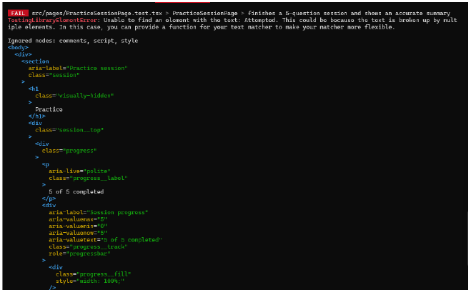
Figure 4. The failing test. The page snapshot showed “5 of 5 completed”, so the app was still mid-pause.

4. Testing
Testing happened at three levels. Automated tests: the project has 157 Vitest and React Testing Library tests covering every operation and difficulty, answer-choice rules, the flip card and both nudges, sessions and summaries, storage failures, statistics, settings, mistake tracking, mastery, similar questions, and session recovery (Figure 5). I ran npm test after every phase. Manual testing: after each phase I used the app on localhost and later on Netlify: full sessions, the recheck nudges, ending sessions early, refreshing in the middle of a session, Reset Statistics and Clear All Data. Gap check: near the end I asked for a check of the accessibility, responsive design and error-handling phases. It found real gaps (two colors with low contrast and no screen-reader announcement of the revealed answer), which we fixed.
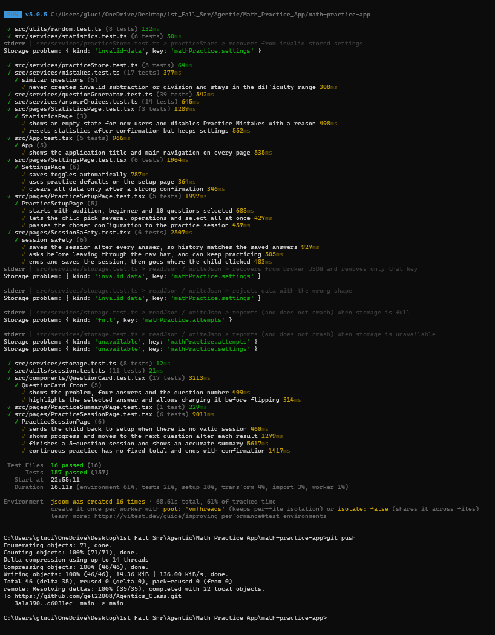
Figure 5. Final test run: 16 test files and 157 tests passing, then pushed to GitHub.
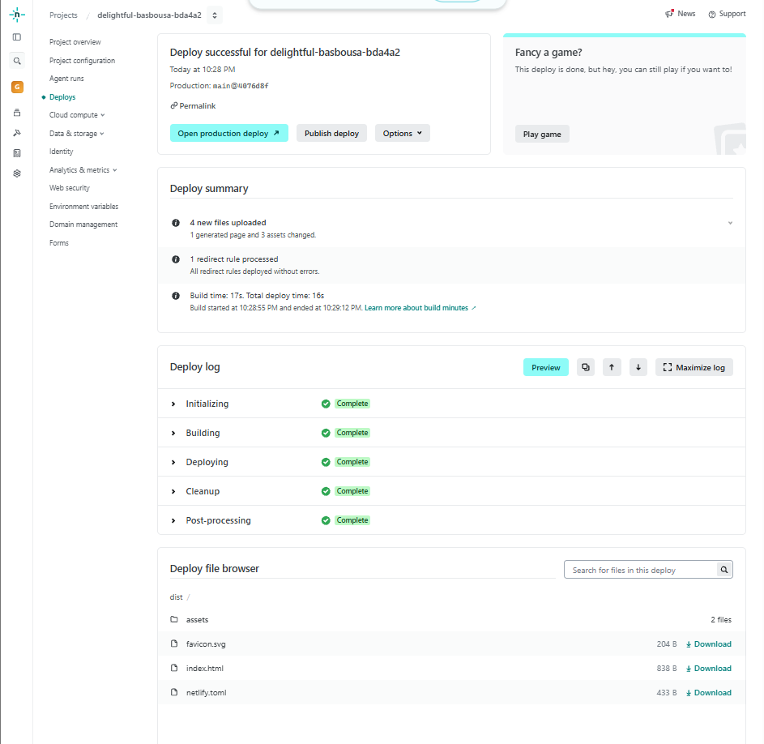
Figure 6. Netlify deploy succeeded; every push to main redeploys the live site.

5. Reflection
The biggest strength of the AI agent was speed and thoroughness: it turned each TODO phase into working code with tests in minutes and suggested things I would not have thought of, like keeping a test from failing randomly on a slower computer. It also explained concepts at my level, and when I asked it to explain one bug as if I were a child, the explanation finally made sense to me.
The limitations were just as clear. Twice the agent’s edits silently failed to apply, and once it told me a fix was done when it was not. The agent’s workspace could not install packages, and only I could see the app in a real browser. Most importantly, the most serious bug (lost sessions) was found by me looking at the Statistics page, not by the agent. I learned that the AI is a fast builder but not a reliable judge of its own work. My job was to set clear rules, ask specific questions, check the evidence myself, and decide between the options it gave me.

